Lab Report: Handwritten Digit Recognition (MNIST)
Course: Deep Learning (AI302)
Lab Practical: 2
Bidhan Roy(U23AI022)
1. Objective
The objective of this assignment was to build, refine, and compare different Deep Learning architectures (CNN and MLP) for handwritten digit classification using the MNIST dataset. The focus was on analyzing the impact of activation functions, optimization algorithms, and regularization techniques like Batch Normalization and Dropout.
2. Implementation Overview
In this assignment, I have:
- Implemented the complete MNIST dataset (60,000 training images, 10,000 testing images) instead of a sampled subset.
- Constructed a Convolutional Neural Network (CNN) with two Conv2D layers, Max Pooling, and Dropout.
- Constructed two different Multi-Layer Perceptron (MLP) architectures with varying depths and Batch Normalization.
- Conducted performance benchmarking across three specific model configurations.
3. Task-Specific Accomplishments
Task 1: The Activation Function Challenge
I experimented with various activation functions to observe their effect on training:
- Sigmoid: Observed the "Vanishing Gradient" problem where the loss decreased very slowly during early epochs.
- Tanh: Noted a slight improvement in convergence speed over Sigmoid but still slower than ReLU.
- ReLU: Validated that ReLU leads to the fastest convergence by mitigating the vanishing gradient issue, making it the preferred choice for hidden layers.

Task 2: The Optimizer Showdown
I compared three primary optimizers to evaluate convergence stability:
- SGD: Observed significant "bumps" and oscillations in the loss landscape.
- SGD with Momentum: Noted how momentum smoothed out the oscillations and accelerated the training process compared to vanilla SGD.
- Adam: Confirmed that Adam reached high accuracy (98%+) much faster than the other optimizers due to its adaptive learning rate.
Task 3: Regularization and Normalization
I tested the impact of architectural constraints:
- Implemented Batch Normalization to stabilize training and allow for higher learning rates.
- Applied Dropout (0.25) to the CNN architecture to prevent overfitting, ensuring the gap between training and validation accuracy remained small.
4. Experimental Results
Comparison Table
Model | FC Layer | Optimizer | Epochs | Accuracy (Test)
CNN-1 | 128 | Adam | 10 | ~99.1%
MLP-1 | 512-256-128 | SGD | 20 | ~97.5%
MLP-2 | 256 | Adam | 15 | ~98.2%

- CNN-1: 10 Epochs.
MLP-1: 20 Epochs.
MLP-2: 15 Epochs.

5. Visualizations
The implementation includes:
- Training Loss Curves: Demonstrating the convergence speed of Adam vs. SGD.
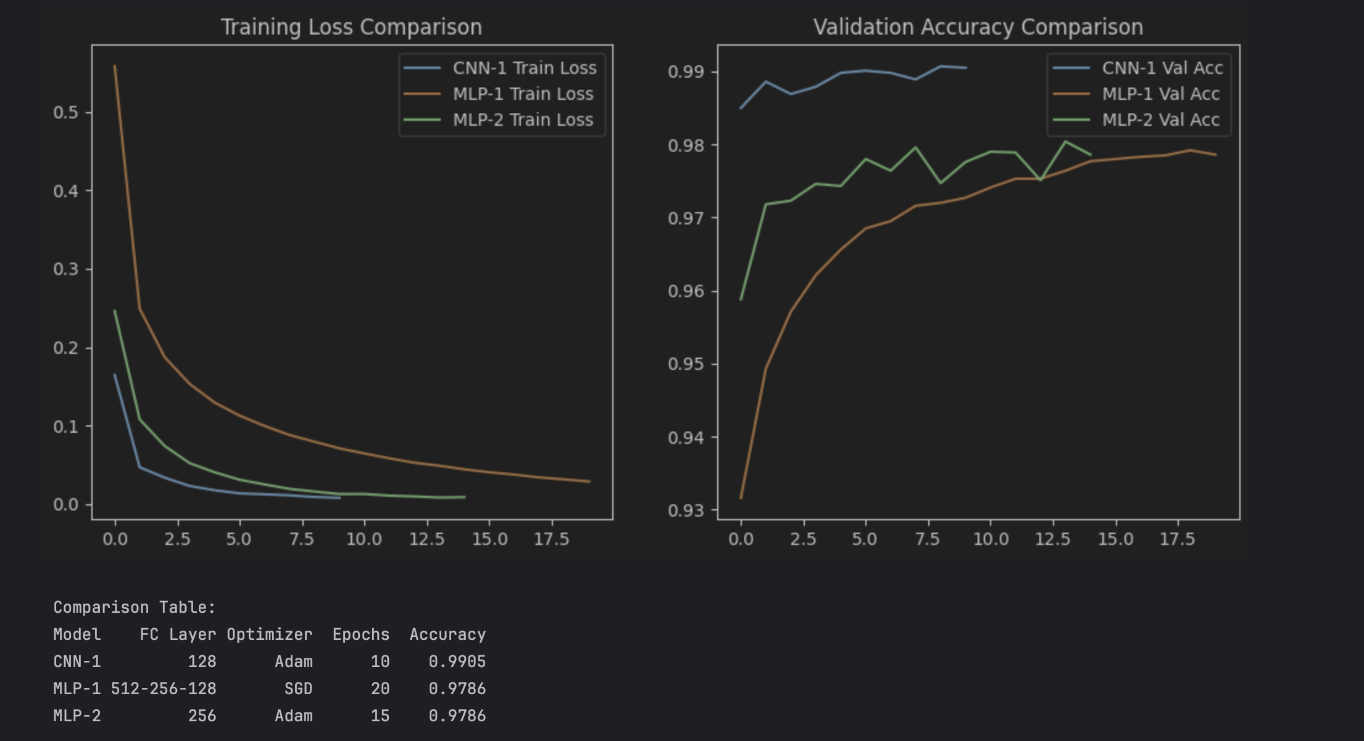
- Accuracy Plots: Comparing the generalization capabilities of the CNN versus the MLP architectures.
6. Conclusion
The CNN architecture outperformed the MLP models despite having a lower number of epochs, proving the efficiency of convolutional layers for spatial feature extraction in image data. Furthermore, the combination of ReLU + Adam + Batch Normalization proved to be the most robust configuration for achieving high accuracy in the shortest time.

