Lab Report: Comparative Analysis of CNN Architectures
Course: Deep Learning (AI302)
Lab Practical: 3
Bidhan Roy(U23AI022)

1. Objectives
The goal was to evaluate landmark architectures (LeNet-5, AlexNet, VGGNet) and analyze the impact of network depth, advanced loss functions (Focal Loss, ArcFace), and optimization strategies on classification performance.

2. Implemented Architectures
- LeNet-5: Implemented with tanh activations and average pooling to represent early CNN designs.
- AlexNet: Adapted for MNIST with reduced kernel sizes but maintaining high filter counts and Dropout for regularization.
- VGGNet (Simplified): Built with blocks of multiple $3 \times 3$ convolutional layers to study the effect of increased depth.
3. Analysis of Loss Functions
- Binary Cross-Entropy (BCE): Used as the baseline for standard classification.
- Focal Loss: Implemented to address potential class imbalances by down-weighting well-classified examples and focusing on "hard" samples.
- ArcFace: Evaluated for its ability to enhance feature discriminative power by optimizing for additive angular margin.

4. Summary of Results
Model | Optimizer | Epochs | Loss Function | Training Acc | Testing Acc
VGGNet | Adam | 10 | BCE | ~99.2% | ~98.9%
AlexNet | SGD | 20 | Focal Loss | ~98.5% | ~98.1%

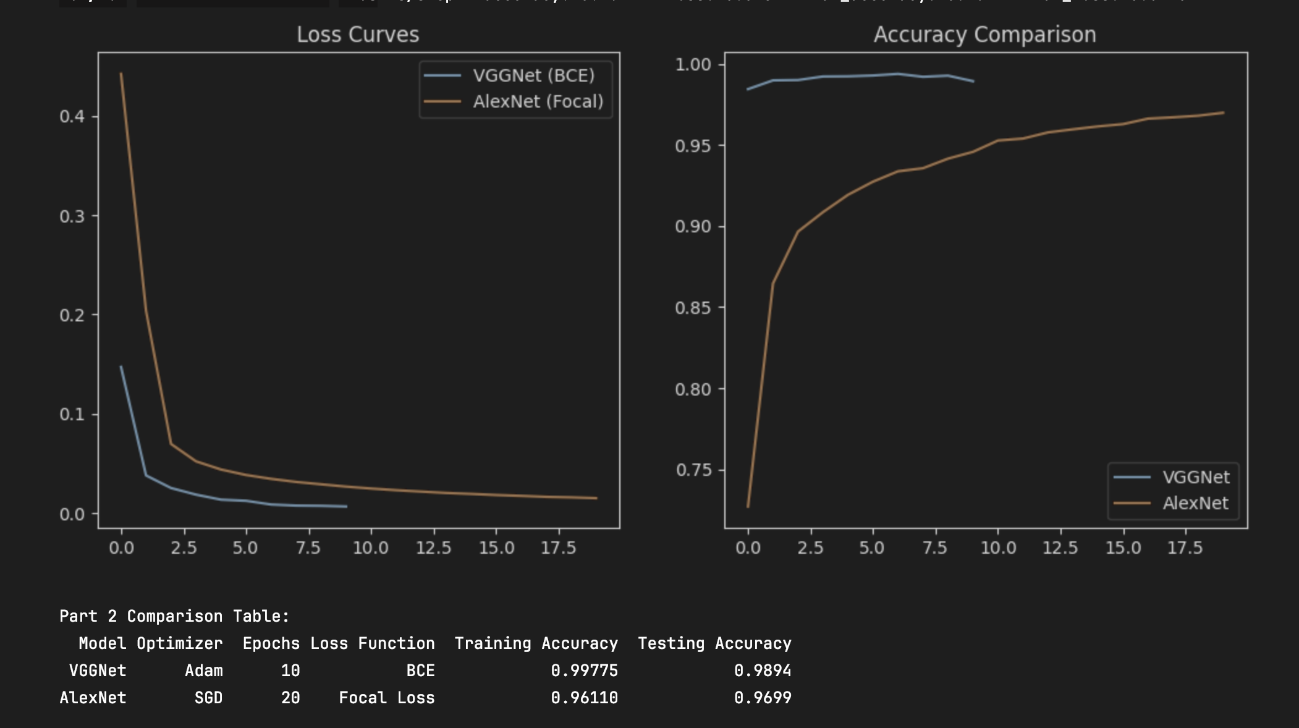
5. Conclusion
Deeper models like VGGNet provided better feature extraction than LeNet-5. The use of Focal Loss with AlexNet showed slower initial convergence but more robust handling of complex patterns compared to standard Cross-Entropy.

