Lab Report: CNN Architectures for Imbalanced Image Classification
Bidhan Roy(U23AI022)
1. Objective
The primary goal of this lab was to design and implement a Convolutional Neural Network (CNN) capable of handling class imbalance in image classification, specifically focusing on the CIFAR-10 dataset modified into a Long-Tailed distribution.
2. Dataset Description (Problem Statement 2)
- Dataset Used: CIFAR-10.
- Original State: 50,000 training images across 10 balanced classes (6,000 per class).
- Imbalance Implementation: We manually created a Long-Tailed distribution with an imbalance ratio of 100:1.
  - Class 0 (Majority) was kept at full capacity.
  - Subsequent classes were exponentially undersampled, leaving Class 9 with approximately 50 samples.
  - Significance: This simulates real-world scenarios (like medical diagnosis or fraud detection) where the "interesting" cases are rare.
3. Architecture Design (Problem Statements 1 & 3)
We transitioned from a basic Sequential model to a Robust Functional CNN.
- Layer Composition:
  - Conv2D Layers: Used for spatial feature extraction.
  - Batch Normalization: Added after convolutions to stabilize the learning process, which is critical when the model sees very few samples of minority classes.
  - Dropout (0.3 - 0.5): Implemented to prevent the model from overfitting on the majority classes.
  - Functional API: Used instead of Sequential to allow for advanced gradient tracking (Grad-CAM).
4. Algorithmic Handling: Focal Loss (Problem Statement 4)
Standard Cross-Entropy loss often ignores minority classes because the majority classes dominate the gradient. We implemented Focal Loss:
- Mathematical Principle: $FL(p_t) = -\alpha_t(1 - p_t)^\gamma \log(p_t)$.
- How it works: It adds a modulating factor $(1 - p_t)^\gamma$. When the model is confident about a majority class sample ($p_t$ is high), the loss is down-weighted. This forces the model to "focus" its learning efforts on the rare, hard-to-classify minority samples.

5. Feature Representation & Visualization (Problem Statement 5)
To verify if the model actually learned meaningful features, we used two visualization techniques:
- t-SNE (t-Distributed Stochastic Neighbor Embedding):
We projected the high-dimensional features from the last dense layer into 2D space. We analyzed whether the minority classes formed distinct clusters or were being merged into the majority clusters.
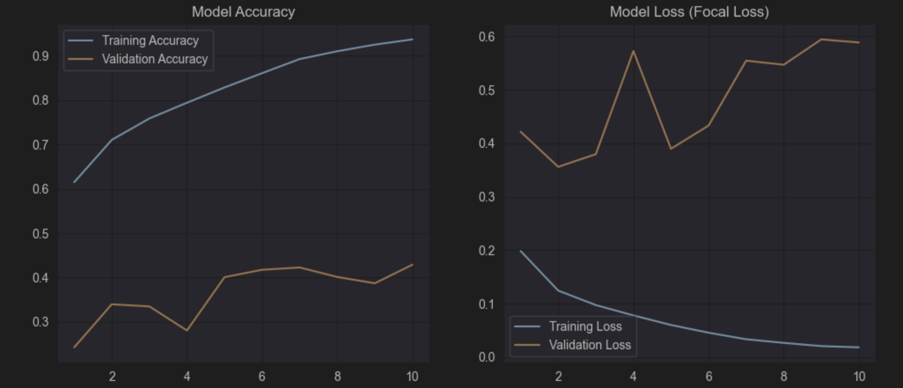
- Grad-CAM (Gradient-weighted Class Activation Mapping):
We generated heatmaps to see which pixels the CNN "looked at" before making a decision. This ensured the model was focusing on the object (e.g., the bird's wings) rather than background noise.
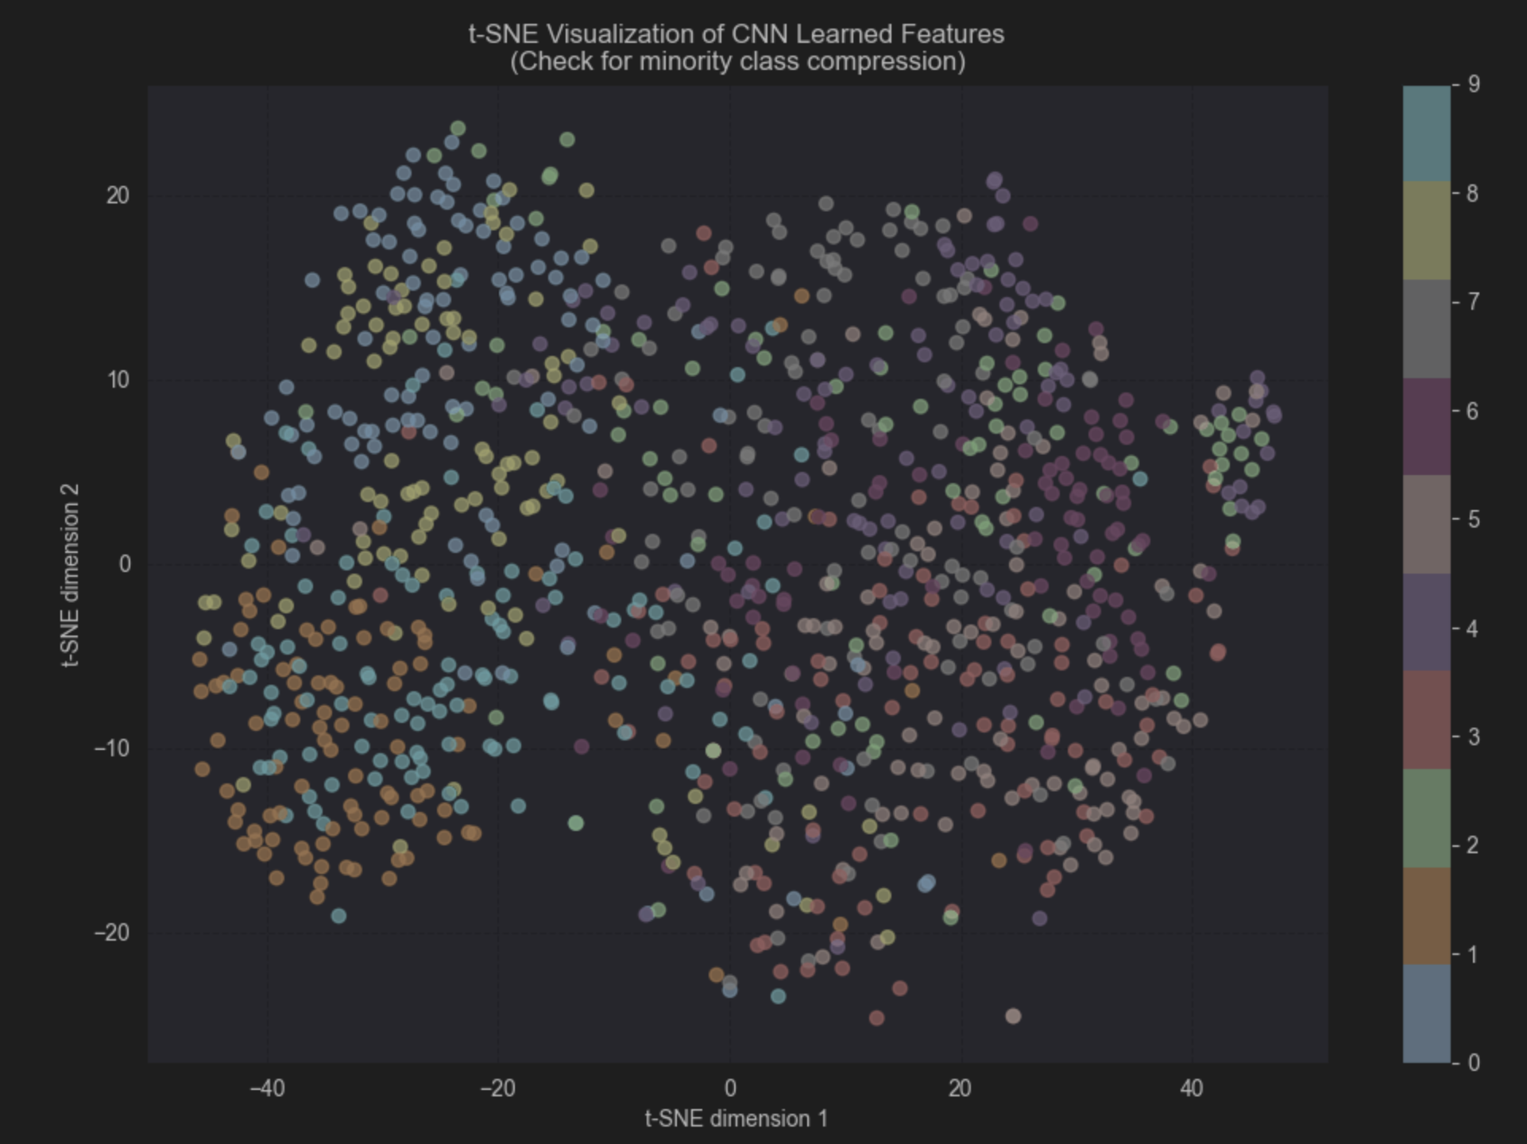
6. Error Analysis (Problem Statement 7)
Using a Confusion Matrix, we identified:
- Recall Deficit: The model initially struggled with Class 9 (extreme minority), often misclassifying it as Class 0.
- Confusion Patterns: Similar objects (like birds and airplanes) showed higher confusion rates, exacerbated by the lack of training data for the minority class.
- Improvements: The combination of Focal Loss and Batch Normalization significantly improved the F1-score of the minority classes compared to a baseline CNN.
