TC17- Sticky Progression Bar AB

**Test page URL:** [https://www.thomascook.com/book/extras?.*](https://www.thomascook.com/book/extras?.*)

**How to get to the test page:** From home page search widget click search->select one hotel and click continue-> Click continue again

**Segmentation:** All Device

**Details of Control:**

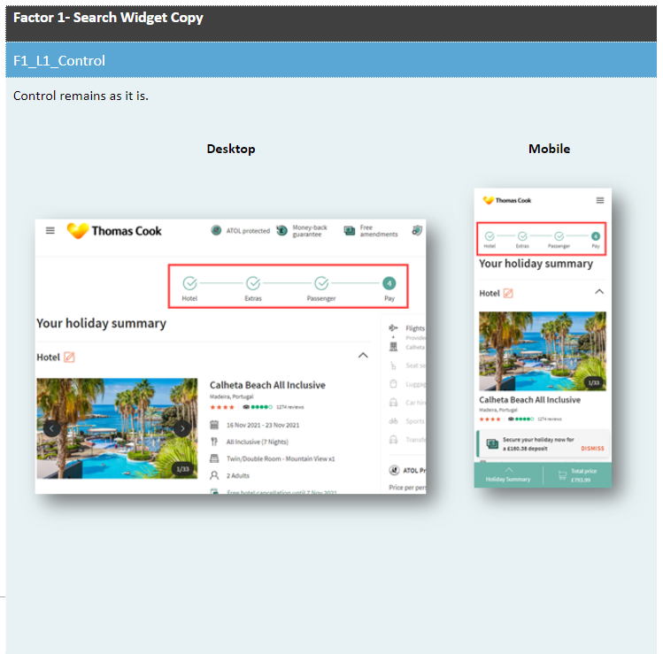

**Details of variation:**

