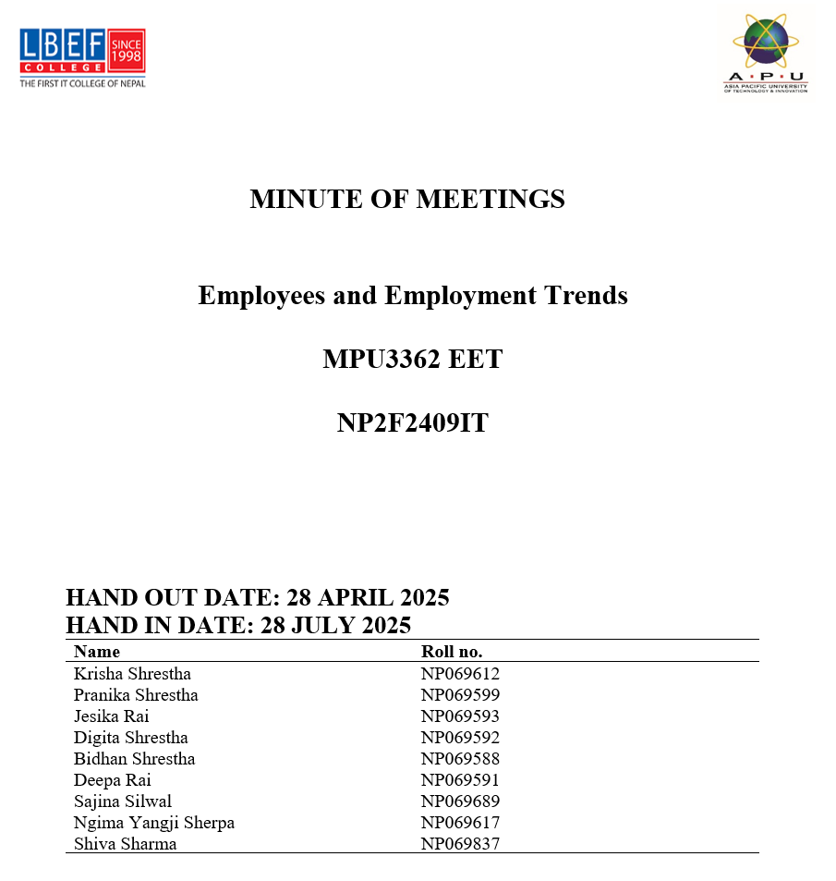

Meeting Minutes
Meeting Title: Upcoming Event Planning – Talk show on Tech Unplugged
Date: July 10, 2025
Time: 8:30 AM
Location: Meeting Hall, Block C
Module Leader: Ms. Garima Giri
Recorder: Bidhan Shrestha
Agenda:
- Approval of role and responsibilities of the event happening by the module leader
- Conformation of guest speakers
- Finalizing the venue and seating arrangements
- Marketing Plans to attract students of LBEF
- Budget planning on Juice and water
- Finalize the date, time and day of the event
Event Overview
Coordinator Digita came up with the idea of talk show and its title “Tech Unplugged: Real Journeys in Data, Design, and Quality Assurance”. And the event is scheduled to held on 27th July 2025, at the seminar hall of Lord Buddha Education Foundation.
Speaker coordinator
Bidhan Shrestha reached out to the speakers for the talk show and made sure that they got the official invitation from the team.
Event Coordinator
Jesika Rai will be responsible for managing the behind-the-scenes details of the event planning process and make sure that everything happens on time.
Venue Management
Pranika Shrestha will confirm the reservation of the venue for the day and will circulate mail to the students regarding the event.
Marketing and Designing
Krisha Shrestha will be responsible for poster designs and circulating the photos of the event on the college’s social platform coordinating with the marketing head.
Technical Set up
Shiva Sharma will be responsible for technical support.
On-site operation
Deepa Rai will be responsible for supervising the physical arrangements on the day of the event and will also be responsible for collecting feedback on the event.
Hosting
Ngima Yangji Sherpa and Sajina Silwal will be hosting the event. Yanzi will be opening and closing the event, and Sajina will be interacting, by asking questions with the three speakers.
Decisions made
The official invitation to the three speakers will be sent by Bidhan Shrestha.
And another official invitation to the students will be sent via Mrs. Garima Giri.
A group of four will do the classrooms visit.
Script will be reviewed by July 24.
Feedback forms will be prepared beforehand and will be distributed to the audience at the end of the event.

Minute Meeting Link:
www.youtube.com/watch?v=n3u-gq4s9Hg&feature=youtu.be

Member Present
