AI Voice-of-Customer
Analysis System

1. Project Overview
The AI Voice-of-Customer (VoC) Analysis System is an internal web application that collects customer feedback from multiple channels, applies AI-driven analysis, and presents actionable insights to company management.

The system is not a customer-facing product. Customers never interact with it directly. Instead, it works silently in the background — ingesting feedback that customers have already posted on other platforms — and surfaces intelligence for internal teams.

1.1 Technology Stack
Layer | Technology | Purpose
Frontend | Angular (TypeScript)
Backend | ASP.NET Core (C#)
Database | MS SQL / MySQL via EF Core
AI Service | Olama API | Sentiment analysis, topic labelling, insight generation
Auth | JWT (JSON Web Token) | Stateless login and role-based access

2. Problem Statement

2.1 The Problem
Companies receive customer feedback across many platforms simultaneously — app store reviews, support tickets, email, and survey responses. Reading and making sense of this manually is slow, inconsistent, and impossible to scale. Critical issues get buried. Trends go unnoticed. Management relies on gut feel rather than data.

2.2 What This System Solves
- Aggregates feedback from all sources into one place
- Automatically labels each feedback with a sentiment and a topic using AI
- Groups similar feedback and generate concise summaries for management
- Provides a real-time dashboard so executives can spot problems immediately

2.3 Target Users
Role | Problem They Have | How This App Helps
Analyst | Manually managing feedback CSV exports is tedious | Upload CSVs in one click; system handles the rest
Executive/Manager | No single view of what customers are saying | Dashboard with charts, trends, and AI-written summaries

3. Features (Functional Scope)

3.1 Feedback Ingestion
- Analyst can upload a CSV file containing customer feedback
- Analyst can manually enter a single feedback record (for testing or ad-hoc use)
- Each feedback is stored with its source, customer identifier, text, and submission date
- Each record is flagged as IsAnalyzed = 0 when first saved

3.2 Sentiment Analysis
- A background worker automatically picks up unanalyzed feedback
- Each feedback is sent to Olama, which returns a label: Positive, Negative, or Neutral
- The result is stored in the SentimentResults table
- The background worker runs every few minutes — no manual trigger required

3.3 Topic Clustering
- In the same AI call as sentiment, olama also returns a short topic label (e.g. 'Delivery Speed')
- The topic is stored against the feedback in the Topics table
- Management can see which topics have the most feedback

3.4 Insight Summaries
- The analyst can trigger insight generation for any topic
- The system sends all feedback under that topic to Olama
- Olama returns a 2-sentence management summary with an urgency level: Low / Medium / High / Critical
- Insights are stored in the Insights table and shown on the Topics & Insights page

3.5 Executive Dashboard
- Shows total feedback count, % Positive, % Negative, % Neutral as KPI cards
- Shows a sentiment trend chart over time (bar chart by month)
- Shows top topics ranked by feedback volume
- Shows the latest AI-generated insights with urgency badges

4. System Architecture (High-Level)
The system follows a standard three-tier architecture. Each tier has a clearly defined responsibility and communicates only with the tier directly adjacent to it.

4.1 Architecture Diagram
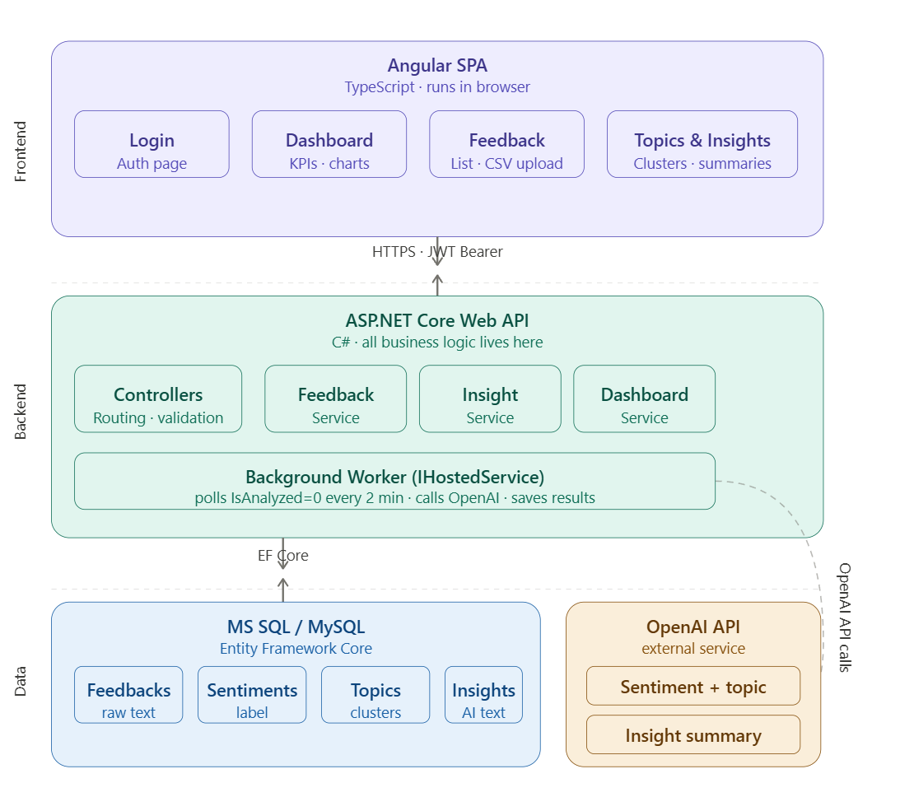

4.2 Layer Responsibilities
Layer | Technology | Responsibility
Angular SPA | TypeScript + Angular Material | Renders pages, calls REST APIs, displays results
ASP.NET Core API | C# + EF Core | Business logic, validation, routes all requests
Background Worker | IHostedService (built-in .NET) | Polls DB, calls Ollama AI, saves AI results automatically
Database | MS SQL / MySQL | Persists all data — feedback, results, users
Olama API | External HTTP API | AI analysis — never called from Angular, only from backend

5. Design

5.1 Module Design
The backend (ASP.NET Core) is split into Controllers and Services. Controllers handle routing only. All business logic lives in Services.

Backend Modules
Module / Service | File | Responsibility
FeedbackController | Controllers/FeedbackController.cs | Routes: ingest, bulk-ingest, list, detail
AnalyticsController | Controllers/AnalyticsController.cs | Routes: sentiment-summary, topics, insights
DashboardController | Controllers/DashboardController.cs | Route: dashboard/stats
AuthController | Controllers/AuthController.cs | Route: auth/login
FeedbackService | Services/FeedbackService.cs | Save feedback, read feedback, apply filters
AnalysisWorker | Workers/AnalysisWorker.cs | Background loop: picks IsAnalyzed=0, calls AI
Ollama Ai Service | Services/ Ollama Service.cs | Builds prompts, calls Ollama AI, parses JSON response
InsightService | Services/InsightService.cs | Groups feedback by topic, calls Ollama AI, saves insight
DashboardService | Services/DashboardService.cs | Queries DB and builds dashboard stats object
AuthService | Services/AuthService.cs | Validates credentials, generates JWT token
AppDbContext | Data/AppDbContext.cs | EF Core context — all DB table access goes here

Frontend Modules (Angular)
Folder / Module | Responsibility
core/auth/ | AuthService, JWT interceptor (attaches token to every request), AuthGuard
features/login/ | Login page component
features/dashboard/ | Dashboard page — KPI cards, charts, insights table
features/feedback/ | Feedback list page — table, filters, CSV upload
features/topics/ | Topics & Insights page — topic list + insight panel
shared/components/ | Reusable: SentimentBadgeComponent, StatCardComponent, LoadingSpinnerComponent

5.2 API Design
All endpoints are prefixed with /api. All endpoints except /api/auth/login require a valid JWT token in the Authorization header.

Auth
# | Method | Endpoint | Request Body | Response
1 | POST | /api/auth/login | { email, password } | { token, role }

Feedback
# | Method | Endpoint | Input | Response
2 | POST | /api/feedback/ingest | { sourceId, customerIdentifier, rawText, submittedAt } | { feedbackId }
3 | POST | /api/feedback/bulk-ingest | multipart/form-data (CSV file) | { count, errors[] }
4 | GET | /api/feedback | Query: page, pageSize, sentiment, sourceId, dateFrom, dateTo | { items[], total }
5 | GET | /api/feedback/{id} | feedbackId in path | Full feedback record + sentiment + topic

Analytics
# | Method | Endpoint | Input | Response
6 | GET | /api/analytics/sentiment-summary | Query: dateFrom, dateTo | { positive%, negative%, neutral% }
7 | GET | /api/analytics/topics | Query: dateFrom, dateTo | { topics[{ name, count }] }
8 | GET | /api/analytics/insights | Query: topicName (optional) | { insights[{ title, summary, urgency, count }] }

Dashboard
# | Method | Endpoint | Input | Response
9 | GET | /api/dashboard/stats | Query: dateFrom, dateTo | { totalFeedback, sentimentBreakdown, topTopics[], recentInsights[] }

Note on AI endpoints: There are no API endpoints for triggering AI. The background worker handles analysis automatically. The only AI-related user action is clicking 'Generate Insight' on the Topics page, which calls GET /api/analytics/insights.

5.3 Data Flow

Flow 1 — Feedback Ingestion (CSV Upload)
- Analyst opens the Feedback List page and clicks 'Upload CSV'
- Angular sends a POST /api/feedback/bulk-ingest with the file
- FeedbackController receives the file, passes it to FeedbackService
- FeedbackService parses each row and inserts a record into the Feedbacks table with IsAnalyzed = 0
- API returns { count: 150, errors: [] } to Angular
- Angular shows a success message with the count

Flow 2 — AI Analysis (Background Worker)
- AnalysisWorker runs every 2 minutes on a loop
- It queries the DB: SELECT TOP 20 FROM Feedbacks WHERE IsAnalyzed = 0
- For each feedback, it calls OllamaService.Analyze(rawText)
- OllamaService sends a prompt to Ollama and parses the JSON response: { sentiment, topic }
- AnalysisWorker saves the result to SentimentResults and Topics tables
- It updates the Feedbacks record: IsAnalyzed = 1
- No API call is involved — this runs entirely on the server

Flow 3 — Dashboard Load
- Executive opens the Dashboard page
- Angular calls GET /api/dashboard/stats?dateFrom=...&dateTo=...
- DashboardController calls DashboardService.GetStats(dateFrom, dateTo)
- DashboardService runs aggregation queries on the DB (counts, percentages, grouped topics)
- The result is returned as a single JSON object to Angular
- Angular renders KPI cards, charts, and the insights table from this one response

Flow 4 — Insight Generation
- Analyst or Executive clicks 'Generate Insights' on the Topics & Insights page
- Angular calls GET /api/analytics/insights?topicName=Delivery Speed
- InsightService fetches all feedback records where topic = 'Delivery Speed'
- InsightService sends the feedback texts + topic name to Ollama with the insight prompt
- Ollama returns: { title, summary, urgency }
- InsightService saves the result to the Insights table
- The insight is returned to Angular and displayed on the page

5.4 Database Design

Table: Feedbacks
Column | Type | Note
FeedbackId | INT PK (auto) | Primary key
SourceId | INT FK | Seeded source reference (App Store, Zendesk, etc.)
CustomerIdentifier | NVARCHAR(256) | Email or anonymous ID
RawText | NVARCHAR(MAX) | The actual feedback text
SubmittedAt | DATETIME2 | When the customer originally wrote it
IsAnalyzed | BIT default 0 | 0 = pending AI analysis, 1 = done

Table: Source

Column Type
SourceId INT PK Auto increment

Name NVARCHAR(100) e.g. "App Store", "Zendesk", "CSV Survey"

Table: SentimentResults
Column | Type | Note
SentimentId | INT PK (auto) | Primary key
FeedbackId | INT FK | One-to-one link to Feedbacks
Label | VARCHAR(20) | Positive | Negative | Neutral

Table: Topics
Column | Type | Note
TopicId | INT PK (auto) | Primary key
Name | NVARCHAR(100) | AI-assigned topic label e.g. 'Delivery Speed'
FeedbackId | INT FK | The feedback this topic belongs to

Table: Insights
Column | Type | Note
InsightId | INT PK (auto) | Primary key
Title | NVARCHAR(200) | One-line headline from AI
Summary | NVARCHAR(MAX) | 2-sentence AI-written paragraph
TopicName | NVARCHAR(100) | Which topic this insight covers
UrgencyLevel | VARCHAR(20) | Low | Medium | High | Critical
FeedbackCount | INT | How many feedbacks supported this insight

Table: Users
Column | Type | Note
UserId | INT PK (auto) | Primary key
Email | NVARCHAR(256) | Login email (unique)
PasswordHash | NVARCHAR(512) | Bcrypt hashed — never store plain text
Role | VARCHAR(30) | Analyst | Executive

5.5 Error Handling

Backend — API Errors
Scenario | HTTP Status | Response
Invalid login credentials | 401 Unauthorized | { error: 'Invalid email or password' }
Missing or expired JWT token | 401 Unauthorized | { error: 'Token invalid or expired' }
Feedback record not found | 404 Not Found | { error: 'Feedback not found' }
CSV file has invalid format | 400 Bad Request | { error: 'Invalid CSV format', details: [...] }
Required field missing | 400 Bad Request | { error: 'RawText is required' }
Unexpected server error | 500 Internal Error | { error: 'Something went wrong' }

Background Worker — AI Errors
- If Ollama returns an error, the feedback record is NOT marked as IsAnalyzed = 1
- The worker logs the error and moves to the next record
- The failed feedback will be retried automatically on the next worker cycle
- After 3 failed attempts, the record is marked IsAnalyzed = -1 (failed) so it stops retrying

Frontend — Angular Error Handling
- An HTTP interceptor catches all failed API calls globally
- A user-friendly toast/snackbar message is shown for every error
- Loading spinners are shown while any API call is in progress
- If the JWT token is expired, the user is redirected to the Login page automatically

6. Assumptions & Limitations

6.1 Assumptions
- Feedback is in English. No multilingual support is in scope for this version.
- The Olama API is available, and the API key is valid and funded.
- Feedback sources (App Store,CSV) are managed by seeding the DB — no admin UI is needed.
- Each feedback has exactly one topic assigned by AI. Complex multi-topic analysis is out of scope.
- Users are created directly in the database by the admin — no self-registration flow is needed.
- Volume is moderate — up to a few thousand feedback records per day. High-volume optimization is not required.

6.2 Limitations
- AI accuracy depends on Ollama. The system trusts the AI output without human review.
- There is no real-time data streaming. The dashboard shows data as of the last API call.
- The background worker processes feedback in small batches. Very large CSV uploads may take a few minutes to fully analyze.
- No token refresh is implemented. If a session expires, the user must log in again.
- No automated integration with live sources (App Store API, Zendesk webhook) is in scope. Feedback arrives via CSV upload only.
- No audit log. Changes to data are not tracked in this version.

This document covers Version 1.0 of the VoC Analysis System.
It is intended as a reference for the development team during implementation.
Any changes to scope or design should be reflected here before development begins.

