**Contacts Organizer**

**User Operating Manual**

1. Dashboard

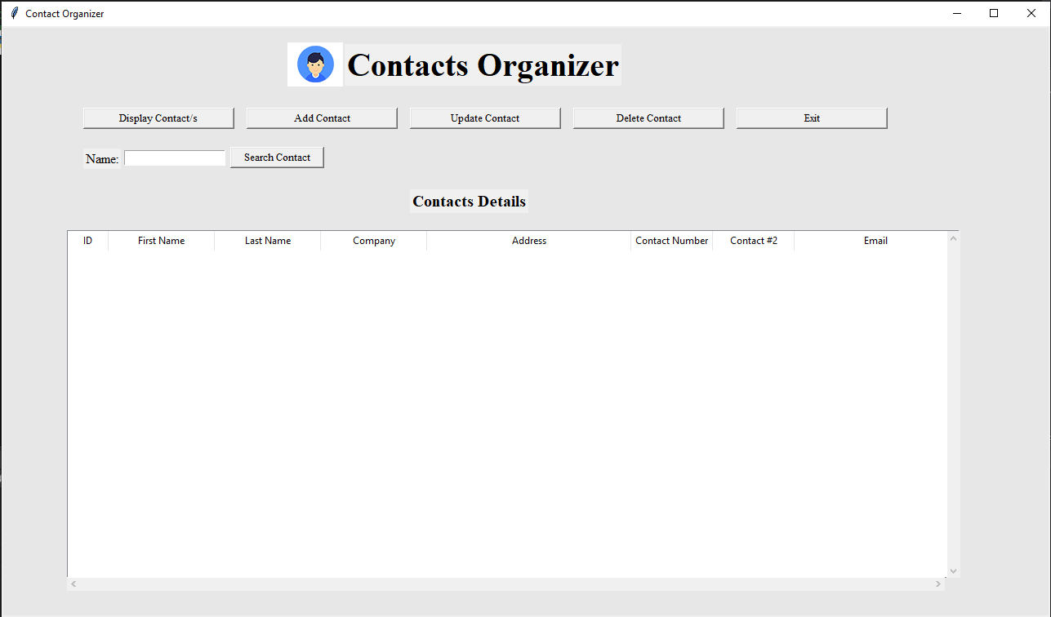

1. Display Contacts

Click on the display contacts button to view the contact list.

1. Search Contact

Provide the value in Name field and click on search contact to search by name.

1. Add Contact

Click on Add Contact button to open the form to add the contact.

First name, last name and Contact # is the required filed to save data. Provide the data and click on Save button to save the record. The message will be displayed as below

After success message is displayed, the prompt message is displayed asking for the new record as below

Click on the Yes button to add new record and No button to close the Add form window.

1. Update Contact

Select the record to be updated and click on the Update Contact button. The Add contact form will be shown with prefilled data. Make the necessary changes and click on the Update button to make the changes.

1. Delete Record

Select the record to be deleted and click on the Delete Contact button. The dialog box will be displayed to confirm the deletion, click on Yes to delete the selected data. Click on No to close the dialog box.

If data is deleted, the following message is shown.

