

USER MANUAL


ENGLISH










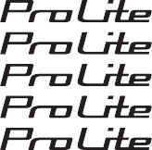
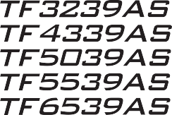
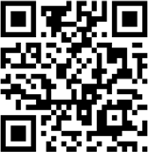
Thank you very much for choosing the iiyama LCD monitor for signage.
We recommend that you take a few minutes to read this comprehensive manual carefully before installing and switching on the monitor. Please keep this manual in a safe place for your future reference.

Scan the QR code to find out additional software/ services available for your IIYAMA product or go to: iiyama.com/signup





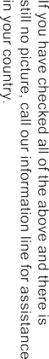


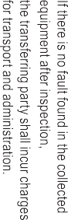


ENGLISH
CE MARKING DECLARATION OF CONFORMITY
This LCD monitor complies with the requirements of the EC/EU Directive 2014/30/EU “EMC Directive”, 2014/35/EU “Low Voltage Directive”, 2009/125/EC “ErP Directive” and 2011/65/EU “RoHS Directive”.
The electro-magnetic susceptibility has been chosen at a level that gives correct operation in residential areas, business and light industrial premises and small-scale enterprises, inside as well as outside of the buildings. All places of operation are characterized by their connection to the public low voltage power supply system.
IIYAMA CORPORATION: Wijkermeerstraat 8, 2131 HA Hoofddorp, The Netherlands
Model No. : PLT3239, PLT4339, PLT5039, PLT5539, PLT6539

We recommend recycling of used product. Please contact your dealer or iiyama service center. Recycle information is obtained via the Internet, using the address: https://iiyama.com
You can access the Web page of different countries from there.

- We reserve the right to change specifications without notice.
- All trademarks used in this user manual are the property of their respective owners.
- Eprel registration number TF3239AS-B1AG : 2040941 TF4339AS-B1AG : 2047575
TF5039AS-B1AG : 2043908 TF5539AS-B1AG : 2045805
TF6539AS-B1AG : 2047547

TABLE OF CONTENTS
ENGLISH
FOR YOUR SAFETY 1
SAFETY PRECAUTIONS 1
SPECIAL NOTES ON LCD MONITORS 3
CUSTOMER SERVICE 5
CLEANING 5
BEFORE YOU OPERATE THE MONITOR 6
FEATURES 6
CHECKING THE CONTENTS OF THE PACKAGE 6
UNPACKING 6
SPECIAL NOTES ON TOUCH PANEL 7
CONTROLS AND CONNECTORS 7
INSTALLATION 11
CONNECTING YOUR MONITOR 13
FUNCTIONS OF THE REMOTE CONTROL 15
PREPARING THE REMOTE CONTROL 16
REMOTE CONTROL ID 17
BASIC OPERATIONS USING THE REMOTE CONTROL 18
COMPUTER SETTING 20
SCREEN SETUP 21
OPERATING THE MONITOR 22
ADJUSTMENT MENU CONTENTS 23
STANDBY FEATURE 42
TROUBLE SHOOTING 43
RECYCLING INFORMATION 44
APPENDIX 45
SPECIFICATIONS : ProLite TF3239AS-B1AG 45
SPECIFICATIONS : ProLite TF4339AS-B1AG 46
SPECIFICATIONS : ProLite TF5039AS-B1AG 47
SPECIFICATIONS : ProLite TF5539AS-B1AG 48
SPECIFICATIONS : ProLite TF6539AS-B1AG 49
DIMENSIONS : ProLite TF3239AS 50
DIMENSIONS : ProLite TF4339AS 50
DIMENSIONS : ProLite TF5039AS 51
DIMENSIONS : ProLite TF5539AS 51
DIMENSIONS : ProLite TF6539AS 52
COMPLIANT TIMING 53

FOR YOUR SAFETY
ENGLISH
SAFETY PRECAUTIONS
WARNING

STOP OPERATING THE MONITOR WHEN YOU SENSE TROUBLE
If you notice any abnormal phenomena such as smoke, strange sounds or fumes, unplug the monitor and contact your dealer or iiyama service center immediately. Further use may be dangerous and can cause fire or electric shock.

NEVER REMOVE THE CABINET
High voltage circuits are inside the monitor. Removing the cabinet may expose you to the danger of fire or electric shock.

DO NOT PUT ANY OBJECT INTO THE MONITOR
Do not put any solid objects or liquids such as water into the monitor. In case of an accident, unplug your monitor immediately and contact your dealer or iiyama service center. Using the monitor with any object inside may cause fire, electric shock or damage.

INSTALL THE MONITOR ON A FLAT, STABLE SURFACE
The monitor may cause an injury if it falls or is dropped.

DO NOT USE THE MONITOR NEAR WATER
Do not use where water may be splashed or spilt onto the monitor as it may cause fire or electric shock.

OPERATE UNDER THE SPECIFIED POWER SUPPLY
Be sure to operate the monitor only with the specified power supply. Use of an incorrect voltage will cause malfunction and may cause fire or electric shock.

PROTECT THE CABLES
Do not pull or bend the power cable and signal cable. Do not place the monitor or any other heavy objects on the cables. If damaged, the cables may cause fire or electric shock.

ADVERSE WEATHER CONDITIONS
It is advisable not to operate the monitor during a heavy thunder storm as the continual breaks in power may cause malfunction. It is also advised not to touch the plug in these circumstances as it may cause electric shock.

ENGLISH
CAUTION

INSTALLATION LOCATION
Do not install the monitor where sudden temperature changes may occur, or in humid, dusty or smoky areas as it may cause fire, electric shock or damage. You should also avoid areas where the sun shines directly on the monitor.

DO NOT PLACE THE MONITOR IN A HAZARDOUS POSITION
The monitor may topple and cause injury if not suitably located. Please also ensure that you do not place any heavy objects on the monitor, and that all cables are routed such that children may not pull the cables and possibly cause injury.

MAINTAIN GOOD VENTILATION
Ventilation slots are provided to keep the monitor from overheating. Covering the slots may cause fire. To allow adequate air circulation, place the monitor at least 10cm (or 4 inches) from any walls. In case the monitor will be installed inside a kiosk or any other equipment, please make sure enough ventilation is available to avoid overheating of the monitor. Contact the iiyama service center in case you need advice.

DISCONNECT THE CABLES WHEN YOU MOVE THE MONITOR
When you move the monitor, turn off the power switch, unplug the monitor and be sure the signal cable is disconnected. If you do not disconnect them, it may cause fire or electric shock.

UNPLUG THE MONITOR
If the monitor is not in use for a long period of time it is recommended that it is left unplugged to avoid accidents.

HOLD THE PLUG WHEN DISCONNECTING
To disconnect the power cable or signal cable, always pull it by the plug. Never pull on the cable itself as this may cause fire or electric shock.

DO NOT TOUCH THE PLUG WITH WET HANDS
Pulling or inserting the plug with wet hands may cause electric shock.

ENGLISH
SPECIAL NOTES ON LCD MONITORS
- The following symptoms are normal with LCD monitors and do not indicate a problem.
  - When you first turn on the LCD monitor, the picture may not fit in the display area because of the type of computer that is used. In this case, adjust the picture position to the correct position.
NOTE
  - You may find slightly uneven brightness on the screen depending on the desktop pattern you use.
  - Due to the nature of the LCD screen, an afterimage of the previous screen may remain after switching the image, when the same image is displayed for hours. In this case, the screen is recovered slowly by changing the image or turning off the Power Switch for hours.
- This LCD cannot be used outdoors.
- If you use a cable longer than the supplied one, the picture quality is not guaranteed. Touch function can be disrupted if the USB cable length exceeds 3m.

USAGE CONFIRMATION
ENGLISH
Product maximum non-stop usage hours following the installation guidelines in a clean and temperature-controlled environment: 24/7
The monitor is compatible for usage in Landscape/Portrait and Tabletop (face-up) applications. If being used in Tabletop application, please utilise the Fan-On function.

IMAGE PERSISTENCE / IMAGE STICKING
Please be aware that all LCD screens can experience Image Persistence or Image Sticking. This occurs when a residual image remains visible on a screen when static images are displayed for long periods of time. LCD Image Persistence is not permanent but constant images being displayed for a long period of time should be avoided.
To counteract Image Persistence, turn off the monitor for as long as the previous image was displayed, so if an image was on the monitor for 1 hour and there is evidence of a residual or “ghost” image, you should turn off the monitor for 1 hour in order to clear the residual image.
For all LFD products, iiyama recommends displaying moving images and utilising a moving screen saver at regular intervals whenever the screen is idle. You could also turn off the monitor when not in use to assist the prevention.
Other ways to reduce the risk of Image Persistence will be to utilise the Fan-On function (if available), Low Backlight and Low Brightness settings.

FOR EXTENDED USE AS A PUBLIC MONITOR
- Image Sticking on LCD Panel
When a static image is displayed for hours, an electric charge trace remains near the electrode inside the LCD producing a “ghost” image. (Image Persistence).
Image Persistence is not a permanent feature.
- Recommendations
To prevent Image Sticking and promote longer life expectancy of monitor, we recommend the following:
- Avoid static images displayed for long periods – change static images on continuous loop.
- Turn off monitor when not in use, either by remote control or use Standby or “Schedule” functions.
- Check the Monitor Menu Settings for “Pixel Shift” or “White wash” and activate it when available.
This will reduce the Image Sticking Effect.
- When monitor is installed in high ambient temperature environment(s) or in an enclosed position, utilise the Cooling Fan, Screen Saver and Low Brightness functions.
- Suitable ventilation for any monitor is an expectation of any installation – climate control systems may need to be employed.
- We strongly recommend utilisation of active cooling with fans for long operation times or high ambient temperature environments.

CUSTOMER SERVICE
NOTE  If you have to return your unit for service and the original packaging has been discarded, please contact your dealer or iiyama service center for advice or replacement packaging.

CLEANING
WARNING  If you drop any materials or liquids such as water into the monitor when cleaning, unplug the power cable immediately and contact your dealer or iiyama service center.
CAUTION  For safety reasons, turn off the power switch and unplug the monitor before you clean it.
NOTE  To protect the LCD panel, do not scratch or rub the screen with a hard object.
  - Never use any of the following strong solvents. These will damage the cabinet and the LCD screen.
Thinner | Benzine | Abrasive cleaner
Spray-type cleaner | Wax | Acid or Alkaline solvent
  - Touching the cabinet with any product made from rubber or plastic for a long time may cause degeneration or loss of paint on the cabinet.

CABINET Stains can be removed with a cloth lightly moistened with a mild detergent solvent.
Then wipe the cabinet with a soft dry cloth.

LCD SCREEN
ENGLISH
Periodic cleaning with a soft dry cloth is recommended.
Don’t use tissue paper etc. because these will damage the LCD screen.

BEFORE YOU OPERATE THE MONITOR
ENGLISH
FEATURES
- Supports Resolutions up to 1920 × 1080 ProLite TF3239AS
3840 × 2160 ProLite TF4339AS / ProLite TF5039AS / ProLite TF5539AS / ProLite TF6539AS

High Contrast
1200:1 (Typical) ProLite TF3239AS / ProLite TF4339AS / ProLite TF5539AS / ProLite TF6539AS
5000:1 (Typical) ProLite TF5039AS
- Brightness 500cd/m² (Typical without touch panel)
- Digital Character Smoothing
- 2 × 10W Stereo Speakers
- Standby Feature
- VESA Mounting Standard Compliant 200mm×200mm ProLite TF3239AS / ProLite TF4339AS
400mm×400mm ProLite TF5039AS / ProLite TF5539AS / ProLite TF6539AS

Glass with AG Coating

CHECKING THE CONTENTS OF THE PACKAGE
The following accessories are included in your package. Check to see if they are enclosed with the monitor. If anything is missing or damaged, please contact your local iiyama dealer or regional iiyama office.
- Power Cable (2 pcs) *  HDMI Cable  RS-232C Cable
- USB Cable  Remote Control  Battery (2 pcs)
- Cable Cover with 2 screws  EU/UK Energy Label  Safety Guide
- Quick Start Guide

CAUTION
* All guarantees and warranties are void for any problems or damage caused by a power cable not supplied by iiyama.
An approved power cable greater or equal to H05VVF, 3G, 0.75mm² must be used.

UNPACKING

CAUTION
Moving the monitor requires at least two people. If not, it may drop and could result in a serious injury.

ENGLISH
SPECIAL NOTES ON TOUCH PANEL

CAUTION
Permanent damage can occur if Sharp Edged, Pointed or Metal items are used to activate Touch. This could invalidate any remaining warranty.
We recommend to use conductive rubber tip type stylus (tip R8.0 or over) or finger.

CONTROLS AND CONNECTORS

<Front>


 | Power Indicator | State | LED
 | Power Indicator | Main Power Switch “Off” | Off
 | Power Indicator | Functionally “Off” | Off
 | Power Indicator | Normal operation | Solid blue
 | Power Indicator | Standby mode | Blinking blue
 | Remote Sensor

<Back>
ENGLISH

ProLite TF3239AS
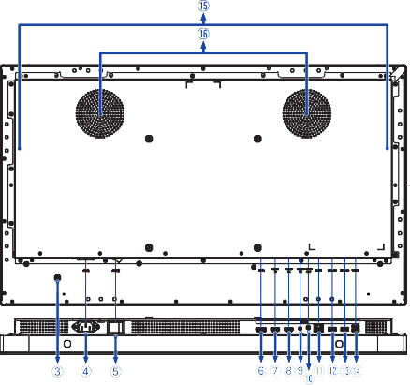

ProLite TF4339AS
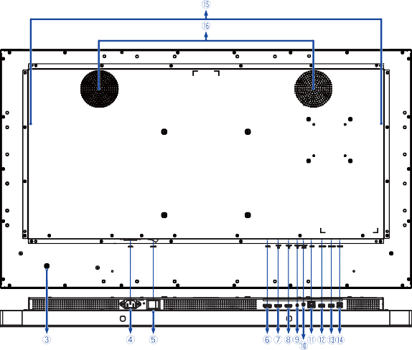

ProLite TF5039AS
ENGLISH
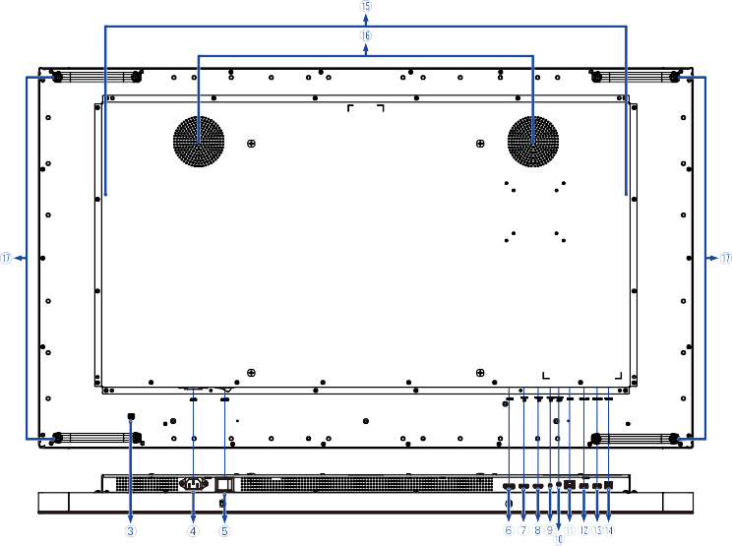

ProLite TF5539AS
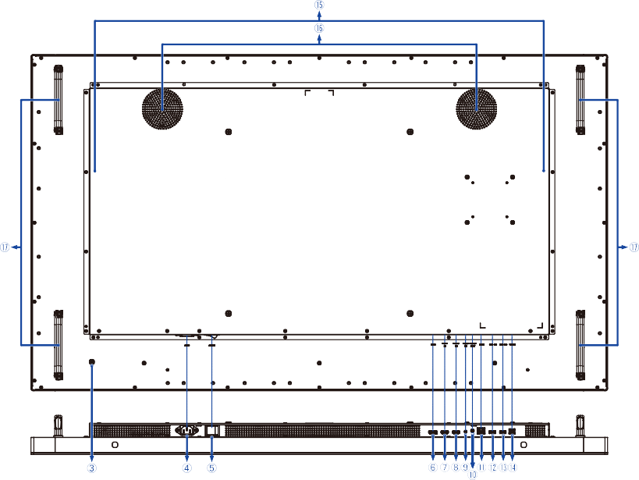

ProLite TF6539AS
ENGLISH
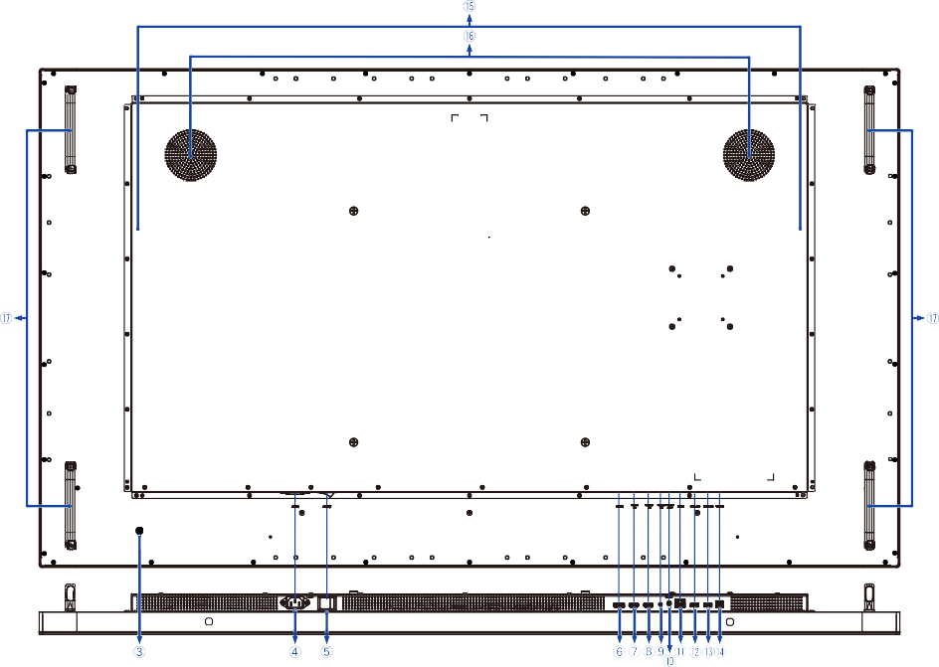

 |  | Power Button
 | AC IN | AC Inlet | AC Connector (: Alternating current)
 | AC-SW (ON) / (OFF) | Main Power Switch
 | DP IN | DisplayPort | DisplayPort Connector
 | HDMI1 IN | HDMI | HDMI Connector
 | HDMI2 IN | HDMI | HDMI Connector
 | RS232 IN | RS232C | RS232C Connector
 | AUDIO OUT | Mini Jack | Headphone Connector *
 | RJ45 | RJ45 | RJ45 Connector
 | USB2.0 | USB2.0 (DC5V, 500mA) | USB Type-A Downstream Connector
 | USB2.0 | USB2.0 (DC5V, 500mA) | USB Type-A Downstream Connector
 | TOUCH | USB Touch | USB Type-B Upstream Connector
 | Speakers
 | Fans
 | Handles
* Proper operation of connected external devices other than headphones is not guaranteed.

ENGLISH
INSTALLATION

CAUTION
- Follow the manual instructions for the type of mount you have selected. Refer all servicing to qualified service personnel.
- Moving the monitor requires at least two people.
- Before installing, please make sure the wall is strong enough to hold the necessary weight of the monitor and the mount.

[WALL MOUNTING]

Mounting Stage Screw
Model | Screw | “L” length
ProLite TF3239AS | M6 | 12mm
ProLite TF4339AS | M6 | 12mm
ProLite TF5039AS | M6 | 12mm
ProLite TF5539AS | M6 | 12mm
ProLite TF6539AS | M8 | 16mm

L
Chassis

CAUTION
When using the wall mounting, consideration of thickness of the mounting stage needs to be taken. Tighten the screws to fasten the monitor. Using a screw not specified may cause electric shock or damage because it may contact with the electrical parts inside the monitor.

[ROTATING THE MONITOR]
ENGLISH

This monitor is designed to be compatible in landscape, portrait and face-up modes.
A

Power Indicator, Remote Sensor
Available
Not Available
Landscape
Portrait
Face-up
A
A
A

[FAN]

CAUTION
If the screen is used in face-up position, please be sure to turn on the “Fan” function.
If you do not use the fan, the internal temperature rises and the product life cycle may get shorter.
If the screen is built into an external cabinet, please be sure to implement a cooling unit inside of the cabinet.
Dirt and dust may stick to the fan, reducing the cooling effect which may result in a shorter life cycle of the product. Please clean regularly.


ENGLISH
CONNECTING YOUR MONITOR
Ensure that both the computer and the monitor are switched off.
Connect the computer to the monitor with the signal cable. Connect the computer to the monitor with the USB Cable.
Connect the Power Cable to the monitor first and then to the power source. Turn on your monitor (Main Power Switch and Power Button) and computer.
Follow the OOBE (Out of Box Experience) instructions to complete the screen setup.
NOTE  Make sure that the building installation has a circuit breaker of 120/240V, 20A (maximum).
  - The signal cables used for connecting the computer and monitor may vary with the type of computer used. An incorrect connection may cause serious damage to both the monitor and the computer. The cable supplied with the monitor is for a standard connector. If a special cable is required please contact your local iiyama dealer or regional iiyama office.
  - Make sure you tighten the finger screws at each end of the signal cable.
  - The touch function is ready for use about 8 seconds after connecting the USB cable and can be operated with a pen, finger or any other pointer.
  - The Class I pluggable equipment Type A must be connected to protective earth.
  - The socket-outlet shall be installed near the equipment and shall be easily accessible.
  - Excessive sound pressure from ear-/headphones can cause hearing damage/hearing loss.

[Example of Connection]

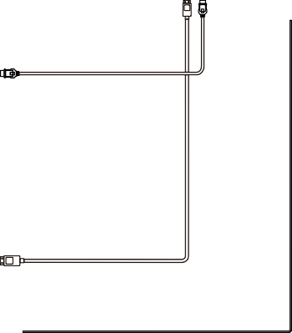
<Back>
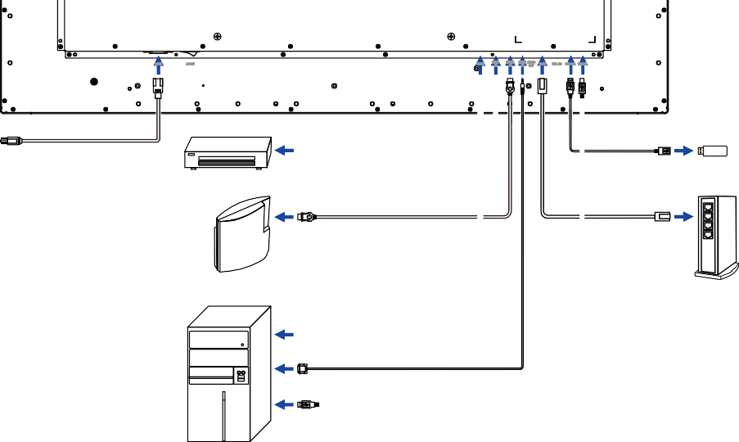
Power Cable (Accessory)
HDMI Cable (Accessory)
AV Equipment etc.
USB Cable USB Device (Not included)
HDMI Cable (Not included)
LAN(RJ45) Cable
(Not included)
Game Equipment etc.
Router
DisplayPort Cable (Not included) RS-232C Cable (Accessory)
USB Cable (A-B) (Accessory)
Computer

[Attaching the Cable Cover]
ENGLISH

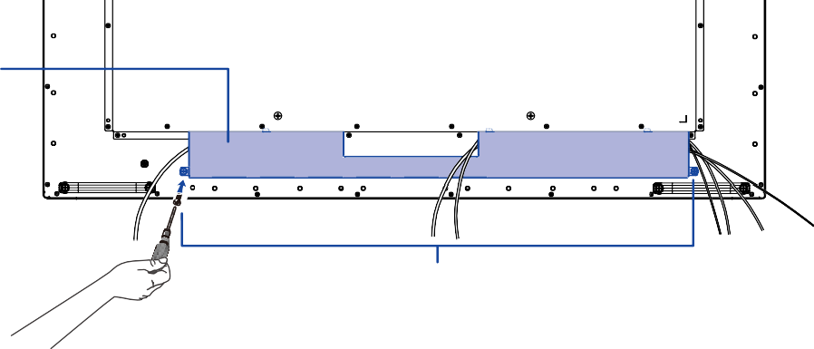
A
B

A : Cable Cover
B : Screws

ENGLISH
FUNCTIONS OF THE REMOTE CONTROL
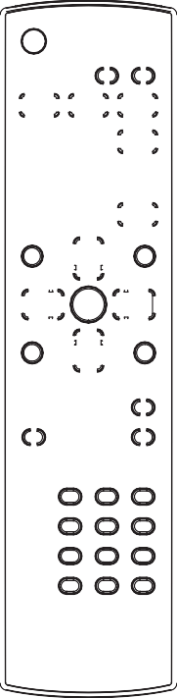
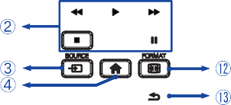
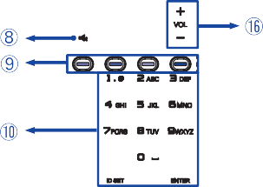
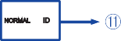
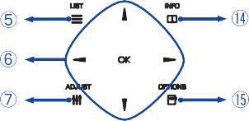
 |  | Turns the monitor ON and OFF.
 | [PLAY] | Control playback of media files.  : Play  : Stop  : Pause  : Fast-Rewind  : Fast-Forward
 | SOURCE | Selects the source.  Press or button to select from HDMI1, HDMI2, DisplayPort, Browser, CMS, File Manager, Media Player, PDF Player or Custom. Press [OK] button to confirm and exit.
 | [HOME] | Opens the monitor’s on-screen menu systems.
 | LIST | Returns to the previous menu. Only Browser, Media Player and PDF Player inputs.
Navigate through submenus and settings.
: Up Button
: Down Button
: Left Button
: Right Button In Media Player:
: Previous file : Next file
In PDF Player:
: Previous page : Next page
 | OK | Confirms your selection or saves changes.
 | ADJUST | Not available on this model.
 | [MUTE] | Turns on or off the mute function when the Menu is not displayed.
 | [COLOR] | Not available on this model.
 | [NUMBER]/ ID SET/ ENTER | Enter text for network setting or ID setting.
 | [ID Mode] | ID: To enter ID Mode NORMAL: To leave ID Mode
 | FORMAT | Changes picture format.
 | [BACK] | Returns to a previous menu or closes the OSD Menu.
 | INFO | Provides source and resolution information. Press the button for 6 seconds to unlock the remote control.
 | OPTIONS | Displays edit bar. Only Browser, Media Player and PDF Player inputs.
 | VOL + / – | Volume + : Increases the sound volume. Volume – : Decreases the sound volume.

PREPARING THE REMOTE CONTROL
To use the remote control, insert the two dry batteries.

CAUTION
- Do not use any other batteries other than those specified in this manual for the Remote Control.
- Do not insert old and new batteries together in the Remote Control.
- Make sure that the terminals match the “+” and “–” indications in the battery compartment.
- Remove the dead batteries immediately to prevent them from liquid leaking into the battery compartment.
- Burst batteries or the electrolyte from these batteries may cause stains, fire or injury.


Open the battery cover.

Align and insert two AAA batteries according to their plus and minus ports (as indicated in the

remote control).
Battery x 2

ENGLISH


Close the battery cover.

NOTE  Refer to the above instructions when taking out the batteries.
- Replace with new batteries when the Remote Control does not work close to the monitor. Use AAA dry batteries. Risk of explosion if battery is replaced by an incorrect type.
- Operate the Remote Control by pointing it toward the Remote Sensor on the monitor.
- Other manufacturers remote control will not work with this monitor. Use the provided Remote Control ONLY.
- Used batteries needed to follow the city rule to be discarded. (suggestion: to dispose of used batteries, please follow correct policy as per your council regulations)
- Batteries shall not be exposed to excessive heat such as sunshine, fire or the like.
- If you do not intend to use the remote control for a long period, remove the batteries.

ENGLISH
REMOTE CONTROL ID
You can set the remote control ID when you want to use the remote control on specific monitors.
ID Mode (To enter ID Mode): Press and hold the ID button until the red LED blinks twice.
Normal Mode (To leave ID Mode): Press and hold the NORMAL button until the green LED
blinks twice.

Programming ID Mode
To assign an ID to a remote control.
  - Enter ID Mode.
  - Press and hold the ID SET button until the red LED turned on.
  - Using the number button, input the desired ID. (01 - 255)
  - Press the ENTER button to confirm ID.
  - The red LED will blink twice when ID has been confirmed.

NOTE
    - Not pressing any button within 10 seconds will exit the ID Mode.
    - If an error pressing of buttons other than the digits occured, wait 1 second after the red LED lights off and then lights up again, then press the correct digits again.
    - To cancel or stop programming an ID, press the ID SET button.
    - It is necessary to set up the ID number for each monitor before selecting its ID number.

Use ID Mode
  - Enter ID Mode.
  - Input the ID of the monitor which would like to control by number button.
  - Press the ENTER button.

ENGLISH
USING THE REMOTE CONTROL

Turning the monitor ON
The monitor is turned On and the Power Indicator turns Blue when you press the Power Button on the monitor or the Remote Control. The monitor is turned Off and the Power Indicator goes Off when you press the Power Button on the monitor or the Remote Control again.
NOTE
Even when using the standby mode or turning Off the Main Power Switch, the monitor will consume a small amount of electricity. Disconnect the Power Cable from the power supply whenever the monitor is not in use or during the night, to avoid unnecessary power consumption.
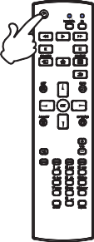

Display the adjustment menu page
The menu page appears on the screen when you press the HOME button on the Remote Control. The menu page disappears when you press the BACK button on the Remote Control again.
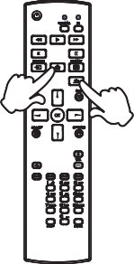

Move the cursor vertically
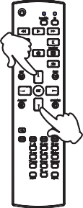
Select adjustment by pressing the / button on the remote control while the menu page is displayed on the screen.

Move the cursor horizontally
ENGLISH
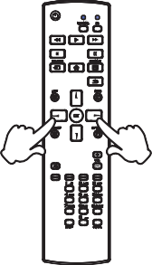
Select menu or setting, or perform the adjustment by pressing the / button on the remote control while the menu page is displayed on the screen.

Adjust the volume of sound
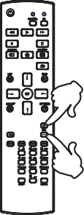
Press the + / – button on the remote control to adjust the volume of sound when the menu page is not displayed on the screen.

Switch the input signal
This is activated when you successively press the SOURCE button on the remote control.
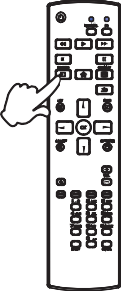

COMPUTER SETTING
- Signal Timing
Change to the desired signal timing listed on page 53: COMPLIANT TIMING.
- Windows 10/11 Plug & Play
The iiyama LCD monitor complies with DDC2B of VESA standard. The Plug & Play function runs on Windows 10/11 by connecting the monitor to DDC2B compliant computer with the Signal Cable supplied.

NOTE
- For additional information on how to download the driver for your touch screen monitor, please access the internet site: https://iiyama.com
- Monitor Drivers are not required in most cases for Macintosh or Unix operating systems. For further information, please contact your computer dealer first for advice.

- Power-on sequence
ENGLISH
Turn ON the monitor first, and then the computer.
- TOUCH support operation system:

OS Version  (Windows) | Windows
OS Version  (Windows) | Win 8, 10, 11 | Win 7 | XP
Supported touches | Multi-touch |  | 1
Supported Platform & IO Interface | I2C/USB | USB
Note | Windows inbox driver  (No driver needed) |  | Single-touch  (Need driver)

OS Version  (Linux Distribution) | Android | Ubuntu | Fedora | Debian | RHEL | SUSE
OS Version  (Linux Distribution) | 7.0~14 | 18.04~24.04 | 22~38 | 9~11 | 8~9.1 | 15-SP3~15-SP5
Supported touches | Multi-touch
Supported Kernel version | 4.4~6.2 | 4.15~6.8 | 4.0-6.2 | 4.19-5.10 | 4.18~5.10 | 3.10~5.14
Supported Platform & IO Interface | USB/I2C |  | x86 (USB)
Note | Driver supports Multi-touch *

OS Version  (Mac OS) | Mac OS 10.14 ~14
Supported touches | Multi-touch
Supported Platform & IO Interface | USB
Note | Driver supports Multi-touch *
* For Multi-touch driver, please visit our web site (https://iiyama.com).

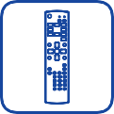

SCREEN SETUP
ENGLISH
Follow the OOBE (Out of Box Experience) instructions to complete the screen setup.
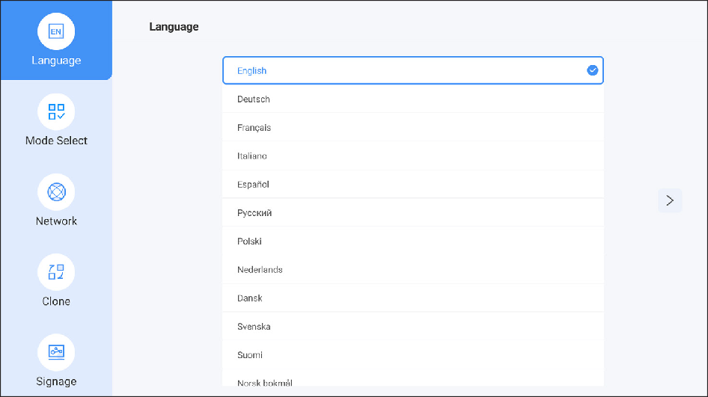

[PALM REJECTION FUNCTION]
Palm rejection is a way to disregard touch made with “a large contact area” while finger touch operation.
A large contact area: palm, clenched fist, elbow, arm, etc.
When you touch the screen with such a large contact area, palm rejection is activated and the touch action is not recognized by the screen.

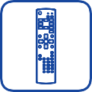

OPERATING THE MONITOR
ENGLISH
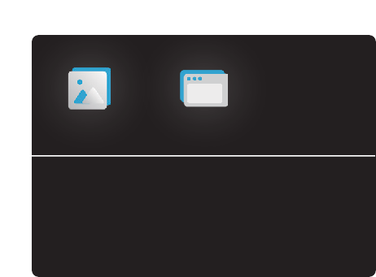
To create the best picture, your iiyama LCD monitor has been preset at the factory with the COMPLIANT TIMING shown on page 53. You can also adjust the picture using the following operations.
Picture
Screen
Audio
Configuration 1
Configuration 2
Advanced Option

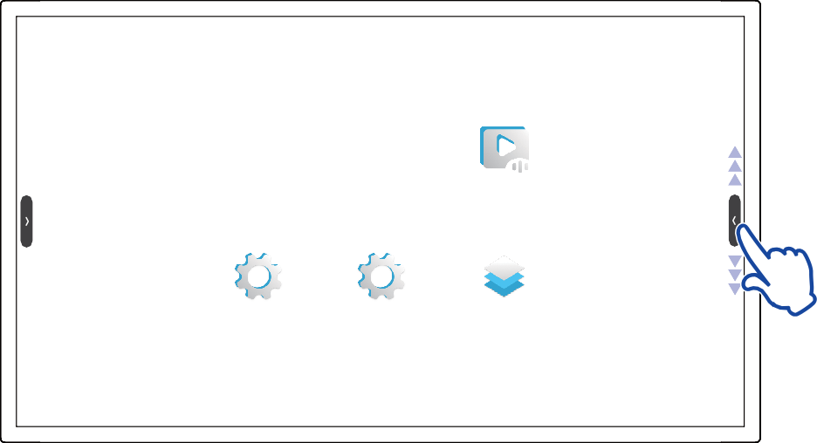
Press the HOME button to start the On Screen Display feature.
Select the menu to make an appropriate adjustment or setting.
- Touch the screen with your finger anywhere for 3 seconds and the Sidebar appears.
NOTE

Touch either the left or right Sidebar to reveal more content.

BACK HOME
Android launcher SOURCE
- Any changes are automatically saved in the memory when the On Screen Display disappears. Turning off the power should be avoided while using the Menu.
- All adjustments have only one setting which applies to all signal timings.

ENGLISH
ADJUSTMENT MENU CONTENTS

Picture
Picture
Brightness 30
Contrast 50
Sharpness 20
Black level 50
Tint 50
Color 50

Noise redution off

Gamma selection NATIVE
Adjustment Item | Problem / Option
Brightness *¹ | Too dark Too bright
Contrast *² | Too dull Too intense
Sharpness *² | Too soft Too sharp
Black level *² | Black is too dark Black is too bright
Tint *² | Purplish Greenish
Color *² | Too week Too strong
Noise reduction *² | Off | Noise Reduction is turned off.
Noise reduction *² | Low | Electronic image noise caused by different media players is reduced.
Noise reduction *² | Middle | Electronic image noise caused by different media players is reduced more than Low.
Noise reduction *² | High | Electronic image noise caused by different media players is reduced more than Medium.
Gamma selection | You can set the Gamma.  Native / 2.2 / 2.4 / Sgamma / D-image
Low blue light | Off | Return to normal.
Low blue light | On | Blue light is reduced.
Color temperature | 3000K | 9300K
Color temperature | 4000K | 10000K
Color temperature | 5000K | Native | Original color temperature
Color temperature | 6500K | User1 | User preset 1
Color temperature | 7500K | User2 | User preset 2

Picture
Picture
Color 50

Noise reduction off

Gamma selection NATIVE

Low blue light off

Color temperature NATIVE

Color control Action

Overscan off

Picture reset Action
Adjustment Item | Option
Color control *³ | Set user color.
Color control *³ | For User1 | R | Too weak Too strong
Color control *³ | For User1 | G
Color control *³ | For User1 | B
Color control *³ | For User2 | 2000K-10000K
Overscan *² | Off | Fix overscan.
Overscan *² | On | Edges of a screen are trimmed.
Picture reset | Cancel | Return to Menu.
Picture reset | OK | Picture setting will be restored to factory-preset data.
*¹ Adjust the Brightness when you are using the monitor in a dark room and feel the screen is too bright. Brightness adjustment is disabled when “Brightness” of “Panel saving” is on.
ENGLISH
*² Not available for Browser, CMS, File Manager, Media Player, PDF Player and Custom inputs.
*³ Available only when “Color temperature” is set to “User1” or “User2”.

Screen | Screen  Zoom mode Full  Custom zoom Action  Screen reset Action
Adjustment Item | Option
Zoom mode *¹ | Full | Enlarge the picture horizontally to fill the screen if the picture source is 4:3 (standard definition). When the picture source is 16:9 (high definition), it is not scaled.
Zoom mode *¹ | 4:3 | Display all pictures in 4:3 aspect ratio.
Zoom mode *¹ | Real | Display the picture dot by dot.
Zoom mode *¹ | 21:9 | Display all pictures in 21:9 aspect ratio.
Zoom mode *¹ | Custom | Customize zoom screen.
Custom zoom *² | Zoom | Zoom the horizontal and vertical size of the image  simultaneously.
Custom zoom *² | H zoom | Zoom the horizontal size of the image.
Custom zoom *² | V zoom | Zoom the vertical size of the image.
Custom zoom *² | H position *³ | Zoom / H Zoom values.
Custom zoom *² | V position *³ | Zoom / V Zoom values.
Screen reset | Cancel | Return to Menu.
Screen reset | OK | Screen setting will be restored to factory-preset data.
*¹ Not available for Browser, CMS, File Manager, Media Player, PDF Player and Custom inputs.
ENGLISH
*² It can be chosen only when “Zoom mode” is set to “Custom”.
*³ Not available when the value of “Zoom”, “H zoom” and “V zoom” is “0”.

Audio | Audio |  |  |  | Audio
Audio | Balance |  |  | 50 | Volume | 20
Audio | Treble |  |  | 50 | Audio out(line out) | 20
Audio | Bass |  |  | 50 | Maximum volume | 100
Audio | Volume |  |  | 20 | Minimum volume | 0
Audio | Audio out(line out) |  |  | 20 | Mute | off
Audio | Maximum volume |  |  | 100 | Audio reset | Action
Audio | Minimum volume |  |  | 0 | Audio out sync | off
Audio | Mute |  |  | off | Speaker setting | on
Adjustment Item |  |  | Problem / Option
Balance |  |  | Left side speaker is louder. Right side speaker is louder.
Treble |  |  | Too weak Too strong
Bass |  |  | Too weak Too strong
Volume |  |  | Too soft Too loud
Audio out (line out) |  |  | Adjust audio output volume. Too soft  Too loud
Maximum volume |  |  | Set the maximum volume.
Minimum volume |  |  | Set the minimum volume.
Mute |  |  | Off | Return the sound volume to the previous level.
 |  |  | On | Turn off the sound temporarily.
Audio reset |  |  | Cancel | Return to Menu.
 |  |  | OK | Audio setting will be restored to factory-preset data.
Audio out sync |  |  | Off | The speaker volume is different from the audio out (line-out) volume.
 |  |  | On | The speaker volume is consistent with the audio out (line-out) volume.
Speaker setting |  |  | Off | Disable the built-in speaker.
 |  |  | On | Enable the built-in speaker.
ENGLISH

Configuration 1
Configuration 1

Android launcher Action

Switch on state Force On

Touch lock off

Touch mode off

Mouse mode off

Panel saving Action

RS232 routing RS232

Boot on source Action
Adjustment Item | Option
Android launcher | Enable Android launcher in settings to access feature.
Switch on state | Force on | The monitor will turn on when the power cable is connected to a wall outlet.
Switch on state | Power off | The monitor will remain off when the power cable is connected to a wall outlet.
Switch on state | Last status | The monitor will return to the previous power status (on/off/ standby) when removing and replacing the power cable.
Touch lock | Off | Enable touch screen operation.
Touch lock | On | Disable touch screen operation.
Touch mode *¹ | Off | Normal touch (with bare hands or stylus device)
Touch mode *¹ | Glove | Touch with gloved hand (Supports thickness +2mm)
Touch mode *¹ | Through glass | Touch through glass (Supports thickness +6mm)
Mouse mode | Off | Mouse mode is turned off.
Mouse mode | On | Multi-touch operation is switched to single touch operation.
Panel saving | Brightness | Off | Backlight adjustment is off.
Panel saving | Brightness | On | The image brightness will be reduced to 40% of the maximum.
Panel saving | Pixel shift | For the monitor to slightly shift the position of pixels in four directions (up, down, left or right).
Panel saving | Pixel shift | Auto | Move the position of the image automatically.
Panel saving | Pixel shift | Off | Pixel shift is turned off.
Panel saving | Pixel shift | On | Move the position of the image at set intervals. 10 - 900 seconds
Panel saving | White wash | Display an entire white screen to reduce image burn-in. Recommended display time is 4 hours or more.  Press button to return to the menu.
*¹ Turn on the power and set the “Touch mode” after the monitor installation is completed.
ENGLISH
Turning on the power and setting the “Touch mode” before the monitor installation may cause misalignment or malfunction of the touch calibration.
The maximum touch points change depending on the selected mode.

 | Max. touch points
Off | 40*
Glove | 5
Through glass | 2
* Normal setting on Windows OS allows up to 10 touch points.

Configuration 1
Configuration 1

Touch mode off

Mouse mode off

Panel saving Action

RS232 routing RS232

Boot on source Action

WOL off

Configuration1 reset Action

Factory reset Action
Adjustment Item | Option
RS232 routing | Select the RS232 control port. RS232 / LAN RS232
Boot on source *² | Last input | When the power is turned on, it starts with the same setting as when the power was last turned off.  Off / On
Boot on source *² | Input | Select input source when boot up.  HDMI1 / HDMI2 / DisplayPort / Browser / CMS / File Manager / Media Player / PDF Player / Custom
Boot on source *² | Playlist | Select playlist index for Browser, Media Player and PDF Player.
WOL | Off | Disable wake on LAN function.
WOL | On | Enable wake on LAN function.
Configuration1 reset | Cancel | Return to Menu.
Configuration1 reset | OK | Configuration1 setting will be restored to factory-preset data.
Factory reset | Cancel | Return to Menu.
Factory reset | OK | Factory-preset data is restored.
*² No failover function, system will keep source even the source is no signal input.
ENGLISH

Configuration 2 | Configuration 2 |  |  |  | Configuration 2
Configuration 2 | OSD timeout |  |  | on |  | 10
Configuration 2 |  |  |  | 45 | Logo and animation | on
Configuration 2 | OSD H position |  |  | 50 | Logo setting | Action
Configuration 2 | OSD V position |  |  | 50 | Animation setting | Action
Configuration 2 | System rotation |  |  | Landscape | Monitor ID | 1
Configuration 2 | Information OSD |  |  | on | Monitor information | Action
Configuration 2 |  |  |  | 10 | HDMI version | 2.0
Configuration 2 | Logo and animation |  |  | on | Configuration2 reset | Action
Adjustment Item |  | Problem / Option
OSD timeout |  | You can set the OSD display duration time between 5 and 120 seconds.  Off / On (5 - 120 seconds)
OSD H position |  | OSD is too left OSD is too right
OSD V position |  | OSD is too low OSD is too high
System rotation |  | Landscape |  | Display the OSD in Landscape mode.
 |  | Portrait |  | Display the OSD in Portrait mode.
Information OSD |  | Set the period of time the information is displayed on the upper right corner of the screen when the input source is switched.  Off / On (1 - 60 seconds)
Logo and animation |  | Off | iiyama Logo and animation does not display when the monitor is turned on.
 |  | On | iiyama Logo and animation display when the monitor is turned on.
 |  | User | Custom logo option in android is set, there will be only custom logo when the monitor is turned on.
Logo setting *¹ |  | Select boot logo.
Animation setting *¹ |  | Select boot animation.
Monitor ID |  | Set ID to the monitor. 1 - 255
Monitor information |  | Show information about your monitor, including Model name, Serial No., Operation hours and Software version.
HDMI version *² |  | Set the version of the HDMI.  2.0 / 1.4 / Auto
Configuration2 reset |  | Cancel | Return to Menu.
 |  | OK | Configuration2 setting will be restored to factory-preset data.
*¹ The “Logo setting” and “Animation setting” are only available when you select “User” of “Logo and animation” function.
ENGLISH
Power-on logo format: bmp / 1920x1080 / 16 bit / RGB565
Power-on animation format: 4K available / png (normal) / Frame sequence play
*² HDMI input only

Advanced Option |  | Advanced Option  Kiosk mode Side bar  No signal image IR control Power LED light Fan  Off timer Schedule | Action 3s touch hold  Action Action on auto off Action
Adjustment Item | Option
Kiosk mode *¹ | Restrict the functionality of the monitor so that it can only be used for specific purposes. Enter the password you set on the first screen setup. Password (Cancel / OK)
Side bar | Select the side bar display setting.
Side bar | 3s touch hold |  | Touch the screen for 3 seconds to display it.
Side bar | Always off |  | Always hide
Side bar | Always on |  | Always show
No signal image | Customize the image for the no signal screen.  Image / Office meeting guide / Title / Room / Date & Time / Duration (30 mins / 1h / 1.5h / 2h / 2.5h / 3h / off) / Text color (White / Black) / Show current time
Motorized stand *² | When using a motorized stand, you can adjust and customized the height.
Motorized stand *² | Up |  | Raise the motorized stand.
Motorized stand *² | Down |  | Lower the motorized stand.
Motorized stand *² | Slot 1 / Slot 2 |  | Memorize your preferred height in Slot 1 or Slot 2.
IR control | Select the operation mode of the remote control.
IR control | Unlock *³ |  | Unlocked
IR control | Lock All |  | Lock all of the remote control.
IR control | Lock All but Power |  | Lock all except the power of the remote control.
IR control | Lock All but Volume |  | Lock all except the volume of the remote control.
IR control | Lock all except PWR & VOL |  | Lock all except the volume and power of the remote control.
Power LED light | Off | The Power Indicator is turned Off.
Power LED light | On | The Power Indicator is turned On.
Fan *⁴ | Off | Fan is turned off.
Fan *⁴ | On | Fan is turned on.
Fan *⁴ | Auto | The fan turns on automatically when the monitor’s internal temperature reaches 50°C or higher.
Off timer | Set when turn off the monitor. (in hours)  Off / On (1 - 24 hours)
ENGLISH

Advanced Option
Advanced Option

Schedule Action

HDMI with One Wire off

HDMI with one wire power off off

Auto signal detection Action

Language English

OSD transparency off

Power saving Mode 2:WOL off,.. Advanced option reset Action
Adjustment Item | Option
Schedule | Schedule list | Up to 7 schedules can be set.
Schedule | Start time *⁵ | Set start time.
Schedule | End time *⁵ | Set end time.
Schedule | Input | Select default input source to use when the monitor is automatically turned on next time.  HDMI1 / HDMI2 / DisplayPort / Browser / CMS /  File Manager *⁶ / Media Player / PDF Player / Custom
Schedule | Playlist | Choose playlist for the Browser, Media Player and PDF Player.
Schedule | Days of the week | Set the day of the week.  SUN / MON / TUE / WED / THU / FRI / SAT
Schedule | Every week | Set whether to repeat every week.  Off / On
Schedule | Enable *⁷ | Enable / disable schedule.
HDMI with One Wire | Off | HDMI with One Wire is turned off.
HDMI with One Wire | On | Control all devices connected by HDMI cable with one remote control.
HDMI with one wire power off | Off | HDMI with One Wire Power Off is turned off.
HDMI with one wire power off | On | Use the power button on the device connected with the HDMI cable to switch to standby mode.
Auto signal detection *⁸ | Off | Disable the Auto signal detection.
Auto signal detection *⁸ | All *⁹ | Detects all sources automatically if there is no signal on the default input and selects the available signal automatically.
Auto signal detection *⁸ | Failover | Detects sources automatically with user-defined order if there is no signal on the default input and selects the available signal automatically.
Language | English | English | Deutsch | German
Language | Français | French | Italiano | Italian
Language | Español | Spanish | Русский | Russian
Language | Polski | Polish | Nederlands | Dutch
Language | Dansk | Danish | Svenska | Swedish
Language | Suomi | Finnish | Norsk bokmål | Norwegian
Language | Čeština | Czech
ENGLISH

Advanced Option
Advanced Option

Schedule Action

HDMI with One Wire off

HDMI with one wire power off off

Auto signal detection Action

Language English

OSD transparency off

Power saving Mode 2:WOL off,.. Advanced option reset Action
Adjustment Item | Option
OSD Transparency | The background of OSD is made transparent.  Off / On (5 - 100)
Power saving | Mode1: WOL off, source input wake-up off, Backlight off Mode2: WOL off, source input wake-up on, Backlight off Mode3: WOL on, source input wake-up off, Backlight off Mode4: WOL on, source input wake-up on, Backlight off
Advanced option reset | Cancel | Return to Menu.
Advanced option reset | OK | Advanced Option setting will be restored to factory-preset data.
*¹ Functions disabled in Kiosk mode
ENGLISH
Configuration 1 | Android launcher
Configuration 2 | Logo and animation
Configuration 2 | Logo setting
Configuration 2 | Animation setting
Advanced Option | No signal image
*² Disabled if not connected to a motorized stand.
*³ To unlock, press and hold the INFO button on the remote control for 6 seconds.
*⁴ If the screen is used in face-up position, please be sure to turn on the “Fan” function.
*⁵ The “Start time” must be less than the “End time”.
*⁶ The photo or video files in the iiyama_play folder inside the USB flash drive can be automatically played using the Schedule setting.
Play order is alphabetical, 0 ~ 9, aA ~ zZ, case-insensitive.
*⁷ Adjustments to “Enable” should be made only after “Start time”, “End time”, “Input” and “Days of the week” have been correctly set.
*⁸ The monitor detects and select available signal source automatically.
*⁹ Order of detection: HDMI1 HDMI2 DisplayPort Browser CMS File Manager Media Player PDF Player Custom

USING ANDROID LAUNCHER
ENGLISH

On-screen prompt

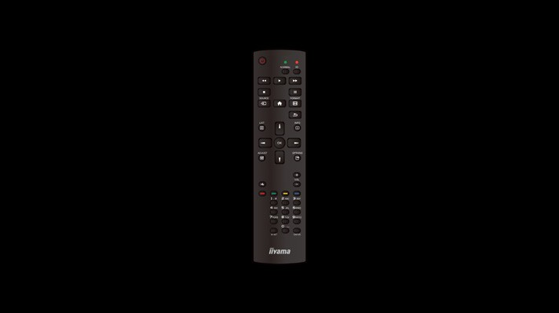
Display the Android launcher using one of the following methods:
Press the HOME button and number 1668 on the remote control.
Select menu “Android launcher” in “Configuration 1”.
Touch “Android launcher” of Side Bar.

Android Launcher





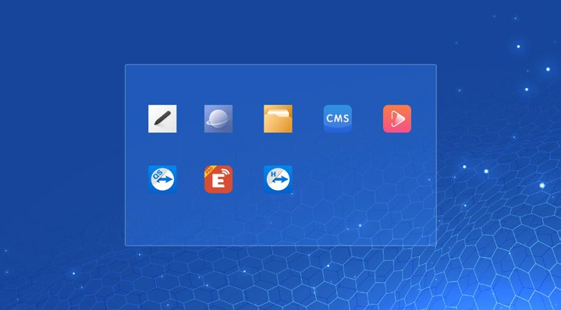
Settings
Apps
Network
Storage

Whiteboard Browser File Manager CMS Media Player

QuickSupport ESharePro Host

* Android upgrade is not available on this model.
- Settings : Go to settings app.
- Apps : Show all apps. (Whiteboard / Browser / File Manager / CMS / Media Player / QuickSupport / ESharePro / Host)
- Network : Set Ethernet.
- Storage : Display current Android storage information.
NOTE
  - Supported file system FAT32
  - Supported file format
    - Music: MP3, M4A, AAC, LPCM
    - Video: 3G2, 3GP, AVI, F4V, FLV, MP4, M2TS, M2V, M4V, MKV, MOV, MPEG, MTS, OGM, PMP, TP, TS, VOB, WEBM
    - Image: JPG, JPEG, BMP, PNG, GIF

Settings
ENGLISH

Network & internet Network & internet
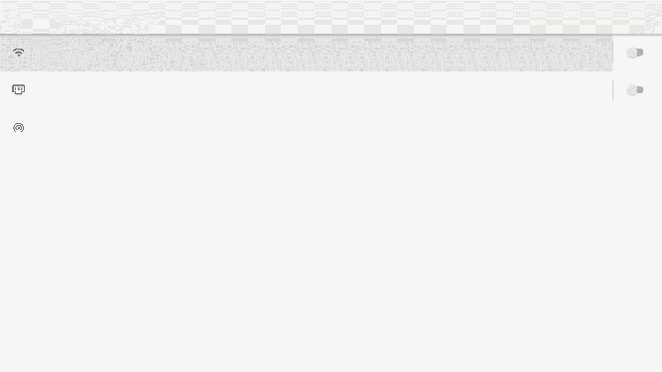
Wi-Fi Off

Ethernet
Ethernet is disabled

Hotspot Off
Item | Option
Wi-Fi * | Set the wifi function Enable / Disable and pairing to WiFi device.
Wi-Fi * | Wifi list | Display a list of WiFi networks
Wi-Fi * | Add network | Network name
Wi-Fi * | Add network | Security
Wi-Fi * | Add network | Advanced options
Wi-Fi * | Wifi preferences | Turn on wifi automatically
Wi-Fi * | Wifi preferences | Notify for public networks
Wi-Fi * | Wifi preferences | Advanced
Wi-Fi * | Saved networks | Save wifi networks on this monitor.
Ethernet | Set the wired network. Enable / Disable
Ethernet | IP address | Assign IP adress for this monitor.
Ethernet | Netmask | Assign Netmask for this monitor.
Ethernet | Gateway | Assign Gateway for this monitor.
Ethernet | DNS1 | Assign DNS server address.
Ethernet | DNS2 | Assign DNS server address.
Ethernet | Ethernet IP mode | Static
Ethernet | Ethernet IP mode | DHCP
Hotspot * | Wifi hotspot | Set the Hotspot function.  Enable / Disable (Hotspot name / security / hotspot password / AP Band / Turn off hotspot automatically)
* Available when connecting to Wifi Dongle.

Apps & notifications Apps & notifications
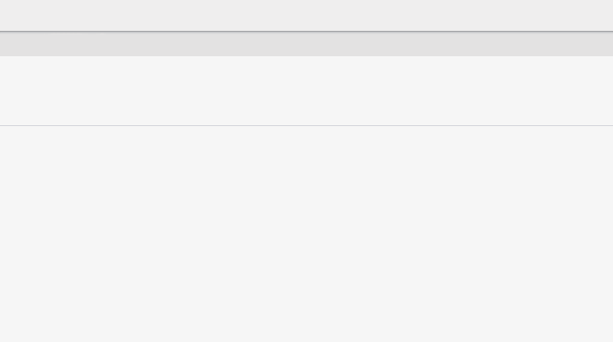
App info
20 apps installed

Default apps Opera

Permission manager
Control app access to your data
Item |  | Option
App info |  | Display all applications.
Default apps |  | Browser app | Set the default apps.
Default apps |  | Home app | Set the default apps.
Default apps |  | Opening links | Set the default apps.
Premission manager |  | App permissions | Set app permissions.
ENGLISH

Display Display
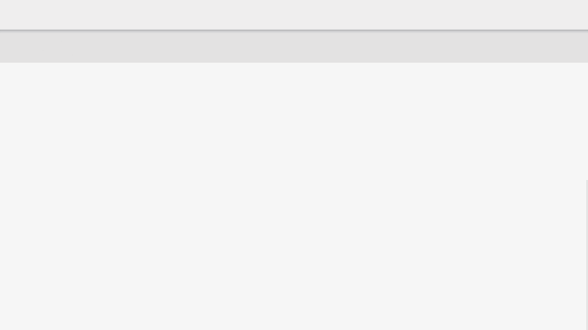
Font size Default
Item |  | Option
Font size |  | Small | Set the font size.
Font size |  | Default | Set the font size.
Font size |  | Large | Set the font size.
Font size |  | Largest | Set the font size.

Signage display Signage display
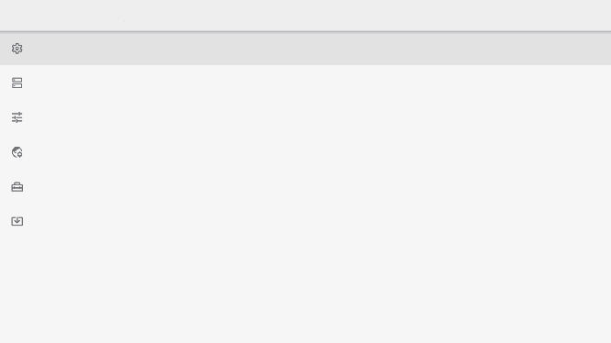
General settings
display name, screen shot

Server settings
email notification, FTP, ADB over network

Source settings
edit media player, edit browser player, edit pdf player, custom app

Network application proxy

System tools
clear storage, reset, clone and import, usb external storage Lock

System updates OTA, local update
Item |  | Option
General settings |  | Signage display name | Set the monitor name.
General settings |  | Screenshot | Enable / Disable (Interval, Start time, End time, Repeat , Sav e t o, Purge scr eens hot s , Send screenshots via email)
Server settings |  | Email notification | Enable / Disable (SMTP, Manager email, Test)
Server settings |  | FTP | Enable / Disable (Account, Password, Storage path, Port)
Server settings |  | ADB over network | Enable / Disable ADB function.
Source settings |  | Edit media player | Edit Media Player playlist and effect settings.
Source settings |  | Edit browser player | Edit Browser list and effect settings.
Source settings |  | Edit PDF player | Edit PDF Player playlist and effect settings.
Source settings |  | Storage path | Set the storage location for Browser, Media player, and PDF player.
Source settings |  | Custom app | Select app opened under the Custom channel.
Source settings |  | Custom source name | Customize the names of each signal source.
Network application |  | Proxy | Set the proxy server.  Enable / Disable (Proxy hostname: Proxy server IP Adress, Proxy port: Proxy server port number, Type: Proxy server type)  Authentication / username / password
System tools |  | Clear storage | Clear all data in signage folders. All / Internal storage / USB storage
System tools |  | Reset | Erase all data | Factory-preset data is restored.
System tools |  | Clone and import | Clone | Copy the signage display configuration, OSD setting and media files.*
System tools |  | Clone and import | Import | Import from signage folder. Internal storage / External storage
System tools |  | USB external storage Lock | Lock / Unlock the USB External Storage.
System updates |  | OTA | Firmware update.
System updates |  | Local update
* Media files are the media contents that are copied to this device while creating playlists in Browser, Media Player and PDF player source.
ENGLISH

Security Security
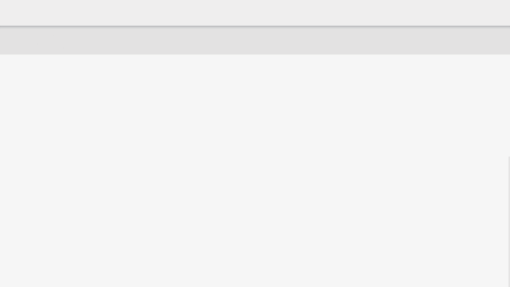
Device admin apps
No active apps

Unknown sources
Allow installation of apps from all sources
Item |  | Option
Device admin apps |  | Display credential storage information.
Unknown sources |  | Enable / Disable installation of apps from unknown sources.
ENGLISH

System System
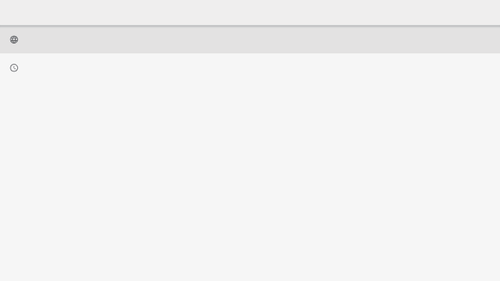
Languages & input Android Keyboard (AOSP)

Date & time
GMT+02:00 Central European Summer Time
Item |  | Option
Language & input |  | Languages | Set display language, keyboard and input method.  Language: English / Deutsch / Français / Italiano / Español / Русский / Polski / Nederlands / Dansk / Svenska / Suomi / Norsk bokmål / Čeština
Language & input |  | On-screen keyboard
Language & input |  | Physical keyboard
Date & time |  | Use network-provided time | Set the Date and Time.  Use Automatic Date & Time Format, 24-Hour Format.
Date & time |  | Time zone
Date & time |  | Ntp server

About device About device
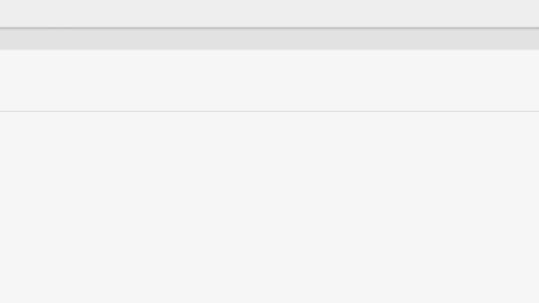
Legal information

Model TFxx39AS

Android version 11

Build number
t7_an400_arm64-userdebug 11 RQ3A.210805.001.A1 eng.yangpe.20240705.010628 test-keys

Build version TU39MD2-B11-01
Item |  | Option
Legal information |  | Third-party licenses | Main information about: Legal / Model / Android version / Build number / Build version  Automatically search update .zip from USB. When you select the updated .zip file, the monitor will restart and the update will start.
Legal information |  | System WebView licenses
Model |  | Model
Model |  | Serial number
Model |  | Hardware version
Android version |  | Android version
Android version |  | Android security update
Android version |  | Kernel version
Android version |  | Build number
Build number
Build version
ENGLISH
- Quick Info
Press the INFO button and number 77 on the remote control to confirm the Network and the Monitor Information.

Apps / Sources
ENGLISH

[Whiteboard]
The Whiteboard application is useful for business presentations, meetings, training sessions, and more. With touch operations, you can easily create lines, shapes, and tables, and you can also paste images and videos.

[Browser]
Search or enter address to go to the webpage you want. Personalize your browser with an Opera account.

[File Manager]
Browse the files stored in the internal storage including USB.

[Media Player]
- Play file: Select the file to play
- Play order: Set the play order of the files
- Play mode: Set the playback mode
- Picture style: Set the picture size
- Create list: Create a new playlist

Play file
    - Select “Play file” on the page.
    - Select the file and press OK button.
    - Press the OK button to play.

Play order
Select “Play order” on the page.
- Sequences: Play files in sequences.
- Reverse: Play files in reverse.
- Random: All files in the list play randomly.
- Cycle: All files in the list play repeatedly.

Play mode
Select “Play mode” on the page.
- Auto: Autoplay duration(s). 5s / 15s / 30s / 60s
- Manual: Play the file manually.

Picture style
ENGLISH
Select “Picture style” on the page.
  - Scale: Display the image in its original aspect ratio.
  - Full: Enlarge the image to full screen.

Create list
- Select “Create list” on the page.
- Select “Add file”.
- Select the file and add to the list.

- Remote control
  - : Move up.
  - : Move down.
  - : Select file.
  - : Play the media file.
  - : Display edit bar.
Delete all: Delete all playlist files.
Back: Return.
  - : To pause the media file.
  - : To skip forward 10 seconds.
  - : To skip backward 10 seconds.
  - : To stop the playing file and return to Menu.
  - : Previous file
  - : Next file

[QuickSupport]
TeamViewer QuickSupport mobile app allows you to quickly receive remote support on your smartphone or tablet.

[EShare Pro]
EShare Pro is a multiscreen interaction application which makes the user experience natural and enjoyable for home entertainment, business presentation, and educational training.
EShare Pro must be activated to get full functionality.
Please go to https://iiyama.com/gb_en/eshare to obtain a license key.

[Host]
The TeamViewer Host app for Android allows for remote control of unattended Android devices. A connection is possible even when the device is not being actively used.

[PDF Player]
ENGLISH
- Play file: Select the file to play
- Play order: Set the play order of the files
- Play mode: Set the playback mode
- Create list: Create a new playlist

Play file
  - Select “Play file” on the page.
  - Select the file and press OK button.
  - Press the OK button to play.

Play order
Select “Play order” on the page.
- Sequences: Play files in sequences.
- Reverse: Play files in reverse.
- Random: All files in the list play randomly.
- Cycle: All files in the list play repeatedly.

Play mode
Select “Play mode” on the page.
- Auto: Autoplay duration(s). 5s / 15s / 30s / 60s
- Manual: Play the file manually.

Create list
  - Select “Create list” on the page.
  - Select “Add file”.
  - Select the file and add to the list.

- Remote control
  - : Move up.
  - : Move down.
  - : Select file.
  - : Play the PDF file.
  - : Display edit bar.
Delete all: Delete all playlist files.
Back: Return.
  - : To pause the PDF file.
  - : Previous page
  - : Next page

STANDBY FEATURE
This product features the standby function. When activated, it automatically reduces unnecessary power consumption of the monitor when your computer is not in use.
There is a standby step the monitor takes as described below. The standby function, including any timer settings is configured by the operating system. Check your operating system manual for information on how this can be configured.

Standby Mode
When the video signal from the computer is off, the monitor enters into Standby Mode which reduces the power consumption to less than 0.5W*. The screen becomes dark, and the power indicator blinks blue. From Standby Mode, the image reappears in several seconds when either the keyboard or the mouse are touched again.


Power Indicator
NORMAL MODE

STANDBY MODE
Solid blue

Blinking blue

POWER
0 0.5W *
100%

CONSUMPTION
ENGLISH

* When the USB devices are not connected.

TROUBLE SHOOTING
If the monitor fails to operate correctly, please follow the steps below for a possible solution.
- Perform the adjustments described in OPERATING THE MONITOR, depending on the problem you have. If the monitor does not get a picture, skip to 2.
- Consult the following items if you cannot find an appropriate adjustment item in OPERATING THE MONITOR or if the problem persists.
- If you are experiencing a problem which is not described below or you cannot correct the problem, discontinue using the monitor and contact your dealer or iiyama service center for further assistance.

Problem Check
The picture does not appear.

(Power indicator does not light up.)

(Power indicator is blue.)

(Power indicator is blinking blue.)

The screen is not synchronized.
- The Power Cable is firmly seated in the socket.
- The Power Switch is turned ON.
- The AC socket is live. Please check with another piece of equipment.
- If the blank screen saver is in active mode, touch the keyboard or the mouse.
- Increase the Contrast and/or Brightness.
- The computer is ON.
- The Signal Cable is properly connected.
- The signal timing of the computer is within the specification of the monitor.
- If the monitor is in standby mode, touch the keyboard or the mouse.
- The computer is ON.
- The Signal Cable is properly connected.
- The signal timing of the computer is within the specification of the monitor.
- The Signal Cable is properly connected.
- The signal timing of the computer is within the specification of the monitor.

The screen position is not in the center.
The screen is too bright or too dark.
The screen is shaking.
- The signal timing of the computer is within the specification of the monitor.

- The video output level of the computer is within the specification of the monitor.
- The power voltage is within the specification of the monitor.
- The signal timing of the computer is within the specification of the monitor.

No sound. □ The audio equipment (computer etc.) is ON.
  - The Audio Cable is properly connected.
  - The Volume is turned up.
  - The Mute is OFF.
  - The audio output level of the audio equipment is within the specification of the monitor.

The sound is too loud or too quiet.
ENGLISH
A strange noise is heard.
- The audio output level of the audio equipment is within the specification of the monitor.
- The audio cable is properly connected.

RECYCLING INFORMATION
ENGLISH

For better environment protection please don’t dispose your monitor. Please visit our web site: https://iiyama.com for monitor recycling.

APPENDIX
ENGLISH
Design and specifications are subject to change without prior notice.
SPECIFICATIONS : ProLite TF3239AS-B1AG

Touch Screen | Technology | Projected capacitive 40 points
Touch Screen | Light transmission | 87%
Touch Screen | Hardness | 7H
Touch Screen | Thickness | 3mm
Touch Screen | Communication system | USB serial transfer
Size Category |  | 32"
LCD  Panel | Panel technology | IPS
LCD  Panel | Size | Diagonal: 31.5" (80cm)
LCD  Panel | Pixel pitch | 0.12125mm H × 0.36375mm V
LCD  Panel | Brightness | 500cd/m² (Typical without touch panel) 435cd/m² (Typical with touch panel) 130cd/m² (Default / Energy Saving)
LCD  Panel | Contrast ratio | 1200 : 1 (Typical)
LCD  Panel | Viewable angle | Horizontal: 178°, Vertical: 178° (Typical)
LCD  Panel | Response time | 8ms (Gray to Gray)
Display Colors |  | Approx. 16.7 million
Sync Frequency |  | Horizontal: 28.0-160.0kHz, Vertical: 23-85Hz
Native Resolution |  | 1920 × 1080, 2.1 MegaPixels
Supported Max. Resolution |  | 1920 × 1080, 60Hz
Input Connector |  | HDMI × 2, DisplayPort × 1
LAN Port |  | RJ45
Serial Port |  | RS-232C In
Input Video Signal |  | HDMI1, HDMI2, DisplayPort
USB Standard |  | USB2.0 (DC5V, 500mA)
Number of USB Ports Connector shape |  | 1 Upstream: Type-B  2 Downstream: Type-A
Headphone Connector *¹ |  | ø 3.5mm Mini jack (Stereo)
Speakers |  | 10W × 2 (Stereo speakers)
Maximum Screen Size |  | 698.40mm W × 392.85mm H / 27.5" W × 15.5" H
Power Source |  | 100-240VAC, 50-60Hz, 1.0A
Power Consumption *² |  | 50W (Typical)  Standby mode: 0.5W maximum, Off mode: 0.3W maximum
Dimensions Net Weight |  | 746.0 × 440.5 × 62.5mm / 29.4 × 17.3 × 2.5" (W×H×D)  13.2kg / 29.1lbs
Environmental Considerations |  | Operating:  Storage: | Temperature Humidity Temperature Humidity | 0 to 40°C / 32 to 104°F  20 to 80% (No condensation)  -20 to 60°C / -4 to 140°F  10 to 90% (No condensation)
Approvals |  | CE, UKCA, TÜV-Bauart, EAC, cTÜVus
NOTE *¹ Proper operation of connected external devices other than headphones is not guaranteed.
*² When the USB devices are not connected.

ENGLISH
SPECIFICATIONS : ProLite TF4339AS-B1AG

Touch Screen | Technology | Projected capacitive 40 points
Touch Screen | Light transmission | 87%
Touch Screen | Hardness | 7H
Touch Screen | Thickness | 3mm
Touch Screen | Communication system | USB serial transfer
Size Category |  | 43"
LCD  Panel | Panel technology | IPS
LCD  Panel | Size | Diagonal: 42.5" (108cm)
LCD  Panel | Pixel pitch | 0.2451mm H × 0.2451mm V
LCD  Panel | Brightness | 500cd/m² (Typical without touch panel) 435cd/m² (Typical with touch panel) 105cd/m² (Default / Energy Saving)
LCD  Panel | Contrast ratio | 1200 : 1 (Typical)
LCD  Panel | Viewable angle | Horizontal: 178°, Vertical: 178° (Typical)
LCD  Panel | Response time | 8ms (Gray to Gray)
Display Colors |  | Approx. 1.07 billion
Sync Frequency |  | Horizontal: 28.0-160.0kHz, Vertical: 23-85Hz
Native Resolution |  | 3840 × 2160, 8.3 MegaPixels
Supported Max. Resolution |  | 3840 × 2160, 60Hz
Input Connector |  | HDMI × 2, DisplayPort × 1
LAN Port |  | RJ45
Serial Port |  | RS-232C In
Input Video Signal |  | HDMI1, HDMI2, DisplayPort
USB Standard |  | USB2.0 (DC5V, 500mA)
Number of USB Ports Connector shape |  | 1 Upstream: Type-B  2 Downstream: Type-A
Headphone Connector *¹ |  | ø 3.5mm Mini jack (Stereo)
Speakers |  | 10W × 2 (Stereo speakers)
Maximum Screen Size |  | 941.18mm W × 529.42mm H / 37.1" W × 20.8" H
Power Source |  | 100-240VAC, 50-60Hz, 2.0A
Power Consumption *² |  | 116W (Typical)  Standby mode: 0.5W maximum, Off mode: 0.3W maximum
Dimensions Net Weight |  | 997.0 × 585.5 × 63.5mm / 39.3 × 23.1 × 2.5" (W×H×D)  22.1kg / 48.7lbs
Environmental Considerations |  | Operating:  Storage: | Temperature Humidity Temperature Humidity | 0 to 40°C / 32 to 104°F  20 to 80% (No condensation)  -20 to 60°C / -4 to 140°F  10 to 90% (No condensation)
Approvals |  | CE, UKCA, TÜV-Bauart, EAC, cTÜVus
NOTE *¹ Proper operation of connected external devices other than headphones is not guaranteed.
*² When the USB devices are not connected.

ENGLISH
SPECIFICATIONS : ProLite TF5039AS-B1AG

Touch Screen | Technology | Projected capacitive 40 points
Touch Screen | Light transmission | 87%
Touch Screen | Hardness | 7H
Touch Screen | Thickness | 3mm
Touch Screen | Communication system | USB serial transfer
Size Category |  | 50"
LCD  Panel | Panel technology | VA
LCD  Panel | Size | Diagonal: 49.5" (126cm)
LCD  Panel | Pixel pitch | 0.285375mm H × 0.285375mm V
LCD  Panel | Brightness | 500cd/m² (Typical without touch panel) 435cd/m² (Typical with touch panel) 120cd/m² (Default / Energy Saving)
LCD  Panel | Contrast ratio | 5000 : 1 (Typical)
LCD  Panel | Viewable angle | Horizontal: 178°, Vertical: 178° (Typical)
LCD  Panel | Response time | 9.5ms (Gray to Gray)
Display Colors |  | Approx. 1.07 billion
Sync Frequency |  | Horizontal: 28.0-160.0kHz, Vertical: 23-85Hz
Native Resolution |  | 3840 × 2160, 8.3 MegaPixels
Supported Max. Resolution |  | 3840 × 2160, 60Hz
Input Connector |  | HDMI × 2, DisplayPort × 1
LAN Port |  | RJ45
Serial Port |  | RS-232C In
Input Video Signal |  | HDMI1, HDMI2, DisplayPort
USB Standard |  | USB2.0 (DC5V, 500mA)
Number of USB Ports Connector shape |  | 1 Upstream: Type-B  2 Downstream: Type-A
Headphone Connector *¹ |  | ø 3.5mm Mini jack (Stereo)
Speakers |  | 10W × 2 (Stereo speakers)
Maximum Screen Size |  | 1095.84mm W × 616.41mm H / 43.1" W × 24.3" H
Power Source |  | 100-240VAC, 50-60Hz, 2.2A
Power Consumption *² |  | 137W (Typical)  Standby mode: 0.5W maximum, Off mode: 0.3W maximum
Dimensions Net Weight |  | 1149.5 × 670.0 × 64.0mm / 45.3 × 26.4 × 2.5" (W×H×D)  28.6kg / 63.1lbs
Environmental Considerations |  | Operating:  Storage: | Temperature Humidity Temperature Humidity | 0 to 40°C / 32 to 104°F  20 to 80% (No condensation)  -20 to 60°C / -4 to 140°F  10 to 90% (No condensation)
Approvals |  | CE, UKCA, TÜV-Bauart, EAC, cTÜVus
NOTE *¹ Proper operation of connected external devices other than headphones is not guaranteed.
*² When the USB devices are not connected.

ENGLISH
SPECIFICATIONS : ProLite TF5539AS-B1AG

Touch Screen | Technology | Projected capacitive 40 points
Touch Screen | Light transmission | 87%
Touch Screen | Hardness | 7H
Touch Screen | Thickness | 4mm
Touch Screen | Communication system | USB serial transfer
Size Category |  | 55"
LCD  Panel | Panel technology | IPS
LCD  Panel | Size | Diagonal: 54.6" (139cm)
LCD  Panel | Pixel pitch | 0.315mm H × 0.315mm V
LCD  Panel | Brightness | 500cd/m² (Typical without touch panel) 435cd/m² (Typical with touch panel) 140cd/m² (Default / Energy Saving)
LCD  Panel | Contrast ratio | 1200 : 1 (Typical)
LCD  Panel | Viewable angle | Horizontal: 178°, Vertical: 178° (Typical)
LCD  Panel | Response time | 8ms (Gray to Gray)
Display Colors |  | Approx. 1.07 billion
Sync Frequency |  | Horizontal: 28.0-160.0kHz, Vertical: 23-85Hz
Native Resolution |  | 3840 × 2160, 8.3 MegaPixels
Supported Max. Resolution |  | 3840 × 2160, 60Hz
Input Connector |  | HDMI × 2, DisplayPort × 1
LAN Port |  | RJ45
Serial Port |  | RS-232C In
Input Video Signal |  | HDMI1, HDMI2, DisplayPort
USB Standard |  | USB2.0 (DC5V, 500mA)
Number of USB Ports Connector shape |  | 1 Upstream: Type-B  2 Downstream: Type-A
Headphone Connector *¹ |  | ø 3.5mm Mini jack (Stereo)
Speakers |  | 10W × 2 (Stereo speakers)
Maximum Screen Size |  | 1209.6mm W × 680.4mm H / 47.6" W × 26.8" H
Power Source |  | 100-240VAC, 50-60Hz, 2.3A
Power Consumption *² |  | 139W (Typical)  Standby mode: 0.5W maximum, Off mode: 0.3W maximum
Dimensions Net Weight |  | 1274.0 × 745.0 × 65.0mm / 50.2 × 29.3 × 2.6" (W×H×D)  39.6kg / 87.3lbs
Environmental Considerations |  | Operating:  Storage: | Temperature Humidity Temperature Humidity | 0 to 40°C / 32 to 104°F  20 to 80% (No condensation)  -20 to 60°C / -4 to 140°F  10 to 90% (No condensation)
Approvals |  | CE, UKCA, TÜV-Bauart, EAC, cTÜVus
NOTE *¹ Proper operation of connected external devices other than headphones is not guaranteed.
*² When the USB devices are not connected.

ENGLISH
SPECIFICATIONS : ProLite TF6539AS-B1AG

Touch Screen | Technology | Projected capacitive 40 points
Touch Screen | Light transmission | 87%
Touch Screen | Hardness | 7H
Touch Screen | Thickness | 4mm
Touch Screen | Communication system | USB serial transfer
Size Category |  | 65"
LCD  Panel | Panel technology | IPS
LCD  Panel | Size | Diagonal: 64.5" (164cm)
LCD  Panel | Pixel pitch | 0.372mm H × 0.372mm V
LCD  Panel | Brightness | 500cd/m² (Typical without touch panel) 435cd/m² (Typical with touch panel) 140cd/m² (Default / Energy Saving)
LCD  Panel | Contrast ratio | 1200 : 1 (Typical)
LCD  Panel | Viewable angle | Horizontal: 178°, Vertical: 178° (Typical)
LCD  Panel | Response time | 8ms (Gray to Gray)
Display Colors |  | Approx. 1.07 billion
Sync Frequency |  | Horizontal: 28.0-160.0kHz, Vertical: 23-85Hz
Native Resolution |  | 3840 × 2160, 8.3 MegaPixels
Supported Max. Resolution |  | 3840 × 2160, 60Hz
Input Connector |  | HDMI × 2, DisplayPort × 1
LAN Port |  | RJ45
Serial Port |  | RS-232C In
Input Video Signal |  | HDMI1, HDMI2, DisplayPort
USB Standard |  | USB2.0 (DC5V, 500mA)
Number of USB Ports Connector shape |  | 1 Upstream: Type-B  2 Downstream: Type-A
Headphone Connector *¹ |  | ø 3.5mm Mini jack (Stereo)
Speakers |  | 10W × 2 (Stereo speakers)
Maximum Screen Size |  | 1428.48mm W × 803.52mm H / 56.2" W × 31.6" H
Power Source |  | 100-240VAC, 50-60Hz, 2.9A
Power Consumption *² |  | 183W (Typical)  Standby mode: 0.5W maximum, Off mode: 0.3W maximum
Dimensions Net Weight |  | 1495.0 × 870.0 × 66.0mm / 58.9 × 34.3 × 2.6" (W×H×D)  53.7kg / 118.4lbs
Environmental Considerations |  | Operating:  Storage: | Temperature Humidity Temperature Humidity | 0 to 40°C / 32 to 104°F  20 to 80% (No condensation)  -20 to 60°C / -4 to 140°F  10 to 90% (No condensation)
Approvals |  | CE, UKCA, TÜV-Bauart, EAC, cTÜVus
NOTE *¹ Proper operation of connected external devices other than headphones is not guaranteed.
*² When the USB devices are not connected.

ENGLISH
DIMENSIONS : ProLite TF3239AS

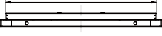
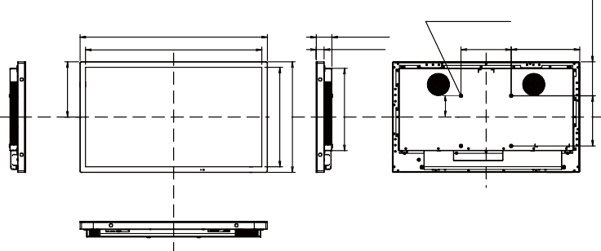
694.0mm/27.3”
746.0mm/29.4”
702.5mm/27.7”
62.5mm/2.5”
31.5mm/1.2”
4xM6 SCREW HOLE (VESA MOUNT)
200.0mm/7.9” 273.0mm/10.7”
85.0mm/3.4”
220.5mm/8.7”
397.0mm/15.6”
440.5mm/17.3”
328.0mm/12.9”
200.0mm/7.9”
135.5mm/5.3”

DIMENSIONS : ProLite TF4339AS

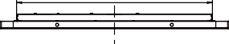
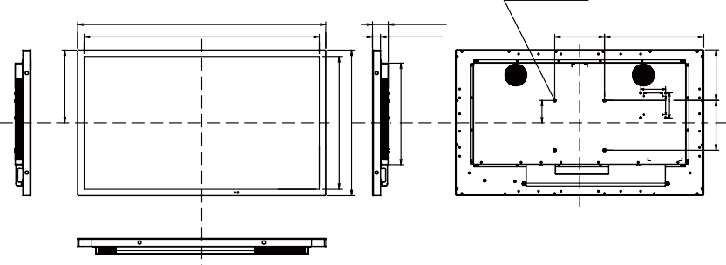
853.0mm/33.6”
4xM6 SCREW HOLE (VESA MOUNT)
997.0mm/39.3”
945.0mm/37.2”
63.5mm/2.5”
32.5mm/1.3”
200.0mm/7.9” 398.5mm/15.7”
100.0mm/3.9”
75.0mm/3.0”
90.5mm/3.6”
292.5mm/11.5”
533.5mm/21.0”
585.5mm/23.1”
408.5mm/16.1”

75.0mm/3.0”
100.0mm/3.9”
200.0mm/7.9” 203.5mm/8.0”

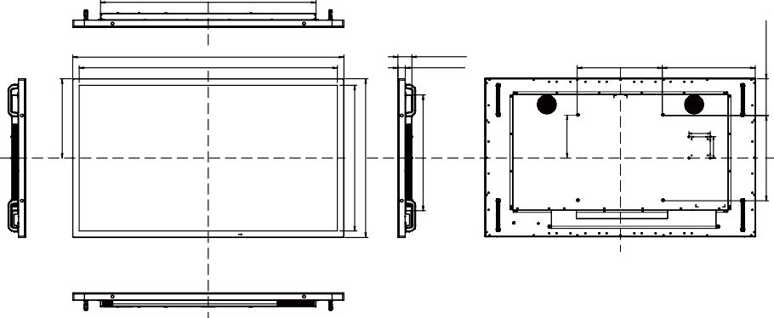
1013.0mm/39.9”
1274.0mm/50.2”
1213.5mm/47.8”
65.0mm/2.6”
34.0mm/1.3”
400.0mm/15.7”
437.0mm/17.2”
200.0mm/7.9”
100.0mm/3.9”
75.0mm/3.0”
372.5mm/14.7”
684.5mm/26.9”
745.0mm/29.3”
543.5mm/21.4”
75.0mm/3.0”
100.0mm/3.9”
400.0mm/15.7”
172.5mm/6.8”
ENGLISH
DIMENSIONS : ProLite TF5039AS

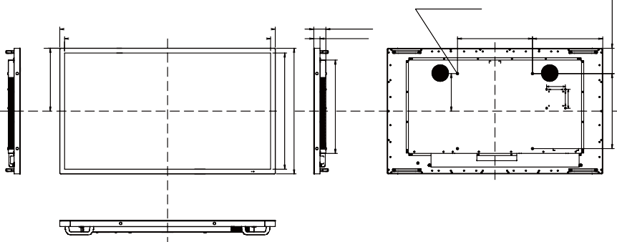
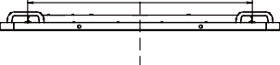
923.0mm/36.3”
4xM6 SCREW HOLE (VESA MOUNT)
1149.5mm/45.3”
64.0mm/2.5”
33.0mm/1.3”
400.0mm/15.7”
374.5mm/14.7”
100.0mm/3.9”
75.0mm/3.0”
199.5mm/7.9”
1101.5mm/43.4”
335.0mm/13.2”
622.0mm/24.5”
670.0mm/26.4”
497.5mm/19.6”
75.0mm/3.0”
100.0mm/3.9”
400.0mm/15.7”
135.5mm/5.3”

DIMENSIONS : ProLite TF5539AS

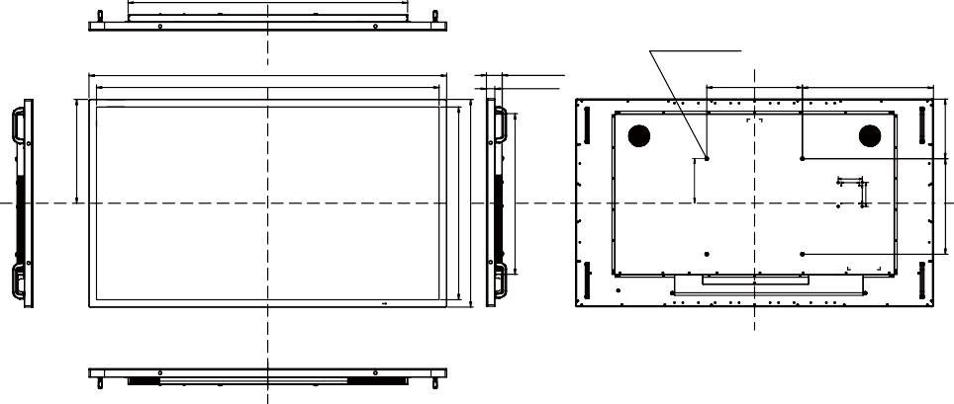
1168.5mm/46.0”
4xM8 SCREW HOLE (VESA MOUNT)
1495.0mm/58.9”
1432.5mm/56.4”
66.0mm/2.6”
35.0mm/1.4”
400.0mm/15.7”
547.5mm/21.6”
187.0mm/7.4”
100.0mm/3.9”
75.0mm/3.0”
ENGLISH
435.0mm/17.1”
807.5mm/31.8”
870.0mm/34.3”
673.5mm/26.5”
75.0mm/3.0”
100.0mm/3.9”
400.0mm/15.7” 250.0mm/9.8”
DIMENSIONS : ProLite TF6539AS

ENGLISH
COMPLIANT TIMING

Timing |  |  | fH (kHz) | fV (Hz) | Dot clock  (MHz) | HDMI1 | HDMI2 | DisplayPort
VESA | VGA | 640x480 | 31.5 | 60.0 | 25.175
VESA | SVGA | 800x600 | 37.9 | 60.0 | 40.000
VESA | XGA | 1024x768 | 48.4 | 60.0 | 65.000
VESA | QVGA | 1280x960 | 64.0 | 60.0 | 108.000
VESA | SXGA | 1280x1024 | 64.0 | 60.0 | 108.000
VESA | WXGA | 1366x768 | 47.7 | 60.0 | 85.500 | Ver1.4 | Ver1.4
VESA | CVT | 1440x900 | 55.9 | 60.0 | 106.500
VESA | UXGA | 1680x1050 | 65.3 | 60.0 | 146.250
VESA | FHD | 1920x1080 | 67.5 | 60.0 | 148.500
VESA | 2048x1152 *² |  | 70.9 | 60.0 | 156.750
VESA | 2560x1080 *² |  | 66.0 | 60.0 | 198.000
VESA | 2560x1440 *² |  | 88.8 | 60.0 | 241.700
VESA | 2560x1600 *² |  | 98.7 | 60.0 | 268.500
VESA | 3200x1800 *² |  | 111.1 | 60.0 | 391.140
VESA | 4K 3840x2160 *² |  | 67.5 | 30.0 | 297.000
VESA |  |  | 135.0 | 60.0 | 594.000
IBM | 720x400 |  | 31.5 | 70.0 | 28.320
SD | 480i | 60Hz | 15.7 | 60.0 | 27.000
SD | 576i | 50Hz | 15.6 | 50.0 | 13.500
SD | 480p | 60Hz | 31.5 | 60.0 | 27.000
SD | 576p | 50Hz | 31.3 | 50.0 | 27.000
HD | 720p | 50Hz | 37.5 | 50.0 | 27.000
HD | 720p | 60Hz | 45.0 | 60.0 | 74.250
HD | 1080i | 50Hz | 28.1 | 50.0 | 74.250
HD | 1080i | 60Hz | 33.7 | 60.0 | 74.250
HD | 1080p | 50Hz | 56.3 | 50.0 | 148.500
HD | 1080p | 60Hz | 67.5 | 60.0 | 148.500
*¹ : Supported
*² Not available for ProLite TF3239AS

APPENDIX 53
M374B21

