

Application Note

RS232 SERIAL INTERFACE COMMUNICATION PROTOCOL

NOTE: The commands provided in this document are a standard set.

Functionality is guaranteed only for the commands/functions which are also available in the OSD Menu of the display.
Functionality of commands listed in this document but not available in the OSD Menu cannot be guaranteed.

Applicable models:

TFxx39AS

INTRODUCTION

Purpose

The purpose of this document is to explain in detail the commands and steps that can be used to control a display via RS232C.
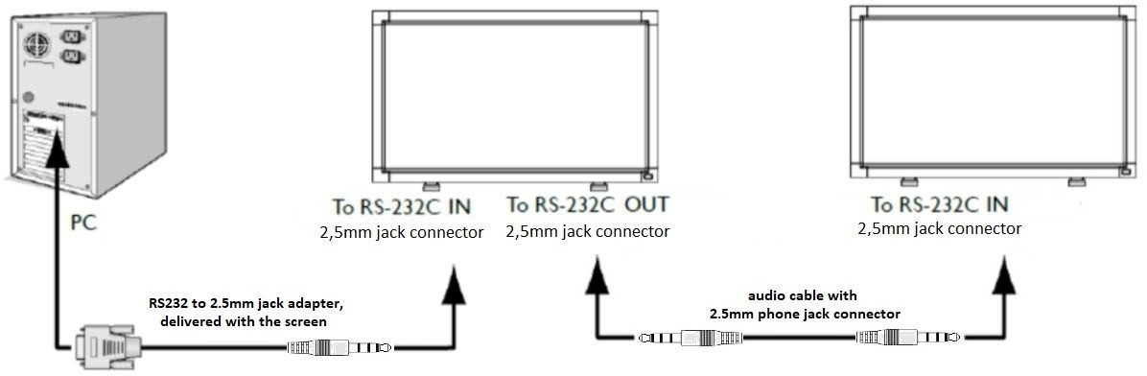

Definitions, Abbreviations and Acronyms
PBS Professional Business Solutions
RC Remote Control
ACK Acknowledge
NACK Not Acknowledge
NAV Not Available
ID Identification
0xXX Hexadecimal notation

COMMAND PACKET FORMAT

Physical Specifications
- Baud Rate : 9600
- Data bits: 8
- Parity : None
- Stop Bit : 1
- Flow Control : None
- The pin assignments for DB9 to jack adapter
P
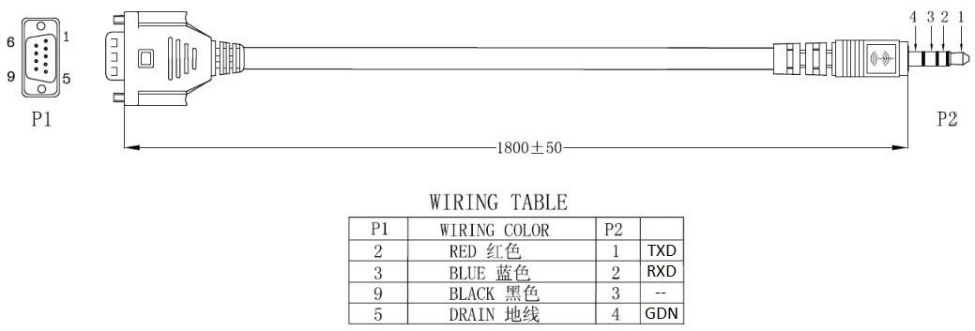

The pin assignments for monitor RS232 Input and Output port
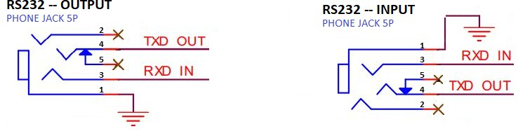

Digital Signage displays use RXD, TXD and GND pins for RS-232C control.

Communication Procedure
Control commands can be sent from a host controller via the RS232 connection. A new command should not be sent until the previous command is acknowledged. However, if a response is not received within 500 milliseconds a retry may be triggered. Every valid command receives an ACK. A command that is valid but not supported in the current implementation will be responded to with a NAV (Not Available). If the command buffer is corrupt (transmission errors) the command will be responded to with a NACK. The display operates according to the received command. If the command is a valid “Get” command, the display responds with the requested info. If the command is a valid “Set” command allowed, the display performs the requested operation.
Figure1 and Figure2 explain the mechanism of the Get and Set commands.

Note: For LAN control, the port number is 5000

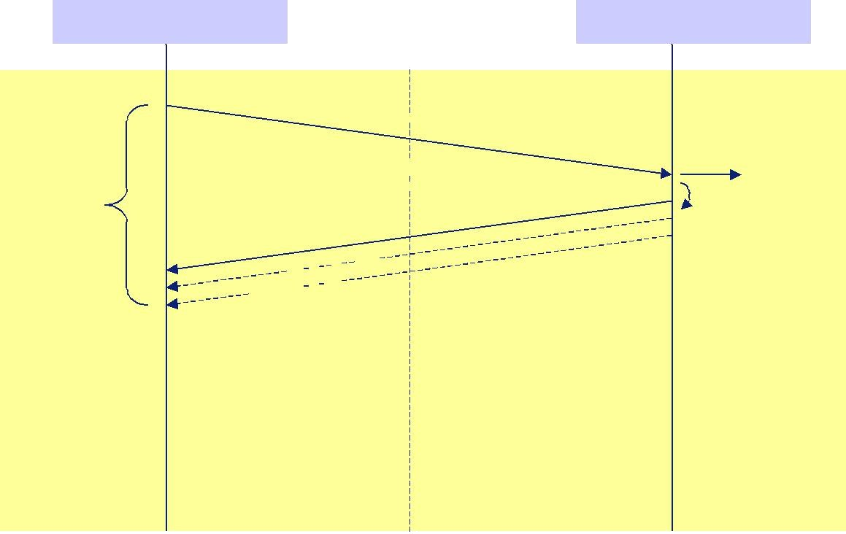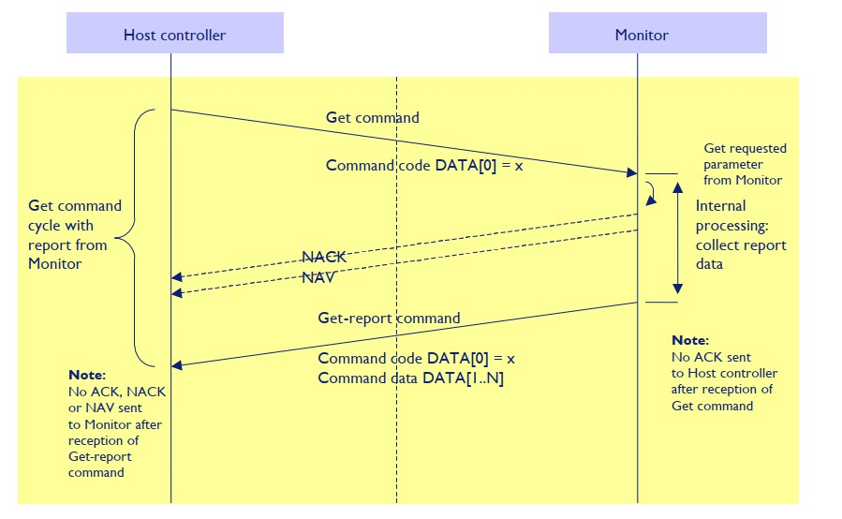

Figure 1: Explanation of mechanism of Get Command.

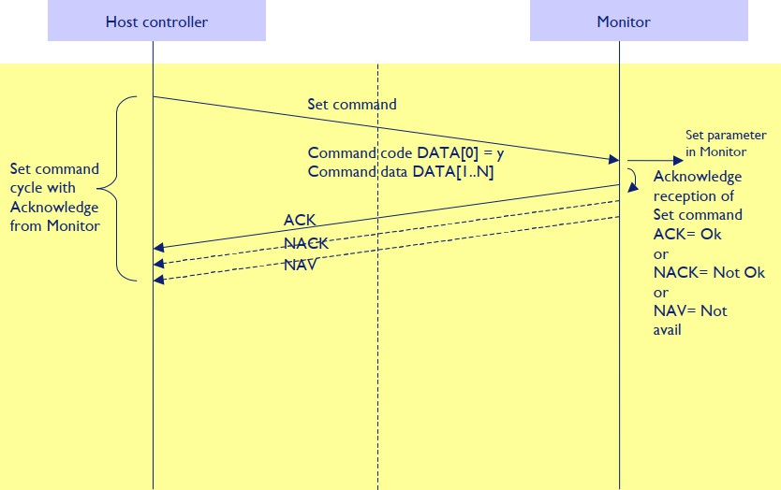

Figure 2: Explanation of mechanism of Set Command.

Command Format

The RS232 packet format:

Header Monitor ID Category Code0 Code1 Length Data Data[0] … Data[N] Checksum
Control
In detail:

Number of Field | Name of Field | Description
Byte 1 | Header | Header = 0xA6
Byte 2 | Monitor ID | Monitor ID Range : 1 ~ 255  Signal mode: Display Address range from 1 to 255  Broadcast mode: Display Address is 0 which indicates no ACK  or Report is expected.
Byte 3 | Category | Category = 0x00 (fixed)
Byte 4 | Code0 (Page) | Page = 0x00 (fixed)
Byte 5 | Code1 (Function)
Byte 6 | Length | Length has to be calculated in the fallowing way: Length = N + 3
Byte 7 | Data Control | Data Control = 0x01 (fixed)
Byte 8 ~ Byte 44 | Data[0] ~ Data[N] | This field can be also empty.  If not empty then the range of Data Size, N = 0 to 36.
Last Byte | Checksum | Checksum.  Range = 0 to 255 (0xFF).  Algorithm: The EXCLUSIVE-OR (XOR) of all bytes in the message except the checksum itself.  Checksum = [Header] XOR [Monitor ID] XOR … DATA[0] … XOR DATA[N]

Command Examples (for display with ID1):

Power off: A60100000004011801BB

Power on: A60100000004011802B8

Notes about powering ON the screen via LAN:

he “Power Save” option in display menu must be set to Mode 2
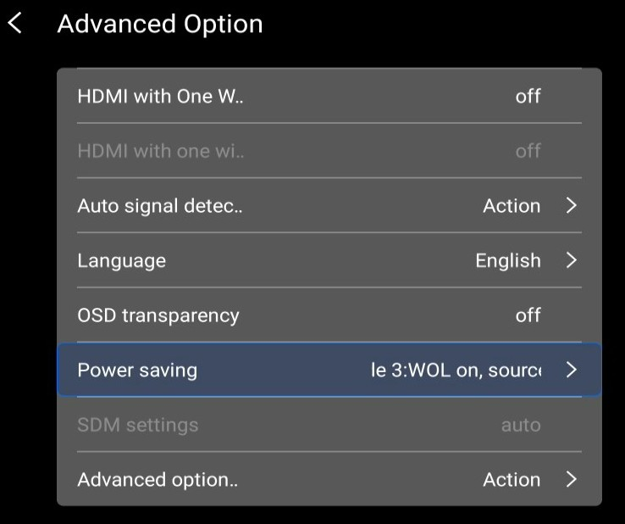
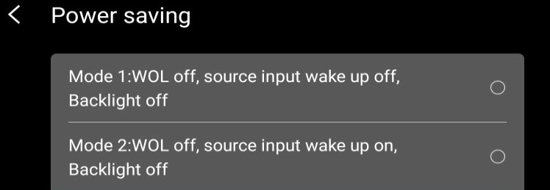

Switch to HDMI1 input: A6010000000701AC0D00000000

Set main volume and audio out to 78% : A6010000000501444E4EE7
Set main volume to 50% and audio out to 0% : A6010000000501443200D5 Set main volume to 0% and audio out to 60% : A601000000050144003CDB Get current volume value: A601000000030145E0
The commands can be sent to the screen with a terminal app, for example Hercules SETUP utility .
To send command with Hercules SETUP utility

- set the proper RS232 routing (RS232/LAN) parameter:
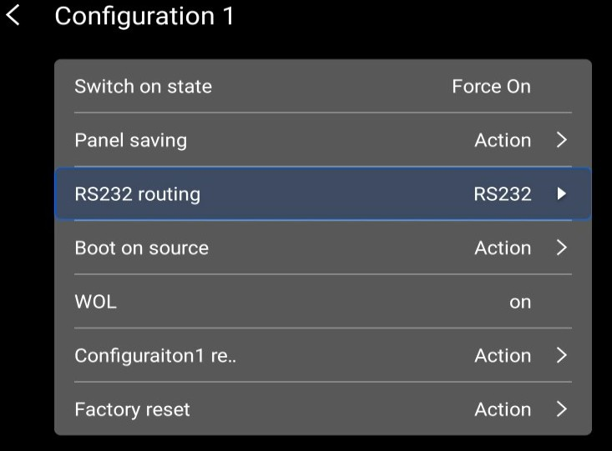

- Set display’s IP address and Port: 5000 for LAN connection / serial port parameter.
- Press Open (for serial connection) or Connect (for LAN connection)
- Insert the command.
- Press Send
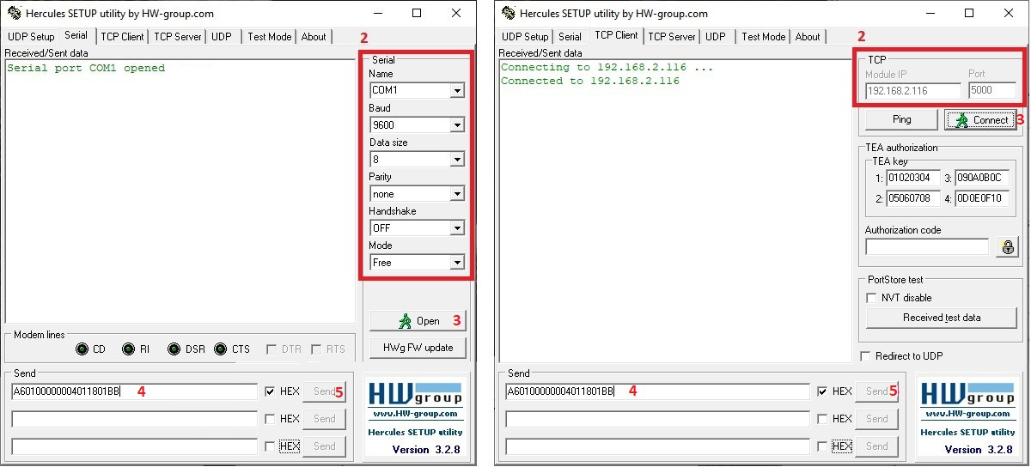

MESSAGES - SYSTEM

Communication Control

This defines the feedback command from monitor to host controller when it receives the display command from the host controller, depending on the command’s availability, the command reported back to host controller can be one of the ACK, NACK or NAV.
Note: there is no reply message when the wrong ID address is being used.

Message-Report
Number of Field | Name of Field | Description
Byte 1 | Header | Header = 0x21
Byte 2 | Monitor ID | Monitor ID Range : 1 ~ 255
Byte 3 | Category | Category = 0x00 (fixed)
Byte 4 | Code0 (Page) | Page = 0x00 (fixed)
Byte 5 | Length | Length = 0x04
Byte 6 | Data Control | Data Control = 0x01 (fixed)
Byte 7 | Command | 0x00(Communication Control)
Byte 8 | Status | 0x00: Completed
Byte 8 | Status | Normal response.
Byte 8 | Status | 0x01: Limit Over
Byte 8 | Status | The packets was received normally, but the data value was
Byte 8 | Status | over the upper limit.
Byte 8 | Status | 0x02: Limit Over
Byte 8 | Status | The packets was received normally, but the data value was
Byte 8 | Status | over the lower limit.
 |  | 0x03: Command cancelled
 |  | The packet is received normally but either the value of data is
 |  | incorrect or request is not permitted for the current host
 |  | value.
 |  | 0x04: Parse Error
 |  | Received not defined format data or check sum Error.
Byte 9 | Checksum | Check Sum  The total from Byte1 to Byte8 calculated by XOR

Platform and Version Labels , Model Number, FW Version, Build date

Platform and Version Labels
This command provides the OTSC protocol version and the display Software version to the host controller.

Message-Get

Bytes | Bytes Description | Bits | Description
DATA[0] | 0xA2 = Platform and |  | Request the OTSC version.
DATA[0] | Version Labels - Get
DATA[1] | Which Label |  | 0x00 | = Get OTSC implementation version
DATA[1] | Which Label |  | 0x01 | = Get the platform label
DATA[1] | Which Label |  | 0x02 | = Get the platform version
DATA[1] | Which Label |  | (Ex: Eagle 1.2, Eagle 1.3, Phoenix 1.0, Himalaya, Andes...)
Example: Get version (Display address 01)
Header | Monitor ID | Category | Code0 | Code1 | Length | Data | Data[0] | Data[1] | Checksum
 |  |  |  |  |  | Control | Data[0] | Data[1] | Checksum

0xA6 | 0x01 | 0x00 | 0x00 | 0x00 | 0x04 | 0x01 | 0xA2 | 0x00 | 0x00

Message-Report

Bytes | Bytes Description | Bits | Description
DATA[0] | 0xA2 = Platform and |  | Request the internal Hardware version.
DATA[0] | Version Label – |  | Request the internal Hardware version.
DATA[0] | Report |  | Request the internal Hardware version.
DATA[1] | Character[0] to |  | 36 (0x24) characters maximum.
to | Character[N-1] |  | No. of characters, N = 1 to 36 (0x24).
DATA[N] |  |  | The actual size determines the value of the message size
 |  |  | byte.

Message-Get (Model Number, FW Version, Build date)

Bytes | Bytes Description | Bits | Description
DATA[0] | 0xA1 = Get Model |  | Request the Model Number and FW version of the device
DATA[0] | Number & FW version
DATA[0] | of device with Date
DATA[1] | Codes to request |  | 0x00 | = Model Number
to | Codes to request |  | 0x01 | = FW version
DATA[N] | Codes to request |  | 0x02 | = Build Date

Message-Report (Model Number, FW Version, Build date)

Bytes | Bytes Description | Bits | Description
DATA[0] | 0xA1 = Report - Model |  | Request the Model number, FW version, FW build date
DATA[0] | Number & FW version |  | Request the Model number, FW version, FW build date
DATA[0] | of device with Date |  | Request the Model number, FW version, FW build date
DATA[1] | Character[0] to |  | 36 (0x24) characters maximum.
to | Character[N-1] |  | No. of characters, N = 1 to 36 (0x24).
DATA[N] |  |  | The actual size determines the value of the message size byte.

MESSAGES - GENERAL

Power state
This command is used to set/get the power state as it is defined as below.

Message-Get

Bytes | Bytes Description | Bits | Description
DATA[0] | 0x19 = Power state - |  | Command requests the display to report its current power
DATA[0] | Get |  | state
Example: (Display address 01)
Header | Monitor ID | Category | Code0 | Code1 | Length | Data | Data[0] | Checksum
 |  |  |  |  |  | Control | Data[0] | Checksum

0xA6 | 0x01 | 0x00 | 0x00 | 0x00 | 0x03 | 0x01 | 0x19 | 0xBC

Message-Report

Bytes | Bytes Description | Bits | Description
DATA[0] | 0x19 = Power State - |  | Command reports Power state
DATA[0] | Report
DATA[1] | Power State |  | 0x01 | = Power Off
DATA[1] | Power State |  | 0x02 | = On
Example: Power State On (Display address 01)
Header | Monitor ID | Category | Page | Length | Data Control | Data[0] | Data[1] | Checksum
0x21 | 0x01 | 0x00 | 0x00 | 0x04 | 0x01 | 0x19 | 0x02 | 0x3E

Message-Set

Bytes | Bytes Description | Bits | Description
DATA[0] | 0x18 = Power state - |  | Command to change the Power state of the display
DATA[0] | Set
DATA[1] | Power state |  | 0x01 | = Power Off
DATA[1] | Power state |  | 0x02 | = On
Example: Power State Deep Sleep (Display address 01)
Header | Monitor ID | Category | Code0 | Code1 | Length | Data | Data[0] | Data[1] | Checksum
 |  |  |  |  |  | Control | Data[0] | Data[1] | Checksum

0xA6 | 0x01 | 0x00 | 0x00 | 0x00 | 0x04 | 0x01 | 0x18 | 0x01 | 0xBB

Lock Functions for IR-Remote Control
The following commands separately are used to lock/unlock the Remote Control and Keypad.

Message-Get

Bytes | Bytes Description | Bits | Description
DATA[0] | 0x1D = Get - Lock Status – IR – |  | Get unlock all /lock all /lock all but
DATA[0] | Remote Control |  | power/lock all but volume/
DATA[0] |  |  | Primary/Secondary status
Example: (Display address 01)
Header | Monitor ID | Category | Code0 | Code1 | Length | Data Control | Data[0] | Checksum
0xA6 | 0x01 | 0x00 | 0x00 | 0x00 | 0x03 | 0x01 | 0x1D | 0xB8

Message-Report (IR-Remote Control)

Bytes | Bytes Description | Bits | Description
DATA[0] | 0x1D = Report - Lock Status – IR – |  | Report unlock all /lock all /lock all but
DATA[0] | Remote Control |  | power/lock all but volume/
DATA[0] |  |  | Primary/Secondary status
DATA[1] | Status indicator byte for Remote |  | 0x01 | = Unlock all
DATA[1] | Control |  | 0x02 | = Lock all
DATA[1] |  |  | 0x03 | = Lock all but Power
DATA[1] |  |  | 0x04 | = Lock all but Volume
DATA[1] |  |  | 0x05 | = Primary (Master)
DATA[1] |  |  | 0x06 | = Secondary (Daisy chain PD)
DATA[1] |  |  | 0x07 | = Lock all except Power & Volume

Example: Lock Keyboard and unlocked Remote Control (Display address 01)
Header | Monitor ID | Category | Page | Length | Data Control | Data[0] | Data[1] | Checksum
0x21 | 0x01 | 0x00 | 0x00 | 0x04 | 0x01 | 0x1D | 0x01 | 0x39

Message-Set (IR –Remote Control)

Bytes | Bytes Description | Bits | Description
DATA[0] | 0x1C = Set - Lock State – IR – |  | Set unlock all/lock all /lock all but
DATA[0] | Remote Control |  | power/lock all but volume/
DATA[0] |  |  | Primary/Secondary status
DATA[1] | Status indicator byte for Remote |  | 0x01 = Unlock all
DATA[1] | Control |  | 0x02 = Lock all
DATA[1] |  |  | 0x03 | = Lock all but Power
DATA[1] |  |  | 0x04 | = Lock all but Volume
DATA[1] |  |  | 0x05 | = Primary (Master) - Reply
DATA[1] |  |  | OTS_SET_IR_ACK(0x21 0x01 0x00 0x00
DATA[1] |  |  | 0x04 | 0x01 0x00 0x00 0x25)
DATA[1] |  |  | 0x06 | = Secondary (Daisy chain PD) -
DATA[1] |  |  | Reply OTS_SET_IR_ACK(0x21 0x01
DATA[1] |  |  | 0x00 | 0x00 | 0x04 0x01 0x00 0x00 0x25)
DATA[1] |  |  | 0x07 | = Lock all except Power & Volume

Example: Unlock local remote control (Display address 01)

Header | Monitor ID | Category | Code0 | Code1 | Length | Data Control | Data[0] | Data[1] | Checksum
0xA6 | 0x01 | 0x00 | 0x00 | 0x00 | 0x04 | 0x01 | 0x1C | 0x01 | 0xBF

Message-Get (Keypad)
Bytes | Bytes Description | Bits | Description
DATA[0] | 0x1B = Get - Keypad Lock Status |  | Set unlock all/lock all /lock all but
DATA[0] | 0x1B = Get - Keypad Lock Status |  | power/lock all but volume/
DATA[0] | 0x1B = Get - Keypad Lock Status |  | Primary/Secondary status

Example: (Display address 01)
Header | Monitor ID | Category | Code0 | Code1 | Length | Data Control | Data[0] | Checksum
0xA6 | 0x01 | 0x00 | 0x00 | 0x00 | 0x03 | 0x01 | 0x1B | 0xBE

Message-Report (Keypad)
Bytes | Bytes Description | Bits | Description
DATA[0] | 0x1B = Report - Keypad Status |  | Report unlock all /lock all/lock all but
DATA[0] | 0x1B = Report - Keypad Status |  | power/ lock all but Volume
DATA[1] | Status indicator byte for Keypad |  | 0x01 = Unlock all
DATA[1] | Status indicator byte for Keypad |  | 0x02 | = Lock all
DATA[1] | Status indicator byte for Keypad |  | 0x03 | = Lock all but Power
DATA[1] | Status indicator byte for Keypad |  | 0x04 | = Lock all but Volume
DATA[1] | Status indicator byte for Keypad |  | 0x07 | = Lock all except Power & Volume
Example: Reporting status of Keypad indicating Lock all for (Display address 01)
Header | Monitor ID | Category | Page | Length | Data Control | Data[0] | Data[1] | Checksum
0x21 | 0x01 | 0x00 | 0x00 | 0x04 | 0x01 | 0x1B | 0x02 | 0x3C

Message-Set (Keypad)
Bytes | Bytes Description | Bits | Description
DATA[0] | 0x1A = Set – Keypad Lock Status |  | Report unlock all /lock all/lock all but
DATA[0] | 0x1A = Set – Keypad Lock Status |  | power/ lock all but Volume
DATA[1] | Status indicator byte for Keypad |  | 0x01 = Unlock all
DATA[1] | Status indicator byte for Keypad |  | 0x02 | = Lock all
DATA[1] | Status indicator byte for Keypad |  | 0x03 | = Lock all but Power
DATA[1] | Status indicator byte for Keypad |  | 0x04 | = Lock all but Volume
DATA[1] | Status indicator byte for Keypad |  | 0x07 | = Lock all except Power & Volume
Example: Set Lock all on Keypad for (Display address 01)
Header | Monitor ID | Category | Code0 | Code1 | Length | Data Control | Data[0] | Data[1] | Checksum
0xA6 | 0x01 | 0x00 | 0x00 | 0x00 | 0x04 | 0x01 | 0x1A | 0x01 | 0xB9

Power state at Cold Start

Command is used to set the cold start power state, the cold start power state are updated and stored by this command.

Message-Get
Bytes | Bytes Description | Bits | Description
DATA[0] | 0xA4 = Power at Cold Start - Get |  | Get Power state at Cold Start state
Example: (Display address 01)
Header | Monitor ID | Category | Code0 | Code1 | Length | Data Control | Data[0] | Checksum
0xA6 | 0x01 | 0x00 | 0x00 | 0x00 | 0x03 | 0x01 | 0xA4 | 0x01

Message-Report
Bytes | Bytes Description | Bits | Description
DATA[0] | 0xA4 = Power at Cold Start – Report |  | Report from Power state at Cold Start
DATA[0] | 0xA4 = Power at Cold Start – Report |  | state
DATA[1] | Power at Cold Start |  | 0x00 | = Power Off
DATA[1] | Power at Cold Start |  | 0x01 | = Forced On
DATA[1] | Power at Cold Start |  | 0x02 | = Last Status
Example: Report status of Forced On for power at cold start. (Display address 01)
Header | Monitor ID | Category | Page | Length | Data Control | Data[0] | Data[1] | Checksum
0x21 | 0x01 | 0x00 | 0x00 | 0x04 | 0x01 | 0xA4 | 0x01 | 0x80

Message-Set

Bytes | Bytes Description | Bits | Description
DATA[0] | 0xA3 = Power at Cold Start - Set |  | Set Power state at Cold Start
DATA[1] | Power state at Cold Start |  | 0x00 | = Power Off
DATA[1] | Power state at Cold Start |  | 0x01 | = Forced On
DATA[1] | Power state at Cold Start |  | 0x02 | = Last Status

The value is stored and it is applied only when the display starts up from cold start power state the next time: Power Off:
The monitor will be automatically switched to Power Off mode (even if the last status was on) whenever the mains power is turned on or resumed after the power interruption.
Forced On:
The monitor will be automatically switched to ON mode whenever the mains power is turned on or resumed after the power interruption.
Last Status:
The monitor will be automatically switched to the last status (either Power Off or On) whenever the mains power is turned on or resumed after the power interruption.
Example: Set Power state at cold start to last status (Display address 01)
Header | Monitor ID | Category | Code0 | Code1 | Length | Data Control | Data[0] | Data[1] | Checksum
0xA6 | 0x01 | 0x00 | 0x00 | 0x00 | 0x04 | 0x01 | 0xA3 | 0x02 | 0x03

MESSAGES - INPUT SOURCES

Input Source
This command is used to change the current input source.

Message-Set

Bytes | Bytes Description | Bits | Description
DATA[0] | 0xAC = Input Source – Set |  | Command requests the display to set the current
DATA[0] | 0xAC = Input Source – Set |  | input source
DATA[1] | Input Source Type |  | 0x01 = VIDEO
DATA[1] | Input Source Type |  | 0x02 | = S-VIDEO
DATA[1] | Input Source Type |  | 0x03 | = COMPONENT
DATA[1] | Input Source Type |  | 0x04 | = CVI 2 (not applicable)
DATA[1] | Input Source Type |  | 0x05 | = VGA
DATA[1] | Input Source Type |  | 0x06 | = HDMI 2
DATA[1] | Input Source Type |  | 0x07 | = Display Port 2
DATA[1] | Input Source Type |  | 0x08 | = USB 2
DATA[1] | Input Source Type |  | 0x09 | = Card DVI-D
DATA[1] | Input Source Type |  | 0x0A = Display Port 1
DATA[1] | Input Source Type |  | 0x0B= Card OPS
DATA[1] | Input Source Type |  | 0x0C = USB 1
DATA[1] | Input Source Type |  | 0x0D= HDMI
DATA[1] | Input Source Type |  | 0x0E= DVI-D
DATA[1] | Input Source Type |  | 0x0F = HDMI3
DATA[1] | Input Source Type |  | 0x10= BROWSER
DATA[1] | Input Source Type |  | 0x11= SMARTCMS
DATA[1] | Input Source Type |  | 0X12= DMS (Digital Media Server)
DATA[1] | Input Source Type |  | 0x13= INTERNAL STORAGE
DATA[1] | Input Source Type |  | 0x14= Reserved
DATA[1] | Input Source Type |  | 0x15= Reserved
DATA[1] | Input Source Type |  | 0x16= Media Player
DATA[1] | Input Source Type |  | 0x17= PDF Player
DATA[1] | Input Source Type |  | 0x18= Custom
DATA[1] | Input Source Type |  | 0x19=HDMI 4
DATA[2] | Reserved |  | (Reserved, value is 0)
DATA[3] | Reserved |  | (Reserved, value is 0)
DATA[4] | Reserved |  | (Reserved, value is 0)
Example: Set on DVI-D (Display address 01)
Header | Monitor ID | Category | Code0 | Code1 | Length | Data | Data[0] | Data[1] | Data[2] | Data[3] | Data[4] | Checksum
 |  |  |  |  |  | Control
0xA6 | 0x01 | 0x00 | 0x00 | 0x00 | 0x07 | 0x01 | 0xAC | 0x0E | 0x00 | 0x00 | 0x00 | 0x03

  - Current Source

Message-Get

Bytes | Bytes Description | Bits | Description
DATA[0] | 0xAD = Current Source – Get |  | Command requests the display to report the
DATA[0] | 0xAD = Current Source – Get |  | current input source in use.
Example: (Display address 01)
Header | Monitor ID | Category | Code0 | Code1 | Length | Data Control | Data[0] | Checksum
0xA6 | 0x01 | 0x00 | 0x00 | 0x00 | 0x03 | 0x01 | 0xAD | 0x08

Message-Report
Bytes | Bytes Description | Bits | Description
DATA[0] | 0xAD = Current Source – |  | Command reports to the host controller the
DATA[0] | Report |  | current input source in use by the display.
DATA[1] | Input Source Type/Number |  | 0x01 = VIDEO
DATA[1] | Input Source Type/Number |  | 0x02 | = S-VIDEO
DATA[1] | Input Source Type/Number |  | 0x03 | = COMPONENT
DATA[1] | Input Source Type/Number |  | 0x04 | = CVI 2 (not applicable)
DATA[1] | Input Source Type/Number |  | 0x05 | = VGA
DATA[1] | Input Source Type/Number |  | 0x06 | = HDMI 2
DATA[1] | Input Source Type/Number |  | 0x07 | = Display Port 2
DATA[1] | Input Source Type/Number |  | 0x08 | = USB 2
DATA[1] | Input Source Type/Number |  | 0x09 | = Card DVI-D
DATA[1] | Input Source Type/Number |  | 0x0A = Display Port 1
DATA[1] | Input Source Type/Number |  | 0x0B= Card OPS
DATA[1] | Input Source Type/Number |  | 0x0C = USB 1
DATA[1] | Input Source Type/Number |  | 0x0D= HDMI
DATA[1] | Input Source Type/Number |  | 0x0E= DVI-D
DATA[1] | Input Source Type/Number |  | 0x0F = HDMI3
DATA[1] | Input Source Type/Number |  | 0x10= BROWSER
DATA[1] | Input Source Type/Number |  | 0x11= SMARTCMS
DATA[1] | Input Source Type/Number |  | 0X12= DMS (Digital Media Server)
DATA[1] | Input Source Type/Number |  | 0x13= INTERNAL STORAGE
DATA[1] | Input Source Type/Number |  | 0x14= Reserved
DATA[1] | Input Source Type/Number |  | 0x15= Reserved
DATA[1] | Input Source Type/Number |  | 0x16= Media Player
DATA[1] | Input Source Type/Number |  | 0x17= PDF Player
DATA[1] | Input Source Type/Number |  | 0x18= Custom
DATA[1] | Input Source Type/Number |  | 0x19=HDMI 4
DATA[2] | Reserved |  | (Reserved, value is 0)
DATA[3] | Reserved |  | (Reserved, value is 1)
DATA[4] | Reserved |  | (Reserved, value is 0)

Example: Current Input Source: DVI-D (Display address 01)
Header | Monitor ID | Category | Page | Length | Data Control | Data[0] | Data[1] | Data[2] | Data[3] | Data[4] | Checksum
0x21 | 0x01 | 0x00 | 0x00 | 0x07 | 0x01 | 0xAD | 0x0E | 0x00 | 0x01 | 0x00 | 0x84

MESSAGES - VIDEO

Video Parameters
The following commands are used to get/set video parameters as it is defined below.

Message-Get

Bytes | Bytes Description | Bits | Description
DATA[0] | 0x33 = Video Parameters – |  | Command requests the display to report its current
DATA[0] | Get |  | video parameters.
Example: (Display address 01)
Header | Monitor ID | Category | Code0 | Code1 | Length | Data Control | Data[0] | Checksum
0xA6 | 0x01 | 0x00 | 0x00 | 0x00 | 0x03 | 0x01 | 0x33 | 0x96

Message-Report

Bytes | Bytes Description | Bits | Description
DATA[0] | 0x33 = Video Parameters – |  | Command reports to the host controller the current
DATA[0] | Report |  | video parameters of the display.
DATA[1] | Brightness. |  | 0 to 100 (%) of the user selectable range of the display.
DATA[2] | Color. |  | 0 to 100 (%) of the user selectable range of the display.
DATA[3] | Contrast. |  | 0 to 100 (%) of the user selectable range of the display.
DATA[4] | Sharpness. |  | 0 to 100 (%) of the user selectable range of the display.
DATA[5] | Tint (Hue) |  | 0 to 100 (%) of the user selectable range of the display.
DATA[6] | Black Level |  | 0 to 100 (%) of the user selectable range of the display.
DATA[7] | Gamma Selection |  | 0x01= Native, 0x02 = S gamma, 0x03 = 2.2, 0x04 = 2.4,
DATA[7] | Gamma Selection |  | 0x05 = D-image(DICOM gamma)
Example: All video parameters are set to 55 % (0x37) and Gamma Curve is set to 2.2 (Display address 01)
Header | Monitor ID | Category | Page | Length | Data Control | Data[0] | Data[1] | Data[2] | Data[3] | Data[4] | Data[5] | Data[6] | Data[7] | Checksum
0x21 | 0x01 | 0x00 | 0x00 | 0x0A | 0x01 | 0x33 | 0x37 | 0x37 | 0x37 | 0x37 | 0x37 | 0x37 | 0x03 | 0x1B

Message-Set

Bytes | Bytes Description | Bits | Description
DATA[0] | 0x32 = Video Parameters – |  | Command to change the current video parameters
DATA[0] | Set |  | Command to change the current video parameters
DATA[1] | Brightness. |  | 0 to 100 (%) of the user selectable range of the display.
DATA[2] | Color. |  | 0 to 100 (%) of the user selectable range of the display.
DATA[3] | Contrast. |  | 0 to 100 (%) of the user selectable range of the display.
DATA[4] | Sharpness. |  | 0 to 100 (%) of the user selectable range of the display.
DATA[5] | Tint (Hue) |  | 0 to 100 (%) of the user selectable range of the display.
DATA[6] | Black Level |  | 0 to 100 (%) of the user selectable range of the display.
DATA[7] | Gamma Selection |  | 0x01= Native, 0x02 = S gamma, 0x03 = 2.2, 0x04 = 2.4,
DATA[7] | Gamma Selection |  | 0x05 = D-image(DICOM gamma)

Example: Set all video parameters to 0x37 (55 %) (Display address 01)
Header | Monitor ID | Category | Code0 | Code1 | Length | Data Control | Data[0] | Data[1] | Data[2] | Data[3] | Data[4] | Data[5] | Data[6] | Data[7] | Checksum
0xA6 | 0x01 | 0x00 | 0x00 | 0x00 | 0x0A | 0x01 | 0x32 | 0x37 | 0x37 | 0x37 | 0x37 | 0x37 | 0x37 | 0x03 | 0xAC

Message-Get
Bytes | Bytes Description | Bits | Description
DATA[0] | 0x35 = Color Temperature – Get |  | Command requests the display to report its current
DATA[0] | 0x35 = Color Temperature – Get |  | color temperature.
Example: (Display address 01)
 |  |  |  |  |  | Data
Header | Monitor ID | Category | Code0 | Code1 | Length | Control | Data[0] | Checksum
0xA6 | 0x01 | 0x00 | 0x00 | 0x00 | 0x03 | 0x01 | 0x35 | 0x90

Message-Report
Bytes | Bytes Description | Bits | Description
DATA[0] | 0x35 = Color Temperature – |  | Command reports to the host controller the current color
DATA[0] | Report |  | temperature of the display.
DATA[1] | Color temperature |  | 0x00 = User 1
DATA[1] | Color temperature |  | 0x01 | = Native
DATA[1] | Color temperature |  | 0x02 | = 11000K(Not applicable)
DATA[1] | Color temperature |  | 0x03 | = 10000K
DATA[1] | Color temperature |  | 0x04 | = 9300K
DATA[1] | Color temperature |  | 0x05 | = 7500K
DATA[1] | Color temperature |  | 0x06 | = 6500K
DATA[1] | Color temperature |  | 0x07 | = 5770K (Not applicable)
DATA[1] | Color temperature |  | 0x08 | = 5500K(Not applicable)
DATA[1] | Color temperature |  | 0x09 = 5000K
DATA[1] | Color temperature |  | 0x0A = 4000K
DATA[1] | Color temperature |  | 0x0B = 3400K (Not applicable)
DATA[1] | Color temperature |  | 0x0C = 3350K (Not applicable)
DATA[1] | Color temperature |  | 0x0D = 3000K
DATA[1] | Color temperature |  | 0x0E = 2800K (Not applicable)
DATA[1] | Color temperature |  | 0x0F = 2600K (Not applicable)
DATA[1] | Color temperature |  | 0x10 | = 1850K (Not applicable)
DATA[1] | Color temperature |  | 0x12 | = User 2
Example: The current color temperature is set to Nature (Display address 01)
Header | Monitor ID | Category | Page | Length | Data Control | Data[0] | Data[1] | Checksum
0x21 | 0x01 | 0x00 | 0x00 | 0x04 | 0x01 | 0x35 | 0x01 | 0x10

Message-Set
Bytes | Bytes Description | Bits | Description
DATA[0] | 0x34 = Color Temperature – |  | Command reports to the host controller the current color
DATA[0] | Report |  | temperature of the display.
DATA[1] | Color temperature |  | 0x00 = User 1
DATA[1] | Color temperature |  | 0x01 | = Native
DATA[1] | Color temperature |  | 0x02 | = 11000K(Not applicable)
DATA[1] | Color temperature |  | 0x03 | = 10000K
DATA[1] | Color temperature |  | 0x04 | = 9300K
DATA[1] | Color temperature |  | 0x05 | = 7500K
DATA[1] | Color temperature |  | 0x06 | = 6500K
DATA[1] | Color temperature |  | 0x07 | = 5770K (Not applicable)
DATA[1] | Color temperature |  | 0x08 | = 5500K(Not applicable)
DATA[1] | Color temperature |  | 0x09 | = 5000K
DATA[1] | Color temperature |  | 0x0A = 4000K
DATA[1] | Color temperature |  | 0x0B = 3400K (Not applicable)
DATA[1] | Color temperature |  | 0x0C = 3350K (Not applicable)
DATA[1] | Color temperature |  | 0x0D = 3000K
DATA[1] | Color temperature |  | 0x0E = 2800K (Not applicable)
DATA[1] | Color temperature |  | 0x0F = 2600K (Not applicable)
DATA[1] | Color temperature |  | 0x10 | = 1850K (Not applicable)
DATA[1] | Color temperature |  | 0x12 | = User 2
Example: The current color temperature is set to Nature (Display address 01)
 |  |  |  |  |  | Data
Header | Monitor ID | Category | Code0 | Code1 | Length | Control | Data[0] | Data[1] | Checksum
0xA6 | 0x01 | 0x00 | 0x00 | 0x00 | 0x04 | 0x01 | 0x34 | 0x01 | 0x97

Message-Get
Bytes | Bytes Description | Bits | Description
DATA[0] | 0x37 = Color Parameters – |  | Command reports to the host controller the current
DATA[0] | Report |  | video parameters of the display.
DATA[1] | Red color gain value |  | 0 to 255 of the user selectable range of the display.
DATA[2] | Green color gain value |  | 0 to 255 of the user selectable range of the display.
DATA[3] | Blue color gain value |  | 0 to 255 of the user selectable range of the display.
DATA[4] | Red color offset value |  | 0 to 255 of the user selectable range of the display. Reply
DATA[4] | Red color offset value |  | 0.
DATA[5] | Green color offset value |  | 0 to 255 of the user selectable range of the display. Reply
DATA[5] | Green color offset value |  | 0.
DATA[6] | Blue color offset value |  | 0 to 255 of the user selectable range of the display. Reply
DATA[6] | Blue color offset value |  | 0.

Example: All color parameters are set to 255 (0xFF) (Display address 01)
Header | Monitor ID | Category | Page | Length | Data Control | Data[0] | Data[1] | Data[2] | Data[3] | Data[4] | Data[5] | Data[6] | Checksum
0x21 | 0x01 | 0x00 | 0x00 | 0x09 | 0x01 | 0x37 | 0xFF | 0xFF | 0xFF | 0xFF | 0xFF | 0xFF | 0x1F

Message-Set
Bytes | Bytes Description | Bits | Description
DATA[0] | 0x36 = Color Parameters – |  | Command reports to the host controller the current
DATA[0] | Report |  | video parameters of the display.
DATA[1] | Red color gain value |  | 0 to 255 of the user selectable range of the display.
DATA[2] | Green color gain value |  | 0 to 255 of the user selectable range of the display.
DATA[3] | Blue color gain value |  | 0 to 255 of the user selectable range of the display.
DATA[4] | Red color offset value |  | 0 to 255 of the user selectable range of the display.
DATA[5] | Green color offset value |  | 0 to 255 of the user selectable range of the display.
DATA[6] | Blue color offset value |  | 0 to 255 of the user selectable range of the display.

Example: All color parameters are set to 255 (0xFF) (Display address 01)
Header | Monitor ID | Category | Code0 | Code1 | Length | Data | Data[0] | Data[1] | Data[2] | Data[3] | Data[4] | Data[4] | Data[5] | Checksum
 |  |  |  |  |  | Control
0xA6 | 0x01 | 0x00 | 0x00 | 0x00 | 0x09 | 0x01 | 0x36 | 0xFF | 0xFF | 0xFF | 0xFF | 0xFF | 0xFF | 0x99

Picture Format
This command is used to control the display screen format.

Message-Get

Bytes | Bytes Description | Bits | Description
DATA[0] | 0x3B = Picture Format – |  | Command requests the display to report its current
DATA[0] | Get |  | picture format
Example: (Display address 01)
Header | Monitor ID | Category | Code0 | Code1 | Length | Data Control | Data[0] | Checksum
0xA6 | 0x01 | 0x00 | 0x00 | 0x00 | 0x03 | 0x01 | 0x3B | 0x9E

Message-Report

Bytes | Bytes Description | Bits | Description
DATA[0] | 0x3B = Picture Format – |  | Command report to the host controller the
DATA[0] | Report |  | current picture format of the display.
DATA[1] | Picture Format* | Bit 7..4 | Not used.
DATA[1] | Picture Format* | Bit 3..0 | Picture Format.
DATA[1] | Picture Format* | Bit 3..0 | 0x00 | = Normal (4:3)
DATA[1] | Picture Format* | Bit 3..0 | 0x01 | = Custom
DATA[1] | Picture Format* | Bit 3..0 | 0x02 | = Real (1:1)
DATA[1] | Picture Format* | Bit 3..0 | 0x03 | = Full
DATA[1] | Picture Format* | Bit 3..0 | 0x04 | = 21:9
DATA[1] | Picture Format* | Bit 3..0 | 0x05 | = Dynamic (DSXX6QBK not support)
DATA[1] | Picture Format* | Bit 3..0 | 0x06 | = 16:9

* For further explanations, please see section 6.2.3 – Message-Set.
Example: Current Picture Format is Widescreen on Full Display (Display address 01)
Header | Monitor ID | Category | Page | Length | Data Control | Data[0] | Data[1] | Checksum
0x21 | 0x01 | 0x00 | 0x00 | 0x04 | 0x01 | 0x3B | 0x03 | 0x1D

Message-Set

Bytes | Bytes Description | Bits | Description
DATA[0] | 0x3A = Picture Format – |  | Command requests the display to set the specified
DATA[0] | Set |  | picture format
DATA[1] | Picture Format | Bit 7..4 | Not used.
DATA[1] | Picture Format | Bit 3..0 | Picture Format.
DATA[1] | Picture Format | Bit 3..0 | 0x00 | = Normal (4:3)
DATA[1] | Picture Format | Bit 3..0 | 0x01 | = Custom
DATA[1] | Picture Format | Bit 3..0 | 0x02 | = Real (1:1)
DATA[1] | Picture Format | Bit 3..0 | 0x03 | = Full
DATA[1] | Picture Format | Bit 3..0 | 0x04 | = 21:9
DATA[1] | Picture Format | Bit 3..0 | 0x05 | = Dynamic (DSXX6QBK not support)
DATA[1] | Picture Format | Bit 3..0 | 0x06 | = 16:9
* For further explanations, please see section 6.2.3 – Message-Set.

Example: Set Picture Format to Widescreen on Full Display (Display address 01)
Header | Monitor ID | Category | Code0 | Code1 | Length | Data Control | Data[0] | Data[1] | Checksum
0xA6 | 0x01 | 0x00 | 0x00 | 0x00 | 0x04 | 0x01 | 0x3A | 0x03 | 0x9B

MESSAGES - AUDIO

Volume
This command is used to set/get the Volume as it is defined as below.

Message-Get

Bytes | Bytes Description | Bits | Description
DATA[0] | 0x45 = Volume – |  | Command requests the display to report its current Volume
DATA[0] | Get |  | level

The interface to set Software must be such that they also modify the variables representing these current parameters.
To mute the display, send Volume = 0. This command does not overwrite the system mute status of the display.
Example: (Display address 01)
 | Monitor |  |  |  |  | Data
Header | ID | Category | Code0 | Code1 | Length | Control | Data[0] | Checksum
0xA6 | 0x01 | 0x00 | 0x00 | 0x00 | 0x03 | 0x01 | 0x45 | 0xE0

Message-Report

Bytes | Bytes Description | Bits | Description
DATA[0] | 0x45 = Volume – Report |  | Command reports current Volume level
DATA[1] | Volume. |  | 0 to 100 (%) of the user selectable range of the display.
DATA[2] | Audio Out Volume level |  | 0 to 100 (%) of the user selectable range of the display.
Example: Current Display settings: Volume:77% (0x4D), Audio Out:77%(0x4D) (Display address 01)
Header | Monitor ID | Category | Page | Length | Data Control | Data[0] | Data[1] | Data[2] | Checksum
0x21 | 0x01 | 0x00 | 0x00 | 0x05 | 0x01 | 0x45 | 0x4D | 0x4D | 0x61

Message-Set
This command can set volume level for speaker & audio out individually.

Bytes | Bytes Description | Bits | Description
DATA[0] | 0x44 = Volume – Set
DATA[1] | Volume. |  | 0 to 100 (%) of the user selectable range of the display.
DATA[2] | Audio Out Volume level |  | 0 to 100 (%) of the user selectable range of the display.

Example: Set the Display Volume to 77% (0x4D) (Display address 01)
 | Monitor |  |  |  |  | Data
Header | ID | Category | Code0 | Code1 | Length | Control | Data[0] | Data[1] | Data[1] | Checksum
0xA6 | 0x01 | 0x00 | 0x00 | 0x00 | 0x05 | 0x01 | 0x44 | 0x4D | 0x4D | 0xE7

Volume Limits

This command is used to set the volume limit (minimum, maximum and switch on volume).

Message-Set

Bytes | Bytes Description | Bits | Description
DATA[0] | 0xB8 = Volume Limits– Set |  | The 3 values must conform to the rule :

 |  |  | Min <= Switch On <= Max
DATA[1] | Minimum Volume |  | 0 to 100 (%) of the user selectable range of the display.
DATA[2] | Maximum Volume |  | 0 to 100 (%) of the user selectable range of the display.
DATA[3] | Switch On Volume |  | 0 to 100 (%) of the user selectable range of the display.

Example: Set the Display to the following: 10% (0x0A), 77% (0x4D), 50% (0x32) (Display address 01)
 | Monitor |  |  |  |  | Data
Header | ID | Category | Code0 | Code1 | Length | Control | Data[0] | Data[1] | Data[2] | Data[3] | Checksum
0xA6 | 0x01 | 0x00 | 0x00 | 0x00 | 0x06 | 0x01 | 0xB8 | 0x0A | 0x4D | 0x32 | 0x6D

Audio Parameters
This command is used to set/get the audio parameters as it is defined as below.

Message-Get

Bytes | Bytes Description | Bits | Description
DATA[0] | 0x43 = Audio Parameters – Get |  | Command requests the display to report its current
DATA[0] | 0x43 = Audio Parameters – Get |  | audio parameters
Example: (Display address 01)
 | Monitor |  |  |  |  | Data
Header | ID | Category | Code0 | Code1 | Length | Control | Data[0] | Checksum
0xA6 | 0x01 | 0x00 | 0x00 | 0x00 | 0x03 | 0x01 | 0x43 | 0xE6

Message-Report

Bytes | Bytes Description | Bits | Description
DATA[0] | 0x43 = Audio Parameters – Report |  | Command reports Audio Parameters
DATA[1] | Treble. |  | 0 to 10 of the user selectable range of the display.
DATA[2] | Bass. |  | 0 to 10 of the user selectable range of the display.
Example: Current Display settings: Treble:5 (0x5) , Bass:10 (0x10) (Display address 01)
Header | Monitor ID | Category | Page | Length | Data Control | Data[0] | Data[1] | Data[2] | Checksum
0x21 | 0x01 | 0x00 | 0x00 | 0x05 | 0x01 | 0x43 | 0x05 | 0x10 | 0x72

Message-Set

Bytes | Bytes Description | Bits | Description
DATA[0] | 0x42 = Audio Parameters – Set |  | Command to change the Audio Parameters of the
DATA[0] | 0x42 = Audio Parameters – Set |  | display
DATA[1] | Treble. |  | 0 to 10 of the user selectable range of the display.
DATA[2] | Bass. |  | 0 to 10 of the user selectable range of the display.
The interface to set Software must be such that they modify the variables representing these current parameters
Example: Set the Display to the fallowing: Treble:5 (0x05) , Bass:10 (0x10) (Display address 01)
 | Monitor |  |  |  |  | Data
Header | ID | Category | Code0 | Code1 | Length | Control | Data[0] | Data[1] | Data[2] | Checksum
0xA6 | 0x01 | 0x00 | 0x00 | 0x00 | 0x05 | 0x01 | 0x42 | 0x05 | 0x10 | 0xF4

MISCELLANEOUS

Operating Hours
The command is used to record the working hours of the display.

Message-Get

Bytes | Bytes Description | Bits | Description
DATA[0] | 0x0F = Misc Info - |  | Command requests the display to report from miscellaneous
DATA[0] | Get |  | information parameters
DATA[1] | Item |  | 0x02 = Operating Hours
DATA[1] | Item |  | (All other values are reserved)
Example: (Display address 01)
Header | Monitor | Category | Code0 | Code1 | Length | Data | Data[0] | Data[1] | Checksum
Header | ID |  |  |  |  | Control | Data[0] | Data[1] | Checksum
0xA6 | 0x01 | 0x00 | 0x00 | 0x00 | 0x04 | 0x01 | 0x0F | 0x02 | 0xAF

Message-Report

Bytes | Bytes Description | Bits | Description
DATA[0] | 0x0F = Misc Info – |  | Command reports current Operating Hours
DATA[0] | Report |  | Command reports current Operating Hours
DATA[1] | Operating Hours
to | Operating Hours |  | DATA[1] and DATA[2] form the MSByte and LSByte,
DATA[2] | Operating Hours |  | respectively, of the 16-bit-wide Operational Hours value.

Example: Current Display Operation Hours counter value (Display address 01)
Header | Monitor ID | Category | Page | Length | Data Control | Data[0] | Data[1] | Data[2] | Checksum
0x21 | 0x01 | 0x00 | 0x00 | 0x05 | 0x01 | 0x0F | 0x4D | 0x00 | 0x66

Auto Adjust
This command works for VGA (host controller) video auto adjust.

Message-Set

Bytes | Bytes Description | Bits | Description
DATA[0] | 0x70 = Video Alignment – |  | Command requests the display to make auto
DATA[0] | Set |  | adjustment on VGA Input source.
DATA[1] | Item |  | 0x40 = Auto Adjust
DATA[1] | Item |  | (* All other values are reserved *)
DATA[2] |  |  | ( reserved, default 0 )
Example: (Display address 01)
 | Monitor |  |  |  |  | Data
Header | ID | Category | Code0 | Code1 | Length | Control | Data[0] | Data[1] | Data[2] | Checksum
0xA6 | 0x01 | 0x00 | 0x00 | 0x00 | 0x05 | 0x01 | 0x70 | 0x40 | 0x00 | 0x93

  - Serial Code

Message-Get

Bytes | Bytes Description | Bits | Description
DATA[0] | 0x15 = Serial Code Get |  | Command requests the display to report its Serial Code
DATA[0] | 0x15 = Serial Code Get |  | Number (Production code) 14 digits
Example: (Display address 01)
Header | Monitor | Category | Code0 | Code1 | Length | Data | Data[0] | Checksum
Header | ID |  |  |  |  | Control | Data[0] | Checksum
0xA6 | 0x01 | 0x00 | 0x00 | 0x00 | 0x03 | 0x01 | 0x15 | 0xB0

Message-Report

Bytes | Bytes Description | Bits | Description
DATA[0] | 0x15 = Serial Code – Report |  | Command reports Serial Code
DATA[1] | 1st Character |  | Character acc. ASCII character map (HEX)
DATA[2] | 2nd Character
DATA[3] | 3rd Character
DATA[14] | 14th Character |  | Character acc. ASCII character map (HEX)

Scheduling

Scheduling Parameters
The following commands are used to get/set scheduling parameters as it is defined below.

Message-Get
Bytes | Bytes Description | Bits | Description
DATA[0] | 0x5B = Scheduling |  | Command requests the display to report its
DATA[0] | Parameters - Get |  | current Scheduling parameters
DATA[1] | Page |  | 1 to 7 of the scheduling pages

Example: (Display address 01)
Header | Monitor ID | Categ | Code0 | Code1 | Length | Data | Data[0] | Data[1] | Checksum
X | Monitor ID | ory | X | X | Length | Control | Data[0] | Data[1] | Checksum
 | Monitor ID | X |  |  | Length | X | Data[0] | Data[1] | Checksum
0xA6 | 0x01 | 0x00 | 0x00 | 0x00 | 0x04 | 0x01 | 0x5B | 0x01 | 0xF8

Message-Report

Bytes | Bytes Description | Bits | Description
DATA[0] | 0x5B = Scheduling |  | Command reports to the host controller the
DATA[0] | Parameters – Report |  | current Scheduling parameters of the display.
DATA[1] | Page |  | 0: Page disable
DATA[1] | Page |  | 1: Page enable
DATA[2] | Start time hour |  | 0 to 23 of the start time hour
DATA[2] | Start time hour |  | 24: NULL
DATA[3] | Start time minute |  | 0 to 59 of the start time minute
DATA[3] | Start time minute |  | 60: NULL
DATA[4] | End time hour |  | 0 to 23 of the end time hour
DATA[4] | End time hour |  | 24: NULL
DATA[5] | End time minute |  | 0 to 59 of the end time minute
DATA[5] | End time minute |  | 60: NULL
DATA[6] | Video source |  | 0 to 100 (%) of the user selectable range of the
DATA[6] | Video source |  | display.
DATA[6] | Video source |  | For video source:
DATA[6] | Video source |  | 0x00 | = NULL
DATA[6] | Video source |  | 0x01 | = VIDEO
DATA[6] | Video source |  | 0x02 | = S-VIDEO
DATA[6] | Video source |  | 0x03 | = COMPONENT
DATA[6] | Video source |  | 0x04 | = CVI 2 (not applicable)
DATA[6] | Video source |  | 0x05 | = VGA
DATA[6] | Video source |  | 0x06 | = HDMI 2
DATA[6] | Video source |  | 0x07 | = Display Port 2
DATA[6] | Video source |  | 0x08 | = USB 2
DATA[6] | Video source |  | 0x09 | = Card DVI-D
DATA[6] | Video source |  | 0x0A = Display Port
DATA[6] | Video source |  | 0x0B= Card OPS
DATA[6] | Video source |  | 0x0C = USB
DATA[6] | Video source |  | 0x0D= HDMI
DATA[6] | Video source |  | 0x0E= DVI-D
DATA[6] | Video source |  | 0x0F = HDMI3
DATA[6] | Video source |  | 0x10= BROWSER
DATA[6] | Video source |  | 0x11= SMARTCMS
DATA[6] | Video source |  | 0X12= DMS (Digital Media Server)

 |  |  | 0x13= INTERNAL STORAGE
 |  |  | 0x14= Reserved
 |  |  | 0x15= Reserved
 |  |  | 0x16=Media Player
 |  |  | 0x17=PDF Player
 |  |  | 0x18=Custom
DATA[7] | Working day(s) |  | To set the scheduling working days.
DATA[7] | Working day(s) |  | Bit0 = 1: every week
DATA[7] | Working day(s) |  | Bit1 = Monday
DATA[7] | Working day(s) |  | Bit2 = Tuesday
DATA[7] | Working day(s) |  | Bit3 = Wednesday
DATA[7] | Working day(s) |  | Bit4 = Thursday
DATA[7] | Working day(s) |  | Bit5 = Friday
DATA[7] | Working day(s) |  | Bit6 = Saturday
DATA[7] | Working day(s) |  | Bit7 = Sunday
DATA[8] | Bookmark/Playlist/File |  | To set the set Tag from 1 through 7.
DATA[8] | Tag(s) |  | 0x00 | = none
DATA[8] |  |  | 0x01 | = Tag 1
DATA[8] |  |  | 0x02 | = Tag 2
DATA[8] |  |  | 0x03 | = Tag 3
DATA[8] |  |  | 0x04 | = Tag 4
DATA[8] |  |  | 0x05 | = Tag 5
DATA[8] |  |  | 0x06 | = Tag 6
DATA[8] |  |  | 0x07 | = Tag 7

Example: Report page1 with DisplayPort starts at 06:30 and ends at 22:00 every day.
Header | Monitor | Category | Page | Length | Data | Data (0) | Data (1) | Data (2)
Header | ID | Category | Page | Length | Control | Data (0) | Data (1) | Data (2)
0x21 | 0x01 | 0x00 | 0x00 | 0x0B | 0x01 | 0x5B | 0x00 | 0x06
Data (3) | Data (4) | Data (5) | Data (6) | Data (7) | DATA[8] | Checksum
0x1E | 0x16 | 0x00 | 0x0A | 0xFF | 0x00 | 0x8A

Message-Set

Bytes | Bytes Description | Bits | Description
DATA[0] | 0x5A = Scheduling |  | Command to change the current Scheduling parameters
DATA[0] | Parameters – Set
DATA[1] | Page |  | BIT 7-BIT4:
DATA[1] | Page |  | 1 to 7 of the scheduling pages
DATA[1] | Page |  | BIT 3-BIT0:
DATA[1] | Page |  | 0: Page disable
DATA[1] | Page |  | 1: Page enable
DATA[2] | Start time hour |  | 0 to
DATA[2] | Start time hour |  | 23 of the start time hour
DATA[2] | Start time hour |  | 24: NULL
DATA[3] | Start time minute |  | 0 to 59 of the start time minute
DATA[3] | Start time minute |  | 60: NULL
DATA[4] | End time hour |  | 0 to 23 of the end time hour
DATA[4] | End time hour |  | 24: NULL
DATA[5] | End time minute |  | 0 to 59 of the end time minute
DATA[5] | End time minute |  | 60: NULL
DATA[6] | Video source |  | 0 to 100 (%) of the user selectable range of the display.
DATA[6] | Video source |  | For video source:
DATA[6] | Video source |  | 0x00 | = NULL
DATA[6] | Video source |  | 0x01 | = VIDEO
DATA[6] | Video source |  | 0x02 | = S-VIDEO
DATA[6] | Video source |  | 0x03 | = COMPONENT
DATA[6] | Video source |  | 0x04 | = CVI 2 (not applicable)

 |  |  | 0x05 | = VGA
 |  |  | 0x06 | = HDMI 2
 |  |  | 0x07 | = Display Port 2
 |  |  | 0x08 | = USB 2
 |  |  | 0x09 | = Card DVI-D
 |  |  | 0x0A = Display Port
 |  |  | 0x0B= Card OPS
 |  |  | 0x0C = USB
 |  |  | 0x0D= HDMI
 |  |  | 0x0E= DVI-D
 |  |  | 0x0F = HDMI3
 |  |  | 0x10= BROWSER
 |  |  | 0x11= SMARTCMS
 |  |  | 0X12= DMS (Digital Media Server)
 |  |  | 0x13= INTERNAL STORAGE
 |  |  | 0x14= Reserved
 |  |  | 0x15= Reserved
 |  |  | 0x16=Media Player
 |  |  | 0x17=PDF Player
 |  |  | 0x18=Custom
DATA[7] | Working day(s) |  | To set the scheduling working days.
DATA[7] | Working day(s) |  | Bit0 = 1: every week
DATA[7] | Working day(s) |  | Bit1 = Monday
DATA[7] | Working day(s) |  | Bit2 = Tuesday
DATA[7] | Working day(s) |  | Bit3 = Wednesday
DATA[7] | Working day(s) |  | Bit4 = Thursday
DATA[7] | Working day(s) |  | Bit5 = Friday
DATA[7] | Working day(s) |  | Bit6 = Saturday
DATA[7] | Working day(s) |  | Bit7 = Sunday
DATA[8] | Bookmark/Playlist/File |  | To set the set Tag from 1 through 7.
DATA[8] | Tag(s) |  | For Video sources, Media Player, Browser and PDF, only
DATA[8] |  |  | 1~7 are valid and 0 will get error ack. For the reset of
DATA[8] |  |  | video sources like HDMI, DVI and so on, the byte is
DATA[8] |  |  | useless.
DATA[8] |  |  | 0x00 | = none
DATA[8] |  |  | 0x01 | = Tag 1
DATA[8] |  |  | 0x02 | = Tag 2
DATA[8] |  |  | 0x03 | = Tag 3
DATA[8] |  |  | 0x04 | = Tag 4
DATA[8] |  |  | 0x05 | = Tag 5
DATA[8] |  |  | 0x06 | = Tag 6
DATA[8] |  |  | 0x07 | = Tag 7

Example: Set page1 with DisplayPort starts at 06:30 and ends at 22:00 every day.
Header | Monitor ID | Category | Code0 | Code1 | Length | Data | Data (0) | Data (1)
 |  |  |  |  |  | Control | Data (0) | Data (1)
0xA6 | 0x01 | 0x00 | 0x00 | 0x00 | 0x0B | 0x01 | 0x5A | 0x10
Data (2) | Data (3) | Data (4) | Data (5) | Data (6) | Data (7) | Data (8) | Checksum
0x06 | 0x1E | 0x16 | 0x00 | 0x0A | 0xFF | 0x00 | 0x1C

Language

Language Parameters
The following commands are used to get/set scheduling parameters as it is defined below.

Message-Get

Bytes | Bytes Description | Bits | Description
DATA[0] | 0xC0 = Language – Get |  | Command requests the display to report its current
DATA[0] | 0xC0 = Language – Get |  | Language
Example: (Display address 01)
Header | Monitor ID | Category | Code0 | Code1 | Length | Data Control | Data[0] | Checksum
0xA6 | 0x01 | 0x00 | 0x00 | 0x00 | 0x03 | 0x01 | 0xC0 | 0x65

Message-Report

Bytes | Bytes Description | Bits | Description
DATA[0] | 0xC0 = Language – Report |  | Command report to the host controller the
DATA[0] | 0xC0 = Language – Report |  | current language of the display.
DATA[1] | Language |  | 0x00 = ENGLISH
DATA[1] | Language |  | 0x01 | = GERMAN
DATA[1] | Language |  | 0x02 | = SIMPLIFIED_CHINESE
DATA[1] | Language |  | 0x03 | = FRENCH
DATA[1] | Language |  | 0x04 | = ITALIAN
DATA[1] | Language |  | 0x05 | = SPANISH
DATA[1] | Language |  | 0x06 | = RUSSIAN
DATA[1] | Language |  | 0x07 | = POLSKI
DATA[1] | Language |  | 0x08 | = TURKISH
DATA[1] | Language |  | 0x09 | = TRADITIONAL_CHINESE
DATA[1] | Language |  | 0x0A = JAPANESE
DATA[1] | Language |  | 0x0B= PORTUGUESE
DATA[1] | Language |  | 0x0C = ARABIC
DATA[1] | Language |  | 0x0D= DANISH
DATA[1] | Language |  | 0x0E= SWEDISH
DATA[1] | Language |  | 0x0F = FINNISH
DATA[1] | Language |  | 0x10= NORWEGIAN
DATA[1] | Language |  | 0x11= DUTCH

Example: Current Language is SIMPLIFIED_CHINESE (Display address 01)
Header | Monitor ID | Category | Page | Length | Data Control | Data[0] | Data[1] | Checksum
0x21 | 0x01 | 0x00 | 0x00 | 0x04 | 0x01 | 0xC0 | 0x02 | 0xE7

10.1.3 | Message-Set
Bytes | Bytes Description | Bits | Description
DATA[0] | 0xC1 = Language – Set |  | Command requests the display to set the specified
DATA[0] | 0xC1 = Language – Set |  | language

DATA[1] | Language |  | 0x00 = ENGLISH
DATA[1] | Language |  | 0x01 | = GERMAN
DATA[1] | Language |  | 0x02 | = SIMPLIFIED_CHINESE
DATA[1] | Language |  | 0x03 | = FRENCH
DATA[1] | Language |  | 0x04 | = ITALIAN
DATA[1] | Language |  | 0x05 | = SPANISH
DATA[1] | Language |  | 0x06 | = RUSSIAN
DATA[1] | Language |  | 0x07 | = POLSKI
DATA[1] | Language |  | 0x08 | = TURKISH
DATA[1] | Language |  | 0x09 | = TRADITIONAL_CHINESE
DATA[1] | Language |  | 0x0A = JAPANESE
DATA[1] | Language |  | 0x0B= PORTUGUESE
DATA[1] | Language |  | 0x0C = ARABIC
DATA[1] | Language |  | 0x0D= DANISH
DATA[1] | Language |  | 0x0E= SWEDISH
DATA[1] | Language |  | 0x0F = FINNISH
DATA[1] | Language |  | 0x10= NORWEGIAN
DATA[1] | Language |  | 0x11= DUTCH

Example: Set Language to ENGLISH (Display address 01)
Header | Monitor ID | Category | Code0 | Code1 | Length | Data Control | Data[0] | Data[1] | Checksum
0xA6 | 0x01 | 0x00 | 0x00 | 0x00 | 0x04 | 0x01 | 0xC1 | 0x00 | 0x63

Pixel Shift
The command is used to set/get the Pixel Shift value.

Message-Get Pixel Shift

Bytes | Bytes Description | Bits | Description
DATA[0] | 0xB1 = Pixel Shift – Get |  | Command requests the display to report its current
DATA[0] | 0xB1 = Pixel Shift – Get |  | Pixel Shift value
Example: (Display address 01)
Header | Monitor ID | Category | Code0 | Code1 | Length | Data Control | Data[0] | Checksum
0xA6 | 0x01 | 0x00 | 0x00 | 0x00 | 0x03 | 0x01 | 0xB1 | 0x14

Message-Report Pixel Shift

Bytes | Bytes Description | Bits | Description
DATA[0] | 0xB1 = Pixel Shift – Report |  | Command reports Pixel Shift Setting
DATA[1] | Off /secs |  | 0x00 | = Off
DATA[1] | Off /secs |  | 0x01 | = 10 secs
DATA[1] | Off /secs |  | 0x02 | = 20 secs
DATA[1] | Off /secs |  | 0x03 | = 30 secs
DATA[1] | Off /secs |  | 0x04 | = 40 secs
DATA[1] | Off /secs |  | …
DATA[1] | Off /secs |  | 0x5A = 900 secs
DATA[1] | Off /secs |  | 0x5B = AUTO
7
Example: Current Display settings: Off and ?? secs (Display address 01)
Header | Monitor ID | Category | Page | Length | Data Control | Data[0] | Data[1] | Checksum
0x21 | 0x01 | 0x00 | 0x00 | 0x04 | 0x01 | 0xB1 | 0x00 | 0x94
0x21 | 0x01 | 0x00 | 0x00 | 0x04 | 0x01 | 0xB1 | 0x03 | 0x97

Message-Set Pixel Shift

Bytes | Bytes Description | Bits | Description
DATA[0] | 0xB2 = Pixel Sensor – Set |  | Command to change the Pixel Shift setting of the
DATA[0] | 0xB2 = Pixel Sensor – Set |  | display
DATA[1] | Off /mins |  | 0x00 | = Off
DATA[1] | Off /mins |  | 0x01 | = 10 secs
DATA[1] | Off /mins |  | 0x02 | = 20 secs
DATA[1] | Off /mins |  | 0x03 | = 30 secs
DATA[1] | Off /mins |  | 0x04 | = 40 secs
DATA[1] | Off /mins |  | …
DATA[1] | Off /mins |  | 0x5A = 900 secs
DATA[1] | Off /mins |  | 0x5B = AUTO
Example: Set the Display to the fallowing: Pixel Sensor off and 50 secs (Display address 01)
Header | Monitor ID | Category | Code0 | Code1 | Length | Data Control | Data[0] | Data[1] | Checksum
0xA6 | 0x01 | 0x00 | 0x00 | 0x00 | 0x04 | 0x01 | 0xB2 | 0x05 | 0x15

Command summary

Command name | Set | Get | Command | Remarks
Command name | Command | Command | Code | Remarks
Communication Control |  |  | 0x00 | Generic report
Platform and version labels |  |  | 0xA2
Power state get |  |  | 0x19
Power state set |  |  | 0x18
User Input Control get |  |  | 0x1D
User Input Control set |  |  | 0x1C
Power state at cold start |  |  | 0xA3
Input Source |  |  | 0xAC
Current Source |  |  | 0xAD
Video parameters get |  |  | 0x33 | Brightness, etc.
Video parameters set |  |  | 0x32 | Brightness, etc.
Color temperature get |  |  | 0x35
Color temperature set |  |  | 0x34
Color parameters get |  |  | 0x37
Color parameters set |  |  | 0x36
Picture Format get |  |  | 0x3B
Picture Format set |  |  | 0x3A
Volume get |  |  | 0x45
Volume set |  |  | 0x44
Volume limits |  |  | 0xB8
Audio parameters get |  |  | 0x43
Audio parameters set |  |  | 0x42
Miscellaneous info |  |  | 0x0F | Operating hours
Auto Adjust |  |  | 0x70 | VGA only
Serial Code Get |  |  | 0x15
Scheduling get |  |  | 0x5B
Scheduling set |  |  | 0x5A
Language get |  |  | 0xC0
Language set |  |  | 0xC1
Pixel Shift get |  |  | 0xB1
Pixel Shift set |  |  | 0xB2

