CORBA Sample Program
Create new project in VS Code

Create add.idl file inside src folder
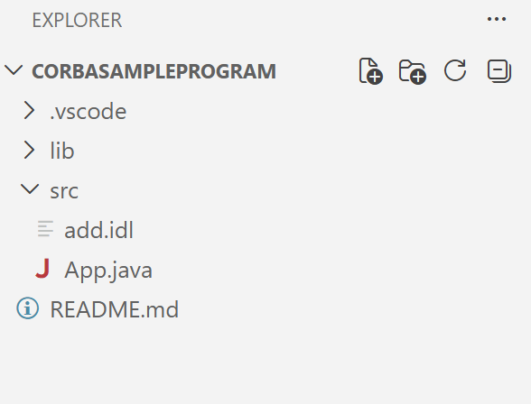
Now add Code inside
module AddModule {
interface Add {
long sum(in long a, in long b);
};
};
Here, Idl file contains
Module (like package)
Interface
Method declarations
- module AddModule → acts like a package
- interface Add → defines remote object
- sum() → remote method
- in → input parameter
Now compile idl file from terminal
Change directory to src where idl file is located
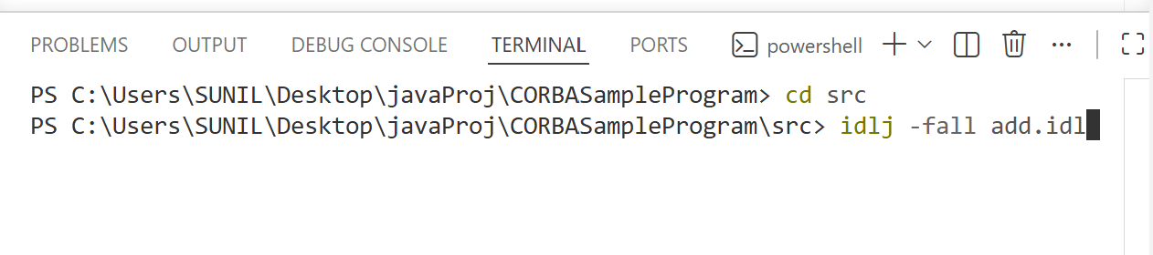
Now hit enter
It will generates folder (AddModule) where these files were created
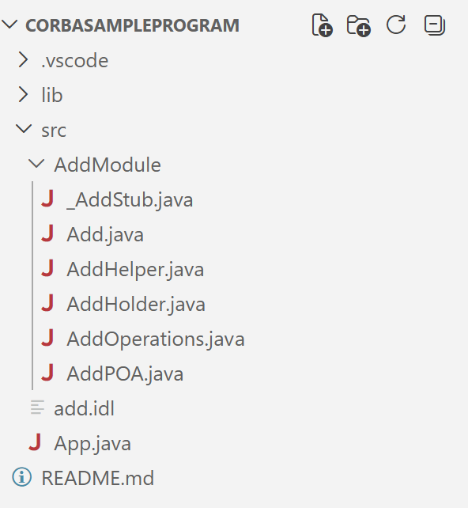
Now, Create AddClient.java and AddServer.java inside src folder
AddServer.java code
import AddModule.*;
import org.omg.CosNaming.*;
import org.omg.CORBA.*;
import org.omg.PortableServer.*;

class AddImpl extends AddPOA {
public int sum(int a, int b) {
return a + b;
}
}

public class AddServer {
public static void main(String args[]) {
try {
ORB orb = ORB.init(args, null);

POA rootpoa = POAHelper.narrow(orb.resolve_initial_references("RootPOA"));
rootpoa.the_POAManager().activate();

AddImpl addImpl = new AddImpl();
org.omg.CORBA.Object ref = rootpoa.servant_to_reference(addImpl);
Add href = AddHelper.narrow(ref);

org.omg.CORBA.Object objRef =
orb.resolve_initial_references("NameService");

NamingContextExt ncRef = NamingContextExtHelper.narrow(objRef);

NameComponent path[] = ncRef.to_name("ADD");
ncRef.rebind(path, href);

System.out.println("Server ready...");

orb.run();
} catch (Exception e) {
System.out.println(e);
}
}
}

AddClient.java code
import AddModule.*;
import org.omg.CosNaming.*;
import org.omg.CORBA.*;

public class AddClient {
public static void main(String args[]) {
try {
ORB orb = ORB.init(args, null);

org.omg.CORBA.Object objRef =
orb.resolve_initial_references("NameService");

NamingContextExt ncRef = NamingContextExtHelper.narrow(objRef);

Add add = AddHelper.narrow(ncRef.resolve_str("ADD"));

int result = add.sum(10, 20);

System.out.println("Result = " + result);
} catch (Exception e) {
System.out.println(e);
}
}

Now, Compile All Files from terminal
javac AddModule/*.java AddServer.java AddClient.java
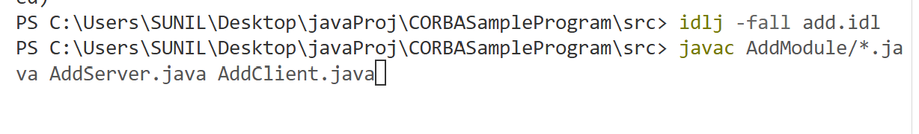
After Compiling it looks like below
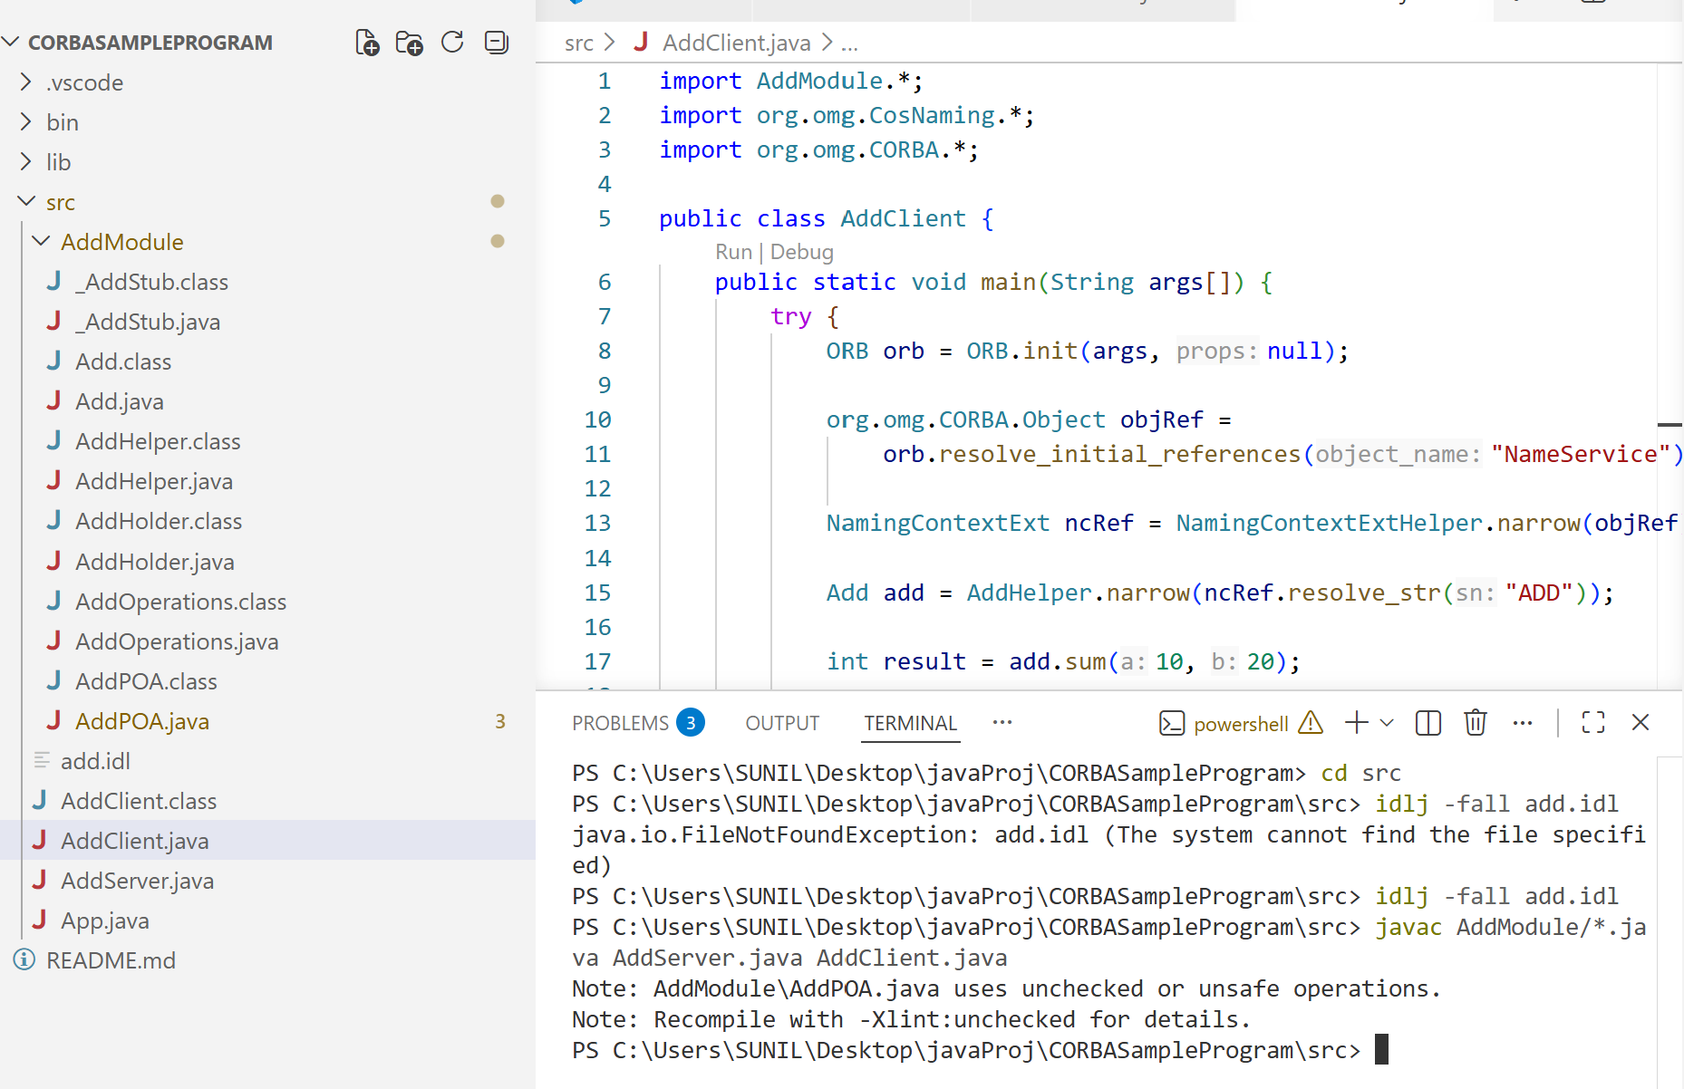

Now, Open new terminal and start naming service
orbd -ORBInitialPort 1050 -ORBInitialHost localhost
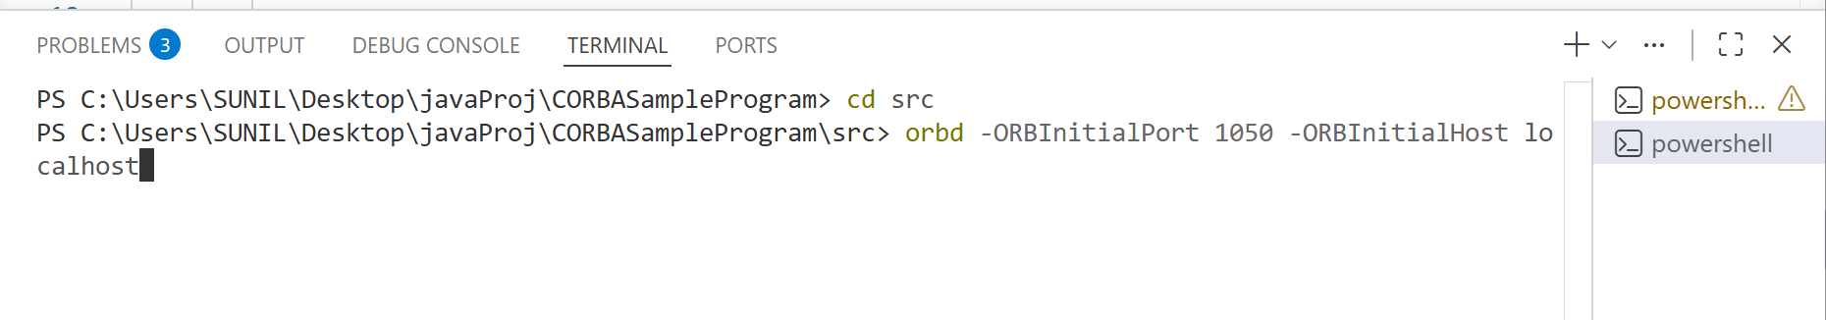
Add new terminal again And run server
java AddServer -ORBInitialPort 1050 -ORBInitialHost localhost
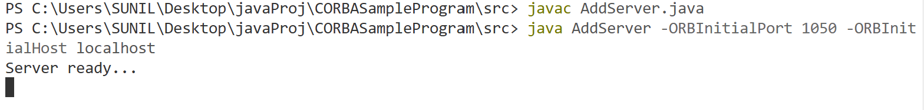
Again add New terminal for AddClient and execute
java AddClient -ORBInitialPort 1050 -ORBInitialHost localhost
