- From the given points find two clusters using K means clustering

(2,10), (2,5), (8,4), (5,8) , (7,4), (6,4)
Source code
import numpy as np
from sklearn.cluster import KMeans
import matplotlib.pyplot as plt
X = np.array([
[2, 10],
[2, 5],
[8, 4],
[5, 8],
[7, 4],
[6, 4]
])
kmeans = KMeans(n_clusters=2, random_state=0)
kmeans.fit(X)
labels = kmeans.labels_
centroids = kmeans.cluster_centers_
print("Cluster Labels:", labels)
print("Centroids:\n", centroids)
plt.scatter(X[:,0], X[:,1], c=labels, cmap='viridis', s=100)
plt.scatter(centroids[:,0], centroids[:,1], c='red', marker='X', s=200)
for i, point in enumerate(X):
plt.text(point[0]+0.1, point[1]+0.1, str(point))
plt.title("K-Means Clustering (k=2)")
plt.xlabel("X-axis")
plt.ylabel("Y-axis")
plt.show()

Output
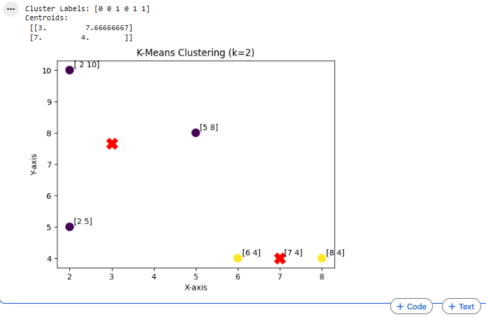

- From the given points, find two clusters using K-means clustering (assume initial centroids are the first two points):

(1,2), (1,4), (3,3), (8,7), (9,8), (8,9)

Source code
import numpy as np
points = np.array([
[1, 2],
[1, 4],
[3, 3],
[8, 7],
[9, 8],
[8, 9]
])
centroids = np.array([
[1, 2],
[1, 4]
], dtype=float)
k = 2
def euclidean_distance(a, b):
return np.sqrt(np.sum((a - b) ** 2))
for iteration in range(10): # max iterations
clusters = [[] for _ in range(k)]
for point in points:
distances = [euclidean_distance(point, c) for c in centroids]
cluster_index = np.argmin(distances)
clusters[cluster_index].append(point)
clusters = [np.array(cluster) for cluster in clusters]
new_centroids = np.array([cluster.mean(axis=0) for cluster in clusters])
print(f"\nIteration {iteration + 1}")
print("Clusters:")
for i, cluster in enumerate(clusters):
print(f"Cluster {i+1}: {cluster}")
print("Centroids:", new_centroids)
if np.allclose(centroids, new_centroids):
break
centroids = new_centroids
print("\nFinal Clusters:")
for i, cluster in enumerate(clusters):
print(f"Cluster {i+1}: {cluster}")

print("\nFinal Centroids:")
print(centroids)

Output

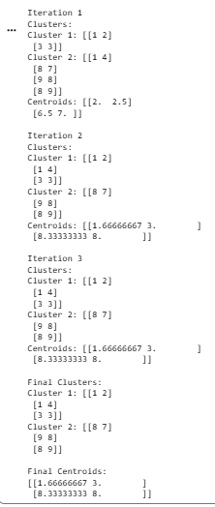

- From the given data points find three cluster using k means++ algorithm

(7,4) , (8,3), (5,9), (3,3), (1,3), (10,1)

Source code
import numpy as np
from sklearn.cluster import KMeans
import matplotlib.pyplot as plt
X = np.array([
[7, 4],
[8, 3],
[5, 9],
[3, 3],
[1, 3],
[10, 1]
])
kmeans = KMeans(n_clusters=3, init='k-means++', random_state=0)
kmeans.fit(X)
labels = kmeans.labels_
centroids = kmeans.cluster_centers_
print("Cluster Labels:", labels)
print("Centroids:\n", centroids)
for i in range(3):
print(f"\nCluster {i+1}:")
for j in range(len(X)):
if labels[j] == i:
print(X[j])
plt.scatter(X[:,0], X[:,1], c=labels, s=100)
plt.scatter(centroids[:,0], centroids[:,1], marker='X', s=200)

for i, point in enumerate(X):
plt.text(point[0]+0.1, point[1]+0.1, str(point))

plt.title("K-Means++ Clustering (k=3)")
plt.xlabel("X-axis")
plt.ylabel("Y-axis")
plt.show()

Output
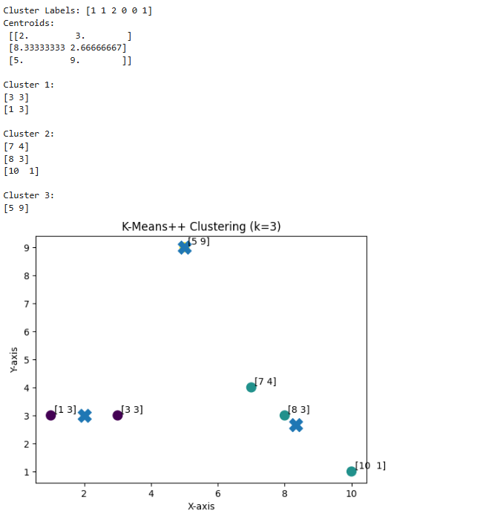

- From the given data points, find three clusters using K-means++ algorithm:

(1,8), (2,9), (3,7), (6,2), (7,3), (8,1)

Source code
import numpy as np
from sklearn.cluster import KMeans
import matplotlib.pyplot as plt
X = np.array([
[1, 8],
[2, 9],
[3, 7],
[6, 2],
[7, 3],
[8, 1]
])
kmeans = KMeans(n_clusters=3, init='k-means++', random_state=0)
kmeans.fit(X)
labels = kmeans.labels_
centroids = kmeans.cluster_centers_
for i in range(3):
print(f"\nCluster {i+1}:")
for j in range(len(X)):
if labels[j] == i:
print(X[j])
print("\nCentroids:")
print(centroids)
plt.scatter(X[:,0], X[:,1], c=labels, s=100)
plt.scatter(centroids[:,0], centroids[:,1], marker='X', s=200)
for point in X:
plt.text(point[0]+0.1, point[1]+0.1, str(tuple(point)))
plt.title("K-Means++ Clustering (k=3)")
plt.xlabel("X-axis")
plt.ylabel("Y-axis")
plt.show()

Output

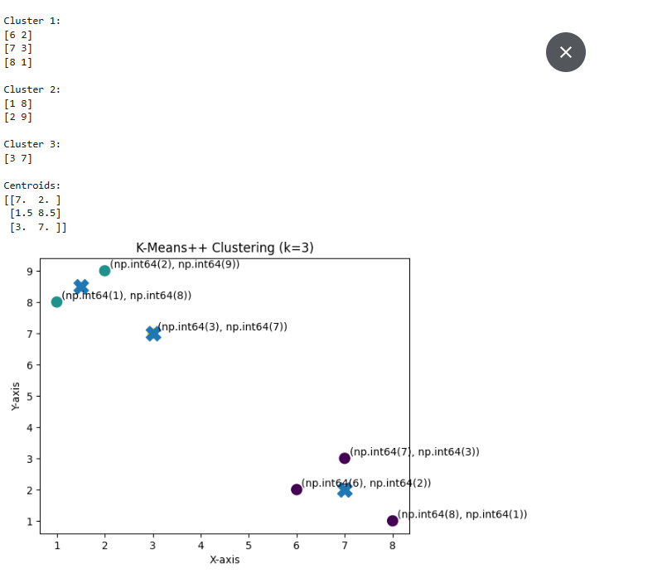

5. a. Find frequent item-sets and association rules from the transaction database given below using FP-growth algorithm. Assume minimum support is 50% and minimum confidence is 60%.
Consider the following data set
Transaction_ID | Items purchased
1 | Sausage, peanut, Beer
2 | peanut, Beer, Apple
3 | Apple, Milk
4 | Sausage, peanut, Apple
5 | Sausage, peanut, Beer, Milk
6 | Sausage, peanut, Beer, Apple

Source code
# pip install mlxtend pandas
import pandas as pd
from mlxtend.preprocessing import TransactionEncoder
from mlxtend.frequent_patterns import fpgrowth, association_rules
# Step 1: Define dataset
transactions = [
['Sausage', 'peanut', 'Beer'],
['peanut', 'Beer', 'Apple'],
['Apple', 'Milk'],
['Sausage', 'peanut', 'Apple'],
['Sausage', 'peanut', 'Beer', 'Milk'],
['Sausage', 'peanut', 'Beer', 'Apple']
]
# Step 2: Convert into one-hot encoded dataframe
te = TransactionEncoder()
te_array = te.fit(transactions).transform(transactions)
df = pd.DataFrame(te_array, columns=te.columns_)
# Step 3: Apply FP-Growth (min support = 50% = 0.5)
frequent_itemsets = fpgrowth(df, min_support=0.5, use_colnames=True)
print("Frequent Itemsets:")
print(frequent_itemsets)
# Step 4: Generate Association Rules (min confidence = 60% = 0.6)
rules = association_rules(frequent_itemsets, metric="confidence", min_threshold=0.6)
print("\nAssociation Rules:")
print(rules[['antecedents', 'consequents', 'support', 'confidence', 'lift']])

Output
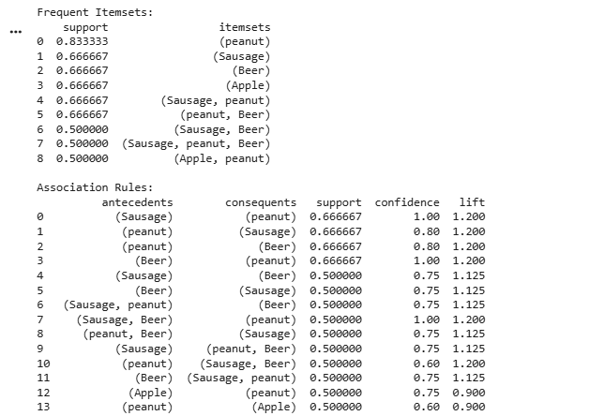
5. b. Find out whether the object with attribute Confident = Yes, Sick = No will Fail or Pass using Bayesian classification.
Consider the following data set
Confident | Studied | Sick | Result
Yes | No | No | Fail
Yes | No | No | Pass
No | Yes | Yes | Fail
No | Yes | Yes | Pass
Yes | Yes | Yes | Pass

Source code
import warnings
warnings.filterwarnings("ignore")
# Dataset
data = [
{'Confident': 'Yes', 'Studied': 'No', 'Sick': 'No', 'Result': 'Fail'},
{'Confident': 'Yes', 'Studied': 'No', 'Sick': 'No', 'Result': 'Pass'},
{'Confident': 'No', 'Studied': 'Yes', 'Sick': 'Yes', 'Result': 'Fail'},
{'Confident': 'No', 'Studied': 'Yes', 'Sick': 'Yes', 'Result': 'Pass'},
{'Confident': 'Yes', 'Studied': 'Yes', 'Sick': 'Yes', 'Result': 'Pass'}
]
test = {'Confident': 'Yes', 'Sick': 'No'}
# Step 1: Count total classes
total = len(data)
classes = ['Pass', 'Fail']
# Step 2: Calculate prior probabilities
priors = {}
for c in classes:
priors[c] = sum(1 for d in data if d['Result'] == c) / total
# Step 3: Likelihood calculation function
def likelihood(feature, value, given_class):
class_data = [d for d in data if d['Result'] == given_class]
count = sum(1 for d in class_data if d[feature] == value)
return count / len(class_data)
# Step 4: Compute posterior probabilities
posteriors = {}
for c in classes:
prob = priors[c]
for feature, value in test.items():
prob *= likelihood(feature, value, c)
posteriors[c] = prob
# Step 5: Prediction
prediction = max(posteriors, key=posteriors.get)
print("Posteriors:", posteriors)
print("Prediction:", prediction)

Output

6. a. Perform agglomerative hierarachial clustering for following points

(0.4, 0.53), (0.22, 0.38), (0.35, 0.32), (0.26, 0.19), (0.08, 0.41), (0.45, 0.3)

Source code
import numpy as np
import pandas as pd
import matplotlib.pyplot as plt

from scipy.cluster.hierarchy import dendrogram, linkage
from scipy.spatial.distance import cdist
from sklearn.cluster import AgglomerativeClustering

# Step 1: Define points
points = np.array([
[0.4, 0.53],
[0.22, 0.38],
[0.35, 0.32],
[0.26, 0.19],
[0.08, 0.41],
[0.45, 0.30]
])

labels = ['A', 'B', 'C', 'D', 'E', 'F']

# Step 2: Distance Matrix
dist_matrix = cdist(points, points)
df = pd.DataFrame(np.round(dist_matrix, 3), index=labels, columns=labels)

print("Distance Matrix:\n")
print(df)

# Step 3: Hierarchical Clustering (Single Linkage)
Z = linkage(points, method='single')

print("\nLinkage Matrix:\n", Z)

# Step 4: Dendrogram
plt.figure()
dendrogram(Z, labels=labels)
plt.title("Agglomerative Hierarchical Clustering (Single Linkage)")
plt.xlabel("Points")
plt.ylabel("Distance")
plt.show()

# Step 5: Final Clusters (k=2)
model = AgglomerativeClustering(n_clusters=2, linkage='single')
clusters = model.fit_predict(points)

print("\nCluster Assignment:")
for i in range(2):
cluster_points = [labels[j] for j in range(len(labels)) if clusters[j] == i]
print(f"Cluster {i+1}: {cluster_points}")

Output

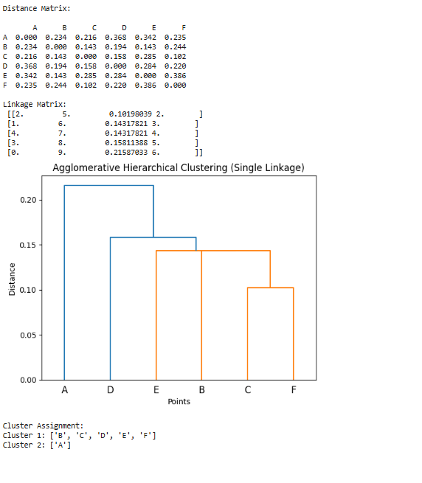

6. b. Perform agglomerative hierarchical clustering for following points.

(0.4, 0.5), (0.45, 0.55), (0.5, 0.52), (0.42, 0.48), (0.38, 0.51), (0.47, 0.49)

Source code
import numpy as np
import pandas as pd
import matplotlib.pyplot as plt

from scipy.cluster.hierarchy import dendrogram, linkage
from scipy.spatial.distance import cdist
from sklearn.cluster import AgglomerativeClustering
# Step 1: Define points
points = np.array([
[0.4, 0.5],
[0.45, 0.55],
[0.5, 0.52],
[0.42, 0.48],
[0.38, 0.51],
[0.47, 0.49]
])
labels = ['A', 'B', 'C', 'D', 'E', 'F']
# Step 2: Distance Matrix
dist_matrix = cdist(points, points)
df = pd.DataFrame(np.round(dist_matrix, 3), index=labels, columns=labels)
print("Distance Matrix:\n")
print(df)
# Step 3: Hierarchical Clustering (Single Linkage)
Z = linkage(points, method='single')
print("\nLinkage Matrix:\n", Z)
# Step 4: Dendrogram
plt.figure()
dendrogram(Z, labels=labels)
plt.title("Agglomerative Hierarchical Clustering (ward Linkage)")
plt.xlabel("Points")
plt.ylabel("Distance")
plt.show()
# Step 5: Final Clusters (k=2)
model = AgglomerativeClustering(n_clusters=2, linkage='ward')
clusters = model.fit_predict(points)
print("\nCluster Assignment:")
for i in range(2):
cluster_points = [labels[j] for j in range(len(labels)) if clusters[j] == i]
print(f"Cluster {i+1}: {cluster_points}")

Output

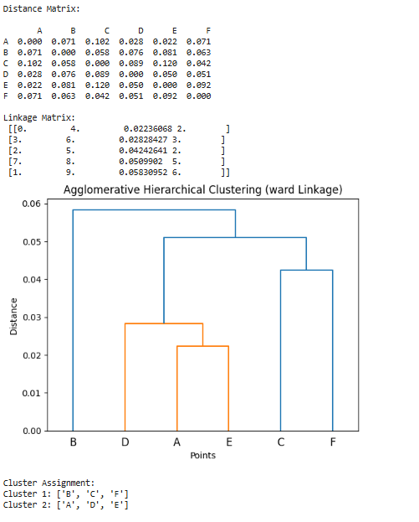

6. c. Perform agglomerative hierarchical clustering for following points

(2.5, 0.8), (2.7, 0.9), (2.6, 0.75), (2.8, 0.85), (2.55, 0.7), (2.65, 0.95)

Source code
import numpy as np
import pandas as pd
import matplotlib.pyplot as plt

from scipy.cluster.hierarchy import dendrogram, linkage
from scipy.spatial.distance import cdist
from sklearn.cluster import AgglomerativeClustering
# Step 1: Define points
points = np.array([
[2.5, 0.8],
[2.7, 0.9],
[2.6, 0.75],
[2.8, 0.85],
[2.55, 0.7],
[2.65, 0.95]
])
labels = ['A', 'B', 'C', 'D', 'E', 'F']
# Step 2: Distance Matrix
dist_matrix = cdist(points, points)
df = pd.DataFrame(np.round(dist_matrix, 3), index=labels, columns=labels)
print("Distance Matrix:\n")
print(df)
# Step 3: Hierarchical Clustering (Single Linkage)
Z = linkage(points, method='single')
print("\nLinkage Matrix:\n", Z)
# Step 4: Dendrogram
plt.figure()
dendrogram(Z, labels=labels)
plt.title("Agglomerative Hierarchical Clustering (ward Linkage)")
plt.xlabel("Points")
plt.ylabel("Distance")
plt.show()
# Step 5: Final Clusters (k=2)
model = AgglomerativeClustering(n_clusters=2, linkage='ward')
clusters = model.fit_predict(points)
print("\nCluster Assignment:")
for i in range(2):
cluster_points = [labels[j] for j in range(len(labels)) if clusters[j] == i]
print(f"Cluster {i+1}: {cluster_points}")

Output

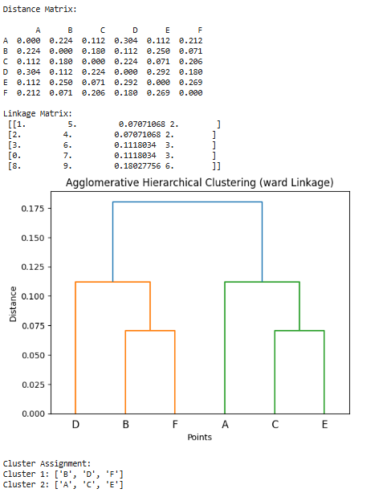

7. a. Cluster the following data points using DBSCAN algorithm assuming eps =2 and minpts =2:

(2 ,10), (2,5), (8,4) ,(5,8), (7,5), (6,4), (1,2) , (4,9)

Source code
import numpy as np
points = np.array([
(2, 10), (2, 5), (8, 4), (5, 8),
(7, 5), (6, 4), (1, 2), (4, 9)
])
eps = 2
minPts = 2
def distance(p1, p2):
return np.linalg.norm(p1 - p2)
def get_neighbors(point_idx):
neighbors = []
for i in range(len(points)):
if distance(points[point_idx], points[i]) <= eps:
neighbors.append(i)
return neighbors
def dbscan():
labels = [0] * len(points) # 0 = unvisited
cluster_id = 0
for i in range(len(points)):
if labels[i] != 0:
continue
neighbors = get_neighbors(i)
if len(neighbors) < minPts:
labels[i] = -1 # noise
else:
cluster_id += 1
labels[i] = cluster_id

j = 0
while j < len(neighbors):
n = neighbors[j]

if labels[n] == -1:
labels[n] = cluster_id

if labels[n] == 0:
labels[n] = cluster_id
new_neighbors = get_neighbors(n)

if len(new_neighbors) >= minPts:
neighbors += new_neighbors
j += 1
return labels
labels = dbscan()
for i, point in enumerate(points):
print(f"Point {tuple(point)} -> Cluster {labels[i]}")

Output

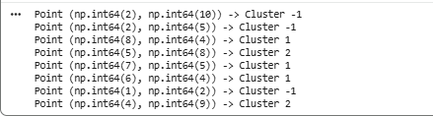

7. b. Cluster the following data points using DBSCAN algorithm assuming eps = 2 and minPts = 2:

(1,3), (2,4), (2,2), (6,7), (7,8), (8,7), (5,5), (9,1)

Source code
import numpy as np
points = np.array([
(1, 3), (2, 4), (2, 2),
(6, 7), (7, 8), (8, 7),
(5, 5), (9, 1)
])
eps = 2
minPts = 2
def distance(p1, p2):
return np.linalg.norm(p1 - p2)
def get_neighbors(point_idx):
neighbors = []
for i in range(len(points)):
if distance(points[point_idx], points[i]) <= eps:
neighbors.append(i)
return neighbors
def dbscan():
labels = [0] * len(points) # 0 = unvisited
cluster_id = 0
for i in range(len(points)):
if labels[i] != 0:
continue
neighbors = get_neighbors(i)

if len(neighbors) < minPts:
labels[i] = -1 # noise
else:
cluster_id += 1
labels[i] = cluster_id
j = 0
while j < len(neighbors):
n = neighbors[j]
if labels[n] == -1:
labels[n] = cluster_id
if labels[n] == 0:
labels[n] = cluster_id
new_neighbors = get_neighbors(n)

if len(new_neighbors) >= minPts:
neighbors += new_neighbors
j += 1
return labels
labels = dbscan()
for i, point in enumerate(points):
print(f"Point {tuple(point)} -> Cluster {labels[i]}")

Output

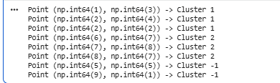

8. Perform k medoids clustering for following

(2,3), (5,7), (8,3), (3,5), (7,2),(6,8) , (1,4), (4,6), (9,5), (5,4)

Source code
import numpy as np
import random
points = np.array([
(2, 3), (5, 7), (8, 3), (3, 5), (7, 2),
(6, 8), (1, 4), (4, 6), (9, 5), (5, 4)
])
k = 2
def distance(p1, p2):
return np.linalg.norm(p1 - p2)
def assign_clusters(medoids):
clusters = {i: [] for i in range(len(medoids))}
for idx, point in enumerate(points):
distances = [distance(point, m) for m in medoids]
cluster_id = np.argmin(distances)
clusters[cluster_id].append(idx)
return clusters
def update_medoids(clusters):
new_medoids = []
for cluster in clusters.values():
min_cost = float('inf')
medoid = None
for i in cluster:
cost = sum(distance(points[i], points[j]) for j in cluster)
if cost < min_cost:
min_cost = cost
medoid = points[i]

new_medoids.append(medoid)
return np.array(new_medoids)
def k_medoids():
medoids = points[random.sample(range(len(points)), k)]
while True:
clusters = assign_clusters(medoids)
new_medoids = update_medoids(clusters)
if np.array_equal(medoids, new_medoids):
break
medoids = new_medoids
return medoids, clusters
medoids, clusters = k_medoids()
print("Final Medoids:", medoids)
for cluster_id, indices in clusters.items():
print(f"\nCluster {cluster_id + 1}:")
for i in indices:
print(points[i])

Output

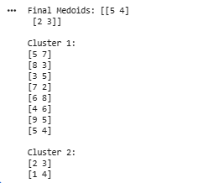

9. Perform K-medoids clustering (assume k=2) for the following data points

(1,2), (2,3), (3,1), (6,7), (7,6), (8,8), (2,1), (7,7), (6,6), (3,2)

Source code
import numpy as np
import random
points = np.array([
(1, 2), (2, 3), (3, 1),
(6, 7), (7, 6), (8, 8),
(2, 1), (7, 7), (6, 6), (3, 2)
])
k = 2
def distance(p1, p2):
return np.linalg.norm(p1 - p2)
def assign_clusters(medoids):
clusters = {i: [] for i in range(len(medoids))}

for idx, point in enumerate(points):
distances = [distance(point, m) for m in medoids]
cluster_id = np.argmin(distances)
clusters[cluster_id].append(idx)
return clusters
def update_medoids(clusters):
new_medoids = []

for cluster in clusters.values():
min_cost = float('inf')
medoid = None
for i in cluster:
cost = sum(distance(points[i], points[j]) for j in cluster)
if cost < min_cost:
min_cost = cost
medoid = points[i]
new_medoids.append(medoid)
return np.array(new_medoids)
def k_medoids():
# Random initial medoids
medoids = points[random.sample(range(len(points)), k)]
while True:
clusters = assign_clusters(medoids)
new_medoids = update_medoids(clusters)
if np.array_equal(medoids, new_medoids):
break
medoids = new_medoids
return medoids, clusters
medoids, clusters = k_medoids()
print("Final Medoids:", medoids)
for cluster_id, indices in clusters.items():
print(f"\nCluster {cluster_id + 1}:")
for i in indices:
print(points[i])

Output

