FAA provides high-quality data for researchers to analyze flight delays in all airports nation wide
https://aspm.faa.gov/tfms/sys/Airport.aspLinks to an external site.
To fetch delay information, you need to go to https://aspm.faa.gov/tfms/sys/Airport.asp
1) Select the date you want to query:
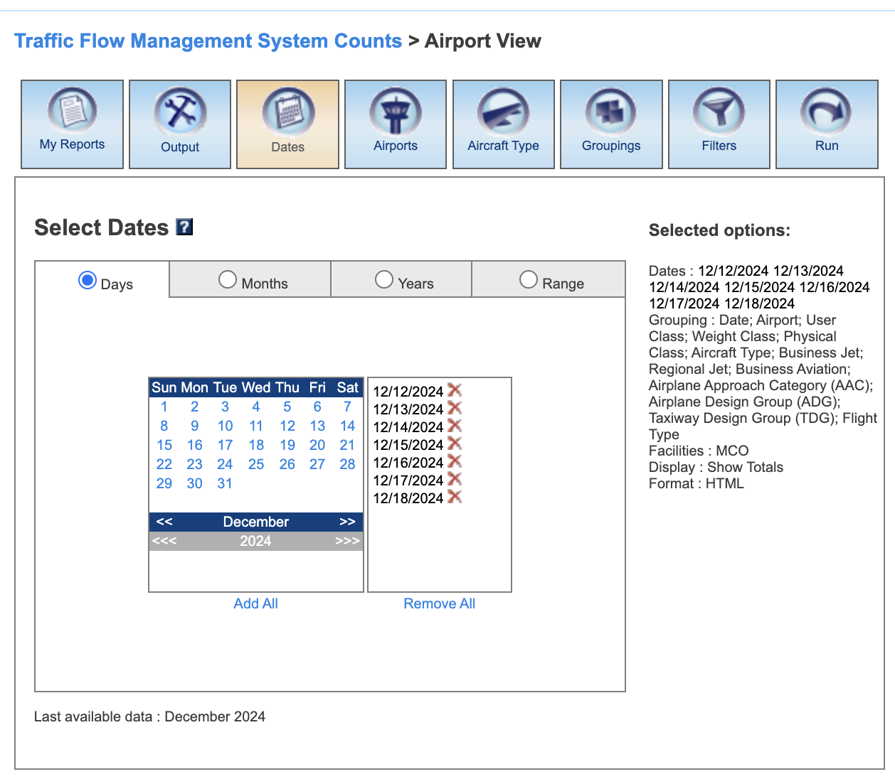

2) Type in the interested airport(s) ICAO ID(s)

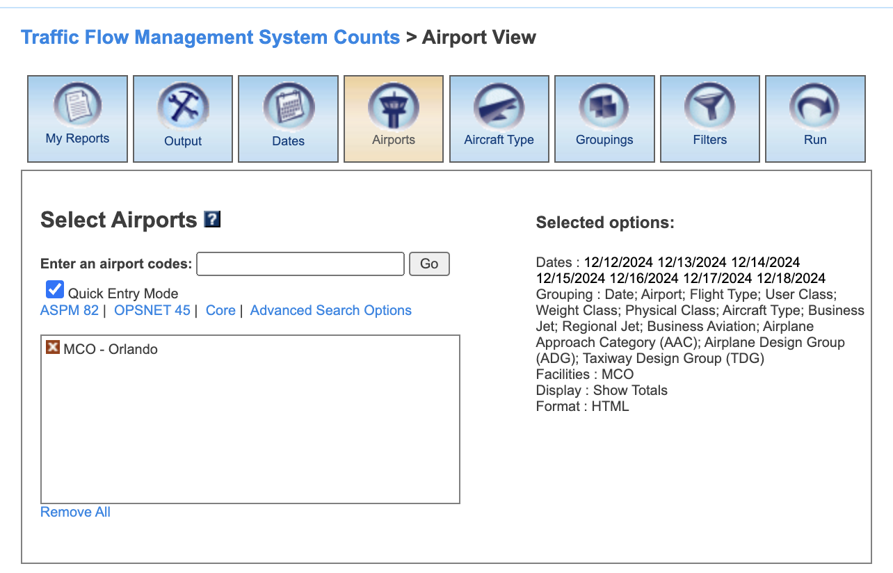

3) Select which field you want to aggregate (I select as many fields as possible so that I can fetch data fine granularity ):
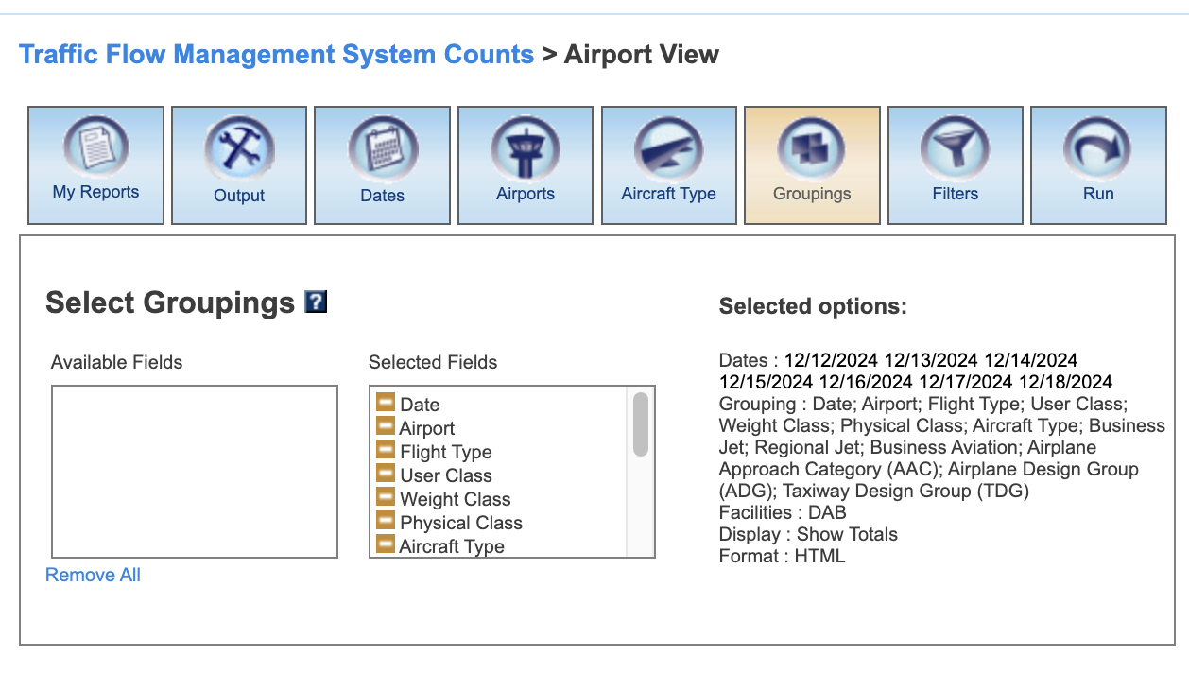
4) Click the Run icon on the top right corner. You should see a web page like below.
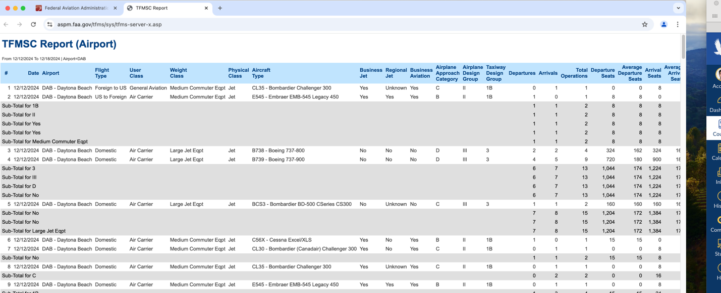
Questions (Screenshots and text illustrations are needed to prove your conclusion, please assemble your answers in one colab notebook)
(a) In the newly opened page in step 4, what will happen if you refresh the page? What HTTP request (GET/POST) is sent to the FAA server? Can you prove that? Hint: You may need to open the web browser's Developer Tools and then click the Refresh button.
Refreshing the page sends the POST request as shown in the header section in the Network Tab (in browser’s Developer Tool).
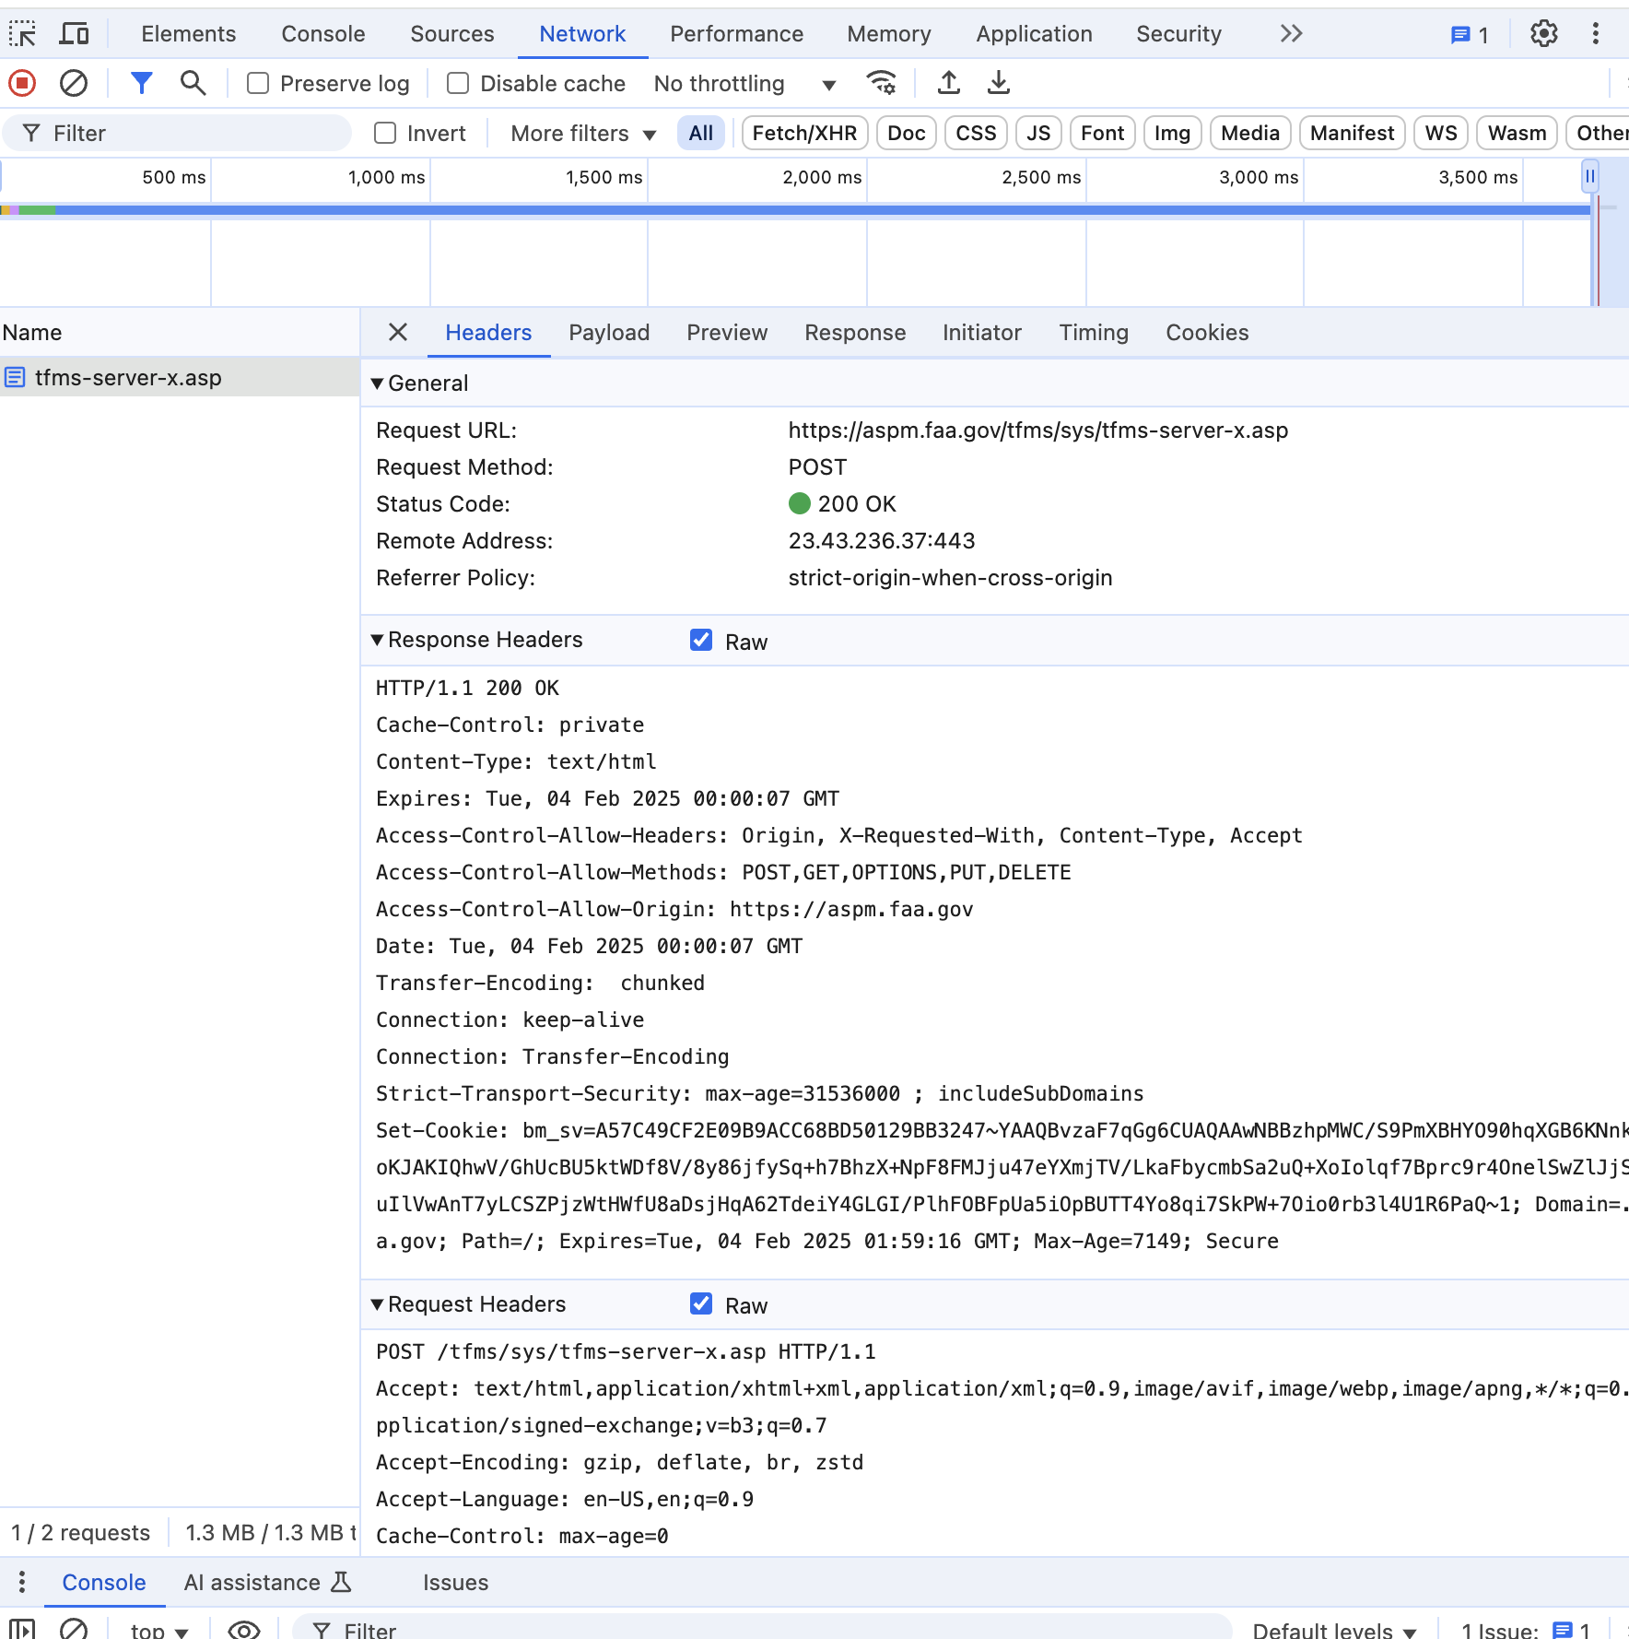

(b) Please analyze the request send by your browser in step 4, can you generate a similar request using the request library and obtain a similar response?
- Yes, we can generate a similar request using Python’s request library. For that we need to examine the HTTP request sent by the browser. Examining the Browser’s Developer Tools > "Network" tab, we can generate the request that was sent when we clicked "Run" button in the webpage. Next, we need to examine different parts of Headers ( General, Response Headers, Request Headers) for information like
  - Request URL
  - Request Method (i.e. POST)
  - Request Headers ( e.g. User-agent, content-type, cookies, etc.)
  - Payload for the request

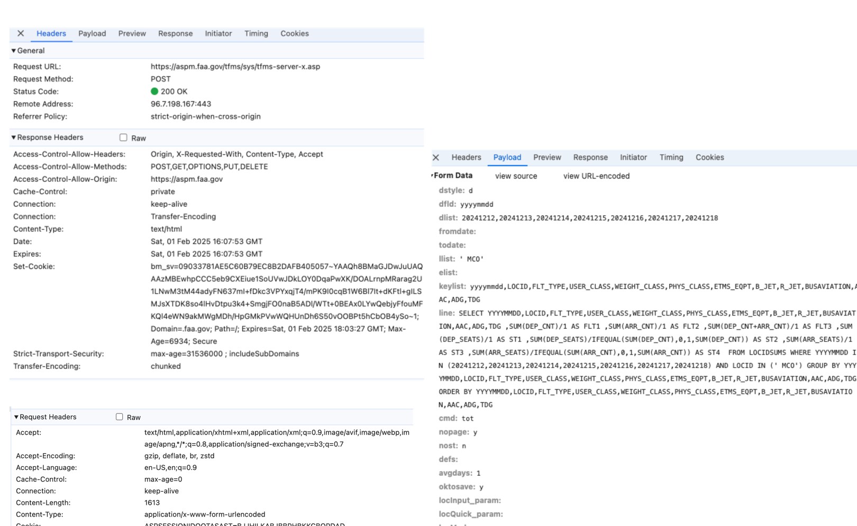

(c) Write an automated program to fetch flight delay report for one week around an airport you select.

