https://gitpod.io#snapshot/e107415b-9ed2-4ed9-9c57-1893d6d3d4f6
https://gitpod.io/new#https://github.com/gitpod-io/empty
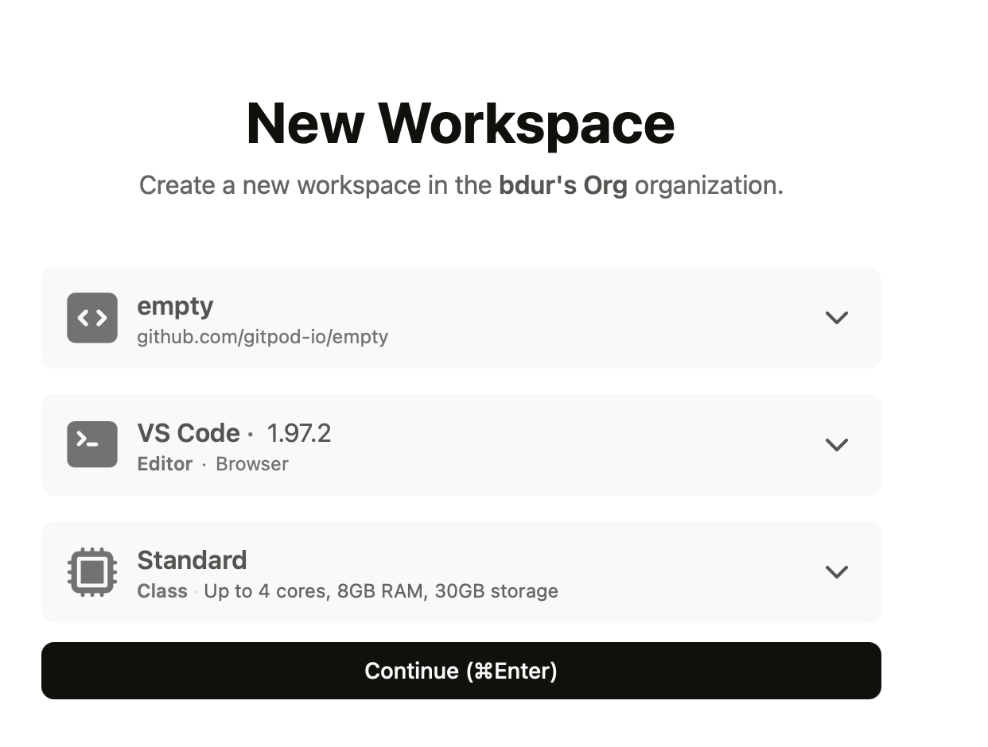
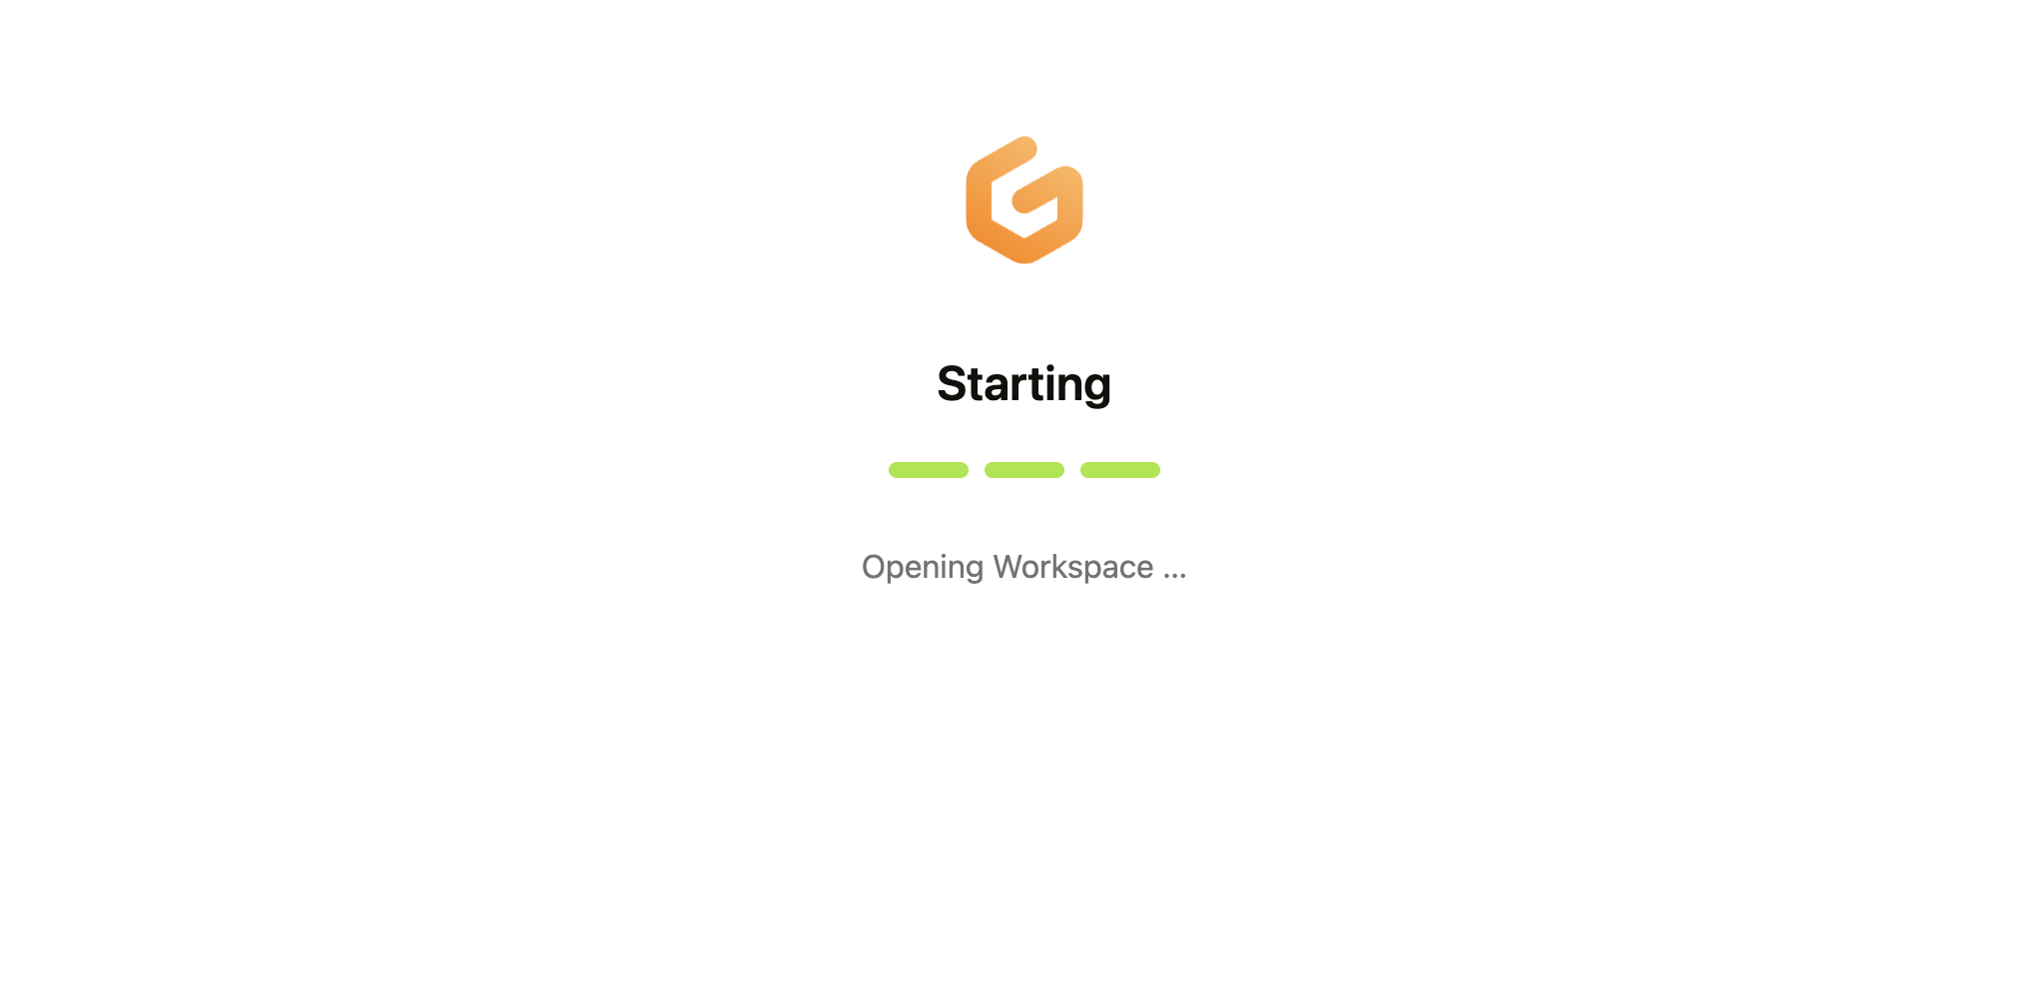

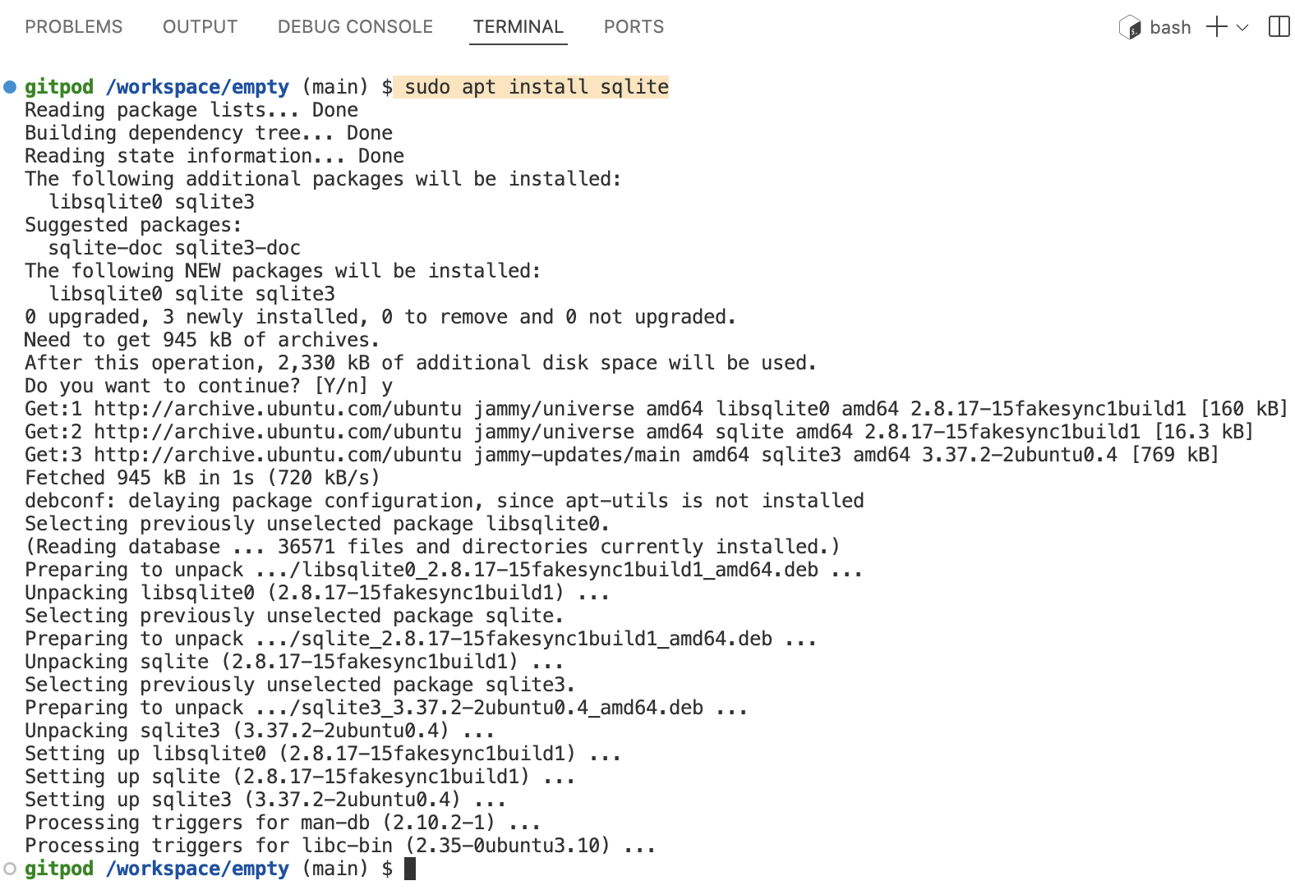

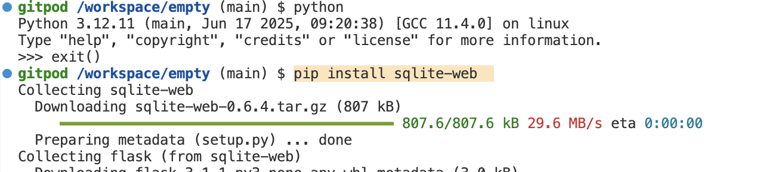

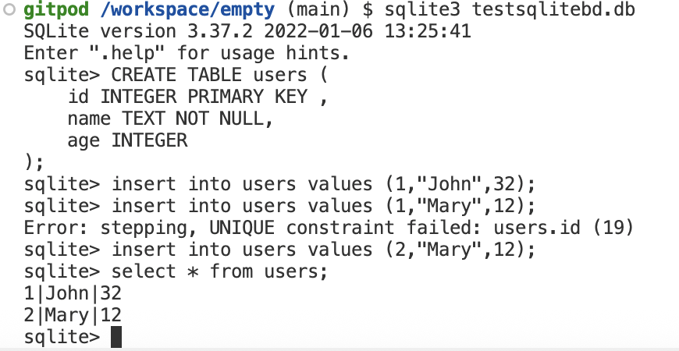
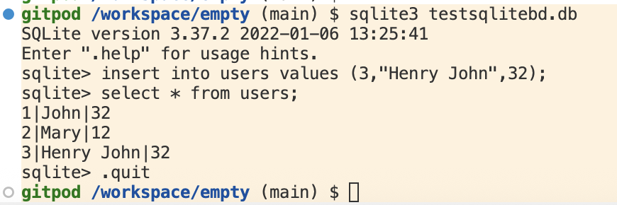

Lanuch sqlite-web with the 'testsqlite.db'.
IN the command terminal execute the following command:
python3 -m sqlite_web testsqlite.db --host=0.0.0.0 --port=8080
The symbol hyphen (-) is replace by underscore (_) in sqlite_web.
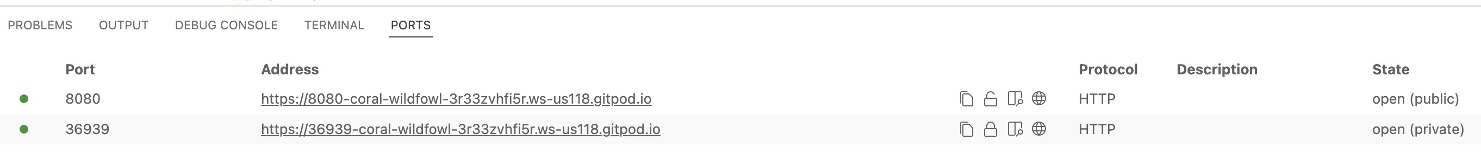
The status is made public, so the Web portal is accessible publicly.
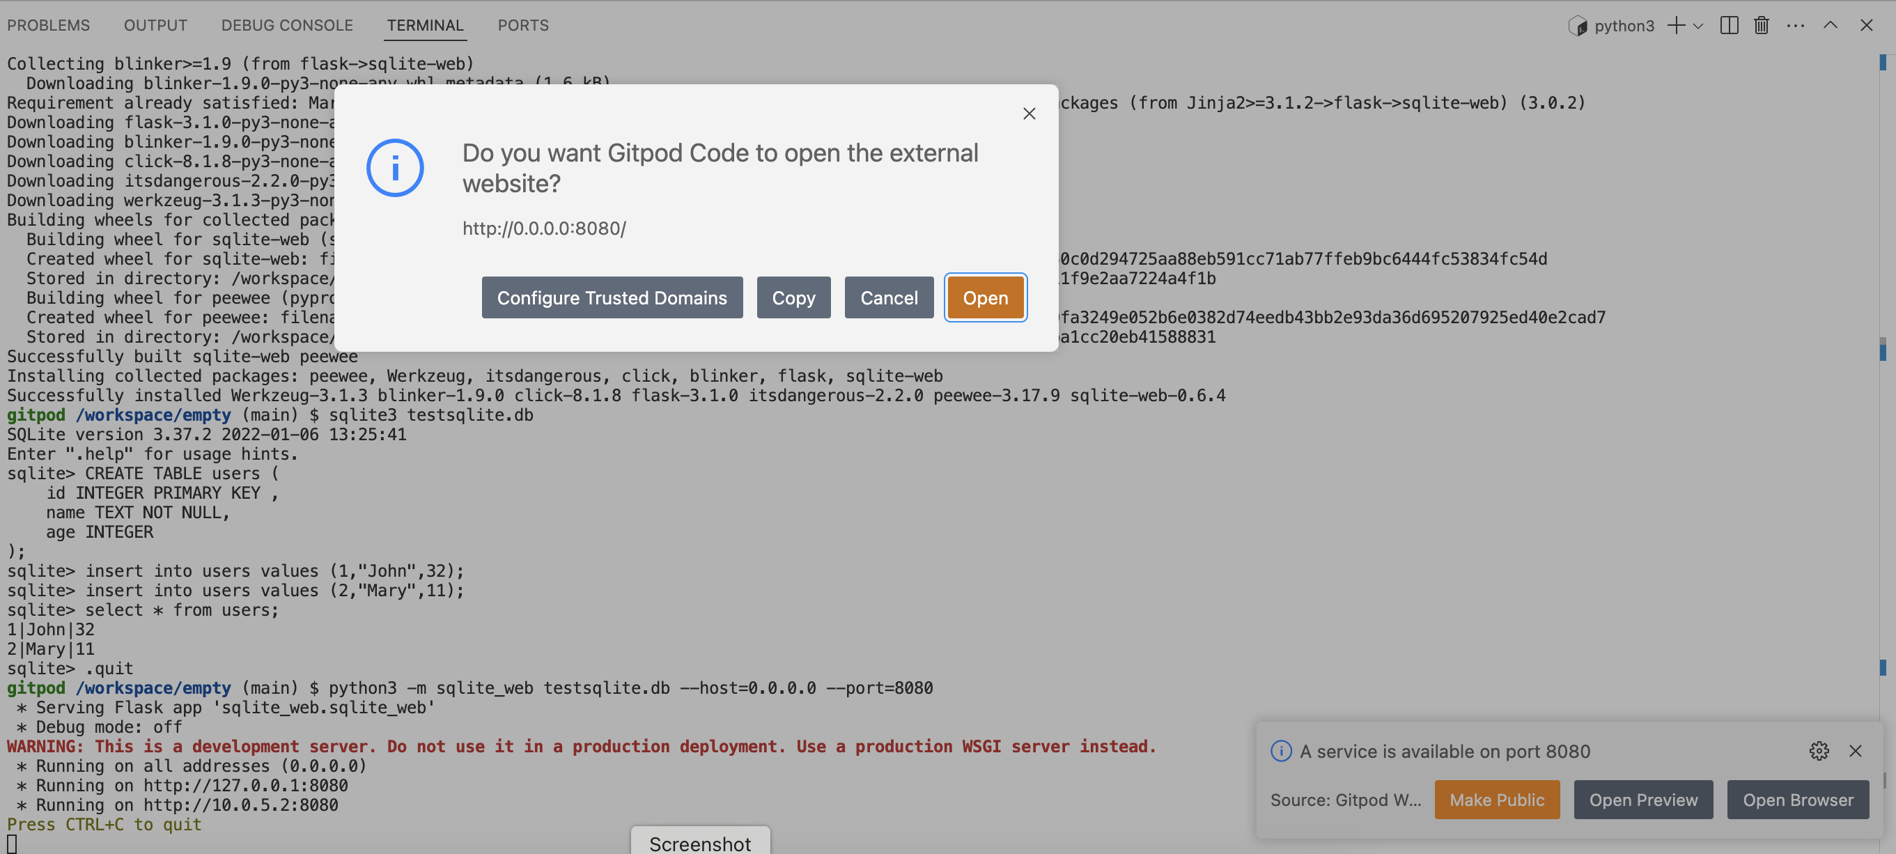

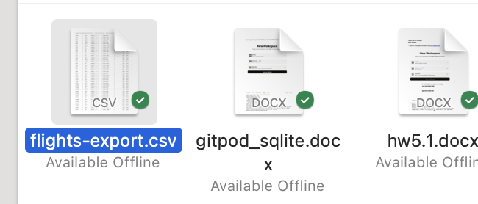
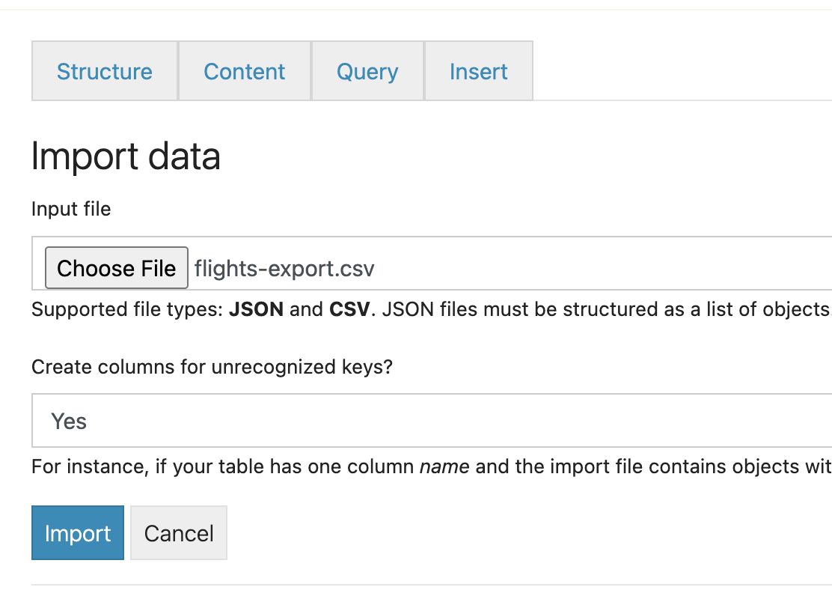

1. Show some data (limit 10 rows):


2. Calculate the total and average number of passengers per year:

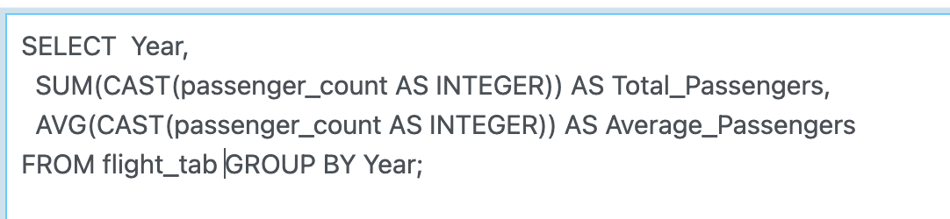

3. Total and average passengers per year, where Net Income > 100:

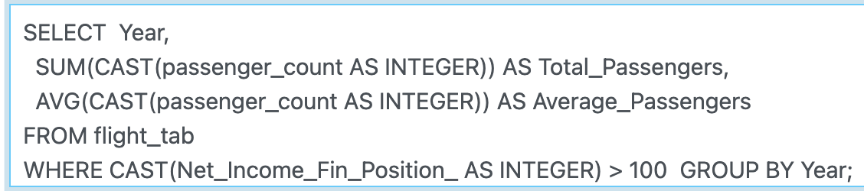

4. Total and average passengers per year from 2010 to 2015:

