Install SQLITE in Gitpod
Bidur Devkota

1. Open an empty gitpod workspace using http://gitpod.new/
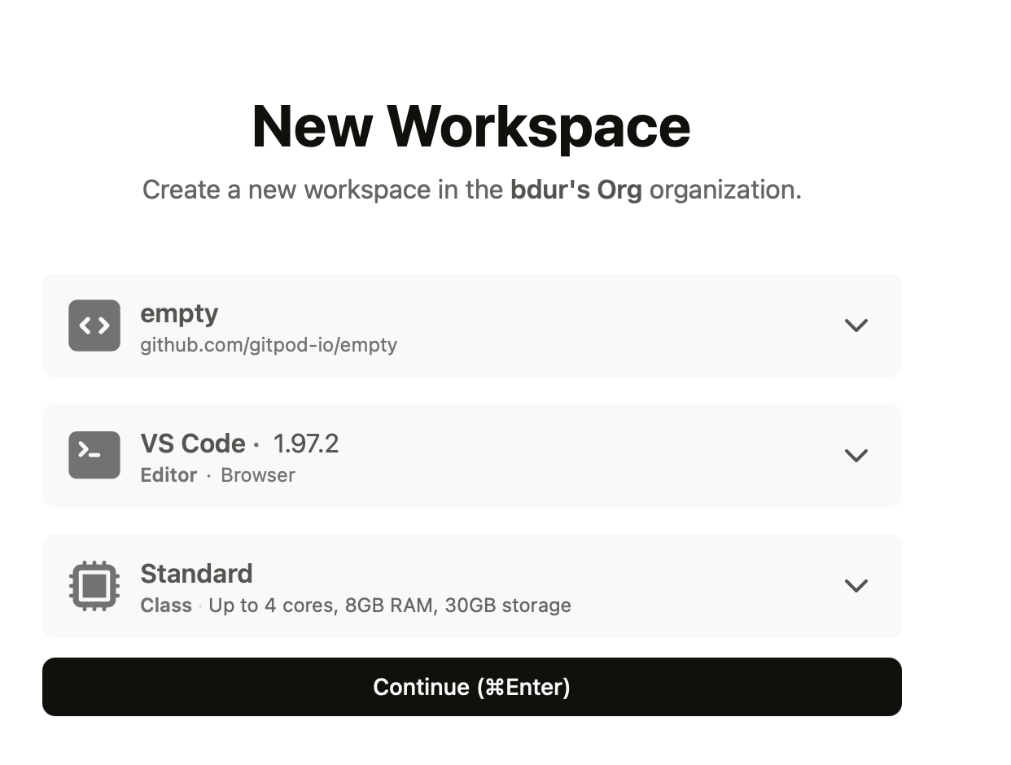


2. Install sqlite and sqlite web using
sudo apt install sqlite
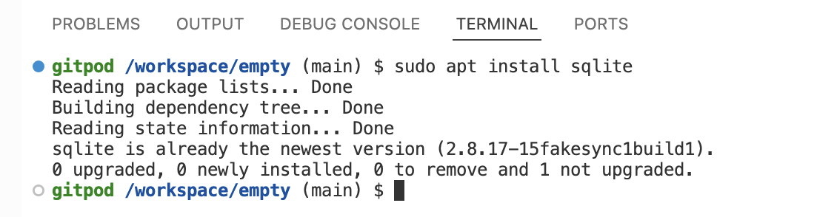
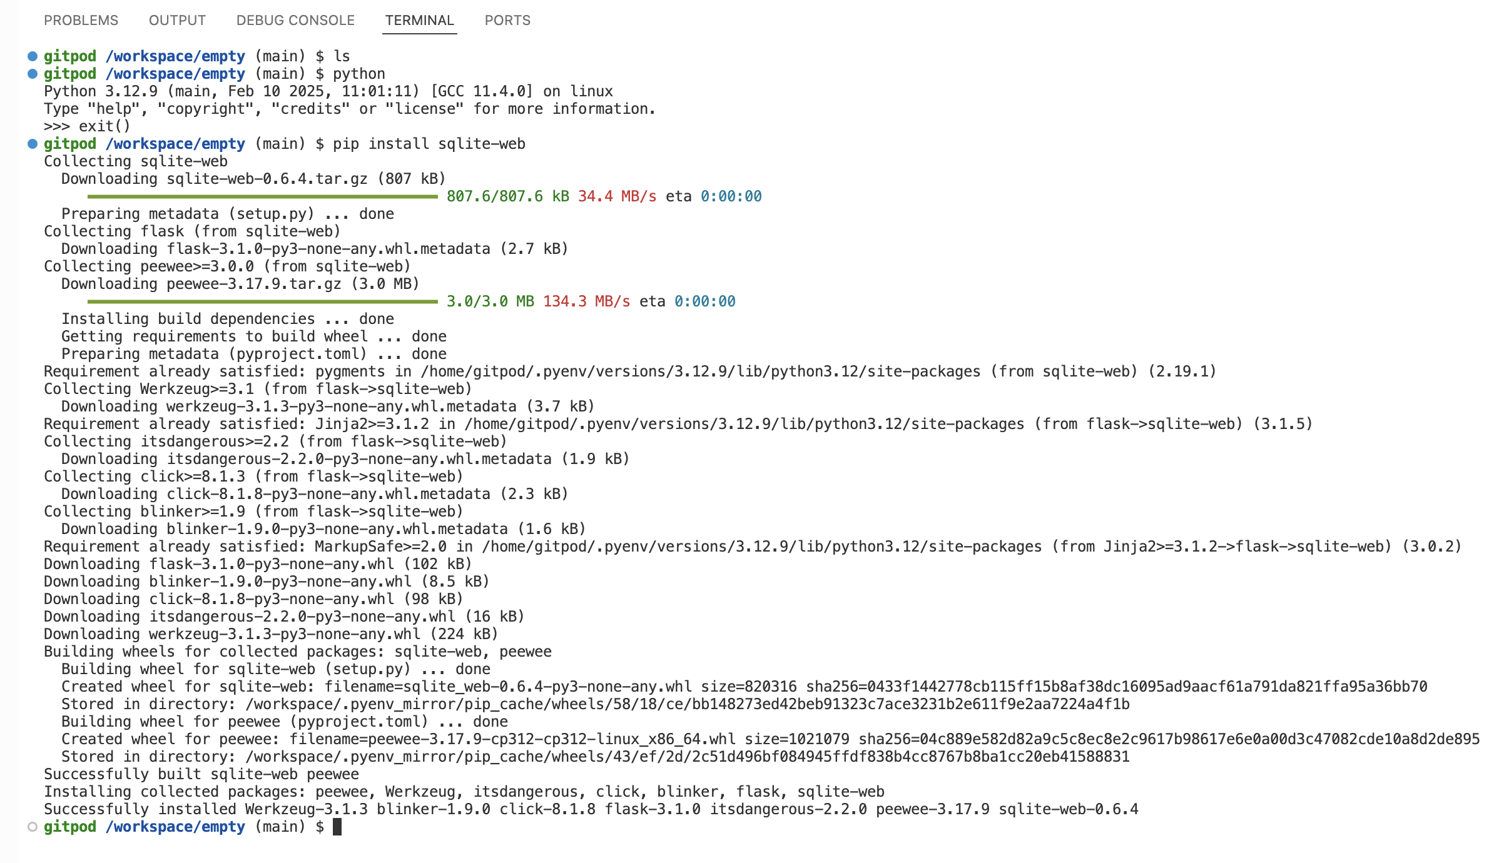
pip install sqlite-web

3. Use command prompt of sqlite to create your first database with filename 'testsqlite.db'.
sqlite3 testsqlitebd.db
CREATE TABLE users (
id INTEGER PRIMARY KEY ,
name TEXT NOT NULL,
age INTEGER
);
insert into users values (1,"John",32);
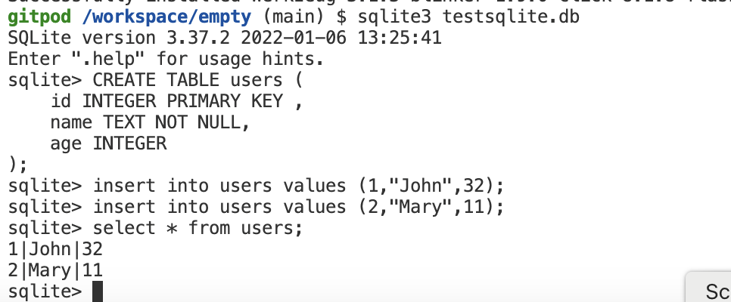

5. Lanuch sqlite-web with the 'testsqlite.db'. And show that you are able to visit the sqlite-web portal from your mobile phone.
IN the command terminal execute the following command:
python3 -m sqlite_web testsqlite.db --host=0.0.0.0 --port=8080
The symbol hyphen (-) is replace by underscore (_) in sqlite_web.
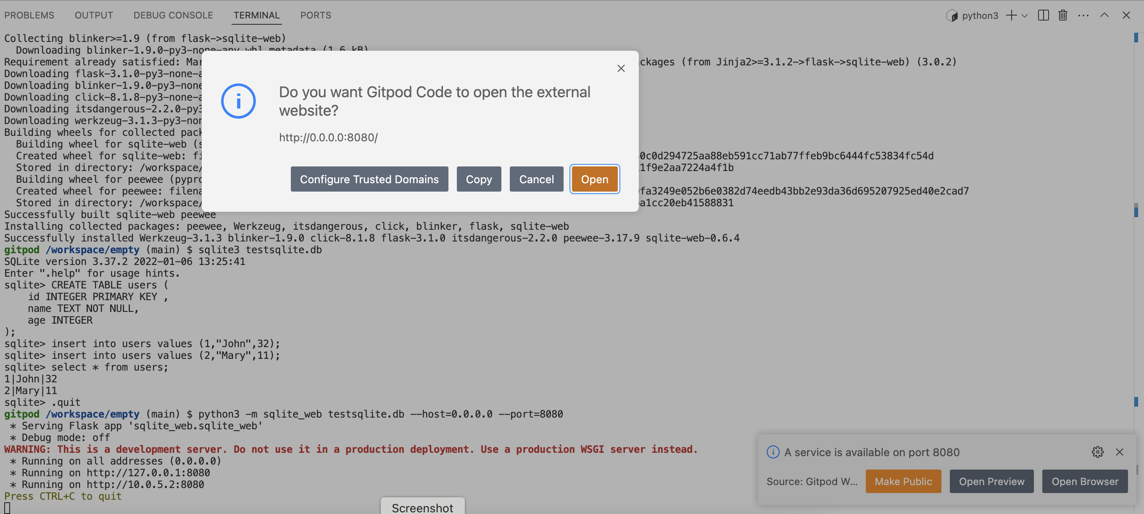

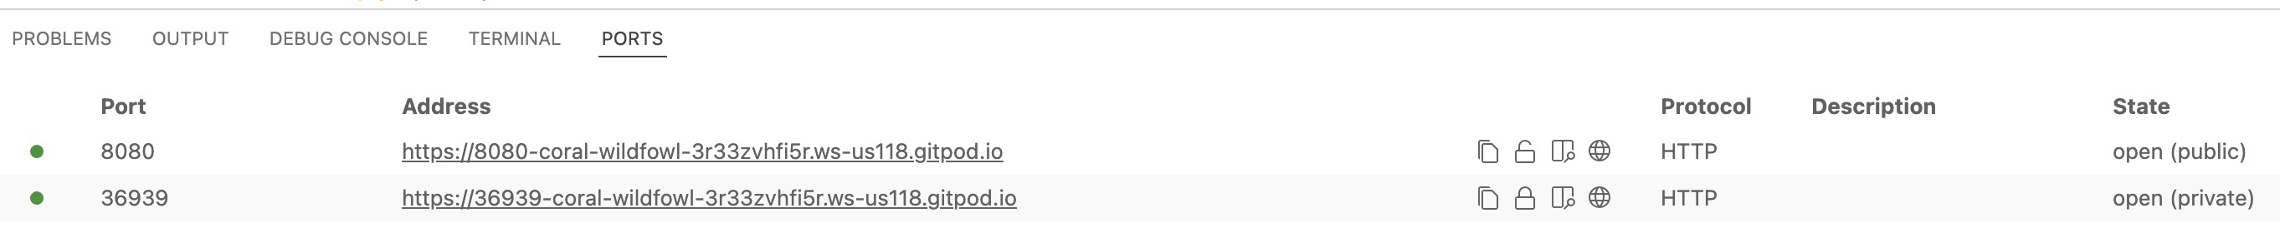
The status is made public, so the Web portal is accessible publicly.
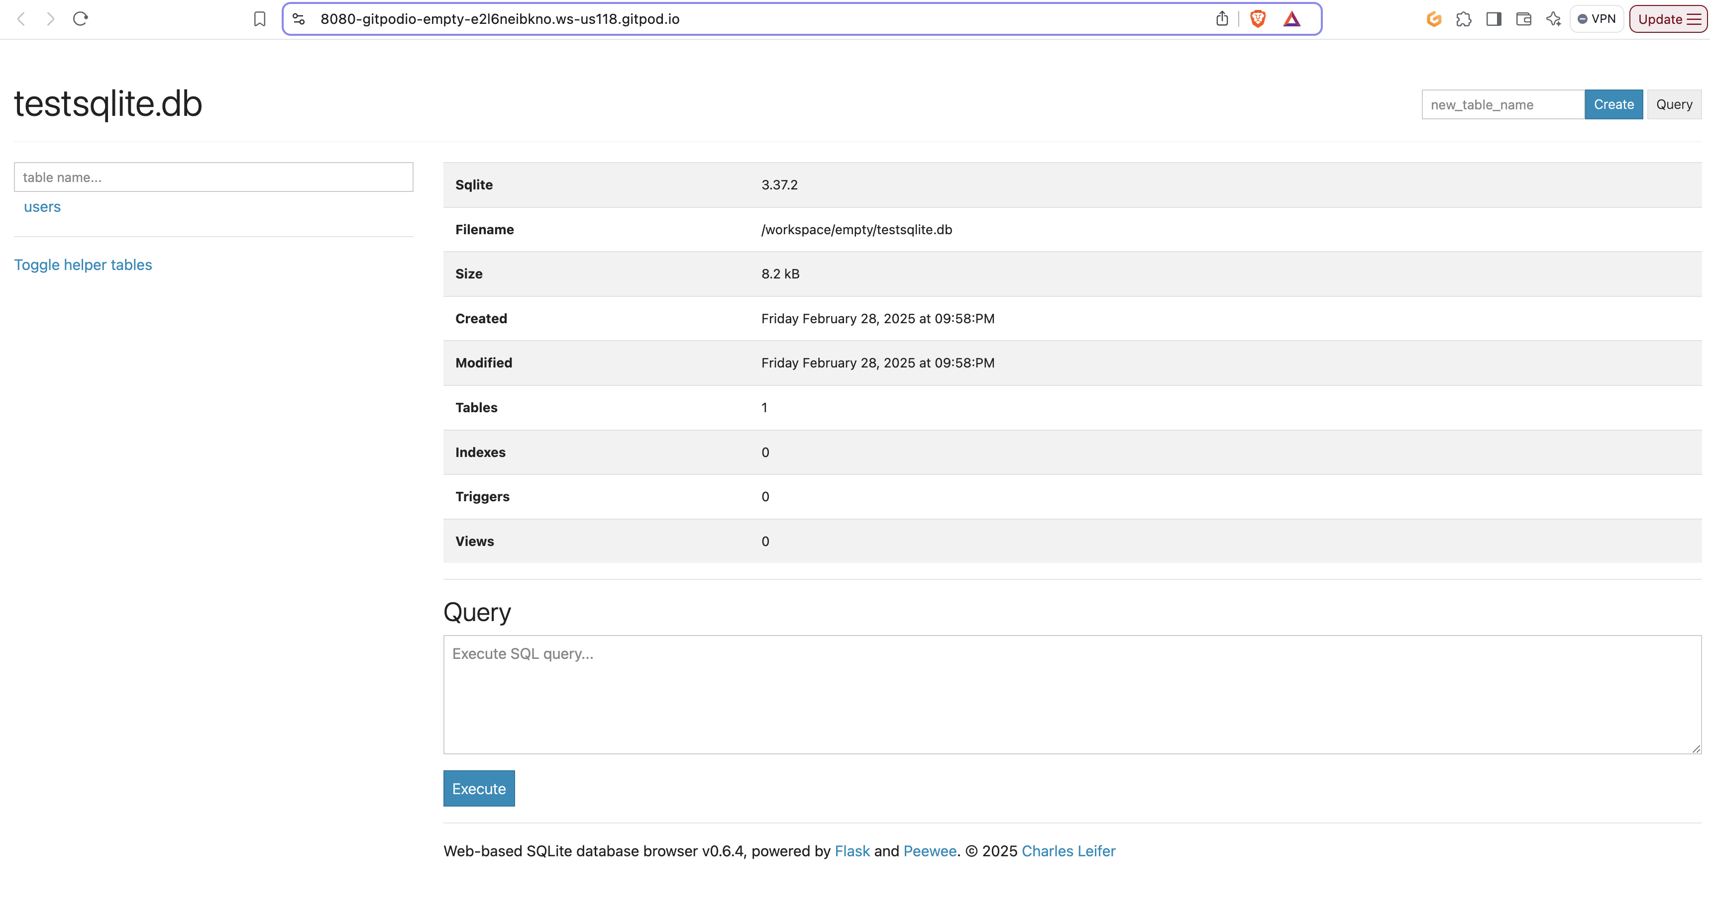

6. Create a table and import the dataset (flights-export.csv ) into testsqlite.db using sqlite-web.
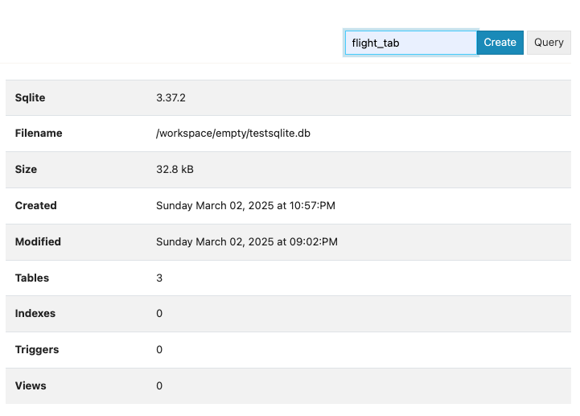
Figure: create new table

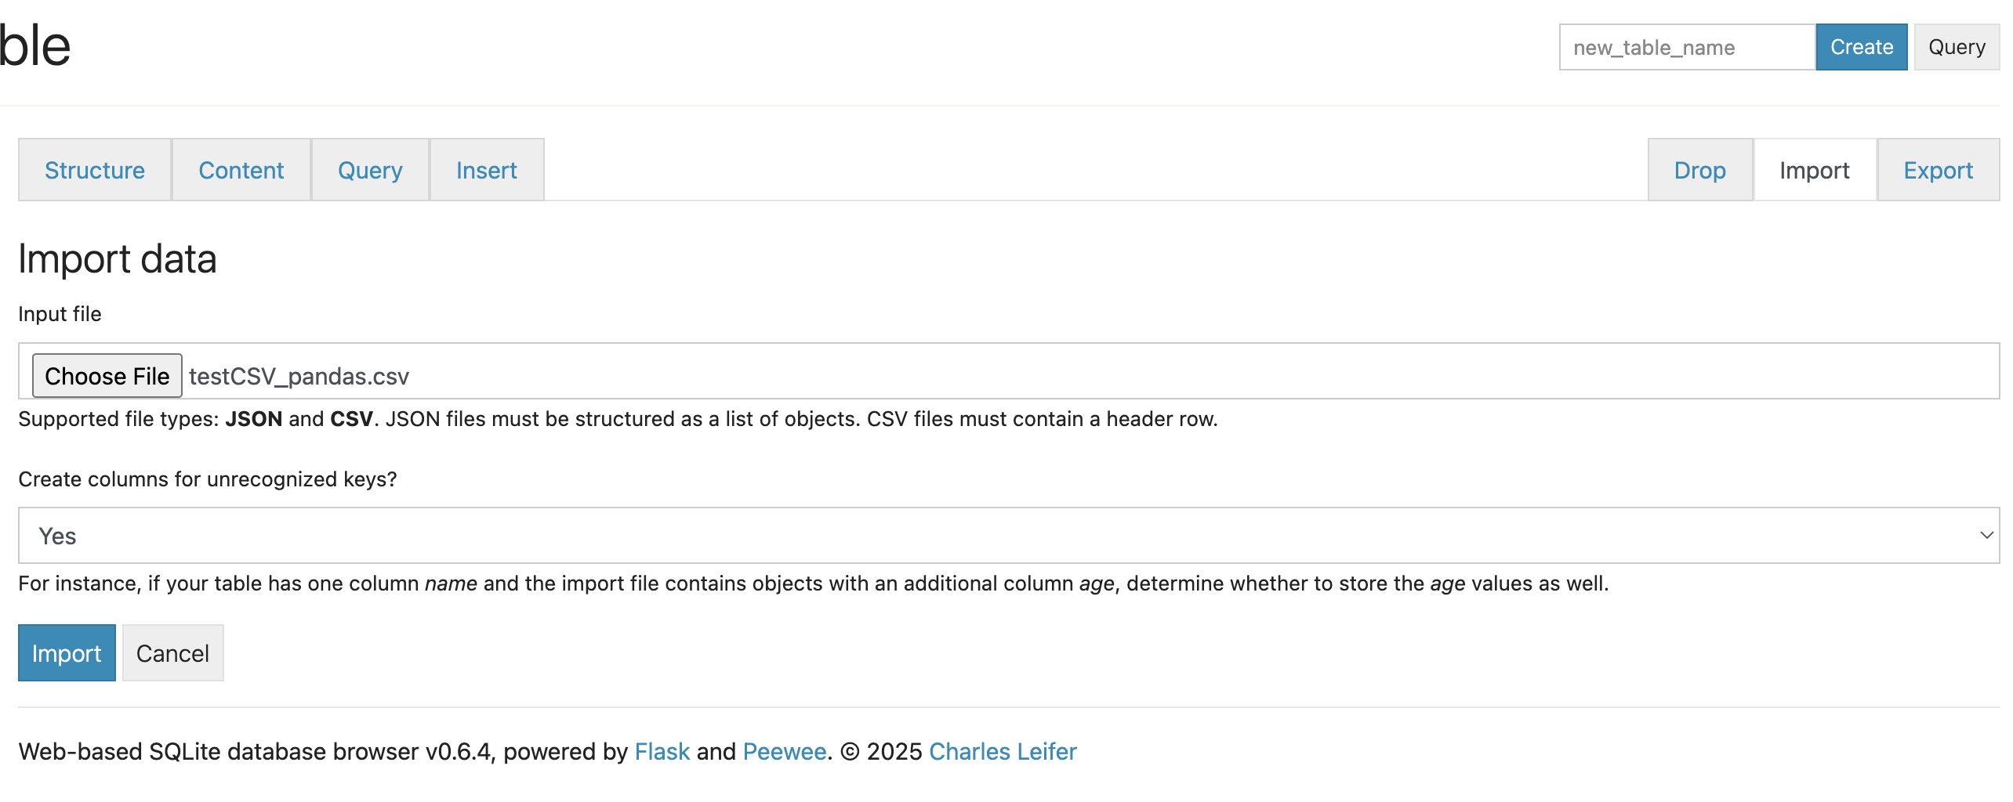
Figure: upload csv file and create table

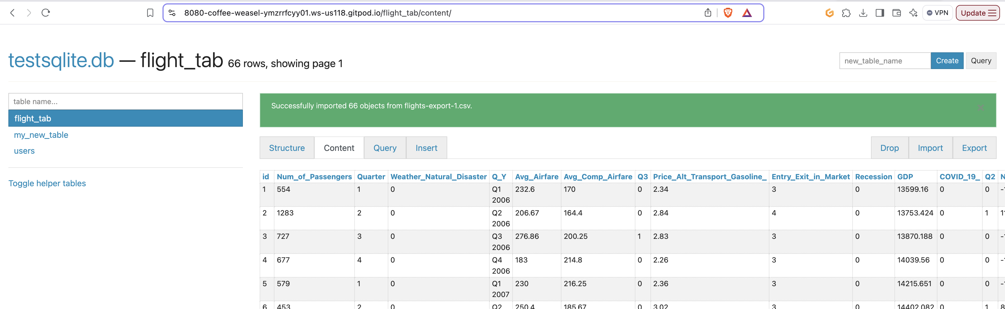
Figure: Few rows of the table

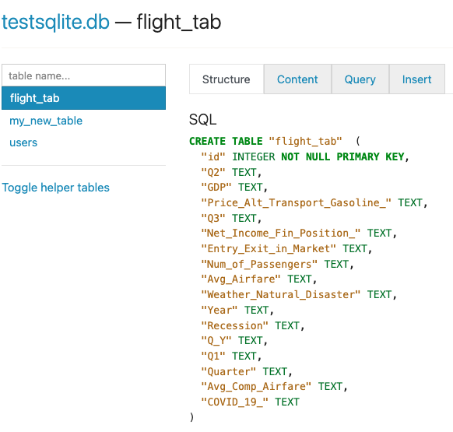
Figure: structure of the table

CREATE TABLE "flight_tab" (
"id" INTEGER NOT NULL PRIMARY KEY,
"Q2" TEXT,
"GDP" TEXT,
"Price_Alt_Transport_Gasoline_" TEXT,
"Q3" TEXT,
"Net_Income_Fin_Position_" TEXT,
"Entry_Exit_in_Market" TEXT,
"Num_of_Passengers" TEXT,
"Avg_Airfare" TEXT,
"Weather_Natural_Disaster" TEXT,
"Year" TEXT,
"Recession" TEXT,
"Q_Y" TEXT,
"Q1" TEXT,
"Quarter" TEXT,
"Avg_Comp_Airfare" TEXT,
"COVID_19_" TEXT
)

7. In sqlite-web use SQL statement to finish the following queries.
a) Calculate the total and average number of passengers per year, given that Net Income (Fin. Position) > 0.
SELECT Year, SUM(CAST(Num_of_Passengers AS INTEGER)) AS total_passengers,
AVG(CAST(Num_of_Passengers AS INTEGER)) AS average_passengers
FROM flight_tab
WHERE CAST(Net_Income_Fin_Position_ AS INTEGER) > 0 GROUP BY Year;
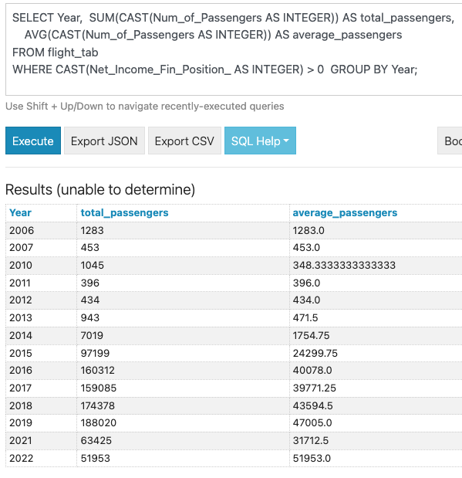

b) Calculate the total and average number of passengers per year, given that Net Income (Fin. Position) < 0.
SELECT Year, SUM(CAST(Num_of_Passengers AS INTEGER)) AS total_passengers,
AVG(CAST(Num_of_Passengers AS INTEGER)) AS average_passengers
FROM flight_tab
WHERE CAST(Net_Income_Fin_Position_ AS INTEGER) < 0
GROUP BY Year;
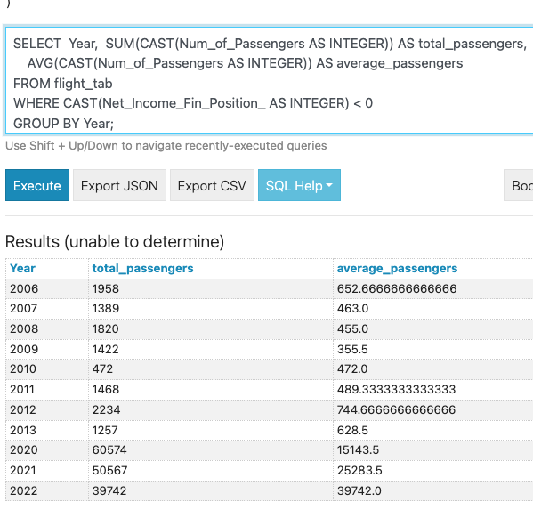
c) Calculate the total and average number of passengers per year.
SELECT
Year, SUM(CAST(Num_of_Passengers AS INTEGER)) AS total_passengers,
AVG(CAST(Num_of_Passengers AS INTEGER)) AS average_passengers
FROM flight_tab GROUP BY Year;
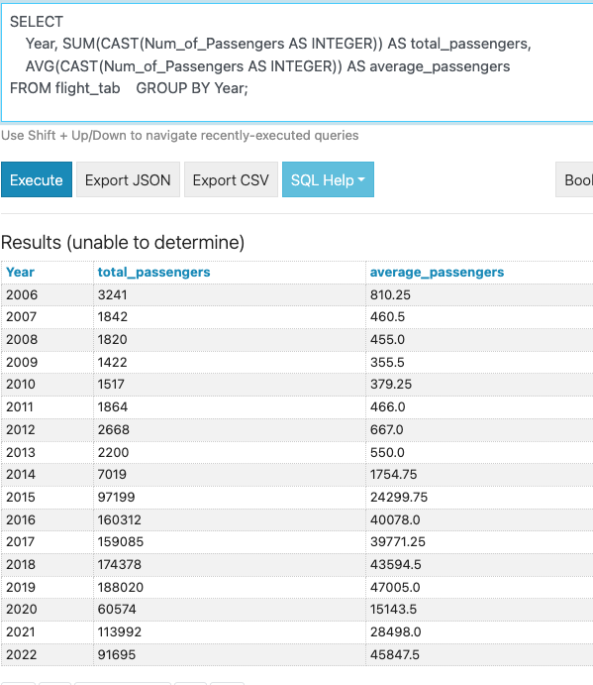
8. Use sqlite command prompt to redo one of the queries in 7.
