Use containerization technology to build the postgres + pg4admin environment
Bidur Devkota,PhD

1. Install postgres database and run
gitpod /workspace/empty (main) $ mdkir ./pg_files
gitpod /workspace/empty (main) $ docker pull postgres
gitpod /workspace/empty (main) $ docker ps
gitpod /workspace/empty (main) $ docker images

gitpod /workspace/empty (main) $ docker run --name postgres_container -e POSTGRES_PASSWORD=12345 -d -p 5432:5432 -v /workspace/empty/pg_files/:/var/lib/postgresql/data postgres

gitpod /workspace/empty (main) $
gitpod /workspace/empty (main) $ docker exec -it postgres_container psql -U postgres
psql (17.5 (Debian 17.5-1.pgdg120+1))
Type "help" for help.

postgres=# CREATE DATABASE flight;
CREATE DATABASE
postgres-# \q

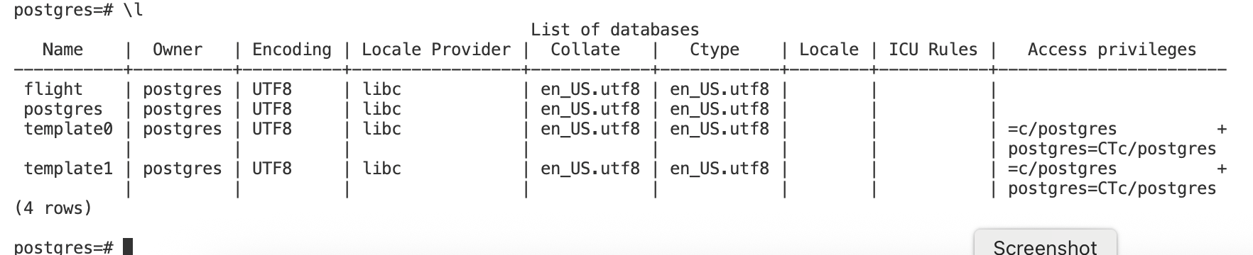

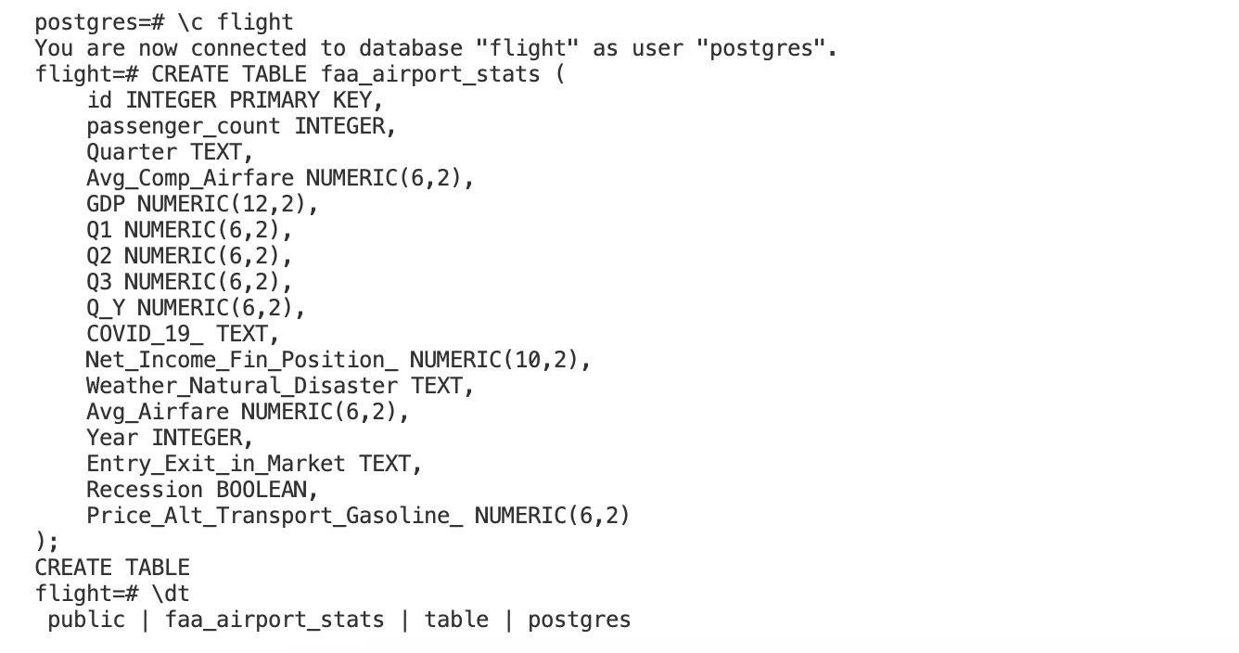
CREATE TABLE faa_airport_stats (
id INTEGER PRIMARY KEY,
passenger_count INTEGER,
Quarter TEXT,
Avg_Comp_Airfare NUMERIC(6,2),
GDP NUMERIC(12,2),
Q1 NUMERIC(6,2),
Q2 NUMERIC(6,2),
Q3 NUMERIC(6,2),
Q_Y NUMERIC(6,2),
COVID_19_ TEXT,
Net_Income_Fin_Position_ NUMERIC(10,2),
Weather_Natural_Disaster TEXT,
Avg_Airfare NUMERIC(6,2),
Year INTEGER,
Entry_Exit_in_Market TEXT,
Recession BOOLEAN,
Price_Alt_Transport_Gasoline_ NUMERIC(6,2)
);

- Create database in postgreSQL server container and create the database and tables
  - Import SQL into gitpod’s postgres:
  - Drag and drop 'flights-export.csv’ in gitpod’s workspace:

  - Install postgresql-client:
    - sudo apt update
    - sudo apt install postgresql-client

  - Login to SQL CLI and create a database
    - psql -h localhost -p 5432 -U postgres
OR
docker exec -it postgres_container psql -U postgres
CREATE DATABASE flight;
CREATE TABLE faa_airport_stats (
id INTEGER PRIMARY KEY,
passenger_count INTEGER,
Quarter TEXT,
Avg_Comp_Airfare NUMERIC(6,2),
GDP NUMERIC(12,2),
Q1 NUMERIC(6,2),
Q2 NUMERIC(6,2),
Q3 NUMERIC(6,2),
Q_Y NUMERIC(6,2),
COVID_19_ TEXT,
Net_Income_Fin_Position_ NUMERIC(10,2),
Weather_Natural_Disaster TEXT,
Avg_Airfare NUMERIC(6,2),
Year INTEGER,
Entry_Exit_in_Market TEXT,
Recession BOOLEAN,
Price_Alt_Transport_Gasoline_ NUMERIC(6,2)
);
\q

  - Import the sql
psql -U postgres -d flight -h localhost -c "\copy faa_airport_stats FROM 'flights-export.csv' WITH (FORMAT csv, HEADER true, DELIMITER ',')"
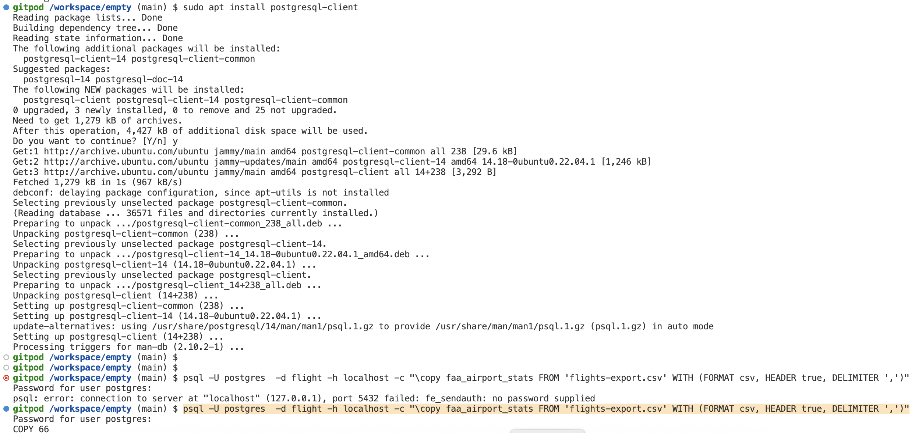

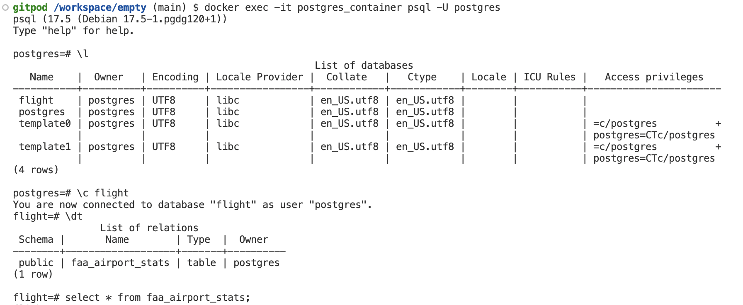

Another Option is to import data using PgAdmin
3. install pgadmin4 and run it
gitpod /workspace/empty (main) $ docker pull dpage/pgadmin4
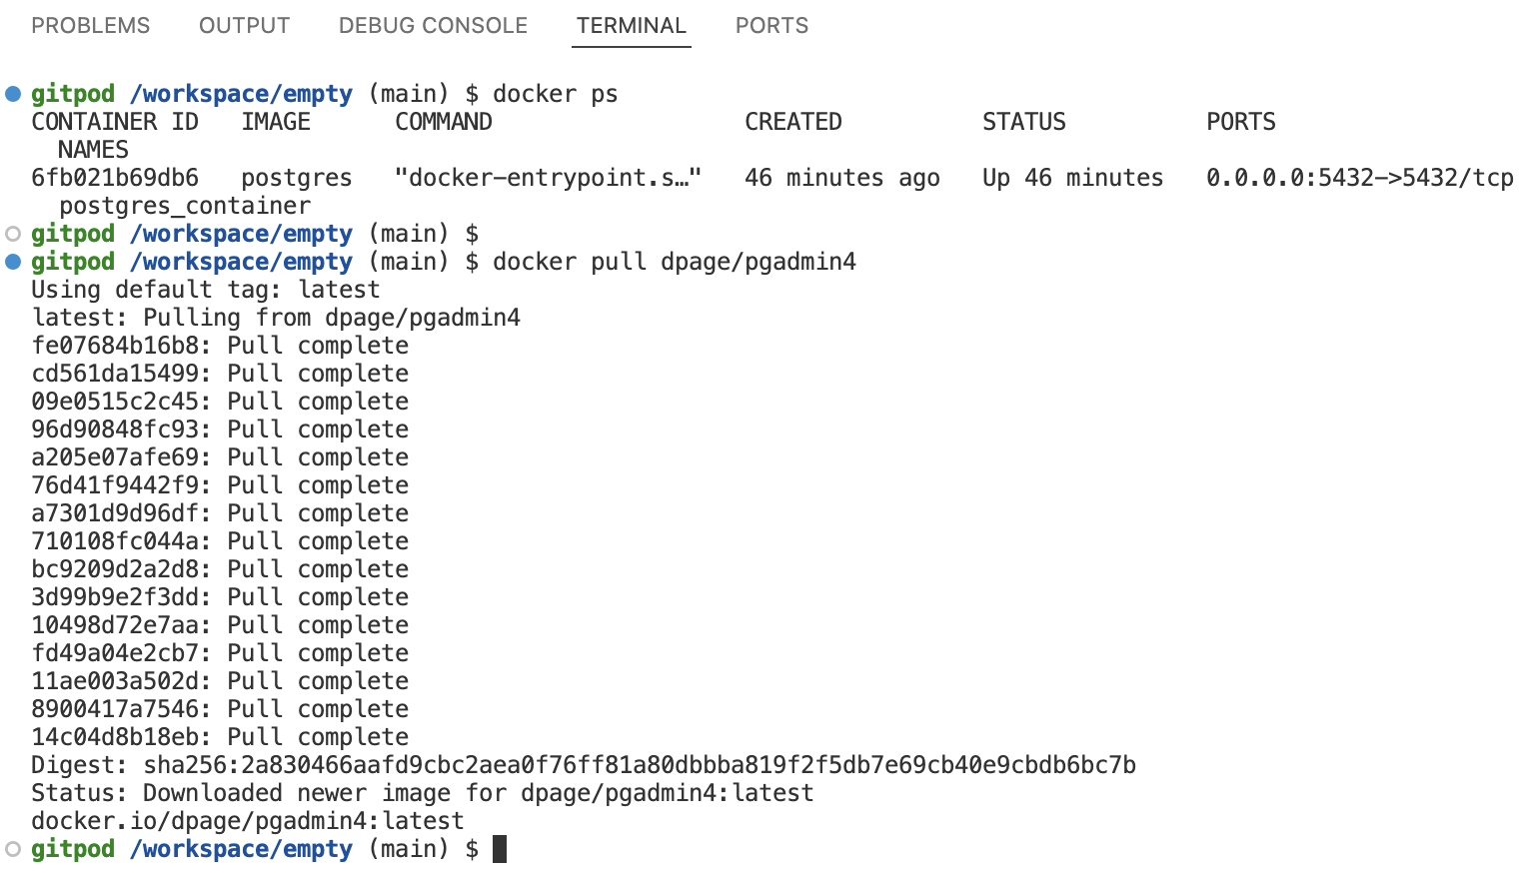
gitpod /workspace/empty (main) $ docker run --name pgadmin_container -p 8080:80 -e 'PGADMIN_DEFAULT_EMAIL=im.bidur@gmail.com' -e 'PGADMIN_DEFAULT_PASSWORD=12345' -d dpage/pgadmin4

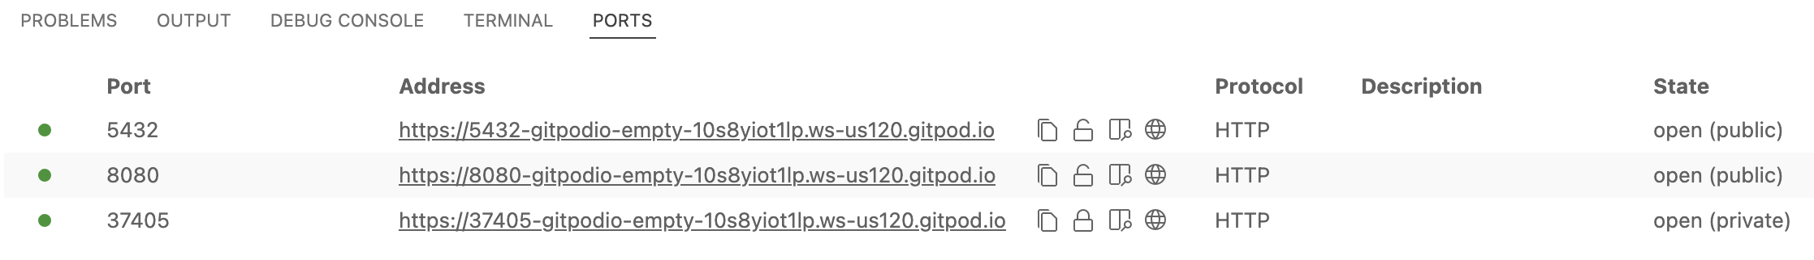
Make sure that the Port for pgadmin4 is public.

Note the IP address of the postgres container
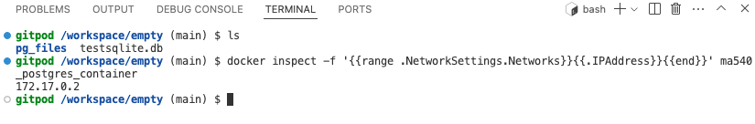
gitpod /workspace/empty (main) $ docker inspect -f '{{range .NetworkSettings.Networks}}{{.IPAddress}}{{end}}' postgres_container

pgAdmin is located at: https://8080-gitpodio-empty-10s8yiot1lp.ws-us120.gitpod.io

4. Access PgAdmin
- Open PgAdmin in browser: https://8080-sapphire-crayfish-1hpcm4lw6pd.ws-us118.gitpod.io/login?next=/

Login to PgAdmin: Provide the login credentials specified at environment variables <PGADMIN_DEFAULT_EMAIL> and <PGADMIN_DEFAULT_PASSWORD>:
  - Email: im.bidur@gmail.com
  - Password: 12345
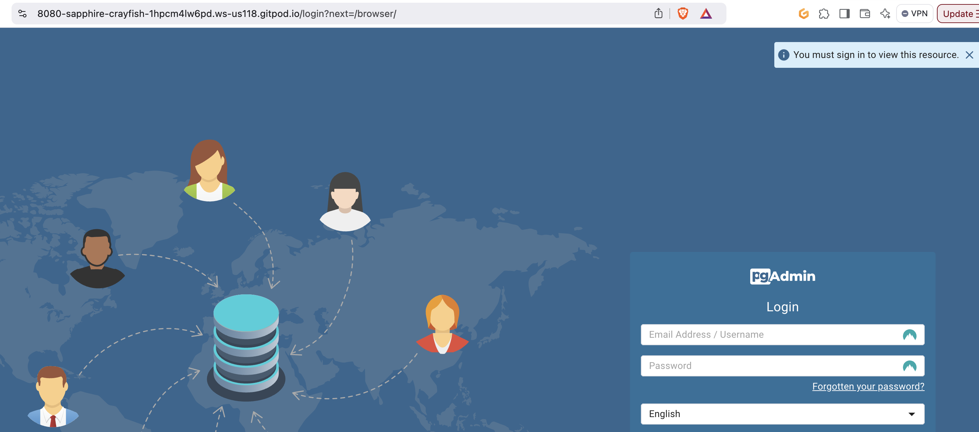

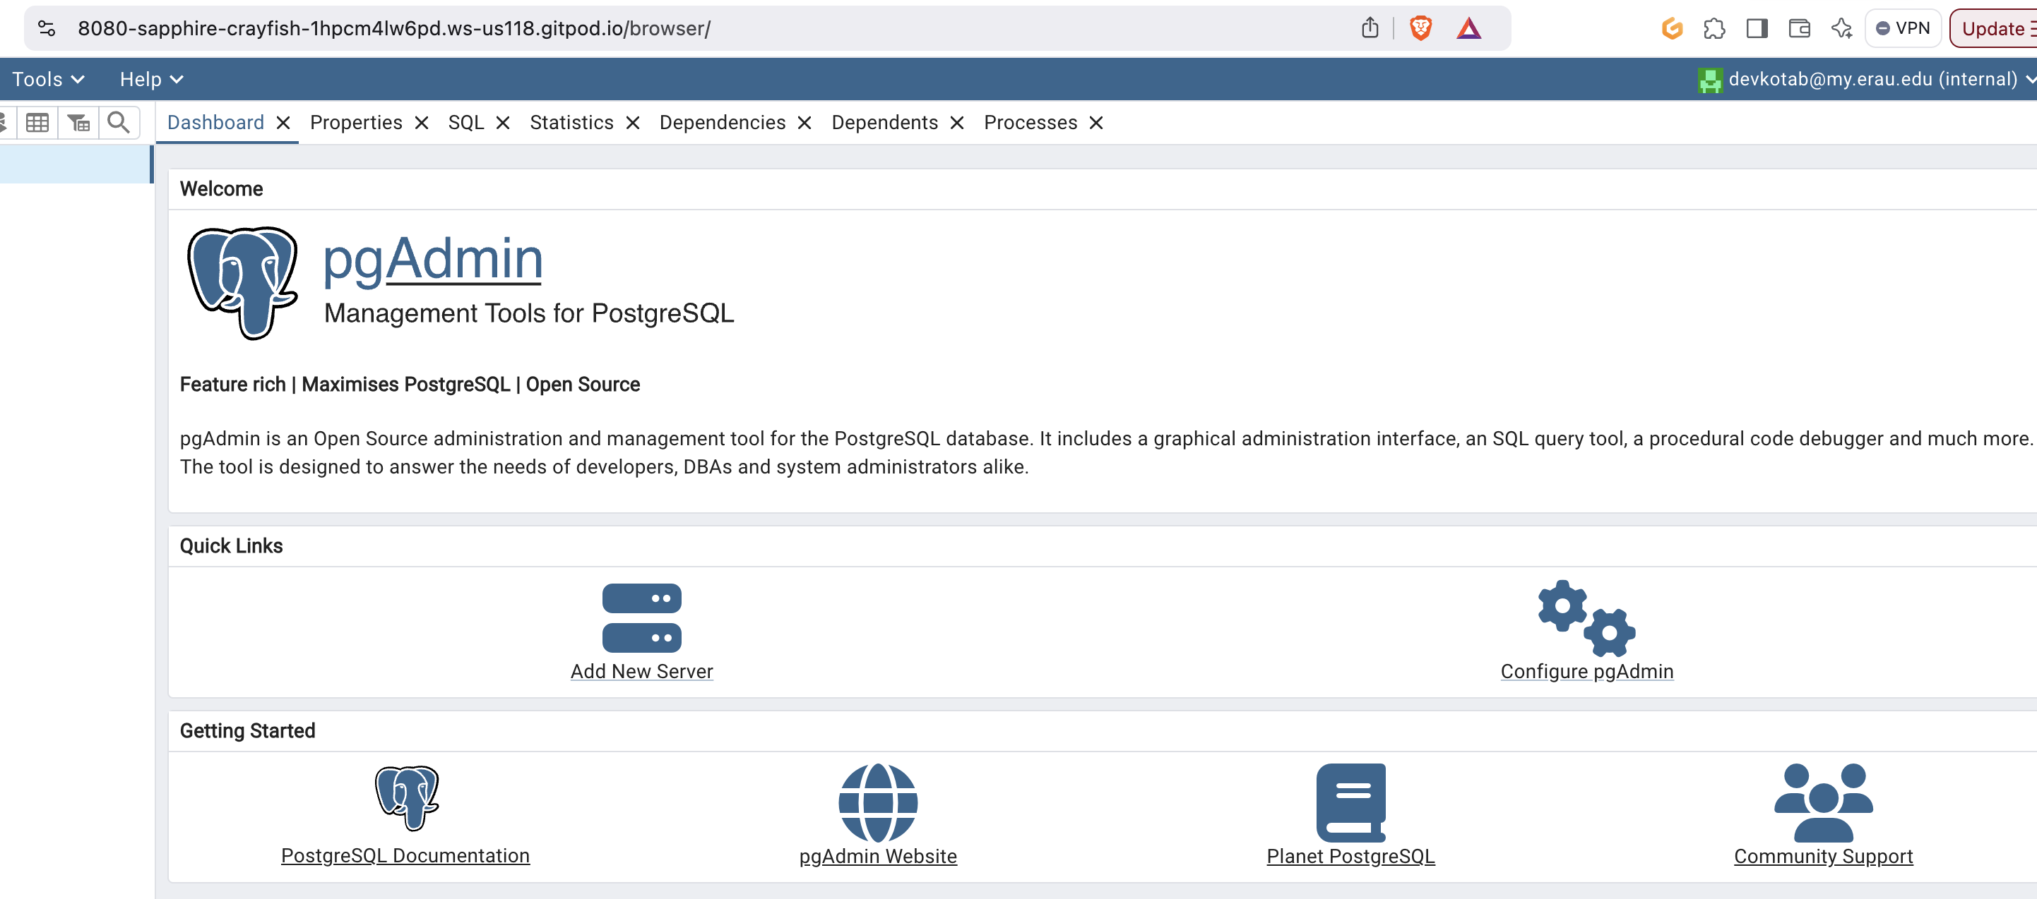

Create a New Server Connection
- In the Dashboard, click on "Add New Server".
- In the "General" tab:
  - Name: DS500-POSTGRES

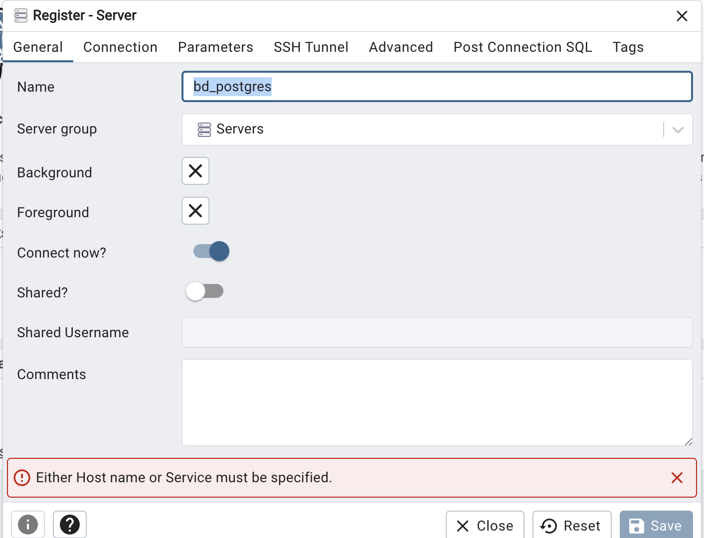

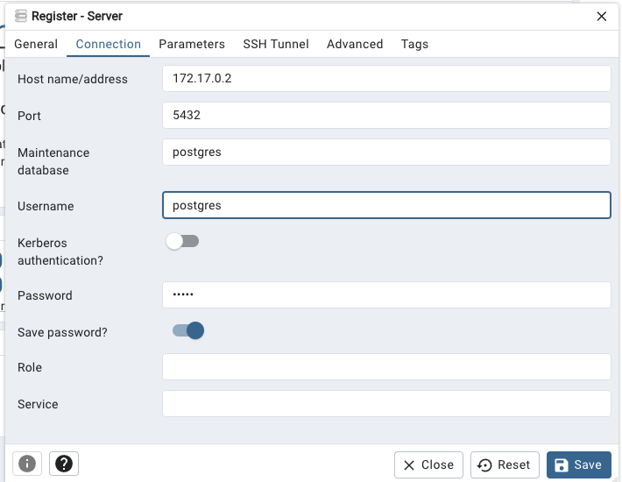
- In the "Connection" tab, enter the necessary fields as shown in the screenshot and save.

5. Note that database ‘flight’ is already there.
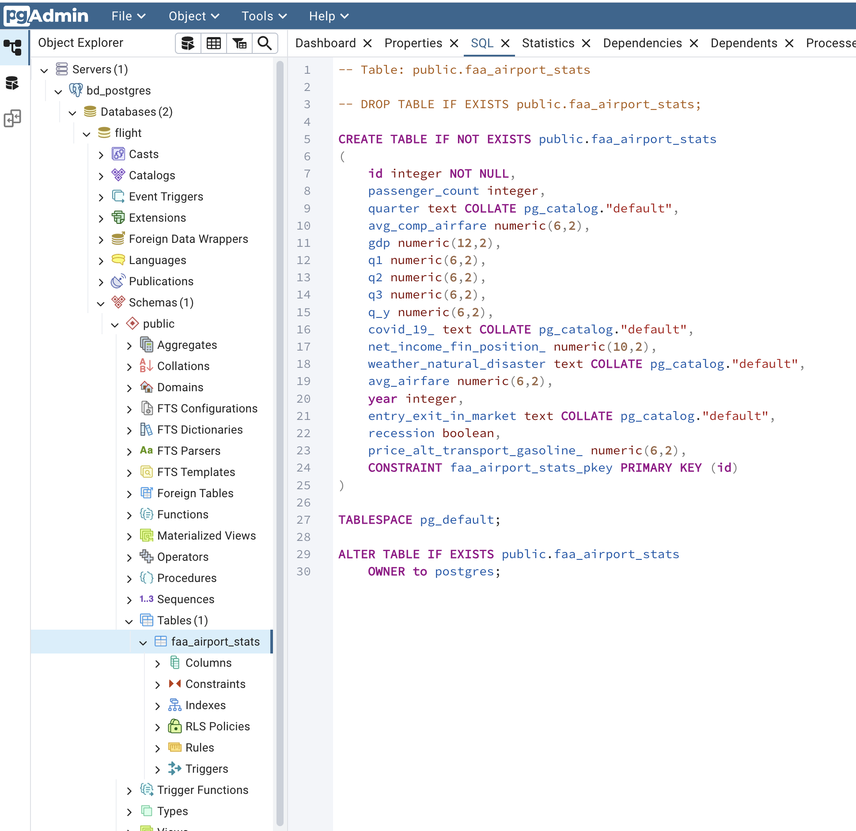

OR create a new database say ‘hw5_2’

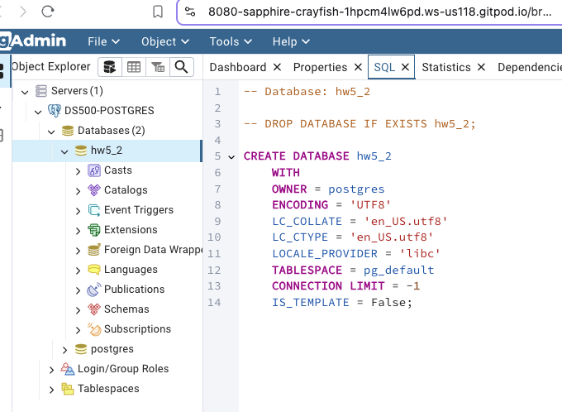

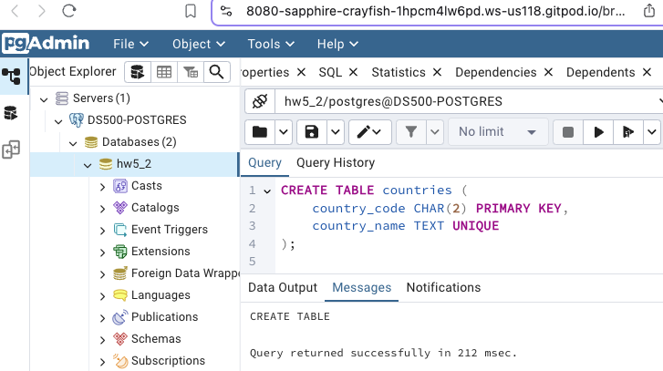
6. Create new table countries and insert values.

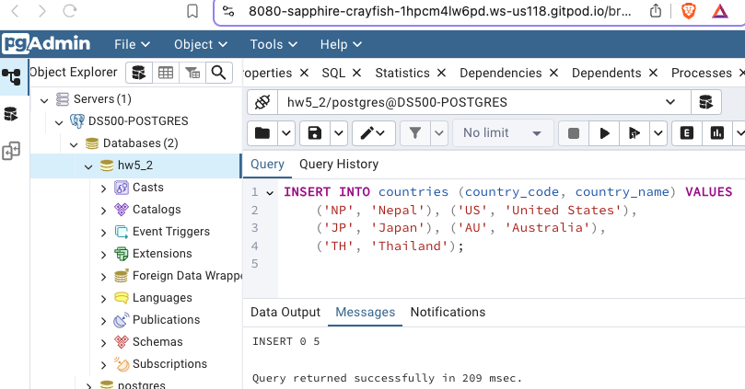

5. Use Chisel to tunnel gitpod and COlab
- Use chisel tunnel to connect to the GitPod postgreSQL server container from Google Colab, and verify that you can execute SQL queries to pull events and their corresponding location information into a pandas dataframe.
  - Run the following in the gitpod terminal ( Chiesel server)
docker run --name postgres_container -e POSTGRES_PASSWORD=12345 -e POSTGRES_USER=postgres -d -p 5432:5432 -v /workspace/empty/pg_files:/var/lib/postgresql/data postgres
curl https://i.jpillora.com/chisel! | bash
chisel server --port 5433
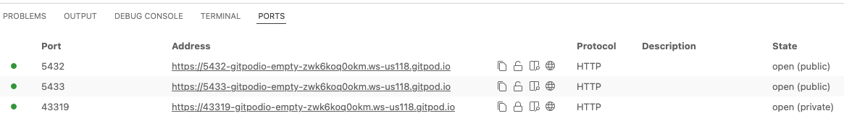

  - Run the following in the Google Colab ( CHiesel CLinet)
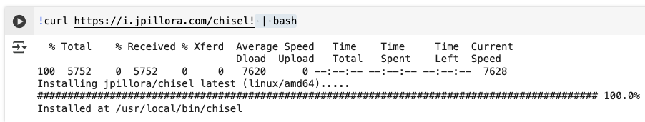
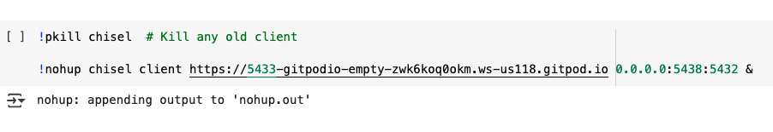

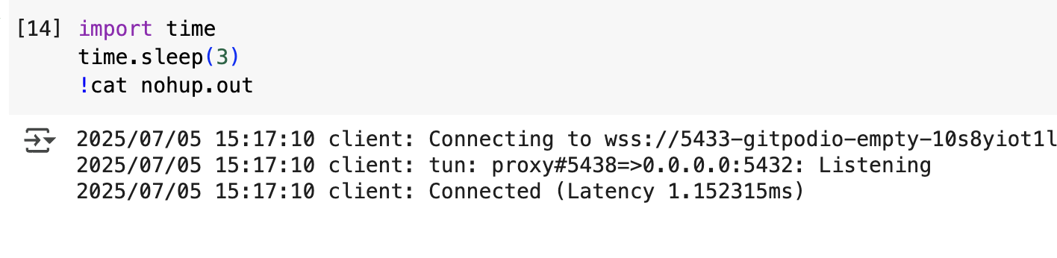

postgres=# create database gu_mit;
postgres=# \c gu_mit
You are now connected to database "gu_mit" as user "postgres".
gu_mit=# \dt
Did not find any relations.
gu_mit=# CREATE TABLE students (
student_id SERIAL PRIMARY KEY,
full_name VARCHAR(100),
email VARCHAR(100) UNIQUE,
enrollment_year INTEGER,
major VARCHAR(50),
gpa NUMERIC(3,2)
);

INSERT INTO students (full_name, email, enrollment_year, major, gpa) VALUES
('Sita KC', 'sita@gu.edu', 2022, 'Computer Science', 3.85),('Ram Patel', 'ram@gu.com', 2022, 'Environment Engineering', 3.77);

