GPS Probe Generation

This program reads a csv file which contains GPS points along the road. Sometimes, such data may be sparse and smooth visualization along the road may not be guaranteed. This program generates intermediate GPS points along the road using OpenStreetMap data. The sample csv file (gps_probe_Nepal.csv) is provided for demo purpose. The csv file assumes four fields ap_id ( i.e. gPS_device ID), timestamp, lat ( i.e. latitude) and lon ( i.e. longitude). Based on the sequence of latitude and longitude points and the timestamps, intermediate points and corresponding timestamp are generated for visualization along the road.

The program works for generating routes that can be visualized in Mobmap. However, this code is an initial version which have to be improved for differnt aspects. This is published here in the hope that it will be useful, but WITHOUT ANY WARRANTY; without even the implied warranty of MERCHANTABILITY or FITNESS FOR A PARTICULAR PURPOSE.

Main Modules used:
- shp2pgsql command
  - Windows: http://download.osgeo.org/postgis/windows
  - Ubuntu: https://manpages.ubuntu.com/manpages/bionic/man1/shp2pgsql.1.html

- Python 3
  - https://www.python.org/downloads/
- pyroutelib3 for generating OSM routes
  - https://pypi.org/project/pyroutelib3/
- pandas for working with data
  - https://pypi.org/project/pandas/
- psycopg2 for connecting with postgresql
  - https://pypi.org/project/psycopg2/
- tkinter for GUI
  - https://pypi.org/project/tkintertable/
- Shapely for Geometric Objects
  - https://pypi.org/project/Shapely/
- Faker for Data anonymization
  - https://pypi.org/project/Faker/

Note: Postgresql is not necessary if you do not wish to clip data to target geography.

1. Edit config.py

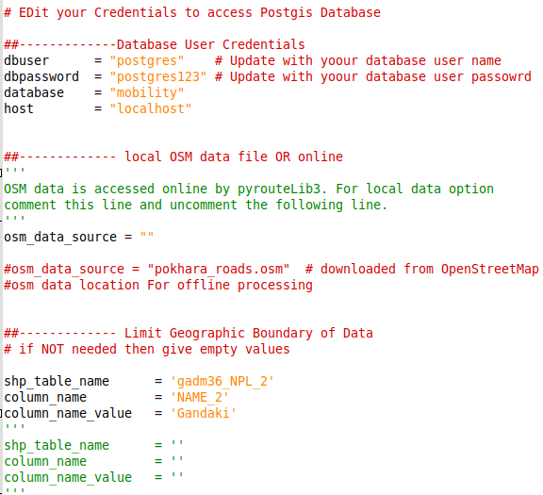Figure 1: Config File

2. Create database and enable POSTGIS extension. (Optional)

- Create Database ‘mobility’

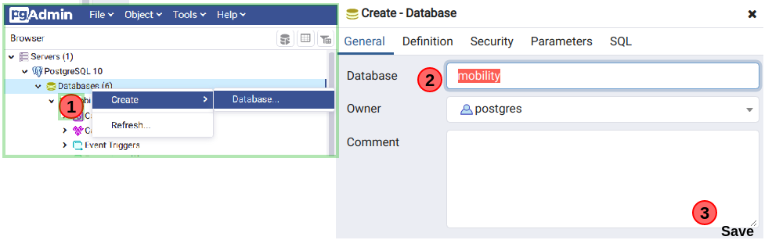Figure 2: Create Database

- Enable PostGIS extension, by running the following queries:

CREATE EXTENSION postgis;
SELECT postgis_full_version();
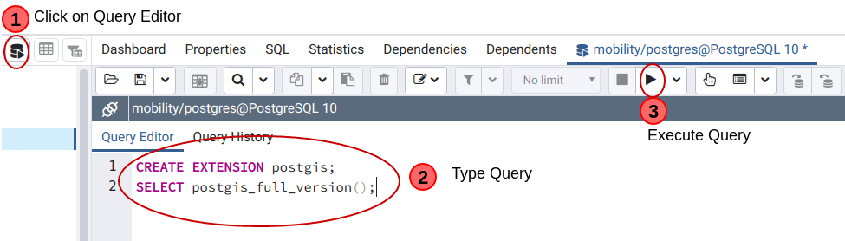Figure 3: Enable postgis extension

3. Run main_program.py ( Online OSM data download)
( python3 main_program.py OR python main_program.py )

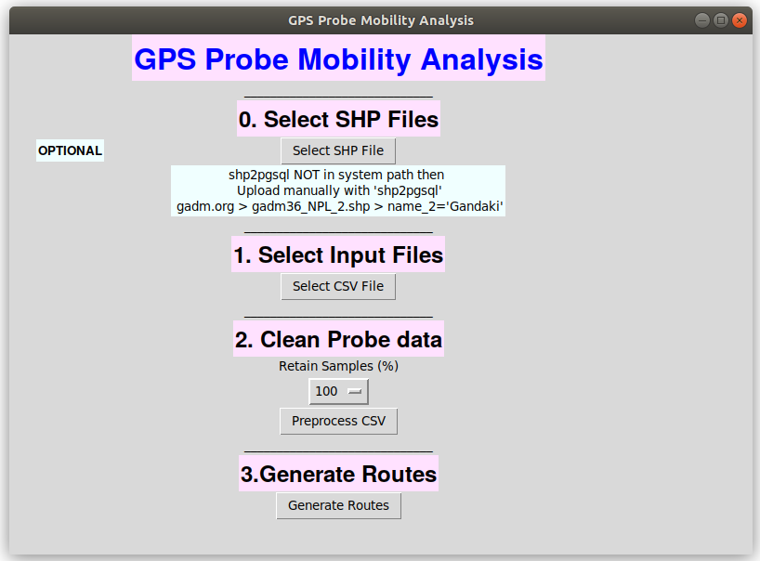Figure 4: Program Interface ( at start)

3.1 Select Input Files:

- Shapefile Upload (Optional)
  - Get Nepal shapefile from <https://biogeo.ucdavis.edu/data/gadm3.6/shp/gadm36_NPL_shp.zip> and select ‘gadm36_NPL_3.shp’
  - If needed use shp2pgsql program to upload it to database. Command line can be used as follows:
shp2pgsql -I -s 4326 gadm36_NPL_3.shp gadm36_NPL_3 | PGPASSWORD=postgres123 psql -d mobility -h localhost -U postgres

  - Make sure the database table names and values match the values in config.py . Leave them blank if you do not need to clip the probe data with shapefile.
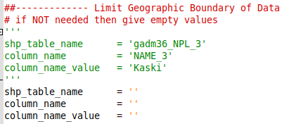Figure 5: Config File

- Select ‘gps_probe_nepal.csv’
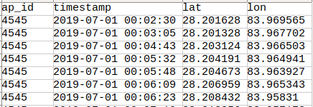Figure 6: Input File Fields

3.2 Clean Probe Data:
- Select sampling percentage. For eg. if you select 10, then the program will use 10% of the ap_id data.
- Removing duplicates.
- Correcting duplicate timestamp at different location.
- Clipping the Probe Data within the selected ( e.g. Kaski ) region only ( if shapefile is provided).

3.3 Input and other Intermediate Files:
- The input/ directory contains original as well as intermediate probe data.
  - Original.csv : raw data uploaded to the system at Step 1.
  - preprocessed_ALL.csv : Preprocessed file ( remove duplicates, corrected same timestamp and multiple location issue ) for all the data.
  - preprocessed.csv : Preprocessed and sampling done.
  - preprocessed_clipped.csv : Probe outside the selected region ( e.g. Gandaki) are removed. The route generation is done with this file as inut.
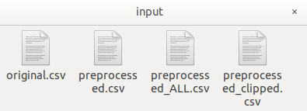Figure 5: Input Folder with Intermediate files

3.4 Generate Routes:
- The output/ directory will contain the output files.
- ‘combined_csv.csv’ contains the generated routes for all ap_id.
- ‘ap_id’ values in ‘combined_csv.csv’ are anonymized with Numerical values and saved as ‘final_csv_4_mobmap_big.csv’ .
- MobMap visualization can be done using ‘final_csv_4_mobmap_big.csv’ .
- Filenames starting with ‘log_’ are log files.
- Make sure the output/ folder is removed before starting the process.
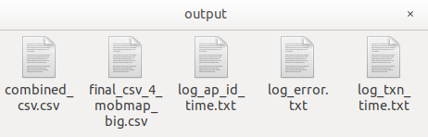
Figure 6: Output Files

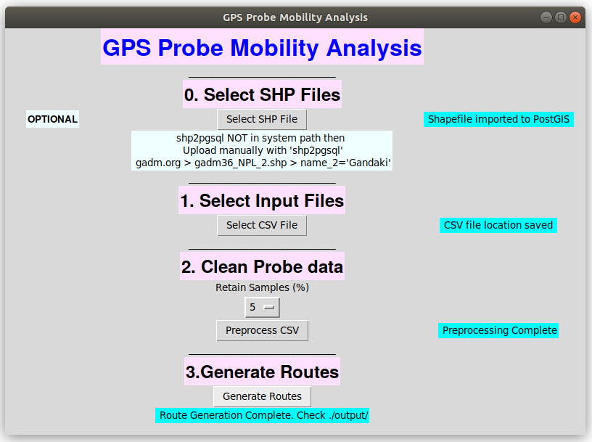Figure 7: Program Interface ( after successful execution)

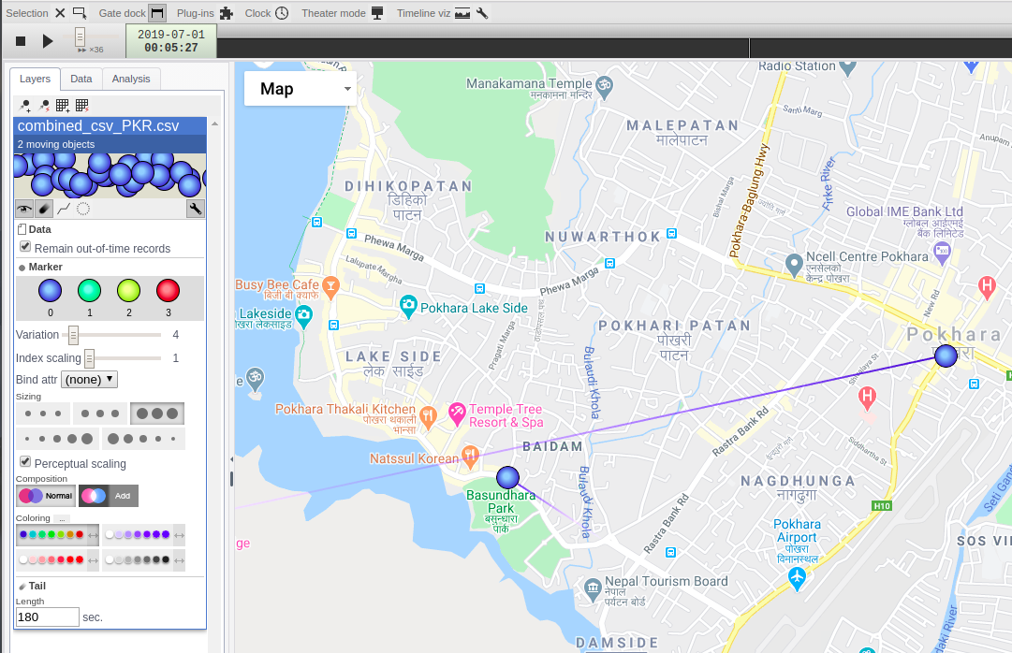Figure 8: Visualization in MobMap

4. Run main_program.py ( Local data source)

4.1 Specify the OSM data file location in config.py

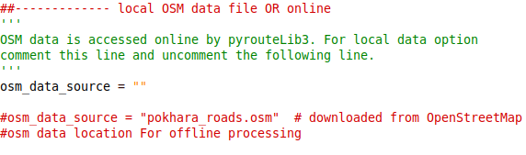Figure 8: Local Data source for route generation where Internet is not available

4.2 OSM data
- Download defined region and regional data from: http://download.geofabrik.de/
- Select smaller or specific region as follows and save ( e.g. my_map.osm)
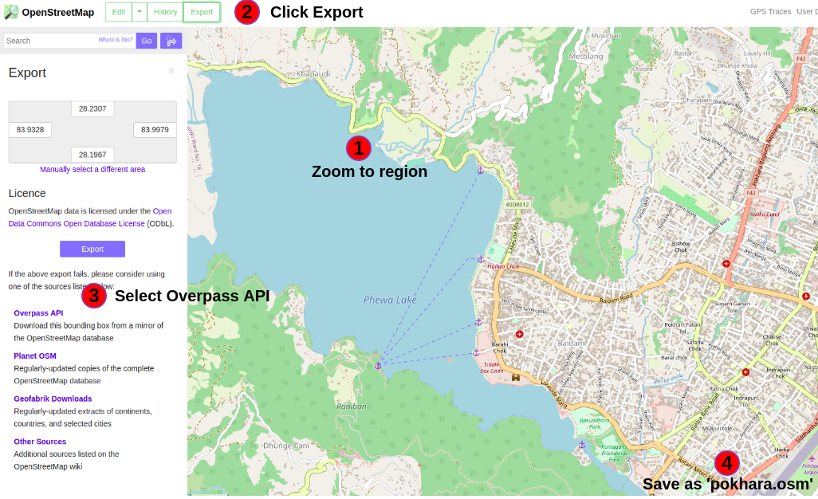

Figure 9: Extract OSM data
- OSM data size effects the performance. Hence, consider fitering unnecessary data from it. An example is shown below:
  - Filter data from ‘pokhara.osm’ using osmfilter tool and save as ‘pokhara_roads.osm’.

osmfilter pokhara.osm --keep="highway=*" > pokhara_roads.osm

