Lab #1 : Introduction to MySQL, its datatypes and its installation

1. Objective
- Understand the basic concepts and purpose of Relational Database Management Systems (RDBMS).
- Install and configure MySQL Server and MySQL Workbench.
- Identify and use different MySQL data types.
- Create databases and tables using SQL commands.

2. Required Software and Tools
MySQL Community Server | Version 8.0 or higher
MySQL Workbench (or XAMPP, phpMyAdmin) | GUI client for database management

3. Background Theory

3.1 What is an RDBMS?
A Relational Database Management System (RDBMS) stores data in tables (rows and columns) and allows data manipulation using SQL. Examples: MySQL, PostgreSQL, Oracle, MS SQL Server.

3.2 Introduction to MySQL
MySQL is an open-source RDBMS developed by Oracle Corporation. It uses SQL for data access and follows a client-server architecture where MySQL Server manages databases and MySQL Workbench acts as a GUI client.

4. Installation Steps (MySQL Server and Workbench)
- Download MySQL Installer from https://dev.mysql.com/downloads/ and then install.
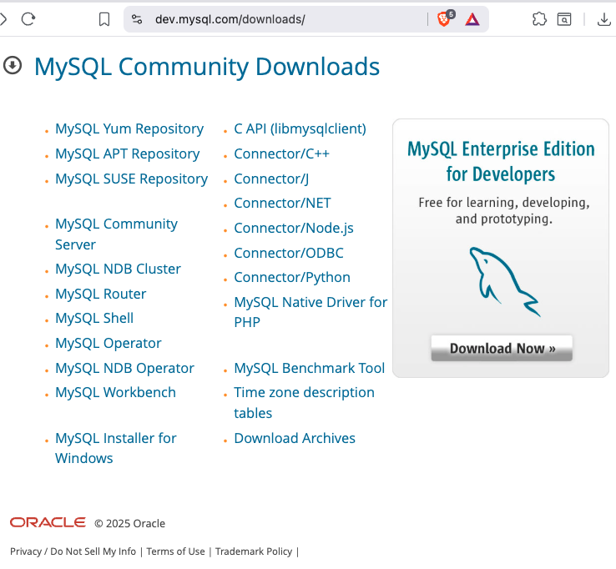

Note your password while installing MySQL ( e.g root123!)

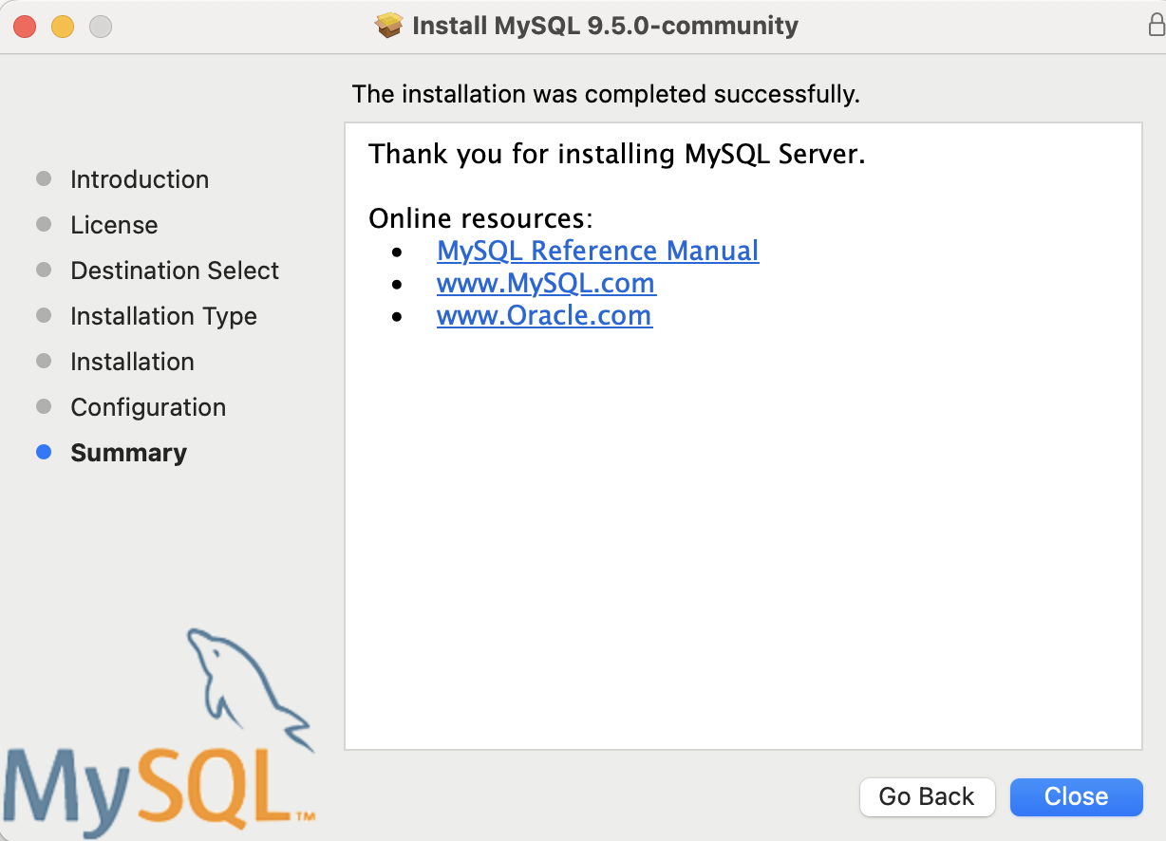

5. MySQL Data Types
Category | Data Type | Example | Description
Numeric | INT, BIGINT, SMALLINT | 10 | Whole numbers
Decimal | DECIMAL(p,s), NUMERIC(p,s) | 15.75 | Fixed precision decimal
Floating | FLOAT, DOUBLE | 12.567 | Approximate numeric values
String | CHAR(n), VARCHAR(n) | 'Pokhara' | Fixed/variable-length string
Text | TEXT, LONGTEXT | Essay text | Long text strings
Date & Time | DATE, TIME, DATETIME | '2025-11-09'  '2025-11-09 11:22:33' | Date/time values
Boolean | BOOLEAN, BIT | 1 / 0 | True/False
Binary | BLOB | image data | Binary large objects

6. Lab Exercises

6.1 Start and login Server
Start /Stop the MySQL server(MacOS)
sudo /usr/local/mysql/support-files/mysql.server start
sudo /usr/local/mysql/support-files/mysql.server stop

Setup PATH
Edit shell configuration file: nano ~/.zshrc
Add this line: export PATH=/usr/local/mysql/bin:$PATH
Save and reload: source ~/.zshrc

Login to MySQL
mysql -u root -p

6.2 Run MySQL queries
- Create a Database
CREATE DATABASE collegeDB;
USE collegeDB;
- Create a Table
CREATE TABLE students (
StusentID INT PRIMARY KEY AUTO_INCREMENT,
name VARCHAR(50) NOT NULL,
age INT,
dob DATE,
address VARCHAR(100)
);
- Insert Records
INSERT INTO students (name, age, dob, address)
VALUES (‘Bidur Devkota', 21, '2004-05-14', 'Pokhara');
(insert your own name here)
- Display Records
SELECT * FROM students;
- Describe Table
DESCRIBE students;

- Create Table class with name, class_roll_num, ernollment_year and insert your own data.

7. Observation Table
Command Executed | Description | Output Screenshot | Remarks

8. Result
- MySQL and MySQL Workbench successfully installed.
- Database and tables created.
- Basic SQL commands executed successfully.
- MySQL data types understood and tested.

9. Conclusion
In this lab, we learned about the MySQL RDBMS environment, its installation, and data types. We created databases and tables, inserted records, and retrieved data using SQL commands.

