GPS Probe Generation

This program reads a csv file which contains GPS points along the road. Sometimes, such data may be sparse and smooth visualization along the road may not be guaranteed. This program generates intermediate GPS points along the road using OpenStreetMap data. The sample csv file (gps_probe_Nepal.csv) is provided for demo purpose. The csv file assumes four fields ap_id ( i.e. gPS_device ID), timestamp, lat ( i.e. latitude) and lon ( i.e. longitude). Based on the sequence of latitude and longitude points and the timestamps, intermediate points and corresponding timestamp are generated for visualization along the road.

The program works for generating routes that can be visualized in Mobmap. However, this code is an initial version which have to be improved for differnt aspects. This is published here in the hope that it will be useful, but WITHOUT ANY WARRANTY; without even the implied warranty of MERCHANTABILITY or FITNESS FOR A PARTICULAR PURPOSE.

Main Modules used:
- Python 3 and its modules like pandas, geopandas, etc.
- Faker for Data anonymization
  - https://pypi.org/project/Faker/
- GraphHopper Map-matching tool
  - https://github.com/graphhopper/map-matching

1. Edit config.py
- Specify
  - target region’s shapefile location (line 3)
  - shapefile’s target attribute column (line 4)
  - target region’s name in shapefile (line 5)
- Specify the map of the target region obtained from openstreetmap (line 9)
  - the input GPS points in the input .csv file must be within this map region.
- Update ROOT_DIR (line 13)
  - Give the location of ‘gpsProbeMatching.ipynb’ as ROOT_DIR

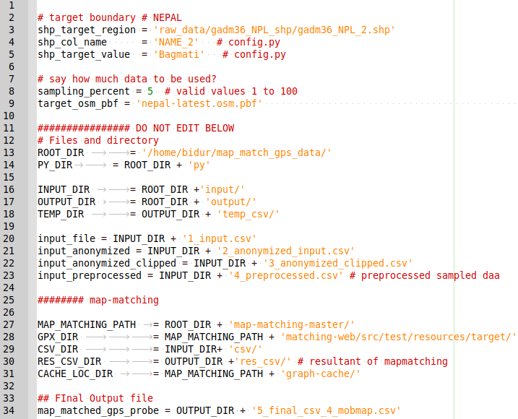Figure 1: ./py/config.py

2. Provide input csv file in gpsProbeMatching.ipynb
- Specify input gps_probe data in notebook

Figure 2: gpsProbeMatching.ipynb

- The contents of the csv file are expected as follows:( For e.g. ap_id indicates car_id)

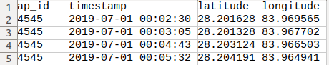Figure 3: Input File Fields

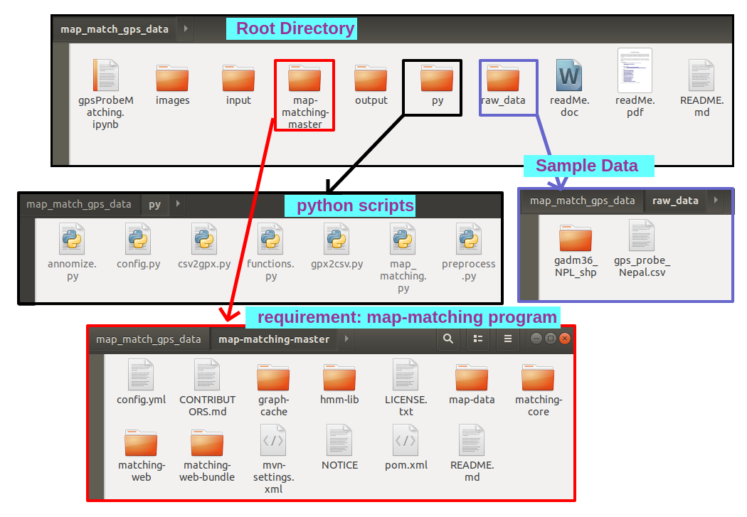
Figure 4: Directory Structure
The instructions below are to be done ONE TIME ONLY

3. Align GPS probe data along the road network ( using Graphhopper map-matching)

3.1. If Java and Maven are not already installed then install them. Java 8 and Maven >=3.3.
- JDK (https://www.java.com/en/download/ )
- OpenJDK (https://jdk.java.net/archive/)
- https://mkyong.com/maven/how-to-install-maven-in-windows/

NOTE: Install JDK or OpenJDK, any of them works.

3.2. Download and install GraphHopper Map-matching tool

Download map-matching to map_match_gps_data directory ( with option 1 OR option 2)
- Option 1: Download: https://github.com/graphhopper/map-matching and copy the code in the appropirate directory as shown in the image in Figure 4 above.

- Option 2: Use git clone comman:
  - Change directory to <map_match_gps_data>
  - git clone https://github.com/graphhopper/map-matching.git

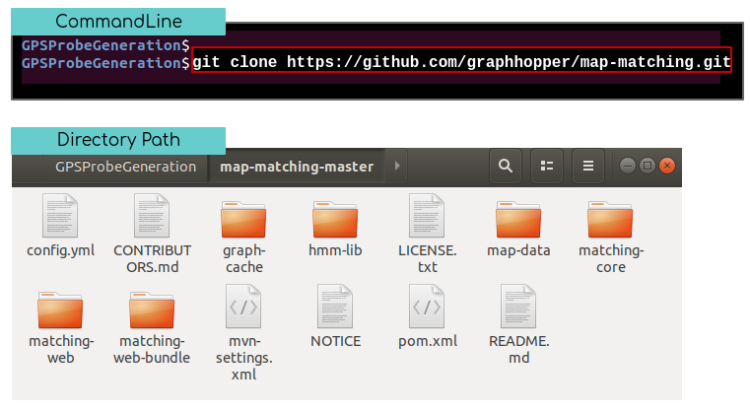
Fig 5: Git clone command to download map-matching

Please confirm that map-matching-master is inside map_match_gps_data as shown in the Figure 4 above.

3.2 Build (install) Graphhopper
- Change directory to <map-matching-master>
- Command: mvn package -DskipTests
Fig 6: Build Command

The build command executes for some time and the successful completion is displayed as follows:
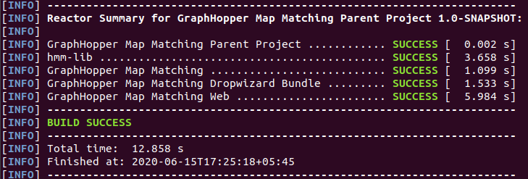Fig 7: Successful Built

3.3 Import OSM map for target geography ( e.g. Nepal)
- Download: https://download.geofabrik.de/asia/nepal-latest.osm.pbf
- Copy to map-data directory.
- Update config.py with the name of the map file target_osm_pbf = nepal-latest.osm.pbf
- NOTE: make sure the GPS Probe is within the map region, otherwise map-matching may encounter exceptions.

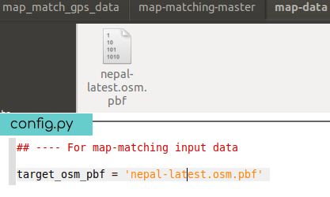

Fig 8: Download and Save nepal-latest.osm.pbf

4. Run notebook code in browser <gpsProbeMatching.ipynb>

4.3 Generated Routes:
- The output/ directory will contain the output files.
- ‘5_final_csv_4_mobmap.csv’ contains the generated routes for all ap_ids combined in a single file.
- MobMap visualization can be done using this file
- res_csv/ contains generated route for individual ap_ids separately.

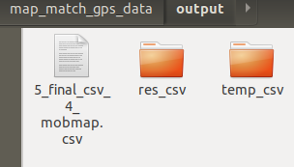

Figure 9: Output Files

4.4 Input and Intermediate Files:
- The input/ directory contains original as well as intermediate probe data.
  - 1_input.csv : original input file.
  - 2_anonymized_input.csv : ap_id field is anonymized
  - 3_anonymized_clipped.csv: Input data which lies beyond the desired geographic boundary is removed.
  - 4_preprocessed.csv: Preprocessed file ( remove duplicates, corrected same timestamp and multiple location issue ) for all the data.
  - csv/ folder : input separated into individual .csv file for each ap_id ( i.e. each car)
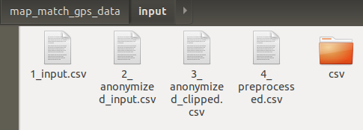
Figure 10: Input Folder with Intermediate files

4.5 MobMap visualization <https://shiba.iis.u-tokyo.ac.jp/member/ueyama/mm/app/>

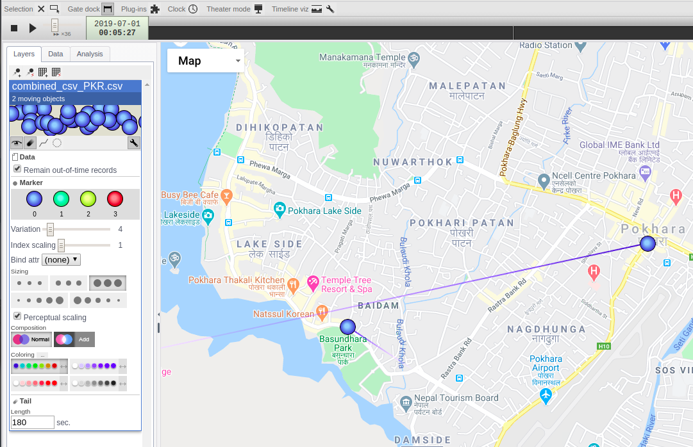Figure 11: Visualization in MobMap

