Fourier Transforms

Project #4

**Submitted by:**

Name: Bidur Bhurtel

DAWG: 856121420

Submitted on November 06, 2019

**Objectives:**

We are going to write a MATLAB program to see the Fourier Transforms and Inverse Fourier Transforms of two different images. We are also going to see the inverse fourier transform by using magnitude of one image and phase of another and then analyze the result.

**Original Image**

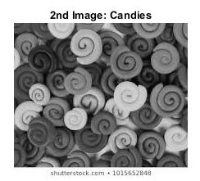

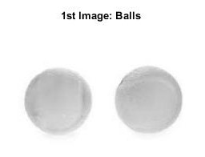

**Results**

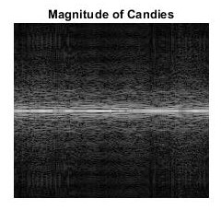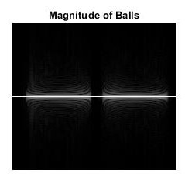

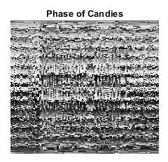

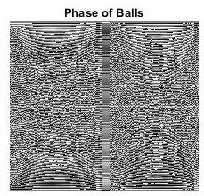

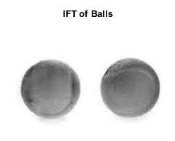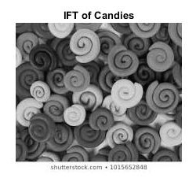

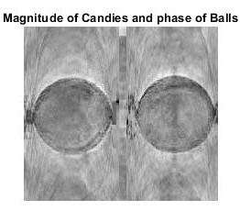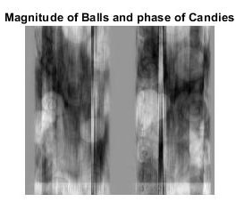

**Comments**

From the Fourier Transform, when we used phase of the image containing candies and magnitude of image with balls for inverse Fourier transform, the inverse Fourier transformed image looked a lot like the image with candies and when the phase of the image with balls and magnitude of image with candies was used for inverse Fourier transform, the inverse Fourier transformed image looked a lot like the image with balls.

So, we reached to the conclusion that the phase of an image is more important in Fourier transform rather than magnitude.

**MATLAB Code**

image_balls = rgb2gray(imread('two_balls.jpg'));

image_vib = rgb2gray(imread('vib.jpg'));

%cropping images to match the sizes

image1 = image_balls(6:195,:);

image2 = image_vib(:,27:238);

%% matrix as variable

image1 = im2double(image1);

image2 = im2double(image2);

%% fft of two balls image

balls_fft = fft(image1);

mag_fft_balls = abs(balls_fft);

phase_fft_balls = angle(balls_fft);

mag_shift_balls = fftshift(mag_fft_balls);

log_transformed_balls = log(1+ abs(mag_shift_balls));

% figure, imshow(log_transformed_balls, []);

%% fft of vibrant image

vib_fft = fft(image2);

mag_fft_vib = abs(vib_fft);

phase_fft_vib = angle(vib_fft);

mag_shift_vib = fftshift(mag_fft_vib);

log_transformed_vib = log(1+ abs(mag_shift_vib));

% figure, imshow(log_transformed_vib, [])

%% inverse fft of images using their own magnitude and phase angle

ifft_balls = ifft(balls_fft);

ifft_vib = ifft(vib_fft);

%% ifft using phase angle of different image

%new image using magnitude of balls and phase of vibrant image

phase_of_vib = mag_fft_balls.*exp(1i*phase_fft_vib);

ifft_phase_vib = ifft(phase_of_vib);

%new image using magnitude of vib and phase of balls

phase_of_balls = mag_fft_vib.*exp(1i*phase_fft_balls);

ifft_phase_balls = ifft(phase_of_balls);

%% for displaying

figure, imshow(image1), title('1st Image: Balls');

figure, imshow(image2), title('2nd Image: Candies');

figure, imshow(log_transformed_balls, []), title('Magnitude of Balls');

figure, imshow(log_transformed_vib, []), title('Magnitude of Candies');

figure, imshow(phase_fft_balls, []), title('Phase of Balls');

figure, imshow(phase_fft_vib, []), title('Phase of Candies');

figure, imshow(ifft_balls, []), title('IFT of Balls');

figure, imshow(ifft_vib, []), title('IFT of Candies');

figure, imshow(ifft_phase_vib, []), title('Magnitude of Balls and phase of Candies');

figure, imshow(ifft_phase_balls, []), title('Magnitude of Candies and phase of Balls');