Labelling Connected Components

Project #1

**Submitted by:**

Name: Bidur Bhurtel

DAWG: 856121420

Submitted on September 30, 2019

**Objectives:**

We are going to write a MATLAB program to determine the connected components in a binary image and give different connected components different labels and finally show connected components distinctively with different colors.

**Original Image:**

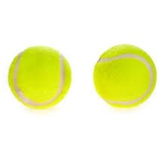

**Results**

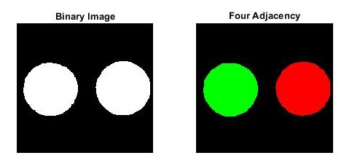

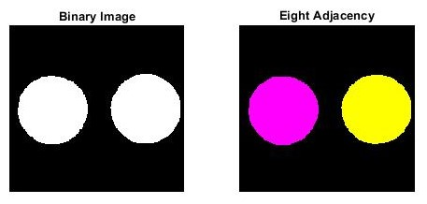

**Comments**

Since the input image has two different balls separated distinctly, the labelling of the connected components in both 4-connected and 8-connected seems very accurate.

**Matlab Code (4-connected)**

image_RGB = imread('two_balls.jpg');

% RGB_gray = rgb2gray(image_RGB);

bw_image = im2bw(image_RGB, 0.9);

bw_image_inverted = imcomplement(bw_image);

size_row = size(bw_image_inverted,1);

size_col = size(bw_image_inverted,2);

% to pad zeroes in the first row and first column

binary_image = [];

for i = 1:size_row+1

for j = 1:size_col+1

if (i == 1 | j==1)

binary_image(i,j) = 0;

else

binary_image(i,j) = bw_image_inverted(i-1, j-1);

end

end

end

labels = zeros(size_row, size_col);

give_label = [];

index_givelabel = 1;

value_givelabel = 11;

give_label(index_givelabel) = value_givelabel;

for row = 2:size_row+1

for col = 2:size_col+1

if (binary_image(row, col) == 1)

if (binary_image(row-1,col) == 0 && binary_image(row,col-1) == 0)

labels(row, col) = give_label(index_givelabel);

index_givelabel = index_givelabel + 1;

value_givelabel = value_givelabel + 1;

give_label(index_givelabel) = value_givelabel;

elseif (binary_image(row-1,col) == 1 && binary_image(row,col-1) == 0)

labels(row, col) = labels(row-1, col);

elseif (binary_image(row-1,col) == 0 && binary_image(row,col-1) == 1)

labels(row, col) = labels(row, col-1);

elseif (binary_image(row-1,col) == 1 && binary_image(row,col-1) == 1)

if(labels(row -1,col) == labels(row, col-1))

labels(row, col) = labels(row-1, col);

else

labels(row, col) = labels(row-1, col);

labels(row, col-1) = labels(row-1, col);

end

end

else

labels(row, col) = 0;

end

end

end

%to make connected labels same

while 1

count = 0;

for i = 2:size_row

for j = 2:size_col

if (labels(i,j) ~= 0)

if (labels(i-1,j) ~=0)

if (labels(i,j) < labels(i-1,j))

labels(i-1,j) = labels(i,j);

count = count + 1;

elseif (labels(i,j) > labels(i-1,j))

labels(i,j) = labels(i-1,j);

count = count + 1;

end

end

if (labels(i,j-1) ~= 0)

if (labels(i,j) < labels(i,j-1))

labels(i,j-1) = labels(i,j);

count = count + 1;

elseif (labels(i,j) > labels(i,j-1))

labels(i,j) = labels(i,j-1);

count = count + 1;

end

end

end

end

end

if (count == 0)

break;

end

end

cmap = [0,0,0;1,0,0;0,1,0];

%remap original image to indeces 1,2,3

B=zeros(size(labels));

B(labels==0)=1;

B(labels==11)=2;

B(labels==13)=3;

%define color image by remapping

color_labelled_image = ind2rgb(B,cmap);

%remapped image

figure;

subplot(1,2,1), imshow(bw_image_inverted);

subplot(1,2,2), imshow(color_labelled_image);