Histogram Equalization

Project #2

**Submitted by:**

Name: Bidur Bhurtel

DAWG: 856121420

Submitted on October 09, 2019

**Objectives:**

We are going to write a MATLAB program for histogram equalization and improve the quality of grayscale image by increasing the contrast of poor-contrast images. We will the compare the histogram of original poor-contrast image and the histogram of equalize image with those images side-by-side.

**Original Images:**

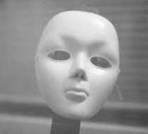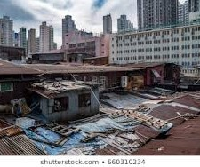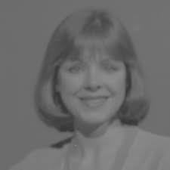

*Fig1: Lady fig2: Mask fig3: Structures*

**Results**

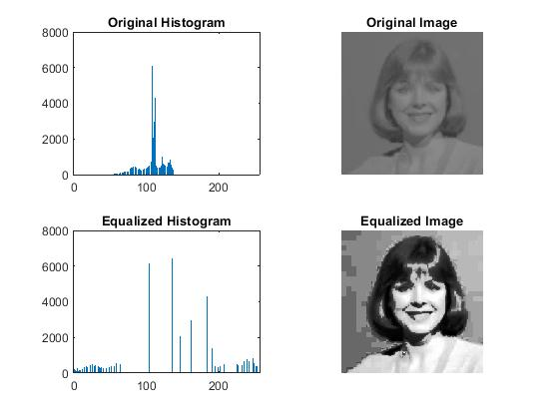

*Fig4: Result of Histogram equalization for fig 1*

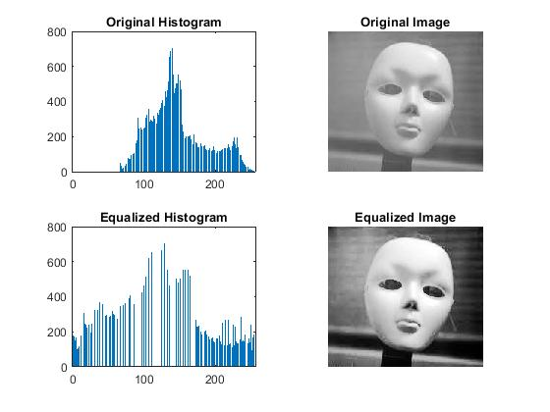

*Fig5: Result of Histogram equalization for fig 2*

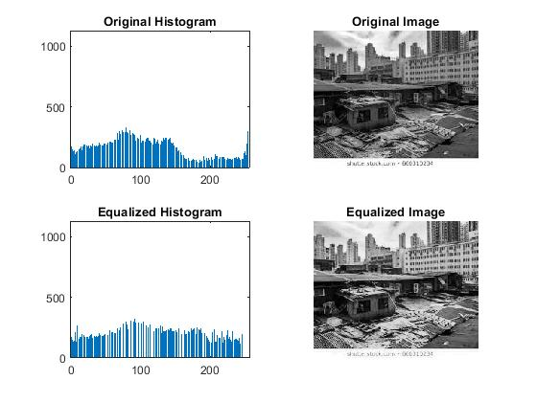

*Fig6: Result of Histogram equalization for fig 3*

**Comments**

We mapped the grayscale intensity value of original image to the value derived from the Cumulative Distribution Function. The Cumulative Distribution Function is given as:

Sk = **∑**j=0 px(rj) ; where px(rj) = probability of intensity rj occuring

The use of the CDF function enhances the contrast of the image significantly as can been seen from the above results.

**Matlab Code**

poor_contrast = rgb2gray(imread('poor_contrast3.jpg'));

size_row = size(poor_contrast,1);

size_col = size(poor_contrast,2);

intensity_label = [0:255];

% for counting the number of each intensity labels

number_of_each_intensity_label = zeros(1,256);

for L = 1:256

for i = 1:size_row

for j = 1:size_col

if (poor_contrast(i,j) == L-1)

number_of_each_intensity_label(L) = number_of_each_intensity_label(L) + 1;

end

end

end

end

% CDF transformation of each intensity label for histgram equalization

hist_equalized_intensity = zeros(1,256);

for k = 1:256

for j = 1:k

hist_equalized_intensity(k) = hist_equalized_intensity(k) + 255*number_of_each_intensity_label(j)/(size_col*size_row);

end

hist_equalized_intensity(k) = round(hist_equalized_intensity(k));

end

% histogram equalized image

new_image = zeros(size_row, size_col);

for L = 1:256

new_image(poor_contrast == L-1) = hist_equalized_intensity(L);

end

number_of_each_intensity_label_new = zeros(1,256);

for L = 1:256

for i = 1:size_row

for j = 1:size_col

if (new_image(i,j) == L-1)

number_of_each_intensity_label_new(L) = number_of_each_intensity_label_new(L) + 1;

end

end

end

end

new_image_gray = mat2gray(new_image);

subplot(2,2,1), bar(intensity_label, number_of_each_intensity_label);

title('Original Histogram');

subplot(2,2,2), imshow(poor_contrast);

title('Original Image');

subplot(2,2,3), bar(intensity_label, number_of_each_intensity_label_new);

title('Equalized Histogram');

subplot(2,2,4), imshow(new_image_gray);

title('Equalized Image');