DATA DIAGNOSTICS USING SECOND ORDER TESTS OF BENFORD’S LAW

by

Mark J. Nigrini
The College of New Jersey
School of Business
Ewing, NJ 08628
nigrini@tcnj.edu

and

Steven J. Miller
Williams College
Department of Mathematics and Statistics
Williamstown, MA 01267
Steven.J.Miller@williams.edu

June 8, 2009

We thank the management of the restaurant company for allowing the use of their corporate data in the case study and the simulations. We thank the auditor for allowing us access to a large file of journal entries. We also wish to thank the reviewers and the editor, Dan Simunic, for their comments and suggestions. The second named author was partly supported by NSF grant DMS0600848.

DATA DIAGNOSTICS USING SECOND-ORDER TESTS OF BENFORD’S LAW

Summary

Auditors are required to use analytical procedures to identify the existence of unusual transactions, events, and trends. Benford’s Law gives the expected patterns of the digits in numerical data, and has been advocated as a test for the authenticity and reliability of transaction level accounting data. This paper describes a new second-order test that calculates the digit frequencies of the differences between the ordered (ranked) values in a data set. These digit frequencies approximate the frequencies of Benford’s Law for most data sets. The second-order test is applied to four sets of transactional data. The second-order test detected errors in data downloads, rounded data, data generated by statistical procedures, and the inaccurate ordering of data. The test can be applied to any data set and nonconformity usually signals an unusual issue related to data integrity that might not have been easily detectable using traditional analytical procedures.

Keywords: Benford’s Law, fraud detection, substantive analytical procedures, detection risk, audit risk.

Data availability: The authors will consider providing the data for other academic research studies.

DATA DIAGNOSTICS USING SECOND-ORDER TESTS OF BENFORD’S LAW

INTRODUCTION
SAS No. 99, Consideration of Fraud in a Financial Statement Audit (AICPA 2002), establishes standards and provides guidance to auditors with respect to the detection of material misstatements caused by error or fraud. The statement requires the auditor to evaluate whether transactions that are unusual may have been entered into to engage in fraudulent financial reporting or to conceal misappropriations of assets. This requirement assumes that unusual transactions can be identified. SAS No. 107, Audit Risk and Materiality in Conducting an Audit (AICPA 2006), states that detection risk is both a function of the effectiveness of an auditing procedure and its application by the auditor. This risk is partly due to an auditor examining less than 100 percent of an account balance or class of transactions, which suggests that moving closer to a 100 percent coverage, or the use of more effective audit procedures can reduce detection risk. SAS No. 111 on Audit Sampling (AICPA 2006) states that the auditor may design a sample to test both the operating effectiveness of an identified control and whether the recorded monetary amount of transactions is correct. Misstatements (or errors) detected by substantive procedures may indicate a control failure. Effective error detection diagnostics can potentially highlight control deficiencies affecting risk in a financial statement audit.
CICA (2007) notes that the benefits of using computer-assisted audit techniques (CAATs) are twofold, namely, (1) risk reduction and increased audit effectiveness and (2) audit economy and efficiency. Since CAATs can be applied to the whole population of interest, they give the auditor a higher quality of audit evidence than might be achieved without the use of computerized techniques. CAATs also provide the means to acquire a better understanding of the client and its environment by allowing the auditor to access large volumes of data at the planning stage, and also to test controls whose effectiveness depends on the internal configuration settings of accounting systems (application controls). The benefits of CAATs presume that the criteria of appropriateness and sufficiency from the third standard of fieldwork have been met. Audit techniques that cover 100 percent of the population score high on the criteria of sufficiency.
Digital analysis based on Benford’s Law is an audit technique that is applied to an entire population of transactional data. Benford’s Law was introduced to the auditing literature in Nigrini and Mittermaier (1997), and researchers have since used these digit patterns to detect data anomalies by testing either the first, first-two, or last-two digit patterns of reported statistics or transactional data (see Rejesus et al. 2006; Moore and Benjamin 2004). Benford’s Law routines are now included in both IDEA and ACL, and Cleary and Thibodeau (2005) critique the diagnostic statistics provided by these software programs.
This paper introduces a new second-order test related to Benford’s Law that could be used by auditors to detect inconsistencies in the internal patterns of data. This new test diagnoses the relationships and patterns found in transactional data and is based on the digits of the differences between amounts that have been sorted from smallest to largest (ordered). These digit patterns are expected to closely approximate the digit frequencies of Benford’s Law. The second-order test is demonstrated using four studies that use (1) accounts payable amounts, (2) journal entry amounts, (3) annual revenue and cost data, and (4) revenue and cost data seeded with errors. The results showed that the second-order test can detect (a) anomalies occurring in data downloads, (b) rounded data, (c) the use of regression output in place of actual transactional data, (d) the use of statistically generated data in place of actual transactional data, and (e) inaccurate ranking in data that is assumed to be ordered from smallest to largest. These error conditions would not have been easily detectable using the usual set of descriptive statistics. The second-order test gives few, if any, false positives in that if the results are not as expected (close to Benford’s Law), then the data does have some characteristic that is rare and unusual, abnormal, or irregular.
The next section of this paper discusses the second-order test of Benford’s Law. Thereafter the accounting studies are reviewed. A discussion section follows in which an agenda for further research is developed, and a concluding section summarizes the paper.

A SECOND-ORDER TEST OF BENFORD’S LAW
Benford’s Law gives the expected patterns of the digits in tabulated data. The law is named after Frank Benford, who noticed that the first few pages of his tables of common logarithms were more worn than the later pages (Benford 1938). From this he hypothesized that people were looking up the logs of numbers with low first digits (such as 1, 2, and 3) more often than the logs of numbers with high first digits (such as 7, 8, and 9) because there were more numbers in the world with low first digits. The first digit of a number is the leftmost digit and 0 is inadmissible as a first digit. The first digits of 2,204, 0.0025 and 20 million are all equal to 2. Benford empirically tested the first digits of 20 diverse lists of numbers and noticed a skewness in favor of the low digits that approximated a logarithmic pattern. He then made some assumptions related to the geometric pattern of natural phenomena (despite the fact that some of his data sets were not related to natural phenomena) and formulated the expected patterns for the digits in tabulated data. These expected frequencies are shown below with D₁ representing the first digit, and D₁D₂ representing the first-two digits of a number:

 | P(D₁=d₁)= | log(1 + 1/ d₁) d₁ ∈ {1, 2, ... ,9}. | (1)
 | P(D₁D₂=d₁d₂)= | log(1 + 1/d₁d₂) d₁d₂ ∈ {10, 11, 12, ... , 99}; | (2)

where P indicates the probability of observing the event in parentheses and log refers to the log to the base 10 (throughout this paper we only study Benford’s Law base 10, although generalizations exist for all bases). For example, the expected probability of the first digit 2 is log(1 + ½) which equals 0.1761.
Durtschi et al. (2004) review the types of accounting data that are likely to conform to Benford’s Law and the conditions under which a “Benford Analysis” is likely to be useful. Benford’s Law as a test of data authenticity has not been limited to internal audit and the attestation functions. Hoyle et al. (2002) apply Benford’s Law to biological findings, and Nigrini and Miller (2007) apply Benford’s Law to earth science data. The mathematical theory supporting Benford’s Law is still evolving. Examples include Berger et al. (2005), Kontorovich and Miller (2005), Berger and Hill (2006), Miller and Nigrini (2008a), and Jung et.al. (2009). Recent mathematical papers have shown interesting new cases where Benford’s Law holds true, yet the tests used by auditors in practice and in published studies are the same tests advocated in Nigrini and Mittermaier (1997).
A set of numbers that closely conforms to Benford’s Law is called a Benford Set in Nigrini (2000, 12). The link between a geometric sequence and a Benford Set is well known in the literature and is discussed in Raimi (1976). The link was also evident to Benford who titled a part of his paper “Geometric Basis of the Law” and declared that “Nature counts geometrically and builds and functions accordingly” (Benford 1938, 563). Raimi (1976) relaxes the tight restriction that the sequence should be perfectly geometric, and states that a close approximation to a geometric sequence will also produce a Benford Set. Raimi further relaxes the geometric requirement and notes that “the interleaving of a finite number of geometric sequences” will also produce a Benford Set. A mixture of approximate geometric sequences will therefore also produce a Benford Set. This is stated as a theorem in Leemis et al. (2000, 5). A geometric sequence can be written as:

 | S_{n}= | ar^{n-1} (with n = 1, 2, 3, …, N). | (3)

where a is the first element of the sequence, and r is the ratio of the (n+1)^{st} element divided by the n^{th} element. A geometric sequence with N elements will have n spanning the range 1, 2, 3, …, N. In a graph of a geometric sequence, the rank (1, 2, 3, …, N) is shown on the X-axis, and the heights are ar^{n-1}. When creating such a sequence for the purposes of simulating a Benford Set, the value of r that would yield a geometric sequence with N elements over [a, b] is as follows,

 | r = | 10^{(log(b) - log(a)) / (N-1)} | (4)

where a and b are the upper and lower bounds of the geometric sequence. The notation [a, b] means that the range includes both the lower bound a and the upper bound b.
The digits of a geometric sequence will form a Benford Set if two requirements are met. First, N should be large and this vague requirement of being “large” is because even a perfect geometric sequence with (say) 1,000 records cannot fit Benford’s Law perfectly. For example, for the first-two digits from 90 to 99, the expected proportions range from 0.0044 to 0.0048. Since any actual count must be an integer, it means that the actual counts (probably either 4 or 5) will translate to actual proportions of either 0.004 or 0.005. As N increases the actual proportions are able to tend towards the exact expected proportions of Benford’s Law. Second, the log(b) – log(a) term in equation (4) should be an integer value. The geometric sequence needs to span a large enough range to allow each of the possible first digits to occur with the expected frequency of Benford’s Law. For example, a geometric sequence over the range [20, 82] will be clipped short with no numbers beginning with either a 1 or a 9 and very few numbers with a first digit of 8. Leemis et al. (2000, 3) state that,

Let W ~ U(a, b) where a and b are real numbers satisfying a < b. If the interval (10ª, 10^{b}) covers an integer number of orders of magnitude, then the first significant digit of the random variable T = 10^{W} satisfies Benford’s Law exactly.

What is meant by the above is that it is the probability distribution of all the digits of the possible values of T that forms a Benford Set. T is a random variable and just one number cannot be “Benford.” So if log(b) –log(a) (from equation (4)) is an integer, and the logarithms are equidistributed, then the exponentiated numbers follow Benford’s Law. Kontorovich and Miller (2005) use the distribution of the mantissas (the fractional parts of the logs) to show conformity to Benford’s Law.
The algebra below shows that the differences between the successive elements of a geometric sequence give a second geometric sequence D_{n} of the form,

 | D_{n} = | ar^{n} - ar^{n-1} (with n = 1, 2, 3, …, N-1) | (5)
 | = | a(r-1) * r^{n-1}.

where the first element of the sequence is now a(r-1), and r is still the ratio of the (n+1)^{th} element divided by the n^{th} element. Since the elements of this new sequence form a geometric series, the distribution of these digits will also conform to Benford’s Law and the N-1 differences will form a Benford Set.
The new second-order test of Benford’s Law is derived from the following set of facts related to the digit patterns of the differences between the elements of ordered data:

- If the data comprises a single geometric sequence of N elements conforming to Benford’s Law, then the N-1 differences between the ordered (ranked) elements of such a data set gives a second data set which also conforms to Benford’s Law.
- If the data comprises N non-discrete random variables drawn from any continuous distribution with a smooth density function (e.g., the Uniform, Triangular, Normal, or Gamma distributions) then the digit patterns of the N-1 differences between the ordered elements will exhibit Almost Benford behavior. Almost Benford behavior means that the digit patterns will conform closely, but not exactly, to Benford’s Law and this behavior will persist even with N tending to infinity.
- Counter examples exist to the above two remarks. The instances where the differences between the ordered elements do not exhibit Benford or Almost Benford behavior are expected to be rare.

With regard to (2) above, Miller and Nigrini (2008b) provide a complete statement of how close the behavior is to Benford’s Law. They show that the cumulative distribution functions of the actual percentages and those of Benford’s Law never differ by more than 3%. They also show that if the random variables are independent and identically distributed with a continuous density which has a second-order Taylor series expansion about each point with first and second derivatives uniformly bounded, then the behavior converges to the Almost Benford mentioned above. These conditions hold for most (if not all) of the standard distributions that one encounters in the real world (e.g., Gaussians, Exponentials, Weibulls, Gammas, Uniform, etc.).
One case where the differences do not form a Benford Set exists with two geometric sequences where, for example, N₁ spans the half-open [30,300) interval and the second geometric sequence N₂ spans the [10, 100) interval. The combined sequence therefore spans the range [10, 300). The differences between the elements do not conform to Benford’s Law even though the digit frequencies of the source data (N₁ and N₂) both individually and combined (appended) all conform perfectly to Benford’s Law. The differences between the ordered elements of the two geometric sequences when viewed separately also form Benford Sets. However, when the two sequences are interleaved, the N₁ + N₂ –1 differences do not conform to Benford’s Law.
Miller and Nigrini (2008b) provide exact statements. The differences are Almost Benford when the X₁ through X_{n} are identically distributed random variables drawn from a continuous distribution that has a second order Taylor series at each point with first and second derivatives that are uniformly bounded. This condition is satisfied by all the distributions commonly encountered. Formally, let Y₁ through Y_{n} be the X_{i}’s arranged in increasing order (Y₁ is the smallest value and Y_{n} the largest); the Y_{i}’s are called the order statistics of the X_{i}’s. For example, assume we have the values 3, 6, 7, 1, and 12 for X₁ through X₅. Then the values of Y₁ through Y₅ are 1, 3, 6, 7 and 12, and the differences between the order statistics are 2, 3, 1 and 5. Miller and Nigrini (2008b) show that the digit patterns of the differences between adjacent order statistics of random variables satisfying these conditions conforms reasonably closely to Benford’s Law (Almost Benford behavior). Exact formulas for the differences between the actual percentages and those of Benford’s Law are given. The key ingredients in the proof are (a) that the differences between adjacent order statistics from a uniform distribution are independent random variables each having the standard exponential distribution, (b) that if instead of being drawn from a uniform distribution each X_{i} is drawn from a nice continuous distribution, then the differences between adjacent order statistics are quantifiably close to having the standard exponential distribution, and (c) that the distribution of digits of a random variable with the standard exponential distribution is very close to Benford’s Law. Since any continuous distribution is well-approximated by the uniform distribution over a short enough region, this result holds true for any continuous distribution, meaning that the distribution of the first digits of the ordered differences is insensitive to the distribution of the underlying data.
The Miller and Nigrini result suggests the following as a substantive analytical procedure, which we call the second-order Benford test:

Let x₁, …, x_{N} be a data set comprising observations drawn from a continuous distribution, and let y₁, …, y_{N} be the x_{i}’s in increasing order. Then, for many natural data sets, for large N, the digits of the differences between adjacent observations (y_{i+1} – y_{i} ) is close to Benford’s Law. Large deviations from Benford’s Law indicate an anomaly that should be investigated.

Since most distributions satisfy these conditions, we expect to observe Almost Benford behavior in many systems. There is a small difference between the Benford and Almost Benford probabilities, and these differences depend (in a quantifiable way, fortunately) on the underlying distribution. The suggested approach in second-order tests is not to use chi-square goodness-of-fit tests, but rather visual goodness-of-fit approaches or mean absolute deviations. The chi-square test cannot usually be used for large data sets because even a small deviation from Benford's law is statistically significant (see the hydrology data in Nigrini and Miller (2007)). For the second-order Benford test, the expected result is not Benford, but rather close to Benford (with cumulative distribution functions differing by at most 3 percent). A rule of thumb is that a difference of 4% or more from the Benford cumulative distribution function indicates an anomaly.
To demonstrate Almost Benford behavior, the data from four distributions were simulated.

Insert Figure 1 about here

Figure 1 shows (a) a histogram of data from a normal distribution with a mean of 500 and a standard deviation of 100, (b) a uniform distribution over the [0,1000) interval, (c) a triangular distribution with a lower endpoint of 0 and an upper endpoint of 1,000 and a mode of 500, and (d) a Gamma distribution with a shape parameter of 2.5 and a scale parameter of 500. Each of the data sets had N=20,000 and the data was generated using Minitab.
The distributions in Figure 1 were chosen so as to have a mixture of density functions with positive, zero, and negative slopes as well as a combination of linear and convex and concave sections in the density functions. The scale parameters (the means) have no effect on the differences between the ordered observations. The shape parameters (the standard deviations) do impact the sizes of the differences, as do the number of records (N). The data was ordered (ranked from smallest to largest) and the first-two digits of the differences are shown in Figure 2.

Insert Figure 2 about here

In Figure 2 the graphs the first-two digits of the differences between the ordered elements show a close approximation to Benford’s Law despite the fact that their densities have different shapes. Almost Benford means that in one or two sections of the graph the actual proportions will tend to be less than those of Benford’s Law, and in one or two sections the actual proportions will tend to exceed those of Benford’s Law (by a quantifiable margin which depends mildly on the underlying distribution). If the simulations were repeated and the results aggregated, then these “over” and “under” sections would be easier to see. The differences between the ordered data elements of random variables drawn from a continuous distribution will exhibit Almost Benford behavior, but they will seldom conform perfectly to Benford’s Law even with N tending to infinity (Miller and Nigrini 2008b). These differences should be close to Benford’s Law for most data sets, and an analysis of the digits of the differences could be used to test for anomalies and errors.

CASE STUDIES
The utility of the second-order test of Benford’s Law is illustrated using four studies. These studies show the results for transaction level accounting data, anomalies detected in a set of journal entries, the findings from revenue and expense data that are potentially biased and erroneous, and from seeding accounting data with errors.

Case #1: Corporate Accounts Payable Data
The data for this case study is the accounts payable data set from Drake and Nigrini (2000). This data set contains invoice date from an accounts payable system of a company in the software business. The table has of 38,176 records of which 36,515 invoices have dollar amounts greater than or equal to $10.00. It has become common practice to delete numbers less than $10.00 when testing against Benford’s Law because (a) these numbers might not have an explicit first-two digits or an explicit second digit (e.g., $0.01 or $6), and (b) these numbers are usually immaterial from an audit perspective.

Insert Figure 3 about here

The graph of the first-two digits of the dollar amounts of the invoices is shown in Figure 3. The fit of the actual proportions to those of Benford’s Law is visually appealing. For most of the higher first-two digit combinations (50 and higher) the difference between the actual and expected proportions is only a small percentage. The calculated chi-square statistic is 773.3 which exceeds the critical value of 112.02 at α = 0.05 with 89 degrees of freedom, and indicates that the null hypothesis of conformity to Benford’s Law should be rejected. The high calculated chi-square statistic is due in part to an N of 36,515. All things being equal, a data set with a large N will have a larger calculated chi-square statistic than one with a smaller N given the same set of actual and expected proportions. The mean absolute deviation of 0.0012 indicates that the average deviation from Benford’s Law is about one-tenth of one percent, which is normal for corporate accounts payable data. The deviations are comparable to those of the accounts payable data analyzed in Nigrini and Mittermaier (1997) and the results support a conclusion of low audit risk when the analytical procedure is used as a high-level reasonableness test.
The results of the second-order test are also shown in Figure 3. The ordered differences gave 23,777 nonzero amounts. Differences of zero (which occur when the same number is duplicated in the list of ordered records) are not shown on the graph. The second-order graph seems to have two different functions. The first Benford-like function applies to the first-two digits of 10, 20, 30, … , 90, and a second Benford-like function applies to the remaining first-two digit combinations (11 to 19, 21 to 29, …., 91 to 99).
The table had 26,067 records with an Amount field from $10.00 to $999.99. Fully 10,320 (39.6 percent) of the differences were equal to zero. For the nonzero differences there were 3,487 differences (13.4 percent) of 0.01 which are shown on the graph as having first-two digits of 10 (because the number could be written as 0.010) and 2,475 (9.5 percent) differences of only 0.02. The reason for the spikes at 10, 20, … , 90 is therefore that the numbers are tightly packed in the $10.00 to $999.99 range with almost one-quarter of the differences being 0.01 or 0.02. The mathematical explanation for the systematic spikes is that the table is not made up of numbers from a continuous distribution. Currency amounts can only differ by multiples of $0.01. The second-order results are because of the high density of the numbers over a short interval and because the numbers are restricted to 100 evenly spaced fractions after the decimal point. These second-order patterns should occur with any discrete data (e.g., population numbers) and the size of the spikes at 10, 20, …, 90 are a function of both N and the range.

Case #2: Corporate Journal Entry Data
This study is an analysis of the 2005 journal entries in a company’s accounting system (the second-order test was not known at the time). The SAS No. 99 tests comprised some high-level overview tests for reasonableness (including Benford’s Law), followed by some more specific procedures as required by the audit program. The table of journal entries contained 154,935 records of which 153,800 were for non-zero amounts. The dollar values ranged from $0.01 to $250 million and averaged zero since the debits were shown as positive values and the credits as negative values. The dollar values were in a field formatted as currency with two decimal places.

Insert Figure 4 about here

The results of the first-two digits test are shown in Figure 4. The data has a reasonable conformity to Benford’s Law as would be expected from a large collection of transactional data. There is a spike at 90, and a scrutiny of the actual dollar amounts (e.g., 90.00, 9086.06) revealed nothing that appeared anomalous except for the fact that 111 amounts with calculated first-two digits of 90 were for amounts equal to 0.01. The reason for this will become clear when the second-order results are discussed.
The second-order results are shown in the second graph of Figure 4. Three issues are apparent. First, there is no spike at 10 and a large spike is expected for data representing dollars and cents in tightly clustered data due to differences of 0.01 which will be shown to have first-two digits of 10 (0.01 is equal to 0.010). Second, there is a large spike at 90 and while spikes are expected at the multiples of 10 (10, 20, …, 90) the largest of these is expected at 10 and the smallest at 90. Third, there is an unusual spike at 99, and 99 has the lowest expected frequency for both the first-order and second-order tests.
The follow-up work showed that while the data was formatted as currency with two digits to the right of the decimal point (e.g., $19.64), there were amounts that had a mysterious nonzero third digit to the right of the decimal point. Transactional data can have a third digit as long as the third digit is a zero. For example, 11.030 can be shown as $11.03. To evaluate how many times a nonzero third digit occurred, all amounts were multiplied by 100 and the digits to the right of the decimal point were analyzed. Approximately one-third of the amounts had a digit of zero to the right of the decimal point. The digits 1 through 9 appeared to the right of the decimal point with an average frequency of 7.3 percent and the percentages ranged from 6.2 percent for the digit 3 to 8.4 percent for the digit 2.
Follow-up work was done to see whether the extra digit occurred more frequently in any particular subset of the data, but the extra digit occurred with an almost equal frequency across the four quarters that made up the fiscal year. Also, no systematic pattern was evident when the data was grouped by source (a field in the table). The proportion of numbers with third digits was about the same for the four largest sources (payroll, labor accrual, spreadsheet, and XMS).
The third digit explains why amounts displayed as $0.01 were shown to have first-two digits of 90. This was because unformatted numbers of 0.009 rounded to $0.01 when formatted as currency. In this example the second-order test showed a data inconsistency that was not apparent from the usual Benford’s Law tests and also not apparent from any other statistical test used by auditors. While the dollar amounts of the errors were immaterial and did not affect any conclusions reached, this might not be the case for data that is required to be to a high degree of accuracy.

Case #3: Franchisor Restaurant Data
This study shows the results of an analysis of accounting data from a large chain of restaurants. The company franchises about 5,000 restaurants and the franchisees report their monthly sales and pay a franchise fee based on these reported sales numbers. The data analyzed were the sales numbers and the food and supplies (hereafter food) purchases by the franchisees. The annual total sales and food purchases for each location was available for each of two successive years, namely 2002 and 2003. The first test was an analysis of the sales numbers for 2002 that were approximately normally distributed with a mean of $1 million and a standard deviation of $400,000. The second-order results are shown in the first graph in Figure 5.

Insert Figure 5 about here

The second-order test shows a reasonable fit when examined visually, but the calculated chi-square statistic of 326.9 exceeds the critical value of 112.02 of the chi-squared distribution with 89 degrees of freedom and α = 0.05. The test therefore calls for a rejection of the null hypothesis that the second-order test conforms to Benford’s Law. The graph shows a tendency to spike at multiples of 10 but these spikes are smaller in size than those for the accounts payable numbers. The tendency to spike at the multiples of 10 was because the sales data was predominantly in whole dollars and there were cases where the differences amounted to an integer less than $10.
The results of the second-order test of the normally distributed food cost numbers (mean of $300,000 and a standard deviation of $100,000) in Figure 5 show a fit that is visually appealing. With a calculated chi-square statistic of 108.2, the null hypothesis that the results conforms to Benford’s Law is not rejected at α = 0.05 with 89 degrees of freedom. There is no tendency to spike at multiples of 10 because the data was in dollars and cents and the relatively large standard deviation produced a large enough spread between the differences to avoid systematic spikes at 10, 20, … 90.
The final test was an analysis of the food cost proportions. For each restaurant this was equal to the sum of the annual food costs divided by the sum of the annual sales. This metric was used by the franchisor to evaluate the reasonableness of the reported sales by the franchisees. The proportions were calculated and the data was approximately normally distributed with a mean of about 0.30 and a standard deviation of 0.04. The second-order results shown in Figure 5 showed that the digits conformed to Benford’s Law. The calculated chi-square statistic was 79.6 which was less than the critical value of 112.02 for 89 degrees of freedom and α = 0.05.
The second-order results followed the Almost Benford behavior described in Miller and Nigrini (2008b) in that the digit patterns of the differences approximated those of Benford’s Law. The weakest fit to Benford’s Law was for the reported sales data and the closest fit was for the calculated food cost proportions. By coincidence, the most error prone data was the reported sales data since these were mainly self-reported numbers that were the basis for the franchisee fees payable. The second most error prone data was the food cost data due mainly to location allocation errors which would occur when a franchisee owned multiple locations, and food cost omissions when the franchisee purchased food directly from an outside supplier. The least error prone data set was the calculated food cost proportions because this was simply an arithmetic calculation (food costs / sales) for each restaurant. The calculation was arithmetically correct even though errors were possible in both the numerator and denominator. These results highlight the fact that the second-order test can show results that are a close visual fit even though the source data contains errors (understated sales). Conformity does not signal that the data is error free, but nonconformity does signal a data integrity issue, unless the data is discrete and spans a narrow range. In contrast to the usual Benford’s Law tests, there is no real value to investigating any spikes. A difference (with say first-two digits of 48) represents the difference between two successive elements in ordered data, and it would be difficult to formulate a rule to say that either or both of these two numbers appeared to be fraudulent or erroneous.

Case #4: Franchisor Restaurant Data Seeded with Errors
The data for this case study was restaurant revenues and food costs for 2003. These accounting numbers were seeded with errors to evaluate the types of errors or anomalies that might be detected by the second-order tests. The 2002 data was compared to 2003. The second-order test on the 2003 sales numbers showed a graph with a similar profile to that of 2002 and a comparable chi-square statistic. The same applied to the food costs and the food cost proportions which had comparable chi-square statistics.

Insert Figure 6 about here

The first simulation was to round the sales numbers to the nearest $10 to create a second data set that approximated the mean and standard deviation of the original data. A comparison of the means and standard deviations would then not show anything unusual since these values were approximately equal for both years. The use of rounded numbers with amounts rounded to the nearest dollar occurs in ERP systems. A situation where all numbers are multiples of $10 would either mean that the rounding function was faulty or that the data was subject to systematic errors. The second-order test results on the rounded numbers are shown in Figure 6 which shows the familiar spiked graph with a Benford-like pattern for the multiples of 10 and a downward skewed series for the other digit combinations. The chi-square statistic exceeded the critical value by a large margin and the second-order test was therefore able to detect the rounded sales numbers.
The second simulation was to order the 2003 sales data and then to regress the sales numbers against the rank (sales = Y and rank = X). The regression equation was 375,000 + 143*Rank with an R-squared of about 0.85. The mean of the fitted values was equal to the mean of the original amounts but there was a small reduction in the standard deviation. The situation envisioned was that of a client fraudulently altering the numbers so that they would give good results to an auditor using a linear regression model for reasonableness tests. The substitution of the fitted values produced a data set where all the calculated differences between the fitted values were equal to 143.295 and the second-order test results in Figure 6 show that all the differences have first-two digits of 14. The calculated chi-square statistic indicated an extreme level of nonconformity to Benford’s Law.
The third simulation was to replace the original sales numbers with numbers from a normal distribution with a mean and standard deviation equal to that of the original numbers. The result would be a new set of sales numbers with a perfect fit to the normal distribution. The third graph of Figure 6 shows a histogram of the original data and the fitted values. The situation envisioned was where a client substituted fitted values from a normal distribution for the original values in the belief that this would produce good results from any statistical technique that assumed normally distributed data. Excel’s NORMINV function was used to generate the fitted values with parameters Rank/N, the original mean, and the original standard deviation; that is, N uniformly spaced numbers were chosen on [0,1] and then we evaluated the inverse cumulative distribution function at these points to simulate N points on the normal distribution (for the standard normal .025 would correspond to -1.96, .5 would correspond to 0 and .975 would correspond to 1.96). The results of the second-order test in Figure 6 shows that the patterns of the digits of the differences has a smooth pattern sharply decreasing to the right of 11. The calculated chi-square statistic indicated an extreme level of nonconformity to Benford’s Law.
The last simulation was to perform the second-order test on data that was not ranked in ascending order. The environment envisioned was that where the auditor was presented with data that should have a natural ranking. This could perhaps be the number of votes cast in precincts ranked from the earliest reporting to the last to report, or miles driven by the taxis in a fleet ranked by gasoline usage. The second-order test could be used to see whether the data was actually ranked on the variable of interest.

Insert Figure 7 about here

In Figure 7 the first digits (as opposed to first-two digits) are shown because it is easier to see the systematic pattern of the deviations. The first case was to randomize the sales numbers and the second-order results show a decreasing frequency from left to right for the digits, but the skewness is less pronounced than that of Benford’s Law. The calculated chi-square statistic is 252.5 which exceeds the critical value of 15.5 (8 degrees of freedom and α=0.05) by a wide margin calling for a rejection of the null hypothesis that the data conforms to Benford’s Law.
The second ranking method was to sort the sales numbers by the ranking of the food costs numbers. The second-order test results show decreasing counts from left to right but the shape is not the same as that of Benford’s Law. The calculated chi-square statistic is 230.1 calling for a rejection of the null hypothesis since it exceeds the critical value of 15.5 (8 degrees of freedom and α=0.05). If the data were correctly ranked, the graph (not shown) would have a visually appealing close fit with a Mean Absolute Deviation of 0.006 and a calculated chi-square statistic of 38.5. Because the expected result is Almost Benford it is conservative to compare the calculated statistic to a cutoff value of 15.5. The correctly ranked data would have the null hypothesis of conformity rejected but it would be a near miss. The fit to Benford’s Law deteriorates significantly with the “incorrect” ranking even though the correlation between the correctly and incorrectly ranked sales numbers was 0.91.
The third ranking method was to rank the sales by restaurant opening date with the first record being the first restaurant opened and the last record being the most recently opened restaurant. The correlation between annual sales and restaurant number was –0.173 indicating a mild disposition towards the lower numbers (oldest restaurants) having higher sales numbers. The second-order results in Figure 7 have a calculated chi-square statistic of 201.5 that exceeds the critical value of 15.5 (8 degrees of freedom and α=0.05) and again calls for a rejection of the null hypothesis of conformity to Benford’s Law.
The fourth ranking simulation was to sort the sales numbers by the food cost proportions (food costs / sum of sales). The expectation would be that those restaurants with higher sales would have lower proportions because they might be able to better manage food waste. The correlation between the food cost proportions and sales numbers was –0.179 which indicated a mild disposition for this to be the case. The second-order results in Figure 7 show a digit pattern is similar to those of the first two graphs and the calculated chi-square statistic of 228.7 exceeds the critical value of 15.5 (8 degrees of freedom and α=0.05) and also calls for a rejection of the null hypothesis of conformity to Benford’s Law.
The results of the ranking simulations are that for those cases where the ranking was strongly affected, the digit patterns were similar with chi-square statistics in excess of 200 and a less pronounced skewness than that of Benford’s Law. Where the ranking was not so significantly disturbed there was a different pattern but still a calculated chi-square statistic in excess of 200. The second-order test correctly signaled that the data was not correctly ranked.

DISCUSSION
The second-order test analyses the digit patterns of the differences between the ordered (ranked) values of a data set. In most cases the digit frequencies of the differences will closely follow Benford’s law irrespective of the distribution of the underlying data. While the usual Benford’s Law tests are usually only of value on data that is expected to follow Benford’s law, the second-order test can be performed on any data set. This second-order test could actually return compliant results for data sets with errors or omissions. However, the data issues that the second-order tests did detect in the studies (errors in the download, rounding, and the use of statistically generated numbers) would not have been detectable using the usual descriptive statistics.
The second-order test might also be of use to internal auditors. In ACFE, AICPA, & IIA (2008) the authors focus on risk and the design and implementation by management of a fraud risk program. They distinguish between prevention which focuses on policies, procedures, training, and communication that stops fraud from occurring, and detection which comprises activities and programs that detect frauds that have been committed. The second-order test would be a detection activity or detective control. Internal auditing is charged with providing assurance that fraud prevention and detection controls are adequate and are functioning as designed.
ACFE, AICPA, & IIA (2008) notes that a “Benford’s Law analysis” can be used to examine transactional data for unusual transactions, amounts, or patterns of activity. The usual suite of Benford’s Law tests are only valid on data that is expected to conform to Benford’s Law whereas this new second-order test can be applied to any set of transactional data. Fraud detection mechanisms should be focused on areas where preventive controls are weak or not cost effective. One fraud detection scorecard factor is whether the organization uses data analysis, data mining, and digital analysis tools to “consider and analyze large volumes of transactions on a real-time basis.” The second-order test could complement the existing suite of data analysis tests.
In a continuous monitoring environment, internal auditors might need to evaluate data from a continuous stream of transactions, such as the sales made by an online retailer or an airline reservation system. Unpublished work by the authors suggests that the distribution of the differences (between successive transactions) should be stable over time and consequently the digits of these differences should also be stable across time. The second-order test could be adapted so that it analyzes the differences between successive transactions. Future research that shows the possible benefits of continuously running digit tests on the differences between the (say) last 10,000 records of transactional data might be valuable. Such research could show what patterns might be expected under conditions of “in control” and “out of control.” The goal would be to identify the types of errors that might cause the graphs to give an “out of control” signal. Future research on data inconsistencies in encouraged given the large penalties for external audit failures and the reputation penalties for management caused by internal frauds.

CONCLUSIONS
Auditors are required to explicitly consider the potential for material misstatements due to fraud. The suite of risk-based auditing statements explicitly allow for a substantive analytical procedure to test both the effectiveness of controls and transaction accuracy. The use of audit techniques that cover the entire population reduces detection risk and increases the chances of finding unusual transactions.
Digital analysis based on Benford’s Law is an audit technique that is applied to a population of transactional data. This paper introduced a new second-order test of Benford’s Law. The test is based on the fact that if the records in any data set are sorted from smallest to largest, then the digit patterns of the differences between the ordered records are expected to closely approximate Benford’s Law in all but a small subset of special circumstances.
The first study used an accounts payable data set. The second-order test results did not conform to Benford’s Law because of the amounts being in dollars and cents with a large number of records spanning a small range of values. The results showed the patterns that could normally be expected from transactional data. The second study analyzed journal entries and the second-order test identified errors that occurred during the data download. The third study analyzed sales and food cost data from franchised restaurants. The results showed Almost Benford behavior for all three data sets. In the fourth study the restaurant data was seeded with errors. The results showed that the second-order test could detect rounded numbers, cases where the original data was replaced by data (with similar descriptive statistics) generated by statistical procedures, and inaccurately sorted (ranked) data.
The second-order test could be included in the set of data diagnostic tools used by internal auditors and management as detective controls. The second-order test has the potential to uncover errors and irregularities that would not be discovered by traditional means.
REFERENCES

Association of Certified Fraud Examiners, American Institute of Certified Public Accountants, and The Institute of Internal Auditors. 2008. Managing the Business Risk of Fraud: A Practical Guide. July 7, 2008. Altamonte Springs, Florida.
American Institute of Certified Public Accountants. 2002. Statement on Auditing Standards No. 99, Consideration of Fraud in a Financial Statement Audit. New York, New York.
American Institute of Certified Public Accountants. 2006. Statement on Auditing Standards No. 107, Audit Risk and Materiality in Conducting an Audit. New York, New York.
American Institute of Certified Public Accountants. 2006. Statement on Auditing Standards No. 111, Amendment to Statement on Auditing Standards No. 39, Audit Sampling. New York, New York.
Benford, F. 1938. The law of anomalous numbers. Proceedings of the American Philosophical Society 78: 551-572.
Berger, A., Bunimovich, L.A., and T.P. Hill. 2005. One-dimensional dynamical systems and Benford’s Law, Transactions of the American Mathematical Society, 357 (1): 197-219.
Berger, A., and T. Hill. 2007. Newton’s Method obeys Benford’s Law. American Mathematical Monthly (114) (Aug-Sept): 588-601.
CICA. 2007. Application of computer-assisted audit techniques (second edition). Canadian Institute of Chartered Accountants: Toronto, Ontario.
Cleary, R., and J. Thibodeau. 2005. Applying Digital Analysis using Benford’s Law to detect fraud: The dangers of type I errors. AUDITING: A Journal of Practice and Theory 24 (1): 77-81.
Drake, P.D., and M.J. Nigrini. 2000. Computer assisted analytical procedures using Benford’s Law. Journal of Accounting Education 18: 127-146.
Durtschi, C., Hillison, W., and C. Pacini. 2004. The effective use of Benford’s Law in detecting fraud in accounting data. Journal of Forensic Accounting (5): 17-33.
Hoyle, D., M. Rattray, R. Jupp, and A. Brass. 2002. Making sense of microarray data distributions. Bioinformatics 18 (4): 576-584.
Jang, D., Kang, J., Kruckman, A., Kudo, J., and S. Miller. 2009. Chains of distributions, hierarchical Bayesian models and Benford’s Law. Journal of Algebra, Number theory: Advances and Applications: forthcoming.
Kontorovich, A.V., and S. J. Miller. 2005. Benford’s Law, values of L-functions, and the 3x+1 problem. Acta Arithmetica 120: 269-297.
Leemis, L.M., Schmeiser, B.W., and D.L. Evans. 2000. Survival distributions satisfying Benford’s Law. The American Statistician 54 (3): 1-6.
Miller, S. J., and M.J. Nigrini. 2008a. The modulo 1 central limit theorem and Benford’s Law for products. International Journal of Algebra 2 (3): 119-130.
Miller, S. J., and M.J. Nigrini. 2008b. Order statistics and Benford’s Law. International Journal of Mathematics and Mathematical Sciences. Volume 2008, Article ID 382948, 19 pages.
Moore, G., and C. Benjamin. 2004. Using Benford’s Law for Fraud Detection. Internal Auditing (Jan/Feb): 4-9.
Nigrini, M.J. 2000. Digital Analysis using Benford’s Law: Tests and Statistics for auditors. Global Audit Publications: Vancouver, British Columbia.
Nigrini, M.J., and S. J. Miller. 2007. Benford's Law applied to hydrology data - results and relevance to other geophysical data. Mathematical Geology 39 (5): 469-490.
Nigrini, M. J., and L. J. Mittermaier. 1997. The use of Benford’s Law as an aid in analytical procedures. AUDITING: A Journal of Practice and Theory 16 (Fall): 52-67.
Raimi, R. 1976. The first digit problem. American Mathematical Monthly 83 (Aug-Sept): 521-538.
Rejesus, R., Little, B.B., and M. Jaramillo. 2006. Is there manipulation of self-reported yield data in crop insurance? An application of Benford’s Law. Journal of Forensic Accounting 7 (2): 495-512.
FIGURE 1

SIMULATED DATA FROM FOUR DISTRIBUTIONS

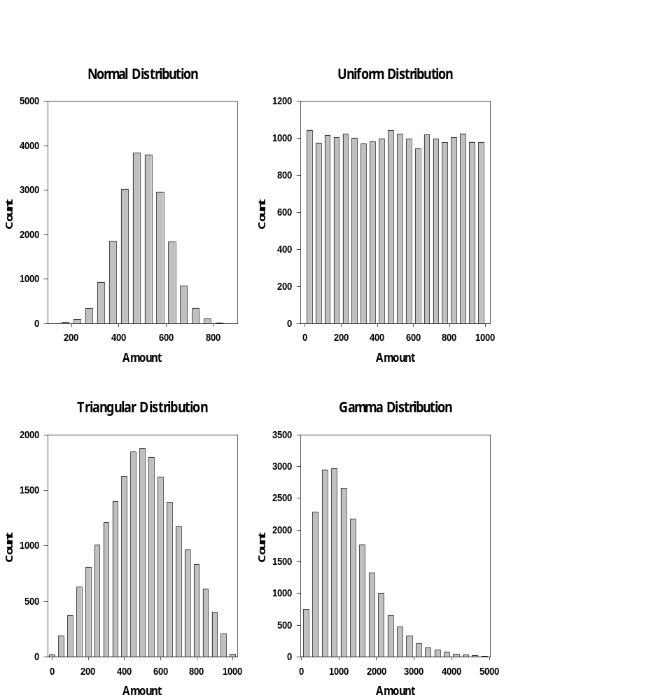

Figure 1 shows data from four distributions. The first graph is a histogram of the data from a normal distribution with a mean of 500 and a standard deviation of 100. The second graph is a uniform distribution over the [0,1000) interval. The third graph is a triangular distribution over the [0,1000) interval with a mode of 500. The fourth graph is a Gamma distribution with a shape parameter of 2.5 and a scale parameter of 500.

FIGURE 2

RESULTS OF THE SECOND-ORDER TEST ON DATA FROM FOUR DISTRIBUTIONS

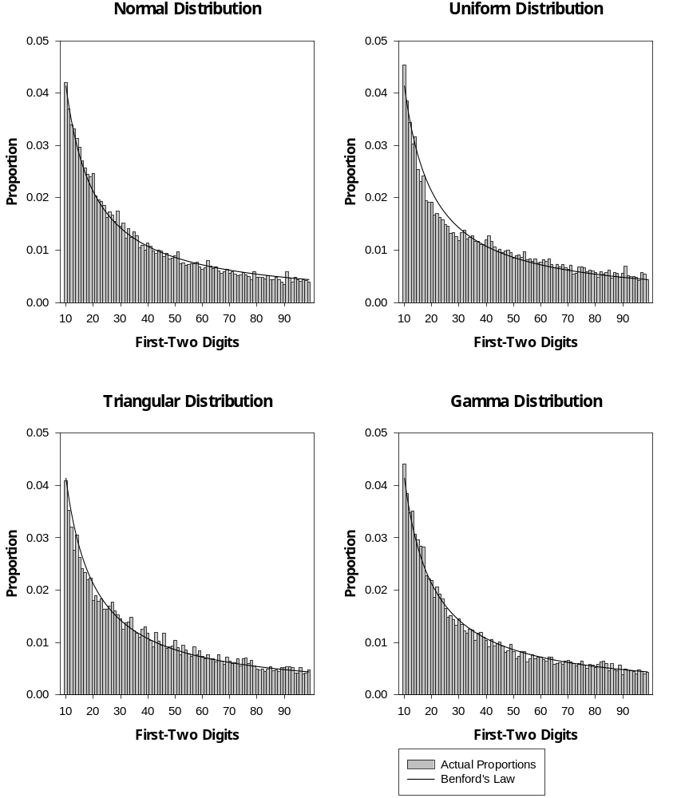

Figure 2 shows the results of the second-order test on the data in Figure 1. The first-two digits are shown on the X-axis and the proportions are shown on the Y-axis. The curved line shows the proportions of Benford’s Law and the actual proportions are represented by the vertical bars.
FIGURE 3

DIGIT PATTERNS OF ACCOUNTS PAYABLE NUMBERS

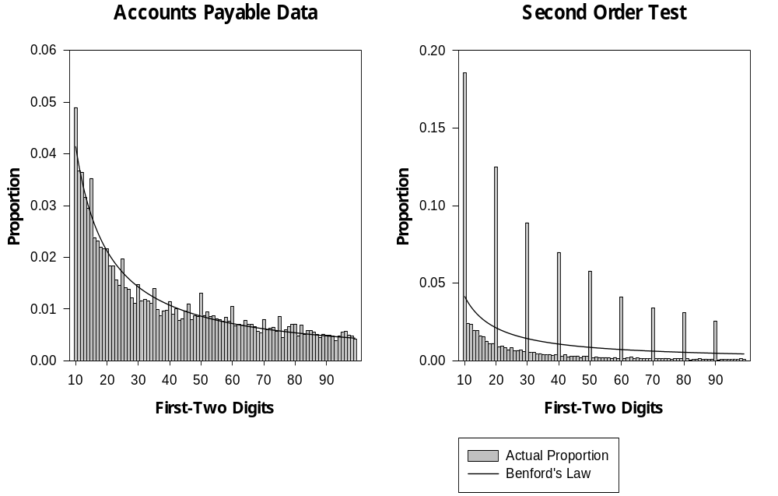

Figure 3 shows the digit frequencies with the first-two digits on the X-axis and the proportions on the Y-axis. The curved line shows the proportions of Benford’s Law and the actual proportions are represented by the vertical bars. The first graph shows the digit frequencies of the original data and the second graph shows the results of the second-order test.

FIGURE 4

DIGIT PATTERNS OF CORPORATE JOURNAL ENTRIES

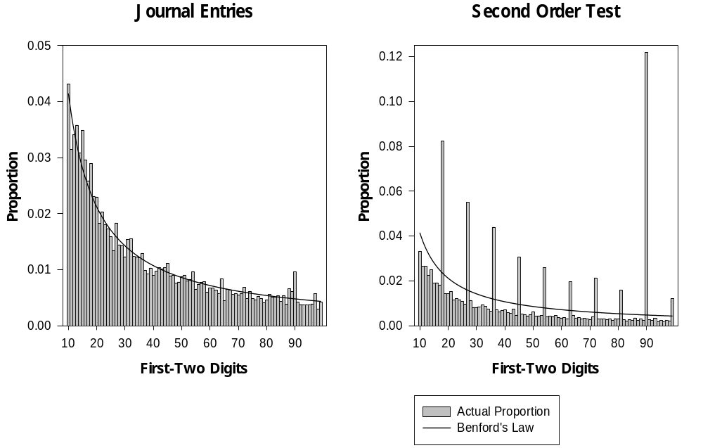

Figure 4 shows the digit frequencies with the first-two digits on the X-axis and the proportions on the Y-axis. The curved line shows the proportions of Benford’s Law and the actual proportions are represented by the vertical bars. The first graph shows the digit frequencies of the original data and the second graph shows the second-order test.

FIGURE 5

SECOND-ORDER TEST ON RESTAURANT DATA

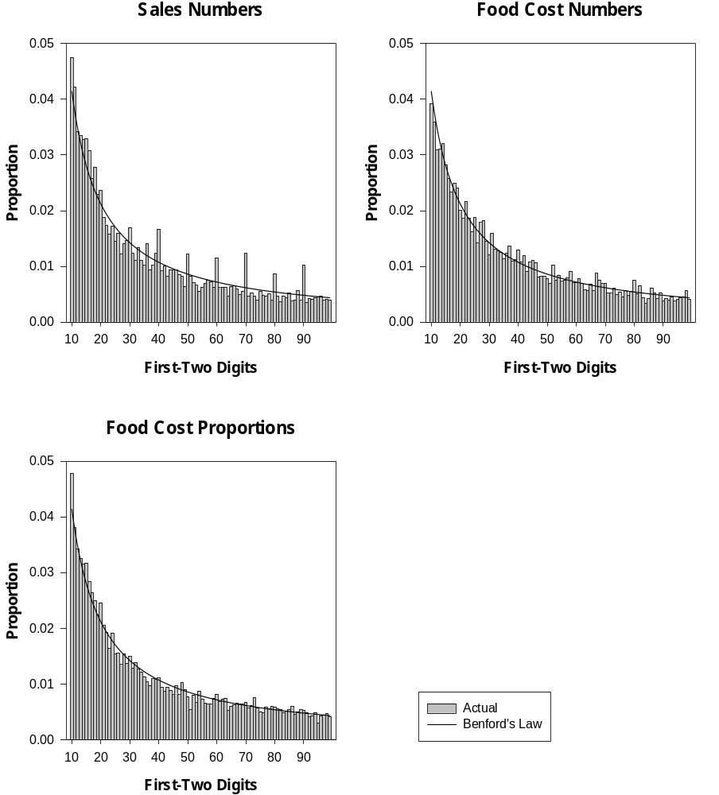

Figure 5 shows the results of the second-order tests on sales and food cost numbers, and food cost proportions. The first-two digits are shown on the X-axis and the proportions are shown on the Y-axis. The curved line shows the proportions of Benford’s Law and the actual proportions are represented by the vertical bars.
FIGURE 6

SEEDING ERRORS IN THE SALES NUMBERS

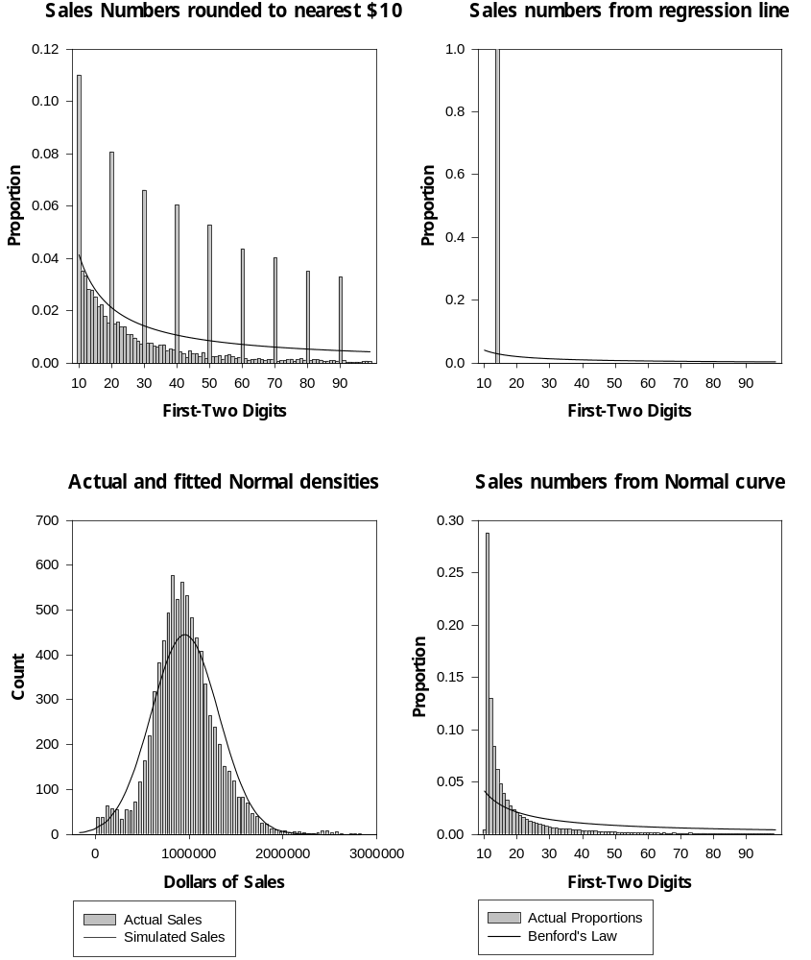

Figure 6 shows the results of seeding the sales data with errors. The first, second, and fourth graphs show the digits on the X-axis and the proportions on the Y-axis. These graphs show the results of rounding, of using values from a regression, and of simulated normal data. The third graph shows the simulated normal density and the histogram of the actual sales data.
FIGURE 7

SORTING ERRORS IN THE SALES NUMBERS

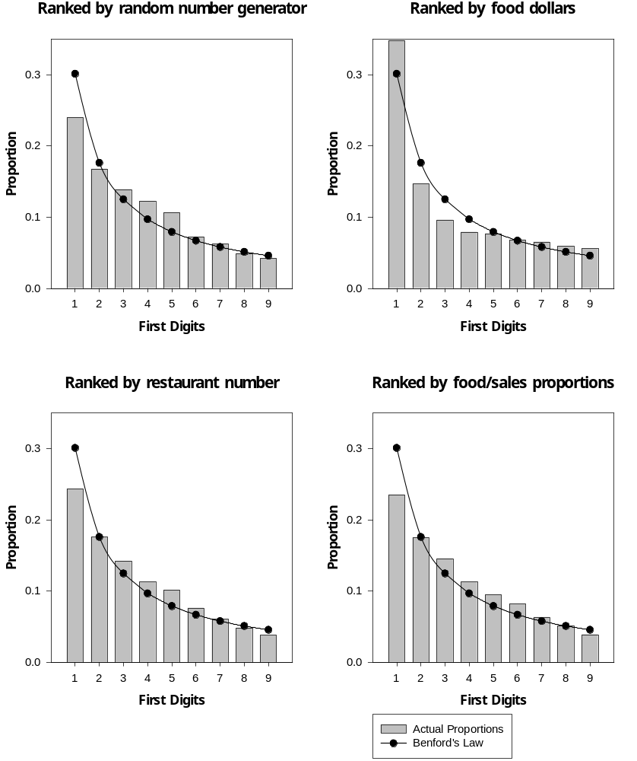

Figure 7 shows the second-order tests on the sales data as incorrectly sorted. The first digits are shown on the X-axis and the proportions are shown on the Y-axis. The curved line shows the proportions of Benford’s Law and the actual proportions are represented by the vertical bars.

