Austin Biehl

August 15, 2020

Foundations of Programming: Python

Assignment 05

PUT GITHUB LINK

# Modifying a To-Do List Manager with Functions

## Introduction

This week, our task was to add functions to our To Do List script from the previous week in order to better organize and execute the code. Similar to the previous week, we were provided with a starter file which had some functions already built into it. I found this assignment challenging, both in terms of handling the problems of my own code, but also needed to integrate it with someone else’s. I will discuss some of these challenges throughout the document.

## Writing the Script

One of the main challenges with this assignment was simply trying to deal with the size of the script. Even before adding our own code, the starter program was nearly twice as long as anything that we’d needed to work on before. It was hard for me to keep track of what was actually going on in the program, since I couldn’t see everything together on one page.

To help counteract this, I ended up creating a separate file and creating the different layers there. For example, I would create the code in the processor class for adding a new task to the file, and then immediately under that create the code for the IO class as well as the main body of the script. This let me see how the different pieces interacted with one another a bit better. I would definitely recommend breaking things up in this way for future students tackling this problem.

Another error that presented itself occurred when I first started try to run the script (Figure 1).

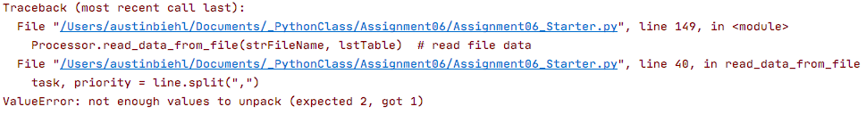

***Figure 1. Value error when running the script.***

Initially, I was quite confused by this error, primarily because the lines that the error was noted as occurring in (149 and 40) were lines of code that had been provided for us in the starter program. With this in mind, I went at looked at the code in line 4 which read, task, priority = line.split(“,”). In this section of the processing layer, I was telling the program how to interpret each line of the file. However, clearly something was going wrong. I went and checked the txt file that the program was using, and finally noticed that there was an additional line under the tasks. The program was looking in this extra line for a “,” and not finding anything, leading to an error. This exercise made me better understand how detail oriented you need to be in order to avoid errors.

Another portion of this assignment that was challenging was testing, and trying to isolate where to make changes in order to get the correct result. However, I eventually was able to get a working program (Figures 2 and 3).

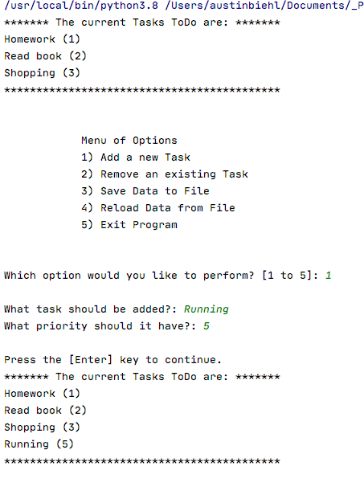

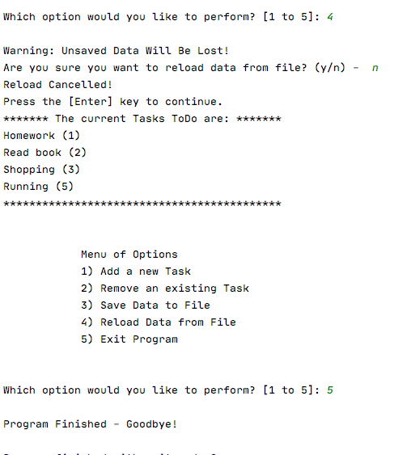

***Figure 2: Program running in PyCharm.***

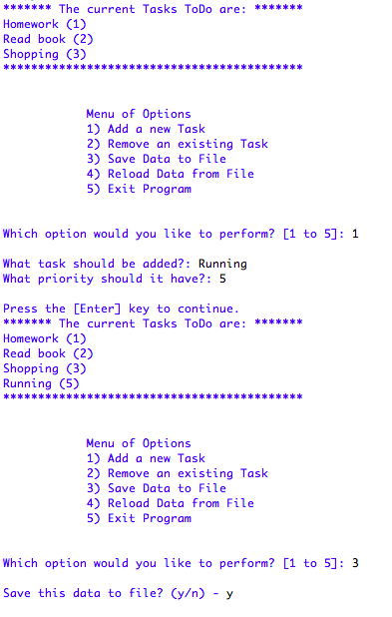

***Figure 3: Program running in Python Shell***

## Summary

While I did come to a functional program, I am still not sure if this assignment helped me to understand the value of using functions. If anything, it seemed like the assignment this week accomplished the same objective as last week, but took 200 lines of code instead of 80. Additionally, I found the troubleshooting with functions to be considerably more challenging, just from the perspective of needing to keep all of the separate parts unified in my head. I think that the previous approach of approaching the program “chronologically” was more intuitive for me. I’m sure that with practice I will get more comfortable with working with functions, but would be interested in knowing more about the overall benefits that they provide when incorporated into a program. Do they decrease run time, errors, or something else?