Austin Biehl

August 30, 2020

Foundations of Programming: Python

Assignment 08

# Classes and Objects in Python

## Introduction

This week our task was once again to take a pre-existing file with pseudocode, and then add our own code to make the program work. While the functionality of the program was very similar to previous assignments, in this case the goals was to use classes and objects in order to accomplish the objectives. In this document, I will talk through the process that I went through, as well as some of the challenges that I faced. Additionally, I will discuss my thoughts on the utility of using classes and objects for a program of this nature.

## Writing the Script

Once again, with the assignment I felt like it was very hard for me to keep track of variables and their names. I can now understand why the developers I see at work have such large screens—it would definitely help when keeping track of everything.

One issue that I had was in the creation of the read data to file and write data to file functions of the file processor class. I noticed that when my script ran, it would print the items in the list with a carriage return after each item. However, when I would use the program and add additional items to the list, there would not be a carriage return. This told me that there was something different between how the program was reading and writing from and to the file. To resolve this issue, in the reading section I decided to add a strip command to remove any additional characters that the script might be reading, even though I myself couldn’t see anything (Figure 1).

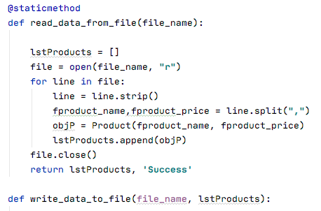

***Figure 1. Stripping carriage returns***

You can see that through the command line = line.strip(), I removed any additional spaces or carriage returns that the program was reading but that were hidden from the viewer.

Through much trial and error, I was able to get a working script that allowed the user to interact with the menu and add information about products and their prices to a file (Figure 2).

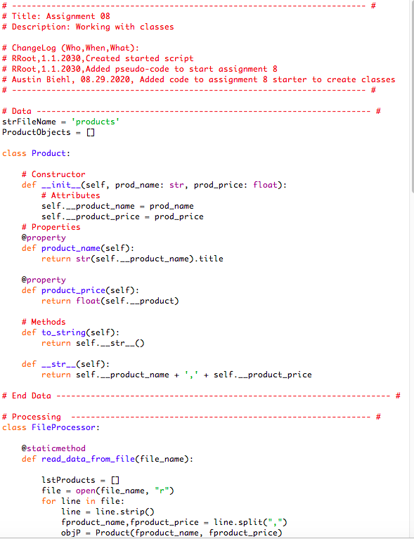

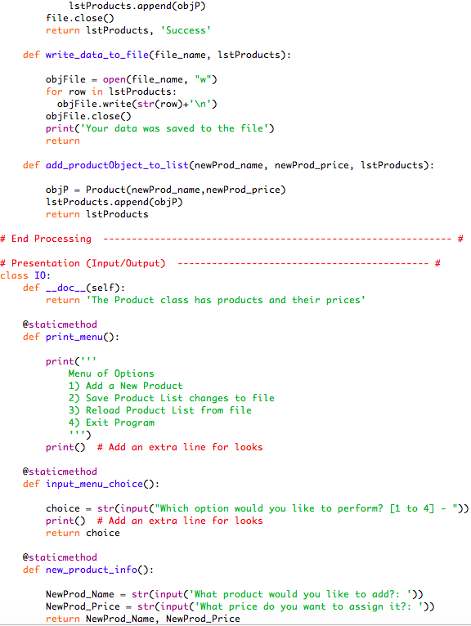

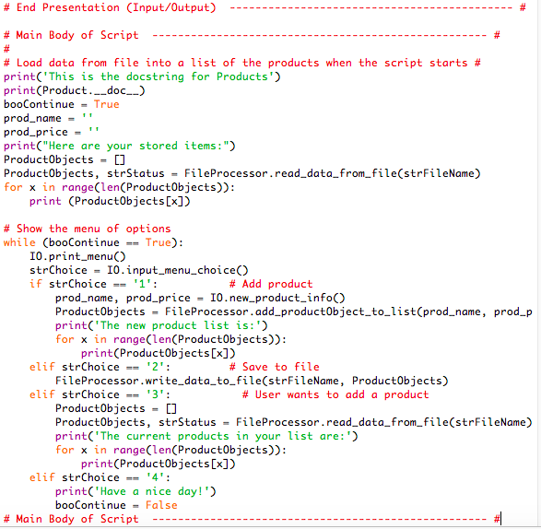

Figure 2. Products and Prices script in Python Shell

Additionally, I ran through all the options in the menu to ensure that the user’s experience didn’t have noticeable problems (Figure 3).

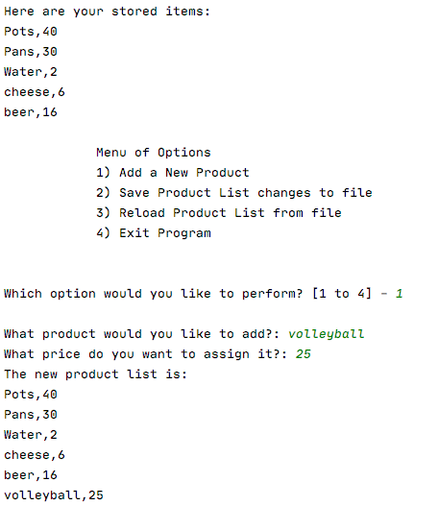

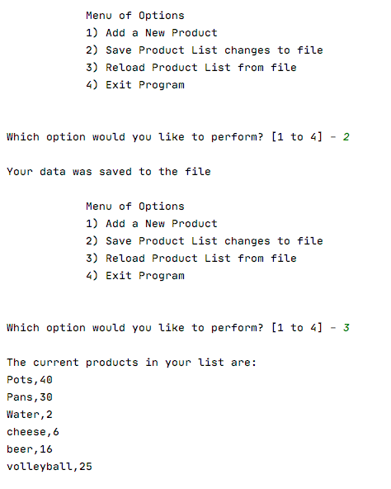

## 

**Figure 3: Output in PyCharm**

## Summary

While this assignment did help with practicing the creating classes and instantiating objects, it did make we wonder if it really made sense to use them in the context of this particular program. From what I could understand from the lecture and the reading, it seems like the advantage of using object-oriented programming is that you create a blueprint or map that you can then use to execute a variety of commands. For example, if you were writing a program that allowed a user to set the temperature of an oven, you could create a class that contained code to tell the oven to receive the input from the user, evaluate its own internal temperature, calculate the difference, increase it’s temperature accordingly, and then shut off when it reached the appropriate temperature. However, all the user needs to know in this case is what temperature they want the oven to be.

However, in the case of this assignment, the program was really just reading and writing data to and from a file, and didn’t really execute any additional functions with that data. Essentially it performed the same function as previous weeks, but the code was just written using objects, classes, and methods, rather than functions. This definitely made me think about what kind of situations object oriented programming could be advantageous to use as a programmer, as opposed to the more straightforward methods that we’ve used in the past.