|  |
| --- |
|  |
| The Documentation |
| [Type the document subtitle] |
|  |
| **[Your Name]** |
| **[Pick the date]** |

[Type the abstract of the document here. The abstract is typically a short summary of the contents of the document. Type the abstract of the document here. The abstract is typically a short summary of the contents of the document.]

Table of Contents

[To update the table of contents, right click the message below and select Update Field (F9 on PC, ⌥⌘U on Mac).]

**No table of contents entries found.**

1. Pages
   1. Page Tree

Home  
 Driving License  
 Assurance Nº  
 Cars Registration  
 QR Code

* 1. Home
     1. User Interface

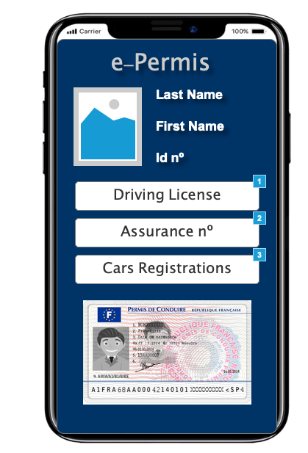

* + 1. Widget Table

| Footnote | Name | Interactions |
| --- | --- | --- |
| 1 | Driving License | OnClick:  Case 1:  Open Driving License in Current Window |
| 2 |  | OnClick:  Case 1:  Open Assurance Nº in Current Window |
| 3 |  | OnClick:  Case 1:  Open Cars Registration in Current Window |

* 1. Driving License
     1. User Interface

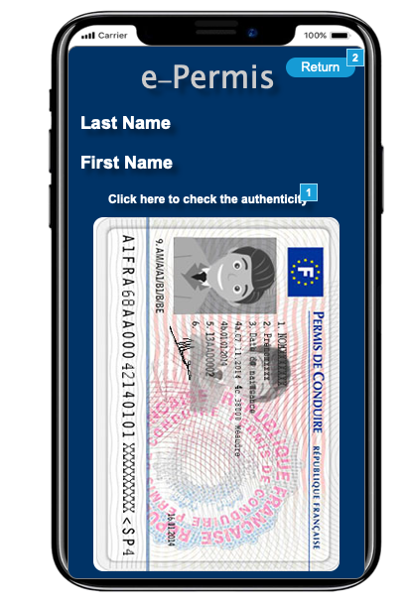

* + 1. Widget Table

| Footnote | Interactions |
| --- | --- |
| 1 | OnClick:  Case 1:  Open QR Code in Current Window |
| 2 | OnClick:  Case 1:  Open Home in Current Window |

* 1. Assurance Nº
     1. User Interface

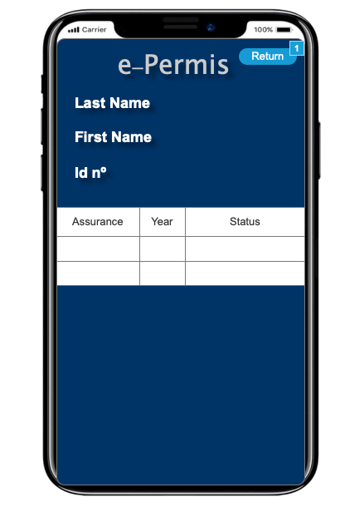

* + 1. Widget Table

| Footnote | Interactions |
| --- | --- |
| 1 | OnClick:  Case 1:  Open Home in Current Window |

* 1. Cars Registration
     1. User Interface

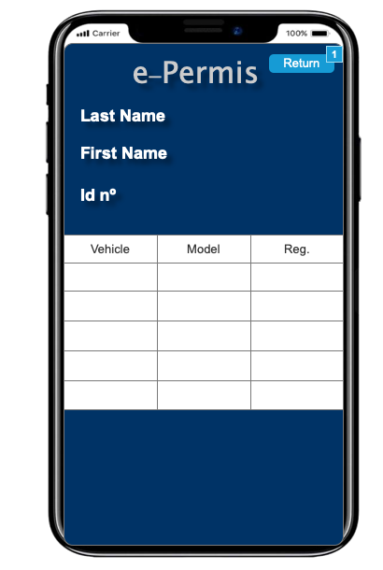

* + 1. Widget Table

| Footnote | Interactions |
| --- | --- |
| 1 | OnClick:  Case 1:  Open Home in Current Window |

* 1. QR Code
     1. User Interface

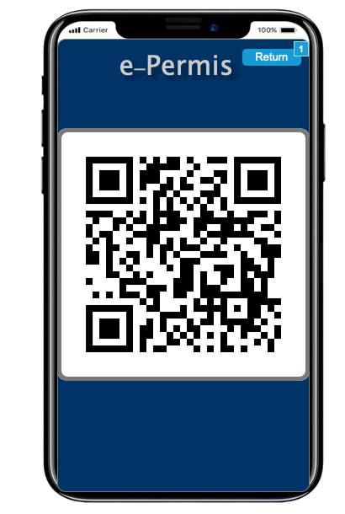

* + 1. Widget Table

| Footnote | Interactions |
| --- | --- |
| 1 | OnClick:  Case 1:  Open Driving License in Current Window |