climada module **country risk**  26 Dec 2014

<https://github.com/davidnbresch/climada_module_country_risk>

[david.bresch@gmail.com](mailto:david.bresch@gmail.com)

This module runs all (available) perils for one country[1]. It generates earthquake (EQ), tropical cyclone (TC), torrential rain (TR) and storm surge (TS) hazard event sets, checks for European winter storm (WS) exposure and runs all risk calculations for a given country (see option for any state/province or admin1 further below).

**country_risk=country_risk_calc(country_name)**

**country_risk_report(country_risk)**

and (see further below)

country_admin1_risk_calc**(country_name,province_name)**

climada_nightlight_entity**(country_name,province_name)**

Procedure is as follows:

1) generate centroids for the country (uses climada_create_GDP_entity[2])

2) figure which hazards affect the country

3) create the hazard event sets, using

- climada_tc_hazard_set (tropical cyclone wind[3])

- climada_tr_hazard_set (tropical cyclone rain[4])

- climada_ts_hazard_set (tropical cyclone surge[5])

- eq_global_hazard_set (earthquake[6])

- European winter storm (hazard not generated, just assigned[7])

4) run the risk calculation for all hazards

In essence, you define the country and the code runs the generation of centroids, default assets (from nightlight intensity, see climada module GDP_entity) and the EQ, TC, TR and TS hazard event sets plus checks for WS Europe exposure. It even figures whether the country is exposed to more than one ocean basin and in such a case generates a suite of TC/TS/TR hazard event sets for each ocean basin. The code is ready for upgrade with additional hazards (usually a new hazard is a new climada module). That’s why the code notifies the user if the specific hazard module is missing (even indicates the github location where to get it from).

**Simply call e.g. country_risk_calc(‘El Salvador’)**

If called without any argument, a list dialog to select the country pops up. See code header for details, i.e. **help country_risk_calc**

Behind the scenes, the code centroids_generate_hazard_sets does the heavy lifting, i.e. steps 2) and 3) from above. This way one can generate all relevant hazard sets with one call to centroids_generate_hazard_sets for any set of centroids (e.g. only a part of a country, a region, a city…[8]):

centroids_hazard_info=...

centroids_generate_hazard_sets(centroids,force_recalc,check_plots)

The resulting structure centroids_hazard_info contains the names of the generated hazard sets (or the ones generated earlier if just called to check for step 2) in centroids_hazard_info.res.hazard(i).hazard_set_file (the somewhat complicated nested structure is due to the flexibility required by country_risk_calc).

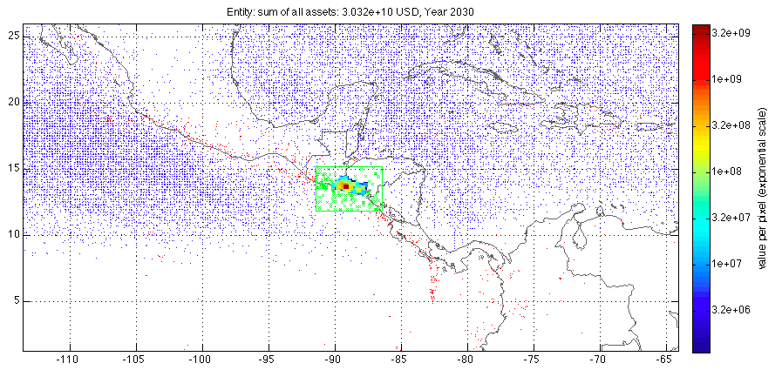

Figure: Step 1 (generate centroids, assets distribution, color scale indicates value per centroid) and step 2 (hazard selection). The green box shows the selection area around the country, the blue dots are all the TC track nodes (historic) and the red dots the epicenters (historic). This figure is generated if check_plot=1 in the call, e.g. country_risk_calc(‘El Salvador’,0,0,1).

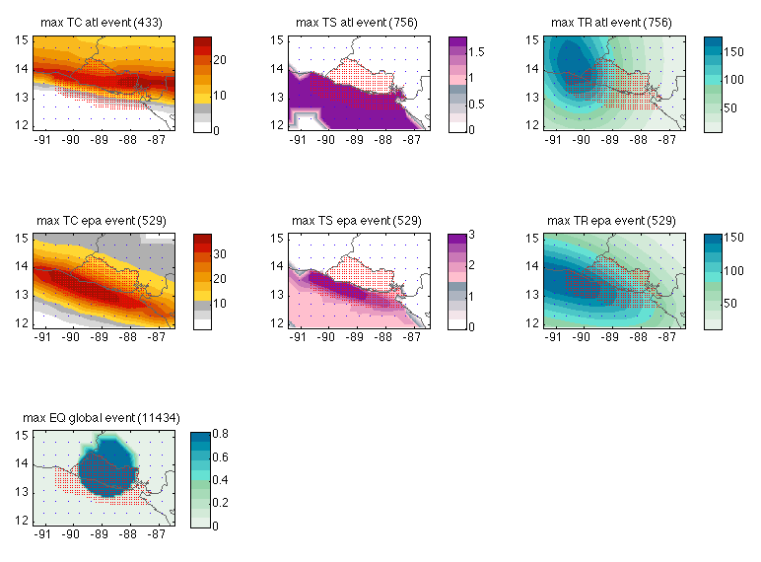

Figure: The most intense single event for all hazard generated for El Salvador (Step 3). Note that El Salvador is both exposed to tropical cyclones from the East and West, that’s why there are two hazard events sets for TC/TS/TR, one for the Atlantic side (atl for Atlantic), one for the Pacific side (epa for East Pacific Ocean). The earthquake model is global. Note further the nice feature of hazard (or peril) – dependent color scales; and the coarser resolution of centroids (blue) around the country (with red dots at high-density centroids) to support plotting hazard intensities around the country, too. This figure is generated if check_plot=1 in the call, e.g. country_risk_calc(‘El Salvador’,0,0,1)

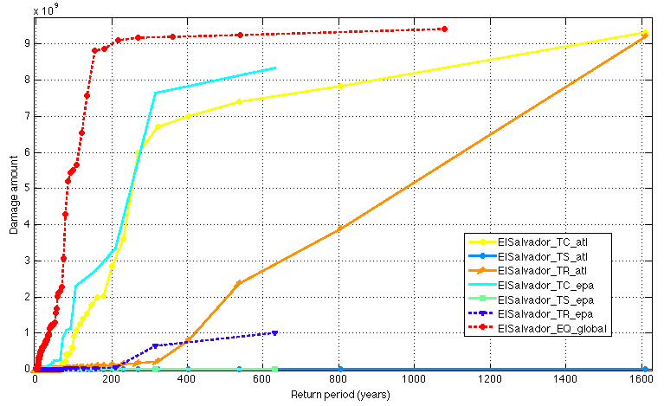

Figure: The resulting damage frequency curves (DFC) for all seven (!) hazards affecting El Salvador (values just for illustration, based on dummy damage functions). This figure is generated with check_plot=1 in the call, e.g. country_risk_report(country_risk_calc(‘El Salvador’,1,1),0,1)

If one runs some select countries, country_risk_report comes handy, e.g:

country_risk=country_risk_calc(‘Barbados’)

country_risk(2)=country_risk_calc(‘El Salvador’)

country_risk(3)=country_risk_calc(‘Costa Rica’)

And then country_risk_report(country_risk,0) results in the following output (to stdout, also an Excel or .csv file is written[9]):

Barbados (1)

TR EL=36572051.496470 (8.481508%o) Barbados_TR_atl

TC EL=23083330.494007 (5.353308%o) Barbados_TC_atl

TS EL=7531.966739 (0.001747%o) Barbados_TS_atl

EQ EL=0.000000 (0.000000%o) Barbados_EQ_global

ElSalvador (2)

EQ EL=415631535.361110 (17.943889%o) ElSalvador_EQ_global

TR EL=141613002.072040 (6.113800%o) ElSalvador_TR_epa

TC EL=59386249.565168 (2.563858%o) ElSalvador_TC_atl

TC EL=16152772.894979 (0.697357%o) ElSalvador_TC_epa

TR EL=621784.438763 (0.026844%o) ElSalvador_TR_atl

TS EL=0.000000 (0.000000%o) ElSalvador_TS_epa

TS EL=0.000000 (0.000000%o) ElSalvador_TS_atl

Costa Rica (3)

EQ EL=523833928.441207 (12.396559%o) Costa Rica_EQ_global

TR EL=1530537.767294 (0.036220%o) Costa Rica_TR_epa

TC EL=73978.520263 (0.001751%o) Costa Rica_TC_epa

TR EL=5765.009179 (0.000136%o) Costa Rica_TR_atl

TS EL=1689.347413 (0.000040%o) Costa Rica_TS_atl

TC EL=60.830655 (0.000001%o) Costa Rica_TC_atl

TS EL=0.000000 (0.000000%o) Costa Rica_TS_epa

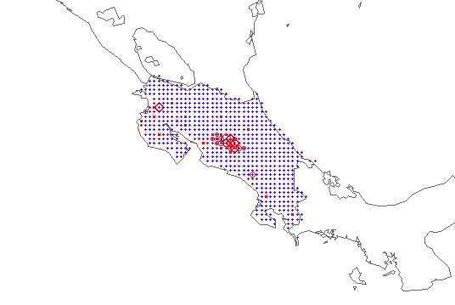

Figure: The local damage for a given peril (here EQ) for one country (here Costa Rica) in spatial resolution (e.g. at each centroid). Produced by the call (following from above resulting structure country_risk):

country_i=3; hazard_i=7[10];

climada_circle_plot(...

country_risk(country_i).res.hazard(hazard_i).EDS.ED_at_centroid,...

country_risk(country_i).res.hazard(hazard_i).EDS.assets.Longitude,...

country_risk(country_i).res.hazard(hazard_i).EDS.assets.Latitude)

**country_admin1_risk_calc**: Same as country_risk_calc, but for a state or province (admin1 level) of any given country. Run the all (available) perils for one country's admin1 level. Obtain the admin1 boundaries (from [www.naturalearthdata.com](http://www.naturalearthdata.com), shape files already part of the data that comes with the country risk module) and carve out the respective centroids (set Value at all others to zero). Run the risk calculation for each admin1 for all hazards. In case one would like to skip hazards, just (temporarily) remove the respective {country_name}_*.mat hazard event sets. ONLY makes sense if country_risk_calc has been run for the respective country (we keep it like this, as automatic mode might trigger lots of un-wanted calculations). If not, the code terminates with the respective messages (no entity found, no hazard set(s) found...). But one can run country_admin1_risk_calc for more than one country, if the respective countries have been run as country_risk_calc. NOTE: Before using this code, make yourself familiar with country_risk_calc and country_risk_report (same format as country_risk_calc).

**climada_nightlight_entity**: Construct an entity file based on high-res (1km!) night light data[11]. Reads an image file with nightlight density[12] and matches it to the local geography. Prompts for country (admin0) and state/province (admin1), constrains the active centroids (with values>0) to the selected country or admin1 and saves the entity. Since we're dealing with admin1, no automatic scaling or allocation of GDP to centroids is performed (for this, see climada_create_GDP_entity[13]).

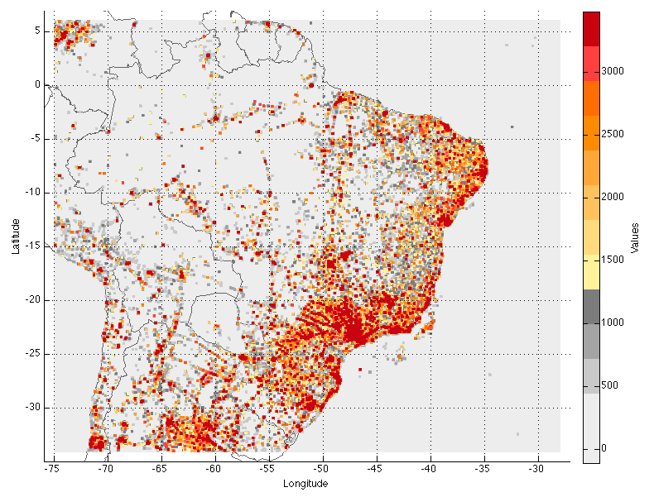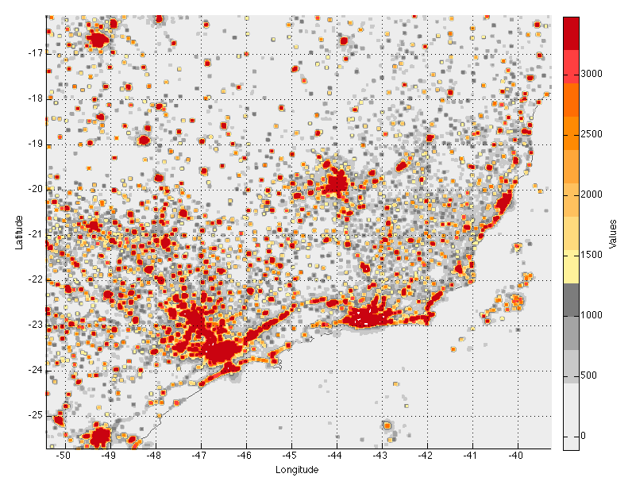

Figure: Brazil value distribution on 1km (!) resolution (left, zoomed in right) as generated by climada_nightlight_entity(‘Brazil’,’’,2)

1. See further below for country_admin1_risk_calc, which runs the calculation for one state/province in a given country. The routine climada_country_risk also allows for processing a list or even all countries. As always, use help climada_country_risk to get a detailed description on the options.
2. See <https://github.com/davidnbresch/climada_module_GDP_entity> and further below for climada_nightlight_entity which allows to generate a high-resolution entity for any country and state/province.
3. Core climada contains the basic tropical cyclone hazard, but please add the module <https://github.com/davidnbresch/climada_module_tc_hazard_advanced> to generate useful probabilistic hazard event sets (see parameter probabilistic in country_risk_calc). Please consider to run climada_tc_get_unisys_databases (climada core) in order to download the latest tropical cyclone databases for all ocean basins (core climate comes with TC Atlantic to start with).
4. See climada module <https://github.com/davidnbresch/climada_module_tc_rain>
5. See climada module <https://github.com/davidnbresch/climada_module_tc_surge> which also requires the module <https://github.com/davidnbresch/climada_module_etopo>
6. See climada module <https://github.com/davidnbresch/climada_module_eq_global>
7. See climada module for European winter storm, which contains the hazard sets <https://github.com/davidnbresch/climada_module_ws_europe>
8. See e.g. the code climada_cut_out_GDP_entity from <https://github.com/davidnbresch/climada_module_GDP_entity> and also country_admin1_risk_calc and climada_nightlight_entity further below (part of module country risk)
9. The report does contain the annual expected damage (ED) as well as defined return periods (such as 100 and 250 years). In case writing an Excel file fails, a .csv file is written.
10. Note that the number seven here corresponds to the 7th hazard analyzed (EQ). The report to stdout shows EQ as the first result, since country_risk_report sorts by descending damage, unless it is called with the second parameter (print_unsorted) set to 1.
11. One can also run it at moderate (10x10km) resolution, see parameter selections, i.e. type help climada_highres_entity
12. The climada module country_risk comes with the .mat file F182012.v4c_web.stable_lights.avg_vis.mat (24MB), since the .tif image is about 700MB. See <http://ngdc.noaa.gov/eog/dmsp/downloadV4composites.html#AVSLCFC3> to obtain the file <http://ngdc.noaa.gov/eog/data/web_data/v4composites/F182012.v4.tar> and unzip the file F182012.v4c_web.stable_lights.avg_vis.tif in there to the /data folder of country_risk module. As the .tif is so much larger, the climada module country_risk comes with the .mat file, but does not contain the original (.tif). Should the .mat file not exist, climada_nightlight_entity creates it on first call. Please note that the GDP_entity could also deal with such a high-res dataset (see respective documentation).
13. See footnote 8 above