climada module tc_hazard_advanced 20 Dec 2014

<https://github.com/davidnbresch/climada_module_tc_hazard_advanced>

[muellele@gmail.com](mailto:muellele@gmail.com), [david.bresch@gmail.com](mailto:david.bresch@gmail.com)

This module implements the tropical cyclone (TC) attenuation after landfall for probabilistic events. Make yourself familiar with the core climada tropical cyclone hazard event set (and its generation) first. A good implementation of both the basic, probabilistic and advanced tropical cyclone hazard generation can be found in the climada module country risk[1] and there in the routine centroids_generate_hazard_sets.

This module is not to be used stand-alone, but usually such as:

% read TC tracks from database file:

tc_track=climada_tc_read_unisys_database

% wind speed decay at track nodes after landfall:

[~,p_rel] = climada_tc_track_wind_decay_calculate(tc_track,1);

% generate the probabilistic TC tracks:

tc_track=climada_tc_random_walk(tc_track);% overwrites to save memory

% add the inland decay correction to all probabilistic nodes:

tc_track = climada_tc_track_wind_decay(tc_track, p_rel,1);

% plot the tracks

for event_i=1:length(tc_track)

plot(tc_track(event_i).lon,tc_track(event_i).lat,'-b');

end % event_i

% overlay historic (to make them visible, too)

for event_i=1:length(tc_track)

if tc_track(event_i).orig_event_flag

plot(tc_track(event_i).lon,tc_track(event_i).lat,'-r');

end

end % event_i

climada_plot_world_borders(2) % plot world borders

box on; axis equal; axis(centroids_rect);

xlabel('blue: probabilistic, red: historic');

% generate the TC hazard event set:

hazard = climada_tc_hazard_set(tc_track,centroids);

The climada tropical cyclone (TC) hazard module forms an integral part of the probabilistic damage model. The hazard module characterizes the peril through the description where, how often and with what intensity events occur. The hazard module can be developed for almost any hazard (wind, flood, storm surge, landslides…). Here, we describe how to generate an **advanced** tropical cyclone hazard.

Tropical cyclones are rapidly rotating storm systems that are characterized by a low-pressure center, strong winds and spiral arrangement of thunderstorms that produce heavy rains. Depending on their location and strength, tropical cyclones are referred differently, such as hurricanes in the western North Atlantic, eastern North Pacific, Caribbean Sea and Gulf of Mexico, typhoons in the western North Pacific, cyclones in the South Pacific, Indian Ocean, the Bay of Bengal and the Arabian Sea. Figure 1 displays historical tropical cyclones worldwide.

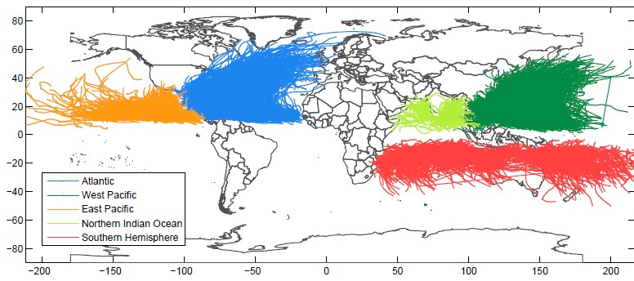

*Figure 1: Historical tropical cyclone tracks in the Atlantic, the West Pacific, East Pacific, Northern Indian Ocean and the Southern Hemisphere.*

### Historical data

1a) Download the data

The climada (core) routine **climada_tc_get_unisys_databases** does it all automatically for you.

Download the raw data from [*http://weather.unisys.com/hurricane*](http://weather.unisys.com/hurricane)*.*

Basin Internet page

North Atlantic (atl) <http://weather.unisys.com/hurricane/atlantic/tracks.atl>

East Pacific (epa) <http://weather.unisys.com/hurricane/e_pacific/tracks.epa>

West Pacific (wpa) <http://weather.unisys.com/hurricane/w_pacific/tracks.wpa>

Southern Hemisphere (both Pacific and South Indian Ocean) (she)

<http://weather.unisys.com/hurricane/s_indian/tracks.she>

North Indian Ocean (nio) <http://weather.unisys.com/hurricane/n_indian/tracks.nio>

Upon download, it is worth adding the extension .txt, so the files can be read with any editor (they are ASCII), such that the North Atlantic file becomes e.g. **tracks.atl.txt**. In order of testing routines and understanding the methodology in a faster way, a shortened version of the North Atlantic dataset, **TEST_tracks.atl.txt** is often used, referred to as **TEST atl** data (just comprising the last few years of data). You find this dataset at *…\climada\data\tc_tracks\TEST_tracks.atl.txt*

Please consult Appendix B for details of the raw data file structure.

1b) Add storm category

Add storm category according to Saffir - Simpson Hurricane Scale to every track (Table 1).

**tc_track =climada_tc_stormcategory(tc_track);**

*Table 1: Saffir-Simpson Hurricane Scale.*

*Category Maximum Sustained Wind Speed* Storm Surge*

*knots mph km/h m/s m*

|  |  |  |  |  |  |
| --- | --- | --- | --- | --- | --- |
| Tropical Depression | < 34 | < 39 | < 63 | < 18 | ≈ 0 |
| Tropical Storm | < 64 | < 73 | < 118 | < 33 | 0,1–1,1 |
| Hurrican Category 1 | < 83 | < 95 | < 153 | < 43 | 1,2–1,6 |
| Hurrican Category 2 | < 96 | <110 | < 177 | < 49 | 1,7–2,5 |
| Hurrican Category 3 | < 113 | <130 | < 209 | < 58 | 2,6–3,8 |
| Hurrican Category 4 | < 135 | <155 | < 249 | < 69 | 3,9–5,5 |
| Hurrican Category 5 | > 135 | > 155 | > 250 | > 70 | > 5,5 |

* 1-minute period, at 10 m (33 ft) above the surface

Source: [*http://en.wikipedia.org/wiki/Saffir%E2%80%93Simpson_Hurricane_Scale*](http://en.wikipedia.org/wiki/Saffir%E2%80%93Simpson_Hurricane_Scale)

### Probabilistic data

2a) Incorporate wind speed decay after landfall

In order to have realistic probabilistic tracks, a wind speed decay function needs to be incorporated. The wind speed decay function can be derived from the historical tc tracks. We use an exponential decay function as proxy for the wind speed decay. The exponential decay function is calculated with the function **climada_tc_track_wind_decay_calculate** y and the parameters are saved in the file **p_rel.mat**. For more information on wind decay after landfall see Appendix 6a).

Firstly we need to identify the timing of landfalls to each tc_track structure and hence we add an on land variable for every TC track. Hint: see **border_mask** (matlab variable) to understand land/sea differentiation.

**tc_track =climada_tc_track_on_land(tc_track,border_mask)**

Secondly, we calculate the wind speed decay after landfall based on historical tc tracks:

[tc_track p_rel]=...  
climada_tc_track_wind_decay_calculate(tc_track,check_plot);

And thirdly, we apply the wind speed decay function to the probabilistic tracks

**tc_track_prob=...  
climada_tc_track_wind_decay(tc_track_prob,p_rel, check_plot);**

Finally add the saffir simpson storm category to each tc track based on the maximum sustained wind speed over the track lifetime.

**tc_track = climada_tc_stormcategory (tc_track);**

Absolute wind speed decay Relative wind speed decay

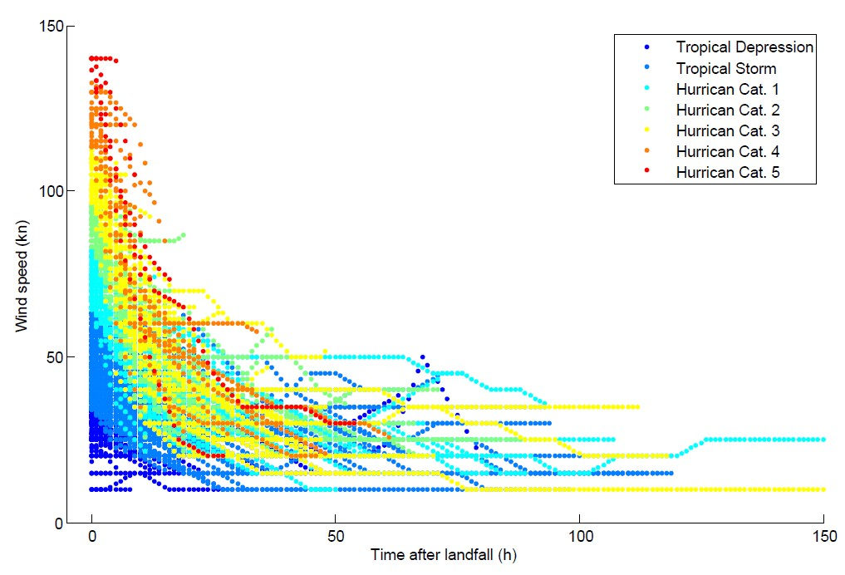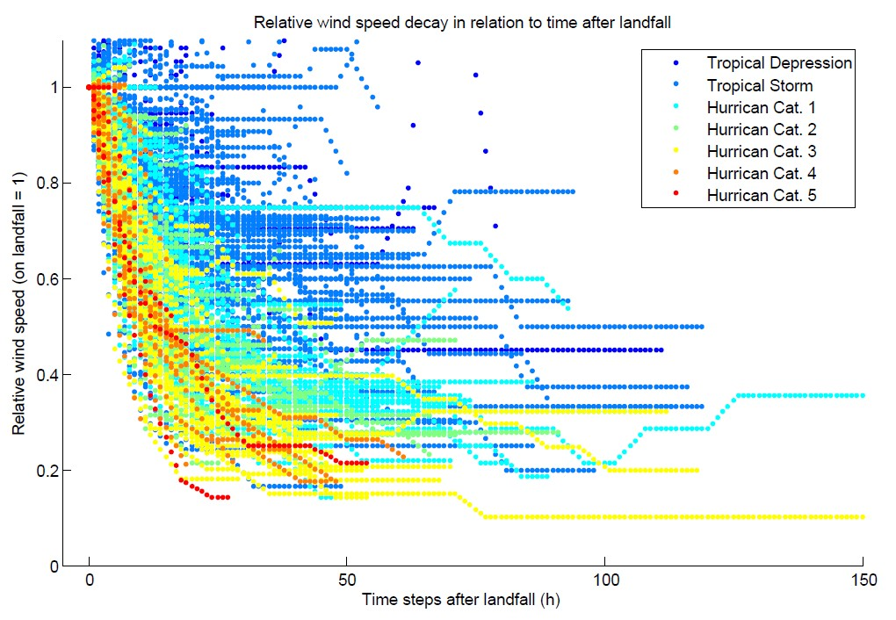

*Figure 2: Absolute wind speed decay after landfall of historical tracks in the North Atlantic (1445 tracks).*

*Figure 3: Relative wind speed decay after landfall of historical tracks in the North Atlantic (1445 tracks). Wind at landfall equals 1.*

Relative wind speed decay with fitted functions Fitted functions of wind speed decay

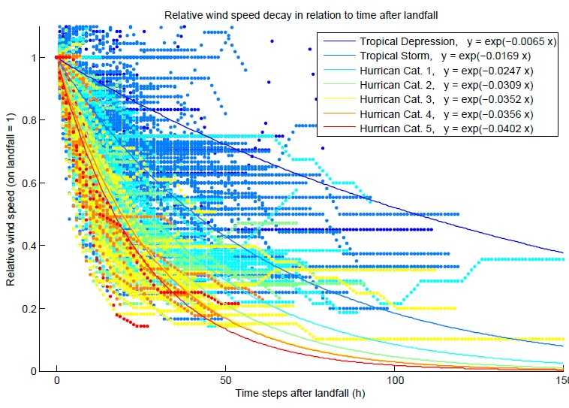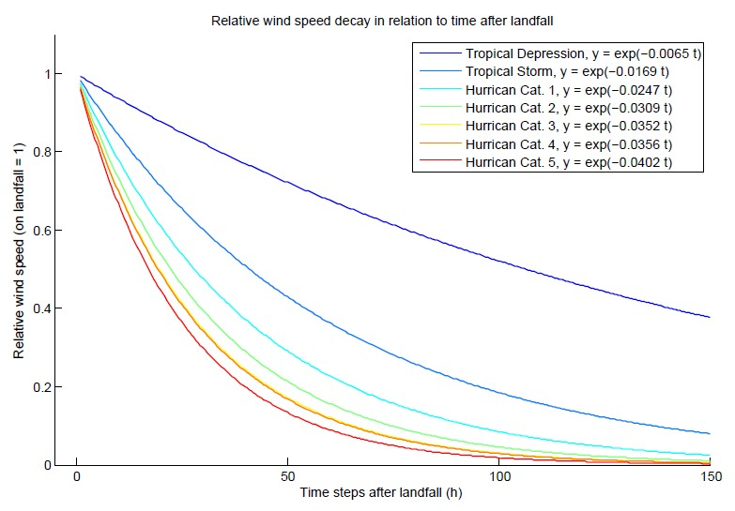

*Figure 4: Relative wind speed decay after landfall of historical tracks in the North Atlantic (1445 tracks). Wind at landfall equals 1. The lines are the fitted functions for the exponential decay with starting point 1 at landfall.*

*Figure 5; Relative wind decay, fitted functions for tropical depression, storm and Hurricanes category 1 to 5.*

### Hazard

3a) Calculate distance to coast for centroids

Calculate distance to closest coastline for every centroid. The basis for this calculation is the coastline data. The coastline data is downloaded from NOAA[2] and saved in *…\climada_module_tc_hazard_adavanced\data\coastline.txt*

**coastline=climada_coastline_read(centroids,coastline_file, check_plot)**

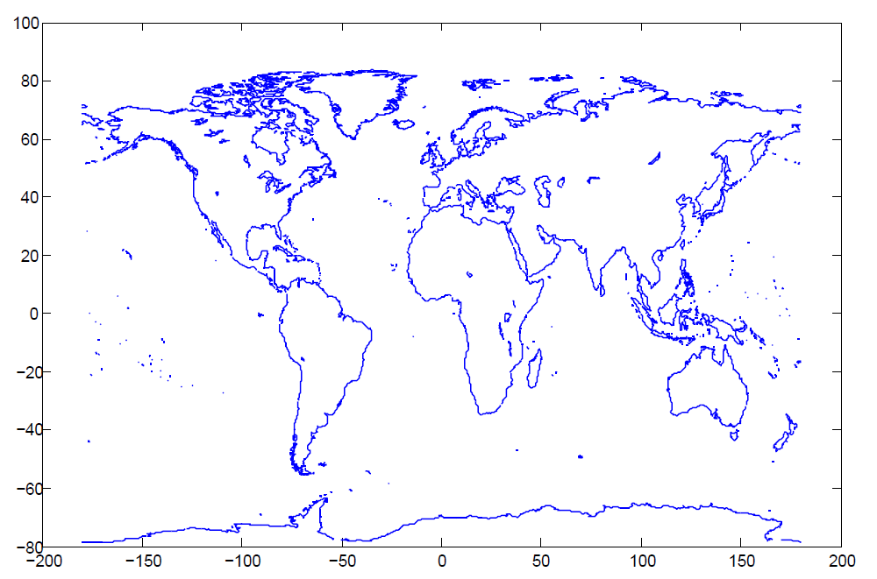*Figure 6: Coast line downloaded from* 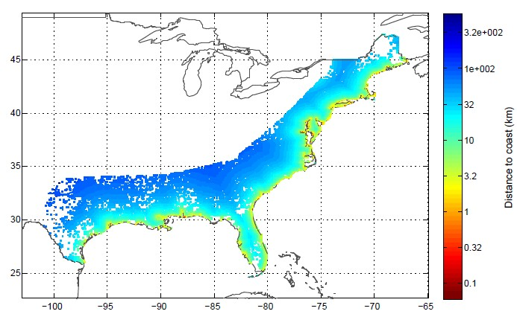

*Figure 7: Distance to coast for every centroid in km and* *displayed with a logarithmic color scheme.*

centroids=...

climada_centroids_distance_to_coast(centroids,coastline,check_figure)

3b) Generate the wind footprint(s)

Generate wind field resulting from single track of tropical cyclone. The function converts **tc_track.MaxSustainedWind** in knots to **res.gust** in m/s.

Normally the wind footprint calculation is tested on a single TC track prior to generation of the hazard event set of all the entire historical and probabilistic track set. The TC windfield calculations are speeded up by only calculating for centroids within 750 km distance of min,max track lon/lat and by not assigning **res.node_lon(centroid_i)**, **res.node_lat(centroid_i).** Uses function **climada_gridded_VALUE**

**res = climada_tc_windfield(tc_track,centroids,equal_timestep,   
 silent_mode, check_plot)**

Method: Currently, the code implements the Holland windfield[3].

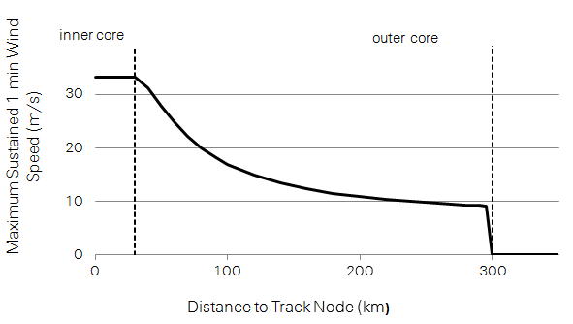

*Figure 8: Maximum sustained 1 min wind speed in relation to the distance to the track node.*

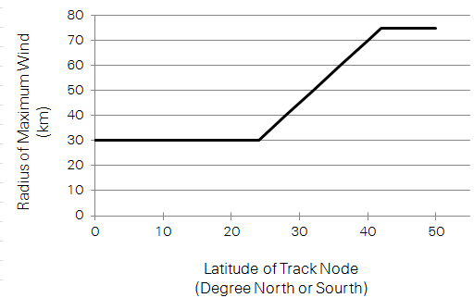

*Figure 9: Radius of maximum wind in relation to latitude of track node.*

Finally the wind speed (S) describes the maximum sustained 1 min wind speed. To get wind gusts that a few seconds (3..5 s) wind peaks are typically around 27% higher than a 1 min sustained wind in a hurricane environment[4].

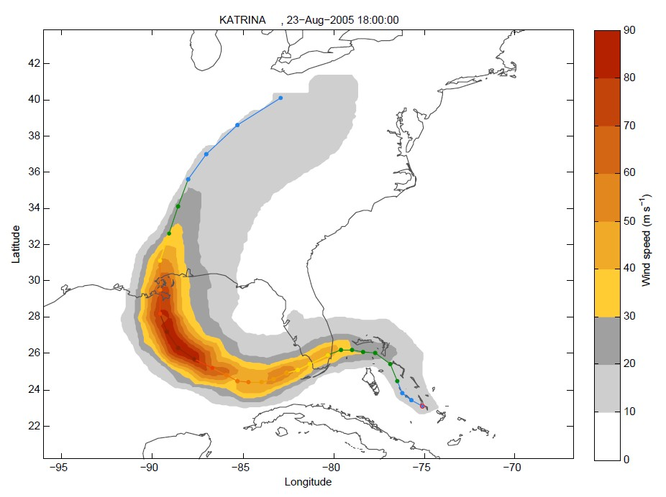

*Figure 10: Wind footprint calculated based on track 1340 Katrina.*

Any other windfield parametrization can be implemented in a similar fashion (just implement in a copy of climada_tc_windfield, e.g. **climada_tc_windfield2**, see also the routine **climada_tc_hazard_set** to change the caller when generating the probabilistic set).

In order to test the wind field calculation, the following might help:

Use the tc_track structure (should still be in memory), but start with only one track, e.g. tc_track(84) for the 84th track. Investigate tc_track.name to find a particular event. Use e.g. the following code to show a list of track number, year and name:

for i=1:length(tc_track)

fprintf('%i %i %s\n',i,tc_track(i).yyyy(1), char(tc_track(i).name));

end

Load the centroids using **centroids = climada_centroids_read('',1)**, note that this call also plots the centroids (use the zoom function on the map). See also the parameter **check_plot** in the PARAMETER section of the code or refer to the routine **climada_color_plot**.

3c) Calculate the wind fields for a single track and display as animation

Refines tc track to 1hour resolution, calculates wind field for every time step of 1h. The function displays the wind fields for selected aggregated time steps, e.g. 3h, 6h, 24h. Aggregation default is 6h.

climada_tc_windfield_animation(tc_track(1340),centroids,   
 aggregation, check_avi)

res=climada_tc_windfield_timestep(tc_track(1340),centroids,   
 equal_timestep);

Uses functions **climada_gridded_VALUE** and **climada_tc_windfield_timestep.**

Movie saved in *...\results\windfield_animation_trackname_24h.avi*

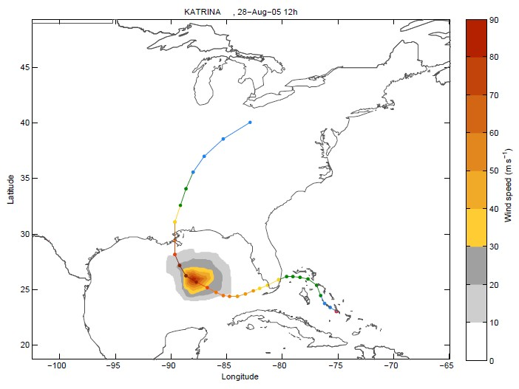

*Figure 14: Wind field calculated for every timestep.*

3d) Create the Hazard Set (i.e. all Footprints)

**hazard=climada_tc_hazard_set (tc_track,hazard_set_file,centroids**

3e) Hazard weakening due to distance to coast

A correction for wind speed decrease is introduced in the **hazard.arr** array in order to incorporate the weakening of tropical cyclone when over land. The hazard weakening function depends on the distance to coast as well on the category of the tropical cyclone.

**hazard=...  
 climada_hazard_distance_to_coast (hazard,centroids,tc_track)**

The weakening of the tropical cyclone is assumed with an exponential decay as a function of the distance D from the centroid to the coast (in km). a and b are parameters that vary depending on the cyclone intensity (Saffir-Simpson Scale). The values for the parameters a, b and c for different countries are listed in Table 1.

*Table 1: Parameters for cyclone weakening function depending on cyclone category and country.*

|  |  |  |  |
| --- | --- | --- | --- |
| *USA* |  | | |
| Cyclone category | a | b | c |
| Tropical depression, storm | 0.90 | 700 | 0.90 |
| H. cat 1 and 2 | 0.85 | 500 | 0.85 |
| H. cat 3, 4, and 5 | 0.85 | 320 | 0.35 |
| *Australia*  Tropical depression, storm | 1 | 700 | 0.9 |
| H. cat 1 and 2 | 1 | 25 | 0.5 |
| H. cat 3, 4, and 5 | 1 | 10.5 | 0.2 |
| *Japan*  Tropical depression, storm | 1 | 700 | 0.9 |
| H. cat 1 and 2 | 1 | 25 | 0.5 |
| H. cat 3, 4, and 5 | 1 | 10.5 | 0.2 |
| China  Tropical depression, storm | 1 | 50 | 0.1 |
| H. cat 1 and 2 | 1 | 15 | 0.1 |
| H. cat 3, 4, and 5 | 1 | 8.5 | 0.1 |

For more information on the calibration see Appendix 6.2 Calibration of hazard weakening 6b.

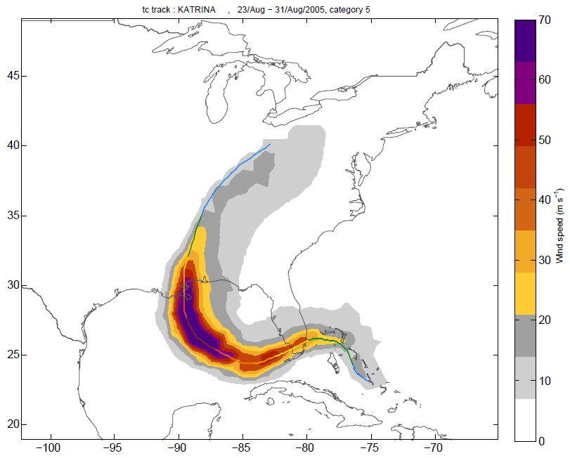

*Figure 11: Unweakened hazard on the example of the footprint of Hurricane Katrina.*

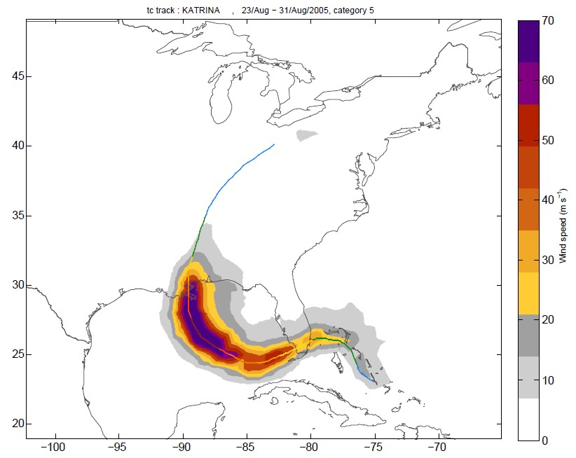

*Figure 12: Weakened hazard on the example of the footprint of Hurricane Katrina.*

3f) Create a climate change hazard set

The future hazard set is based on a climate change scenario and today’s hazard set. The intensity or frequency of storms, or particular categories of storms, can be changed accordingly to a specific climate change scenario, by the input structure *screw*. The default values for screw are the climate change projections from IPCC special report on weather extremes (SREX, March 2012[5]) with the given time horizon of 2100, see Table 2. The time

horizon can be set for any given year between today and 2100 and the climate change projections are linearly interpolated.

*Table 2: Default values for screw. The climate change scenario is based on the IPCC SREX*

screw(1) .variable_to_change ‘frequency’

.frequency 0.8

.time_horizon 2100

crew.cat [4 5]

screw(2) .variable_to_change ‘frequency’

.frequency -­‐0.28

.time_horizon 2100

.cat [0 1 2 3]

screw(3) .variable_to_change 'intensity'

.frequency 0.11

.time_horizon 2100

.cat [ 0 1 2 3 4 5]

**hazard=climada_hazard_clim_scen(hazard,tc_track,  
 hazard_save_name,reference_year,screw)**

3g) Analyze Statistics; Plot Wind Speed for Specific Return Periods at all Centroids for Historical Data Set, Probabilistic Data Set or Climate Change Scenario

Plot wind speed based historical, probabilistic or climate change data, for requested return periods at all centroids. If no return periods are specified, it takes return periods indicated in **climada_global.LFC_return_periods**.

**hazard=climada_hazard_stats(hazard,return_periods,   
 hazard_R_file,check_plot,centroids,rain,check_printplot)**

Probabilistic w ind speed (m/s)

0 50 100



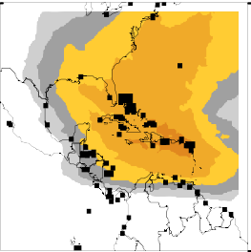25 yr intensity 50 yr intensity

100 yr intensity

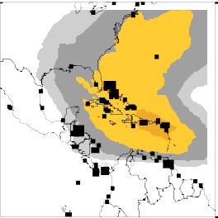

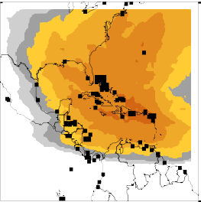200 yr intensity 500 yr intensity 1000 yr intensity

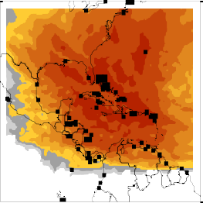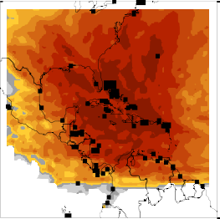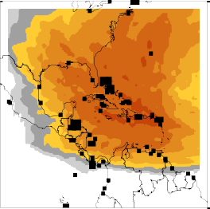

*Figure 15: Wind speed maps for specific return periods.*

6. Appendix

6a) Background on hurricane wind speed decay after landfall

NOAA, Hurricane Research Division[6],

The sustained (1 min or longer average) winds are reduced because of the dampening effect of larger roughness over land (i.e. bushes, trees and houses over land versus a relatively smooth ocean). The gusts are stronger because turbulence increases and acts to bring faster winds down to the surface in short (a few seconds) bursts.

After just a few hours, a tropical cyclone over land will begin to weaken rapidly -­‐ not because of friction -­‐ but because the storm lacks the moisture and heat sources that the ocean provided. This depletion of moisture and heat hurts the tropical cyclone's ability to produce thunderstorms near the storm centre. Without this convection, the storm rapidly fills.

Nature conducted this experiment during Andrew as the hurricane traversed the very wet Everglades, Big Cypress and Corkscrew Swamp areas of southwest Florida. Andrew weakened dramatically: peak winds **decreased about 33%** and the sea level pressure in the eye rose 19 mb[7].

Hurricane Science, University of Rhode Island (URI), Graduate School of Oceanography (GSO)[8]

Landfall usually causes a hurricane to quickly decay. Hurricanes require evaporation from the warm ocean surface to survive. Once a hurricane makes landfall, it is separated from its ocean energy source, and hence, can no longer extract heat from the ocean. Since the air masses over land are drier and contain more aerosol particles than over the ocean, less moisture is carried into the storm, cloud coverage lessens, and air is cooled and then sinks, disrupting the hurricane’s secondary circulation and hindering critical thunderstorm development. To a lesser extent, the increased roughness of the land surface also weakens a hurricane as increased friction causes a reduction in surface circulation.

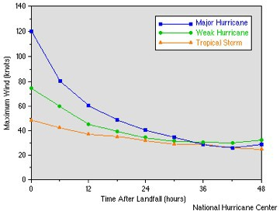

*Figure 13: This graph shows how rapidly wind speed decreases once a hurricane reaches land. The roughness of the land terrain increases friction, but more critical, once over land, the system is cut off from its heat and moisture sources. Sustained winds in a hurricane will decrease at a relatively constant rate (approximately half*)

*the wind speed in the first 24 hours). Thus, the faster the forward speed of a landfalling hurricane, the further inland hurricane force winds may penetrate. Image credit the National Hurricane Center (NHC).*

6b) Calibration of hazard weakening

USA

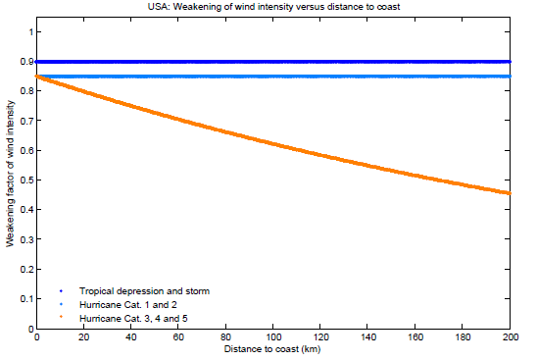

*Figure 14: Hazard wind weakening depending on distance to coast and cyclone category for USA.*

Australia

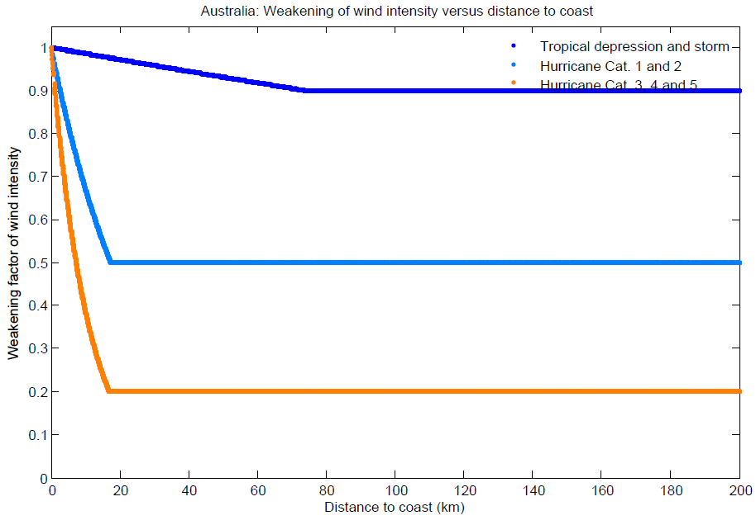

*Figure 15: Wind weakening for Australia*

China

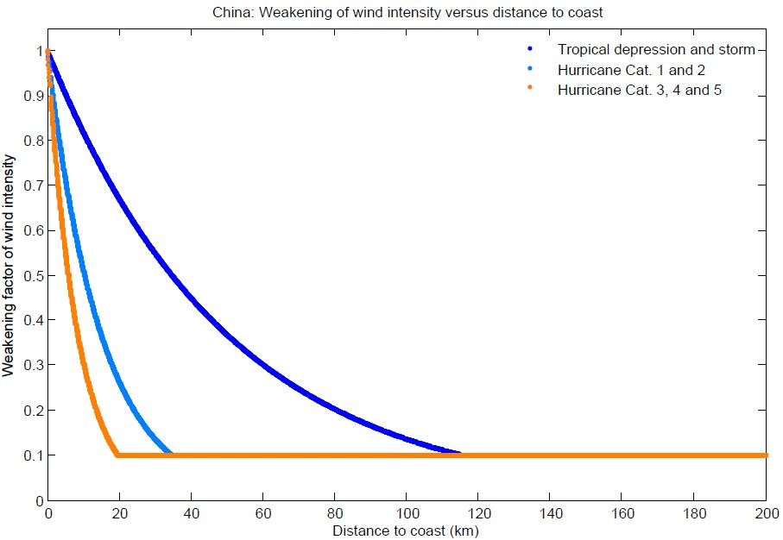

*Figure 16: Wind weakening for China.*

Japan

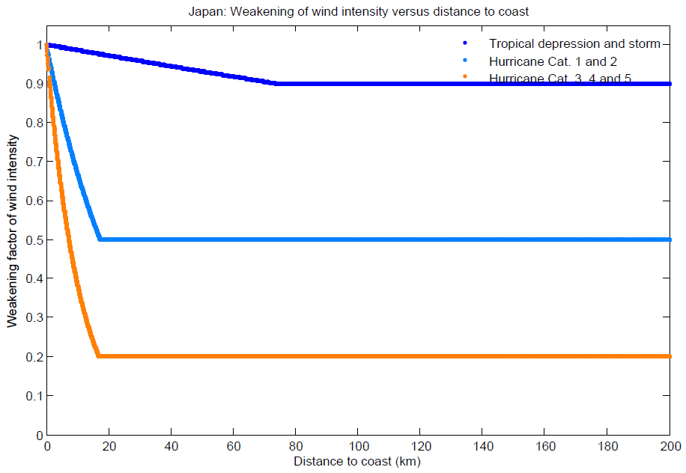

*Figure 17: Wind weakening for Japan*

1. <https://github.com/davidnbresch/climada_module_country_risk>
2. Coastline data from NOAA <http://www.ngdc.noaa.gov/mgg/coast/>
3. Holland, G. J., 1980: An analytic model of the wind and pressure profiles in hurricanes. Monthly Weather Review, 108, 1212-1218.
4. <http://www.prh.noaa.gov/cphc/pages/FAQ/Winds_and_Energy.php>
5. <http://www.ipcc-­‐wg2.gov/SREX/images/uploads/SREX-­‐All_FINAL.pdf>
6. NOAA Hurricane Research Division: <http://www.aoml.noaa.gov/hrd/tcfaq/C2.html>
7. Powell and Houston 1996 : <http://www.aoml.noaa.gov/hrd/tcfaq/tcfaqREF.html#P>
8. Hurricane Science, University of Rhode Island (URI): [*http://www.hurricanescience.org/science/science/hurricanedecay/*](http://www.hurricanescience.org/science/science/hurricanedecay/)