Working title:   
Measurement of beliefs in conspiracy myths in a random sample and in a non-random sample

Draft: 31.07.2024, SZ

***1. Description of Questions***

Wording

* A1: To what extent do you agree with the statement: "There are many very important things happening in the world that the public is never informed about"?
* A2: To what extent do you agree with the statement: "Politicians do not usually tell us the true motives behind their decisions"?
* A3: To what extent do you agree with the statement: "Government agencies closely monitor all citizens"?
* A4: To what extent do you agree with the statement: "Events that seem unrelated at first glance are often the result of secret activities"?
* A5: To what extent do you agree with the statement: "There are secret organizations that have great influence on political decisions"?

Scales

1. SOEP 0 - 10 (definitely not - definitely)
2. Civey 1 - 5 (strongly disagree, somewhat disagree, somewhat disagree, partly disagree, somewhat agree, strongly agree)

***2. Description of Sample***

(i) Civey Sample: distinct sample sizes for each question, partly overlapping

|  |  |  |  |  |  |
| --- | --- | --- | --- | --- | --- |
|  | A1 | A2 | A3 | A4 | A5 |
| A1 | 6098 | 0 | 0 | 0 | 0 |
| A2 | 0 | 6102 | 3369 | 3050 | 3115 |
| A3 | 0 | 3369 | 6101 | 3115 | 3076 |
| A4 | 0 | 3050 | 3115 | 6097 | 3126 |
| A5 | 0 | 3115 | 3076 | 3126 | 6111 |

(ii) SOEP Survey, Wave 38 in year 2021, all adult household members without refugee samples: N=36.228; N=2205 persons did not reply any of the questions A1-A5: remain N=34.023 with item-nonresponse nA1= 269, nA2=541, nA3=631, nA4=1561, nA5=1043

***3. Survey Mode and Frame***

1. Civey: CAWI; from 2021-04-12 to 2022-01-01
2. SOEP: mode-mix, from 2021-04-08 to 2022-03-08

|  |  |  |  |  |  |
| --- | --- | --- | --- | --- | --- |
| CAPI | CAWI | CATI | PAPI | CAPIbyPhone | CASI |
| 6362 | 3079 | 866 | 4973 | 18513 | 230 |

***4. Covariates***

*Demographics*

* Age (18-29, 30-39, 40-49, 50-64,65+)
* Gender (female, male)
* Marital Status (Married / widowed, Single, Divorced)
* Kids in Household (yes, no)

*Education and Employment*

* Educational Degree (Abitur, Mittlere Reife, Hauptschule / kein Abschluss)
* Employment Status (Employed, not employed)
* Occupational Degree (Tertiary education, Vocational training, No degree, Still in training)
* Occupational Position (Employee, Blue-collar worker, Civil servant, Senior executive, Not employed, Self-employed)

*Attitude*

* Religion (protestant, catholic, no confession, other)
* Party Choice (AfD, CDU/CSU, FDP, Grüne, Linke, SDP, non-voters, others)

*Context*

* Region (Eastern / Western Germany)
* Population Density (five groups, quintiles)

***5. Descriptive Results***

Table: Mean Value of Answers to Questions related to Conspiracy Myths

|  |  |  |  |  |  |
| --- | --- | --- | --- | --- | --- |
|  | A1 | A2 | A3 | A4 | A5 |
| SOEP | 3.46 | 3.43 | 2.51 | 2.38 | 2.57 |
| SOEP CAWI | 3.39 | 3.41 | 2.37 | 2.11 | 2.24 |
| CIVEY | 3.78 | 4.07 | 2.80 | 2.72 | 3.12 |

Note: with transformed Scale of SOEP to fit Scale of Civey.

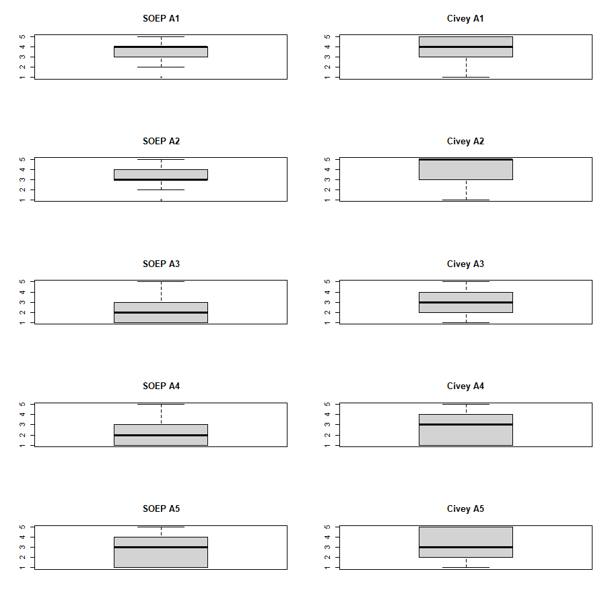

Figure: Boxplots of Distribution of Answers Given to Questions related to Conspiracy Myths.

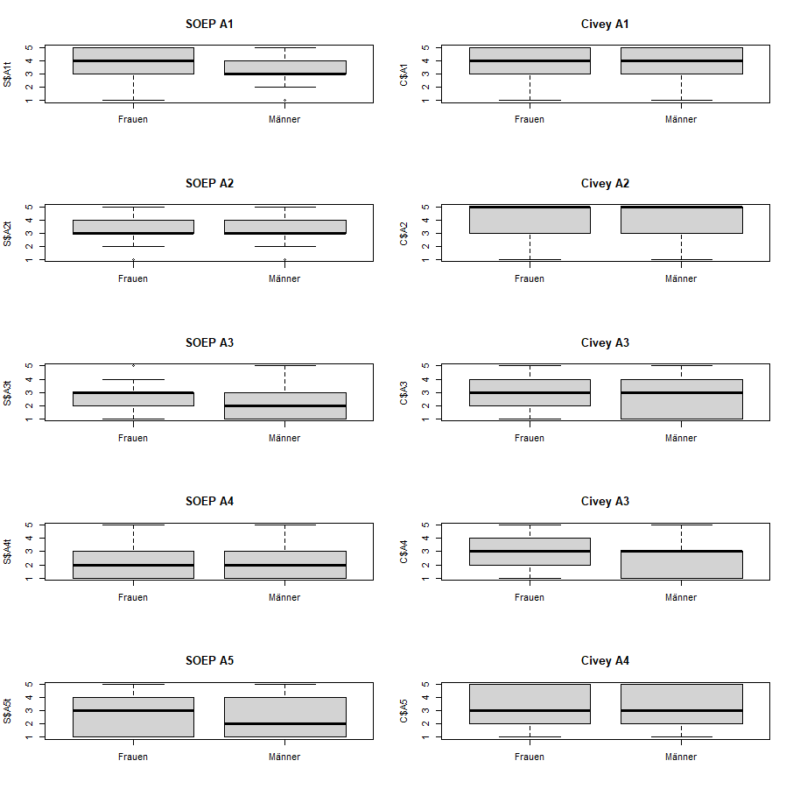

Figure: Boxplots of Distribution of Answers Given to Questions related to Conspiracy Myths according to sex.

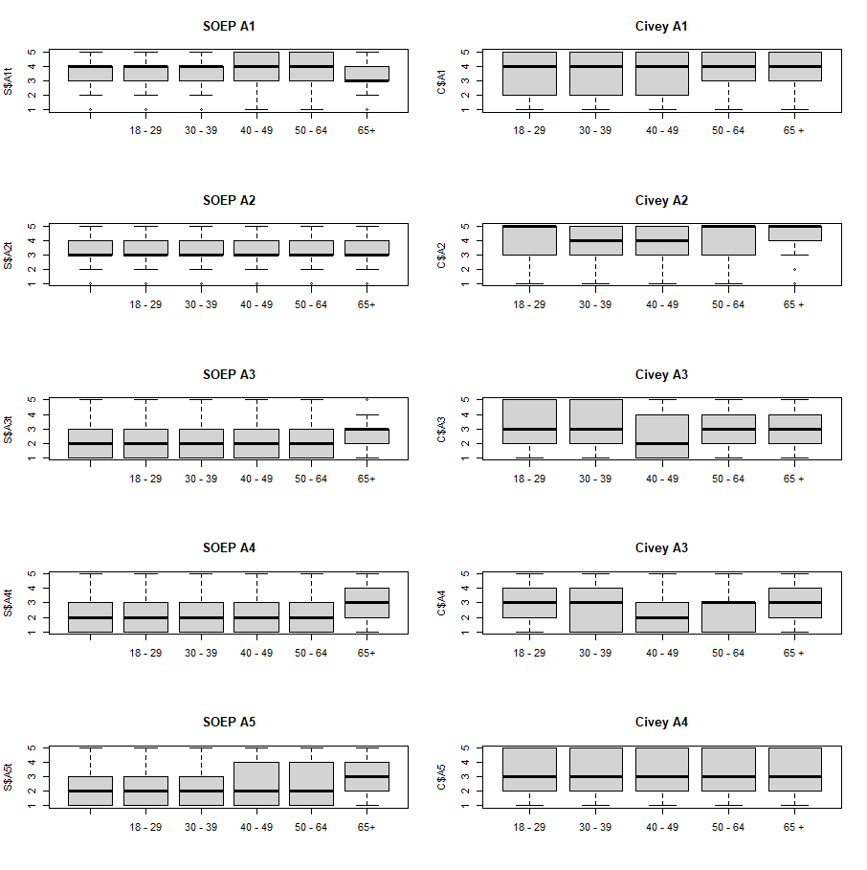

Figure: Boxplots of Distribution of Answers Given to Questions related to Conspiracy Myths according to age group.

Table: Effect Sizes in Linear Model for A1

|  |  |  |
| --- | --- | --- |
|  | SOEP | Civey |
| Age (ref. 18-29) |  |  |
| 30-39 | -0.06* | 0.19 |
| 40-49 | -0.03 | 0.11 |
| 50-64 | -0.08* | 0.27* |
| 65+ | -0.12* | 0.29* |
| Sex (ref. Females) |  |  |
| Males | -0.15* | -0.28* |
| Sample Size | N=32221 (N=1792 NA) | N=6093 |
| Rsq | 0.005 | 0.013 |

Note: SOEP model controls for survey modes with CAWI as reference. * is p < 0.05.

Table: Effect Sizes in Linear Model for A2

|  |  |  |
| --- | --- | --- |
|  | SOEP | Civey |
| Age (ref. 18-29) |  |  |
| 30-39 | 0.08* | -0.16 |
| 40-49 | 0.10* | -0.18 |
| 50-64 | 0.09* | -0.04 |
| 65+ | 0.05* | 0.00 |
| Sex (ref. Females) |  |  |
| Males | -0.07* | -0.12* |
| Sample Size | N=31953 (N=2059 NA) | N=6097 |
| Rsq | 0.004 | 0.004 |

Note: SOEP model controls for survey modes with CAWI as reference. * is p < 0.05.

Table: Effect Sizes in Linear Model for A3

|  |  |  |
| --- | --- | --- |
|  | SOEP | Civey |
| Age (ref. 18-29) |  |  |
| 30-39 | 0.14* | -0.11 |
| 40-49 | 0.13* | -0.40* |
| 50-64 | 0.15* | -0.37* |
| 65+ | 0.29* | -0.44* |
| Sex (ref. Females) |  |  |
| Males | -0.12* | -0.10* |
| Sample Size | N=31872 (N=1214 NA) | N=6096 |
| Rsq | 0.004 | 0.004 |

Note: SOEP model controls for survey modes with CAWI as reference. * is p < 0.05.

Table: Effect Sizes in Linear Model for A4

|  |  |  |
| --- | --- | --- |
|  | SOEP | Civey |
| Age (ref. 18-29) |  |  |
| 30-39 | 0.03 | -0.24 |
| 40-49 | 0.06* | -0.34* |
| 50-64 | 0.16* | -0.21* |
| 65+ | 0.53* | -0.03 |
| Sex (ref. Females) |  |  |
| Males | -0.14* | -0.20* |
| Sample Size | N=30966 (N=3047 NA) | N=6092 |
| Rsq | 0.034 | 0.012 |

Note: SOEP model controls for survey modes with CAWI as reference. * is p < 0.05.

Table: Effect Sizes in Linear Model for A5

|  |  |  |
| --- | --- | --- |
|  | SOEP | Civey |
| Age (ref. 18-29) |  |  |
| 30-39 | 0.05* | 0.00 |
| 40-49 | 0.09* | -0.13 |
| 50-64 | 0.011* | -0.03 |
| 65+ | 0.44* | -0.02 |
| Sex (ref. Females) |  |  |
| Males | -0.14* | -0.16* |
| Sample Size | N=31465 (N=2547 NA) | N=6105 |
| Rsq | 0.025 | 0.002 |

Note: SOEP model controls for survey modes with CAWI as reference. * is p < 0.05.

Appendix

A1

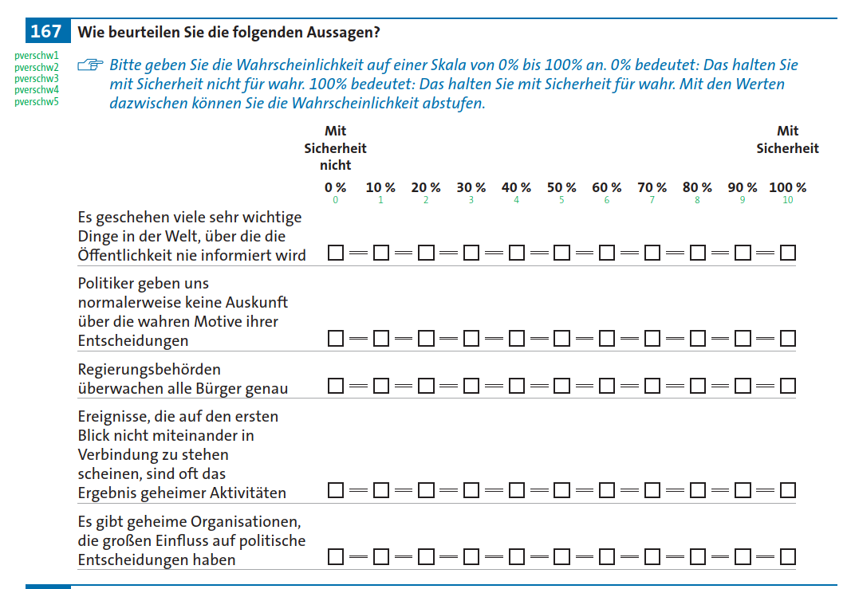

A1: Inwieweit stimmen Sie der Aussage zu: „Es geschehen viele sehr wichtige Dinge in der Welt, über die die Öffentlichkeit nie informiert wird“?

Skala: SOEP 0 (mit Sicherheit nicht) - 10 (mit Sicherheit); Civey 1 (stimme gar nicht zu, stimme eher nicht zu, stimme eher nicht zu, teils-teils, stimme eher zu, stimme voll und ganz zu)

A2: Inwieweit stimmen Sie der Aussage zu: „Politiker geben uns normalerweise keine Auskunft über die wahren Motive ihrer Entscheidungen“?

A3: Inwieweit stimmen Sie der Aussage zu: „Regierungsbehörden überwachen alle Bürger genau“?

A4: Inwieweit stimmen Sie der Aussage zu: „Ereignisse, die auf den ersten Blick nicht miteinander in Verbindung zu stehen scheinen, sind oft das Ergebnis geheimer Aktivitäten“?

A5: Inwieweit stimmen Sie der Aussage zu: „Es gibt geheime Organisationen, die großen Einfluss auf politische Entscheidungen haben“?