Working title:   
Measurement of beliefs in conspiracy myths in a random sample and in a non-random sample

Draft: 09.02.2025, SZ

***1. Description of Questions***

Wording

* ~~A1: To what extent do you agree with the statement: "There are many very important things happening in the world that the public is never informed about"?~~ *(Kicked out since there are not enough overlapping respondents with the other questions.)*
* A2: To what extent do you agree with the statement: "Politicians do not usually tell us the true motives behind their decisions"?
* A3: To what extent do you agree with the statement: "Government agencies closely monitor all citizens"?
* A4: To what extent do you agree with the statement: "Events that seem unrelated at first glance are often the result of secret activities"?
* A5: To what extent do you agree with the statement: "There are secret organizations that have great influence on political decisions"?

Scales

1. SOEP 0 - 10 (definitely not - definitely)
2. Civey 1 - 5 (strongly disagree, somewhat disagree, somewhat disagree, partly disagree, somewhat agree, strongly agree)

***2. Description of Sample***

(i) Civey Sample: distinct sample sizes for each question, partly overlapping

|  |  |  |  |  |  |
| --- | --- | --- | --- | --- | --- |
|  | A1 | A2 | A3 | A4 | A5 |
| ~~A1~~ | ~~6098~~ | ~~0~~ | ~~0~~ | ~~0~~ | ~~0~~ |
| A2 | ~~0~~ | 6102 | 3369 | 3050 | 3115 |
| A3 | ~~0~~ | 3369 | 6101 | 3115 | 3076 |
| A4 | ~~0~~ | 3050 | 3115 | 6097 | 3126 |
| A5 | ~~0~~ | 3115 | 3076 | 3126 | 6111 |

(ii) SOEP Survey, Wave 38 in year 2021, all adult household members without refugee samples: N=17.597 answered at least one question A1-A5

***3. Survey Mode and Frame***

1. Civey: CAWI; from 2021-04-12 to 2022-01-01
2. SOEP: mode-mix, from 2021-04-08 to 2022-03-08

|  |  |  |  |  |  |
| --- | --- | --- | --- | --- | --- |
| CAPI | CAWI | CATI | PAPI | CAPIbyPhone | CASI |
| 3294 | 1473 | 439 | 2606 | 9671 | 114 |

***4. Variables used for Raking / Poststratification***

*Demographics*

* Age (18-29, 30-39, 40-49, 50-64,65+)
* Gender (female, male)
* Marital Status (Married / widowed, Single, Divorced)
* Kids in Household (yes, no)

*Education and Employment*

* Educational Degree (Abitur, Mittlere Reife, Hauptschule / kein Abschluss)
* Employment Status (Employed, not employed)
* Occupational Degree (Tertiary education, Vocational training, No degree, Still in training)
* ~~Occupational Position (Employee, Blue-collar worker, Civil servant, Senior executive, Not employed, Self-employed)~~ *(Proportion of missingness in Civey data too high, 8%)*

*Attitude*

* Religion (protestant, catholic, no confession, other)
* ~~Party Choice (AfD, CDU/CSU, FDP, Grüne, Linke, SDP, non-voters, others)~~ *(Measurement concept of party tendency in SOEP and actual choice for voting in Civey data is different.)*

*Context*

* Region (Eastern / Western Germany)
* Population Density (five groups, quintiles)

***5. Descriptive Results***

Table: Mean Value of Answers to Questions related to Conspiracy Myths

|  |  |  |  |  |  |
| --- | --- | --- | --- | --- | --- |
|  | A1 | A2 | A3 | A4 | A5 |
| SOEP | ~~3.45~~ | 3.44 | 2.52 | 2.40 | 2.58 |
| SOEP CAWI | ~~3.35~~ | 3.42 | 2.36 | 2.10 | 2.26 |
| CIVEY | ~~3.78~~ | 4.07 | 2.80 | 2.72 | 3.12 |

Note: with transformed Scale of SOEP to fit Scale of Civey.

Tables: Weighted Data Along SOEP Distribution / Microzensus 2021

(i) Age and Sex

|  |  |  |
| --- | --- | --- |
| Age | Women/Frauen | Men/Männer |
| 18 - 29 | 5426073 | 4944300 |
| 30 - 39 | 5107613 | 4348208 |
| 40 - 49 | 7247014 | 5164774 |
| 50 - 64 | 10905218 | 10035577 |
| 65 + | 7442980 | 7471558 |

(ii) Employment Status and School Degree

|  |  |  |  |  |
| --- | --- | --- | --- | --- |
| EmplyStatus | Abitur | Anderes | Hauptschule / kein Abschluss | Mittlere Reife |
| Erwerbstätig | 19868565 | 5438789 | 6199975 | 13259354 |
| Nicht Erwerbstätig | 6879309 | 2083027 | 8062013 | 6302283 |

(iii) Region and Population Density

|  |  |  |  |  |  |
| --- | --- | --- | --- | --- | --- |
| Ost_West | Hoch | Mittel | Niedrig | Sehr hoch | Sehr niedrig |
| Osten | 893978 | 4001619 | 3552695 | 4079020 | 3715236 |
| Westen | 12333811 | 10108539 | 10677434 | 8440552 | 10290431 |

(iv) Educational and Occupancy Degree

|  |  |
| --- | --- |
| OccDegr | Freq |
| Berufsausbildung | 40571729 |
| Noch in Ausbildung | 710651 |
| Ohne Abschluss | 4477911 |
| Studium oder höher | 22333025 |

(v) Marital Status and Kids in Household

|  |  |  |
| --- | --- | --- |
| FamState | Keine Kinder im Haushalt | Kinder im Haushalt |
| Geschieden | 5468988 | 1381301 |
| Ledig | 13813009 | 4276411 |
| Verheiratet / Verwitwet | 27943235 | 15210371 |

(vi) Religion

|  |  |
| --- | --- |
| Religion | Freq |
| Eine andere | 3819902 |
| Evangelisch | 20337656 |
| Katholisch | 17554126 |
| Konfessionslos | 26381631 |

Appendix A1: Questions in SOEP

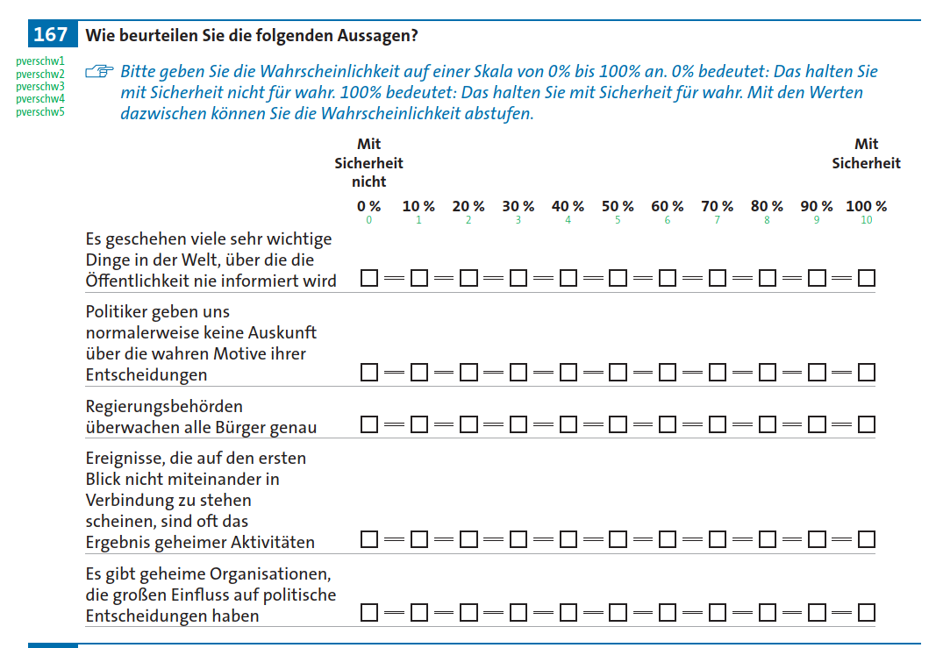

Appendix A2: Missingness Pattern in SOEP Data

