Working title:   
Measurement of beliefs in conspiracy myths in a random sample and in a non-random sample

Draft: 11.02.2025, SZ

***1. Description of Questions***

Wording

* ~~A1: To what extent do you agree with the statement: "There are many very important things happening in the world that the public is never informed about"?~~ *(Kicked out since there are not enough overlapping respondents with the other questions.)*
* A2: To what extent do you agree with the statement: "Politicians do not usually tell us the true motives behind their decisions"?
* A3: To what extent do you agree with the statement: "Government agencies closely monitor all citizens"?
* A4: To what extent do you agree with the statement: "Events that seem unrelated at first glance are often the result of secret activities"?
* A5: To what extent do you agree with the statement: "There are secret organizations that have great influence on political decisions"?

Scales

1. SOEP 0 - 10 (definitely not - definitely)
2. Civey 1 - 5 (strongly disagree, somewhat disagree, somewhat disagree, partly disagree, somewhat agree, strongly agree)

***2. Description of Sample***

(i) Civey Sample: distinct sample sizes for each question, partly overlapping

|  |  |  |  |  |  |
| --- | --- | --- | --- | --- | --- |
|  | A1 | A2 | A3 | A4 | A5 |
| ~~A1~~ | ~~6098~~ | ~~0~~ | ~~0~~ | ~~0~~ | ~~0~~ |
| A2 | ~~0~~ | 6102 | 3369 | 3050 | 3115 |
| A3 | ~~0~~ | 3369 | 6101 | 3115 | 3076 |
| A4 | ~~0~~ | 3050 | 3115 | 6097 | 3126 |
| A5 | ~~0~~ | 3115 | 3076 | 3126 | 6111 |

(ii) SOEP Survey, Wave 38 in year 2021, all adult household members without refugee samples: N=17.597 answered at least one question A1-A5

***3. Survey Mode and Frame***

1. Civey: CAWI; from 2021-04-12 to 2022-01-01
2. SOEP: mode-mix, from 2021-04-08 to 2022-03-08

|  |  |  |  |  |  |
| --- | --- | --- | --- | --- | --- |
| CAPI | CAWI | CATI | PAPI | CAPIbyPhone | CASI |
| 3294 | 1473 | 439 | 2606 | 9671 | 114 |

***4. Variables used for Raking / Poststratification***

*Demographics*

* Age (18-29, 30-39, 40-49, 50-64,65+)
* Gender (female, male)
* Marital Status (Married / widowed, Single, Divorced)
* Kids in Household (yes, no)

*Education and Employment*

* Educational Degree (Abitur, Mittlere Reife, Hauptschule / kein Abschluss)
* Employment Status (Employed, not employed)
* Occupational Degree (Tertiary education, Vocational training, No degree, Still in training)
* ~~Occupational Position (Employee, Blue-collar worker, Civil servant, Senior executive, Not employed, Self-employed)~~ *(Proportion of missingness in Civey data too high, 8%)*

*Attitude*

* Religion (protestant, catholic, no confession, other)
* ~~Party Choice (AfD, CDU/CSU, FDP, Grüne, Linke, SDP, non-voters, others)~~ *(Measurement concept of party tendency in SOEP and actual choice for voting in Civey data is different.)*

*Context*

* Region (Eastern / Western Germany)
* Population Density (five groups, quintiles)

***5. Descriptive Results***

Table: Mean Value of Answers to Questions related to Conspiracy Myths

|  |  |  |  |  |  |
| --- | --- | --- | --- | --- | --- |
|  | A1 | A2 | A3 | A4 | A5 |
| SOEP | ~~3.45~~ | 3.44 | 2.52 | 2.40 | 2.58 |
| SOEP CAWI | ~~3.35~~ | 3.42 | 2.36 | 2.10 | 2.26 |
| CIVEY | ~~3.78~~ | 4.07 | 2.80 | 2.72 | 3.12 |

Note: with transformed Scale of SOEP to fit Scale of Civey.

Tables: Weighted Data Along SOEP Distribution / Microzensus 2021

## Age and Sex Distribution

|  |  |  |
| --- | --- | --- |
| ***Age*** | ***Frauen*** | ***Männer*** |
| ***18 - 29*** | 0.07466044 | 0.07817597 |
| ***30 - 39*** | 0.07869085 | 0.07977954 |
| ***40 - 49*** | 0.07350679 | 0.07365017 |
| ***50 - 64*** | 0.13980523 | 0.14100889 |
| ***65 +*** | 0.14379236 | 0.11692976 |

## Employment Status and School Degree

|  |  |  |  |  |
| --- | --- | --- | --- | --- |
| ***EmployStatus*** | ***Abitur*** | ***Anderes*** | ***Hauptschule / kein Abschluss*** | ***Mittlere Reife*** |
| ***Erwerbstätig*** | 0.2622266 | 0.0565168 | 0.1154298 | 0.18343582 |
| ***Nicht Erwerbstätig*** | 0.0966449 | 0.02943506 | 0.1584069 | 0.09790412 |

## Ost/West and Population Density

|  |  |  |  |  |  |
| --- | --- | --- | --- | --- | --- |
| ***Ost_West*** | ***Hoch*** | ***Mittel*** | ***Niedrig*** | ***Sehr hoch*** | ***Sehr niedrig*** |
| ***Osten*** | 0.01191216 | 0.04954202 | 0.04174768 | 0.04972277 | 0.04544466 |
| ***Westen*** | 0.20709492 | 0.15975835 | 0.1652403 | 0.12212516 | 0.14741199 |

## Occupational Degree Distribution

|  |  |
| --- | --- |
| ***OccDegr*** | ***Proportion*** |
| ***Berufsausbildung*** | 0.636813754 |
| ***Noch in Ausbildung*** | 0.008072039 |
| ***Ohne Abschluss*** | 0.084173463 |
| ***Studium oder höher*** | 0.270940744 |

## Family Status and Kids in Household

|  |  |  |
| --- | --- | --- |
| ***FamState*** | ***Keine Kinder im Haushalt*** | ***Kinder im Haushalt*** |
| ***Geschieden*** | 0.09288687 | 0.01291699 |
| ***Ledig*** | 0.2572691 | 0.04731357 |
| ***Verheiratet / Verwitwet*** | 0.43559032 | 0.15402314 |

## Religion Distribution

|  |  |
| --- | --- |
| ***Rel*** | ***Proportion*** |
| ***Eine andere*** | 0.06703911 |
| ***Evangelisch*** | 0.29836913 |
| ***Katholisch*** | 0.2687349 |
| ***Konfessionslos*** | 0.36585685 |

Appendix A1: Questions in SOEP

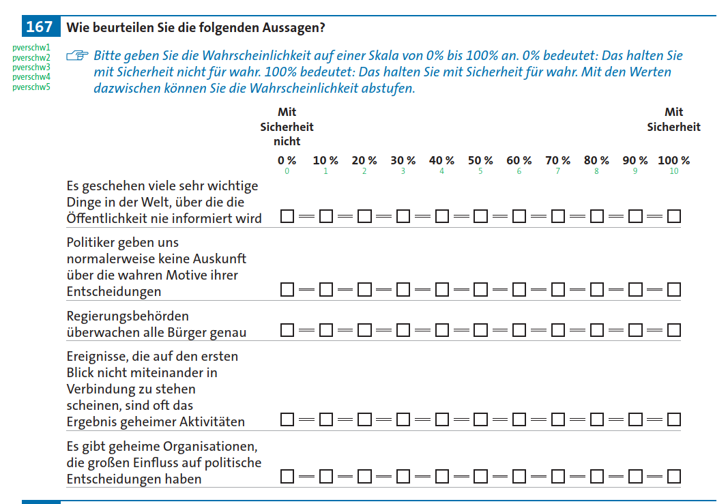

Appendix A2: Missingness Pattern in SOEP Data

