一.简介

百度地图JavaScript API是一套由JavaScript语言编写的应用程序接口，支持PC端和移动端基于浏览器的地图应用开发，且支持HTML5特性的地图开发。

自v1.5版本起，需先申请密钥（ak）。

二.demo

**Demo1：地图展示**

1. <link rel="stylesheet" type="text/css" href="css/bmap.css">

<script type="text/javascript" src="api/mapapi.min.js"></script>

<script type="text/javascript" src="js/BMapLib.js"></script>

2. <div id="allmap" > </div>

<SCRIPT type="text/javascript">

var map = new BMap.Map("allmap"); // 创建Map实例

var point = new BMap.Point(121.465, 31.26) // 创建点

map.centerAndZoom(point, 12); // 初始化地图,设置中心点坐标和地图级别

map.enableScrollWheelZoom(true); //开启鼠标滚轮缩放

</SCRIPT>

**Demo2：同时加载两个地图**

<!-- 放置电子地图的区域1 -->

<div id="map1_container">

<div id="allmap1"></div>

</div>

<!-- 放置电子地图的区域2 -->

<div id="map2_container">

<div id="allmap2"></div>

</div>

<SCRIPT type="text/javascript">

//加载第一张地图

var map1 = new BMap.Map("allmap1"); // 创建Map实例

var point1 = new BMap.Point(121.465, 31.26);

map1.centerAndZoom(point1,12);

map1.enableScrollWheelZoom(); //启用滚轮放大缩小

//加载第二张地图

var map2 = new BMap.Map("allmap2"); // 创建Map实例

var point2 = new BMap.Point(121.465, 31.26);

map2.centerAndZoom(point2,13);

map2.enableScrollWheelZoom(); //启用滚轮放大缩小

</SCRIPT>

**Demo3：设置地图最大、最小级别**

var map = new BMap.Map("allmap",{minZoom:10,maxZoom:12});

var point = new BMap.Point(121.465, 31.26) // 创建点

map.centerAndZoom(point, 12); // 初始化地图,设置中心点坐标和地图级别

map.enableScrollWheelZoom(true);

**Demo4：移动地图**

<p>初始化地图，中心点为（121.465, 31.26），缩放级别为11的上海市地图，2秒后，通过改变中心点坐标，地图平移</p>

<SCRIPT type="text/javascript">

var map = new BMap.Map("allmap");

var point = new BMap.Point(121.465, 31.26)

map.centerAndZoom(point, 12);

setTimeout(function(){

map.panTo(new BMap.Point(121.255,31.26)); //两秒后移动

}, 2000);

</SCRIPT>

**Demo5：缩放地图**

var map = new BMap.Map("allmap");

var point = new BMap.Point(121.465, 31.26)

map.centerAndZoom(point, 12);

setTimeout(function(){

map.setZoom(14); //两秒后放大到14级

}, 2000);

**Demo6：设置地图显示范围**

<http://api.map.baidu.com/library/AreaRestriction/1.2/docs/symbols/BMapLib.AreaRestriction.html>

1. <script type="text/javascript" src="js/AreaRestriction_min.js"></script>

2. var map = new BMap.Map("allmap");

map.centerAndZoom(new BMap.Point(121.465, 31.26), 12);

map.enableScrollWheelZoom();

var b = new BMap.Bounds(new BMap.Point(121.147361,31.092187),new BMap.Point(121.808514,31.379708));

//第一个点为区域左下角坐标，第二个点为区域右上角坐标

try {

BMapLib.AreaRestriction.setBounds(map, b);

} catch (e) {

alert(e);

}

**Demo7：获取地图显示范围**

var map = new BMap.Map("allmap");

map.centerAndZoom(new BMap.Point(121.465, 31.26), 12);

var bs = map.getBounds(); //获取可视区域

var bssw = bs.getSouthWest(); //可视区域左下角

var bsne = bs.getNorthEast(); //可视区域右上角

alert("当前地图可视范围是：" + bssw.lng + "," + bssw.lat + "到" + bsne.lng + "," + bsne.lat);

**Demo8：测距**

var map = new BMap.Map("allmap");

map.centerAndZoom(new BMap.Point(121.465, 31.26), 13);

var pointA = new BMap.Point(121.461265,31.256805); // 创建点坐标A--上海站

var pointB = new BMap.Point(121.508408,31.305689); // 创建点坐标B--复旦大学

alert('从上海站到复旦大学的距离是：'+(map.getDistance(pointA,pointB)).toFixed(2)+' 米。');

//获取两点距离,保留小数点后两位

var polyline = new BMap.Polyline([pointA,pointB], {strokeColor:"blue", strokeWeight:6, strokeOpacity:0.5}); //定义折线

map.addOverlay(polyline); //添加折线到地图上

**Demo9：添加/删除工具条、比例尺控件**

<div id="allmap"></div>

<div id="r-result">

<input type="button" onclick="add_control();" value="添加" />

<input type="button" onclick="delete_control();" value="删除" />

</div>

<p>在地图的左上、右上分别展示完整、缩略样式的缩放平移控件；同时在地图的左上方展

示比例尺控件，点击按钮查看效果</p>

<SCRIPT type="text/javascript">

var map = new BMap.Map("allmap");

map.centerAndZoom(new BMap.Point(121.465, 31.26), 12);

var top_left_control = new BMap.ScaleControl({anchor: BMAP_ANCHOR_TOP_LEFT});

// 左上角，添加比例尺

var top_left_navigation = new BMap.NavigationControl();

//左上角，添加默认缩放平移控件

var top_right_navigation = new BMap.NavigationControl({anchor:

BMAP_ANCHOR_TOP_RIGHT, type: BMAP_NAVIGATION_CONTROL_SMALL}); //右上角，仅包含平移和缩放按钮

/*缩放控件type类型:

BMAP_NAVIGATION_CONTROL_SMALL：仅包含平移和缩放按钮；BMAP_NAVIGATION_CONTROL_PAN:仅包含平移按钮；BMAP_NAVIGATION_CONTROL_ZOOM：仅包含缩放按钮*/

//添加控件和比例尺

function add_control(){

map.addControl(top_left_control);

map.addControl(top_left_navigation);

map.addControl(top_right_navigation);

}

//移除控件和比例尺

function delete_control(){

map.removeControl(top_left_control);

map.removeControl(top_left_navigation);

map.removeControl(top_right_navigation);

}

</SCRIPT>

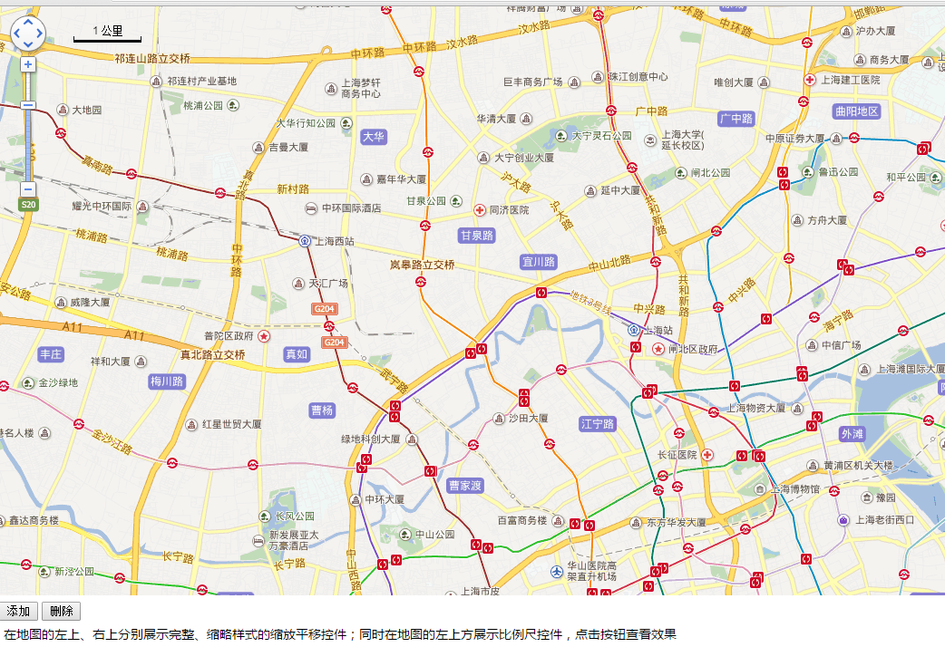

**Demo12：添加版权控件**

var map = new BMap.Map("allmap");

map.centerAndZoom(new BMap.Point(121.465, 31.26), 12);

var cr = new BMap.CopyrightControl({anchor: BMAP_ANCHOR_TOP_RIGHT});

//设置版权控件位置

map.addControl(cr); //添加版权控件

var bs = map.getBounds(); //返回地图可视区域

//Copyright(id,content,bounds)类作为CopyrightControl.addCopyright()方法的参数cr.addCopyright({id: 1, content: "<a href='#' style='font-size:20px;background:red'>我是自定义

版权控件呀</a>", bounds: bs});

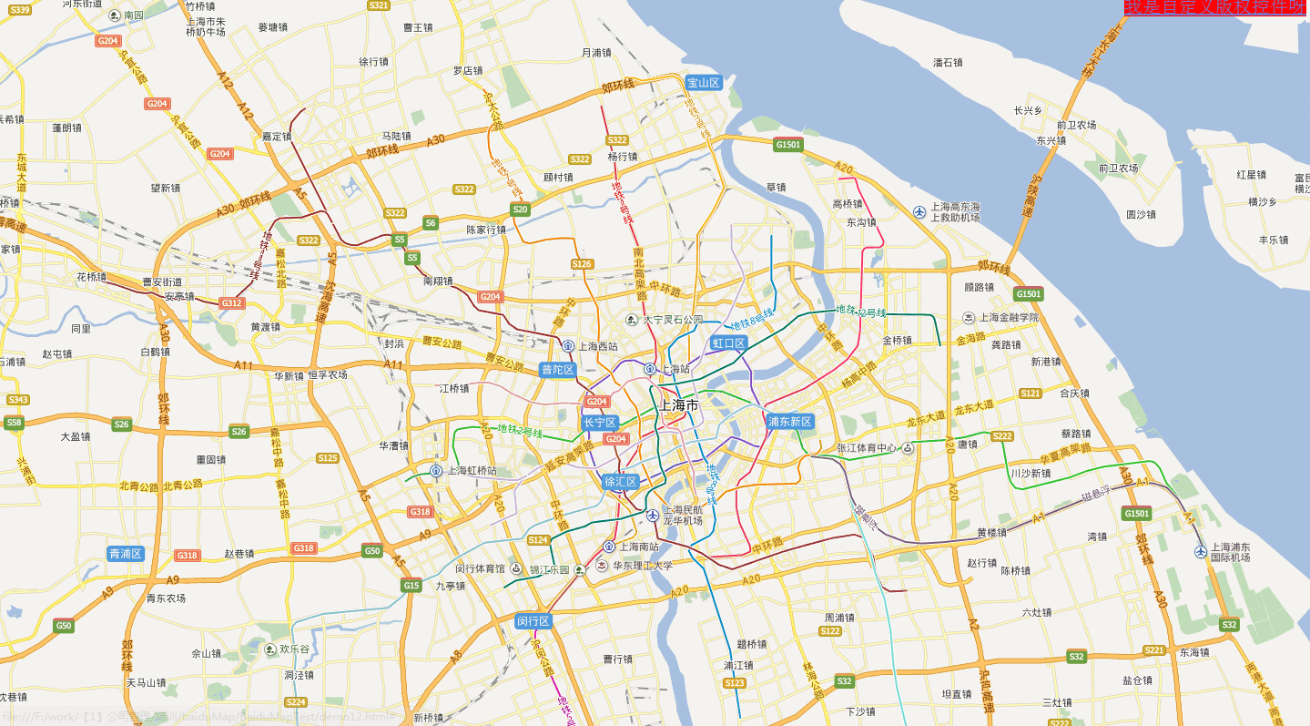

**Demo13：添加自定义控件**

var map = new BMap.Map("allmap");

map.centerAndZoom(new BMap.Point(121.465, 31.26), 11);

// 定义一个控件类,即function

function ZoomControl(){

// 默认停靠位置和偏移量

this.defaultAnchor = BMAP_ANCHOR_TOP_LEFT;

this.defaultOffset = new BMap.Size(10, 10);

}

// 通过JavaScript的prototype属性继承于BMap.Control

ZoomControl.prototype = new BMap.Control();

// 自定义控件必须实现自己的initialize方法,并且将控件的DOM元素返回

// 在本方法中创建个div元素作为控件的容器,并将其添加到地图容器中

ZoomControl.prototype.initialize = function(map){

// 创建一个DOM元素

var div = document.createElement("div");

// 添加文字说明

div.appendChild(document.createTextNode("放大2级"));

// 设置样式

div.style.cursor = "pointer";

div.style.border = "1px solid gray";

div.style.backgroundColor = "white";

// 绑定事件,点击一次放大两级

div.onclick = function(e){

map.setZoom(map.getZoom() + 2);

}

// 添加DOM元素到地图中

map.getContainer().appendChild(div);

// 将DOM元素返回

return div;

}

// 创建控件

var myZoomCtrl = new ZoomControl();

// 添加到地图当中

map.addControl(myZoomCtrl);

覆盖物示例

**Demo14：添加/删除覆盖物**

var map = new BMap.Map("allmap");

var point = new BMap.Point(121.465, 31.26);

map.centerAndZoom(point, 12);

// 创建点

var marker = new BMap.Marker(point);

//创建折线

var polyline = new BMap.Polyline([

new BMap.Point(121.230724,31.34468),

new BMap.Point(121.29224,31.345667),

new BMap.Point(121.371003,31.360962)

], {strokeColor:"blue", strokeWeight:2, strokeOpacity:0.5});

polyline.enableEditing(); //设置折线可编辑

//创建圆

var circle = new BMap.Circle(point,500,{strokeColor:"blue", strokeWeight:2,

strokeOpacity:0.5});

//创建多边形

var polygon = new BMap.Polygon([

new BMap.Point(121.253145,31.273102),

new BMap.Point(121.284766,31.295816),

new BMap.Point(121.316961,31.287422),

new BMap.Point(121.339958,31.259274),

new BMap.Point(121.247396,31.240998)

], {strokeColor:"blue", strokeWeight:2, strokeOpacity:0.5});

polygon.enableEditing();//设置可编辑

//创建矩形

var pStart = new BMap.Point(121.415846,31.14808);

var pEnd = new BMap.Point(121.52968,31.214812);

var rectangle = new BMap.Polygon([

new BMap.Point(pStart.lng,pStart.lat),

new BMap.Point(pEnd.lng,pStart.lat),

new BMap.Point(pEnd.lng,pEnd.lat),

new BMap.Point(pStart.lng,pEnd.lat)

], {strokeColor:"blue", strokeWeight:2, strokeOpacity:0.5});

//添加覆盖物

function add_overlay(){

map.addOverlay(marker); //增加点

map.addOverlay(polyline); //增加折线

map.addOverlay(circle); //增加圆

map.addOverlay(polygon); //增加多边形

map.addOverlay(rectangle); //增加矩形

}

//清除覆盖物

function remove_overlay(){

map.clearOverlays(); //清除所有覆盖物

}

**Demo15：添加动画标注点**

var map = new BMap.Map("allmap");

var point = new BMap.Point(121.465, 31.26);

map.centerAndZoom(point, 12);

var marker = new BMap.Marker(point); // 创建标注

map.addOverlay(marker); // 将标注添加到地图中

marker.setAnimation(BMAP_ANIMATION_BOUNCE); //跳动的动画

**Demo16：设置标注点的新图标**

var map = new BMap.Map("allmap");

var point = new BMap.Point(121.465, 31.26);

map.centerAndZoom(point, 12);

//创建小狐狸

var myIcon = new BMap.Icon("images/fox.gif", new BMap.Size(300,157));

var marker = new BMap.Marker(point,{icon:myIcon}); // 创建标注

map.addOverlay(marker);

marker.enableDragging(); //设置点可拖拽

//marker.disableDragging(); //设置点不可拖拽

**Demo17：文本标注**

var map = new BMap.Map("allmap");

var point = new BMap.Point(121.465, 31.26);

map.centerAndZoom(point, 12);

var opts = {

position : point, // 指定文本标注所在的地理位置

offset : new BMap.Size(30, -30) //设置文本偏移量

}

var label = new BMap.Label("上海欢迎您~", opts); // 创建文本标注对象

label.setStyle({

color : "red",

fontSize : "12px",

height : "20px",

lineHeight : "20px",

fontFamily:"微软雅黑"

});

map.addOverlay(label);

// 设置覆盖物的文字标注

var marker = new BMap.Marker(point); // 创建标注

map.addOverlay(marker); // 将标注添加到地图中

var label = new BMap.Label("我是文字标注哦",{offset:new BMap.Size(20,-10)});

marker.setLabel(label);

**Demo18：添加多个标注点**

var map = new BMap.Map("allmap");

var point = new BMap.Point(121.465, 31.26);

map.centerAndZoom(point, 12);

var points = [{"longitude":"121.451777","latitude":"31.282223","resourceName":"资源2"},

{"longitude":"121.460976","latitude":"31.256542","resourceName":"用户1"},

{"longitude":"121.409808","latitude":"31.269877","resourceName":"用户2"},

];

for (var i = 0; i < points.length; i++) {

(function () {//闭包 避免只显示最后加载的资源的label

var resourceName= points [i].resourceName; //资源名称

var latitude = points [i].latitude; //纬度

var longitude = points [i].longitude; //经度

var point = new BMap.Point(longitude, latitude); //循环生成新的地图点

var marker = new BMap.Marker(point); //按照地图点坐标生成标

map.addOverlay(marker);

//添加label

var label = new BMap.Label(resourceName,{offset:new BMap.Size(20,-10)});

// 设置label样式

label.setStyle({

color : "#CC3333",

fontSize : "13px",

backgroundColor :"#CCFFFF",

border :"0",

fontWeight :"bold"

});

marker.setLabel(label);

})();

}

//删除resourceName=用户2的点

function deletePoint(){

var allOverlay = map.getOverlays();

for (var i = 0; i < allOverlay.length; i++){

if(allOverlay[i].getLabel().content == "用户2"){

map.removeOverlay(allOverlay[i]);

return false;

}

}

}

**Demo19：纯文本的信息窗口**

var map = new BMap.Map("allmap");

var point = new BMap.Point(121.465, 31.26);

map.centerAndZoom(point, 12);

var marker = new BMap.Marker(point); // 创建标注

map.addOverlay(marker); // 将标注添加到地图中

var opts = {

width : 200, // 信息窗口宽度

height: 100, // 信息窗口高度

title : "海底捞吴中店" , // 信息窗口标题

}

var infoWindow = new BMap.InfoWindow("地址：上海市闵行区吴中路1100号", opts); // 创建信息窗口对象

marker.addEventListener("click", function(){

map.openInfoWindow(infoWindow,point); //鼠标点击marker开启信息窗口

});

**Demo20：添加带图文的信息窗口**

var map = new BMap.Map("allmap");

var point = new BMap.Point(121.465, 31.26);

map.centerAndZoom(point, 12);

var marker = new BMap.Marker(point);

map.addOverlay(marker);

// 百度地图API功能

var sContent =

"<h4 style='margin:0 0 5px 0;padding:0.2em 0'>上海站</h4>" +

"<img style='float:right;margin:4px' id='imgDemo' src='images/shanghaitrainstation.jpg'

width='139' height='104' title='上海站'/>" +

"<p style='margin:0;line-height:1.5;font-size:13px;text-indent:2em'>上海站位于上海市静安

区秣陵路303号。毗邻上海长途客运总站，与上海虹桥站、上海南站并称为上海铁路

三大交通枢纽。</p>" + "</div>";

var infoWindow = new BMap.InfoWindow(sContent); // 创建信息窗口对象

marker.addEventListener("click", function(){

this.openInfoWindow(infoWindow);

//获取信息窗口的信息

document.getElementById("r-result").innerHTML = "信息窗口的内容是：<br />" +

infoWindow.getContent();

});

**Demo21：给地图添加右键菜单**

var map = new BMap.Map("allmap");

var point = new BMap.Point(121.465, 31.26);

map.centerAndZoom(point, 12);

var menu = new BMap.ContextMenu();

var txtMenuItem = [

{

text:'放大',

callback:function(){map.zoomIn()}

},

{

text:'缩小',

callback:function(){map.zoomOut()}

}

];

for(var i=0; i < txtMenuItem.length; i++){

menu.addItem(new BMap.MenuItem(txtMenuItem[i].text,txtMenuItem[i].callback,100));

}

map.addContextMenu(menu);

**Demo22：给覆盖物添加右键菜单**

var map = new BMap.Map("allmap");

var point = new BMap.Point(121.465, 31.26);

map.centerAndZoom(point, 12);

var marker = new BMap.Marker(point);

map.addOverlay(marker);

var removeMarker = function(e,ee,marker){

map.removeOverlay(marker);

}

//创建右键菜单

var markerMenu=new BMap.ContextMenu();

markerMenu.addItem(new BMap.MenuItem('删除',removeMarker.bind(marker)));

marker.addContextMenu(markerMenu);

**Demo23：鼠标拉框放大地图**

<script type="text/javascript" src="js/RectangleZoom_min.js"></script>

var map = new BMap.Map("allmap");

var point = new BMap.Point(121.465, 31.26);

map.centerAndZoom(point, 11);

var myDrag = new BMapLib.RectangleZoom(map, {

followText: "拖拽鼠标进行操作"

});

myDrag.open(); //开启拉框放大

//myDrag.close(); //关闭拉框放大

**Demo24 单击获取点击的经纬度**

var map = new BMap.Map("allmap");

var point = new BMap.Point(121.465, 31.26);

map.centerAndZoom(point, 11);

//单击获取点击的经纬度

map.addEventListener("click",function(e){

alert(e.point.lng + "," + e.point.lat);

});

**Demo25鼠标测距**

<!-- 鼠标测距 -->

<script type="text/javascript" src="js/DistanceTool_min.js"></script>

var map = new BMap.Map("allmap");

var point = new BMap.Point(121.465, 31.26);

map.centerAndZoom(point, 12);

var myDis = new BMapLib.DistanceTool(map);

function start_measure(){

myDis.open(); //开启鼠标测距

}

function stop_measure(){

myDis.close(); //关闭鼠标测距

}

**Demo26鼠标绘制工具**

<!--加载鼠标绘制工具-->

<link rel="stylesheet" type="text/css" href="css/DrawingManager_min.css">

<script type="text/javascript" src="js/DrawingManager_min.js"></script>

<!--加载检索信息窗口-->

<link rel="stylesheet" type="text/css" href="css/SearchInfoWindow_min.css">

<script type="text/javascript" src="js/SearchInfoWindow_min.js"></script>

<body>

<div id="allmap"></div>

<div id="result">

<input type="button" value="获取绘制的覆盖物个数" onclick="alert(overlays.length)"/>

<input type="button" value="清除所有覆盖物" onclick="clearAll()"/>

</div>

<SCRIPT type="text/javascript">

var map = new BMap.Map("allmap");

var point = new BMap.Point(121.465, 31.26);

map.centerAndZoom(point, 12);

map.enableScrollWheelZoom();

var overlays = [];

var overlaycomplete = function(e){

overlays.push(e.overlay);

};

var styleOptions = {

strokeColor:"red", //边线颜色。

fillColor:"red", //填充颜色。当参数为空时，圆形将没有填充效果。

strokeWeight: 3, //边线的宽度，以像素为单位。

strokeOpacity: 0.8, //边线透明度，取值范围0 - 1。

fillOpacity: 0.6, //填充的透明度，取值范围0 - 1。

strokeStyle: 'solid' //边线的样式，solid或dashed。

}

//实例化鼠标绘制工具

var drawingManager = new BMapLib.DrawingManager(map, {

isOpen: false, //是否开启绘制模式

enableDrawingTool: true, //是否显示工具栏

drawingToolOptions: {

anchor: BMAP_ANCHOR_TOP_RIGHT, //位置

offset: new BMap.Size(5, 5), //偏离值

},

circleOptions: styleOptions, //圆的样式

polylineOptions: styleOptions, //线的样式

polygonOptions: styleOptions, //多边形的样式

rectangleOptions: styleOptions //矩形的样式

});

//添加鼠标绘制工具监听事件，用于获取绘制结果

drawingManager.addEventListener('overlaycomplete', overlaycomplete);

function clearAll() {

for(var i = 0; i < overlays.length; i++){

map.removeOverlay(overlays[i]);

}

overlays.length = 0

}

</SCRIPT>

</body>

**Demo27事件示例**

<body>

<div id="allmap"></div>

<div id="result">

<button id="close" onclick="removeClick()">注销地图点击事件</button>

</div>

<p>添加点击地图监听事件，点击地图后显示当前经纬度</p>

<p>添加点击marker监听事件，点击marker后显示marker经纬度</p>

<SCRIPT type="text/javascript">

var map = new BMap.Map("allmap");

var point = new BMap.Point(121.465, 31.26);

map.centerAndZoom(point, 12);

/*图块加载完毕*/

map.addEventListener("tilesloaded",function(){alert("地图加载完毕");});

/*地图单击事件*/

function showInfo(e){

alert(e.point.lng + ", " + e.point.lat);

}

map.addEventListener("click", showInfo);

/*注销地图点击事件*/

function removeClick(){

map.removeEventListener("click", showInfo);

}

/*给覆盖物注册事件*/

var marker = new BMap.Marker(point); // 创建点

marker.addEventListener("click",attribute);

map.addOverlay(marker); //增加点

function attribute(){

var p = marker.getPosition(); //获取marker的位置

alert("marker的位置是" + p.lng + "," + p.lat);

}

</SCRIPT>

</body>

**Demo30 GPS坐标转百度坐标**

<script type="text/javascript" src="js/convertor.js"></script>

/*坐标系简介

WGS-84：是国际标准，GPS坐标（Google Earth使用、或者GPS模块）

GCJ-02：中国坐标偏移标准，GoogleMap、高德、腾讯使用

BD-09：百度坐标偏移标准，Baidu Map使用*/

//GPS坐标

var xx = 121.46515863448607;

var yy = 31.260912172420714;

var gpsPoint = new BMap.Point(xx,yy);

//地图初始化

var bm = new BMap.Map("allmap");

bm.centerAndZoom(gpsPoint, 12);

bm.addControl(new BMap.NavigationControl());

//添加谷歌marker和label

var markergps = new BMap.Marker(gpsPoint);

bm.addOverlay(markergps); //添加GPS标注

var labelgps = new BMap.Label("未转换的GPS坐标（错误）",{offset:new

BMap.Size(-90,-10)});

markergps.setLabel(labelgps); //添加GPS标注

//坐标转换完之后的回调函数

translateCallback = function (point){

var marker = new BMap.Marker(point);

bm.addOverlay(marker);

var label = new BMap.Label("转换后的百度坐标（正确）",{offset:new

BMap.Size(20,-10)});

marker.setLabel(label); //添加百度label

bm.setCenter(point);

}

setTimeout(function(){

BMap.Convertor.translate(gpsPoint,0,translateCallback); //GPS转成百度坐标

}, 2000);