Laser on Conveyor Belt

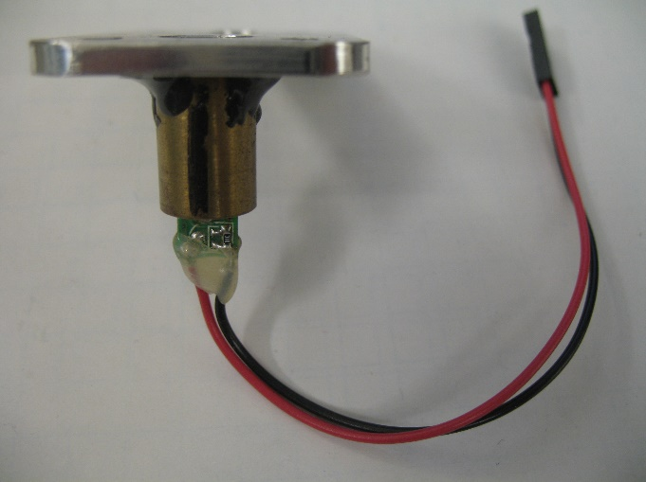

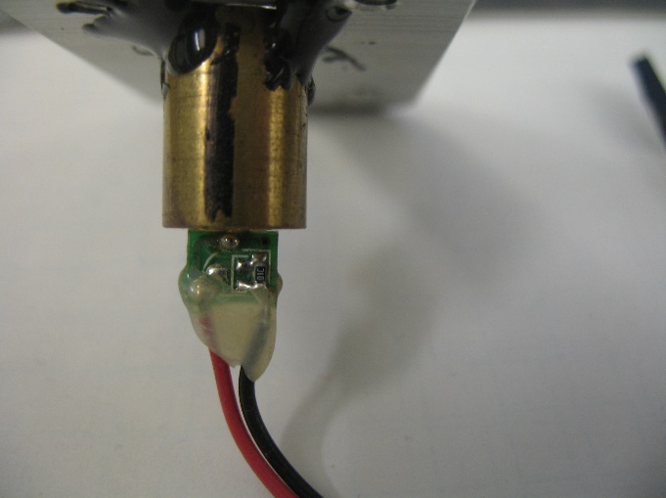

4mW red, 650nm laser diode module. Designed for installation into an OEM product, they are functioning units with a bare, exposed PC board, 6" leads terminated with a 2-contact female connector, 0.1" spacing. The brass body is 10.5 x 15mm. Overall length with PCB is 22mm. Operating voltage is 3VDC @ 25mA. Polymer aspheric lens, 5mm aperture. <2mrad divergence.