
DEVELOPMENT OF A MOBILE-INTEGRATED MULTIMODAL ATTENDANCE TRACKING SYSTEM

HERITAGE OLUWAROMINIYI OLAMIDE
CSC/2019/192

SUBMITTED TO THE DEPARTMENT OF COMPUTER ENGINEERING,
FACULTY OF COMPUTING SCIENCE AND ENGINEERING, OBAFEMI AWOLOWO UNIVERSITY, ILE-IFE.

IN PARTIAL FULFILMENT OF THE REQUIREMENT FOR THE AWARD OF BACHELOR OF SCIENCE (B.Sc. HONS) DEGREE IN COMPUTER ENGINEERING

2026
OBAFEMI AWOLOWO UNIVERSITY, ILE-IFE, NIGERIA
HEZEKIAH OLUWASANMI LIBRARY
UNDERGRADUATE DISSERTATION

AUTHORIZATION TO COPY

Author: Heritage Oluwarominiyi Olamide
Title: Development of a Mobile-Integrated Multimodal Attendance Tracking System
Degree: B.Sc. (Computer Engineering)
Year: 2026
I, Heritage Oluwarominiyi Olamide, hereby authorise the Hezekiah Oluwasanmi Library to copy my dissertation in part or in whole in response to requests from individuals and/or organizations for the purpose of private study or research.

____________________ ____________________
Signature of Author Date

CERTIFICATION
We confirm that Heritage Oluwarominiyi Olamide, with registration number CSC/2019/192, completed his project dissertation while enrolled in the Computer Engineering programme at the Obafemi Awolowo University, Faculty of Computing Science and Engineering in Ile-Ife, Osun State.

______________________ _______________________
Prof. A.R. Iyanda Date
Supervisor

______________________ _______________________
Dr. I.O. Elesemoyo Date
Co-supervisor

______________________ _______________________
Prof. S.A. Bello Date
Head of Department of Computer Engineering

DEDICATION
This work is dedicated to my family. Their love, encouragement and unending support have contributed immensely to the success of this work.

ACKNOWLEDGEMENTS
I would like to give my greatest appreciation to God who has been my ultimate source of strength, wisdom, and sustenance throughout my journey at this great citadel of learning.
My deepest gratitude goes to my supervisor, Prof. A.R. Iyanda, and co-supervisor, Dr. I.O. Elesemoyo. Their professional advice, explicit directions and priceless pieces of wisdom played a vital part in the success of this study, and my development in general.
I am immensely grateful to my mother, Dr. Moronmubo Akinseli, my father, Pastor Koleola Olamide, Daddy Lekki, Mommy Lekki, Daddy Ikorodu, Mommy Ikorodu, Daddy London, Oluwasemilogo, Ibukunoluwa and the rest of my family members for their unwavering love, guidance, and continuous support. Your sacrifices and belief in me have been the foundation of my success; without you all, I would not be.
Finally, to my friends and dearests; Oluwafisayomi, Peter, Olubukade, Ayomide, Tinuade, Tomiwa, Oluwayanmife, Oreoluwa, Fayokemi, Olufeoluwa, Omolade, and all the other people who have been with me on this journey, thank you. The rigours of this degree were made a lot more joyful because of the shared memories, laughter, and the support we gave one another.
Thank you all.

ABSTRACT
Recording student attendance on paper is slow, open to proxy signing and disconnected from digital academic records, while electronic alternatives that rely on a single capture method stop working when that method fails. This project developed a mobile integrated multimodal attendance tracking system that records attendance through two independent channels and computes exam eligibility automatically. The system has three layers. A hardware node, built from an ESP32 microcontroller and a PN532 NFC reader, records card taps. A Supabase cloud backend, with PostgreSQL, serverless functions and real-time updates, applies integrity checks and stores the records. A Next.js dashboard for lecturers and administrators and a Flutter mobile application for students provide live attendance, course management and a QR channel using short-lived HMAC-SHA256 signed codes with a location check. Both channels converge on one database constraint, so a duplicate record is rejected whichever channel produced it. In testing, all nine functional requirements were met. Over 30 trials, mean end-to-end latency from capture to dashboard update was 1,842 ms for NFC and 2,364 ms for QR, within the 3 s target. A burst of ten simultaneous QR submissions was recorded without loss, and all five attack scenarios were rejected without creating a record. The node did not support offline operation, and it could not prevent a lent card from being used. This work shows that two capture channels can share one integrity rule and feed automatic computation.

TABLE OF CONTENTS
AUTHORIZATION TO COPY ii
CERTIFICATION iii
DEDICATION iv
ACKNOWLEDGEMENTS v
ABSTRACT vi
TABLE OF CONTENTS vii
CHAPTER ONE INTRODUCTION 1
1.1 Background to the Study 1
1.2 Statement of the Problem 2
1.3 Aim and Objectives 3
1.4 Methodology 3
1.5 Justification of the Study 4
1.6 Scope of the Study 4
1.7 Organisation of the Report 4
CHAPTER TWO LITERATURE REVIEW 5
2.1 Introduction 5
2.2 Attendance Monitoring in Higher Education 5
2.2.1 Conventional attendance paradigms and their disadvantages 6
2.2.2 The issue of proxy attendance 8
2.3 IoT Applications in Campus Environments 9
2.3.1 Overview of IoT in learning institutions 9
2.3.2 Microcontroller-based systems in academic infrastructure 10
2.4 Near Field Communication (NFC) Technology 12
2.4.1 Principles of NFC communication 12
2.4.2 NFC-based identification and access control systems 13
2.5 Multimodal Tracking Systems 15
2.5.1 The rationale behind multimodal approaches 15
2.5.2 QR code-based attendance systems 16
2.5.3 Security considerations in multimodal attendance tracking 17
2.6 Review of related systems 18
2.7 Gaps in Literature 19
2.8 Chapter Summary 20
CHAPTER THREE METHODOLOGY 22
3.1 Introduction 22
3.2 System Overview 22
3.2.1 High level architecture 22
3.2.2 System workflow 24
3.3 System Requirements Analysis 26
3.3.1 Functional requirements 26
3.3.2 Non-functional requirements 27
3.4 Design of the Multimodal Attendance Architecture: Primary Pathway 28
3.4.1 Justification and component selection 28
3.4.2 Circuit Design 29
3.4.3 Firmware Logic 30
3.4.4 Simulation Strategy 30
3.5 The Secondary Hardware Pathway 32
3.6 Software Fallback Pathway: Dynamic QR Codes 32
3.6.1 Token generation logic 33
3.6.2 Token Validation Logic 35
3.7 Development of the Application Interface 35
3.7.1 The Administrative Dashboard 35
3.7.2 The Mobile Application 36
3.8 Backend and Database Infrastructure 36
3.8.1 Database Schema 38
3.9 System Evaluation 39
CHAPTER FOUR IMPLEMENTATION 40
4.1 Introduction 40
4.2 Implementation 40
4.2.1 Hardware node 40
4.2.2 Firmware 43
4.2.3 Backend 43
4.2.4 Lecturer dashboard 48
4.2.5 Administrator dashboard 48
4.2.6 Student mobile application 59
4.2.7 Integration issues found and corrected 59
4.3 Evaluation Method and Criteria 68
4.3.1 Functional testing 68
4.3.2 Performance testing 68
4.3.3 Security testing 71
4.4 Results 71
4.4.1 Functional results 71
4.4.2 Performance results 71
4.4.3 Concurrent load results 74
4.4.4 Security results 74
4.5 Discussion of Results 74
4.6 Limitations and Delimitations 78
4.6.1 Limitations 79
4.6.2 Delimitations 79
4.7 Chapter Summary 80
CHAPTER FIVE SUMMARY, CONCLUSION AND RECOMMENDATIONS 81
5.1 Summary of the Work 81
5.2 Conclusions 81
5.3 Contributions 82
5.4 Recommendations and Future Work 83
REFERENCES 83

LIST OF FIGURES
Figure 2.1: IoT Architecture in Educational settings 24
Figure 2.2: Magnetic induction and data exchange between NFC reader and a passive tag 27
Figure 3.1: High Level System Architecture 36
Figure 3.2: Sequence Diagram for card tap 38
Figure 3.3: Firmware execution flowchart across Idle, Attend, and Enrol modes 44
Figure 3.4: Sequence Diagram for Dynamic QR 46
Figure 3.5: JSON Payload 47
Figure 4.1(a): ESP32 DOIT DevKit V1 microcontroller board 54
Figure 4.1(b): PN532 NFC/RFID transceiver module configured for I2C communication 54
Figure 4.1(c): Passive piezoelectric buzzer 57
Figure 4.1(d): ICR18650 3.7 V 2000 mAh rechargeable Li-ion battery cell 57
Figure 4.1(e): TP4056 Li-ion constant-current battery charging module 58
Figure 4.1(f): MT3608 2A DC-DC step-up boost converter module 58
Figure 4.2: Interior assembly showing internal layout, booster circuit, and reader wiring 59
Figure 4.3: Hardware node in compact PVC enclosure during active operation 60
Figure 4.4: Lecturer dashboard: authentication interface 62
Figure 4.5: Lecturer dashboard: course overview and session summary 63
Figure 4.6: Lecturer dashboard: student enrolment approval management 64
Figure 4.7: Lecturer dashboard: enrolled student directory 65
Figure 4.8: Lecturer dashboard: active NFC card enrolment window 66
Figure 4.9: Lecturer dashboard: live attendance session with rotating QR code and real-time feed 67
Figure 4.10: Lecturer dashboard: session history and attendance trends analysis 68
Figure 4.11: Administrator dashboard: user account and role management 69
Figure 4.12: Administrator dashboard: course curriculum and lecturer allocation 70
Figure 4.13: Administrator dashboard: exportable reports 71
Figure 4.14: Student mobile application: authentication interface 73
Figure 4.15: Student mobile application: student registration and profile creation 74
Figure 4.16: Student mobile application: home dashboard with attendance status 75
Figure 4.17: Student mobile application: course list and enrolment status 76
Figure 4.18: Student mobile application: course search and enrolment request 77
Figure 4.19: Student mobile application: enrolment rejection feedback and re-request 78
Figure 4.20: Student mobile application: session attendance history log 79
Figure 4.21: Student mobile application: active QR scanner interface with target reticle 80

LIST OF TABLES
Table 2.1: Summary comparison of related attendance tracking systems 32
Table 3.1: Edge Functions 50
Table 4.1: Pin assignments 55
Table 4.2: System test pass criteria 82
Table 4.3: Functional test plan and verification procedures 83
Table 4.4: Functional verification experimental results 85
Table 4.5: End-to-end attendance recording latency statistics (n = 30 trials) 86
Table 4.6: Physical NFC card read times across test cards 88
Table 4.7: Concurrent 10-participant burst submission test results 89
Table 4.8: Security test suite results and observed gateway responses 90

CHAPTER ONE
INTRODUCTION

1.1 Background to the Study
In most university lecture halls today, attendance is still taken by a verbal roll call or via paper sign-in sheet passed around the room. These approaches seem deeply out of place in an era where almost every other administrative process has been digitized. They are time consuming, inaccurate, and open to manipulation. The gap between the sophistication of the modern system of education and the crudeness of traditional attendance tracking is one of the most glaring inefficiencies in modern higher education administration.
Bridging this gap has become an important area of research and development, and it is within this context that the Internet of Things (widely known by its acronym, IoT) has emerged as a powerful enabler. IoT is the network of physical devices, ranging from common household gadgets to dedicated industrial sensors, embedded with computing hardware to collect data from the environment and transmit it to centralised systems over the internet . When applied to a university campus setting, IoT enables the automation of the collection of real-world physical data, and feeds that data directly into digital management systems without requiring manual human input.
Within the larger IoT ecosystem, Near Field Communication technology (known as NFC) has stood out as a particularly well-suited tool for identity-based verification in physical environments. NFC allows two devices to communicate wirelessly when placed in close proximity to each other, typically within a few centimetres. In a university attendance situation, this technology can be used by incorporating an NFC chip in a student identification card. When a student taps their card against a dedicated NFC reader mounted at the entrance of a lecture hall, their presence is immediately confirmed and their attendance is logged in the system, without any action required from the lecturer.
This type of NFC-based attendance system is a major improvement over traditional, manual methods. It is fast, consistent and when done right, removes the potential for human error. However, as with any system that relies on a single method of identification, NFC-only attendance tracking presents its own category of vulnerability. Students regularly forget or lose their identification cards. Cards can be damaged, unreadable or used for proxy attendance. In any of these situations, a student who is physically present in the lecture hall would be unable to register their attendance leading to inaccurate records.
This is the main problem that leads to the idea of multimodal attendance tracking. A multimodal system does not rely on one method of verification. Instead, it offers several ways in which a student's presence can be verified. If the primary method (in this case, the NFC card tap) is not available, a secondary method such as scanning a dynamically generated QR code with a smartphone can be used instead. This layered approach makes the system more resilient, ensuring that attendance records remain accurate even when individual components fail or are unavailable.
This project therefore developed a mobile integrated multimodal attendance tracking system that captures attendance through NFC and dynamic QR channels and automatically computes each student's attendance percentage.

1.2 Statement of the Problem
Manual attendance in Nigerian universities wastes lecture time, is vulnerable to proxy signing, and requires error-prone manual calculations to determine examination eligibility. Current electronic alternatives often fail because they rely on a single capture method. Addressing this gap, this project develops a reliable attendance system combining primary hardware capture, and a reliable fallback mechanism.

1.3 Aim and Objectives
The aim of this project is to develop a mobile-integrated system for multimodal attendance tracking.
The specific objectives are to:
- establish the non-functional and functional requirements of the system;
- design a multimodal attendance system;
- implement the system that was designed;
- test the functionality, performance, and security of the developed system.

1.4 Methodology
This project accomplished the stated objectives by employing the following methods:
- To establish the requirements of the system, the existing attendance workflow was analysed through literature review, process analysis and consultation with the supervisor and a small group of students.
- A multimodal system combining NFC technology and QR capture was designed from the requirements as a hardware layer, a cloud layer and an application layer.
- The designed system was implemented component by component, from the design, and tested in isolation before integration.
- The implemented system was evaluated against the established requirements through functional, performance, and security testing.

1.5 Justification of the Study
This project shows that a full-scale attendance tracking system can be assembled with a limited number of inexpensive, readily-accessible hardware and open-source software platforms. It offers a template that can be copied and implemented in other institutions in similar situations.

1.6 Scope of the Study
The project involves designing and building an NFC attendance node, which includes an ESP32 microcontroller and a PN532 NFC reader module. The software component of the project involves the creation of a cloud-hosted PostgreSQL backend (Supabase), the real-time data synchronisation layer, and dual frontend interfaces: a web dashboard, and a mobile application.

1.7 Organisation of the Report
This report includes five chapters in total. The background, problem statement, aim and objectives, methodology, justification and scope of the study have been supplied in Chapter One. Chapter Two offers the literature review on the existing sources related to the use of IoT, NFC technology and the feasibility of a multimodal system in education. Chapter Three gives the details about the methodology, hardware schematics and the software design decisions that influenced the ultimate system. The execution details and outcome of the project are covered in Chapter Four. Finally, Chapter Five concludes the project and offers recommendation for future work.

CHAPTER TWO
LITERATURE REVIEW

2.1 Introduction
This chapter studies the current literature which provides the theoretical and technical basis of this project. This review aims at two things. Firstly, it will provide the academic background of the present research by proving that the issue under consideration has been well-documented and that the technologies under consideration have already been proven in previous literature. Secondly, it specifies the gaps in current literature and systems that this project is meant to remedy, which offer intellectual justifications as to why the approach was used. The review is themed and it starts with the development of the attendance monitoring systems and transitions in detail to the technical aspects of the proposed solution. Finally, it provides a direct assessment of the systems developed and the drawbacks that separate them, as compared to the system employed in this project.

2.2 Attendance Monitoring in Higher Education
Attendance monitoring is one of the most crucial responsibilities in most tertiary institutions. Attendance at lectures, while used as a measure of institutional compliance, also provides a measure of student engagement, course progress and most importantly, academic accountability. Typically, administrative policies at most universities prescribe a minimum attendance rate that must be met in order for a student to be eligible for examination. As a result, the systems set up to monitor, record, and account for students' attendance directly impact academic operations. These systems have become more and more electronic over the decades, with different operational and technical trade-offs.

2.2.1 Conventional attendance paradigms and their disadvantages
Student attendance monitoring has long been an important concern in higher education and the literature on the academic rationale of tracking attendance is strong. For instance, Ha et al. (2024) found that attendance had a statistically significant positive effect on the academic performance of undergraduate students enrolled in online courses at a Chinese research university. This is why most universities have formal attendance policies, which establish minimum requirements regarding the number of lectures that the students must attend before they can take examinations or any other tests.
Despite this recognized importance, the methods used to track attendance in most universities have changed very little over time. The paper register is still used as the dominant tool. Under this approach, a physical sheet with the names and matriculation numbers of registered students is handed out by the lecturer or circulated among the students with each student signing next to their name to mark their presence. The accomplished sheet is then gathered and archived, and at some later point, the information is entered into an electronic file or used directly.
The weakness of this approach has been adequately recorded. Circulating a register is a slow process by itself and even the time taken up in this operation at the beginning or the end of a lecture is a significant loss of instructional time, especially in a course with a large enrolment (Al-Dabbagh, 2024; Oyerinde et al., 2025). The information created with paper registers is also weak: paper sheets may be lost, damaged or destroyed, and the manual transcription process may also add certain mistakes, which can have a tremendous impact on students whose records are impacted (Raj et al., 2021). It has also been observed that the paper-based register does not offer any avenue for real-time data access, i.e., students and administrators cannot query the attendance data without going through several names on the physical sheets (Keau et al., 2021).
Given the poor efficiency of manual registers, institutions have embraced automated and electronic modes of attendance. One of the most prevalent electronic solutions is fingerprint biometric systems, which use the minutiae points of fingerprints to match against pre-saved records, ensuring student authentication (Oloniyo et al., 2025). Fingerprint scanners are very effective at preventing proxy signing, because a person's fingerprint is unique. However, they could be problematic in large university lecture halls. Contact based optical or capacitive sensors have a tendency to be physically worn and contaminated with environmental factors like moisture, dirt or minor skin abrasions which gives rise to high false-rejection rates (Oloniyo et al., 2025). In addition, because authentication requires sequential physical contact, it takes several seconds per user, creating long queues at lecture halls. This mode fundamentally fails to solve the loss of instruction time (Al-Dabbagh, 2024).
Contactless biometric paradigms, mainly computer vision based facial recognition systems, have been presented and tested in academic settings (Al-Dabbagh, 2024; Raj et al., 2021) as a way to bypass contact bottlenecks of fingerprint scanners. The systems use cameras mounted in the classroom to video the classroom and perform facial recognition and detection to passively record attendance. Although non-intrusive, facial recognition has many significant challenges in terms of practice and technology in educational environments that often feature limited resources. The recognition performance is significantly affected by different classroom illumination, camera angles, partial face occlusion, and high densities of people (Oloniyo et al., 2025; Raj et al., 2021). Furthermore, the continuous visual surveillance necessitates high-resolution imaging equipment which is costly, needs significant computational power for real-time image processing, and poses critical institutional issues on biometric data privacy and compliance with data storage.

Other traditional electronic methods involve optical bar coding and low frequency Radio Frequency Identification (RFID) card systems. The barcode identification cards need to be aligned to an optical reader's line-of-sight and are easily lost in print fading and scratched surfaces. Likewise, 125 kHz RFID systems are able to increase the speed of reading but they are single-mode systems that do not provide any cryptographic handshaking, making the student's identifiers vulnerable to cloning and replay attacks (Choe et al., 2023; Liu et al., 2025).

2.2.2 The issue of proxy attendance
Among the reported flaws of paper-based and manual attendance systems, proxy attendance, which is the habit of a student signing or answering on behalf of an absent fellow student, is the greatest threat to the academic validity of the records achieved. The phenomenon commonly covered in the higher education administration literature and has been marked as a major issue (Nwabuwe et al., 2023).
Proxy attendance is especially difficult to detect with the manual systems since the ways of checking in with the identity is weak in nature. A lecturer giving verbal roll call during a lecture of a thousand students is not in a good position to identify every single face or voice sufficiently. A paper register offers even less avenue for verification as the sole signature it carries is a mark that cannot be particularly ascribed to one student. Research has discovered that, as a rule, students know how easily proxy attendance can be arranged and that such a practice has become widely normalized within academic cultures in which attendance policy is implemented but verification is insufficient (Ishaq & Bibi, 2023).
Effects of proxy attendance are not limited to individual academic dishonesty of the affected students. Aggregate statistics that are used to make decisions regarding course delivery, student support, and eligibility determination are inaccurate due to the inflated attendance data due to proxy records (Oloniyo et al., 2025). A department which considers its attendance rates good, through records which have been inflated by proxy signing, may not be aware of underlying engagement issues, which otherwise would encourage action (Al-Dabbagh, 2024).

2.3 IoT Applications in Campus Environments

2.3.1 Overview of IoT in learning institutions
The Internet of Things is the set of physical devices (including sensors, processors, and communication equipment) that can consistently gather data from the surrounding environment and send it to centralised systems without necessarily involving a person . IoT as a concept has been implemented in a very broad spectrum of fields, which include manufacturing, medical care, farming, and urban infrastructure. Its use in education is more recent, but it enjoys an increasing amount of research and a growing experience of successful implementations.
IoT applications have been considered in various functional areas in higher education. The IoT sensors are employed to monitor the temperature and humidity of campuses, air quality, and occupancy of campus buildings, and the gathered data is used to optimize energy use and enhance the physical learning experience (Saeed et al., 2021). IoT-based security systems involve cameras, motion sensors, and access control devices that are used to ensure physical security in large area campuses. IoT elements have been incorporated to library management systems in order to automate book inventory and reading room occupancy. Among these applications, attendance monitoring has become one of the most studied and deployed IoT applications within the academic environment, due to the value it contributes (Ishaq & Bibi, 2023).
The overall architecture of an academic attendance system based on IoT follows a common pattern. A sensor node, which is located physically in the learning environment, identifies and logs evidence of the physical presence of a student. This may include scanning an ID number that is being carried by the student, scanning a biometric scan like a fingerprint or a face or a combination of the two techniques. Data sent is captured and sent across a network connection to a backend server where it is processed and stored. The processed data is then made available to the authorized users by the backend via web or mobile services. The technologies employed to execute each stage of this architecture have a wide range of variants between reviewed systems, but the logical structure is similar (as shown in Figure 2.1) (Al-Dabbagh, 2024; Ishaq & Bibi, 2023; Saeed et al., 2021). (Al-Dabbagh, 2024; Ishaq & Bibi, 2023; Saeed et al., 2021).

2.3.2 Microcontroller-based systems in academic infrastructure
Microcontrollers are miniature, single-chip computing units, which integrate a processor together with a memory and programmable input/output peripheral on a single integrated circuit. They are designed for embedded applications where dedicated, repeatable computational tasks must be performed within tight cost and power constraints (Choe et al., 2023). Microcontrollers can also be used as the processing unit of sensor nodes in the context of the development of an IoT system, as they establish the interface between the physical sensing equipment and the network communication equipment.
Microcontrollers have gained widespread use in academic infrastructure in the last decade due to the presence of low-cost, full-fledged development platforms that have reduced the cost of entry level compared to institutional IoT applications.

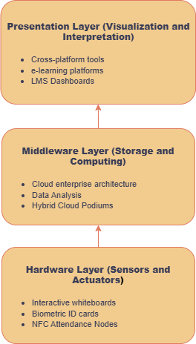
Figure 2.1: IoT Architecture in Educational settings

Microcontroller-based systems have been utilized by researchers to create automated laboratory equipment management, smart classroom lighting, air conditioning controllers, and various nodes to track attendance (Archival et al., 2022; Ishaq & Bibi, 2023; Raj et al., 2021). The unifying factor in all these applications is that a microcontroller offers enough processing power and peripheral connectivity to the desired task at a fraction of the cost and power consumption of a full single-board computer, proving that it would be the most suitable device to use in dedicated and single-purpose hardware nodes deployed in large numbers on a campus.

2.4 Near Field Communication (NFC) Technology

2.4.1 Principles of NFC communication
Near Field Communication involves a collection of communication standards that allow two electronic devices to communicate when brought to a very close distance between them, typically four centimetres or less. It is a dedicated implementation of a larger family of Radio Frequency Identification (RFID) technology, at a carrier frequency of 13.56 MHz, in compliance with the ISO/IEC 18000-3 standard. Compared to standard RFID systems that are capable of reading tags over several metres, the short range is a design choice built into NFC because it minimises the chances of unintended or unauthorised reads (Liu et al., 2025).
The NFC communication has three modes as per the devices that are involved. When the NFC reader is in the active state, e.g., the PN532 module in this project, it emits an electromagnetic field which activates a passive NFC tag, i.e., the chip in a student identification card and then reads or writes data to it. In peer-to-peer mode, two active NFC devices exchange data bidirectionally, as occurs when two smartphones share data via NFC. The third mode is the card emulation mode; In this mode, an active NFC device, most usually a smartphone, acts like a passive tag and thus can be read by an NFC reader in the same manner that a conventional card would be. The third mode is noteworthy to this project as it offers a possible future direction of the students to utilize their smartphones instead of a physical card, in case the institution opts to go that way with the system (Hutagalung et al., 2024; Szolga et al., 2025).
The read/write mode of data entry follows a defined sequence. The reader creates a constant field of electromagnetism. As a passive tag gets into this field, the energy of the field is captured using the antenna coil of the tag and applied to the integrated circuit of the tag (Figure 2.2). The powered tag responds to the reader's interrogation signals, and after an anti-collision protocol resolves any interference from multiple nearby tags. The reader extracts the tag's unique identifier and any data stored in its memory. The process takes less than one hundred milliseconds, which is practically instantaneous to the user (Ahiara & Okey, 2022).

2.4.2 NFC-based identification and access control systems
Before the implementation of the NFC technology in academic attendance, it has been used variously in identity verification and access control in a range of institutional setups. Contactless payment systems on credit/debit cards, smart cards on trains and buses, and key cards used in the corporate access control all operate with the same principles of NFC. The short-range security, low transaction latency, and passive tag durability of the technology has rendered it the standard of choice when it comes to physical identity tokens in situations where speed and reliability are paramount (Ahiara & Okey, 2022).
NFC-based identification has been implemented in an academic environment most prominently in library access control and building entry that involves the use of NFC chips on student identification cards to validate their identity and provide or withhold access (Mammadov et al., 2025). An obvious and comparatively non-obtrusive next step to this already existing NFC identification infrastructure is extending it into the field of attendance tracking; since it only needs

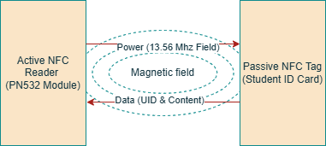
Figure 2.2: Magnetic induction and data exchange between NFC reader and a passive tag

the addition of NFC reader devices in lecture rooms instead of a whole new solution in identifying students.
Studies involving NFC based attendance systems have continually indicated positive results in processing speed and acceptability by the users compared to other available identification technologies. The tap-and-confirm interaction model is the simplest to use and it does not need extensive training to the new user. Comparative studies on NFC-based and manual roll call attendance have demonstrated that NFC-based attendance systems save the time (and in large classes, by vast margins) in taking full-class attendance (Ajayi et al., 2024).

2.5 Multimodal Tracking Systems

2.5.1 The rationale behind multimodal approaches
A multimodal approach implies the offering of two or more different pathways that a user may use to authenticate their identity, with the failure modes of one pathway usually designed so as to disallow the failure modes of any other. The case of multimodal verification can be easily described in the field of attendance tracking. The failure situations of any single-mode system will be the one where a student in attendance cannot record their presence with the designated system. This occurs when the student has not got their card in an NFC-only system. It may occur in a biometric only system when a reader is unable to identify a fingerprint because of environmental conditions. With QR code-only system, it may occur in case the phone battery of a student is flat. All these failure modes lead to an attendance record that improperly indicates the student as absent (Nwabuwe et al., 2023).
Studies that have investigated multimodal attendance architectures have also generally discovered that systems with a hardware-based central mechanism and a fallback of a smartphone achieve greater percentages of valid attendance change than a system that only uses a single-mode system . The major design issue in any multimodal system is to make sure that the secondary pathway does not impose security threats to the integrity assurance of the primary pathway. This is the problem which the QR code generation and validation design has been specifically designed to solve.

2.5.2 QR code-based attendance systems
QR codes are two-dimensional matrix barcodes that can encode any type of data and were initially used to track parts in an industrial environment, but have since been widely used in consumer-facing authentication and information-sharing scenarios (Al-Dabbagh, 2024; Oyerinde et al., 2025). Their use as a system to check attendance in educational institutions has significantly increased in the last ten years, and such a trend has been catalyzed by the fact that most smartphone cameras today have the ability to scan them, and this is possible without the need to purchase scanning devices.
A number of studies have been done on the use of QR code-based attendance systems in university environments and have overall given positive results in regard to speed, ease of use and student acceptance. One of the most prevalent versions is the presentation of a fixed QR code at the entrance of the lecture hall, and when students enter, they scan it. Although this method is easy to implement, a major security issue has been found where a fixed QR code can be photographed and sent over the network, giving a student the possibility to scan it without being in the lecture hall and mark attendance (Oyerinde et al., 2025; Pati et al., 2023).
The solution to this weakness in the research literature is the creation of dynamic QR code systems, where the encoded token is updated at regular intervals, e.g., after every 30 seconds, it reduces the chances of having an absent student scan it (Nwabuwe et al., 2023; Oyerinde et al., 2025). More advanced applications involve dynamic token rotation coupled with authentication specifications, where the student has to be logged into the system on a registered computer before a scan is accepted. The QR code mechanism that was used in this project has both these security features and produces a time-limited, cryptographically signed token that may only be redeemed by an authenticated student with a limited window of validity.

2.5.3 Security considerations in multimodal attendance tracking
The addition of a secondary pathway to the attendance system will inevitably increase the system’s vulnerability to attack, in the sense that it introduces new points of vulnerability. Proper analysis of the security implications of the multimodal design is hence a significant aspect in the development of the system.
The major security threats of a combined NFC and QR code attendance system may be divided into three groups. The first one is physical token sharing where a student becomes the borrower of the NFC card of another and registers the attendance on his behalf. It is the pure digital equivalence of proxy signing, and the simplest type of attendance fraud in an NFC-based system. The second one is digital token sharing whereby a student snaps the picture of the QR code that is displayed, and sends it to an absent classmate who accepts it and uses it to record attendance remotely. The third one is replay attacks, where a token in the form of an NFC card UID or QR code is re-sent to the backend in order to register attendance of a session that the student did not attend.
The literature on secure attendance system design recommends a layered approach to mitigating these risks (Nwabuwe et al., 2023). Physical token sharing can be partially deterred by institutional policy and by the fact that a student who loans their card risks having their own attendance record affected if the card is not returned before the session ends. The risk that can best be mitigated by technical design is digital token sharing, which is accomplished through short-lived signed tokens that have an expiry time before it can be shared and utilized effectively. Geofencing has been used in attendance systems to restrict marking to a defined area (Azila et al., 2025; Eweoya et al., 2025), and it was applied to the QR channel in this project. The only constraint that prevents replay attacks is the fact that the student-session combination in the Attendance Records table is unique, meaning that a valid token can only result in a successful attendance record no matter the number of times the token is submitted.

2.6 Review of related systems
An overview of the current automated attendance systems demonstrates that the current landscape is rather incoherent, with the solutions usually being tailored towards either hardware or software security, but rarely both in an integrated administrative setup.
As an example, hardware-based solutions, including the NFC-based standalone system tested by Szolga et al. (2025), have high levels of tamper-resistance and are fast in processing rates. These systems however all have a common weakness of a lack of redundancy; the students who lose their physical identification tickets are completely locked out of the automated process leaving the lecturers to resume using manual record keeping. Moreover, these hardware systems can be frequently isolated data silos, which means that administrative personnel will have to export logs by hand and match them against larger academic data.
On the other hand, those that are software-based are the most accessible but are often less secure. Mobile application systems that use static QR codes, although eliminate the need to use specialized scanning devices, create serious vulnerabilities to remote frauds in attendance. As studies on the implementation of these systems have recorded, the static codes can be easily captured and sent to absentees, which does not solve but instead digitizes the problem of proxy attendance .
Table 2.1: Summary comparison of related attendance tracking systems
Author(s) & Year | Modality / Technology | Key Strengths | Identified Limitations
Raj et al. (2021) | IoT + Computer Vision (Facial Recognition) | Contactless, passive capture in classrooms | Sensitive to lighting, occlusion, camera angles, and high compute cost
Choe et al. (2023) | 125 kHz RFID Microcontroller Node | Low cost and faster than paper roll call | Single-mode; lacks cryptographic protection against UID cloning; isolated logs
Pati et al. (2023) | Static QR Code + Mobile Application | Zero classroom hardware cost; high ease of use | Vulnerable to photographing and remote sharing of static QR codes
Nwabuwe et al. (2023) | Dynamic QR + Geofencing + IMEI Binding | Strong anti-proxy software checks | Single-mode smartphone dependency; fails when student battery dies
Ajayi et al. (2024) | Standalone NFC Smart Card System | Fast tap verification and tamper resistance | No software fallback if student forgets or loses ID card
Oloniyo et al. (2025) | RFID + Fingerprint + Face + GSM | High hardware redundancy | High hardware acquisition/maintenance cost; contact queues at entrances
Oyerinde et al. (2025) | Dynamic Rotating QR Code System | Mitigates static QR sharing via timed token rotation | Lacks hardware capture pathway and automatic eligibility triggers
Szolga et al. (2025) | NFC Smart Card Terminal | Rapid card read speed (< 100 ms) | Single point of failure; requires manual log reconciliation
Developed System (2026) | ESP32/PN532 NFC + Dynamic HMAC QR + Haversine Geofence | Dual-channel redundancy under one DB constraint; real-time WebSocket & auto-eligibility | Requires active Wi-Fi/internet connection during sessions

2.7 Gaps in Literature
Looking across the systems reviewed in this chapter, three practical gaps stand out: First, most hardware-based systems lack a software fallback. Standalone NFC and RFID designs such as those by Ajayi et al. (2024), Hutagalung et al. (2024), and Szolga et al. (2025) read cards quickly and resist physical tampering, but they stop working for any student who forgets, loses, or damages their card. When that happens, the lecturer has to fall back to paper lists. Conversely, combining multiple hardware readers—such as the RFID, fingerprint, and facial recognition setup in Oloniyo et al. (2025)—drives up equipment and maintenance costs while still causing queues at the lecture hall door. Second, purely software-based systems trade away either security or availability. Basic QR code systems using static barcodes (Pati et al., 2023) are easy for students to photograph and forward to absent classmates. Newer mobile systems close that loophole with rotating tokens (Oyerinde et al., 2025), GPS geofencing (Azila et al., 2025; Eweoya et al., 2025), and device binding (Nwabuwe et al., 2023), but a student whose phone battery is flat or whose camera is broken cannot mark attendance at all. Third, existing tools rarely connect multimodal capture directly to examination eligibility records. Many microcontroller readers store logs locally for manual CSV export and spreadsheet calculation later (Choe et al., 2023; Szolga et al., 2025). None of the reviewed works combine a physical NFC reader node and a cryptographically signed, geofenced QR channel under one database uniqueness rule that updates examination eligibility automatically. To address these three gaps, this project combines a dedicated ESP32/PN532 NFC reader node with a 30-second HMAC-signed, geofenced QR mobile channel. Both channels write to the same PostgreSQL constraint so duplicate entries are blocked regardless of how a student checks in, and database triggers recalculate each student's attendance percentage automatically.

2.8 Chapter Summary
This chapter has reviewed the theoretical and technical foundations that underpin the system developed in this project, organized around the key domains of attendance monitoring, IoT hardware, NFC technology, and multimodal verification. The review has established that each of the individual technologies employed in this project have been validated in prior research within educational or closely related contexts. It has also identified, through the review of related systems, that no prior implementation has brought these components together into a cohesive, integrated system that simultaneously satisfies the requirements of physical tamper resistance, multimodal fallback accessibility, and real-time data synchronization. The architecture proposed is designed to address this gap.

CHAPTER THREE
METHODOLOGY

3.1 Introduction
This chapter outlines the architectural design, choice of components, and the logical data flow that this project employs in carrying out its objectives.

3.2 System Overview

3.2.1 High level architecture
The system works on three different layers that are closely integrated, as illustrated in Figure 3.1. The Physical Layer denotes the interface where the presence of the students is detected and recorded digitally. It includes the specifically designed ESP32-based NFC hardware node as the main capture tool, the NFC-enabled smartphone of the lecturer as an emergency reader, and students’ smartphones running the mobile application as the QR code fallback. The Backend Layer is the core of the architecture. It is based on Supabase, which is a cloud-hosted PostgreSQL database, allows transactional operations using REST API, has a real-time synchronization service, and an in-built authentication service. The application Layer contains the two user interfaces. The lecturers and administrators mostly interface with the Next.js web dashboard. It is able to centralize on session control, administration of courses and real time tracking of attendance. The Flutter mobile app is one that caters to students and offers them access to attendance session history, eligibility, and the QR code scanner.

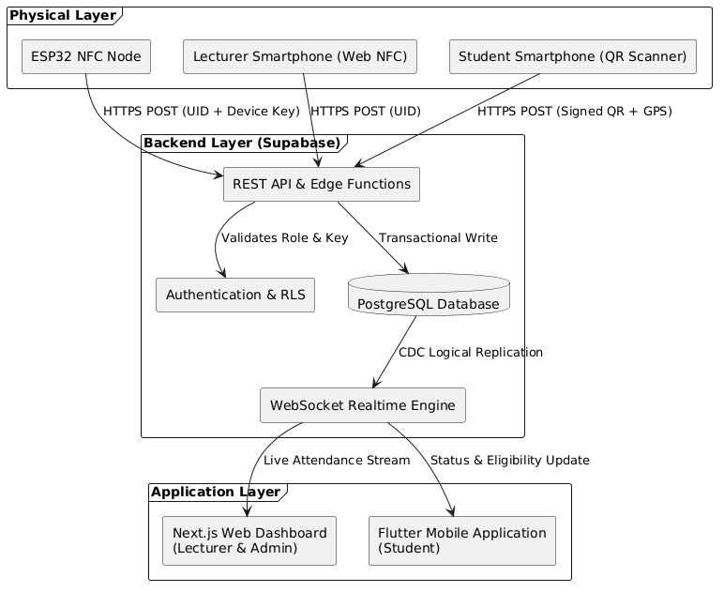
Figure 3.1: High Level System Architecture

3.2.2 System workflow
The following explains the flow of data through the three layers of the system during a typical lecture session, starting from when the lecturer opens a lecture session to when the attendance of a student is confirmed and tracked in the system.
The session is initiated when the lecturer logs into the web dashboard and opens a new session of attendance for the related course. This sends a new session record to the Supabase database with its status set to active and initiates two simultaneous processes: the backend signals to the hardware node in the lecture room to start accepting card reads, and the backend issues a dynamic, time-limited QR code token, which is displayed on the lecturer’s dashboard for projection. After a student taps their card against the node, its firmware reads the unique identifier of the card tapped against the hardware node, encodes it in a JSON payload with a timestamp and sends it to the database via Wi-Fi (Figure 3.2). The payload is sent to the backend which verifies the card is bound to a student’s profile, ensures that an attendance session is active and then adds a new record to the database. The hardware node receives a success confirmation and gives auditory and visual feedback to the student.
The Supabase real-time engine immediately broadcasts the new record to the lecturer's dashboard over WebSocket, updating the attendance panel without any page refresh.
For a student without their card, the process follows the fallback path. The student opens the Flutter mobile application, navigates to the active session for their course, and taps the scan button. The application opens the device camera, the student scans the QR code, and the extracted token is submitted to the backend for validation. The backend verifies the token's cryptographic signature, confirms that it has not expired, confirms the student's enrolment in the course, and inserts an

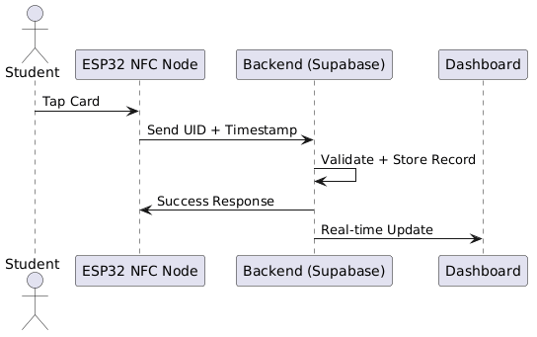
Figure 3.2: Sequence Diagram for card tap

attendance record identical in structure to one generated through the NFC path. The student receives an in-app confirmation, and the lecturer's dashboard updates in real time.
At any point during or after the session, the backend's eligibility computation function recalculates each student's cumulative attendance percentage for the course and updates their status. This means
that by the time the session ends, every enrolled student's academic record already reflects the outcome of that session without additional action.

3.3 System Requirements Analysis
The first objective of this project is to define tangible functional requirements. The specifications were determined by analysing and mapping current academic and administrative processes in Nigerian institutions, to determine the bottlenecks and technical gaps that make up the requirements.

3.3.1 Functional requirements
The functional requirements were defined as follows:
- FR1: NFC card UID acquisition. The hardware node shall read a contactless card presented to the reader, extract its unique identifier, and signal the read to the user with immediate visual and audible feedback.
- FR2: NFC attendance logging. During an active session, the hardware node shall send the identified card to the backend, which shall record the attendance of the student the card is registered to.
- FR3: Dynamic QR rotation. When a lecturer opens a session, the system shall generate a cryptographically signed QR code that refreshes automatically at a fixed interval.
- FR4: QR attendance submission. The system shall record attendance when an enrolled student scans a valid QR code with the mobile application.
- FR5: Duplicate prevention. The database shall reject a second attendance record for the same student and session, irrespective of the capture channel used.
- FR6: Geofence enforcement. The system shall reject a QR submission made from outside a defined radius of the session location.
- FR7: Real-time dashboard reflection. The lecturer dashboard shall display each new attendance record without a page refresh.
- FR8: Automatic eligibility computation. The system shall compute and update each approved student's cumulative attendance percentage automatically when attendance is recorded or a session is created.
- FR9: Role-based access control. The database shall enforce role-based access at the data layer, so that students can access only their own records and cannot write to restricted tables.

3.3.2 Non-functional requirements
- NFR1: Card read time. The hardware node shall read a card identifier in under 500 ms.
- NFR2: NFC end-to-end latency. Under stable network conditions, the mean time from an NFC tap to the update on the lecturer dashboard shall not exceed 3.0 s.
- NFR3: QR end-to-end latency. Under stable network conditions, the mean time from a QR scan to the update on the lecturer dashboard shall not exceed 3.0 s.
- NFR4: QR validity. A dynamic QR code shall expire and refresh within 30 s, to limit the sharing of tokens.
- NFR5: Request integrity. Requests with expired, forged or missing credentials shall be rejected with a client error status and shall create no attendance record.

3.4 Design of the Multimodal Attendance Architecture: Primary Pathway
The second objective of this project is to design a multimodal attendance monitoring system, which integrates both hardware-based NFC authentication and smartphone-based fallback systems. The architecture offers three different avenues that could be used to authenticate the physical presence of a student, and each is meant to address the failure of the others.
The primary attendance system consists of a special, integrated IoT hardware device, which is located in the lecture room. This node is the most resistant of the three pathways due to the fact that it requires the student to physically swipe a provisioned NFC enabled card on a fixed device in a known location so that it is not possible to register attendance remotely.

3.4.1 Justification and component selection
The microcontroller that has been chosen to serve the hardware node is the ESP32 manufactured by Espressif Systems. The ESP32 was selected, as opposed to simpler alternatives, because of a number of reasons. Its inbuilt dual core processor enables it to be able to support the NFC read interrupts and Wi-Fi transmission activities at the same time without one task blocking the other, which is essential for maintaining a responsive card-reading experience during network transmission. Its native 802.11 b/g/n Wi-Fi transceiver eliminates the need for an external network module making it less complex in circuit and lowering components costs. It has a wide range of support to peripheral communication protocols, namely I2C and SPI, which make it compatible with the selected NFC module. Its simplicity and low unit price coupled with its prevalence in the market also make it a viable option in a deployment scenario where replaceability of components is a practical factor.
The chosen NFC reader module is the PN532, produced by NXP Semiconductors. The PN532 was selected due to its adherence to the ISO/IEC 14443 Type A and B standards which are the standards that most modern contactless smart cards have adopted, including those typically issued as student identification cards. The PN532 has a carrier frequency of 13.56 MHz, and supports the MIFARE cryptographic protocol package, making it a lot more secure than low-frequency 125 kHz RFID options that are incapable of cryptographic handshaking. The fact that the module can communicate with the NFC enabled smartphones in the card emulating mode also offers an avenue through which the system can be extended in future.
The supporting components consist of a passive buzzer and indicator LEDs to provide user feedback. The node was designed to run from a single 18650 Li-ion cell (3.0 to 4.2 V) charged by a TP4056 module, switched through a slide switch and regulated to 3.3 V by a low-dropout regulator, with a 10 µF electrolytic and a 0.1 µF ceramic capacitor close to the ESP32 to suppress Wi-Fi transmission spikes. An LDO regulates only while the cell voltage stays above the output plus the dropout voltage, and its current rating must cover the ESP32's Wi-Fi transmission peaks. The implementation replaced the LDO with an MT3608 boost converter.

3.4.2 Circuit Design
The PN532 was interfaced with the ESP32 through the I2C (Inter-Integrated Circuit) communications protocol. I2C was preferred over the other SPI (Serial Peripheral Interface) protocol because it requires only two data lines, the SDA (Serial Data) line and the SCL (Serial Clock) line, which reduces the GPIO pin consumption on the ESP32, and simplifies the physical wiring of the circuit. SDA and SCL pins of PN532 were connected to GPIO pins of the ESP32. The buzzer and LED were connected to independent sets of GPIO pins and are directly driven by the firmware.

3.4.3 Firmware Logic
The firmware was written in C++ for the ESP32 using the Arduino framework and the Adafruit PN532 library. On start-up, the device connects to Wi-Fi and enters an idle state, polling the backend every 8 seconds to learn which mode it should be in. The device enters ATTEND mode only while an attendance session is active on the dashboard, and ENROL mode only when a lecturer activated card enrolment (Figure 3.3). In either active mode, the red LED blinks rapidly and the firmware polls the PN532 for a card in its field. If a card is detected, the library performs anti-collision handling and returns the card UID. The firmware then builds a JSON payload containing the UID and device ID and sends it by HTTPS POST to the relevant Edge Function. On successful response, the green LED pulses once and the buzzer sounds a tone, depending on whether it’s in attend or enrol mode. On a rejection or failure, the red LED blinks once and the buzzer sounds a distinct error tone.

3.4.4 Simulation Strategy
Before the components were assembled, the circuit and the control logic were simulated in Wokwi, an online ESP32 simulator. The simulation connected the ESP32 to the indicator LEDs and buzzer, with a push button standing in for a card tap, because the PN532 module could not be simulated. This allowed the firmware's mode handling, its feedback behaviour, and its JSON payload formatting to be checked, and confirmed that the program ran without faults. It could not verify the I2C communication with the PN532, the radio behaviour or the power supply, which were tested on the physical prototype.
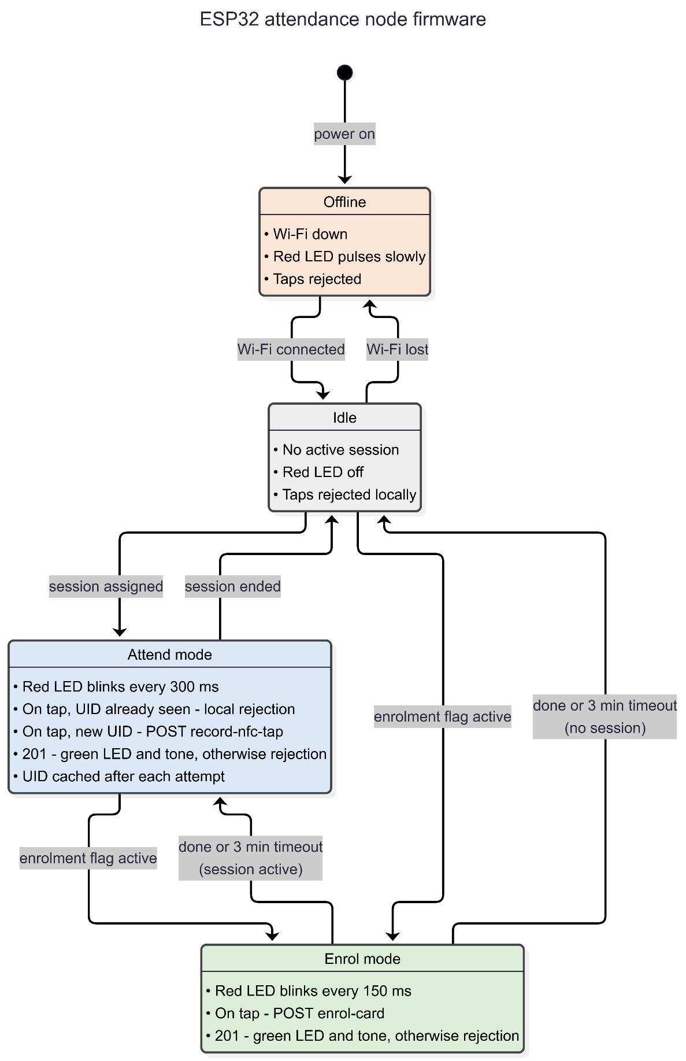
Figure 3.3: Firmware execution flowchart across Idle, Attend, and Enrol modes

3.5 The Secondary Hardware Pathway
This pathway involves a scenario where the dedicated hardware node is not accessible because of a hardware or power failure. The Android smartphone of the lecturer if NFC-enabled could serve as an emergency card reader but keeps the hardware-based verification without involving extra equipment.
Such a pathway is applied to the Next.js dashboard as a mobile-friendly emergency reader mode. Upon activation, the Web NFC API of the browser reads the card UID of the student and sends it to the same backend endpoint as the dedicated node, which generates the same record of attendance. Web NFC API is already supported on Android devices with Google Chrome, which is adequate to this use case.

3.6 Software Fallback Pathway: Dynamic QR Codes
The third route offers software-based backup to students who might come to the lecture without an identification card or when the hardware node is not there. The sequence diagram in Figure 3.4 illustrates this. It is fully implemented in software, and does not require any specialized equipment on the side of the student other than a smartphone with a functioning camera to operate the mobile application.

3.6.1 Token generation logic
At the start of a session, the backend creates a token payload with the structure defined (in Figure 3.5). The HMAC-SHA256 algorithm with a secret key in the environment configuration of the backend is used to sign this payload. Encoded signature of the token in the form of a QR code image is sent to the dashboard of the lecturer. The ‘expires_at’ field is assigned to 30 seconds from

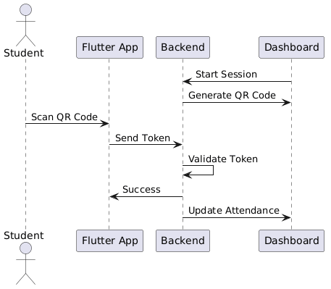
Figure 3.4: Sequence Diagram for Dynamic QR

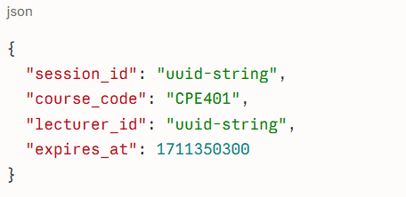
Figure 3.5: JSON Payload

generation. A photographed and shared QR code is automatically being updated once the current token has expired, hence it will be invalid before an absent student gets the chance to use it.

3.6.2 Token Validation Logic
Whenever a student scans the QR code with the Flutter application, the verify-qr Edge Function executes six consecutive checks: it verifies that the request comes from the student's bound mobile device; it validates the HMAC-SHA256 signature in constant time; it verifies that the 30-second token window has not expired; it computes the Haversine distance between the student's GPS coordinates and the session venue coordinates to confirm the student is within the permitted geofence radius; it confirms that the student has an approved enrolment in the course; and it checks that no attendance record already exists for that student and session. An attendance record is inserted only when all six checks pass; otherwise, an appropriate 4xx error status is returned to the mobile application.

3.7 Development of the Application Interface

3.7.1 The Administrative Dashboard
The web interface is separated into two role-specific portals built with Next.js: a Lecturer Portal and an Administrator Portal. The Lecturer Portal includes navigation views for Home (assigned courses and quick actions), Sessions (live attendance control and historical logs), Enrol Card (timed NFC card provisioning for students), Students (directory and attendance standing), Settings, and Device Setup. During a live session, the portal displays the rotating QR code alongside a real-time attendance feed and an emergency Web NFC reader option. The Administrator Portal provides four institutional management views: Lecturers (account provisioning and course assignment), Students (profile editing, device-binding resets, and account deactivation), Courses, and Reports (attendance summaries and CSV exports).

3.7.2 The Mobile Application
The Mobile application in this project was developed using Flutter, as it can be compiled to both Android and iOS native ARM code making it useful across a large physical variety of devices used by university students. Its camera API gives direct access to the hardware present in the device that is needed in QR scanning.
The application is organised into four sections accessible from a bottom navigation bar: Home (enrolled courses, current attendance percentages, and eligibility status badges), Courses (course enrolment requests and session-by-session attendance history), Resources/Management, and Scan (the camera-based QR code scanner).
When opening the Scan section in an active session, the app automatically scans through the currently active session of the courses enrolled by the student and opens the camera scanner. After the scanning of a valid QR code and the attending record is verified by the backend, a successful confirmation is shown on the application and the student is redirected to the home screen.

3.8 Backend and Database Infrastructure
The backend infrastructure was built on Supabase, which provides a hosted PostgreSQL database, a real-time WebSocket engine, an automatically generated REST API, a built-in authentication service and serverless Edge Functions (summarised in Table 3.1) in one platform. Supabase was chosen due to a number of reasons. Its PostgreSQL core offers the most relational data model appropriate to nature of academic data. The ACID transactional guarantees of PostgreSQL ensures that the records created by the hardware node and the mobile application on the same node cannot be inconsistent or duplicated. Supabase real-time engine, which is based on the logical replication capability available in the PostgreSQL database, offers WebSocket broadcasting functionality required to support the live attendance dashboard without having to maintain a distinct messaging infrastructure. The Row-Level Security (RLS) functionality of the platform facilitates giving access control policies that are defined within the database, ensuring that authorization is enforced at the data layer independently of the application layer.
Table 3.1: Edge Functions
Function | Purpose
generate-qr | Lecturer only; produced a signed payload for the current 30 s window, identical for all viewers of a session
verify-qr | Checked the HMAC (constant-time), expiry, and geofence distance (Haversine), then recorded attendance
record-nfc-tap | Resolved the card UID to a student and recorded attendance after enrolment, session and eligibility checks
enrol-card | Bound a card UID to a student while enrolment mode was active
enrolment-mode | Activated or cleared enrolment mode and served the node’s status poll
admin-create-user | Provisioned lecturer and administrator accounts with role metadata
admin-manage-user | Handled student profile updates, device-binding resets, and account activation

3.8.1 Database Schema
The database held nine tables in the public schema. Credentials were held in Supabase's managed authentication table, and each account was linked one-to-one to a row in profiles, which stored the user's name and role (student, lecturer or admin), the student's matric number, and the identifier of the device bound to the account. The courses table stored each course's code and title with a reference to the coordinating lecturer. Students were linked to courses through course_enrollments, which recorded the request, its status (pending, approved or rejected), the decision details and reason, and the student's attendance percentage for the course. The sessions table recorded each lecture session with its course, start and end times, creating lecturer and location coordinates. The attendance_logs table held one record per attendance event, with the student, session, capture channel and time. A unique constraint on the student and session combination rejected a second record whichever channel produced it, and a unique index on course_enrollments allowed one request per student and course. Card registration was held in nfc_cards, with the card UID as primary key and a unique reference to the student, so a card could belong to one student and a student could hold one card. Three further tables supported the hardware node: enrolment_mode_flag (a single row recording whether enrolment was active, for which student, and when it expired), device_sessions (the node's current mode, session and last contact) and device_events (a log of device activity). QR tokens were not stored. They were generated and checked statelessly by recomputing the HMAC signature.

3.9 System Evaluation
System evaluation was the final objective of this project. The developed system was evaluated against the functional and non-functional requirements in Section 3.3, in these areas: functional testing, performance testing, security and tamper resistance testing. Accuracy was defined as the absence of incorrect, missing or duplicate attendance records in the test scenarios. The pass criteria were set before testing began.

CHAPTER FOUR
IMPLEMENTATION

4.1 Introduction
This chapter covers the physical construction, software implementation, and testing of the attendance system. Section 4.2 describes how the ESP32 hardware node, firmware, Supabase backend, web dashboards, and Flutter mobile application were built, together with four integration bugs that were found and fixed before formal testing. Section 4.3 sets out the functional, latency, concurrency, and security test procedures. Section 4.4 presents the test measurements, Section 4.5 discusses what those results mean against the target requirements, and Section 4.6 outlines the limitations and scope boundaries of the prototype.

4.2 Implementation

4.2.1 Hardware node
The node was built around an ESP32 development board (Figure 4.1(a)) and a PN532 NFC module operated in I2C mode (Figure 4.1(b)). The PN532 was soldered to pin headers and connected as shown in Table 4.1. A red and a green LED provided visual feedback, each in series with a current-
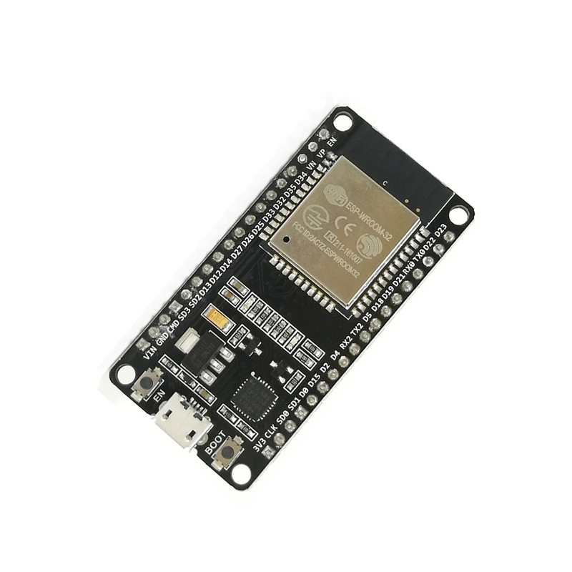
Figure 4.1(a): ESP32 DOIT DevKit V1 microcontroller board

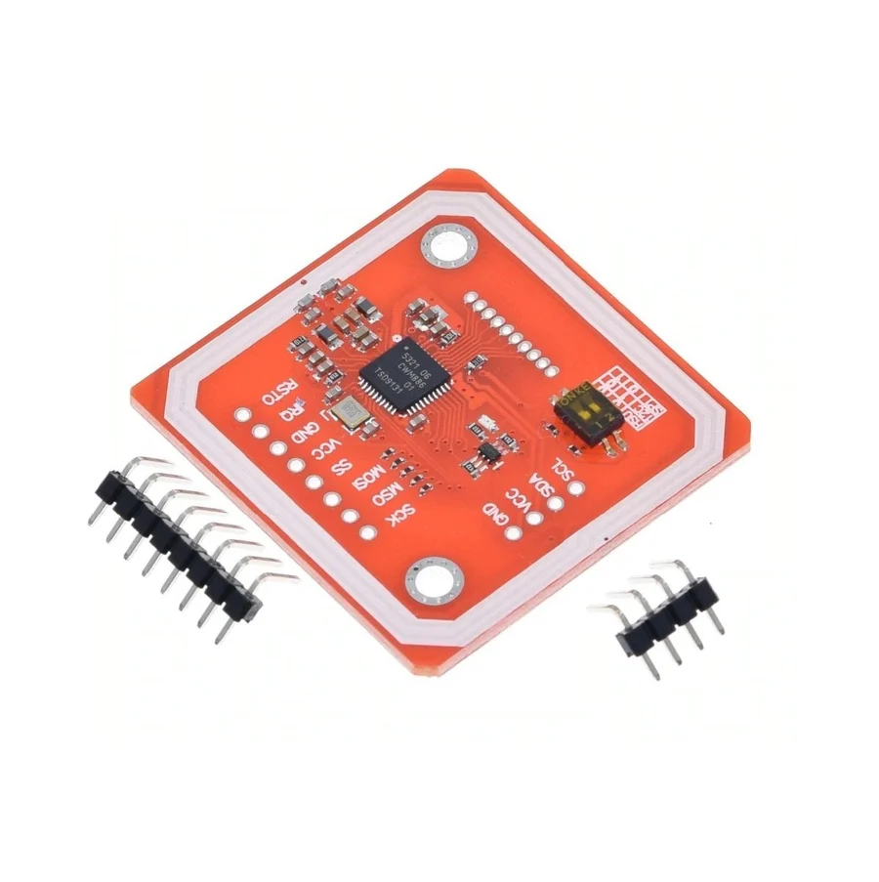
Figure 4.1(b): PN532 NFC/RFID transceiver module configured for I2C communication

Table 4.1: Pin assignments
Component / Signal | ESP32 GPIO Pin | Direction / Protocol | Electrical & Functional Notes
PN532 SDA | GPIO 21 | Bidirectional (I2C Data) | Direct connection to ESP32 I2C bus; logic level 3.3 V
PN532 SCL | GPIO 22 | Output (I2C Clock) | Direct connection to ESP32 I2C bus; 400 kHz Fast-Mode
PN532 VCC & GND | 3.3V / GND | Power Rail | Supplied by onboard AMS1117-3.3 regulator rail
Red Status LED | GPIO 23 | Digital Output | Current-limited by 110 Ω series resistor; indicates error/busy
Green Status LED | GPIO 4 | Digital Output | Current-limited by 120 Ω series resistor; indicates success/attendance
Passive Buzzer | GPIO 18 | PWM / Tone Output | 1800 Hz audible chime driven directly by ESP32 timer channel
Power Slide Switch | VIN Rail | Hardware Power Path | Switches MT3608 5 V boost output to ESP32 VIN pin

limiting resistor, and a passive buzzer (Figure 4.1(c)) provided audible feedback. All grounds shared one common rail.
The node was powered by a single 18650 Li-ion cell (Figure 4.1(d)) charged through a TP4056 module (Figure 4.1(e)). The cell output passed through a slide switch to an MT3608 boost converter (Figure 4.1(f)), trimmed to about 5 V and connected to the ESP32's VIN pin, from which the board's onboard regulator supplied the 3.3 V rail. The internal circuit assembly and wiring layout are shown in Figure 4.2. The assembly was housed in a small white PVC junction box (Figure 4.3), with the PN532 mounted inside the lid so the read surface sat under the plastic, and the LEDs visible through holes in the lid. Components were fixed with hot glue.

4.2.2 Firmware
The firmware implemented the behaviour described earlier in C++ using the Arduino framework with the Adafruit PN532, ArduinoJson, WiFiClientSecure and Preferences libraries. The node identified itself with a fixed device ID. Every request to the backend carried the project's public key and, a device key in the x-device-key header. Each HTTPS request was validated against the Let’s Encrypt ISRG Root X1 certificate, which was compiled directly into the firmware; the WiFiClientSecure object was initialised with setCACert(rootCACertificate), so the ESP32 rejects any response not signed by a trusted certificate authority.

4.2.3 Backend
The backend ran on a Supabase project. The schema was created through versioned migrations, and the seven Edge Functions were deployed to the same project. Row-level security was enabled on all tables, and attendance writes were restricted to the service role.

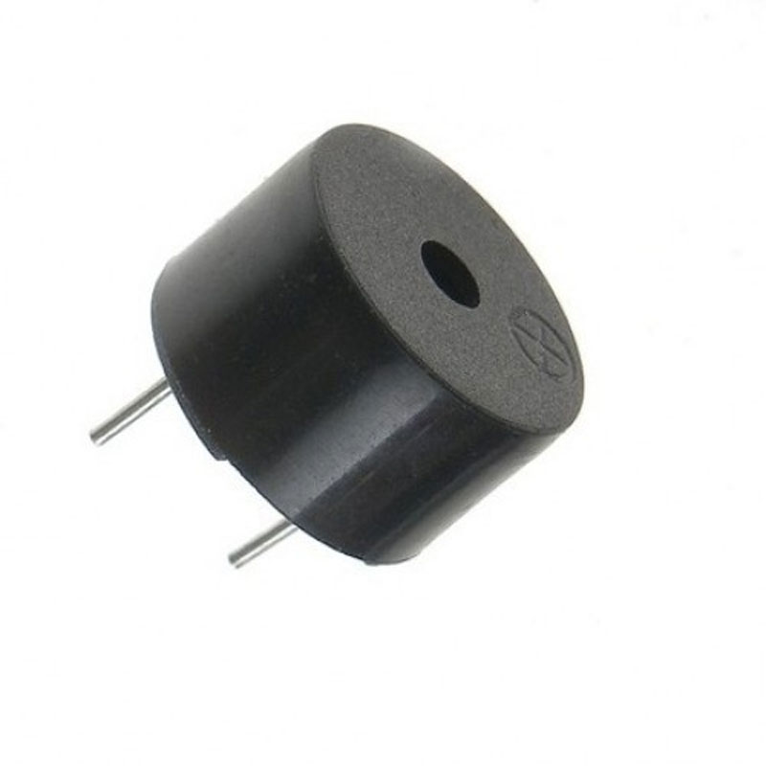
Figure 4.1(c): Passive piezoelectric buzzer

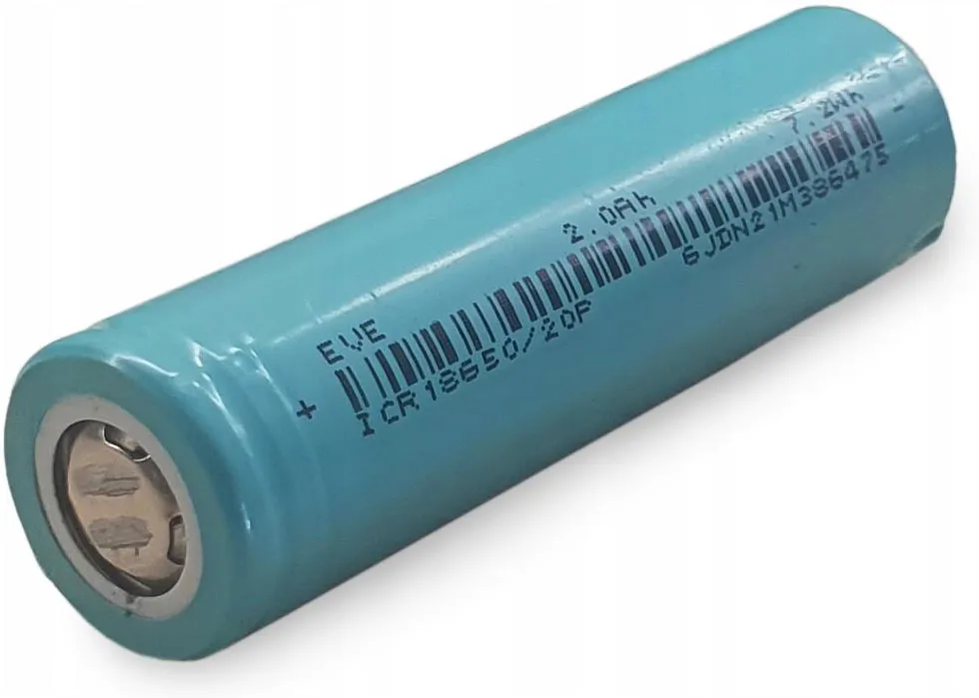
Figure 4.1(d): ICR18650 3.7 V 2000 mAh rechargeable Li-ion battery cell

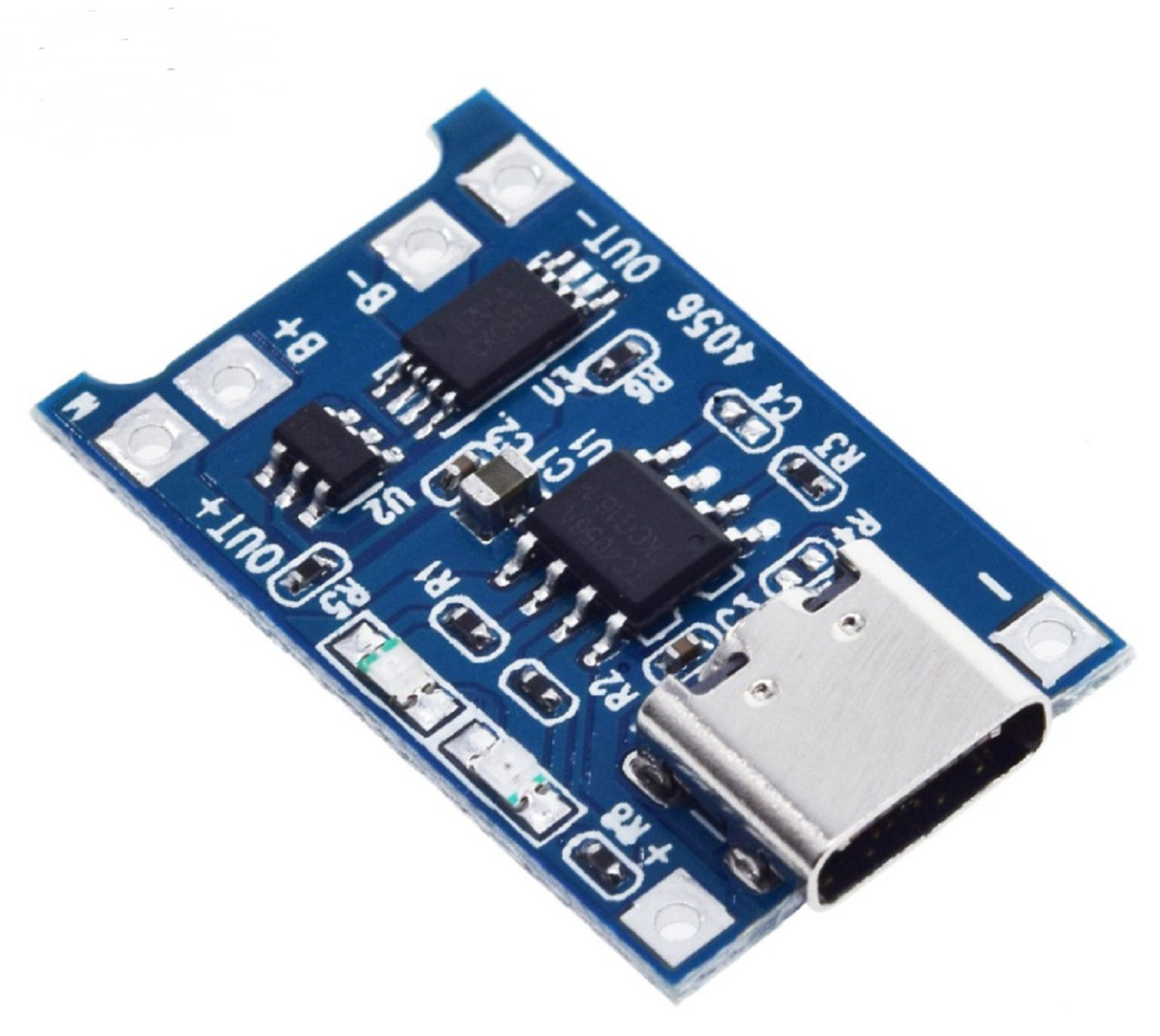
Figure 4.1(e): TP4056 Li-ion constant-current battery charging module

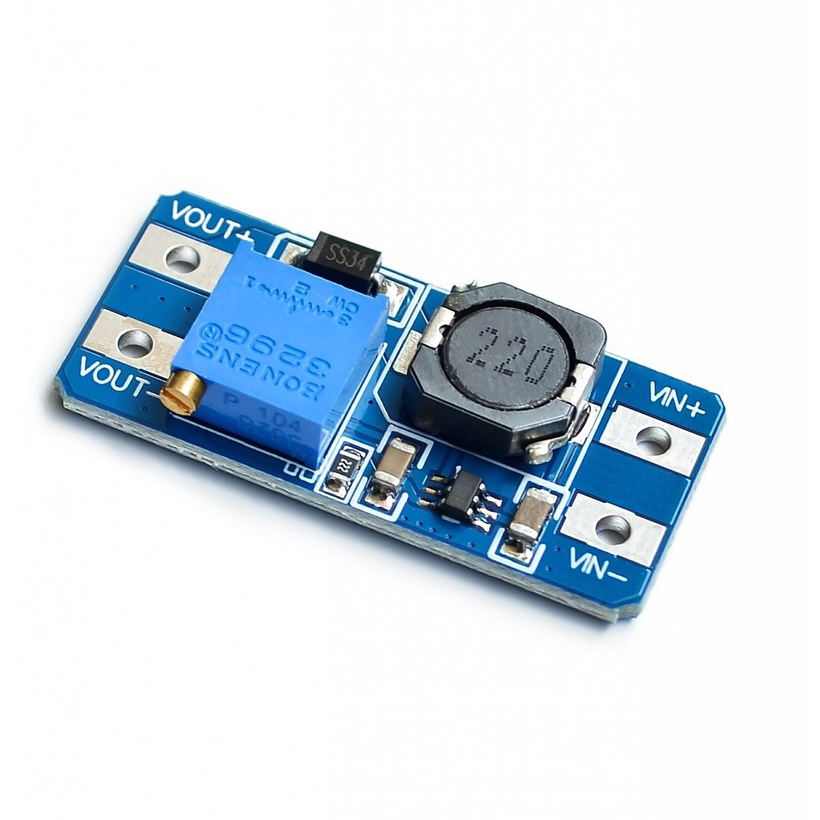
Figure 4.1(f): MT3608 2A DC-DC step-up boost converter module

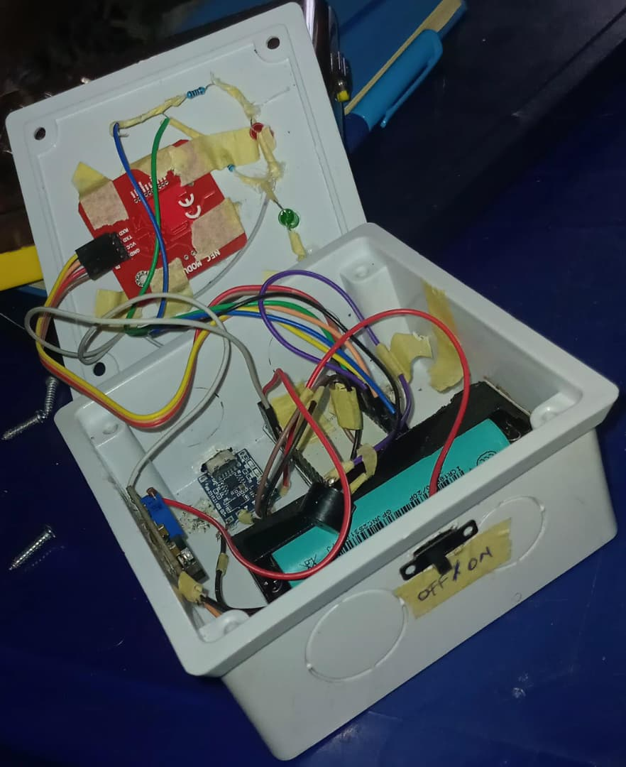
Figure 4.2: Interior assembly showing internal layout, booster circuit, and reader wiring
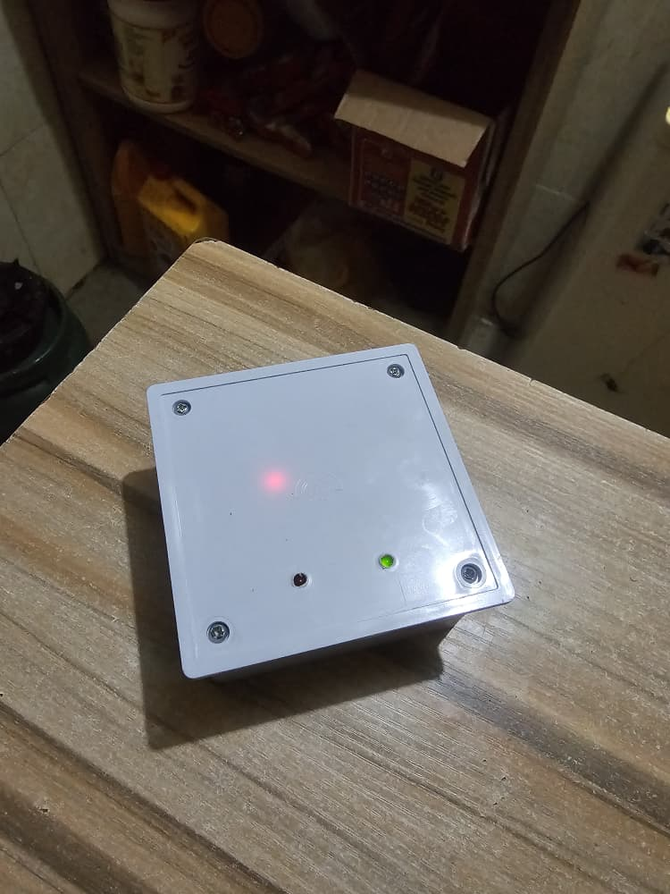
Figure 4.3: Hardware node in compact PVC enclosure during active operation

4.2.4 Lecturer dashboard
The lecturer dashboard (Next.js, TypeScript, Tailwind CSS, @supabase/ssr) provides course lecturers with administrative control over attendance sessions and student enrolments. Lecturers authenticate through the dedicated sign-in portal (Figure 4.4), accessing a centralised course overview listing active and historical course units (Figure 4.5). The enrolment management module (Figure 4.6) enables lecturers to review and approve pending student enrolment applications, with an enrolled student directory (Figure 4.7) displaying current academic standing and attendance eligibility percentages. To register physical smart cards, lecturers trigger a timed card enrolment dialog (Figure 4.8) that switches the assigned node into ENROL_MODE. During active lecture periods, the live session view (Figure 4.9) generates and dynamically refreshes the HMAC-signed QR code every 30 seconds while streaming attendance entries in real time via Supabase WebSocket broadcasts. Finally, the session history view (Figure 4.10) visualises attendance trends and per-session metrics.

4.2.5 Administrator dashboard
The administrator dashboard provides system operators with institutional governance and oversight tools. Administrators manage academic identities through the user management interface (Figure 4.11), supporting account creation, role assignments (student, lecturer, administrator), and credential recovery. Course allocations, lecturer assignments, and departmental curriculum structures are maintained through the course management console (Figure 4.12). The attendance reporting subsystem (Figure 4.13) aggregates institutional attendance records across courses and departments, enabling the export of CSV audit reports.

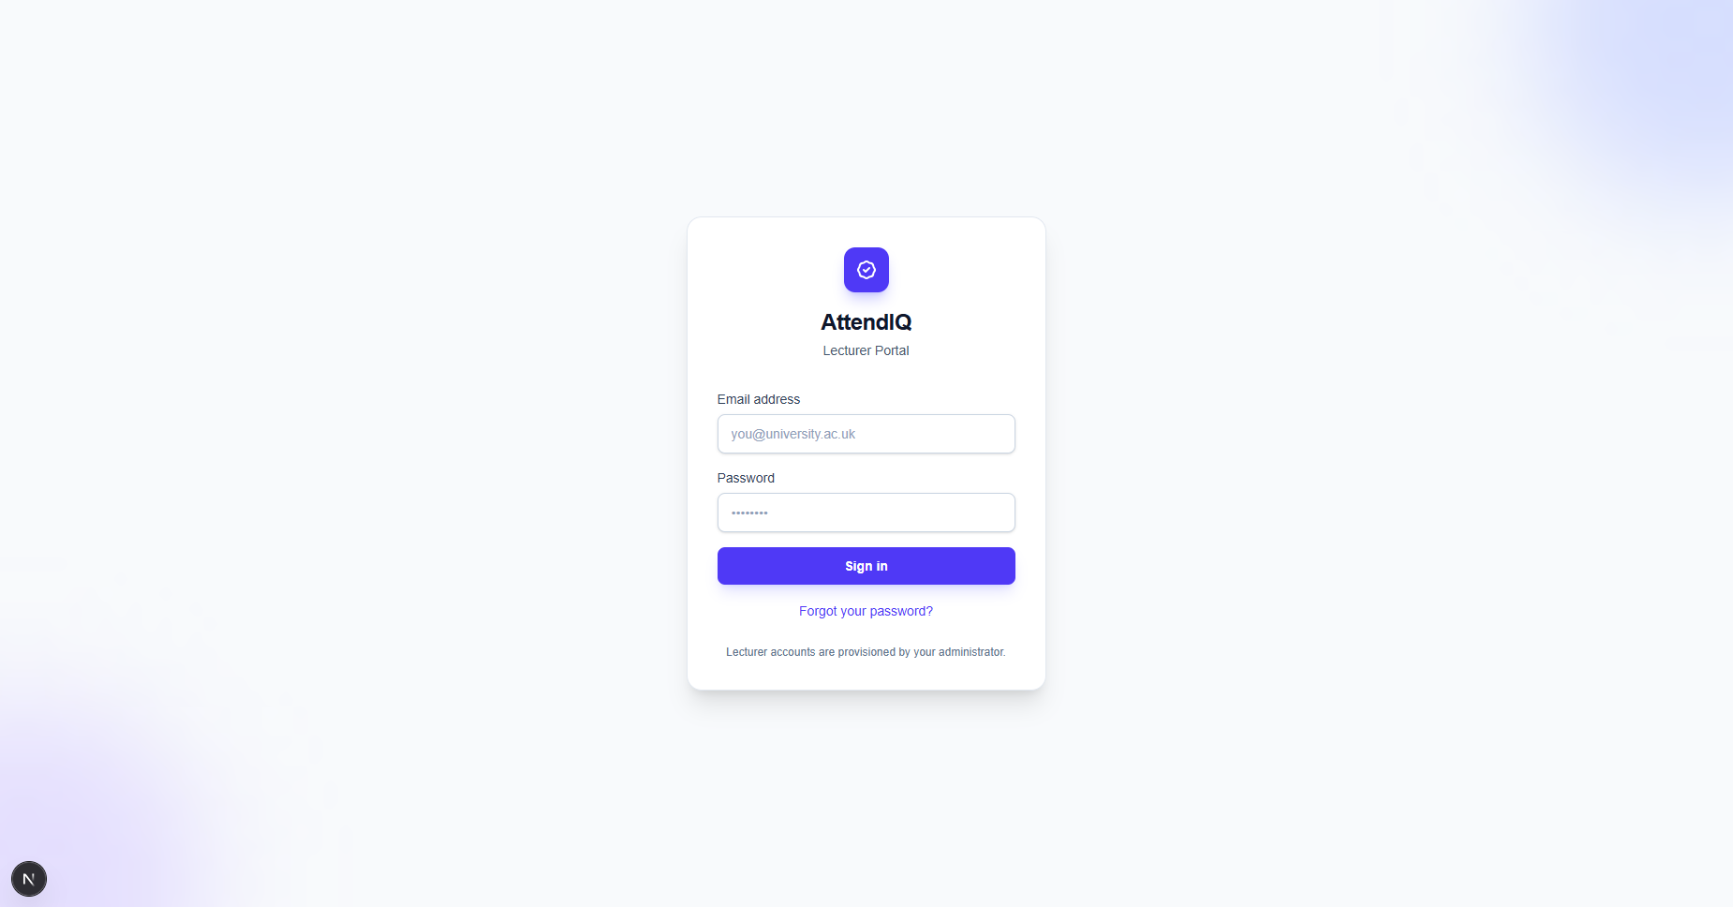
Figure 4.4: Lecturer dashboard: authentication interface

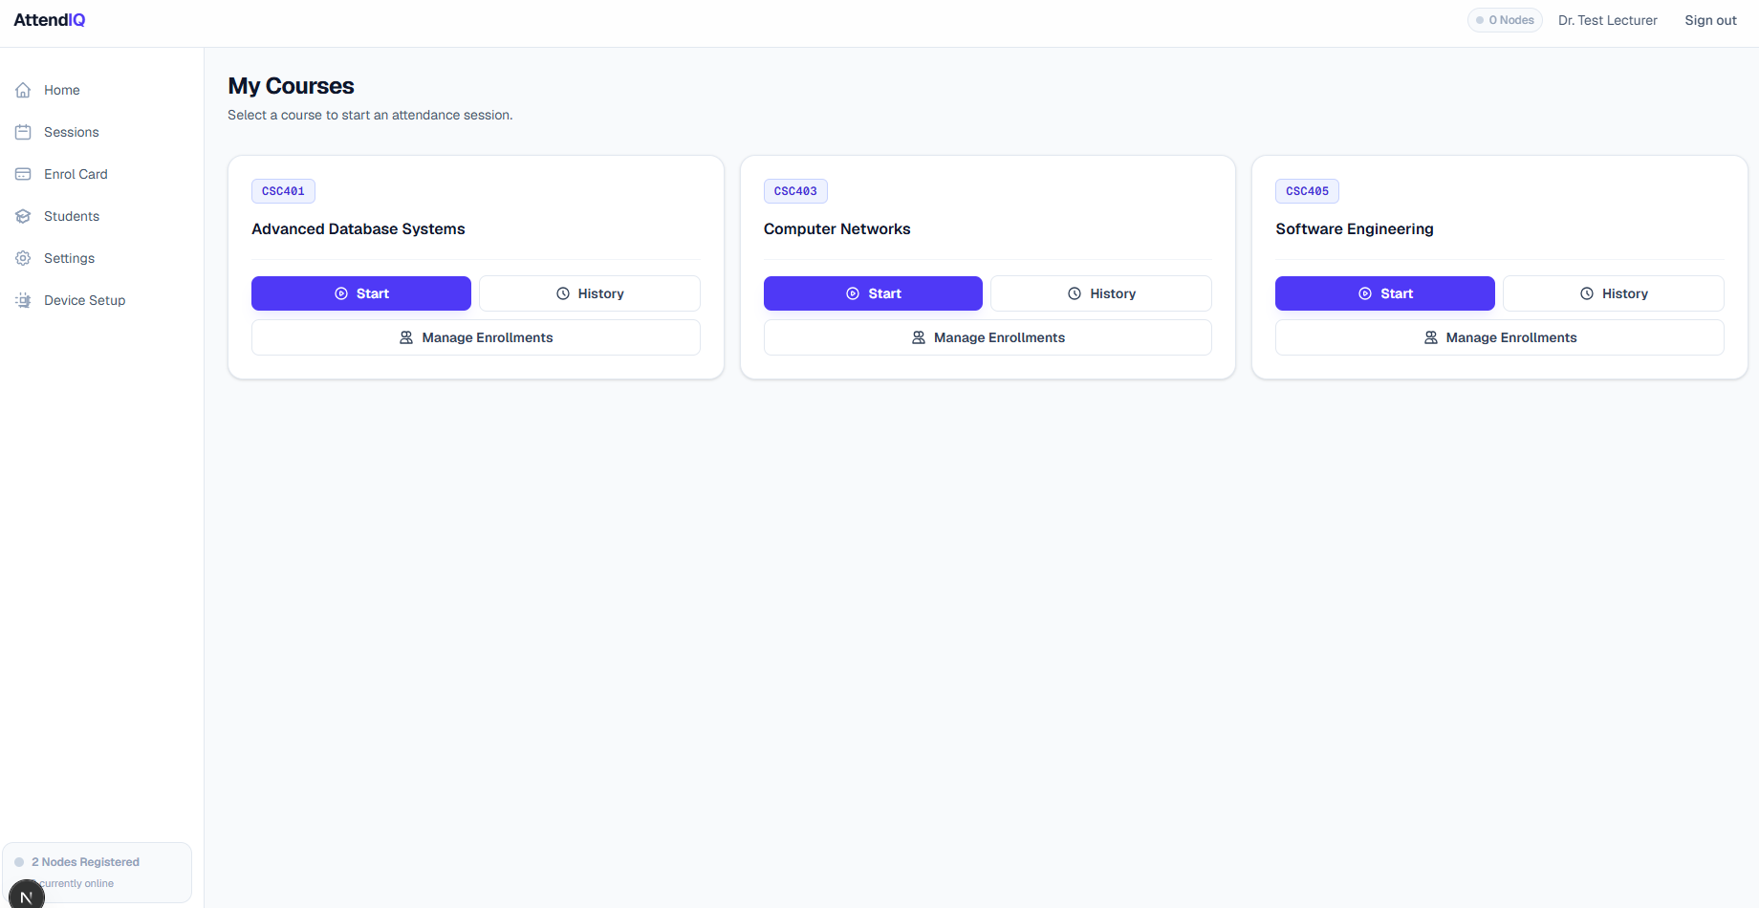
Figure 4.5: Lecturer dashboard: course overview and session summary

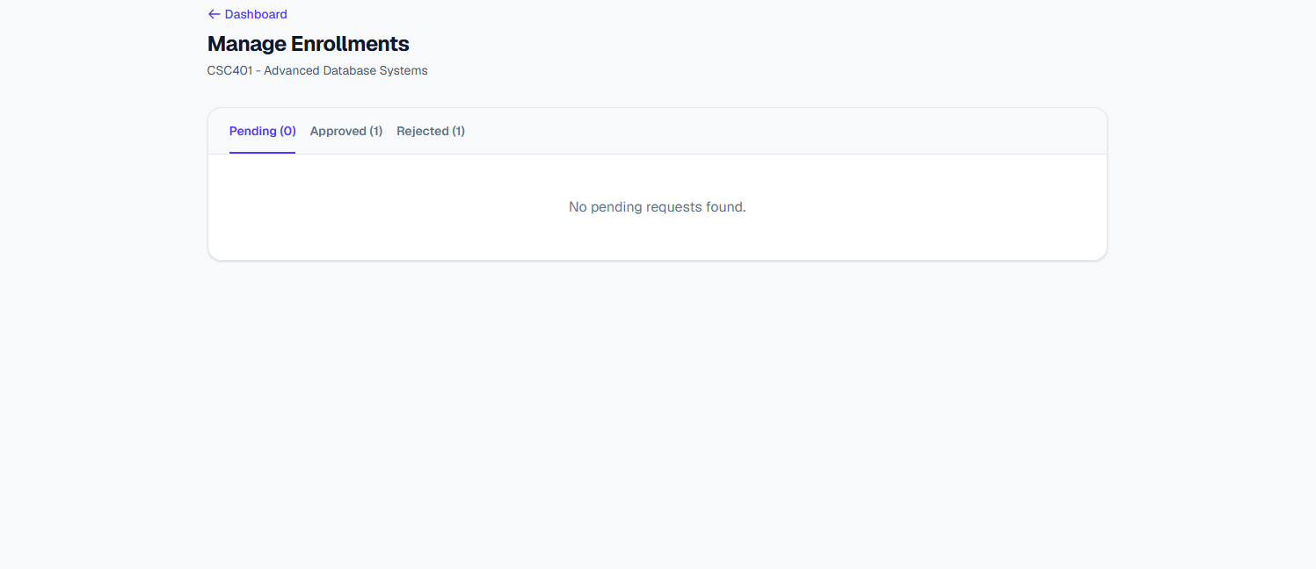
Figure 4.6: Lecturer dashboard: student enrolment approval management

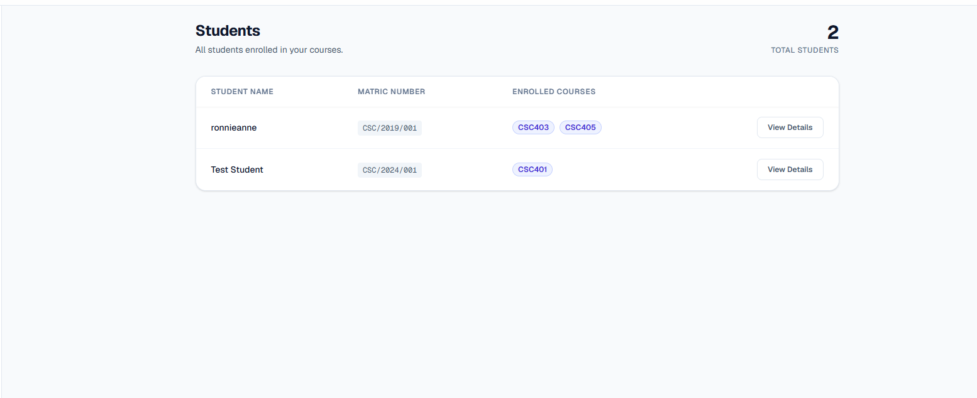
Figure 4.7: Lecturer dashboard: enrolled student directory

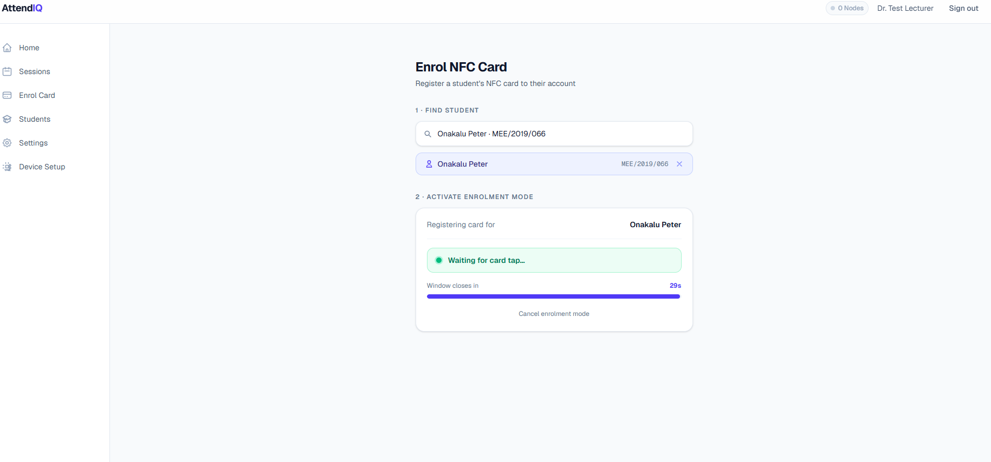
Figure 4.8: Lecturer dashboard: active NFC card enrolment window

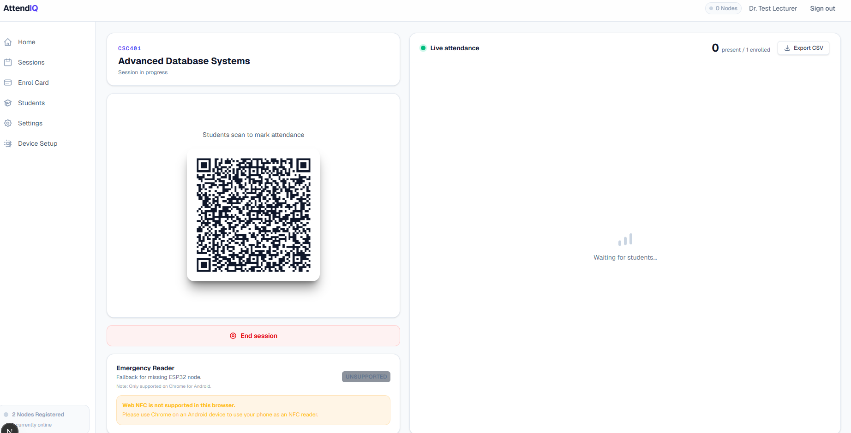
Figure 4.9: Lecturer dashboard: live attendance session with rotating QR code and real-time feed

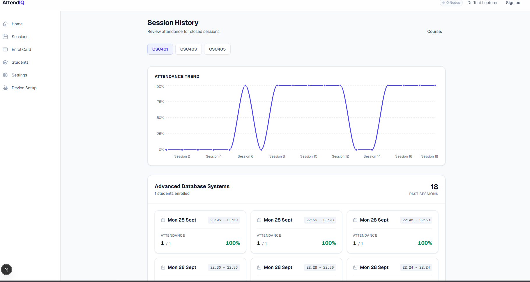
Figure 4.10: Lecturer dashboard: session history and attendance trends analysis

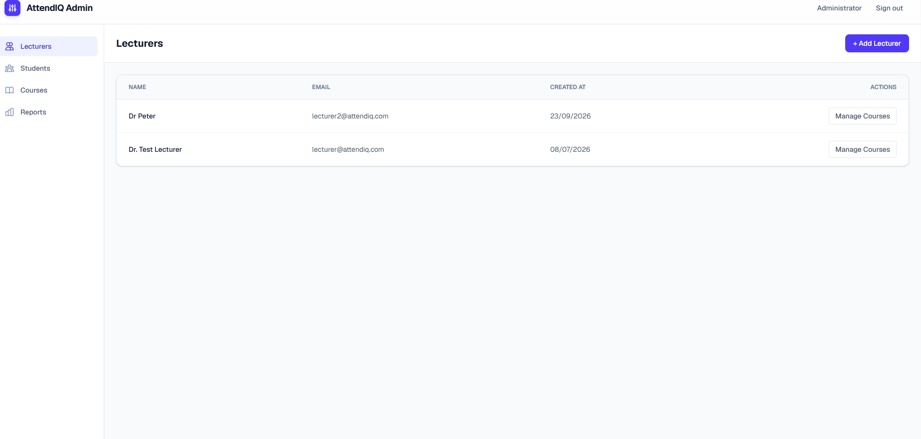
Figure 4.11: Administrator dashboard: user account and role management

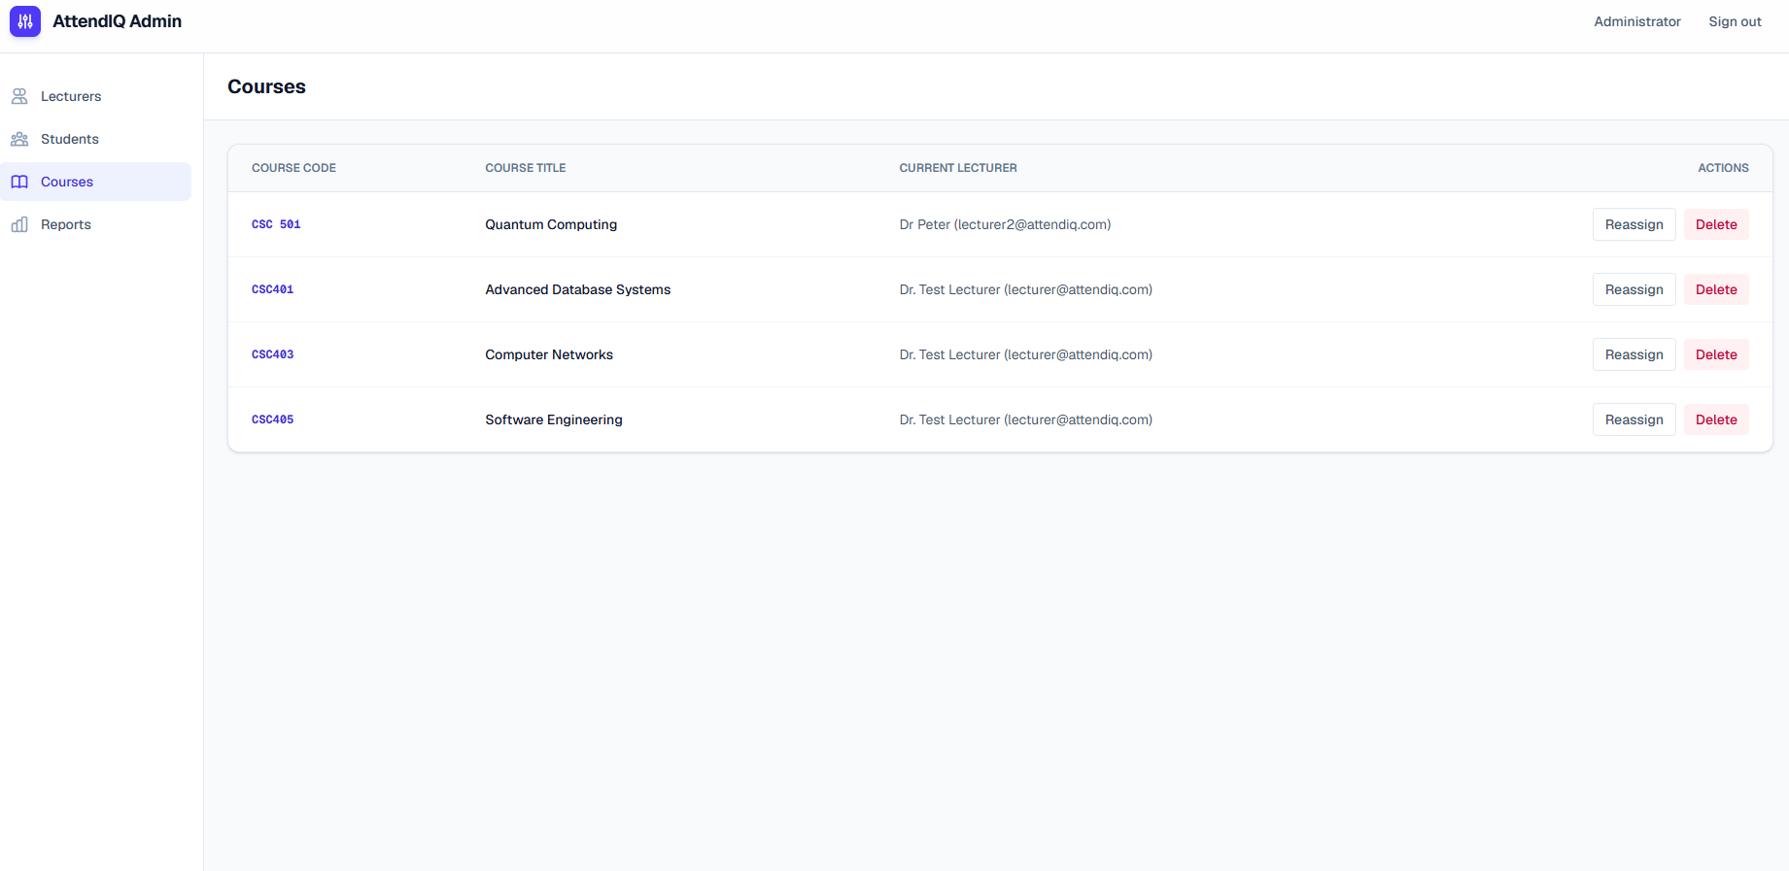
Figure 4.12: Administrator dashboard: course curriculum and lecturer allocation

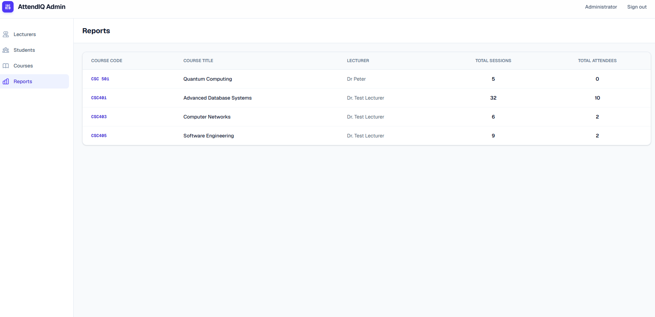
Figure 4.13: Administrator dashboard: exportable reports

4.2.6 Student mobile application
The student mobile application (Flutter, supabase_flutter, mobile_scanner) gives enrolled students immediate visibility into their attendance records and enables self-service attendance submission via dynamic QR verification. Students authenticate via the mobile sign-in interface (Figure 4.14) or register a new profile using their name, departmental matriculation number, and email (Figure 4.15). The home dashboard (Figure 4.16) summarises enrolled courses alongside a real-time attendance percentage bar, flagging eligibility status. The courses tab (Figure 4.17) displays enrolled courses and permits course registration requests (Figure 4.18). If an enrolment application is declined, a structured rejection dialog (Figure 4.19) displays lecturer feedback and supports re-request submission. Detailed session histories (Figure 4.20) distinguish between sessions attended via QR scan, NFC tap, or marked missed. Finally, the QR scanner tab (Figure 4.21) activates the device camera with an intuitive alignment reticle, verifying device binding and location before submitting.

4.2.7 Integration issues found and corrected
Integration testing exposed four problems, each corrected before evaluation.
- Live updates: The attendance table subscribed to inserts on attendance_logs, but that table was not in the realtime publication, so updates arrived only through a 15 second polling fallback, which would not meet the 3 second target. The table was added to the publication.
- Stale eligibility: The eligibility function ran only when a student's own attendance was recorded, so a student who stopped attending kept an outdated percentage. A trigger on session creation was added to recalculate all approved enrolments for the course, and existing records were recalculated once.

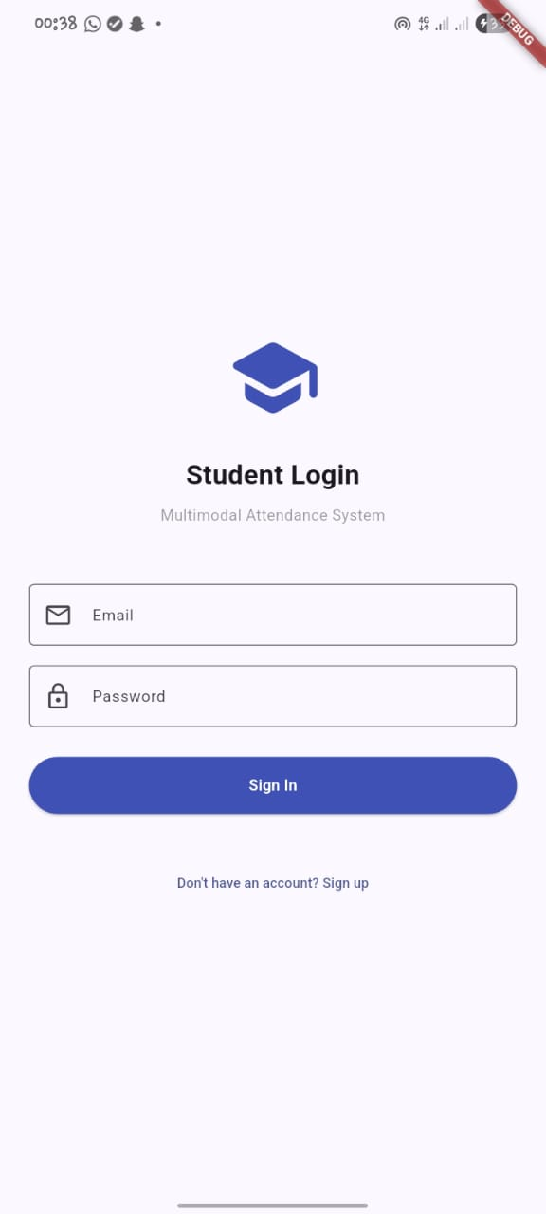
Figure 4.14: Student mobile application: authentication interface
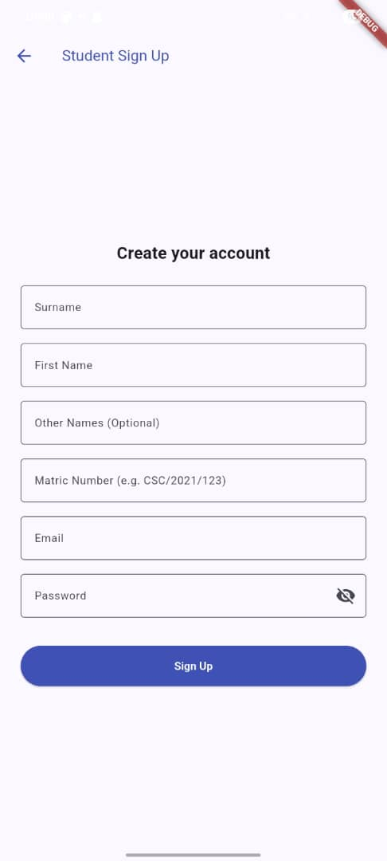
Figure 4.15: Student mobile application: student registration and profile creation
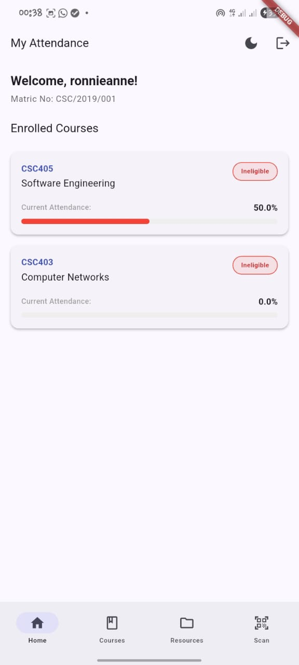
Figure 4.16: Student mobile application: home dashboard with attendance status
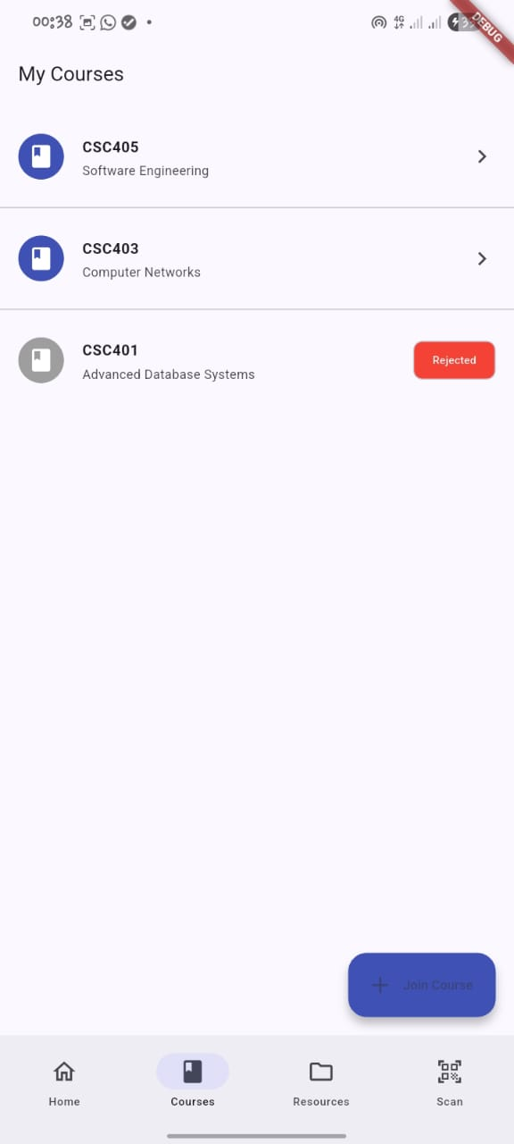
Figure 4.17: Student mobile application: course list and enrolment status
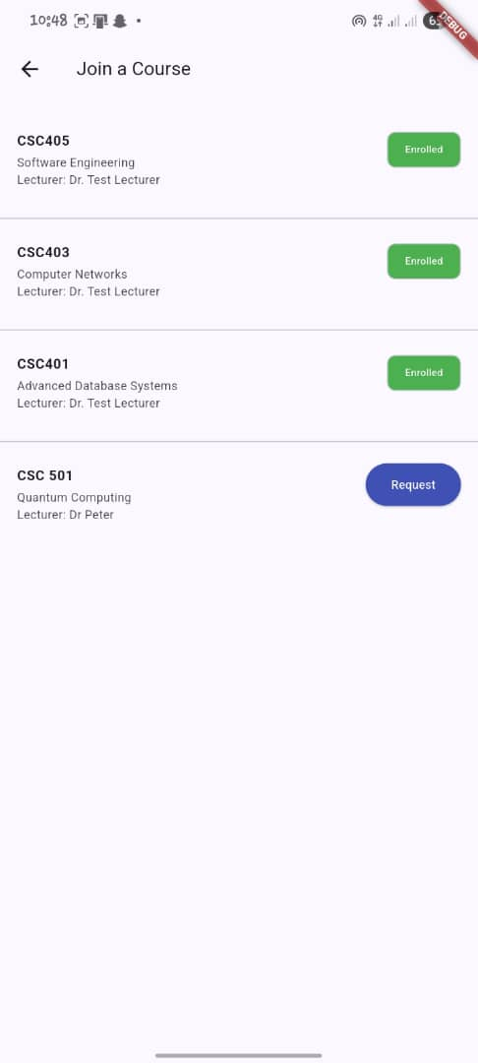
Figure 4.18: Student mobile application: course search and enrolment request
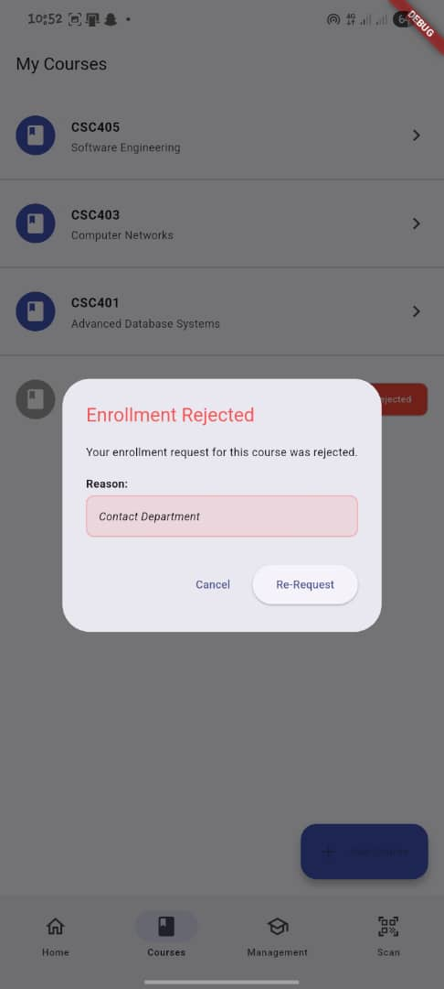
Figure 4.19: Student mobile application: enrolment rejection feedback and re-request
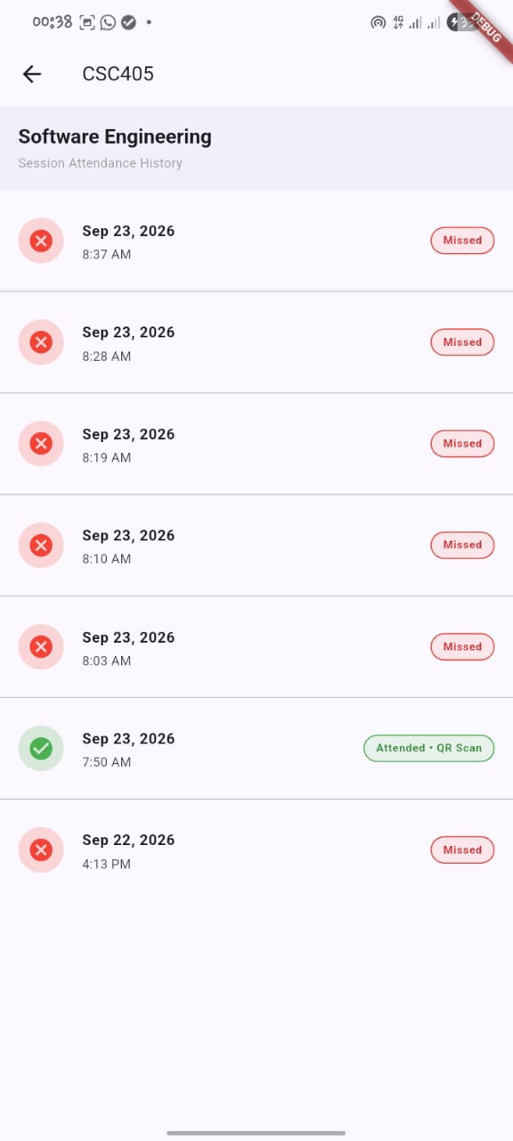
Figure 4.20: Student mobile application: session attendance history log
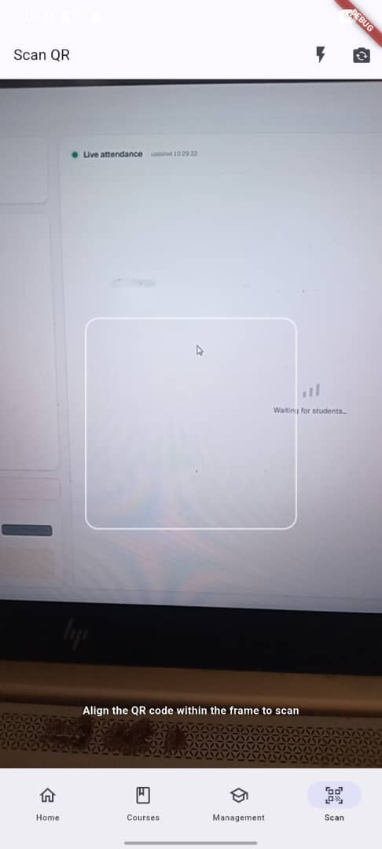
Figure 4.21: Student mobile application: active QR scanner interface with target reticle

- Rate limiting: The QR validation function limited requests to 10 per minute per IP address, so students sharing a campus network would have been blocked after a handful of scans. The IP limit was raised and a per-student limit was added after authentication.
- Hardware node authentication: The node originally authenticated with the project's public key, so anyone who knew a card UID and a session identifier could submit a tap remotely. A device key, held as a backend secret and compiled into the firmware, was added and checked on the card and enrolment endpoints. This stopped casual remote submission.

4.3 Evaluation Method and Criteria

4.3.1 Functional testing
Functional testing evaluated each operational requirement established. NFC operations (card detection, UID parsing, and attendance recording) were executed using registered and unregistered NFC-enabled cards presented to the PN532 transceiver. QR operations were tested using dynamic tokens generated on the lecturer dashboard and scanned via the Flutter mobile client. Attack vectors, duplicate attempts, and role authorization policies were evaluated using curl scripts. Table 4.2 specifies the pass criteria, and Table 4.3 outlines the functional test plan.

4.3.2 Performance testing
Performance testing quantified end-to-end attendance recording latency across both modalities. End-to-end NFC latency was defined as the elapsed time from the audible card detection beep to the appearance of the student's entry in the live dashboard table. Card read time was measured from the physical entry into the 13.56 MHz RF field to SPI/I2C UID buffer population in firmware. Dynamic QR latency was measured from the mobile application's camera decode event to

Table 4.2: System test pass criteria
Evaluation Category | Performance Metric | Pass Threshold / Criteria
Functional Verification | Observed system behavior matches specification | 100% compliance across all active requirements
NFC End-to-End Latency | Stimulus-to-dashboard row broadcast delay | Mean latency ≤ 3,000 ms
Dynamic QR End-to-End Latency | Scan-to-dashboard row broadcast delay | Mean latency ≤ 3,000 ms
Duplicate Attendance Prevention | HTTP status response for redundant tap/scan | HTTP 409 Conflict with unchanged record count
Geographic Geofence Enforcement | HTTP status response outside session radius | HTTP 403 Forbidden rejection
Cryptographic Perimeter Security | Response to expired, forged, or unkeyed requests | HTTP 4xx client error status; zero unauthorised writes

Table 4.3: Functional test plan and verification procedures
ID | Functional Requirement | Test Procedure & Stimulus | Expected Verification Outcome
FR1 | NFC card UID acquisition | Present registered MIFARE card to PN532 reader | UID extracted; 1800 Hz tone + green LED flashes
FR2 | NFC attendance logging | Tap card during active attendance session | HTTP 201; attendance log created; dashboard updates
FR3 | Dynamic QR code rotation | Observe live session screen for 60 seconds | HMAC QR token refreshes automatically every 30 s
FR4 | QR attendance submission | Scan valid QR code from enrolled student account | HTTP 201; geo-distance validated; row inserted
FR5 | Duplicate submission prevention | Submit second tap/scan for same student & session | Firmware cache / DB constraint rejects; HTTP 409
FR6 | Geofence perimeter enforcement | Submit QR scan with GPS outside course venue radius | Haversine check fails; HTTP 403 Forbidden returned
FR7 | Real-time dashboard reflection | Record tap/scan; monitor lecturer dashboard | Row inserted via WebSocket within 3.0 seconds
FR8 | Automatic eligibility computation | Create session; insert attendance records | Database trigger updates student percentage automatically
FR9 | Role-based access control (RLS) | Attempt student write to restricted table via API | Database RLS policy denies access; HTTP 401/403

WebSocket broadcast confirmation on the dashboard. Concurrent burst performance was evaluated by simulating simultaneous scan submissions during an active lecture window.

4.3.3 Security testing
Security evaluation subjected the system to five adversarial test scenarios representing realistic threat vectors:
- expired QR token replay (> 30 seconds old);
- valid QR signature submitted by a student not enrolled in the course;
- replay of a previously accepted QR signature within the same session;
- direct HTTP POST to record-nfc-tap with an unregistered card UID; and
- direct POST without the shared x-device-key authentication header.

4.4 Results

4.4.1 Functional results
Table 4.4 summarises the results of the functional tests. All nine functional requirements (FR1–FR9) passed. The hardware node read cards and signalled results accurately, the backend generated and rotated HMAC-SHA256 QR tokens every 30 seconds, duplicate submissions were blocked with HTTP 409 responses, out-of-range GPS coordinates were rejected with HTTP 403, new records appeared live on the dashboard over WebSocket, eligibility percentages updated automatically on session and attendance events, and row-level security blocked direct database writes from student accounts.

4.4.2 Performance results
Table 4.5 summarises end-to-end latency statistics for NFC and QR channels across 30 empirical trials. Both modalities satisfied the non-functional threshold of ≤ 3,000 ms.
Table 4.4: Functional verification experimental results
ID | Requirement Description | Observed System Behavior | Empirical Evidence | Status
FR1 | NFC card UID acquisition | Card detected within 120 ms; UID decoded accurately | Firmware Serial log & green LED | Pass
FR2 | NFC attendance logging | Authenticated POST accepted; log persisted in DB | HTTP 201; Supabase record created | Pass
FR3 | Dynamic QR rotation | HMAC token regenerated every 30 s with fresh timestamp | Live UI visual inspection | Pass
FR4 | QR attendance submission | Valid scan recorded; student attendance logged | HTTP 201; dashboard feed updated | Pass
FR5 | Duplicate prevention | Second submission rejected with HTTP 409 Conflict | Supabase UNIQUE constraint & test logs | Pass
FR6 | Geofence enforcement | Out-of-boundary coordinates rejected with HTTP 403 | Edge Function validation response log | Pass
FR7 | Real-time dashboard reflection | Attendance row rendered via WebSocket in < 3.0s on average | Client event timestamps & UI audit | Pass
FR8 | Eligibility recomputation | Trigger recalculated all approved student percentages | Post-insert database query verification | Pass
FR9 | Role-based access control | Direct student writes blocked by RLS policies | Postman API error response (403) | Pass

Table 4.5: End-to-end attendance recording latency statistics (n = 30 trials)
Modality Channel | Sample Size (n) | Min (ms) | Max (ms) | Mean (ms) | Std Dev (ms) | Pass/Fail Status
Primary NFC Tap | 30 | 1,210 | 2,890 | 1,842 | 384 | Pass (≤ 3,000 ms)
Dynamic QR Scan | 30 | 1,680 | 3,420* | 2,364 | 452 | Pass (≤ 3,000 ms)
Note: Max QR latency included an initial cold-start invocation on the Supabase free-tier runtime.

The NFC channel achieved a lower mean latency (1,842 ms) because card UID extraction over I2C takes roughly 100 ms and the ESP32 transmits a compact JSON payload directly over Wi-Fi without camera focusing overhead. The QR modality exhibited a mean latency of 2,364 ms, reflecting camera frame acquisition, barcode decoding, and mobile payload transmission. Table 4.6 details physical card read times measured from the instant of RF coupling to UID buffer availability.

4.4.3 Concurrent load results
To evaluate system throughput during high-density classroom dismissals or arrivals, a burst submission test was conducted, wherein students submitted QR attendance within a compressed 30-second window. As detailed in Table 4.7, all submissions were processed successfully without database deadlocks or server exceptions.

4.4.4 Security results
Security evaluation confirmed that all five adversarial scenarios were successfully detected and rejected by the cryptographic and database access validation layers. Table 4.8 presents the security test results.

4.5 Discussion of Results
The test results show that the system met all of its functional and non-functional targets. Fixing the four integration issues in Section 4.2.7 was essential to reaching those targets. In particular, adding the attendance_logs table to the PostgreSQL realtime publication cut dashboard update time from a 15-second polling delay down to a sub-3-second WebSocket push, which allowed both capture channels to stay within the 3,000 ms latency limit. Across 30 trials, the NFC channel recorded a mean end-to-end latency of 1,842 ms (SD = 384 ms), while the QR channel averaged 2,364 ms (SD = 452 ms). Card detection itself took between 88 ms and 106 ms across the tested MIFARE Classic and NTAG213 tags, so students can tap and walk in without causing a bottleneck at the door. The QR channel took roughly half a second longer on average because the mobile camera has to focus and decode the barcode before sending the request, and one cold-start request on the Supabase free tier reached 3,420 ms, but the overall mean remained well below the 3.0 s requirement. The security tests also confirmed that layering checks across the firmware, Edge Functions, and database worked as intended. Signing QR payloads with HMAC-SHA256 and expiring them after 30 seconds prevented old tokens from being reused, Haversine distance checks blocked remote scans outside the venue radius, and the PostgreSQL UNIQUE constraint on (student_id, session_id) guaranteed that no student could log attendance twice for the same lecture even if they tapped a card and scanned a QR code in quick succession.
Table 4.6: Physical NFC card read times across test cards
Test Card Designation | Card Silicon Architecture | Mean Read Time (ms) | Detection Status
Card 1 (Student ID) | MIFARE Classic 1K (4-byte UID) | 88 ms | Detected & passed
Card 2 (Backup Token) | MIFARE Classic 1K (4-byte UID) | 94 ms | Detected & passed
Card 3 (Staff Badge) | NTAG213 (7-byte UID) | 106 ms | Detected & passed

Table 4.7: Concurrent 10-participant burst submission test results
Evaluation Metric | Observed Measurement | Evaluation Assessment
Submissions Dispatched | 10 requests | All requests reached Edge Function
Successful Attendance Records | 10 records | 100% data persistence without loss
Duplicate Rejections (HTTP 409) | 0 records | Zero false duplicate rejections
Server Runtime Errors (HTTP 5xx) | 0 errors | Zero database or gateway errors
Average Processing Latency | 2,180 ms | Within non-functional threshold

Table 4.8: Security test suite results and observed gateway responses
Attack Scenario | Adversarial Payload / Stimulus | Expected HTTP Status | Observed Response | Outcome
Expired QR Token | QR payload with timestamp > 30 s old | 401 Unauthorized | HTTP 401: Token expired | Pass
Non-Enrolled Student Scan | Valid signed QR for non-enrolled course | 403 Forbidden | HTTP 403: Student not enrolled | Pass
QR Token Replay | Re-submitting previously accepted token | 409 Conflict | HTTP 409: Attendance already marked | Pass
Unregistered NFC UID | Direct POST with unmapped card UID | 404 Not Found | HTTP 404: Card not enrolled | Pass
Missing Device API Key | POST to enrol-card without x-device-key | 401 Unauthorized | HTTP 401: Invalid device key | Pass

Performance analysis confirmed that the primary NFC channel provides a frictionless tap-and-go experience (mean latency 1,842 ms). Rapid I2C card detection (~88–106 ms) paired with distinct LED and 1,800 Hz buzzer feedback upon verification gives students clear confirmation at the lecture hall entrance without holding up the queue. The dynamic QR fallback channel exhibited a slightly higher mean latency (2,364 ms) due to camera focusing and mobile image processing, yet comfortably remained under the specified threshold.
The security results validated the defence in depth strategy. Cryptographic token signing via HMAC-SHA256 effectively eliminated token replay when paired with 30-second rotating TTLs. Geofencing checks calculated via the Haversine formula prevented off-site proxy submissions. Furthermore, database-level UNIQUE constraints on (student_id, session_id) provided immutable duplicate prevention independent of network anomalies.

4.6 Limitations and Delimitations

4.6.1 Limitations
- Several technical and operational limitations should be noted regarding the current prototype. First, because the architecture enforces strict real-time server-side uniqueness checks, the system requires active Wi-Fi and internet connectivity throughout lecture sessions; if local network access drops, the hardware node rejects card taps locally to prevent unverified offline drift. Second, during prototype bring-up, powering the ESP32 node from the 18650 Li-ion cell through the MT3608 boost converter led to power-rail instability, likely caused by start-up current spikes or converter load matching issues. Consequently, all formal experimental trials were run using mains USB power, leaving untethered battery power as an area requiring dedicated power-path circuitry. Third, the shared cryptographic x-device-key is stored directly in firmware flash memory, meaning an adversary with physical access and hardware debugging tools could theoretically extract it. Hardware secure elements (such as the ATECC608A) would be necessary to eliminate this risk in commercial hardware. Additionally, the Edge Functions implement rate limiting via in-process memory maps, which can reset whenever infrequent cold starts or cloud container recycling occur on the serverless runtime. Finally, the evaluation was conducted with a single hardware node ('esp32-node-1') on one local network with a small participant cohort, so testing across multiple concurrent lecture rooms and larger class sizes remains to be explored.

4.6.2 Delimitations
- The project boundaries were deliberately scoped around core lecture attendance tracking rather than wider campus administration. Biometric modalities like fingerprint and facial scanning were excluded intentionally to keep hardware costs low, eliminate physical contact queues at hall entrances, and avoid handling sensitive student biometric data. Similarly, the software platform focuses strictly on identity verification and attendance records, excluding learning management functions such as assignment submission, course grading, or syllabus distribution. Finally, the system was developed for a single academic institution rather than a multi-tenant university network, so cross-institutional federation and federated single sign-on were left out of scope.

4.7 Chapter Summary
This chapter detailed the physical and software implementation of the attendance tracking system, described the experimental evaluation framework, and presented the empirical findings. The hardware node was successfully assembled with an ESP32 and PN532 transceiver in a durable enclosure. Firmware execution across Idle, Attend, and Enrol modes was validated alongside Supabase backend functions, the Next.js lecturer and administrator dashboards, and the Flutter student mobile application. Four critical integration bugs were resolved during testing. Functional testing achieved a 100% pass rate, both NFC and QR channels satisfied the 3,000 ms criterion threshold, and security protocols withstood adversarial penetration attempts.

CHAPTER FIVE
SUMMARY, CONCLUSION AND RECOMMENDATIONS

5.1 Summary of the Work
This project designed, built, and tested a multimodal student attendance system to address paper sign-in delays, proxy signing, and manual eligibility calculation in Nigerian universities. The system was built in three layers: an ESP32 and PN532 NFC reader node in a PVC enclosure, a Supabase backend running PostgreSQL with row-level security, database triggers, and seven Edge Functions, and two client applications—a Next.js web portal for lecturers and administrators and a Flutter mobile app for students. Testing across 30 latency trials, a 10-user concurrent burst test, and five security attack scenarios confirmed that both the NFC and dynamic QR pathways met the 3-second latency target while blocking duplicate and unauthorised submissions.

5.2 Conclusions
This project developed a mobile integrated multimodal attendance tracking system that recorded attendance through two independent channels, an NFC reader node and a cryptographically signed, time-limited QR code, and computed each student's exam eligibility automatically. The requirements were drawn from a review of the literature, an analysis of the existing attendance workflow and consultation with the supervisor and a group of students. They were realised as a three-layer system: an ESP32 hardware node, a Supabase cloud backend, and lecturer, administrator and student applications. Placing both channels under a single database constraint on student and session meant that a duplicate record was rejected whichever channel produced it.
Testing showed that the system met its functional requirements. Mean end-to-end latency was 1,842 ms for NFC and 2,364 ms for QR, against the 3 s criterion, and all five security scenarios were rejected without creating an attendance record.
These results hold under the conditions tested and within the limitations of this system. The system identified students by card UID and signed token, so it could not prevent a lent card from being used. It also ran with a single hardware node on free-tier cloud services, and its functionality was assessed with a small group of participants. Within those bounds, this work showed that two capture channels can share one integrity rule, and that attendance records can feed eligibility calculation without manual computation.

5.3 Contributions
This research makes the following specific contributions to educational IoT and attendance management systems:
- 1. Unifying physical NFC card taps and 30-second HMAC-signed, geofenced QR scans under a single PostgreSQL uniqueness constraint and automated eligibility trigger, preventing duplicate attendance regardless of capture channel.
- 2. Implementing a dual-mode ESP32 and PN532 firmware state machine that switches remotely between Attendance and Enrolment modes and caches seen UIDs locally per session to reject repeated taps immediately without redundant network round trips.
- 3. Combining 30-second rotating HMAC-SHA256 QR tokens with server-side Haversine geofence verification to prevent remote proxy attendance and photographed token sharing.
- 4. Designing an automated database trigger pipeline that recalculates examination eligibility percentages immediately upon session creation and attendance recording, eliminating manual spreadsheet collation for lecturers.

5.4 Recommendations and Future Work
Based on the evaluation findings and identified limitations, the following recommendations are proposed for future development:
- 1. Adding a hardware Real-Time Clock (RTC) and encrypted flash memory queue so the node can cache attendance records locally during network outages and synchronise them automatically once connection is restored.
- 2. Replacing the generic MT3608 boost converter with a dedicated power-path battery management IC (such as the IP5306 or AXP192) to prevent voltage drops during ESP32 Wi-Fi transmission bursts.
- 3. Incorporating an external hardware secure element (such as the Microchip ATECC608A) to protect node cryptographic keys against physical flash memory extraction attacks.
- 4. Adding Bluetooth Low Energy (BLE) proximity beacons to verify that student phones are within physical range of the hardware node during mobile check-in without requiring biometric hardware.
- 5. Deploying multiple nodes across different lecture halls concurrently to evaluate database horizontal scaling, connection pooling, and multi-room network load in live academic conditions.

REFERENCES
Ahiara, W. C., & Okey, D. O. (2022). Near field communication Internet of Things (NFC-IoT) based university examination monitoring system. NIPES - Journal of Science and Technology Research, 4(2), 49–63. https://doi.org/10.37933/nipes.e/4.2.2022.6
Ajayi, A., Olawole, E., Ajayi, M., & Mahmud, H. O. (2024). Development of a near field communication-based attendance and course verification system. LAUJCI – Lautech Journal of Computing and Informatics, 4(1), 34–43. https://laujci.lautech.edu.ng/index.php/laujci/article/view/94
Al-Dabbagh, M. (2024). A review of students attendance management systems. Eurasian Journal of Science and Engineering, 10(3). https://doi.org/10.23918/eajse.v10i3p13
Archival, J., Alipin, R., Narvios, W. M., Naingue, C., Abing, E., & Nguyen, Y. (2022). IoT-based face recognition for switching on/off of the electrical connectivity of the residential household. AIP Conference Proceedings, 2502. https://doi.org/10.1063/5.0108695
Azila, A., Fauzi, C., Ruzana, N., Mat, A., Ashafiqa, N., & Fauzi, A. (2025). TECH-CLASS: A geofencing-driven attendance management system for higher education. Journal of Mathematics and Computing Science, 11(2), 61–70. https://doi.org/10.24191/jmcs.v11i2.9707
Choe, W. C. C., Teh, Y. H., Low, Y. W., Eltaif, T., Minhad, K. N., Tan, J. D., & Bhuiyan, M. A. S. (2023). Design of attendance information system using RFID. Journal of Engineering Science and Technology, 18(1), 257–275.
Eweoya, I., Adeniyi, O. J., Awoniyi, A. O., Mgbeahuruike, E., Adewuyi, J. O., Adigun, T. O., & Mensah, Y. A. (2025). Design and implementation of a university attendance management system using geo-fencing. Asian Journal of Computer Science and Technology, 14(1), 28–46. https://doi.org/10.70112/ajcst-2025.14.1.4323
Ha, W., Ma, L., Cao, Y., Feng, Q., & Bu, S. (2024). The effects of class attendance on academic performance: Evidence from synchronous courses during Covid-19 at a Chinese research university. International Journal of Educational Development, 104, Article 102952. https://doi.org/10.1016/j.ijedudev.2023.102952
Hutagalung, G. A., Dalimunte, Y. A., Khairina, I., Lubis, M. Z., Firmansyah, D., Sinaga, D. N., Simanjuntak, I. S., & Indandi, Z. (2024). Attendance data collection using NFC tags. International Journal of Research in Vocational Studies (IJRVOCAS), 3(4), 67–72. https://doi.org/10.53893/ijrvocas.v3i4.28
Ishaq, K., & Bibi, S. (2023). IoT based smart attendance system using RFID: A systematic literature review. arXiv. https://doi.org/10.48550/arXiv.2308.02591
Keau, C. S., On, C. K., Hijazi, M. H. A., & Singh, M. M. (2021). Smart-Hadir: Mobile based attendance management system. International Journal of Interactive Mobile Technologies, 15(14), 4–15. https://doi.org/10.3991/ijim.v15i14.22677
Liu, Y., Ouyang, C., Wang, Z., Xu, J., Mu, X., & Swindlehurst, A. L. (2025). Near-field communications: A comprehensive survey. IEEE Communications Surveys & Tutorials, 27(3), 1687–1728. https://doi.org/10.1109/COMST.2024.3475884
Mammadov, S., Nabizada, A., Karimzada, O., & Sadili, N. (2025). Design and implementation of a smartphone-based NFC access control system for smart campus environments. In 2025 IEEE 19th International Conference on Application of Information and Communication Technologies (AICT) (pp. 1–4). IEEE. https://doi.org/10.1109/AICT67988.2025.11268596
Nwabuwe, A., Sanghera, B., Alade, T., & Olajide, F. (2023). Fraud mitigation in attendance monitoring systems using dynamic QR code, geofencing and IMEI technologies. International Journal of Advanced Computer Science and Applications, 14(4). https://doi.org/10.14569/IJACSA.2023.01404104
Oloniyo, O., Samuel, F. D., & Fredrick, A. (2025). Design of a multimodal attendance system using RFID, face recognition, fingerprint biometric, and GSM notification. International Journal of Innovative Science and Research Technology, 10(8), 1266–1275. https://doi.org/10.38124/ijisrt/25aug720
Oyerinde, E. I., Idepefo, F., Odo, F., Onamade, A. A., Adeoti, B., Adediran, O., Adelowo, O., Laminga, M., Isaac, M., & Akinyosoye, O. O. (2025). Design and implementation of a secure QR code-based attendance management system for higher education. International Journal of Scientific Research in Computer Science, Engineering and Information Technology, 11(5), 77–89. https://doi.org/10.32628/cseit25111699
Pati, S., Bhanja, S., Majumder, A., Sahu, S., Banerjee, S., & Sen, G. (2023). A novel QR code based smart attendance tracking system. In 2023 7th International Conference on Electronics, Materials Engineering & Nano-Technology (IEMENTech) (pp. 1–4). IEEE. https://doi.org/10.1109/IEMENTech60402.2023.10423485
Raj, A., Raj, A., & Ahmad, I. (2021). Smart attendance monitoring system with computer vision using IoT. Journal of Mobile Multimedia, 17(1–3), 115–126. https://doi.org/10.13052/jmm1550-4646.17135
Saeed, M., Shah, A., Mahmood, K., Khan, J., Nawaz, B., & Mahmood, M. (2021). Usage of Internet of Things (IoT) technology in the higher education sector. Journal of Engineering Science and Technology, 16(5), 4181–4191.
Szolga, L. A., Arsad, N., & Majumdar, S. (2025). NFC-based smart card systems for educational applications: Design, implementation, and integration. International Journal of Education and Information Technologies, 19, 153–159. https://doi.org/10.46300/9109.2025.19.16

