HeartCare - MLOps Pipeline for Heart Disease Risk Prediction
Machine Learning Operations (MLOps) AIMLCZG523 - Assignment 01
End-to-End ML Model Development, CI/CD, and Production Deployment
Field | Details
Student name | Gopika Arora
BITS ID | 2025AE05176
Course | Machine Learning Operations (AIMLCZG523)
Code repository | https://github.com/bigDDDeveloper/mlops/tree/master (public, branch master)
Pipeline video | Project_overview.mp4 - Google Drive
Submission date | 19-10-2026

1. Project Overview
This project builds a machine learning classifier that predicts the risk of heart disease from patient clinical data and serves it as a cloud-ready, monitored REST API. It covers the full MLOps lifecycle: data acquisition and EDA, feature engineering, model development with experiment tracking, reproducible packaging, automated testing with CI/CD, containerization, Kubernetes deployment, and monitoring.
Dataset: Heart Disease UCI Dataset (UCI ML Repository, id=45), fetched with the ucimlrepo package. It has 303 patient records, 13 clinical features (age, sex, chest pain type, resting blood pressure, cholesterol, fasting blood sugar, resting ECG, max heart rate, exercise angina, ST depression, slope, number of major vessels, thalassemia) and a target that is binarized to disease present / absent.
Technology stack:
Area | Tools used
Data & ML | Python 3.12, pandas, NumPy, scikit-learn 1.9.1, matplotlib, seaborn
Experiment tracking | MLflow (SQLite backend) + JSON fallback log
Serving | FastAPI, uvicorn, pydantic
Testing & CI | pytest (26 tests), flake8, GitHub Actions
Packaging & deploy | Docker (python:3.12-slim), Kubernetes on Minikube, Helm chart
Monitoring | prometheus-client, Prometheus, Grafana, JSON access logs

2. Setup / Installation Instructions
Prerequisites: Python 3.11+ (CI and Docker use 3.12), git, and optionally Docker + Minikube for containerization and deployment. Every step below runs from a clean clone using only requirements.txt.
Clean setup on Linux / macOS:
git clone https://github.com/bigDDDeveloper/mlops.git && cd mlops
bash setup.sh # creates .venv and installs requirements
source .venv/bin/activate
bash run_pipeline.sh # acquire -> validate -> features -> train -> package + tests
Windows (PowerShell):
python -m venv .venv
.\.venv\Scripts\Activate.ps1
pip install -r requirements.txt
python -m src.orchestration.pipeline
Serve the API locally:
uvicorn src.serving.app:app --host 0.0.0.0 --port 8000
# interactive docs at http://localhost:8000/docs
Full stack with Docker Compose (API + Prometheus + Grafana):
docker compose up --build
# API http://localhost:8000 | Prometheus http://localhost:9090 | Grafana http://localhost:3000 (admin/admin)
The dataset downloads automatically on the first run and is cached to data/raw/ for offline reproducibility. All randomness is seeded (random_state=42).

3. Data Acquisition and EDA

3.1 Acquisition and Cleaning
- src/data_acquisition/acquire_data.py downloads the data with ucimlrepo.fetch_ucirepo(id=45), saves the raw CSV plus dataset metadata, then cleans and encodes it.
- Duplicate rows are dropped (none found).
- Missing values: ca had 4 and thal had 2 NaNs. Categorical columns are filled with the mode, continuous columns with the median.
- The multi-class severity target (0-4) is binarized to presence (1) / absence (0).
- A separate validation stage (src/validation/validate_data.py) checks schema, value ranges, duplicates, missing values and class balance, and writes data_quality_report.md/.json. It flags the raw missing values, which is exactly what the cleaning step then fixes.
- Outputs: data/processed/heart_disease_clean.csv and heart_disease_encoded.csv.

3.2 Exploratory Data Analysis
- Class balance: 164 negative (54.13%) vs 139 positive (45.87%), imbalance ratio 1.18:1. This is treated as balanced, and class_weight="balanced" is still used as a safe default.
- Strongest correlations with the target: thal (0.52), ca (0.46), exang (0.43), oldpeak (0.43), thalach (-0.42), cp (0.41).
- Continuous features are roughly bell-shaped except oldpeak, which is right-skewed with many zeros. Cholesterol has a few high outliers (above 400 mg/dl) that were kept, since they are clinically plausible.
- Patients with disease tend to have a lower maximum heart rate (thalach) and a higher ST depression (oldpeak), which matches the correlation ranking.
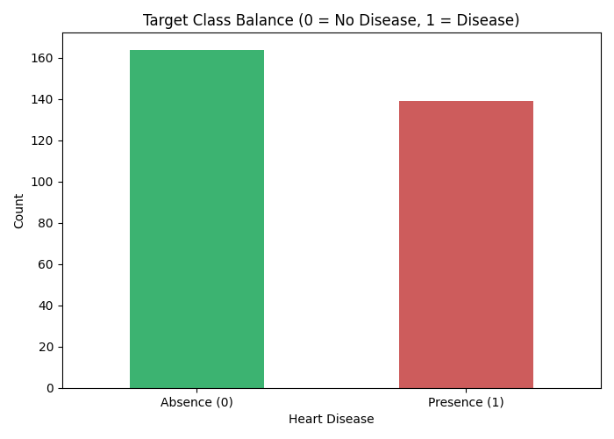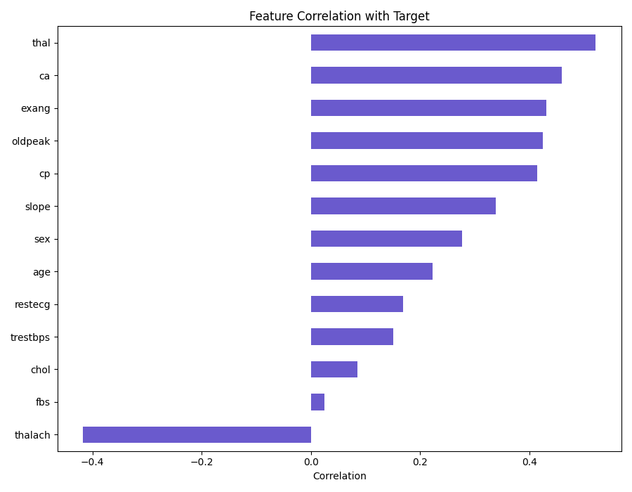
Figure 1: (a) Target class balance and (b) feature correlation with the target
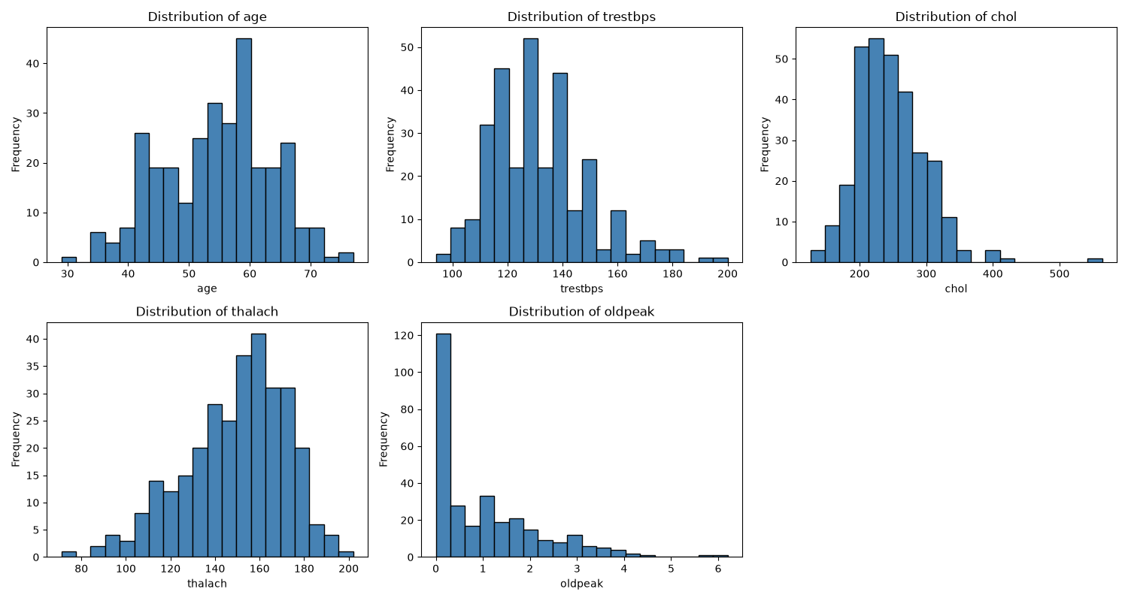
Figure 2: Histograms of the continuous features
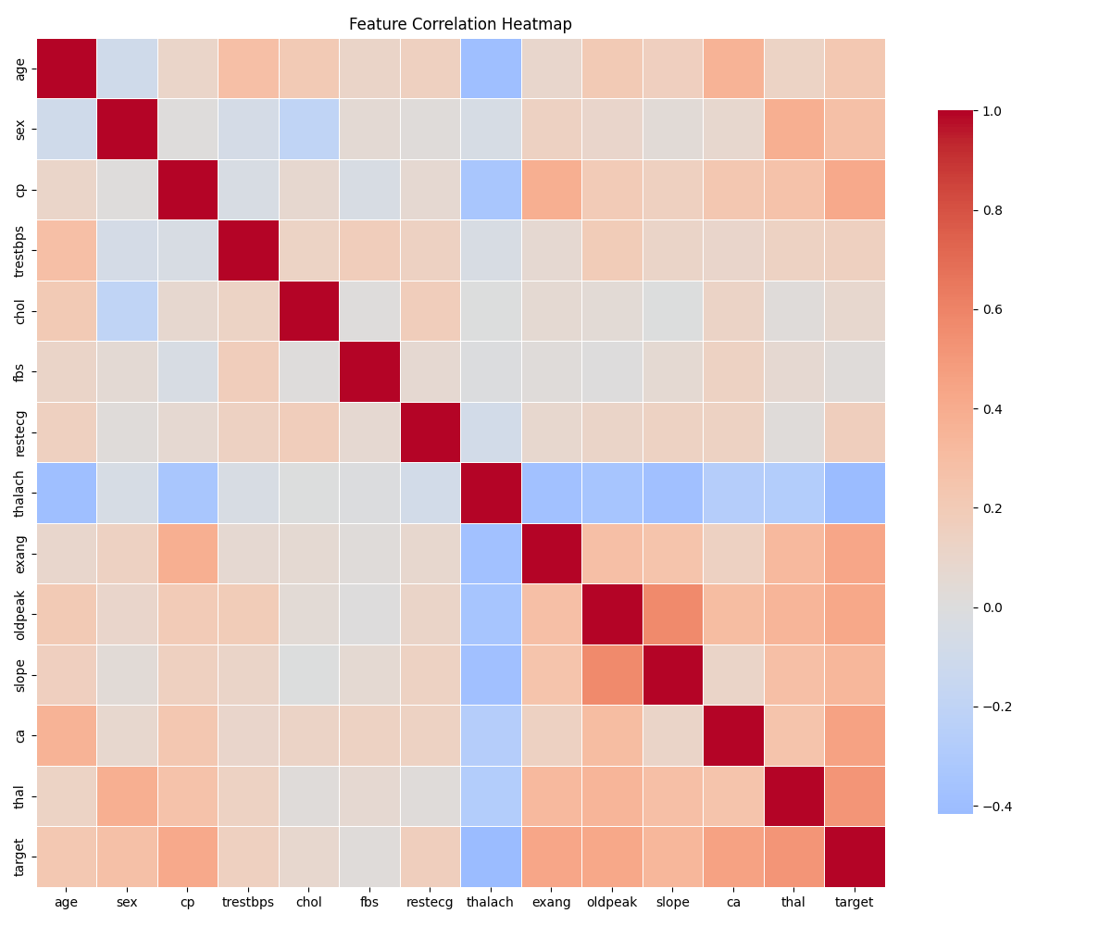
Figure 3: Feature correlation heatmap
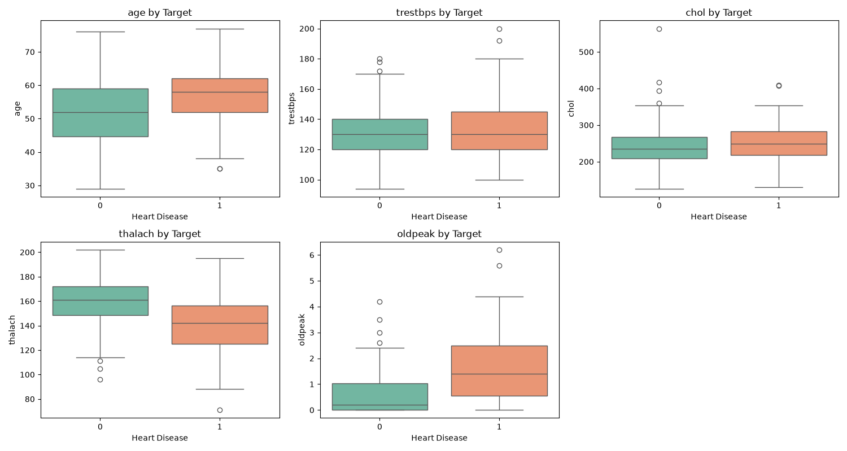
Figure 4: Continuous features split by target class

4. Feature Engineering and Model Development

4.1 Feature Engineering
- Categorical columns are one-hot encoded (drop_first), giving 20 model features.
- Continuous columns (age, trestbps, chol, thalach, oldpeak) are standardized with a StandardScaler fitted on the training split only, to avoid data leakage.
- Stratified 80/20 train/test split (242 train / 61 test) that keeps the class ratio.

4.2 Models and Tuning
Two classifiers were trained and tuned with 5-fold stratified GridSearchCV, optimizing ROC-AUC:
Model | Search grid | Best parameters
Logistic Regression | C in {0.01, 0.1, 1, 10}, penalty l2, solver lbfgs, class_weight balanced | C=10.0, l2, lbfgs
Random Forest | n_estimators {100, 200}, max_depth {None, 5, 10}, min_samples_leaf {1, 2, 4}, class_weight balanced | n_estimators=100, max_depth=5, min_samples_leaf=2

Each model is evaluated on accuracy, precision, recall, F1 and ROC-AUC on the held-out test set, together with cross-validated ROC-AUC and accuracy on the training set. The final model is the one with the highest test ROC-AUC. For a medical classifier, ranking risk well and limiting false negatives matter most, so recall is checked alongside it.
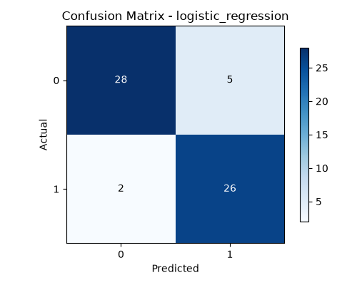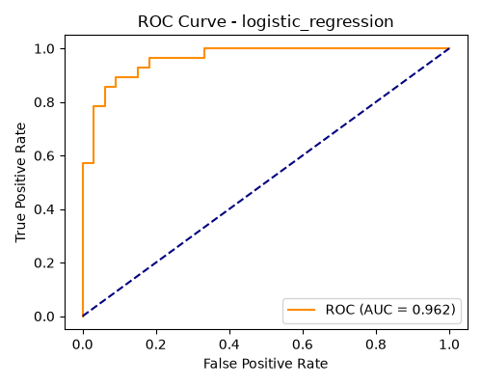
Figure 5: Selected model (Logistic Regression) on the test set: (a) confusion matrix, (b) ROC curve (AUC = 0.962)
On the 61 test patients the selected model misses only 2 disease cases (false negatives) and raises 5 false alarms.

5. Experiment Tracking Summary
All runs are tracked with MLflow (SQLite backend mlflow.db, artifacts under mlruns/, experiment heart_disease_classification). Each run logs the best hyperparameters, CV and test metrics, the confusion matrix and ROC curve plots, and the trained model (mlflow.sklearn.log_model). A JSON tracking fallback (models/experiments.json) is written in parallel, so the pipeline is reproducible even without MLflow.
Model | CV ROC-AUC | Accuracy | Precision | Recall | F1 | Test ROC-AUC
Logistic Regression | 0.9022 | 0.8852 | 0.8387 | 0.9286 | 0.8814 | 0.9621
Random Forest | 0.8882 | 0.9016 | 0.8438 | 0.9643 | 0.9000 | 0.9502

Selected model: Logistic Regression (C=10.0, L2) with test ROC-AUC 0.9621 and recall 0.9286. Random Forest scores slightly higher on accuracy and recall on this small 61-patient test set, but Logistic Regression ranks risk better: it has the higher ROC-AUC both on the test set and in 5-fold cross-validation (0.9022 vs 0.8882), which makes it the more reliable choice. It is also the simpler and more explainable of the two models.
To open the tracking UI: mlflow ui --backend-store-uri sqlite:///mlflow.db, then browse to http://localhost:5000.
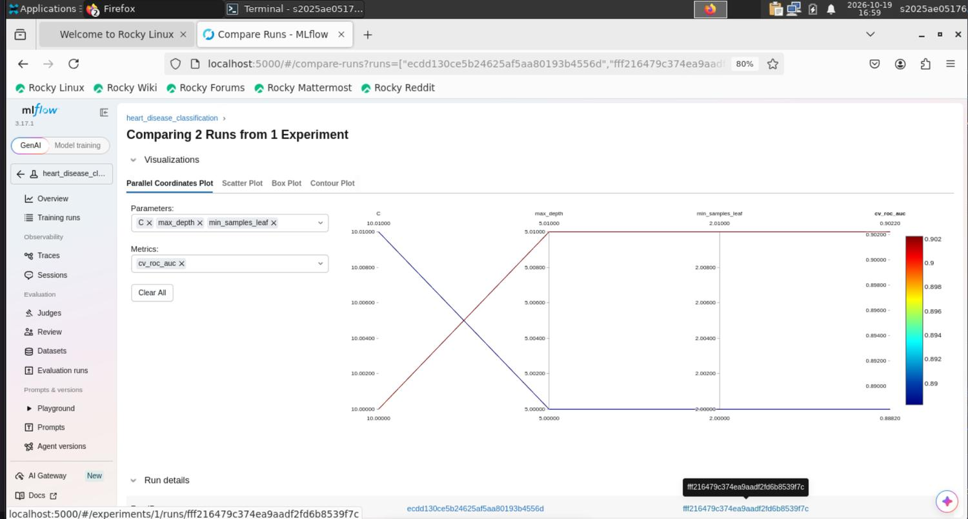
Figure 6: MLflow UI - comparing the logistic_regression and random_forest runs of the heart_disease_classification experiment
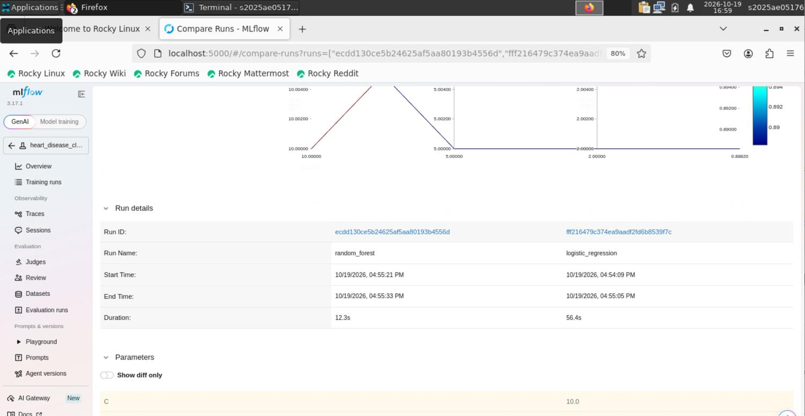
Figure 7: MLflow run details for the two runs (run IDs, start/end time, duration, parameters)

6. Model Packaging and Reproducibility
- Single pipeline artifact: src/packaging/package_model.py rebuilds the winning estimator with its best parameters and wraps it with a custom preprocessing transformer (src/packaging/preprocessing.py) in one scikit-learn Pipeline, saved as models/heart_disease_pipeline.pkl. The API therefore receives raw patient JSON and transforms it exactly as in training.
- Model card: models/model_card.json records the model type, hyperparameters, test metrics, expected input columns, label mapping and a sample input.
- Pinned environment: requirements.txt lists every dependency, with scikit-learn pinned to 1.9.1 so the pickle always loads under the version that trained it. The serving image uses a smaller docker/requirements-serving.txt.
- Determinism: random_state=42 everywhere (split, CV folds, models). Re-running the pipeline reproduces the Logistic Regression metrics exactly.
- One-command rebuild: setup.sh + run_pipeline.sh (or python -m src.orchestration.pipeline) regenerates data, plots, reports and the model from scratch. Each stage is timed and logged, and a failing stage stops the run with a clear error.
Packaging smoke test output for the sample patient:
{"prediction": 0, "label": "no_disease", "confidence": 0.9845, "probability_disease": 0.0155}

7. Architecture
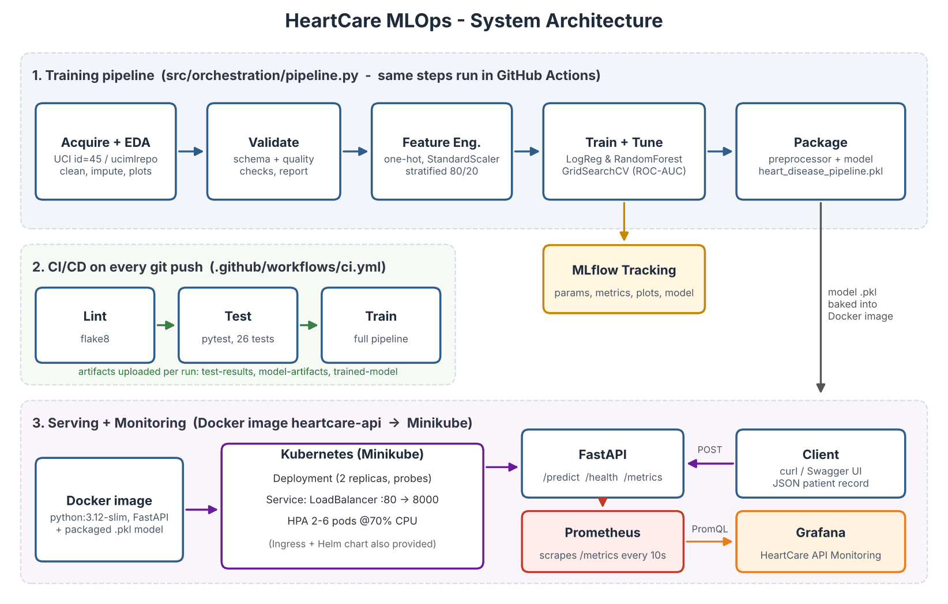
Figure 8: End-to-end architecture of the HeartCare MLOps system
The training pipeline runs locally and again in GitHub Actions on every push. Its output is a single pipeline .pkl that is copied into the Docker image. The image runs on Minikube as a 2-replica Deployment behind a LoadBalancer Service, with a HorizontalPodAutoscaler. Prometheus scrapes the /metrics endpoint of the API and Grafana visualizes it.

8. CI/CD Pipeline and Automated Testing

8.1 GitHub Actions Workflow
Workflow file: .github/workflows/ci.yml. It is triggered on every push, pull request, or manually, and has three jobs, each depending on the previous one:
Job | What it does | Artifacts
Lint (flake8) | flake8 src tests --count; any style or syntax error fails the job | -
Unit tests | Installs requirements, builds data + model, runs pytest -v with JUnit XML | test-results, model-artifacts (models, logs, docs, plots)
Model training | Runs the full training pipeline standalone | trained-model (pipeline .pkl, model card, model report)

The pipeline fails on code or test errors and gives clear logs. For example, several runs on 17-Oct-2026 failed while the scikit-learn version and Dockerfile were being fixed, and the next commits turned the pipeline green again. The latest run (commit 26a9f0f, "feat: Added k8s monitoring") passed all three jobs.
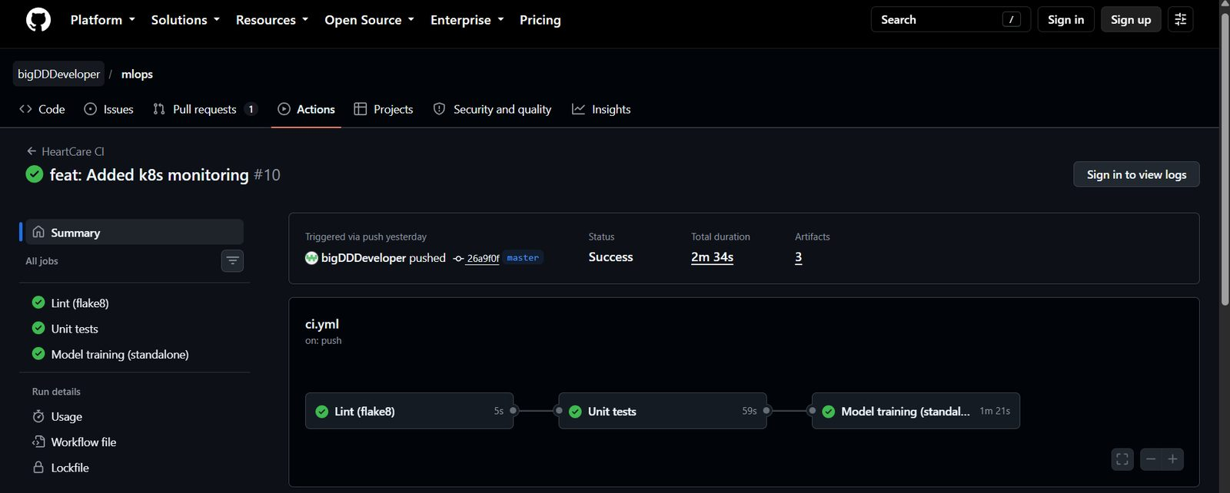
Figure 9: GitHub Actions - lint, test and train jobs all passing

8.2 Unit Tests
Test file | Tests | What is covered
test_data_processing.py | 7 | duplicate removal, missing-value filling, target binarization, integer categoricals, one-hot encoding, class-imbalance summary
test_preprocessing.py | 6 | pipeline transformer: fitted columns, output shape, numeric output, fixed columns, scaling, missing input columns
test_validation.py | 8 | missing-value, duplicate, schema, range and class-balance checks
test_model_and_api.py | 5 | single and batch prediction, /health, /predict, rejection of invalid input (422)
Total | 26 | all passing locally and in CI

9. Model Containerization (Docker)
docker/Dockerfile builds a slim image (python:3.12-slim) that installs only the serving requirements, copies src/ and the packaged model, runs as a non-root user, declares a HEALTHCHECK on /health and starts uvicorn on port 8000.
API endpoints:
Endpoint | Method | Purpose
/predict | POST | One patient record (JSON) -> prediction, label, confidence, probability_disease
/predict/batch | POST | List of records -> list of predictions
/health | GET | Liveness / readiness: status and model_loaded
/metrics | GET | Prometheus metrics
/docs | GET | Swagger UI (auto-generated)

Inputs are validated with pydantic (value ranges per field), so a bad request gets a 422 error instead of a wrong prediction.
docker build -f docker/Dockerfile -t heartcare-api:v2 .
docker run -p 8000:8000 heartcare-api:v2
curl -X POST http://localhost:8000/predict -H "Content-Type: application/json" \
-d '{"age":63,"sex":1,"cp":4,"trestbps":145,"chol":233,"fbs":1,"restecg":2,"thalach":150,"exang":0,"oldpeak":2.3,"slope":3,"ca":0,"thal":6}'

# response
{"prediction":0,"label":"no_disease","confidence":0.9845,"probability_disease":0.0155}
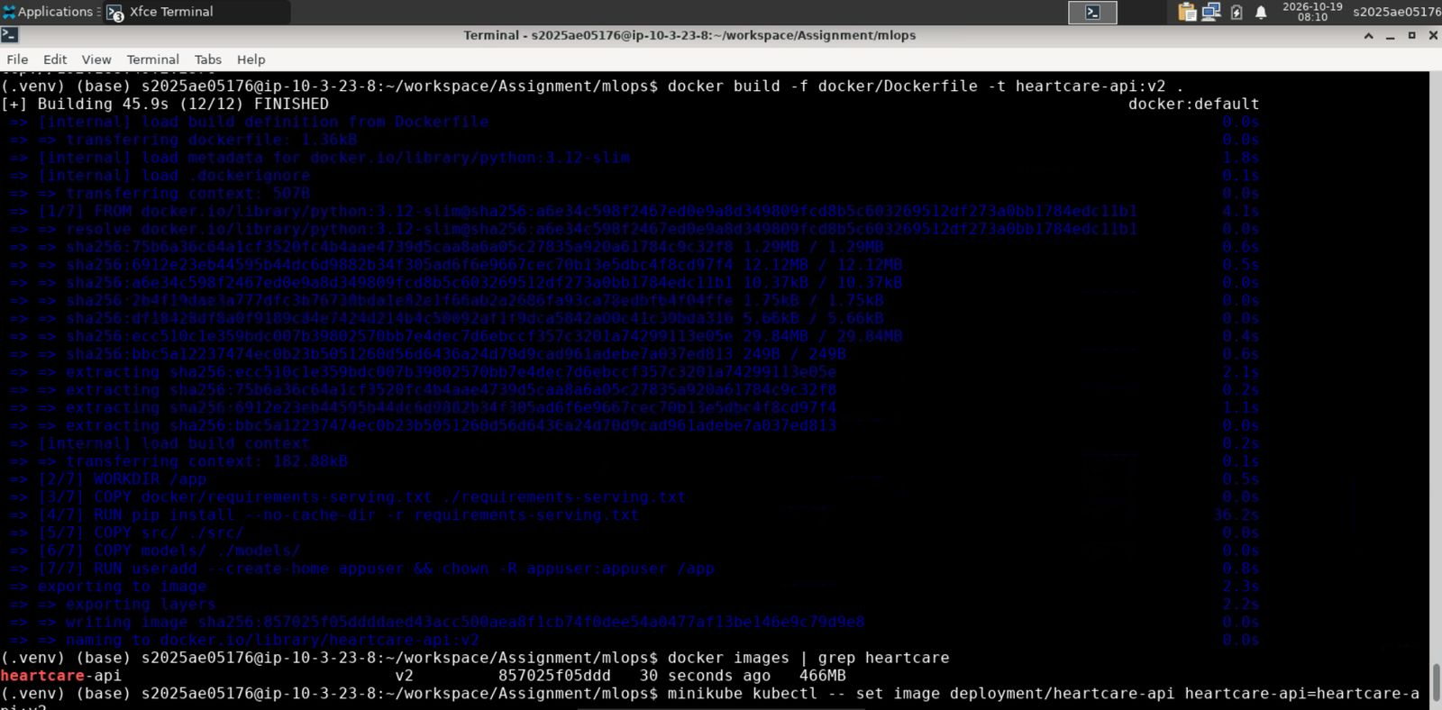
Figure 10: Docker image heartcare-api:v2 built successfully (12/12 steps) and listed by docker images
The same image is what runs in Kubernetes, so the live /predict call with its JSON reply (prediction + confidence) is shown once, through the Kubernetes service, in section 10.

10. Production Deployment (Kubernetes / Minikube)
Manifest | Purpose
k8s/deployment.yaml | 2 replicas, CPU/memory requests and limits, liveness + readiness probes on /health, non-root securityContext, Prometheus scrape annotations
k8s/service.yaml | LoadBalancer Service, port 80 -> container port 8000
k8s/hpa.yaml | HorizontalPodAutoscaler, 2 to 6 pods at 70% CPU
k8s/ingress.yaml | Optional NGINX Ingress (host heartcare.local)
k8s/helm/heartcare/ | Helm chart with the same Deployment, Service and HPA, parameterized in values.yaml

minikube image load heartcare-api:v2
minikube kubectl -- apply -f k8s/deployment.yaml -f k8s/service.yaml -f k8s/hpa.yaml
minikube kubectl -- set image deployment/heartcare-api heartcare-api=heartcare-api:v2
minikube kubectl -- get pods
URL=$(minikube service heartcare-api --url); echo $URL
curl $URL/health
curl -X POST $URL/predict -H "Content-Type: application/json" -d '{"age":63,"sex":1,"cp":4,"trestbps":145,"chol":233,"fbs":1,"restecg":2,"thalach":150,"exang":0,"oldpeak":2.3,"slope":3,"ca":0,"thal":6}'
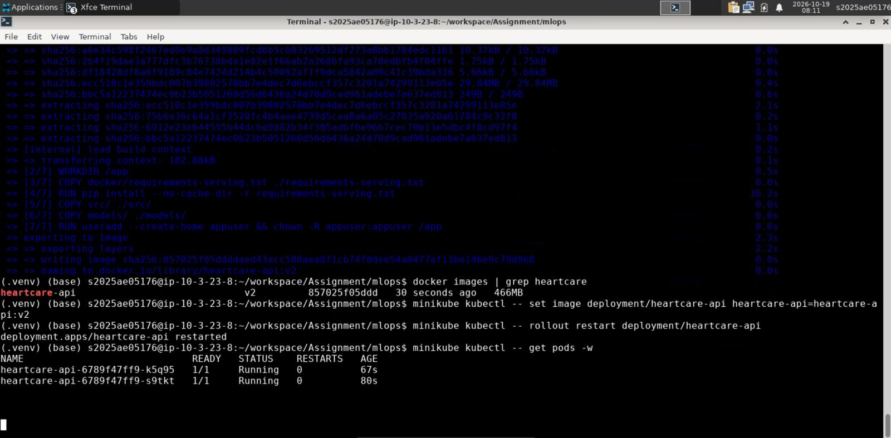
Figure 11: Image v2 rolled out to the cluster; both heartcare-api pods Running (1/1)
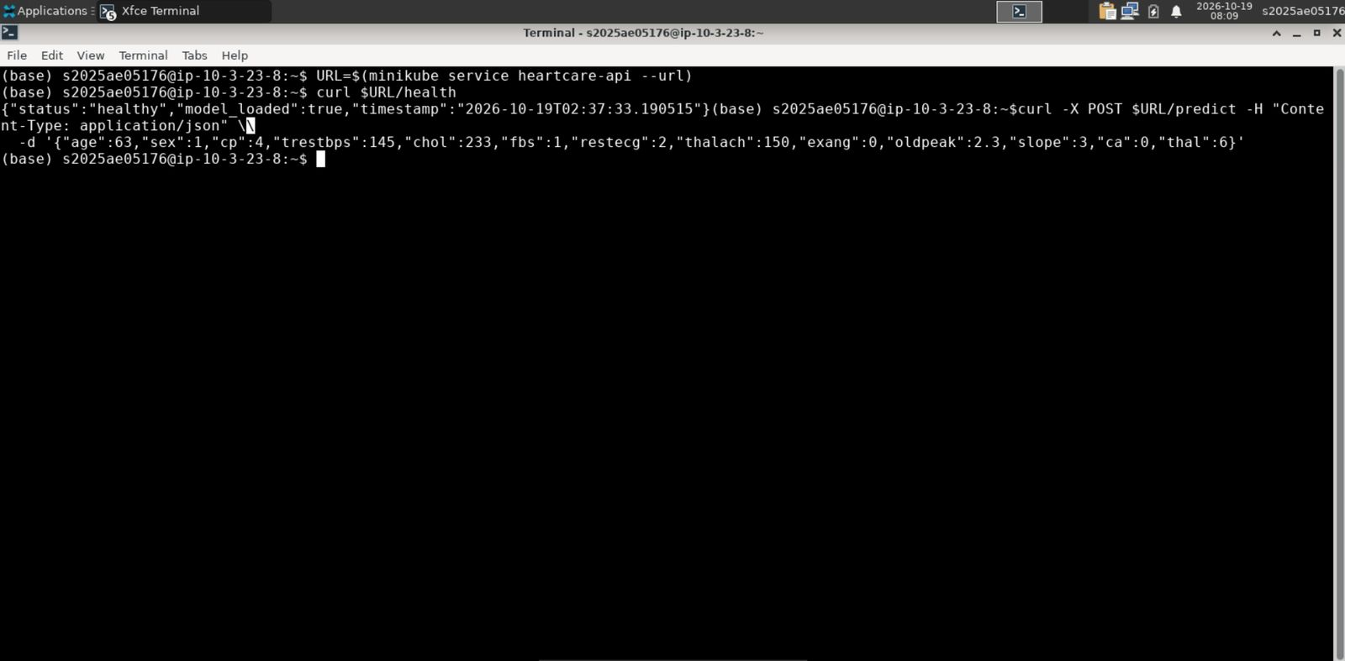
Figure 12: Service URL resolved with minikube service and /health returning healthy with model_loaded=true
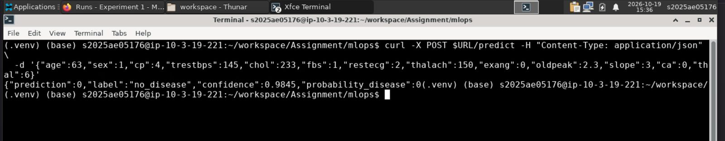
Figure 13: POST /predict through the Kubernetes service returning prediction, label and confidence (0.9845)

11. Monitoring and Logging
Every request goes through a middleware that writes one JSON access-log line (timestamp, method, endpoint, status, latency, client) and updates the Prometheus metrics below. They are exposed on /metrics.
Metric | Type | Meaning
api_requests_total{endpoint,method,status} | Counter | Request count by endpoint and status code
request_latency_seconds{endpoint} | Histogram | Request latency (used for p95)
predictions_total{label} | Counter | Predictions by label (disease / no_disease)
prediction_errors_total | Counter | Failed predictions
model_ready | Gauge | 1 when the model pipeline is loaded

Prometheus and Grafana run in the same Minikube cluster (k8s/monitoring/). Prometheus scrapes heartcare-api:80/metrics every 10 seconds. Grafana is auto-provisioned with Prometheus as its data source and the "HeartCare API Monitoring" dashboard: model status, total requests, total predictions, prediction errors, request rate by endpoint, p95 latency, predictions by label and status codes. The same stack can also be started with docker compose.
minikube kubectl -- apply -f k8s/monitoring/prometheus.yaml
minikube kubectl -- create configmap grafana-dashboard-json \
--from-file=heartcare_dashboard.json=monitoring/grafana/provisioning/dashboards/heartcare_dashboard.json
minikube kubectl -- apply -f k8s/monitoring/grafana.yaml
minikube service prometheus --url ; minikube service grafana --url
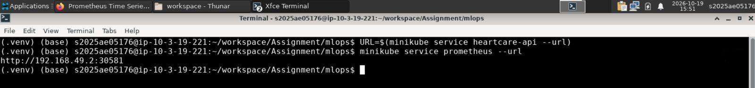
Figure 14: Prometheus exposed from Minikube with minikube service prometheus --url
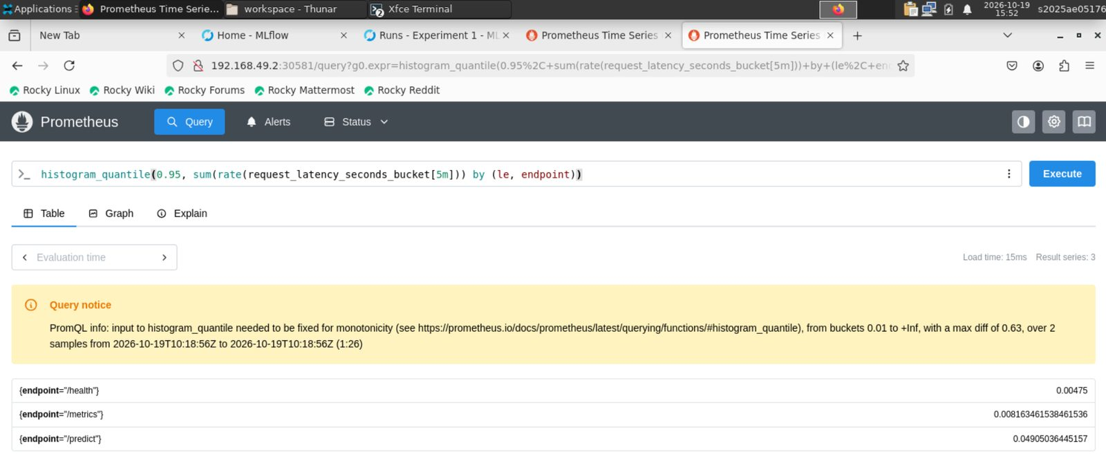
Figure 15: Prometheus p95 request latency per endpoint (/health, /metrics, /predict) scraped from the API
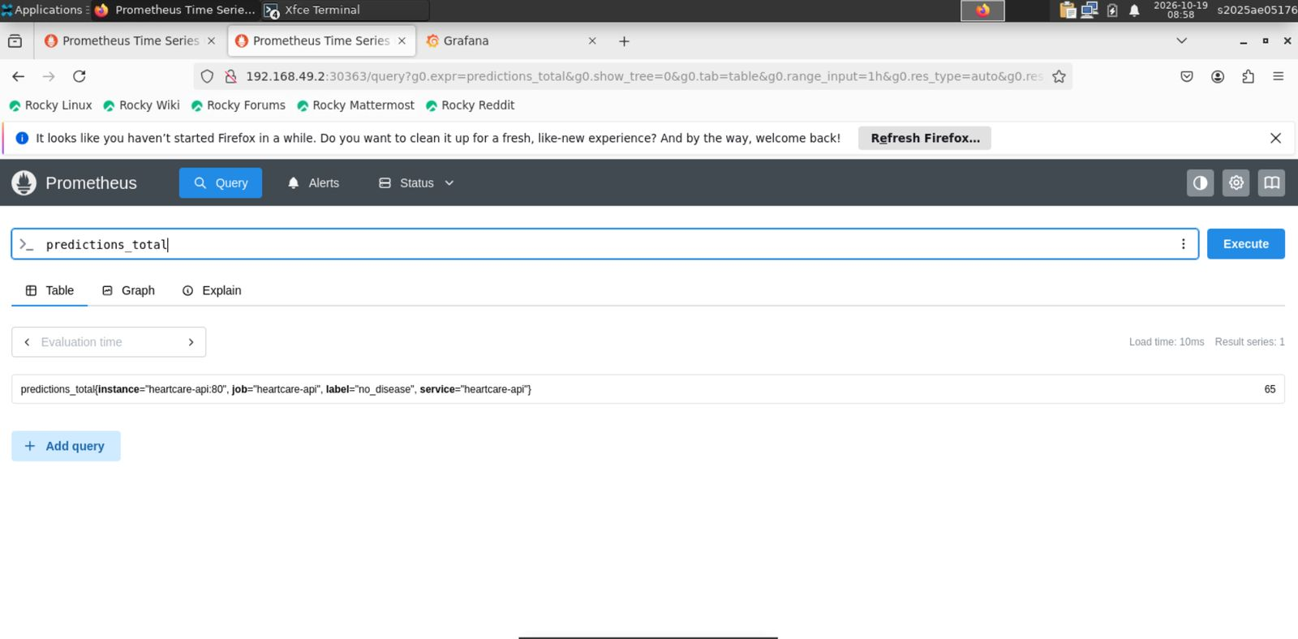
Figure 16: Prometheus query predictions_total scraped from the heartcare-api job
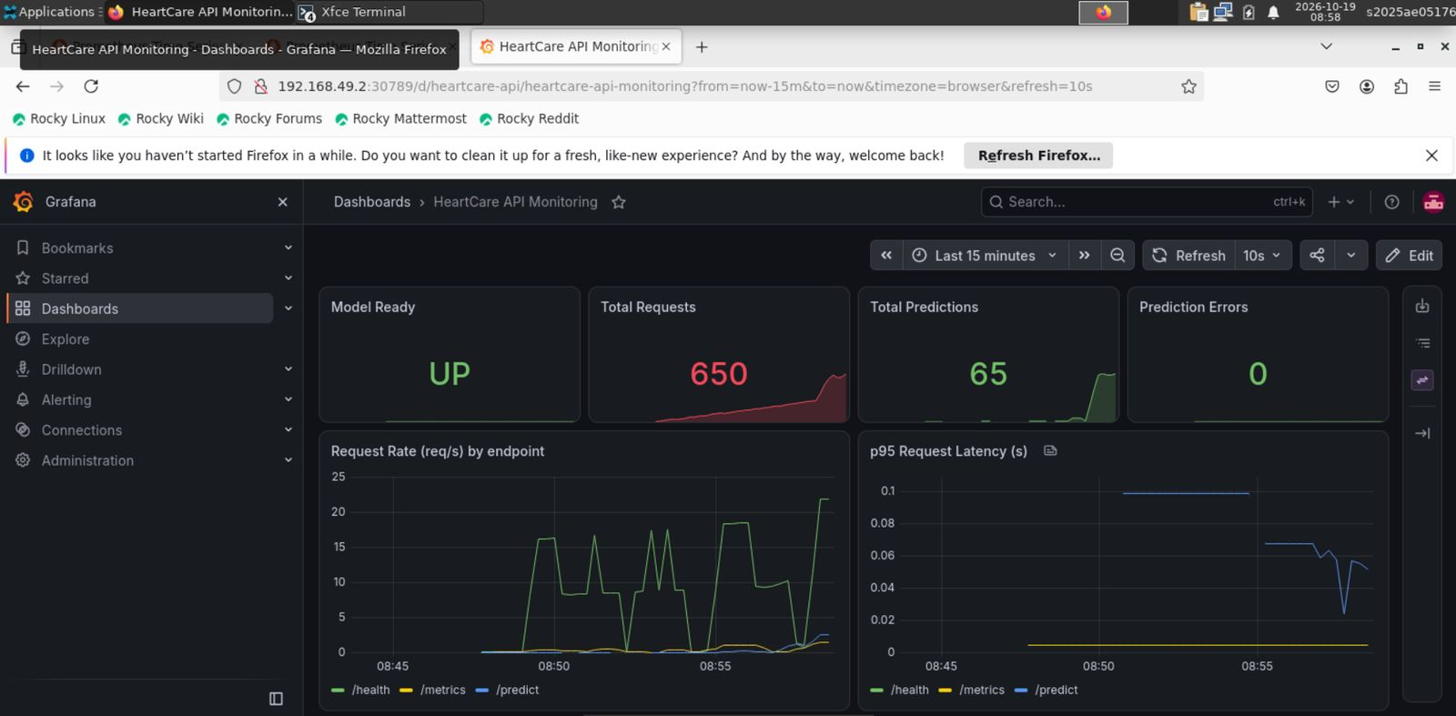
Figure 17: Grafana "HeartCare API Monitoring" dashboard with live traffic

12. API Access Instructions
The API is deployed on a local Minikube cluster, so there is no public URL. To test it:
- Kubernetes: run minikube service heartcare-api --url and send requests to the printed URL (e.g. http://192.168.49.2:<NodePort>).
- Docker: docker run -p 8000:8000 heartcare-api:v2, then use http://localhost:8000.
- Swagger UI is at <URL>/docs for trying /predict from the browser, and Grafana / Prometheus are reachable with minikube service grafana --url and minikube service prometheus --url.

13. Code Repository and Deliverables
Repository: https://github.com/bigDDDeveloper/mlops/tree/master (public; the repository root is the project root, default branch master).
Deliverable | Location
Code, Dockerfile, requirements | src/, docker/Dockerfile, requirements.txt, docker/requirements-serving.txt
Cleaned dataset + download script | data/cleaned/heart_disease_clean.csv, src/data_acquisition/acquire_data.py
Scripts (EDA, training, inference) | src/data_acquisition, src/training, src/packaging, src/serving
Unit tests | tests/ (26 pytest tests)
CI workflow | .github/workflows/ci.yml
Deployment manifests / Helm | k8s/*.yaml, k8s/helm/heartcare/, k8s/monitoring/
Monitoring config | monitoring/prometheus.yml, monitoring/grafana/, docker-compose.yml
Screenshots | screenshots/
Final report | report/HeartCare_MLOps_Report.docx (+ PDF)
Pipeline video | https://drive.google.com/file/d/1mazlkWU5K9K2UhdHX895KMuLAH797ruZ/view

14. Conclusion
The project delivers a working, reproducible MLOps pipeline for heart disease risk prediction: a tuned Logistic Regression model with ROC-AUC 0.962 and recall 0.93, tracked in MLflow, packaged as a single pipeline, tested and trained automatically in GitHub Actions, containerized, deployed on Kubernetes with autoscaling, and monitored with Prometheus and Grafana.

