Info Display — Screen Reference
Document type: User Location: Documents/User/Info_Display_Screen_Reference.md Applies to: KCMk1_InfoDisp firmware 1.15.2
The controller carries two Info Displays, each a 1024 × 600 touchscreen running the same firmware. Info Display 1 (panel A1, sidebar on the left) is the vehicle panel: it always shows an instrument for the vehicle you are flying. Info Display 2 (panel B1, sidebar on the right) is the mission panel: it follows the mission phase, and it alone carries the autopilot consoles. Every screen can be reached from either unit; only the sixth sidebar key differs.
Every picture in this document is a true rendering: the firmware's own drawing code, run on a computer against a model of the display controller, in the flight state the caption describes. Layout, fonts, colours and thresholds are therefore the panel's. Thresholds quoted here are the firmware defaults in AAA_Config.ino and the shared KCMk1_SystemConfig.h.

Common elements

Title bar and the AUTO / MAN chip
Each screen's name is centred in the title bar. At the right of the bar a small outlined chip says who chose the screen:
Chip | Meaning
AUTO (grey outline) | The panel's automatic screen selection chose this screen.
MAN (green outline) | You chose it with a sidebar key, and the panel is holding your choice.

A manual choice means not this, now rather than never. It is released when the situation the panel was responding to changes (its automatic choice changes), when you press the key of the screen the panel currently wants, or when you switch vessel or enter a new flight scene.

Sidebar keys
Six keys run down the outboard edge. A key's caption shows its family name while another screen is up, and the active mode's name while one of its screens is showing (that key is then highlighted). Pressing a key from another screen goes to its automatic choice; pressing it again cycles its modes.
Key | Caption at rest | Screens, in cycle order | First press goes to
1 | PFD | SPACECRAFT → AIRCRAFT → ROVER (Info Display 2 adds VEHICLE INFO) | The PFD that suits the vessel
2 | LNCH | PRE-LAUNCH (automatic on the pad), then ASCENT ↔ CIRCULARIZATION | The mode that fits the flight phase
3 | ORB | ORBIT → ORBIT ADVANCED → MANEUVER | ORBIT
4 | TGT | TARGET → DOCKING → NAVIGATION | DOCKING inside 200 m of a target, else TARGET
5 | LNDG | POWERED DESCENT ↔ RE-ENTRY | POWERED DESCENT
6 | VEH on Info Display 1, A/P on Info Display 2 | VEHICLE INFO (Info Display 1); the five autopilot consoles (Info Display 2) | See the autopilot section

The sidebar keys are the only touch targets on most screens. The exceptions are the reference chip on the two PFDs, the PRE-LAUNCH board (a tap dismisses it), and the autopilot consoles.

Automatic screen selection
Each panel re-checks its choice every frame. To stop it flapping, an automatic switch waits at least 4 s after the previous one and at least 10 s after a sidebar press, and every numeric rule has a release band wider than its trigger.
Info Display 1 answers one question, what instrument suits this vehicle:
Priority | Condition | Screen
1 | Vessel type is Rover | ROVER
2 | Vessel type is Plane and the vessel is in an atmosphere | AIRCRAFT
3 | Anything else, including EVA | SPACECRAFT

Info Display 2 follows the mission. The first rule that matches wins:
Priority | Condition | Screen
0 | An autopilot is armed or engaged | That autopilot's console
1 | On the pad or runway (pre-launch), any vessel type | PRE-LAUNCH
2 | Descending with periapsis in the body's re-entry corridor, while still above the atmosphere or faster than Mach 3 | RE-ENTRY
3 | Descending faster than 5 m/s below 10 km radar altitude (not a plane in an atmosphere) | POWERED DESCENT
4 | A Plane flying in an atmosphere, apoapsis below its top | NAVIGATION
5 | A target within 200 m | DOCKING
6 | Landed or splashed | TARGET if one is set, else VEHICLE INFO
7 | Climbing with periapsis below the orbit-safe altitude (not a rover or EVA) | ASCENT / CIRCULARIZATION
8 | A manoeuvre node with ignition less than 10 min away, including during the burn | MANEUVER
9 | A target between 200 m and 2,000 m | TARGET
10 | On EVA | TARGET
11 | Everything else | ORBIT

The orbit-safe altitude is the higher of the body's atmosphere top and its highest terrain: 70 km at Kerbin, 7.1 km at the Mun. Aircraft screens key off the vessel type KSP reports, so a plane must be typed Plane in KSP to get AIRCRAFT and NAVIGATION.

Colours
Appearance | Meaning
Grey label, left of a value | Readout name; labels never change colour except where noted
Green value | Nominal
Yellow value | Caution: approaching a limit
White on red | Alarm: act now
Dark grey --- | No data, or the value does not apply right now
Cyan | A console edit or command sent but not yet confirmed
Bright green, violet, magenta, cyan, blue markers | KSP navball colours: prograde, target, normal, radial, manoeuvre

Where a table says "yellow 150–299", the bounds are inclusive of whole units: values are compared after truncation to whole numbers unless the table gives decimals.

Number formats
Quantity | Format
Distance, altitude | Two decimals below 1,000 m (310.00 m); whole metres with separators to 999,999 m (124,665 m); then km, Mm, Gm
Speed | One decimal below 1,000 m/s (842.0 m/s); whole numbers with separators from 1,000 (2,200 m/s)
Time | 48 s; 15 m: 06 s under an hour; 1h 09m from one hour; 3d 04h from one Kerbin day (6 h). A leading - means the moment has passed. Autopilot consoles use the compact m:ss.

Standby

Outside a flight scene, and until the KerbalSimpit link to KSP is up, both units show the standby splash. It needs no action; the panel switches to its flight screen when a flight scene starts.

Vehicle screens (key 1, PFD)

SPACECRAFT (caption SPC)
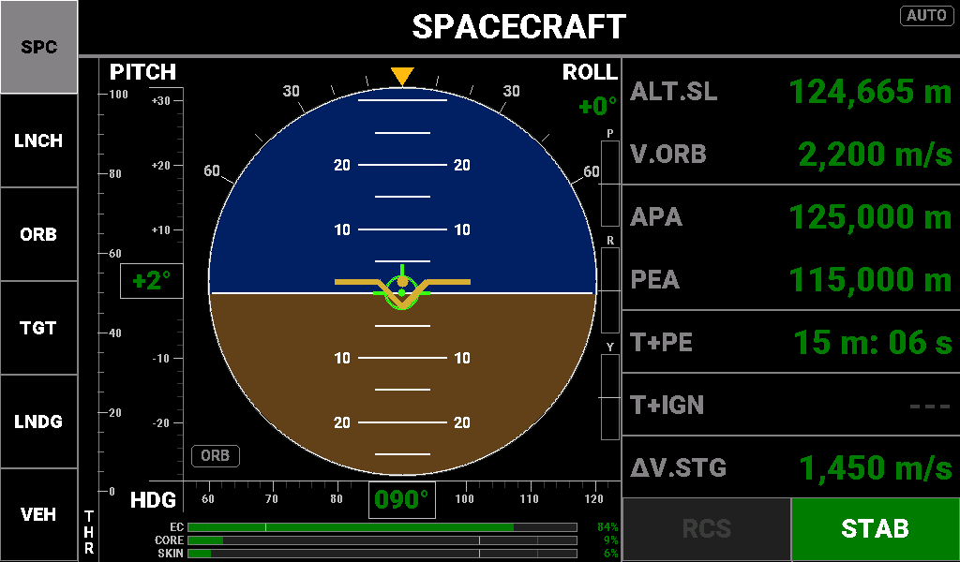
A ship in a 115 × 125 km, 6° Kerbin orbit, nose prograde, SAS in stability assist.
Purpose. The primary flight display for everything that is not a rover or an aircraft in an atmosphere: rockets, capsules, probes, landers, stations and a Kerbal on EVA. An attitude ball fills the centre; the right column carries the orbital numbers flown from ascent through orbit and burns.
Reaching it. Key 1. Info Display 1 selects it automatically for every vessel except a rover or a plane in an atmosphere. On Info Display 2 it is reached only by hand.
Layout.
- Attitude ball (centre). Royal-blue sky, brown ground, white horizon. The gold wing symbol is fixed and level; the ball moves behind it. Centre to rim is 30°.
  - Pitch ladder: a rung every 5°, labelled every 10°.
  - Red chevrons appear past 32° of pitch and point back toward the horizon; they clear below 28°.
  - Navball markers, drawn while within about 25° of the nose: prograde and retrograde in bright green, normal and anti-normal in magenta, radial in cyan, target and anti-target in violet (with a target set), and the manoeuvre node in blue (with a node). Prograde, normal and radial follow the active velocity reference.
- Bank scale and roll pointer (top arc). Ticks at 0, ±10, ±20, ±30, ±45 and ±60°. The yellow pointer is a sky pointer: it turns with the horizon, so in a left bank it sits right of the top mark, and it stops at ±60°. The ROLL value beside it is a signed whole number of degrees and is always green on this screen.
- PITCH tape (left of the ball). Signed labels every 10°, with the boxed pitch value. Triangles on its edge mark the velocity vector (green), the target (violet) and the node (blue); a marker off the scale parks at the end.
- HDG tape (below the ball). About ±34° visible, N in yellow, the boxed heading in three digits, and the same three marker triangles.
- THR bar (far left). Throttle, 0–100 %, in orange. It is a control input, so it has no colour thresholds.
- P / R / Y rate bars (right of the ball). Pitch, roll and yaw rate, filling white from the centre line to ±10 °/s. Up is positive on all three: nose up, roll right, nose right. A bar sitting on its centre line means no rotation on that axis.
- EC / CORE / SKIN bars (bottom strip). Each bar and its percentage share one colour, with caution and alarm ticks drawn on the bar.
  - EC (electric charge): green from 20 %, yellow 5–19 %, red below 5 %.
  - CORE and SKIN (hottest part's temperature as a share of its limit): green up to 75 %, yellow 76–90 %, red above 90 %.
- Reference chip ORB / SRF (lower left of the ball). Which velocity the screen uses; see Buttons.
- TRIM. Cyan text above the right end of the heading tape while trim hold is on.
Reading the screen.
- Fly attitude on the ball: put the wing symbol on the marker you want to point at. During RCS work and burns, watch the P/R/Y bars; centred bars mean the craft has stopped rotating.
- In orbit, the right column gives the orbit and the next burn. T+IGN turns yellow in the last minute; once the engine is lit for a node, the row becomes ΔV.REM, the Δv the node still needs. Cut the engine at zero.
- Below the velocity-switch altitude, row 5 shows vertical speed instead.
- Watch EC and the temperature bars on long coasts and during re-entry.
Special states.
- Velocity reference. The panel uses orbital velocity (V.ORB) above 6 % of the body's radius while climbing or level, or above 5.5 % while descending (36 km and 33 km at Kerbin), and surface velocity (V.SRF) below. The swap redraws the screen.
- Row 4 shows T+AP or T+PE, whichever apsis comes sooner.
- Row 5 has three modes: V.VRT below the switch altitude, T+IGN above it, and ΔV.REM while a node burn is running (node set, throttle above 1 %, ignition time passed). Pinning the reference chip does not change row 5.
- Dashes. ALT.SL, V.ORB / V.SRF, APA, PEA and T+AP dash out when KSP sends neither a positive apoapsis nor a positive periapsis. T+IGN dashes with no node.
- Escape trajectory. APA shows ∞.
- EVA. With a Kerbal on EVA, rows 2–6 become ALT.RDR, V.SRF, DIST, V.CLOSE and EC, and row 1 always shows V.ORB, so orbital and surface speed are both on screen: the pair tells station-keeping from drifting.
Readouts (right column).
Label | Description | Colour coding / thresholds
ALT.SL | Altitude above sea level | Green always
V.ORB / V.SRF | Orbital or surface speed, following the velocity reference | Green always
APA | Apoapsis altitude | Green always; ∞ on escape
PEA | Periapsis altitude; negative while suborbital | Green always
T+AP / T+PE | Time to whichever apsis comes sooner | Green always
V.VRT | Vertical speed, signed (row 5, low altitude) | Green always: reported, never alarmed here
T+IGN | Time to ignition: node time minus half the burn duration (row 5, high altitude) | Green at 60 s or more; yellow under 60 s; white on red once ignition time has passed; --- with no node
ΔV.REM | Δv the node still needs (row 5, during the burn) | Green always
ΔV.STG | Δv left in the current stage | Green from 300 m/s; yellow 150–299 m/s; white on red below 150 m/s

On EVA the rows read:
Label | Description | Colour coding / thresholds
V.ORB | Orbital speed (always shown on EVA) | Green always
ALT.RDR | Height above the terrain | Green always
V.SRF | Surface speed | Green always
DIST | Distance to the target | Green; --- with no target
V.CLOSE | Closing speed; negative means closing | Green; --- with no target
EC | Suit charge | Green from 20 %; yellow 5–19 %; white on red below 5 %

Buttons.
- RCS and SAS mode (bottom of the column) are indicators; switch them with the panel hardware.
  - RCS: white on green when on, dark grey when off.
  - SAS shows the active mode in navball colours: STAB white on green; PRO and RETR on bright green; NRM and ANRM on magenta; RAD+ and RAD- on sky blue; TGT and ATGT on violet; MNVR on blue; SAS in dark grey when SAS is off.
- ORB / SRF chip is the one touch control. A tap pins the other velocity reference, or returns to automatic if the automatic rule already wants it. A grey outline means automatic, green means pinned. A pin releases by itself when the automatic answer changes.

AIRCRAFT (caption ACFT)
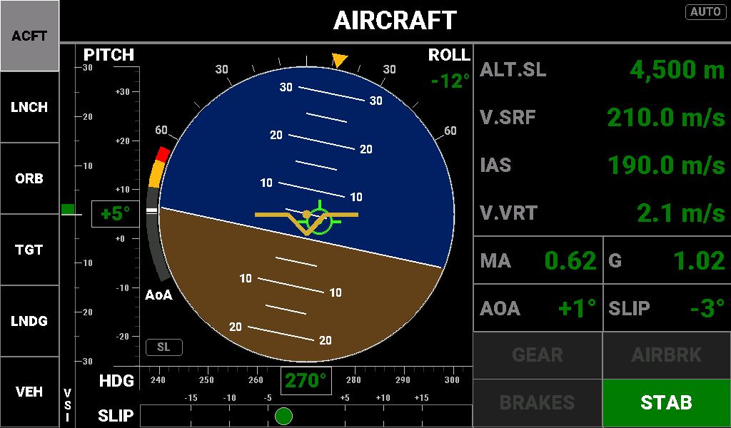
A jet at 4,500 m, 190 m/s indicated, in a 12° left bank.
Purpose. The primary flight display for a vessel typed Plane while it is in an atmosphere: the same attitude ball, with aircraft instruments around it (vertical speed, slip and angle of attack) and airspeeds, Mach and G on the right.
Reaching it. Key 1, second in its cycle. Info Display 1 selects it automatically for a Plane in an atmosphere and hands back to SPACECRAFT when it leaves.
Layout.
- Attitude ball, tapes and bank scale as on SPACECRAFT, except the ball shows only surface prograde and retrograde (plus target and node when set), and the tapes carry only the green velocity triangle.
- VSI bar (far left). Vertical speed, ±30 m/s, zero at the ball's centre height, climbing upward. In cruise the fill is always green. On an approach (gear down, or below the radar-altimeter handover height) it turns yellow below −5 m/s and red below −8 m/s.
- AoA arc (left edge of the ball). −25° to +25°, zero at 9 o'clock. Dark grey, yellow from +10° to +20°, red from +20° to +25°: only stall-side angles are coloured. The white pointer is the current angle of attack.
- SLIP strip (bottom). A ball on a ±20° scale that moves right when the nose points right of the flight path. Green up to 5°, yellow above 5°, red above 15°.
- IAS trend chevrons (magenta, beside IAS). One, two or three chevrons predict the airspeed change over the next 6 s: one from 2 m/s, two from 6, three from 12.
- SL / RDR chip. Which altitude row 1 shows; see Buttons.
Reading the screen. Fly attitude on the ball and speed on IAS, keep the slip ball centred, and treat the AoA arc and AOA row as the stall warning (IAS has no stall colour). AoA is nose pitch minus flight-path pitch, so it is most accurate wings-level. On approach, lower the gear or descend below 750 m radar altitude: row 1 switches to radar altitude and V.VRT and the VSI begin to alarm on landing descent rates. A yellow GEAR button in flight means the gear is down above 160 m/s.
Special states.
- Row 1 switches to ALT.RDR below 750 m radar altitude and back to ALT.SL above 850 m. The gap stops it flickering at one height.
- The landing bands on V.VRT and the VSI follow the automatic radar test or gear down; pinning RDR with the chip does not turn them on.
- AOA and SLIP dash out below 0.5 m/s surface speed.
Readouts (right column).
Label | Description | Colour coding / thresholds
ALT.SL / ALT.RDR | Altitude above sea level, or radar altitude (one decimal under 10 m, whole metres under 100 m, nearest 5 m above) | ALT.SL green always. ALT.RDR green from 500 m; yellow 50–499 m; white on red below 50 m
V.SRF | Surface speed | Green always
IAS | Indicated airspeed, with trend chevrons | Green always
V.VRT | Vertical speed, signed | Cruise: green always. Approach: green from −5 m/s; yellow below −5 to −8 m/s; white on red below −8 m/s
MA | Mach number | Yellow 0.85–1.20 (transonic); green otherwise
G | Load factor | Green from −2.0 to 4.0 g; yellow above 4.0 or below −2.0; white on red above 9.0 or below −5.0
AOA | Angle of attack, signed whole degrees | Green below +10°; yellow +10° to +19°; white on red from +20°; --- below 0.5 m/s
SLIP | Heading minus surface track, signed whole degrees | Green below 5°; yellow 5°–14°; white on red from 15°, either side; --- below 0.5 m/s

The ROLL value at the top of the ball is green up to 60° of bank, yellow above 60° and white on red above 90°.
Buttons. All are indicators except the chip.
Button | State | Colours
GEAR | On the ground, down / up | White on green / white on red
GEAR | In flight, down | White on green; on yellow above 160 m/s surface speed
GEAR | In flight, up | Dark grey
AIRBRK | Deployed / stowed | Dark grey on cyan / dark grey
BRAKES | On / off on the ground / off in flight | White on green / white on red / dark grey
SAS mode | Any | As on SPACECRAFT

The SL / RDR chip works like SPACECRAFT's: a tap pins the other altitude source or returns to automatic.

ROVER (caption ROVR)
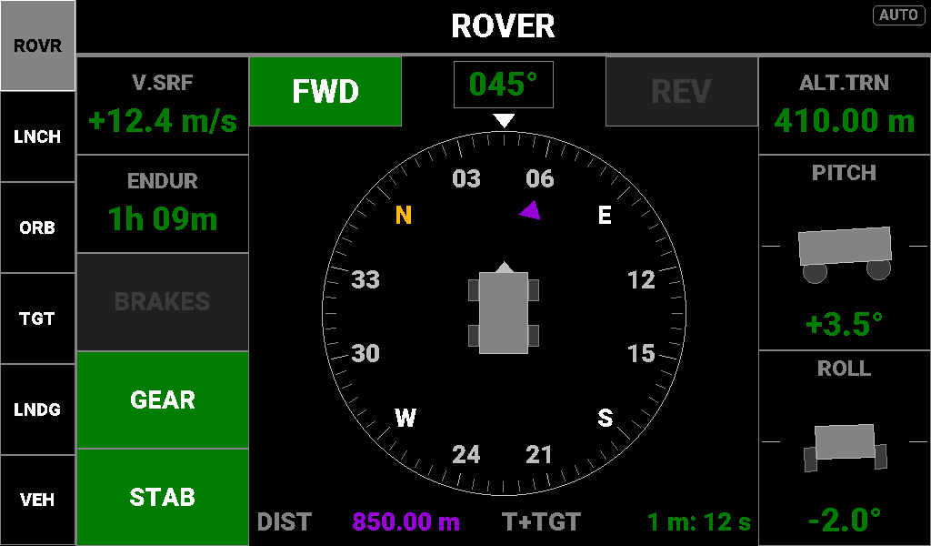
A rover on the Mun at 12.4 m/s, heading 045°, driving to a flag 850 m away.
Purpose. The driving instrument: a heading-up compass with the target bearing, speed and direction, battery endurance, and how far the vehicle is tilting. It answers where am I pointed, can I get there on this charge, and am I about to tip over.
Reaching it. Key 1, third in its cycle. Info Display 1 selects it whenever the vessel is typed Rover.
Layout.
- Compass card (centre). Turns so your heading is always at 12 o'clock, under the white nose triangle; the heading box above it gives the heading in three digits. N is yellow, E/S/W white, and the numbers are tens of degrees.
- Target marker. A violet triangle at the target's bearing relative to the nose, shown while a target is set. At 12 o'clock you are pointed straight at it.
- FWD / REV blocks (top corners). The wheel-throttle command: FWD white on green above +1 %, REV on yellow below −1 %, both muted in neutral. They show the command, not the direction you are actually moving.
- Left column: V.SRF, ENDUR, then the BRAKES, GEAR and SAS indicators.
- Right column: ALT.TRN, then the PITCH and ROLL tilt pictures with their values. The pictures (side view with the front to the right, and rear view) show the tilt; the numbers beneath carry the warning colours. The pictures stop turning at ±45°.
- DIST / T+TGT strip (bottom). Range and time to the target, shown while a target is set.
Reading the screen. Steer until the violet triangle sits under the nose and watch DIST count down. T+TGT says whether the battery lasts the trip: green with more than a fifth of your endurance to spare, yellow when the trip uses more than four fifths, and white on red when the battery runs out first. It is one-way only; a green T+TGT does not mean you can drive back. A yellow, negative V.SRF means you are rolling backwards, whatever FWD/REV says. On slopes, PITCH and ROLL turn yellow then red as you near rollover; roll has the tighter limits.
Special states.
- With no target, the marker and the whole bottom strip disappear.
- T+TGT shows --- when you are not closing on the target faster than 0.5 m/s.
- ENDUR shows --- until it has enough samples (about 6 s after boot or a vessel switch) or while the drain is too small to matter (under 0.002 % per second, more than about 14 h at full charge). It shows CHG in green while the battery is charging. Endurance is sampled on every screen, so it has a value the moment ROVER appears.
Readouts (right column).
Label | Description | Colour coding / thresholds
ALT.TRN | Terrain elevation under the rover (altitude above sea level minus radar altitude) | Green always
PITCH | Slope along the vehicle, signed, positive nose up | Green below 20°; yellow 20°–29.9°; red text from 30°
ROLL | Sideways lean, signed, positive right side down | Green below 15°; yellow 15°–24.9°; red text from 25°

Other readouts.
Label | Description | Colour coding / thresholds
Heading box | Vessel heading | Green always
V.SRF | Surface speed with direction sign, ±99.9 m/s | Green moving forward; yellow moving backward; dark grey +0.0 when stopped
ENDUR | Time to an empty battery at the drain measured over the last ~48 s | Green from 1 h; yellow under 1 h; white on red under 10 min; CHG green; --- dark grey
DIST | Distance to the target | Violet
T+TGT | Time to reach the target at the current closing speed | Green with endurance to spare; yellow from 80 % of ENDUR; white on red at or beyond ENDUR; green while ENDUR is --- or CHG

Buttons. Indicators only.
- BRAKES: white on green when on, dark grey when off.
- GEAR: white on green when deployed (the normal driving state), dark grey when retracted.
- SAS: active mode in navball colours, as on SPACECRAFT.

VEHICLE INFO (caption VEH)
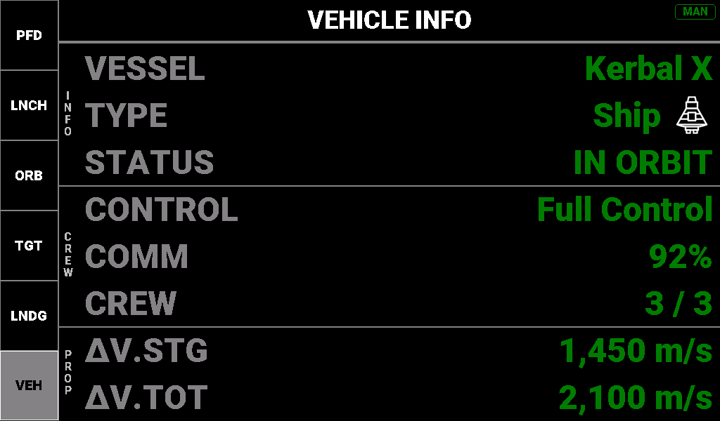
The orbiting ship from the SPACECRAFT picture.
Purpose. A text summary of the active vessel: identity, situation, control, comms, crew and Δv reserves. A status check for the pad, after landing or when switching vessels, not a flying instrument.
Reaching it. Info Display 1: key 6 (VEH), a single screen. The panel never chooses it there, so it always shows MAN and hands back to the PFD when the PFD choice changes. Info Display 2: the fourth stop on key 1, and chosen automatically when landed or splashed with no target set.
Layout. Eight full-width rows in three groups marked INFO, CREW and PROP at the left edge. The TYPE row ends with the vessel-type icon used on the Annunciator.
Reading the screen. Read top to bottom. A sky-blue STATUS ending · RECOVERABLE means the vessel can be recovered. Anything but a green "Full Control" limits what you can command. A yellow or red COMM means the probe link is weak or lost. Compare ΔV.STG with ΔV.TOT to judge whether the stage and the mission have the Δv left.
Readouts.
Label | Description | Colour coding / thresholds
VESSEL | Vessel name | Green always
TYPE | Vessel type and its icon | Ship green; Probe magenta; Relay violet; Rover olive; Lander navy; Plane sky blue; Station maroon; Base brown; EVA dark green; debris, objects, flags, science and parts dark red
STATUS | PRE-LAUNCH, IN FLIGHT, SUB-ORBITAL, IN ORBIT, ESCAPE ORBIT, LANDED, SPLASHED or DOCKED, with · RECOVERABLE when it applies | Sky blue when recoverable; green otherwise
CONTROL | Control level | Full Control green; Limited Manned dull yellow; Limited Probe orange; No Control white on red
COMM | CommNet signal | Green from 50 %; yellow 1–49 %; white on red at 0 %
CREW | Crew aboard / capacity | Green always
ΔV.STG | Current-stage Δv | Green from 300 m/s; yellow 150–299 m/s; white on red below 150 m/s. On the last stage the caution threshold rises to 500 m/s so the two Δv rows agree
ΔV.TOT | Total vessel Δv | Green from 500 m/s; yellow 150–499 m/s; white on red below 150 m/s

Buttons. None.

Launch screens (key 2, LNCH)
The LAUNCH key has three modes, one per part of the launch arc. While LAUNCH is showing, the key's caption is the current mode: PRE, ASC or CIRC.
- PRE-LAUNCH is armed whenever KSP reports the vessel as pre-launch. Info Display 2 brings it up automatically; on Info Display 1 press LNCH.
- PRE-LAUNCH → ASCENT happens at launch, or when you tap the board. Either keeps the screen on AUTO. Pressing the PRE key also moves on, but sets MAN for the whole flight, which stops step 3; tap the board instead. Once dismissed, the board does not return while you stay on the pad.
- ASCENT → CIRCULARIZATION happens by itself when the throttle is at or below 2 % and apoapsis is at or above the orbit-safe altitude (70 km at Kerbin). The switch then latches, so opening the throttle for the circularisation burn does not send the screen back. It returns to ASCENT only when the vessel is landed, splashed or back on the pad, or when apoapsis falls below the orbit-safe altitude. A throttle-down for max Q or a staging gap does not count, because apoapsis is not yet high enough.
- On ASC or CIRC, pressing the key again flips between the two and sets MAN; the automatic switch then stays off until you change vessel or start a new flight.
Info Display 2 keeps LAUNCH up while you are climbing with periapsis below the orbit-safe altitude, and moves to ORBIT (or MANEUVER, with a burn due) once periapsis clears it.

PRE-LAUNCH (caption PRE)
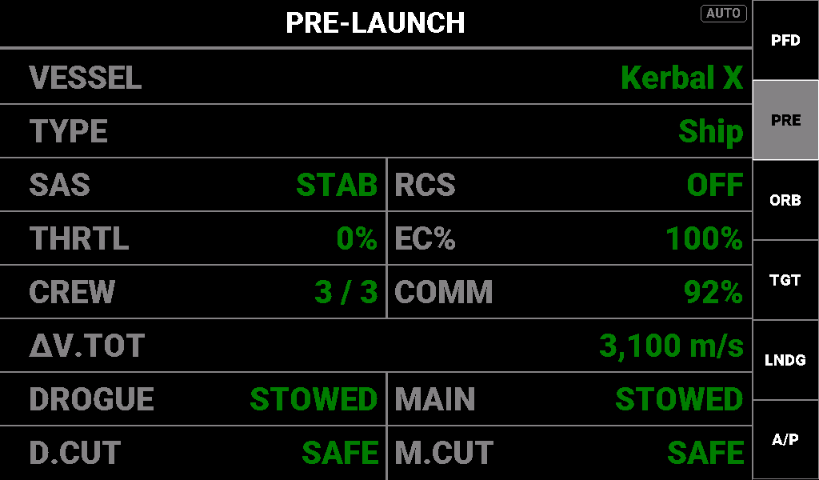
A ship on the pad, everything set for launch.
Purpose. A go / no-go board to read before staging: identity, control state, power, crew, comms, total Δv and the parachute action groups. Every value should be green.
Layout. Eight full-width rows; rows 3–5 and 7–8 are split into two cells. No graphics.
Reading the screen. Scan the right edge of each cell for anything not green. White on red is a no-go: SAS off, RCS on, throttle open, EC below 75 %, comms below 10 %, total Δv below 150 m/s, or a parachute group already active. Yellow is a caution: SAS in a mode other than STAB, EC 75–89 %, comms 10–49 %, total Δv 150–499 m/s. Percentages are truncated, so 89.9 % EC reads 89 % and shows yellow.
Readouts.
Label | Description | Colour coding / thresholds
VESSEL | Vessel name | Green always
TYPE | KSP vessel type | Green always
SAS | SAS mode: OFF, STAB, PROGRADE, RETRO, NORMAL, ANTI-NRM, RAD-OUT, RAD-IN, TARGET, ANTI-TGT, MANEUVER | STAB green; any other mode yellow; OFF white on red
RCS | RCS on or off | OFF green; ON white on red
THRTL | Throttle | 0 % green; anything else white on red
EC% | Electric charge | Green from 90 %; yellow 75–89 %; white on red below 75 %
CREW | Crew aboard / capacity | Green always
COMM | CommNet signal | Green from 50 %; yellow 10–49 %; white on red below 10 %
ΔV.TOT | Total vessel Δv | Green from 500 m/s; yellow 150–499 m/s; white on red below 150 m/s
DROGUE | Drogue-deploy action group (custom group 1) | STOWED green; ARMED! white on red
MAIN | Main-deploy action group (custom group 3) | STOWED green; ARMED! white on red
D.CUT | Drogue-cut action group (custom group 2) | SAFE green; FIRED! white on red
M.CUT | Main-cut action group (custom group 4) | SAFE green; FIRED! white on red

Buttons. None; a tap anywhere on the board moves on to ASCENT.

ASCENT (caption ASC)
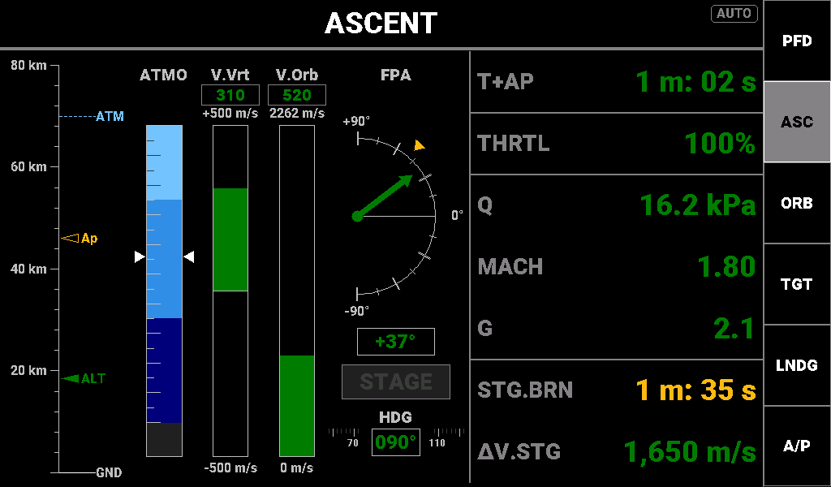
Full throttle at 18.5 km, Mach 1.8, apoapsis 46 km.
Purpose. The instruments for the powered climb. The left side shows the trajectory as pictures (altitude and apoapsis, atmosphere depth, vertical and orbital speed, flight-path angle and heading); the right column carries the numbers that have no picture.
Layout.
- Altitude ladder (far left). A scale from GND upward that grows as you climb (2, 5, 10, 20, 40, 80 km, then the target orbit plus 30 km) and never shrinks during the flight. The filled green ALT triangle is your altitude; the hollow yellow Ap triangle is apoapsis (always hollow by design). A dashed sky-blue ATM line marks the top of the atmosphere, and a dashed green TGT ORB line marks the target orbit (the orbit-safe altitude plus 20 km: 90 km at Kerbin) once the scale reaches it.
- ATMO gauge. How deep in the atmosphere you are, sea level at the top: sky blue (dense), mid blue, then navy, with a dark segment at the bottom for vacuum. The two white triangles mark the current depth. It has no number; Q is the atmospheric number to watch.
- V.Vrt bar. Vertical speed, −500 to +500 m/s, filling up in green while climbing and down in red while descending. The box above gives the value, green when climbing, red when descending.
- V.Orb bar. Orbital speed, from 0 to the circular-orbit speed at the target orbit (the top label). A full bar means orbital speed. The box above it shows surface speed below 6 % of the body's radius (36 km at Kerbin) and orbital speed above.
- FPA dial. Flight-path angle: +90° straight up, 0° at the horizon. The green needle is your actual flight path; the yellow triangle is the target angle for a gravity turn (vertical below 1,500 m, then easing to 0° at the target orbit). The box gives the angle.
- STAGE. Dark until the current stage's Δv is spent (0.5 m/s or less), then white on red: stage now.
- HDG tape. Heading, with a yellow bug at the due-east launch azimuth (090°) and a green triangle for your direction of travel above 20 m/s. Markers within about 18° of your heading hide behind the heading box, so no bug showing means you are within about 18° of 090°.
Reading the screen. Keep the green FPA needle on the yellow target triangle. Watch the hollow Ap triangle climb toward the TGT ORB line. Back off the throttle if Q goes yellow (20 kPa) or red (40 kPa); it peaks around 5–8 km. STG.BRN and ΔV.STG warn of staging before the STAGE light does. T+AP turning yellow means apoapsis is less than 30 s away. Cut the throttle once apoapsis is above the atmosphere; the screen moves to CIRCULARIZATION by itself.
Special states. T+AP dashes with no apoapsis, on the pad or landed. Q and MACH dash outside the atmosphere. A closed throttle shows white on red here, because during the ascent it is an event; CIRCULARIZATION has no throttle alarm.
Readouts (right column).
Label | Description | Colour coding / thresholds
T+AP | Time to apoapsis | Green from 30 s; yellow under 30 s; red if negative; --- with no apoapsis
THRTL | Throttle | Green above 0 %; white on red at 0 %
Q | Dynamic pressure, ½ρv² | Green below 20 kPa; yellow 20–39.9 kPa; white on red from 40 kPa; --- outside the atmosphere
MACH | Mach number | Green always; --- outside the atmosphere
G | Load factor | Green below 4.0 g; yellow 4.0–8.9 g; white on red from 9.0 g
STG.BRN | Seconds of thrust left in the current stage | Green from 120 s; yellow 60–119 s; white on red below 60 s
ΔV.STG | Δv left in the current stage | Green from 300 m/s; yellow 150–299 m/s; white on red below 150 m/s

CIRCULARIZATION (caption CIRC)
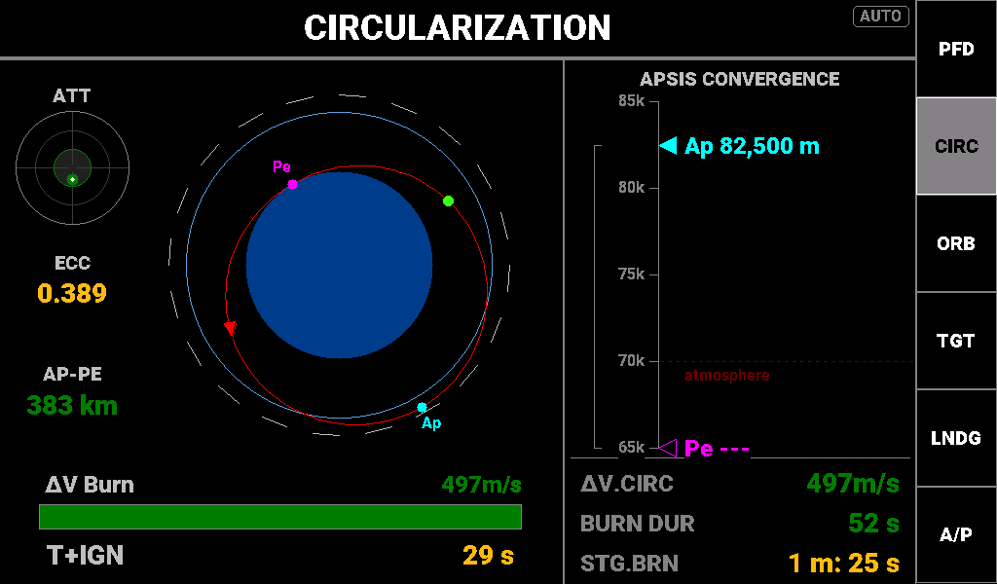
Coasting to an 82.5 km apoapsis, 29 s before ignition, with a circularisation node placed at apoapsis and SAS holding the node.
Purpose. For the coast to apoapsis and the circularisation burn. The left side shows the orbit you have and the burn aids; the right third is the apsis convergence tape, periapsis climbing to meet apoapsis above the orbit-safe floor; the three rows beneath it say whether this stage can finish the burn.
Layout.
- ATT disc (top left). How far your nose is from the manoeuvre node's burn direction. The dot shows where to point: green within 5°, yellow from 5° to 15°, red beyond. It stops at the 15° ring, and is grey and centred with no node.
- ECC and AP-PE (left rail). The orbit's eccentricity and the height difference between apoapsis and periapsis.
- Orbit diagram (centre). The body, its atmosphere ring, a dashed circle at the target orbit, and your orbit, compressed so its shape reads clearly. The orbit line is green with periapsis above the atmosphere, yellow with periapsis inside it, red with periapsis below the surface. Ap is cyan, Pe magenta, the vessel a green dot; a chevron shows the direction of travel.
- ΔV Burn bar (bottom). With a node placed, the node's remaining Δv, draining as you burn. Green, or yellow when the stage has less than 1.1 × the node's Δv. With no node, the bar is empty and the value shows the panel's own estimate in grey (est 74m/s).
- T+IGN (bottom row). Countdown to the start of the burn.
- APSIS CONVERGENCE tape (right). A vertical scale with the cyan Ap and magenta Pe markers and a grey bracket spanning the gap between them. The dashed dark-red line is the orbit-safe floor, labelled atmosphere or terrain. A marker below the bottom of the scale is drawn hollow with ---, typically a suborbital periapsis at the start of the burn; it fills in once it comes on scale.
Reading the screen.
- Place a KSP manoeuvre node at apoapsis. T+IGN, BURN DUR, the ATT disc and the ΔV bar all work from the node; without one they show --- or stay grey.
- Point at the node until the ATT dot is green in the centre ring.
- Light the engine when T+IGN turns white on red (under 10 s).
- During the burn the ΔV bar drains, the magenta Pe marker climbs toward the cyan Ap marker, and the bracket closes.
- You are done when ECC turns green (below 0.020) and the orbit line is green. The mission panel then hands over to ORBIT.
Special states. ECC and AP-PE dash with no apoapsis. ΔV.CIRC dashes when there is no usable estimate (no apoapsis, or already circular). On a suborbital coast the estimate uses the true ellipse, periapsis below the surface included, so it agrees with a KSP circularisation node (497 m/s in the picture).
Readouts (right column).
Label | Description | Colour coding / thresholds
Ap marker | Apoapsis on the tape | Cyan; hollow with --- below the scale
Pe marker | Periapsis on the tape | Magenta; hollow with --- below the scale
ΔV.CIRC | Δv to circularise at apoapsis, estimated from apoapsis and periapsis | Green always; --- with no usable estimate
BURN DUR | Burn duration of the next node | Green always; --- with no node
STG.BRN | Seconds of thrust left in the current stage | Green from 120 s; yellow 60–119 s; white on red below 60 s

Other readouts.
Label | Description | Colour coding / thresholds
ECC | Eccentricity, three decimals | Green below 0.020; yellow from 0.020; --- with no apoapsis
AP-PE | Apoapsis minus periapsis | Green always; --- with no apoapsis
ΔV Burn value | The node's remaining Δv, or est and the panel's estimate with no node | Node: green, or yellow when stage Δv is below 1.1 × the node's; estimate grey
T+IGN | Node time minus half the burn duration | Green from 60 s; yellow 10–59 s; white on red under 10 s, including once ignition has passed; --- with no node

Orbit screens (key 3, ORB)
A first press of ORB always lands on ORBIT; pressing it again cycles ORBIT → ORBIT ADVANCED → MANEUVER.

ORBIT (caption ORB)
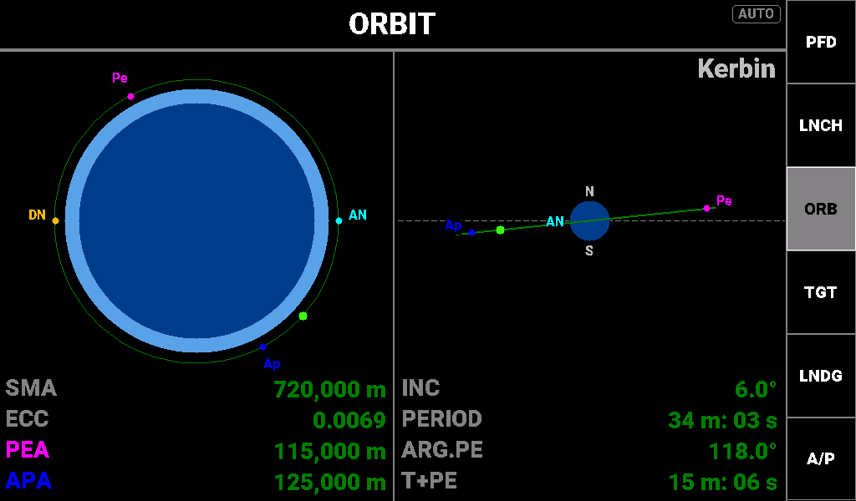
The same 115 × 125 km orbit, shortly after apoapsis.
Purpose. A picture of the current orbit drawn two ways: face-on (shape, apsides, atmosphere) and edge-on (inclination), with eight readouts beneath. This is where the mission panel rests when nothing more urgent is happening.
Layout.
- Body name (top right). The body you are orbiting.
- Plan view (left). The orbit seen face-on, ascending node to the right, travel counter-clockwise. The ellipse is always drawn the same size, so its shape shows eccentricity but its size does not show the orbit's size; read SMA for that.
  - The body is drawn to scale against the orbit, with its atmosphere as a lighter ring (Eve, Kerbin, Duna, Jool and Laythe).
  - Orbit line colour: green with both apsides above the orbit-safe altitude (the atmosphere top, or the highest terrain on an airless body); yellow with either apsis below it; orange on an escape trajectory.
  - Pe (magenta) and Ap (blue) dots with labels. Pe is hidden when periapsis is at or below sea level; Ap is hidden on escape.
  - AN (cyan) and DN (yellow) node dots, drawn when inclination is above 0.5°.
  - The vessel is a bright-green dot on the line.
  - On escape the view shows the hyperbola in orange; more than two body radii up it switches to a view of the whole sphere of influence (dashed grey circle).
- Inclination view (right). The orbit seen edge-on along the line of nodes: a dashed equator through the body, N above and S below, and the orbit line tilted by the inclination in the same colour as the plan view. The vessel dot slides along it and crosses the body at the nodes; Pe and Ap dots show how far north or south of the equator each apsis lies.
- Readout strip (bottom): four rows under each view.
Reading the screen. The line colour is the quick check: green is a stable orbit, yellow means part of the orbit dips into the atmosphere (it will decay or aerobrake) or, on an airless body, below the highest terrain (it may hit the ground), orange means you are leaving the sphere of influence. Use the plan view to see where Pe and Ap lie relative to the vessel, and the fourth right-hand row for how long until the next one. A near-flat line in the inclination view means an equatorial orbit; to change plane, burn as the vessel dot crosses the body. The diagram redraws in small steps, so during a burn its shape moves in jumps while the numbers change smoothly.
Special states. PEA shows --- with periapsis at or below sea level on a closed orbit; APA and PERIOD show ∞ on escape. The PEA and APA labels are drawn in the marker colours (magenta, blue) so each label names its dot.
Readouts (left half, under the plan view).
Label | Description | Colour coding / thresholds
SMA | Semi-major axis; negative on escape | Green always
ECC | Eccentricity, four decimals; 1 or more on escape | Green always
PEA | Periapsis altitude | Green; label magenta; --- at or below sea level
APA | Apoapsis altitude | Green; label blue; ∞ on escape

Readouts (right half, under the inclination view).
Label | Description | Colour coding / thresholds
INC | Inclination | Green always
PERIOD | Orbital period | Green; ∞ on escape
ARG.PE | Argument of periapsis | Green always
T+PE / T+AP | Time to the next apsis; the label follows whichever comes next | Green; --- when not available

Buttons. None.

ORBIT ADVANCED (caption ORB+)
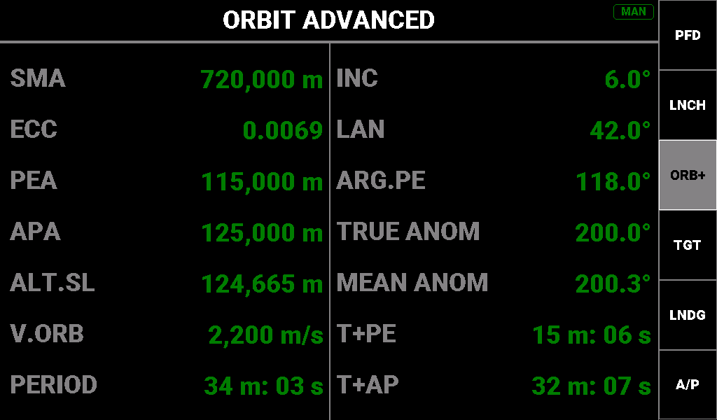
The same orbit as the ORBIT picture.
Purpose. All fourteen orbital elements as text, for detailed planning: shape and size on the left, orientation and position on the right. SMA, ECC, PEA, APA and PERIOD use the same names and formats as ORBIT, so the two screens compare directly.
Reaching it. Press ORB on ORBIT. The panel never chooses it, so it shows MAN.
Reading the screen. True and mean anomaly give the vessel's position on the orbit; LAN with ARG.PE fixes the orbit's orientation in space.
Readouts (left column).
Label | Description | Colour coding / thresholds
SMA | Semi-major axis | Green always
ECC | Eccentricity | Green always
PEA | Periapsis altitude | Green; --- below sea level
APA | Apoapsis altitude | Green; ∞ on escape
ALT.SL | Current altitude above sea level | Green always
V.ORB | Orbital speed | Green always
PERIOD | Orbital period | Green; ∞ on escape

Readouts (right column).
Label | Description | Colour coding / thresholds
INC | Inclination | Green always
LAN | Longitude of the ascending node | Green always
ARG.PE | Argument of periapsis | Green always
TRUE ANOM | True anomaly | Green always
MEAN ANOM | Mean anomaly | Green always
T+PE | Time to periapsis | Green; --- when not available
T+AP | Time to apoapsis | Green; ∞ on escape; --- when not available

Buttons. None.

MANEUVER (caption MNVR)
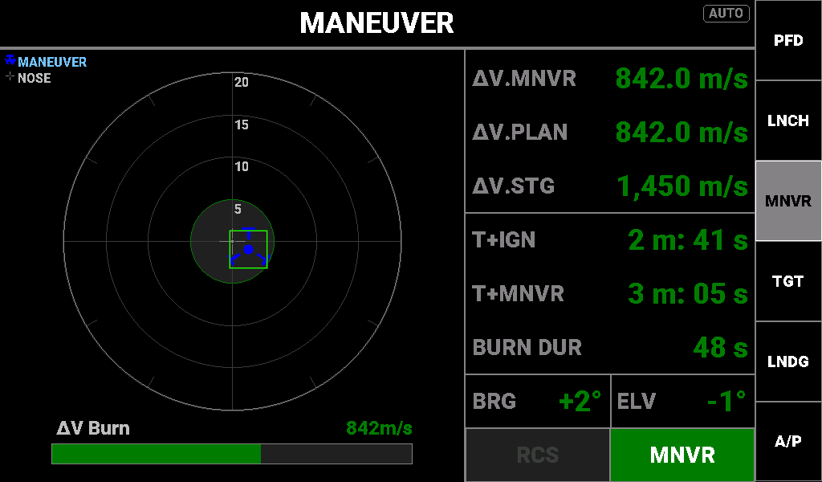
An 842 m/s node 3 minutes out, nose within 2° of the burn vector, SAS holding the node.
Purpose. Lines you up for and times the next manoeuvre node: a reticle shows the burn vector against your nose, and the right-hand panel gives the node's Δv, the stage's Δv, the ignition countdown, burn duration and pointing error.
Reaching it. Press ORB twice from ORBIT. Info Display 2 selects it when a node's ignition is less than 10 minutes away, including during the burn, and holds it until ignition moves more than about 12 minutes out or the node is removed.
Layout.
- Reticle. Rings at 5°, 10°, 15° and 20° from the nose; the 5° zone is the shaded disc with a green ring. The grey cross at the centre is your nose.
- Manoeuvre marker. The blue KSP node symbol, placed by where the burn vector is relative to your nose in the vessel's own frame, so pitch and yaw move it as expected at any roll. Its distance from the centre is the angle off the nose. Beyond about 17° it pins to the rim in dim navy: the direction is still right, but read BRG and ELV for the true error.
- Alignment box. A bright-green square around the marker when the total error is under 5°.
- ΔV Burn bar. The node's remaining Δv as a share of the stage's Δv, full when the node needs more than the stage has. Green, or yellow when the stage has less than 1.1 × the node's Δv.
Reading the screen.
- Select MNVR on SAS (the SAS button turns green), or steer until the marker sits on the cross. The green box confirms you are within 5°.
- Watch T+IGN: yellow at 60 s, white on red at 10 s, which means light the engine now.
- During the burn the bar and ΔV.MNVR count down.
- A yellow ΔV.STG means the stage has less than 10 % margin over the burn; expect to stage partway through.
Special states. With no node, the screen shows NO MANEUVER in white on red and rebuilds as soon as a node appears. T+IGN and T+MNVR dash while the node has no Δv; BURN DUR dashes with no burn duration. BRG and ELV are coloured axis by axis while the box uses the combined angle, so at 4° and 4° both read green but the box is absent.
Readouts (right column).
Label | Description | Colour coding / thresholds
ΔV.MNVR | Δv remaining on the next node | Green always
ΔV.PLAN | Total Δv of all planned nodes | Green always
ΔV.STG | Δv in the current stage | Green; yellow when below 1.1 × ΔV.MNVR
T+IGN | Time to ignition: node time minus half the burn duration | Green from 60 s; yellow under 60 s; white on red under 10 s, including once passed
T+MNVR | Time to the node itself | Green; yellow under half the burn duration (the burn should be running); white on red once passed
BURN DUR | Estimated burn duration | Green always
BRG | Burn vector right (+) or left (−) of the nose | Green under 5°; yellow 5°–9°; white on red from 10°
ELV | Burn vector above (+) or below (−) the nose | As BRG

Buttons. Indicators only.
- RCS: white on green when on, dark grey when off.
- SAS: MNVR white on green (the right mode for a burn); STAB black on sky blue (acceptable, holding attitude); any other mode white on red (wrong for a burn); SAS dark grey when off.

Target screens (key 4, TGT)
A first press of TGT opens DOCKING when a target is within 200 m, otherwise TARGET; pressing it again cycles TARGET → DOCKING → NAVIGATION. TARGET and DOCKING share one scope design, at two magnifications.
How the scope works (TARGET and DOCKING). The grey cross at the centre is your nose. Markers are drawn in the vessel's own frame, so screen-up is always the craft's roof and screen-right its right side, the same axes as the RCS translation keys; rolling the craft swings the markers round the cross, and the rings stay put. A marker's distance from the centre is its true angle off the nose. Past the scope's pin limit a marker stops at the rim and dims to half brightness: its direction is still right, but read the angle readouts for the true value. When the target or your velocity is behind you, the anti-target or retrograde symbol replaces it. A legend at the top left names the markers.

TARGET (caption TGT)
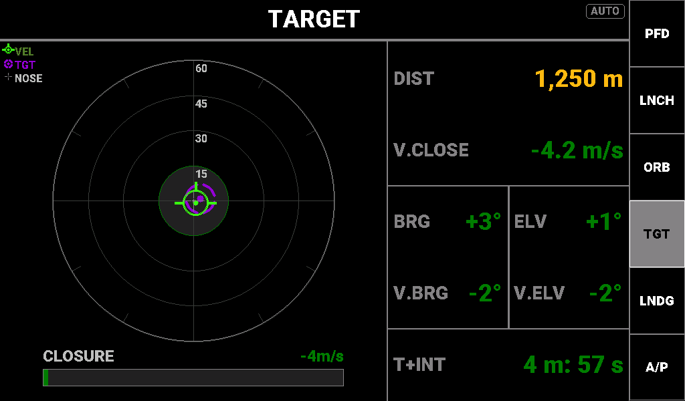
Closing on a target 1,250 m away at 4.2 m/s, nose 3° off and the approach 2° off.
Purpose. The rendezvous scope for the middle distance: where the target is relative to your nose, where your velocity relative to the target is heading, and the range, closure rate and time to intercept. Use it to aim the approach and set the closing speed before DOCKING takes over inside 200 m.
Reaching it. Key 4 as above. Info Display 2 selects it with a target between 200 m and 2,000 m (once shown it holds from 150 m to 2,400 m), when landed or splashed with a target set, and on EVA. Info Display 1 never selects it.
Layout.
- Scope. ±60° full scale. Rings at 15° (green ring around a shaded disc, the good zone), 30°, 45° and 60° (the rim), labelled up the vertical axis. Markers pin beyond about 51°.
- TGT marker (violet, KSP target symbol): the direction to the target.
- VEL marker (green, prograde symbol): the direction of your velocity relative to the target. It moves the way you thrust.
- CLOSURE bar (under the scope): closure speed, full at 250 m/s, with the signed value at the right of its label. Green while closing, yellow when opening or zero, red when closing faster than 500 m/s inside 5,000 m.
Reading the screen.
- Point the nose at the TGT marker; BRG and ELV read 0°.
- Translate until VEL sits on TGT; V.BRG and V.ELV read 0°. They turn yellow at the 15° ring and white on red at the 30° ring.
- Keep V.CLOSE negative and moderate; T+INT shows how long you have.
- When DIST turns white on green (under 200 m), change to DOCKING. In AUTO the panel does this itself.
Special states. With no target set the screen shows NO TARGET SET in white on red, and the scope returns by itself when you set one. V.BRG and V.ELV show --- when the total approach error is over 90° (you are moving away from the target).
Readouts (right column).
Label | Description | Colour coding / thresholds
DIST | Range to the target | White on green under 200 m (time for DOCKING); yellow under 5,000 m; green otherwise
V.CLOSE | Closure rate; negative is closing | White on red faster than 500 m/s inside 5,000 m; yellow when zero or opening; green when closing
BRG | Target bearing from the nose, right positive | Green always
ELV | Target elevation from the nose, up positive | Green always
V.BRG | Approach-path error left/right: how far right of the target your velocity points | Green under 15°; yellow from 15°; white on red from 30°; --- past 90° total
V.ELV | Approach-path error up/down | As V.BRG
T+INT | Time to intercept, DIST ÷ closure speed | Green; --- unless closing faster than 0.5 m/s

Buttons. None.

DOCKING (caption DOCK)
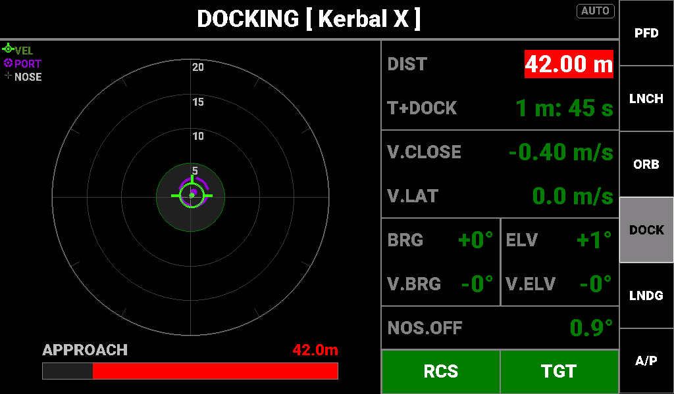
42 m from the port, closing at 0.4 m/s, nose within 1° of the port, RCS on and SAS on TARGET.
Purpose. The final-approach reticle for the last 200 m: the TARGET scope at three times the magnification, with the drift, alignment and time-to-contact figures you fly the docking on. The title bar carries the vessel name, for example DOCKING [ Kerbal X ].
Reaching it. Key 4: the first press opens it inside 200 m. Info Display 2 selects it with a target 200 m or closer (it holds to 250 m once shown).
Layout.
- Reticle. ±20° full scale. Rings at 5° (green, shaded good zone), 10°, 15° and 20°. Markers pin beyond about 17°; NOS.OFF gives the true angle.
- PORT marker (violet): the direction to the target port.
- VEL marker (green): your velocity relative to the port. It moves the way you thrust: if it sits up and right of the cross, translate left and down to centre it. On the cross there is no drift across your nose; on PORT you are flying straight down the approach line.
- APPROACH bar (under the reticle): fills from the right as you close, empty at 250 m and full at contact, with the distance at the right of its label. Green, yellow under 200 m, red under 50 m.
Reading the screen.
- Put PORT on the cross; NOS.OFF turns green under 5°.
- Walk VEL onto PORT with RCS translation; V.BRG and V.ELV turn green under 5°.
- Keep V.LAT green (under 0.1 m/s).
- Hold V.CLOSE negative: it turns white on red if you close faster than 2 m/s inside 100 m.
- T+DOCK turns yellow at 30 s and white on red at 10 s: contact is imminent.
Special states.
- DOCKED fills the screen in white on green when KSP reports a docking. It stays until you undock or switch vessel; the focus change KSP makes just after docking does not clear it.
- NO TARGET SET fills the screen in white on red while no target is set.
- V.BRG and V.ELV show --- past 90° of total error. A small negative angle can show as -0°.
Readouts (right column).
Label | Description | Colour coding / thresholds
DIST | Range to the target port | White on red under 50 m; yellow under 200 m; green otherwise
T+DOCK | Time to contact, DIST ÷ closure speed | White on red under 10 s; yellow under 30 s; green otherwise; --- unless closing
V.CLOSE | Closure rate, always signed, two decimals; negative is closing | White on red faster than 2 m/s inside 100 m; yellow when zero or opening; green when closing
V.LAT | Lateral drift: speed across the line to the port, one decimal | Green under 0.1 m/s; yellow from 0.1; white on red from 0.5
BRG | Port bearing from the nose, right positive | Green always
ELV | Port elevation from the nose, up positive | Green always
V.BRG | Approach-path error left/right | Green under 5°; yellow from 5°; white on red from 10°; --- past 90° total
V.ELV | Approach-path error up/down | As V.BRG
NOS.OFF | Total angle between your nose and the port, one decimal | Green under 5°; yellow from 5°; white on red from 10°

Buttons. Indicators only.
- RCS: white on green when on, dark grey when off.
- SAS: TGT white on green (the right mode for docking); STAB black on cyan; any other mode white on red; SAS white on red when SAS is off.

NAVIGATION (caption NAV)
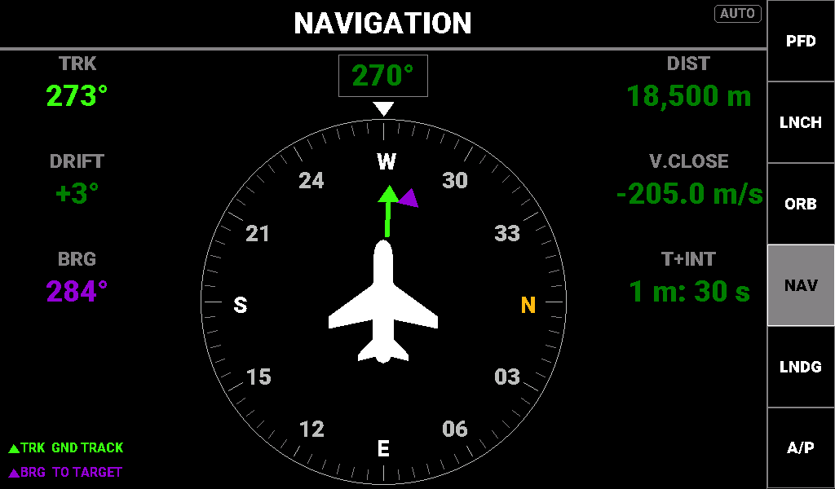
Heading 270°, tracking 273° with 3° of drift, a target 18.5 km away at bearing 284°.
Purpose. A heading-up plan view for flight in an atmosphere, the partner to the AIRCRAFT display on the other panel: where the nose points, where the aircraft is actually going over the ground, the angle between the two (drift, or crab), and the bearing, range and time to a target. DRIFT appears on no other screen.
Reaching it. Key 4: one or two further presses past TARGET (a first press never lands here). Info Display 2 selects it for a vessel typed Plane that is flying in an atmosphere with apoapsis below its top; a spaceplane whose apoapsis has left the atmosphere gets ORBIT instead.
Layout.
- Compass card. Rotates so your heading is always at 12 o'clock, under a fixed white nose triangle; the heading box above it shows the heading. N is yellow; ticks every 5°. The white aircraft at the centre is you.
- Ground-track marker and line (bright green): the direction you are moving over the ground. The wedge between the line and 12 o'clock is the drift angle. Hidden below 5 m/s.
- Target marker (violet): the bearing to the target. Drawn on top where the two markers meet.
- Left column: TRK, DRIFT and BRG. Right column: DIST, V.CLOSE and T+INT.
- Legend (bottom left): TRK GND TRACK in green, BRG TO TARGET in violet.
Reading the screen. If the green line leans right of 12 o'clock you are drifting right; DRIFT gives the angle and turns yellow at 10°. To fly to the target, turn until the violet marker sits under the nose; to arrive with the wind allowed for, put the violet marker on the green one instead. NAV works without a target; only the target figures dash out.
Special states. Below 5 m/s surface speed the track marker goes and TRK and DRIFT show ---. With no target, the violet marker goes and BRG, DIST, V.CLOSE and T+INT show ---. T+INT also dashes unless you are closing faster than 0.5 m/s.
Readouts (right column).
Label | Description | Colour coding / thresholds
DIST | Range to the target | Green; --- with no target
V.CLOSE | Closing speed; negative is closing | Green; --- with no target
T+INT | Time to intercept, DIST ÷ closing speed | Green; --- with no target or when not closing faster than 0.5 m/s

Other readouts (left column).
Label | Description | Colour coding / thresholds
TRK | Ground track: the direction of surface velocity | Bright green; --- below 5 m/s
DRIFT | Track minus heading, signed whole degrees | Green under 10°; yellow from 10° either way; --- below 5 m/s
BRG | Absolute bearing to the target | Violet; --- with no target

Buttons. None.

Landing screens (key 5, LNDG)
A first press of LNDG always opens POWERED DESCENT; pressing it again toggles POWERED DESCENT ↔ RE-ENTRY.

POWERED DESCENT (caption DESC)
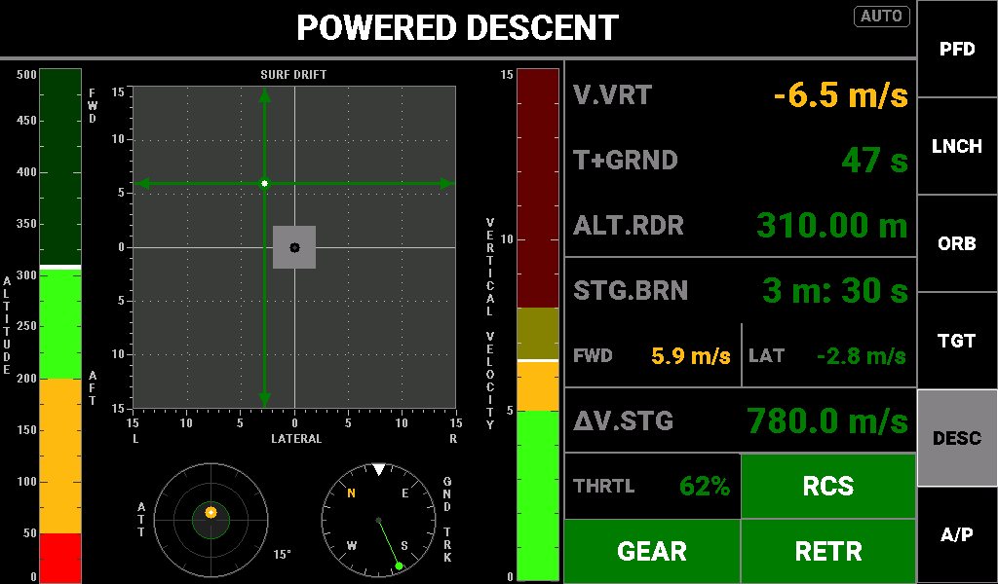
310 m over the Mun, descending at 6.5 m/s and drifting forward at 5.9 m/s, gear down.
Purpose. The landing screen for a powered touchdown on any body: radar altitude, descent rate, drift over the ground and how upright the lander is, each against limits that tighten as touchdown approaches, with time to ground, fuel and the gear, RCS and SAS states.
Reaching it. Key 5. Info Display 2 selects it when descending faster than 5 m/s below 10 km radar altitude (it holds to 12 km), unless the vessel is a plane in an atmosphere.
Layout.
- ALTITUDE tape (far left): radar altitude 0–500 m, filled up to a white marker, green above 200 m, yellow 50–200 m, red below 50 m. Above 500 m it reads full. Below 50 m it rescales to 0–50 m (back above 55 m) with a red marker.
- SURF DRIFT cross-pointer (centre): horizontal speed over the ground, ±15 m/s per axis. The vertical needle is left/right drift, the horizontal needle fore/aft (up is forward); where they cross is your drift, and the black centre dot is zero. The lighter square marks ±2 m/s; dotted lines mark ±5 and ±10 m/s. Needle colour follows the combined drift against the same limits as FWD and LAT.
- ATT bullseye (below left): tilt from vertical, the dot's direction following roll. Rim 15°, rings at 5° and 10°. Green under 2°, yellow 2°–5°, red from 5°. Centre the dot to stand the lander upright.
- GND TRK compass (below right): heading-up rose with the nose at the top; the green arrow shows which way you are moving over the ground. Hidden at 1 m/s or less.
- VERTICAL VELOCITY tape: descent rate 0–15 m/s, green to 5, yellow 5–8, red 8–15. Empty while climbing.
Reading the screen.
- For touchdown keep the vertical-velocity fill and V.VRT green (slower than 5 m/s).
- Fly the needle crossing onto the centre dot. As T+GRND falls the FWD and LAT limits tighten, down to yellow at 1 m/s and red at 2 m/s in the last 10 s.
- Keep the ATT dot inside the green ring.
- Have GEAR green before T+GRND turns yellow.
- Watch STG.BRN and ΔV.STG for fuel.
Special states. T+GRND shows --- in orbit, on an escape path, without radar altitude, or when not descending. FWD and LAT are capped at ±99.9 m/s.
Readouts (right column).
Label | Description | Colour coding / thresholds
V.VRT | Vertical speed; negative is descending | Green; yellow faster than 5 m/s down; white on red faster than 8 m/s down
T+GRND | Estimated time to ground | Green; yellow under 30 s; white on red under 10 s. Colours relax only 3 s clear of a limit (yellow again at 13 s, green at 33 s); --- when not applicable
ALT.RDR | Radar altitude | Green; yellow under 200 m; white on red under 50 m
STG.BRN | Burn time left in the current stage | Green; yellow under 120 s; white on red under 60 s, including 0 s
FWD | Forward (+) / aft (−) drift | Set by T+GRND. Over 60 s or ---: yellow from 20 m/s, no red. 30–60 s: yellow from 5, white on red from 15. 10–30 s: yellow from 2, white on red from 8. 10 s or less: yellow from 1, white on red from 2
LAT | Right (+) / left (−) drift | As FWD
ΔV.STG | Δv left in the current stage | Green; yellow under 300 m/s; white on red under 150 m/s
THRTL | Throttle | Green always

Buttons. Indicators only.
- RCS: white on green when on, dark grey when off.
- GEAR: white on green when down, dark grey when up.
- SAS: STAB or RETR white on green; SAS white on red when off; any other mode shows SAS in dark grey.

RE-ENTRY (caption ENTR)
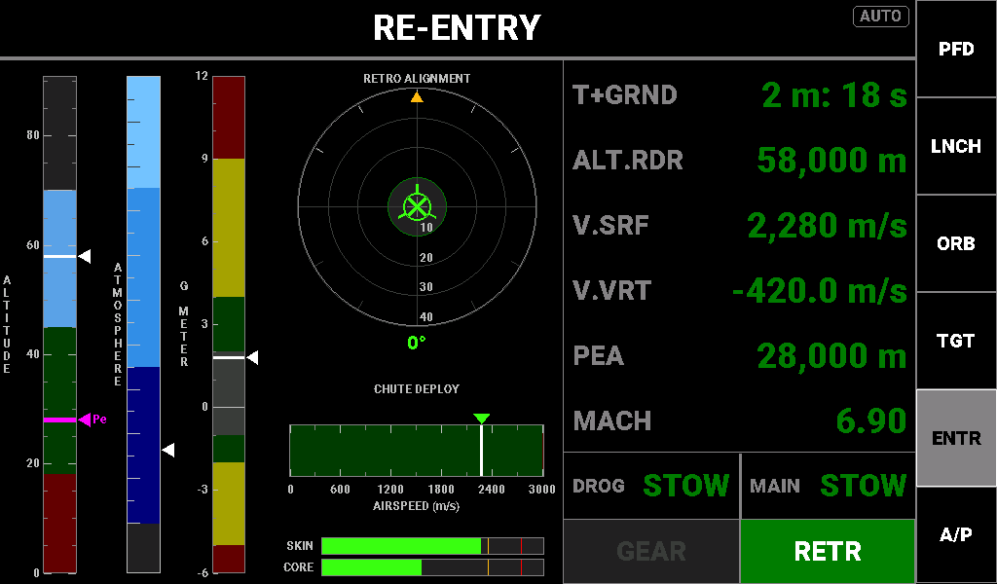
A capsule at 58 km on Kerbin, periapsis 28 km in the corridor, nose retrograde.
Purpose. The atmospheric entry screen: whether periapsis is in the entry corridor, how deep in the atmosphere you are, the G load, whether the heat shield faces the airflow, when each parachute is safe to deploy, and part temperatures.
Reaching it. Key 5, a second press. Info Display 2 selects it on a body with an atmosphere when you are descending with periapsis below the top of the safe corridor and are above the atmosphere or faster than Mach 3. Only an engaged autopilot and PRE-LAUNCH outrank it.
Layout.
- ALTITUDE (corridor) tape (far left): altitude above sea level, 0 to 1.3 × the atmosphere top, in km. White marker: you. Magenta marker and Pe: periapsis. The bands rise for fast entries:
  - Red, too steep: below 18 km at Kerbin.
  - Green, the safe corridor: up to 45 km at Kerbin.
  - Cyan, aerobraking only: up to the atmosphere top (light-grey line).
  - Near-black: above the atmosphere, no re-entry.
- ATMOSPHERE bar: air density relative to sea level, scaled so that thin upper air still registers. The marker parks in the bottom slot in vacuum, and on bodies without sea-level density data (density is known for Kerbin, Eve, Duna, Jool and Laythe).
- G METER: −6 to +12 g. Green −2 to +4 g (grey nominal band −1 to +2 g), yellow to +9 g and −5 g, red beyond.
- RETRO ALIGNMENT ball: the marker shows where the airflow comes from (surface retrograde). Centred, the nose points retrograde and the heat shield faces the airflow. Green under 10°, yellow 10°–30°, red from 30°; AoA under the ball gives the angle. The yellow pointer at the top shows bank; the rings are labelled down the lower axis.
- CHUTE DEPLOY bar: your airspeed against each chute's safe speed, tagged MAIN (green) and DROG (yellow). Green zone: main safe; yellow: drogue only; red: neither. The zones slide left as the air thickens (about 250 and 500 m/s at Kerbin sea level); in thin air a safe speed beyond the end of the scale has no line or tag, and the zone colour alone says which chutes are safe. The triangle over your speed takes the same colours.
- SKIN / CORE bars: the hottest part's temperature as a share of its limit; yellow from 75 %, red from 90 %, ticked at both.
Reading the screen.
- Before entry, put the magenta Pe marker in the green band; PEA reads green. Red is too steep; cyan means you will only aerobrake.
- Hold the retrograde marker inside the green ring; SAS RETR shows green.
- Watch the G meter and SKIN/CORE for loads and heating.
- Deploy a chute only when its row reads STOW in green and the CHUTE DEPLOY triangle is green (main) or at least yellow (drogue).
- Low down, ALT.RDR and V.VRT pick up the landing limits.
Special states. Row 0 reads T+ATM while you are above the atmosphere with periapsis inside it, and T+GRND otherwise; row 1 reads ALT.SL above the atmosphere and ALT.RDR inside it. Chute states are remembered until a vessel switch, and CUT is final.
Readouts (right column).
Label | Description | Colour coding / thresholds
T+ATM | Time until you enter the atmosphere (row 0, above the atmosphere) | Green; --- with no estimate
T+GRND | Time to ground (row 0, inside the atmosphere) | Green; yellow under 30 s; white on red under 10 s, with the same 3 s relax margin as POWERED DESCENT; --- when not descending
ALT.SL | Altitude above sea level (row 1, above the atmosphere) | Green always
ALT.RDR | Radar altitude (row 1, inside the atmosphere) | Green; yellow under 500 m; white on red under 50 m
V.SRF | Surface speed | Green always
V.VRT | Vertical speed | Below 500 m radar altitude: yellow faster than 5 m/s down, white on red faster than 8 m/s down. Green otherwise
PEA | Periapsis altitude | By corridor band: white on red too steep; green in the corridor; cyan aerobraking; light grey above the atmosphere
MACH | Mach number | Yellow 0.85–1.20 (transonic); green otherwise
DROG | Drogue state: STOW, ARM, OPEN or CUT | STOW: green; yellow from 85 % of the drogue's dynamic-pressure limit; white on red at the limit. ARM (cyan): deployed, but the air is too thin to open it. OPEN: yellow while still partly open above 2,500 m; green below; white on red if opened over the limit. CUT: red
MAIN | Main chute state | As DROG, with the main chute's limit and full opening at 1,000 m

The chutes are read from custom action groups: 1 deploys the drogue, 2 cuts it, 3 deploys the main and 4 cuts it.
Buttons. Indicators only.
- GEAR: white on green when down, dark grey when up.
- SAS: STAB or RETR white on green; any other mode white on red with its name; SAS white on red when off above Mach 3, dark grey when off at lower speed.

Autopilot consoles (key 6 on Info Display 2, A/P)
The autopilots run on the master controller; these consoles set them up and show what they are doing. They exist on Info Display 2 only, so there is exactly one place that sends autopilot commands.

Common behaviour
The A/P key. Captioned A/P at rest, and with the console's short name (ASC, ORAP, LDAP, ACAP, RVAP) while one is on screen. It fills green while any autopilot is armed, engaged or executing.
- First press picks a console for the situation, checking in this order:
  - On the pad (pre-launch), any vessel: ASCENT.
  - A rover that is landed or splashed: ROVER.
  - A Plane in an atmosphere: AIRCRAFT.
  - Any other vessel that is landed or splashed: LANDING.
  - Descending inside an atmosphere: LANDING.
  - Descending faster than 5 m/s below 10 km radar altitude: LANDING.
  - Throttle above 2 %, climbing, periapsis below the surface: ASCENT.
  - Otherwise: ORBITAL.
- Repeat presses cycle only the consoles the vessel type can use:
  - Rockets and most craft: ASC → ORAP → LDAP.
  - Planes: ACAP → ORAP → LDAP.
  - Rovers on the ground: RVAP only; off the ground, RVAP → ORAP → LDAP.
  - Kerbals on EVA, flags and debris: no cycle.
- Automatic return. With the chip on AUTO, Info Display 2 goes back by itself to the console whose autopilot is flying the vessel (priority ORBITAL, LANDING, AIRCRAFT, ROVER, ASCENT). A console with nothing engaged never appears on its own.
Banner (the strip under the title):
- Left: the engaged modes in large green text (for example ALT HDG IAS), or A/P OFF in grey. The ascent console shows its phase here.
- Centre: a note in orange, either a disconnect or refusal reason (shown for about five seconds) or status text such as a burn phase, IGN IN m:ss, SLOPE LIMIT or STOPPING.
- Right: body · vessel in grey, then the overall state, ENGAGED, ARMED or EXECUTING in bright green, or A/P OFF in grey. A trailing ... means a tap is still waiting for the master to confirm it. The banner never shows a state the autopilot has not reached.
Mode buttons have three states, shown in the legend on every console:
State | Appearance | Meaning
OFF | Black, thin grey outline | Mode off. A tap engages it.
PENDING | Black, cyan outline and text | Your tap is sent but not yet confirmed. A second tap reverses it. Drops back after 3 s if the master refuses.
ENGAGED | Green fill | Mode engaged. A tap disengages it.

Engaging a mode captures the current value as its setpoint, so engagement is bumpless. Modes in the same group exclude each other.
Setpoint boxes and keypad. Tap a boxed value to open the on-screen keypad; the header gives the field and its range. ENT (green) sends the value, clamped to the range; the red X cancels; OFF (where offered) disables the function; +/- changes sign where the field allows it. A box is grey while its mode is off, green while engaged, and cyan while an edit waits for confirmation. You can edit a setpoint at any time; an engaged mode retargets to the new value, and setting a box never engages its mode. A rejected edit stays cyan until you enter a value the autopilot accepts.
A/P OFF (orbital, landing, aircraft and rover consoles) turns off every autopilot: it disarms the ascent autopilot, drops all aircraft and rover modes, aborts any burn or approach hold, and drops all landing modes.
Pilot input disconnects every autopilot. Moving the rotation or translation stick past 10 % for 150 ms, touching the throttle lever while an autopilot drives it, moving an undriven lever more than 2 %, or pressing a lever button disconnects everything. The banner shows STICK or A/T OFF: LEVER. Only one autopilot can steer and one drive the throttle at a time; engaging another takes over and the previous owner drops with OTHER AP.
Disconnect and refusal reasons (orange, banner centre): STICK, A/T OFF: LEVER, BRAKES, AIRBORNE, ROLL LIMIT, NO ATMO, TELEMETRY, ASCENT ARMED, REFUSED, NO NODE, NO TARGET, SOI CHANGE, FUEL, LANDED, OTHER AP, FLARE, ARRIVED, ALIGN, HANDOFF, REPLANNED. The meaning of each is given with its console below.

ASCENT AUTOPILOT (caption ASC)
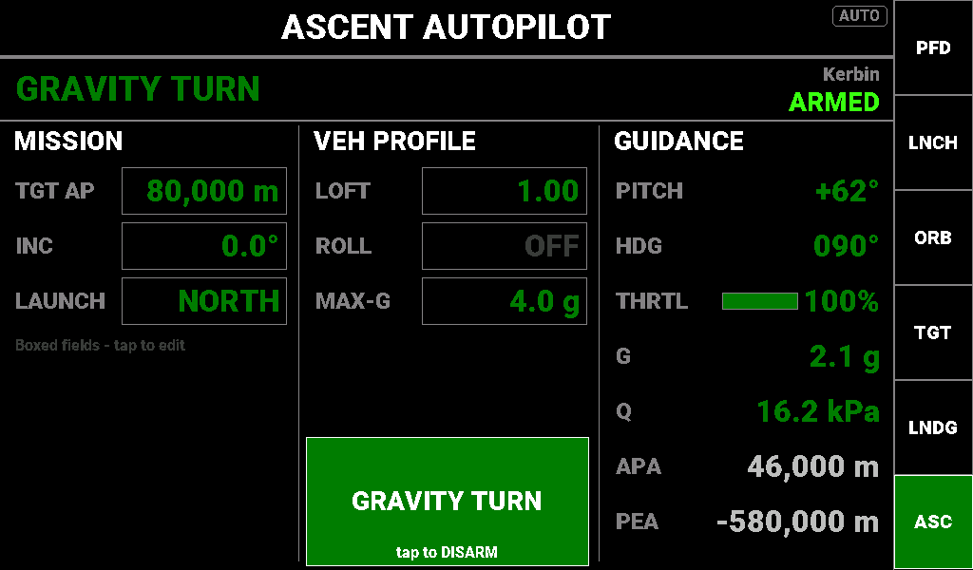
Armed for an 80 km equatorial orbit, flying the gravity turn.
Purpose. Sets up and arms the launch-to-orbit autopilot: target apoapsis, inclination, launch direction and vehicle profile. Once armed it flies the vertical rise, gravity turn, coast and circularisation burn, then hands control back. One ARM / DISARM button controls it; there are no mode buttons.
Layout.
- MISSION. TGT AP (target apoapsis, m); INC (target inclination, 0–180°); LAUNCH (NORTH or SOUTH, toggled by a tap).
- VEH PROFILE. LOFT (trajectory shape, 0.5–2.0: below 1 is aggressive, above 1 lofted); ROLL (roll hold, ±180°, or OFF); MAX-G (acceleration limit, 0–20 g, or OFF).
- ARM button. Disarmed: orange ARM. Armed: shows the current phase, filled in the phase colour, with "tap to DISARM". While a tap is pending its border turns cyan and the hint reads ARMING... or DISARMING....
- GUIDANCE. Read-only commanded and live values.
Operating it.
- Set TGT AP, INC and LAUNCH, then the profile. Each value is cyan until confirmed.
- Tap ARM. The banner shows ARMED, and the A/P key turns green.
- Launch. The banner and button step through VERTICAL, GRAVITY TURN, COAST, CIRCULARIZE and COMPLETE.
- To stop, tap the button (DISARM), or take the stick or throttle.
Special states. Phase colours: IDLE grey; VERTICAL and GRAVITY TURN green; COAST and CIRCULARIZE cyan; COMPLETE sky blue; ABORT white on red. After a pilot-input disconnect the console simply shows IDLE / DISARMED, with no reason line. The banner gives the body name only.
Readouts (GUIDANCE column).
Label | Description | Colour coding / thresholds
PITCH | Commanded pitch above the horizon | Green always
HDG | Commanded heading | Green always
THRTL | Commanded throttle, bar and percentage | Green always
G | Current load factor | Green; with MAX-G set, yellow from 90 % of MAX-G and red at MAX-G
Q | Dynamic pressure, Pa below 1,000, kPa above | Green always
APA | Current apoapsis | Light grey always
PEA | Current periapsis, negative while suborbital | Light grey always

ORBITAL AUTOPILOT (caption ORAP)
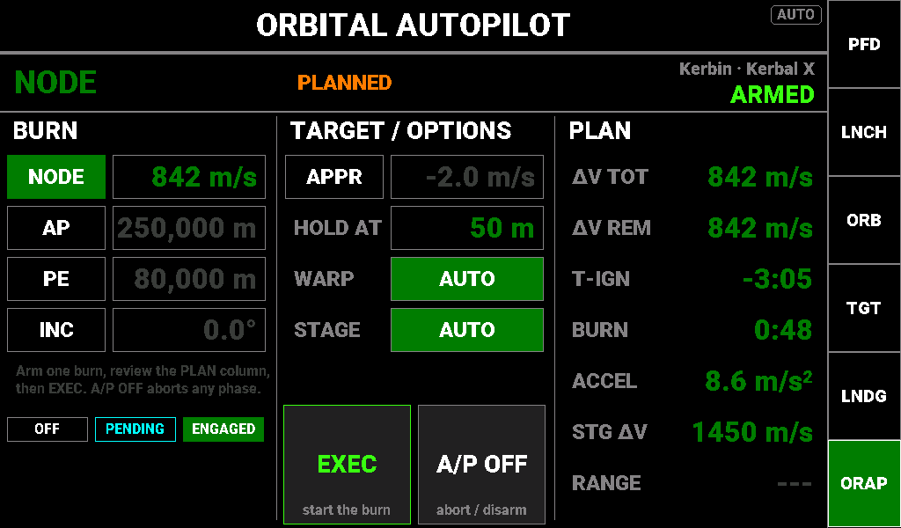
An 842 m/s node burn armed and planned, waiting for EXEC.
Purpose. Executes one of four burns (the next manoeuvre node, an apoapsis change, a periapsis change, or a plane change to a target inclination) and runs a rendezvous approach-rate hold. Burns take two steps: arming plans the burn and fills the PLAN column; EXEC starts it. It never time-warps unless you ask.
Layout.
- BURN. NODE (box shows the node's Δv, or NO NODE), AP and PE (target altitudes, m), INC (target inclination). Only one burn can be armed.
- TARGET / OPTIONS. APPR engages the approach hold at once (it is not a burn); its box is the closing-rate setpoint, −20 to +5 m/s, negative closing. HOLD AT is the stand-off distance, 5–5,000 m. WARP and STAGE toggle automatic time-warp and staging (AUTO green, OFF black).
- EXEC. Bright green and live once a burn is PLANNED. In WARP READY with WARP on AUTO it reads WARP: a tap warps to ignition. Grey otherwise.
- A/P OFF. Aborts and turns everything off.
Operating it.
- For a node burn, create the node in KSP; for AP, PE or INC, enter the target.
- Tap the burn's mode button. When it turns green the banner shows PLANNED and the PLAN column fills.
- Check ΔV TOT, T-IGN, BURN, and STG ΔV against ΔV TOT.
- Tap EXEC. The banner shows ALIGNING, then WARP READY (tap WARP, or wait), then BURNING; ΔV REM counts down in bright green and the banner ends on DONE.
- For an approach hold, set the closing rate and HOLD AT, then tap APPR.
Special states. Phase text in the banner centre: PLANNED, ALIGNING, WARP READY, WARPING, BURNING and ABORT in orange, DONE in sky blue. Reasons: NO NODE (no node, or it was removed); REFUSED (no valid plan, stale telemetry, or closing too fast for the range); FUEL (the burn needs more Δv than the stage has with auto-stage off, or the stage ran dry); NO TARGET; ALIGN (not pointed within 2° after 30 s); REPLANNED (the orbit changed after EXEC; tap EXEC again). The AP, PE and INC boxes cannot be edited while BURNING.
Readouts (PLAN column).
Label | Description | Colour coding / thresholds
ΔV TOT | Planned burn Δv | Green with a plan; --- otherwise
ΔV REM | Δv still to burn | Bright green while burning; green otherwise; --- with no plan
T-IGN | Time to ignition, counting toward zero, then up after ignition | Orange under 30 s and after ignition; green otherwise; --- with no plan
BURN | Burn duration | Green; --- with no plan
ACCEL | Acceleration estimate, m/s² | Green; --- with no estimate
STG ΔV | Δv in the current stage | Orange when a plan needs more than the stage has; green otherwise
RANGE | Distance to the target | Green with a target; --- without

LANDING AUTOPILOT (caption LDAP)
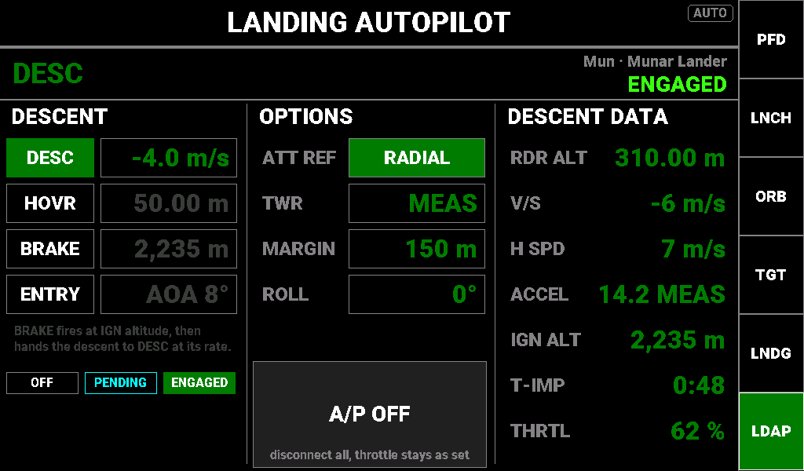
Holding −4 m/s on descent 310 m over the Mun, radial attitude reference.
Purpose. Four landing modes: DESC holds a vertical speed with the throttle, HOVR holds a radar altitude, BRAKE arms a suicide burn that fires at a computed ignition altitude and then hands over to DESC, and ENTRY holds a re-entry angle of attack and roll. DESC, HOVR and BRAKE exclude each other; ENTRY is separate.
Layout.
- DESCENT. DESC (rate, −50 to +20 m/s); HOVR (height above ground, 2–5,000 m); BRAKE (box shows the computed ignition altitude, not editable); ENTRY (angle of attack, −30 to +40°).
- OPTIONS. ATT REF toggles RETRO (surface retrograde, kills horizontal speed) and RADIAL (straight up, a vertical descent). TWR overrides the thrust-to-weight used for BRAKE (0–20, or OFF to use the measured or estimated value, shown MEAS or EST). MARGIN adds metres to the ignition altitude (0–5,000). ROLL is the ENTRY roll angle.
- A/P OFF. Disconnects everything; the throttle is left where it is.
Operating it.
- Set DESC to your touchdown rate (for example −4 m/s) and choose ATT REF.
- On a fast approach tap BRAKE: IGN ALT shows the ignition altitude and the banner counts down IGN IN m:ss. At ignition the banner shows FIRING; when vertical speed reaches the DESC rate, DESC takes over.
- Or tap DESC for a rate-controlled descent, or HOVR to hold the current height.
- On touchdown the throttle goes to zero, everything disconnects and the banner shows LANDED.
- For re-entry, set the ENTRY angle and ROLL and tap ENTRY. Rockets disconnect at 250 m/s; planes hand over to the aircraft autopilot (HANDOFF).
Special states. The BRAKE box and IGN ALT turn orange when the burn is marginal, needing more than 90 % of the available acceleration. Reasons: REFUSED (on the ground, stale telemetry, or less than 1.2 g available for BRAKE); LANDED; HANDOFF; FUEL (annunciated, the throttle is kept).
Readouts (DESCENT DATA column).
Label | Description | Colour coding / thresholds
RDR ALT | Radar altitude | Green always
V/S | Vertical speed | Orange when time to impact is under 30 s; green otherwise
H SPD | Horizontal speed | Green always
ACCEL | Acceleration estimate and its source (MEAS, EST or TWR) | Green; --- with no estimate
IGN ALT | Computed BRAKE ignition altitude | Orange when marginal; green; --- when unknown
T-IMP | Time to impact at the current descent rate | Orange under 30 s; green; --- when not descending
THRTL | The landing autopilot's commanded throttle | Green while DESC, HOVR or BRAKE is engaged; grey otherwise

AIRCRAFT AUTOPILOT (caption ACAP)
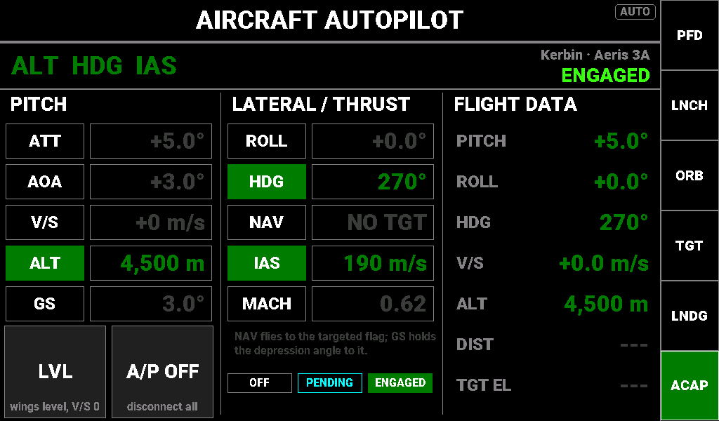
Cruise holds engaged: 4,500 m, heading 270°, 190 m/s.
Purpose. Hold modes for aircraft in three groups: pitch (ATT, AOA, V/S, ALT, GS), lateral (ROLL, HDG, NAV) and thrust (IAS, MACH, driving the motorised throttle lever). One mode per group can be engaged and the groups combine freely; ALT + HDG + IAS is normal cruise. NAV and GS fly an approach to a targeted flag.
Layout.
- PITCH. ATT (pitch attitude, ±45°); AOA (−10 to +25°); V/S (±100 m/s); ALT (0–70,000 m); GS (glide slope, the depression angle to the target, 1–10°).
- LVL engages ROLL 0° and V/S 0 in one tap. A/P OFF disconnects everything.
- LATERAL / THRUST. ROLL (±60°); HDG; NAV (box shows the bearing to the target, or NO TGT); IAS (20–1,500 m/s); MACH (0.10–6.00).
- Commanded throttle is not shown: with IAS or MACH engaged, the throttle lever itself is the readout.
Operating it.
- In level flight, tap ALT, HDG and IAS; each captures its current value.
- To change a target, tap its box and enter the new value.
- For an approach, target a flag and engage NAV and GS. GS drops at 200 m range (FLARE); the flare is yours.
- Tap LVL to recover, A/P OFF or any stick or lever input to hand back.
Special states. Reasons: REFUSED (no atmosphere, stale telemetry, or IAS/MACH with the throttle module in precision mode); NO TARGET (NAV or GS without a target); NO ATMO (out of the atmosphere for more than 2 s); FLARE. LEVER OFF in grey means the autothrottle is engaged but the throttle module is not following it. An attitude mode turns stock SAS off; a full disconnect returns SAS to stability assist.
Readouts (FLIGHT DATA column).
Label | Description | Colour coding / thresholds
PITCH | Live pitch | Green always
ROLL | Live bank | Green always
HDG | Live heading | Green always
V/S | Live vertical speed | Green always
ALT | Altitude above sea level | Green always
DIST | Distance to the target | Green with a target; --- without
TGT EL | Elevation angle to the target, negative below you | Green with a target; --- without

ROVER AUTOPILOT (caption RVAP)
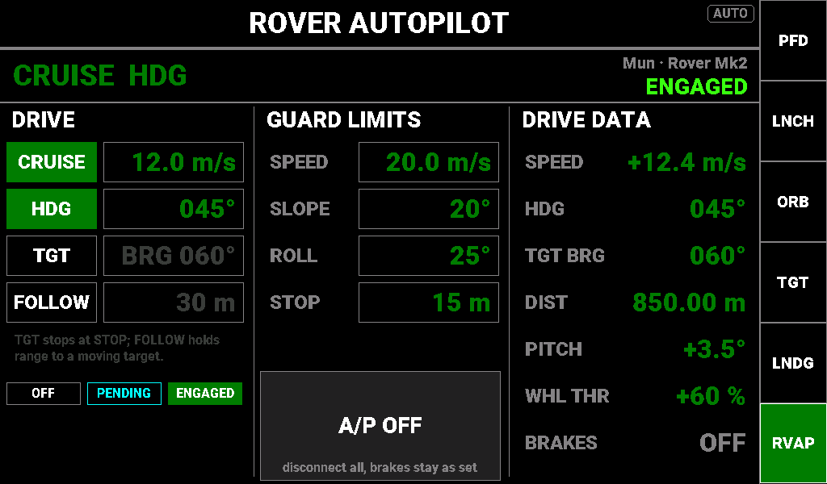
Cruise at 12 m/s on heading 045° on the Mun.
Purpose. Drive modes: CRUISE holds a signed ground speed (negative is reverse), HDG steers to a heading, TGT drives to the target and stops short of it, and FOLLOW holds a range to a moving target. Guard limits cap speed on slopes and stop the rover if it rolls too far.
Layout.
- DRIVE. CRUISE (−10 to +60 m/s); HDG; TGT (box shows the target bearing, or NO TGT); FOLLOW (range, 5–500 m). HDG, TGT and FOLLOW all steer, so only one can be engaged.
- GUARD LIMITS. SPEED (cruise cap, 1–60 m/s); SLOPE (5–45°: cruise speed is scaled down on steeper grades); ROLL (5–60°: beyond it the rover stops and brakes); STOP (TGT stop distance, 2–200 m).
- A/P OFF. Disconnects everything; the brakes are left as they are.
Operating it.
- Check the guard limits.
- Tap CRUISE (it captures your speed) and edit its box for a new speed; tap HDG to hold your heading.
- To drive to a target, set one, engage TGT with CRUISE, and set STOP. Inside 200 m the banner shows STOPPING; at the STOP distance the rover brakes and the banner shows ARRIVED.
- Engage FOLLOW to shadow a moving vessel at its range.
- Stop with A/P OFF, the brakes (which drop CRUISE with BRAKES), or any stick or lever input.
Special states. SLOPE LIMIT while the slope guard is reducing speed. Reasons: ROLL LIMIT (roll passed the limit; cruise drops and the brakes stay on until you release them); AIRBORNE (not touching the ground for more than half a second); REFUSED (engaged off the ground or with stale telemetry, or the target was lost).
Readouts (DRIVE DATA column).
Label | Description | Colour coding / thresholds
SPEED | Signed ground speed; negative when moving backward | Orange while the slope guard acts or while STOPPING; green otherwise
HDG | Live heading | Green always
TGT BRG | Bearing to the target | Green with a target; --- without
DIST | Distance to the target | Orange while STOPPING; green with a target; --- without
PITCH | Live pitch, the slope | Orange while the slope guard acts; green otherwise
WHL THR | Commanded wheel throttle | Green while CRUISE or FOLLOW is engaged; grey otherwise
BRAKES | Brakes on or off | ON yellow; OFF grey

