Exercice 3 :

readStream() have to be done, not existed.

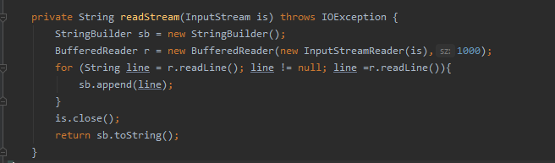

Exercice 4 :

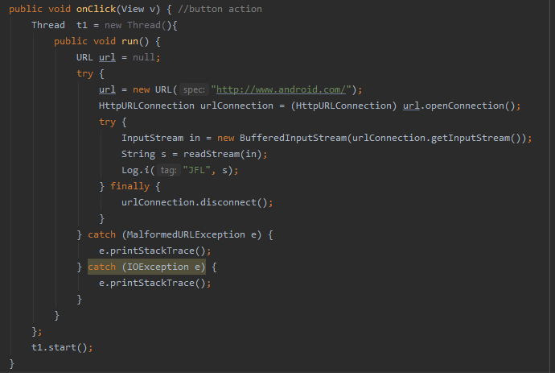

EXERCICE 12 :

Remove jsonFlickrFeed

EXERCICE 13 :

Exercice 18 :

