Overview of Functions shopCloud360 (Intershop)
& additional required features
Legend:
Green = especially important
Yellow = nice to have
Grey = not required

shopCloud360 (Intershop) Functions
Implementation timeframe: 3–5 months
(includes all functions listed below)
- Cloud-native SaaS
- AI Copilot
- Product consultation
- Add products to the shopping cart directly within the chat
- Image-based product recognition
- Intelligent on-site search (powered by SPARQUE)
- Price, stock availability, and direct add-to-cart option within search
- Linking information from the ERP system (e.g. order history, product databases, and external sources)
- Custom design
- Mobile-optimized responsive design
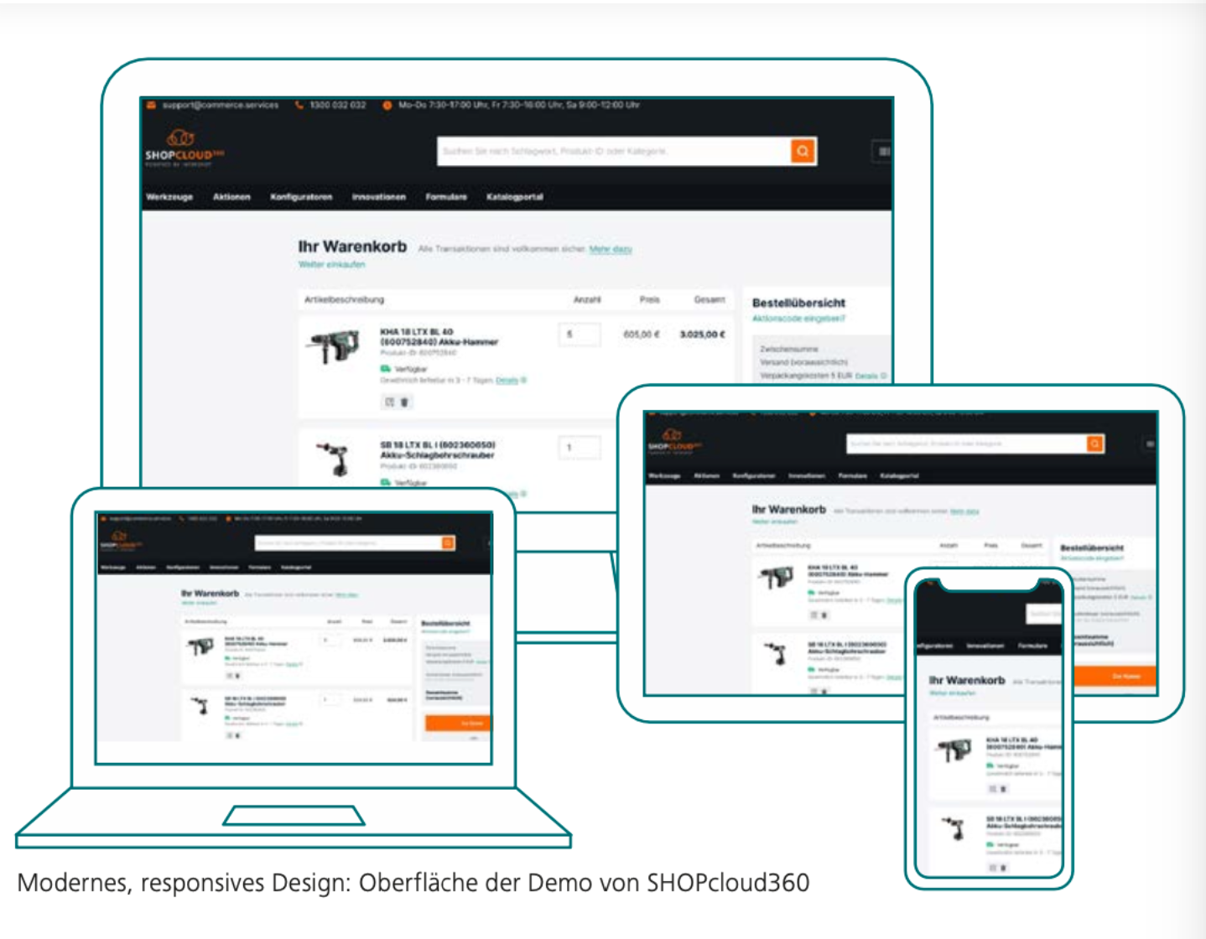

Content & Product Data
- Content hub (platform for brand content and landing pages)
- Seamless integration of supplier content
- Linking static content with dynamic references to our product data
- Content subscription: content can be easily subscribed to and customized as needed; automatic synchronization reduces maintenance effort
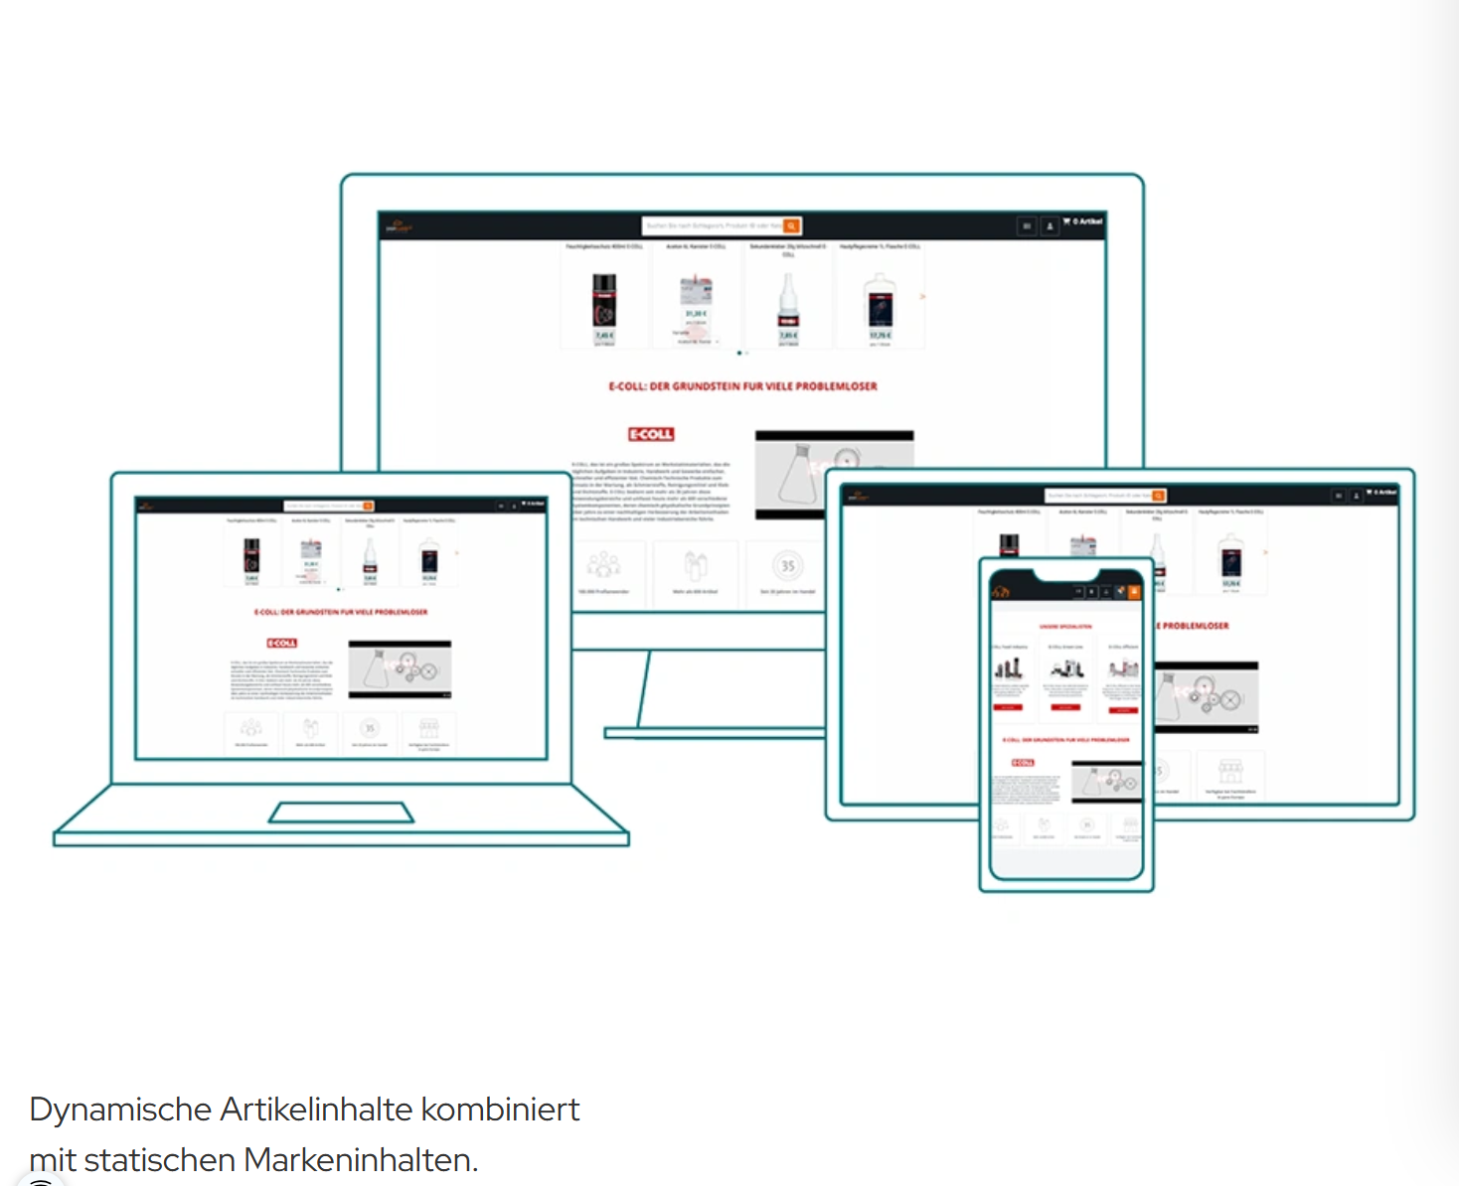
Product range hub:
- Central data source for product data
- All EDE product ranges are centrally available
(Note: This option already exists in the current shop; however, there is still maintenance effort as we need to transfer the data into our individual structure and potentially enrich it)
- Smooth integration with PIM systems, including nextPIM

Integration & Interfaces
Integration Hub:
Middleware between shopCloud360 and external systems such as ERP, PIM, and warehouse management systems
- Synchronization of: stock levels, prices (customer-specific), orders, documents, and quotations
- Low implementation effort due to low-code integration
- Preconfigured standard connectors, e.g. for Enventa
- Real-time retrieval of external warehouse stock, e.g. elc logistics center
- Automated order transfer to ERP
Additional integrations:
- Integrated barcode scanning solution “Scandit”
- Up to 480 scans per minute
- Multidimensional variant display with filter options
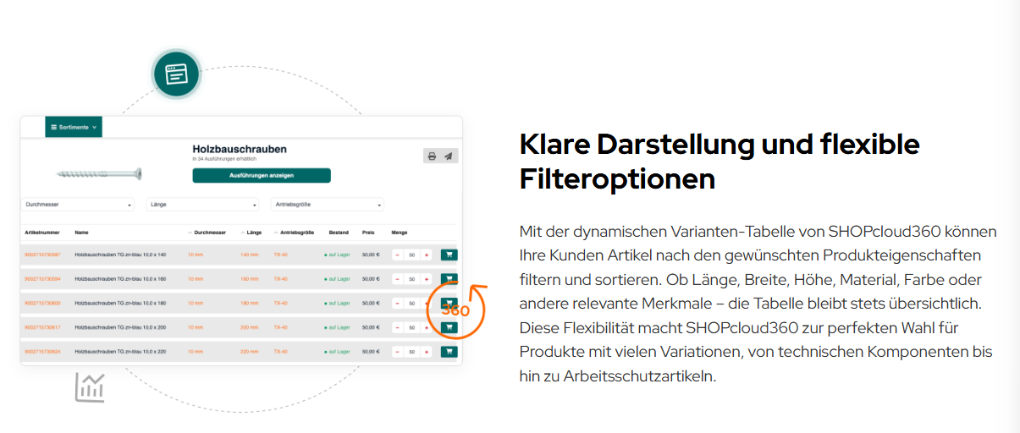
Interfaces:
- OCI
- SAP Ariba Network
- Coupa
- OSD
- PinnCalc
- IDS-Connect

Channels & eProcurement
- Modular channels and sub-shops
- Central control of which content is displayed in which channel
(suitable for own brand worlds or marketing campaigns)
eProcurement:
- C-parts management and supply of key accounts
- Booking of all order items to cost centers
- Individual assignment of single items to different cost centers
- Budget management at user or cost center level
- Approval option: orders can optionally require review and approval by supervisors
- User management: detailed role distribution for admins, viewers, approvers, etc.
- Reports and analytics: exportable reports for spend control

Additional Required Functions

Returns & Claims Management
- Return registration by customers via self-service in the customer account
(ideally with assignment of a continuous return number from the ERP; returns should be transferred to the ERP)
- Photo upload
- Status display for returns (received, under review, approved, credit note sent)
- Repair request selectable
- Individually configurable return policies per customer

Serial Number Management & Machine History
- Linking with warranty and maintenance data
- Maintenance processes are currently manual; these workflows would need to be digitized in parallel

Data Refinement & Quality
Simplified and automated data enrichment:
- Incoming product data must be transformable based on rules
- Attributes should be automatically renameable, mergeable, and splittable
- Units must be normalized (e.g. mm, cm, kg)
- Automatic category assignment
Automated product text generation via templates, e.g. EDE provides for angle grinders:
- Voltage: 230V
- Power: 750W
- Weight: 3.2 kg
→ Powerful 750W angle grinder with 230V operating voltage and a weight of 3.2 kg
Mapping engine:
- Free attribute mapping
- Important: additional field for discontinued product status
(this data is provided by EDE in its datasets)
- Configurable rule definitions (e.g. EDE field “Artikeltext1” = shop field “Short Description”)
- Adjustable without developer involvement
Data quality checks:
- Shop should be able to validate: required attributes present?
(weights, customs tariff numbers, product descriptions)
Automatic image logic:
- Fallback images if product images are missing
- Automatic addition of manufacturer logos if not already available

Multi-Tenancy & Internationalization
- Multi-tenant capability
- Multiple legal entities (DE / CH) within one system
- Different VAT logics (DE / EU / CH / non-EU)
- Currency conversion to CHF for Swiss customers
- Additional languages: English, French

Security Requirements
- ISO 27001 hosting
- GDPR-compliant data storage (EU servers)
- Two-factor authentication (optionally enforceable)
- Maintenance mode: shop can be disabled for all users by us during changes

User Registration & Management
- New user registrations must be manually approved by us
- Clear dashboard showing all pending registrations with bulk approval options
- Option to create the company itself as the top-level user per customer number
- Sub-users with admin rights or configurable user permissions
- Ability to assign new users directly as sub-users of an existing user with the same customer number
- Configurable email notifications for new registrations, password resets, etc.
- Mass customer deletion or customer import via configurable CSV
- 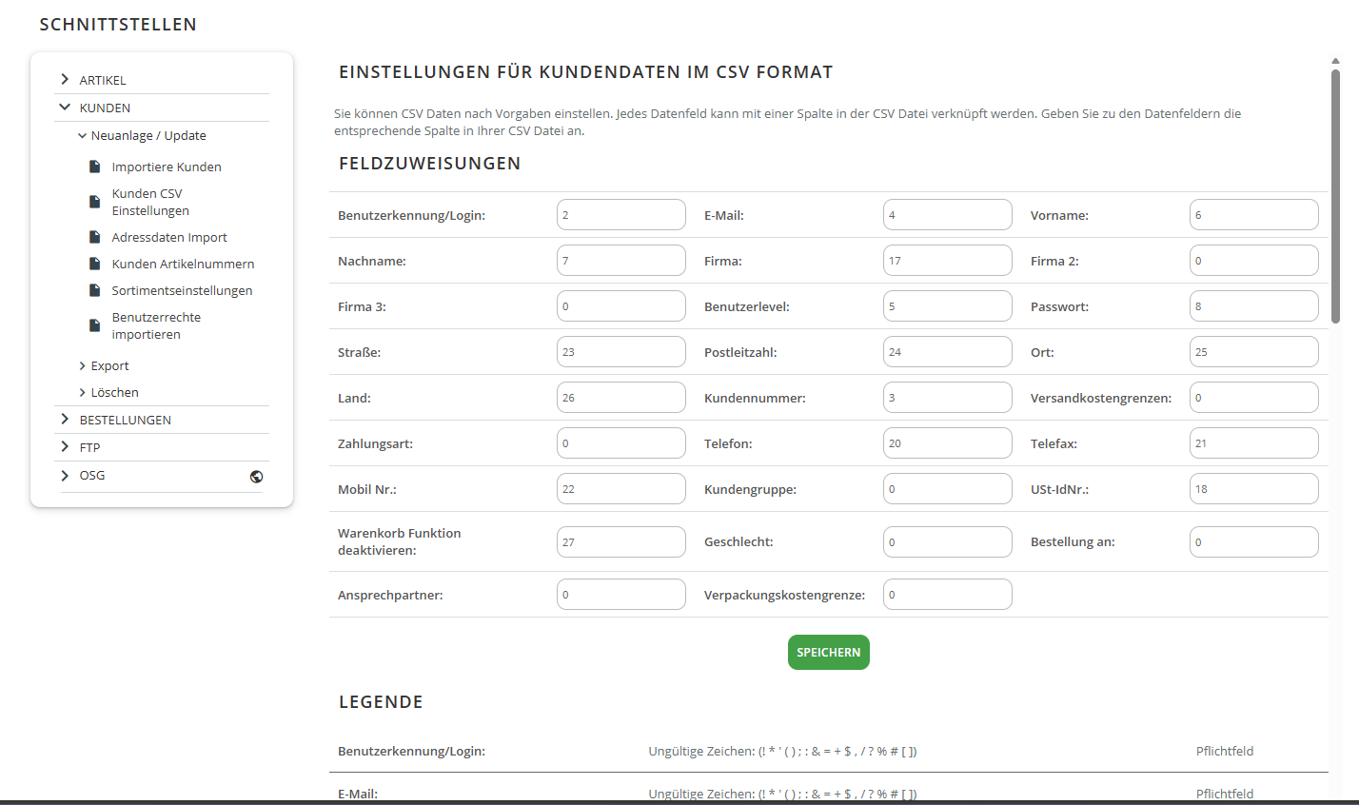

Customer-Specific Features
- Customer-specific assortments
- Option to transfer customer-specific assortments from nextPIM to the shop and define which users or user groups can see which assortments
- Customers can create their own product lists
- Customers can configure order templates
- CSV imports should be possible, potentially directly into the shopping cart
- For each order, the customer can enter an individual order reference
- Customers can view the status of their orders/repairs in their account
(ERP logic required to map internal statuses to external statuses, e.g. “delivery note printed”)

Advanced AI & ERP Functions
- AI-based cross-selling recommendations based on ERP purchase history
- AI-assisted spare parts identification
- AI-driven automatic product enrichment
- Advanced intelligent search
  - Synonym database (e.g. “Flex” = angle grinder)
  - Error tolerance
  - Replacement product logic for discontinued items
- Display of tiered pricing
- Display of partial delivery capability
Extended ERP integration:
- Quotation number lookup from ERP → quotation acceptance directly in the shop
- Documents as downloadable PDFs
- Granular customer-specific settings
(shipping costs, minimum order value, payment methods, permissions)
- Individually selectable payment terms with correct ERP representation
- Flexible integration of payment service providers (e.g. Stripe, PayPal)

Analytics & Reporting
- Newsletter integration
- Exportable evaluations:
  - Top revenues
  - Top products
  - Search statistics
  - Cart abandonment rate
  - Customer activity (active vs. inactive customers)
- AI-based trend forecasts
- Optional API access for Power BI
- 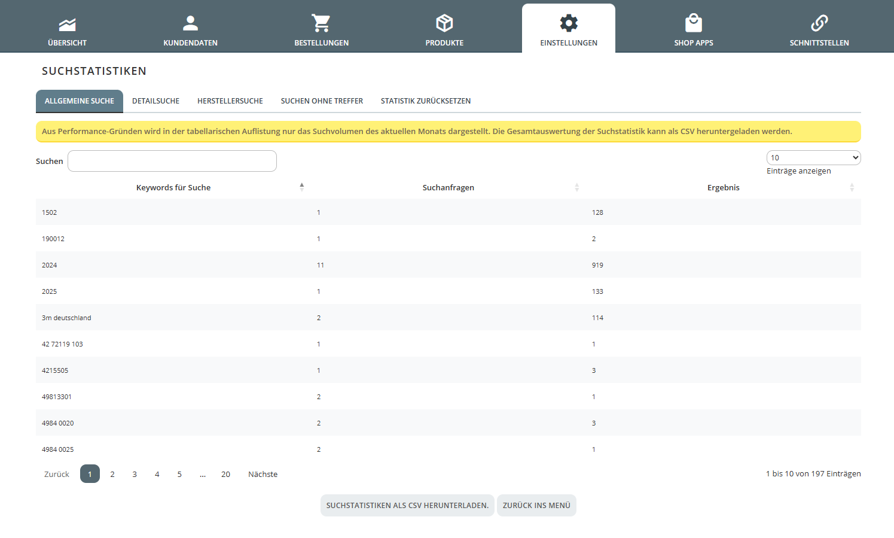ERP query logbook
- 