*Mario Bros C++*

User’s Manual

Controls:

* Use to left/right arrow keys to move or the ‘A’ and ‘D’ keys to move.
* Press SpaceBar to Jump.

How to Play:

* Collect the coins.
* Avoid the enemies, jump on top of them to kill them.
* Your score increases as you continue to collect the coins.
* 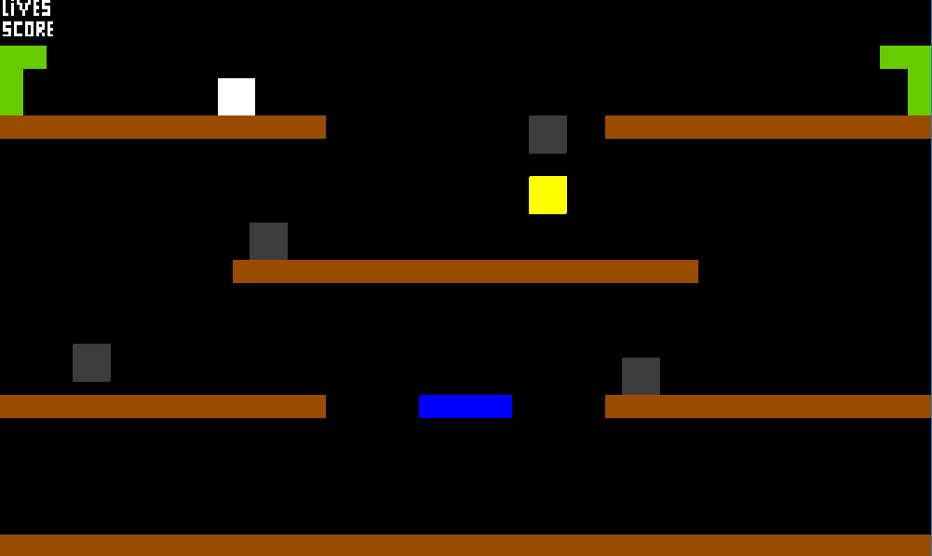You lose if you get killed by an enemy.