Software Requirements Specification
Movie Recommendation System
Group:16
Swathi Vallabhaneni, Aevin Tate Tweedie, Russell Keith
Sullivan

1. Introduction 4
1.1 Purpose 4
1.2 Scope 4
1.3 Definitions, Acronyms, and Abbreviations 4
1.4 References 5
2. Overall Description 5
2.1 Product Perspective 5
2.2 Product Function 5
User Management 5
Movie Catalog 5
Recommendation System 5
User Interactions 5
2.3 User Characteristics 6
2.4 Constraints 6
2.5 Assumptions and Dependencies 6
2.6 Operating Environment 6
2.7 User Interface Overview 6
2.8 System Interfaces 7
3. Specific Requirements 7
3.1 Functional Requirements 7
3.1.1 User Management 7
3.1.2 Movie Management 7
3.1.3 Recommendation Engine 8
3.1.4 User Interactions 8
3.2 Non-Functional Requirements 8
3.2.1 Performance Requirements 8
3.2.2 Security Requirements 9
3.2.3 Reliability Requirements 9
3.2.4 Usability Requirements 9
3.2.5 Scalability Requirements 9
3.3 Use Cases 10
3.3.1 User Registration 10
3.3.2 User Login 10
3.3.3 Search Movies 11
3.3.4 Rate Movie 11
3.3.6 Comment on Movie 12
3.3.7 View Recommendations 12
4.System Models 13
4.1 UML Class Diagram 13
4.2 Database Schema Diagram 14
4.3 Entity Descriptions 15
4.4 Data Integrity Constraints 16
4.5 Performance Optimization 16
5. System Interfaces 17
5.2 Hardware Interfaces 17
5.3 Software Interfaces 17
5.4 Communication Interfaces 17
6. Appendices 18
6.1 Glossary 18

1. Introduction

1.1 Purpose
This Software Requirements Specification (SRS) document describes the requirements for the Movie Recommendation System. It outlines the system’s functional and non-functional requirements, interfaces, and constraints that will guide development and testing. The document is intended for developers, project members, and instructors to understand how the system should behave and what features must be implemented. The system focuses on helping users discover movies through personalized recommendations based on their interactions such as ratings, favorites, and viewing history.

1.2 Scope
The Movie Recommendation System is a web-based application designed to help users discover movies tailored to their preferences. The system will provide personalized movie recommendations based on user behavior, ratings, and preferences. Key features include:
- User registration and authentication
- Personalized movie recommendations using collaborative and content-based filtering
- User interaction tracking (favorites, ratings, comments, watch history)
- Advanced search and filtering capabilities
- Social features including user comments and reviews

The application focuses only on movie discovery and recommendation. It does not provide movie streaming or playback services and relies on external movie database APIs for movie information.

1.3 Definitions, Acronyms, and Abbreviations
Term | Definition
SRS | Software Requirements Specification
UI | User Interface
API | Application Programming Interface
DBMS | Database Management System
ML | Machine Learning

1.4 References
- IEEE Std 830-1998, IEEE Recommended Practice for Software Requirements Specifications
- The Movie Database (TMDb) API Documentation, https://developers.themoviedb.org
- OWASP Foundation, OWASP Top 10 Web Application Security Risks, https://owasp.org
- W3C Web Content Accessibility Guidelines (WCAG) 2.1, https://www.w3.org/TR/WCAG21/
- PostgreSQL Documentation, https://www.postgresql.org/docs/
- React Documentation, https://react.dev

2. Overall Description

2.1 Product Perspective
The Movie Recommendation System is a standalone web application that integrates with external movie databases and APIs. The system consists of the following major components:
- Frontend web interface for user interactions
- Backend server handling business logic and API requests
- Relational database storing user data, movie information, and interactions
- Recommendation engine implementing collaborative and content-based filtering algorithms

2.2 Product Function
The primary functions of the system include:

User Management
- User registration with email verification
- Secure authentication and session management
- User profile management with preference settings

Movie Catalog
- Browse comprehensive movie database with detailed information
- Search movies by title, genre, year, and rating
- Filter movies based on multiple criteria

Recommendation System
- Generate personalized recommendations based on user behavior
- Provide explanations for recommendations
- Update recommendations based on new user interactions

User Interactions
- Rate movies on a numerical scale
- Add movies to favorites list
- Write and view comments on movies
- Track watch history

2.3 User Characteristics
The system is designed for the following user types:
- End Users: Movie enthusiasts of varying technical proficiency seeking personalized recommendations
- Administrators: Technical staff managing the system, user accounts, and content
- Guest Users: Visitors who can browse and search movies but cannot rate, comment, or add favorites without registering.

2.4 Constraints
- Must comply with data privacy regulations (GDPR, CCPA)
- Performance requirements for recommendation generation (under 2 seconds)
- Database storage limitations
- The system must be implemented using the selected technology stack (React, backend REST API, relational database).

2.5 Assumptions and Dependencies
- Users have reliable internet connectivity
- External movie database APIs remain available and accessible
- Sufficient server resources for hosting the application

2.6 Operating Environment
The Movie Recommendation System will operate as a web based application accessible through modern web browsers including Google Chrome, Mozilla Firefox, Microsoft Edge, and Safari. The system will run on standard desktop and laptop computers as well as mobile devices with internet connectivity. The backend server will be hosted on a cloud or local server environment capable of running the application server, database management system, and recommendation engine services. The development and deployment environment requires a server capable of running the backend runtime environment, relational database system, and containerization platform. The application will be deployed using Docker containers and requires standard development tools including a JavaScript runtime, package manager, and database server for development, testing, and maintenance.

2.7 User Interface Overview
The Movie Recommendation System provides a web based graphical user interface designed for ease of use and accessibility. The main interface components include:
- Home Page: Displays personalized recommendations for logged in users and trending or popular movies for guest users
- Movie Detail Page: Shows detailed movie information including title, description, release year, average rating, genres, user comments, and rating options.
- Search and Filter Page: Allows users to search for movies by title or keywords and apply filters such as genre, release year, and rating
- User Profile Page: Enables registered users to manage their account information, view favorites, and access watch history.
- Authentication Pages: Provide registration, login, and password recovery functionality.

2.8 System Interfaces
The system follows a client-server architecture. The frontend web application communicates with the backend server through RESTful API calls using HTTP requests. The backend processes business logic, authentication, and recommendation generation. It interacts with the relational database to store and retrieve user data, movie information, and interaction history. The system may also communicate with external movie database APIs to retrieve movie metadata.

3. Specific Requirements

3.1 Functional Requirements

3.1.1 User Management
FR-UM-001: User Registration
The system shall allow new users to register by providing a unique username, valid email address, and secure password meeting complexity requirements (minimum 8 characters, including uppercase, lowercase, and numbers). The system shall prevent registration if the username or email already exists.

FR-UM-002: User Authentication
The system shall authenticate users using their username/email and password, implementing secure password hashing (bcrypt or Argon2).

FR-UM-003: Profile Management
The system shall allow users to update their profile information, including preferred genres and viewing preferences.

FR-UM-004: Password Recovery
The system shall provide a password reset mechanism via email verification.

3.1.2 Movie Management
FR-MM-001: Movie Display
The system shall display comprehensive movie information including title, description, release year, average rating, and associated genres.

FR-MM-002: Movie Search
The system shall provide search functionality allowing users to find movies by title, partial title, or keywords.

FR-MM-003: Movie Filtering
The system shall allow users to filter movies by genre, release year range, and minimum rating.

FR-MM-004: Genre Management
The system shall maintain a comprehensive genre taxonomy and allow movies to be associated with multiple genres.

FR-MM-005: Access Permissions
The system shall allow guest users to browse and search movies but require authentication for rating, commenting, and adding favorites.

3.1.3 Recommendation Engine
FR-RE-001: Personalized Recommendations
The system shall generate personalized movie recommendations for each user based on their ratings, favorites, watch history, and preferred genres.

FR-RE-002: Recommendation Explanations
The system shall provide explanations for why specific movies are recommended to users.

FR-RE-003: Collaborative Filtering
The system shall implement collaborative filtering to identify similar users and recommend movies liked by users with similar preferences.

FR-RE-004: Content-Based Filtering
The system shall implement content-based filtering to recommend movies similar to those the user has previously enjoyed.

3.1.4 User Interactions
FR-UI-001: Movie Rating
The system shall allow users to rate movies on an integer scale, with ratings stored with timestamps.

FR-UI-002: Favorites Management
The system shall allow users to add and remove movies from their favorites list.

FR-UI-003: Comments
The system shall allow users to post, edit, and delete comments on movies, with all comments timestamped.

FR-UI-004: Watch History
The system shall track and store user watch history for use in generating recommendations.

FR-UI-005: Interaction Logging
The system shall log all user interactions including action type, movie ID, filter preferences, and timestamps for analytics and recommendation improvement.

3.2 Non-Functional Requirements

3.2.1 Performance Requirements
NFR-PR-001: Response Time
The system shall respond to user requests within 2 seconds under normal load conditions (up to 1000 concurrent users).

NFR-PR-002: Recommendation Generation
The system shall generate personalized recommendations within 2 seconds of request.

NFR-PR-003: Database Query Performance
Database queries shall execute within 500 milliseconds for standard operations.

3.2.2 Security Requirements
NFR-SE-001: Password Security
All user passwords shall be hashed using industry-standard algorithms (bcrypt with minimum work factor of 10, or Argon2).

NFR-SE-002: Data Encryption
All data transmission shall use HTTPS/TLS encryption.

NFR-SE-003: Authentication
The system shall implement session-based authentication with secure token generation and expiration.

NFR-SE-004: Input Validation
All user inputs shall be validated and sanitized to prevent SQL injection, XSS, and other security vulnerabilities.

3.2.3 Reliability Requirements
NFR-RE-001: Uptime
The system shall maintain 99.5% uptime during business hours.

NFR-RE-002: Data Backup
Database backups shall be performed daily with retention of at least 30 days.

NFR-RE-003: Error Handling
The system shall gracefully handle errors and provide meaningful error messages to users without exposing sensitive system information.

3.2.4 Usability Requirements
NFR-US-001: User Interface
The user interface shall be intuitive and require minimal training for basic operations.

NFR-US-002: Responsive Design
The system shall be responsive and functional on desktop, tablet, and mobile devices.

NFR-US-003: Accessibility
The system shall comply with WCAG 2.1 Level AA accessibility standards.

3.2.5 Scalability Requirements
NFR-SC-001: User Capacity
The system shall support at least 10,000 registered users with room for expansion.

NFR-SC-002: Database Growth
The database architecture shall accommodate growth in movie catalog and user interactions without performance degradation.

3.3 Use Cases

3.3.1 User Registration
Actor: Guest User
Description:
A new user creates an account to access personalized features such as favorites and recommendations.

Preconditions:
The user is not logged in and has access to the website.

Postconditions:
A new account is created and stored in the database.

Main Flow:
- The user opens the registration page.
- The user enters a username, email, and password.
- The system validates the input format.
- The system checks that the email and username are unique.
- The password is securely stored.
- The system confirms successful registration.

Alternate Flows:
- If the email already exists, the system asks the user to use a different email.
- If the password does not meet requirements, the user is asked to correct it.
- If required fields are missing, submission is prevented.

3.3.2 User Login
Actor: Registered User
Description:
A registered user logs in to access their personalized movie features.

Preconditions:
The user already has an account.

Postconditions:
The user session is created and the user is redirected to the home page.

Main Flow:
- The user enters their email/username and password.
- The system verifies the credentials.
- The system creates a session.
- The home page is displayed.

Alternate Flows:
- If the password is incorrect, an error message is shown.
- If the account does not exist, the user is prompted to register.

3.3.3 Search Movies
Actor: Any User (Guest or Registered)

Description:
The user searches for movies using keywords or filters.

Preconditions:
The user is on the movie catalog page.

Postconditions:
Matching movies are displayed.

Main Flow:
- The user enters a keyword or selects filters.
- The system searches the database.
- Results are displayed.

Alternate Flows:
- If no movies match, a “no results found” message is shown

3.3.4 Rate Movie
Actor: Registered User
Description:
The user rates a movie to improve recommendation accuracy.

Preconditions:
The user is logged in and viewing a movie page.

Postconditions:
The rating is stored and the movie’s average rating is updated.

Main Flow:
- The user selects a rating value.
- The system validates the rating range.
- The rating is saved in the database.
- The average rating is recalculated.

Alternate Flows:
- If the user already rated the movie, the existing rating is updated.

3.3.5 Add to Favorites
Actor: Registered User
Description:
The user adds a movie to their favorites list.

Preconditions:
The user is logged in.

Postconditions:
The movie is saved in the favorites list.

Main Flow:
- The use clicks the add to favorites button
- The system stores the movie in the favorites table.
- Confirmation is displayed.

Alternate Flows:
If the movie already exists in favorites, it is not added again.

3.3.6 Comment on Movie
Actor: Registered User
Description:
The user posts a comment on a movie page.

Preconditions:
The user is logged in and viewing a movie.

Postconditions:
The comment is saved and displayed.

Main Flow:
- The user enters a comment.
- The system validates the text.
- The comment is stored in the database.
- The comment appears on the page.

Alternate Flows:
Empty comments cannot be submitted.

3.3.7 View Recommendations
Actor: Registered User
Description:
The system displays personalized movie recommendations based on user activity.
Preconditions:
The user is logged in.

Postconditions:
A list of recommended movies is shown.

Main Flow:
- The user opens the home page.
- The system reads user interactions such as ratings and favorites.
- The system calculates recommendation scores.
- Recommended movies are displayed.

Alternate Flows:
If the user has no activity history, popular movies are shown instead.

4.System Models

4.1 UML Class Diagram
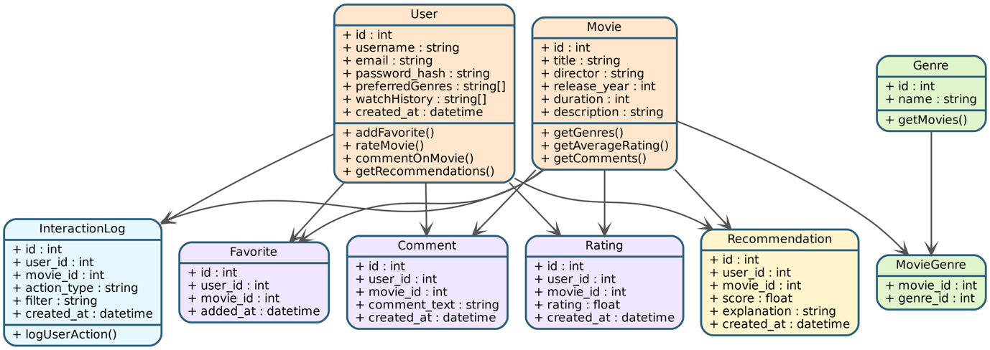
Figure 4.1: UML Class Diagram
The diagram above illustrates the complete UML class diagram for the movie recommendation system, showing all nine classes with their attributes, methods, relationships, and cardinality constraints. The User class serves as a primary entity with methods for core interactions (addFavorite(), rateMovie(), commentOnMovie(), getRecommendations()), while the Movie class provides data access operations (getGenres(), getAverageRating(), getComments()). Five association classes—Favorite, Comment, Rating, Recommendation, and InteractionLog—capture the many-to-many relationships between users and movies with timestamps and additional metadata. The Genre class connects to movies through the MovieGenre junction class, enabling the many-to-many relationship where movies can belong to multiple genres. Each relationship displays multiplicity notation (1 to 0..*) indicating one-to-many associations, and all classes include complete attribute definitions with data types (int, string, float, datetime, arrays), forming a comprehensive object-oriented blueprint of the system architecture.

4.2 Database Schema Diagram
The Movie Recommendation System uses a relational database design organized into three functional categories: Core Entities (User, Movie, Genre), User Interaction Entities (Favorite, Comment, Rating), and System Feature Entities (Recommendation, InteractionLog, MovieGenre).

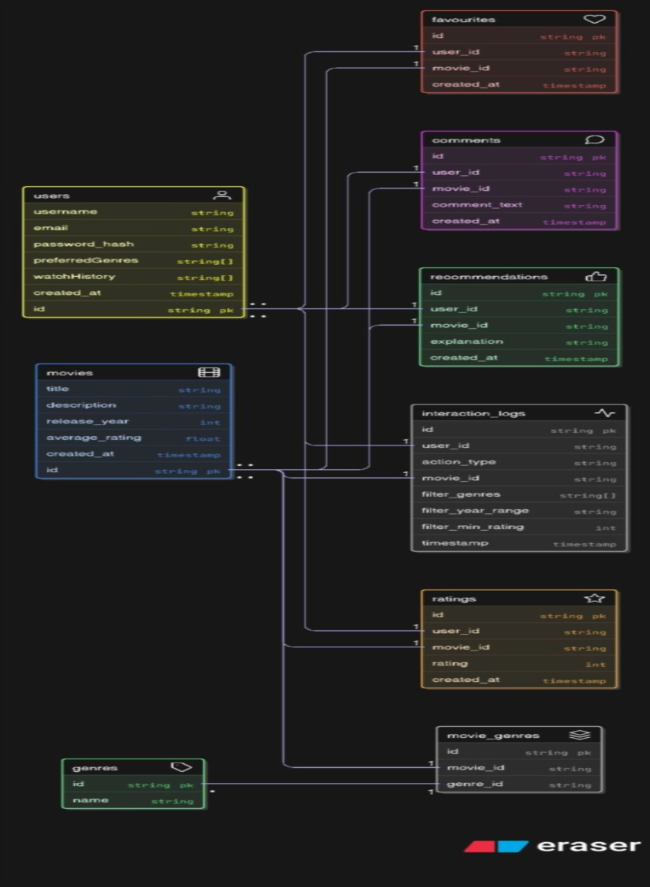
Figure 4.2: Entity-Relationship Diagram

The ER diagram above illustrates the complete database schema with all entity relationships, primary keys, foreign keys, and data types.

4.3 Entity Descriptions
Core Entities
User
- Manages user accounts, authentication, and preferences
- Key fields: id, username, email, password_hash, preferredGenres, watchHistory, created_at
- Array fields (preferredGenres, watchHistory) enable efficient recommendation processing
Movie
- Stores movie catalog with metadata
- Key fields: id, title, director, release_year, duration, description
Genre
- Maintains standardized movie genre taxonomy
- Key fields: id, name
- Normalized to prevent data redundancy
User Interaction Entities
Favorite
- Tracks user's favorite movies
- Key fields: id, user_id (FK), movie_id (FK), added_at
- Enables quick access to preferred content
Comment
- Stores user reviews and comments
- Key fields: id, user_id (FK), movie_id (FK), comment_text, created_at
- Facilitates community engagement
Rating
- Captures numeric movie ratings
- Key fields: id, user_id (FK), movie_id (FK), rating, created_at
- Provides quantitative feedback for recommendations
System Feature Entities
Recommendation
- Stores AI-generated personalized recommendations
- Key fields: id, user_id (FK), movie_id (FK), score, explanation, created_at
- explanation field provides transparency in recommendation reasoning
InteractionLog
- Tracks all user interactions for analytics and ML training
- Key fields: id, user_id (FK), movie_id (FK), action_type, filter, created_at
- Supports behavior analysis and recommendation algorithm improvement
MovieGenre
- Junction table for Movie-Genre many-to-many relationship
- Key fields: movie_id (FK), genre_id (FK)
- Composite primary key ensures unique movie-genre pairings

4.4 Data Integrity Constraints
Primary Keys: All entities have unique, auto-incrementing primary keys
Foreign Keys: Referential integrity enforced on all relationships
Unique Constraints:
- users.username and users.email must be unique
- genres.name must be unique
- Composite constraints on favorites(user_id, movie_id) and ratings(user_id, movie_id) prevent duplicates
Validation Constraints:
- ratings.rating must be within valid range (1-5)
- movies.release_year and movies.duration must be positive values
- Critical fields (usernames, emails, titles, foreign keys) are NOT NULL

4.5 Performance Optimization
Indexing Strategy:
- users.email and users.username for authentication
- movies.title for search functionality
- Composite indexes on (user_id, movie_id) for Favorites, Ratings, and Comments
- recommendations(user_id, score) for efficient retrieval
- interaction_logs(user_id, created_at) for temporal analytics
Scalability: The normalized structure minimizes redundancy, and interaction logging is separated from core entities to allow for future archival strategies. The schema supports horizontal scaling through database sharding by user_id if needed.

5. System Interfaces
5.1 User Interfaces
The system shall provide a graphical web interface accessible through modern browsers. The interface shall support navigation between major application views including home, search, movie details, profile management, and authentication pages. The interface shall provide interactive elements for rating, commenting, filtering, and managing favorites.

5.2 Hardware Interfaces
The system does not require any specialized hardware interfaces. It operates on standard web servers and can be accessed through standard computing devices with web browsers.

5.3 Software Interfaces
Database Management System:
- PostgreSQL 12+ or MySQL 8+ for relational data storage
External APIs:
- TMDb API or OMDb API for movie metadata retrieval (optional enhancement)
- Email service API (SendGrid, Mailgun) for user notifications
Backend Framework:
- Node.js with Express.js, Python with Django/Flask, or similar web framework

5.4 Communication Interfaces
- HTTP/HTTPS protocols for client-server communication
- RESTful API architecture for frontend-backend communication
- JSON data format for API requests and responses
- WebSocket support for real-time features (optional enhancement)

6. Appendices

6.1 Glossary
Term | Definition
Collaborative Filtering | A recommendation technique that predicts user preferences based on preferences of similar users
Content-Based Filtering | A recommendation technique that suggests items similar to those a user has liked in the past
Junction Table | A database table that implements a many-to-many relationship between two entities
RESTful API | Architectural style for web services using HTTP methods and stateless communication

