CSC242 Introduction to Programming Concepts **PROJECT**

|  |  |
| --- | --- |
| **First Name** |  |
| **Last Name** |  |
| **ID#** |  |
| **Email Address** |  |

Table of Contents

How to submit your work 1

Project - Simulate an ATM machine. 2

# How to submit your work

After filling all the parts in this file, please follow the following steps.

1. Add your name and Student ID# to the first page.
2. Save the file in the original format (Docx or Doc)

(please do not convert to other file formats e.g. PDF, ZIP, RAR, …).

1. Rename the file as

*YOUR First Name YOUR Last Name -* ***Project****.docx*

**Example:** John Smith - Project.docx

1. Upload the file and submit it (only using Blackboard)

# Project - Simulate an ATM machine.

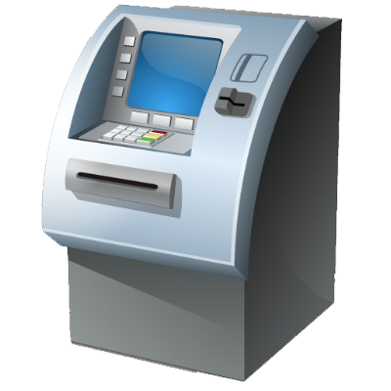

**Steps**

1. The system should show the following top menu. Write a function that simply displays this menu.
2. Sign in
3. Balance
4. Deposit
5. Withdraw
6. Exit
7. We assume that this ATM machine holds account for only 10 people. So, use an array to store client’s account balance. Suppose all accounts start with an initial balance of $1000. With this structure in mind we use array indices (0, 1, 2, 3, 4, 5, 6, 7, 8, 9) as user’s account number (a single digit) and array values as balances. The user must first sign in to use the machine by entering their account number (0, 1, 2, 3,.. 9). If the user enters an incorrect account number the system should give a warning message and display the menu again.
8. User can request account **Balance** by entering option 2. Write a function to complete the following task:

* The system displays the current balance.
* If balance is below $100, the system should display the message “Low Balance”.
* Then go back to the top menu.

1. If option menu 3, which is **Deposit** is selected, write a function to compete the task:

* the system should prompt the user to enter the amount. The ATM machine validates the input by verifying that the input is positive.
* If not a warning message is displayed “invalid amount”, and the user is prompted to try again, if amount is negative again, the deposit operation is terminated and the top menu is displayed again.
* If amount is positive the Balance is updated.

1. If option 4, which is **Withdraw** is selected, write a function to compete the task:

* the ATM machine prompts the user to enter amount, then checks if user has sufficient Balance.
* If the balance is insufficient, then a warning message along with user’s balance is displayed.
* The user is prompted to enter a new amount for a second time, if amount is OK withdraw operation is completed and balance is updated and menu is displayed.
* If balance is still insufficient withdraw operation is terminated and top menu is displayed.

1. For option **exit**, write a function that display a “Good Bye” message and exits/log out from user’s account. The ATM machine’s menu is displayed, however this time the next user must sign in by entering his account number (0, 1, 2, …, 10).

Submit code with **comments**, **sample runs** for each of the options with at least two different users.

|  |
| --- |
| Your C++ code for this HW |
| -- Copy and paste your code here |

|  |
| --- |
| The result of the query |
| Copy and paste the result here (e.g. the screen shot of the result you get by running the code). |

**The end.**