启动容器报以下错误



Error response from daemon: Cannot start container

07d70c26e62d4c2cac39db62c7f0ca82fb27fc21a3ffa8602dbf351e697c0786: iptables failed: iptables -t nat -A DOCKER -p tcp -d 0/0 --dport 3306 -j DNAT --to-destination 172.17.0.4:3306 ! -i docker0: iptables: No chain/target/match by that name.

(exit status 1)

重启docker报一下错误

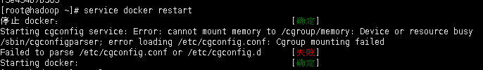

解决方案：

Cgclear

service docker restart