1. Summary/Specs

This is my official report of my findings and method of use for the Arduino-based Acoustic Levitators, BigLev and TinyLev, as first proposed by Azier Marzo, Victor Contreras, James Drewitt, and various other collaborators. For optimizing the levitators, current was the most important factor to minimize. This was achieved by altering the distances between the cavities and changing the OCR1A number. Optimizing the amplitude peak-to-peak voltage from the transducers was also important as that tended to improve levitation by generating a stronger pushing force. Increasing the amplitude peak-to-peak voltage was achieved by also optimizing the OCR1A and testing the transducers with an oscilloscope to take out the weakest transducers and keep the strongest. Besides the optimal specs for the levitator, this report explains how to operate, assemble, and configure the acoustic levitators with helping images. Also, it provides graphs and specific data for our findings. In our lab, we made 3 acoustic levitators, two BigLev models and one TinyLev model. We found the TinyLev to provide the best performance. The BigLev models can be found in the instructables page linked below. We have the necessary TinyLev models as files in the GitHub.

1. Introduction and General Assembly

The combination of acoustic levitation with laser heating was developed originally by Intersonic corporation on contract from NASA. It involved stabilizing the sample levitated in the gas jet by six Langevine horn-type custom-made acoustic transducers. During the last 30 years, two commercial instruments were produced in the USA and operated in Germany and Japan for high-temperature research on oxide melts.

Marzo publication [3] of multi-transducer acoustic levitation design and open sharing of software and sources for the components lead to rapid employment of acoustic levitators in several research groups (Drewitt, others [1]. Using Marzo’s design, acoustic levitation of Hg (13.6 g/cm3) without any support by gas jets was demonstrated [1].

For a general assembly of the acoustic levitators, the instructables link at the end can be viewed. For the TinyLev, we used metal rods with shaft collars to hold the cavities up and adjust the distance between the cavities. For the BigLev, we cut the holders in the original BigLev 3D model off and printed out the BigLevLip models to attach to the acoustic levitators and enable three rods to be used with shaft collars. To put together the circuit models, wee used screws where the holes are to both put together the circuit holder and enclosure along with securing the driver board.

1. BigLev Specs

Primary Items:

* Transducers: Taidacent OD 16mm 40khz Transducers High Sensitivity Ultrasonic Transducer Ranging Probe RT Split Ultrasonic Transceiver Sensor
* Controller Board: ELEGOO Nano Board CH340/ATmega328P Without USB Cable, Compatible with Arduino Nano V3.0 (Nano x 3 Without Cable)
* Driver Board: L298N Motor Driver Controller Board Module
* Full Shopping list used: <https://drive.google.com/file/d/1DWnBdM5cI4lgIsuW8EiMI6vwoWCgvMc8/view?usp=sharing>

Best operating specs:

* Operating Voltage: 5-25V(refrain from going past 20 V for more than a few minutes as the heat sink gets quite hot)
* Current range: ~0.30 - 0.65 A
* Distance (red BigLev): 111.50-112.50 mm or 164.5-165.5 mm
* Distance (white BigLev): The best distance I found was between 144-146 mm
* 0CR1A: 191

1. TinyLev Specs

Primary Items:

* Transducers: Manorshi Electronics MSO-A1040H07T
* Same things for everything else; only the transducers are different

Best operating specs:

* Operating Voltage: 5-25V (same concern with overheating and high voltage)
* Current range:
* Distance: From both tests, 53-54 mm and 34-35 mm are the best ranges where lowest current was seen. 42-43 mm may also work well. Was successful at levitating Al2O3 and ZrO2 at 55.07 mm of separation.
* 0CR1A: 191
* Levitation of 2mm Al2O3 on TinyLev witnessed at 55.93 mm, 19.6V and 0.51 A. For 55.07 mm, levitation 2mm sized Al2O3 witnessed at 11.9 V, and 3mm ZrO2 was levitated at 19.6V.

**Manual/Standard Operating Procedures - Acoustic Levitators**

This part of the document is the overview troubleshooting manual for the acoustic levitators. It will detail how to set up, configure, test, and use the acoustic levitators. Much of this document will revolve around helping to yield the best performance out of the acoustic levitators. As I, Azier Marzo, and his associates have found, the acoustic levitator performs best when it is able to operate fully at a high amplitude and as low of a current as possible. This optimal performance can be achieved through a combination of settings.

Section 1: Configuring the Software:

* Updating the code

The code for the acoustic levitators was written for the Arduino circuit and thus operates only in the Arduino IDE program. The code mostly consists of commands for the pins and board, but there is a small variable of the code that can be altered to dictate the frequency and current of the acoustic levitators. Below is the line to look out for:

The variable to change is the 0CR1A. The 0CR1A number has an inverse relationship to the frequency of the transducers as the frequency is approximately 8 MHz divided by whatever number you have for your 0CR1A (Frequency = 8MHz/OCR1A #). For example, with 191 as the 0CR1A, you will have a frequency of around 41.8 kHz. At a value of 200, your frequency will be 40 kHz. The 0CR1A also alters the current and the amplitude of the transducers. Changes in current can be seen just by measuring the current after each subsequent change in the 0CR1A. For the acoustic levitators, we found an 0CR1A of 191 to be ideal as it gave the best amplitude along with a lowered current. Measuring and testing the amplitude is discussed in Section of the manual. The best 0CR1A values tended to be between 190 and 200.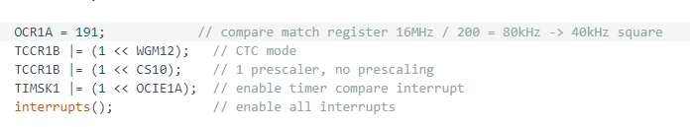

* Uploading the code & Troubleshooting

To upload the code, simply plug a USB into the Arduino board and click on the ⇨ button to upload the code. Any changes can be saved with the ⇩ button.



To ensure the code is uploading to the right place, you may need to configure the drivers for the software and select the board it goes to. This can be done in Tools > Board > Board manager. For this levitator, we downloaded the Arduino AVR Boards driver. Also, at the top left, there’s a drop down menu to select the correct board being used. For the acoustic levitator, we used an Arduino Nano board. Other issues that may arrive could be with the COM port. In Tools > Port, one can choose what USB port the code is sent through. Make sure the Arduino board is connected to the correct port.

Section 2: Connecting/Wiring the Acoustic Levitator

* Connecting the acoustic levitator

The Acoustic levitator has 3 ports to connect to. The cut-out slot on the bottom side of the levitator is for the USB to connect to the Arduino Nano board. The circular male port is for the female DC power supply connector. The blue DB-9 connector is for the acoustic levitator to connect to.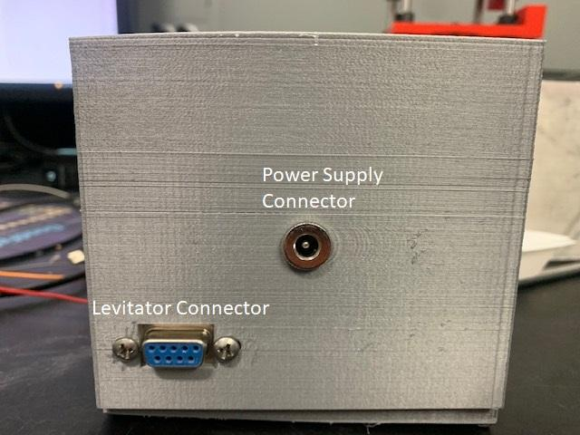

* Wiring the acoustic levitator

In case the wires come loose or changes need to be made, it is important to discuss the wiring of the acoustic levitator. For wiring the acoustic levitator wires to the driver board, you should connect them as follows:

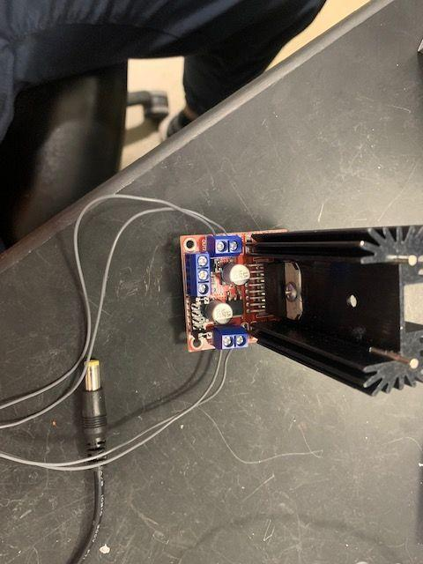

The gray wires are the wires from the levitator. Each pair of wires corresponds to a different cavity of the levitator and each pair should go to a different side. Don’t mix the wires and connect them in random combinations to those ports. For connecting the driver board to the Arduino Nano, look at the images below:

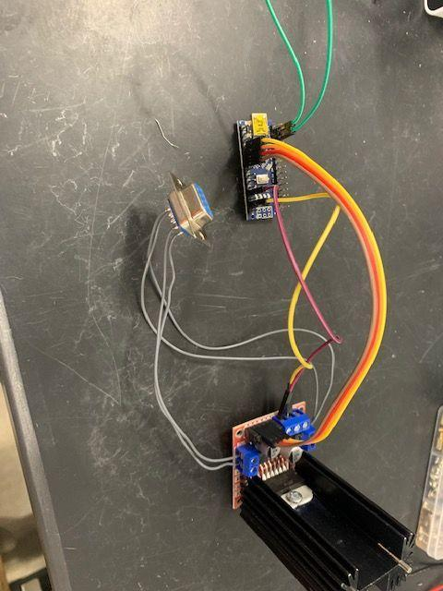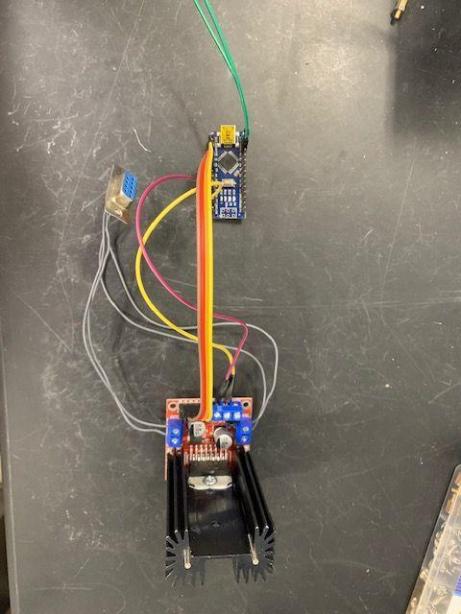

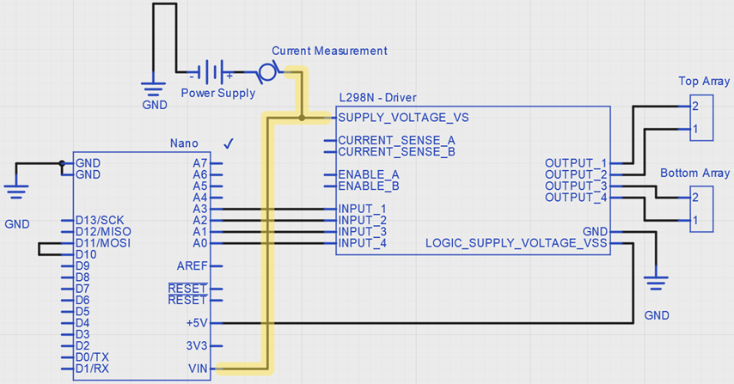

In the images of my circuit, the green wire is the connection in the schematic going from D10 to D11. The Bottom array and Top array are the acoustic levitator connections. The purple wire is the connection from +5V on the Arduino board to the right +5V port on the driver board. The singular yellow connector is going from the GND on the Arduino board to the GND connection on the driver board. The multi-colored bundle of four wires, as shown in the schematic, goes from Input 1, 2, 3, and 4, to A3, A2, A1, and A0. The connections for the power supply:

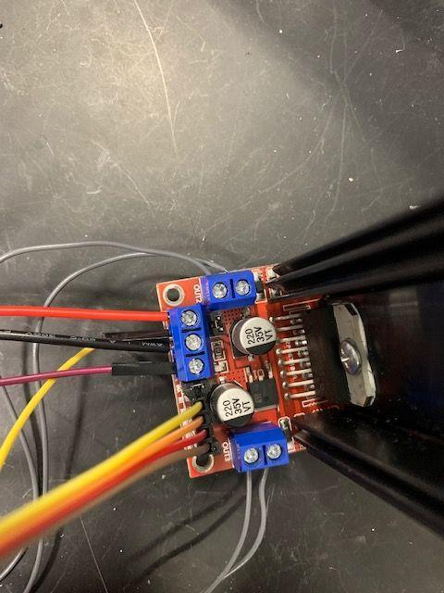

Here, the black wire from the power supply connector should go to ground with the ground wire from the Arduino, while the red wire goes into the +12V port. As a last note, make sure the screws are tight when assembling the box to make sure the wires stay connected.

Section 3: Testing the Amplitude of the Acoustic Levitator

To test the amplitudes of the acoustic levitator, a handheld Tablet oscilloscope can be used. It gives the amplitudes in V and the frequency in Hz. To start testing, a transducer needs to be wired up to one of the probes like so:

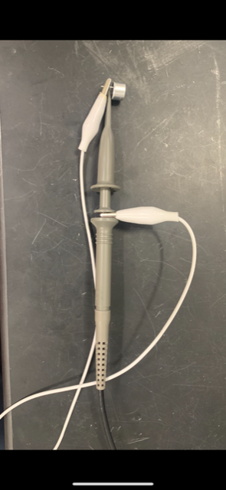

Doing this allows one of the transducers to act as a microphone while the acoustic levitator outputs sound. 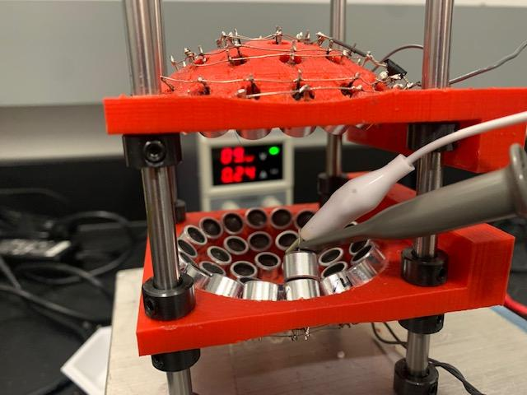

Putting the oscilloscope probe against the transducer like in the left should get an oscilloscope graph like in the right. On the bottom, there is Vpp, frequency, cycle, and Vrms data displayed. If one goes to measure on the right, the displayed measured values can be selected for each channel. Use the Autoset button to automatically adjust the axes and adjust them to the oscilloscope data produced by the levitator. Testing the amplitude can also be done to ensure that the transducers did not break or that one of the acoustic levitator connectors is disconnected. 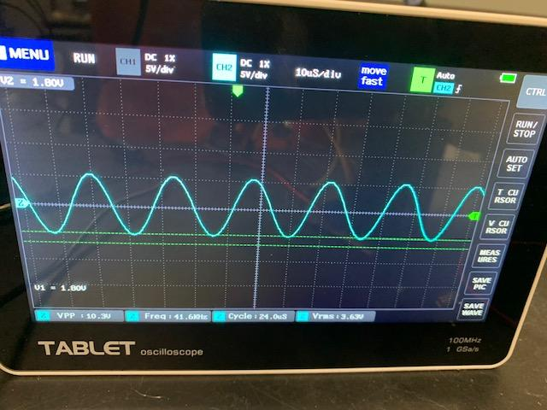

Section 4: Configuring the Correct Distance for the Acoustic Levitator

One of the main factors in getting good levitation performance is setting the levitator to correct distances where the sound waves from the transducers will produce a standing wave. This distance needs to be quite precise and small differences away from that distance can make the levitator’s performance much worse. To gauge the correct distance, the current can be measured with a multimeter. Points of lowest current indicate the best distance for optical performance. To measure the current with a multimeter, it can be set up like so: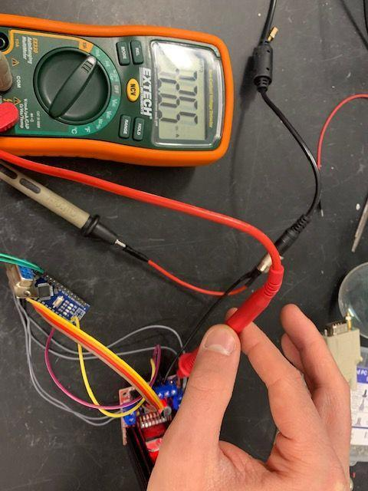

Here, like the schematic shown in section 2, there is a multimeter in between the red cable’s connection to the +12V connection on the driver board. To set this up, the red cable can be taken out and connected to the black probe of the multimeter, and then the red probe goes into the +12V port of the driver board. To make sure the current is flowing and being measured, set the multimeter to measure mA. Doing this will turn the driver board on and measure the current. From here you can see how distance changes change the current in the multimeter. To change the distance precisely, I took washers and stacked them on the black collars then put the levitator cavities on. For the TinyLev, I obtained these distance charts from 2 different tests:

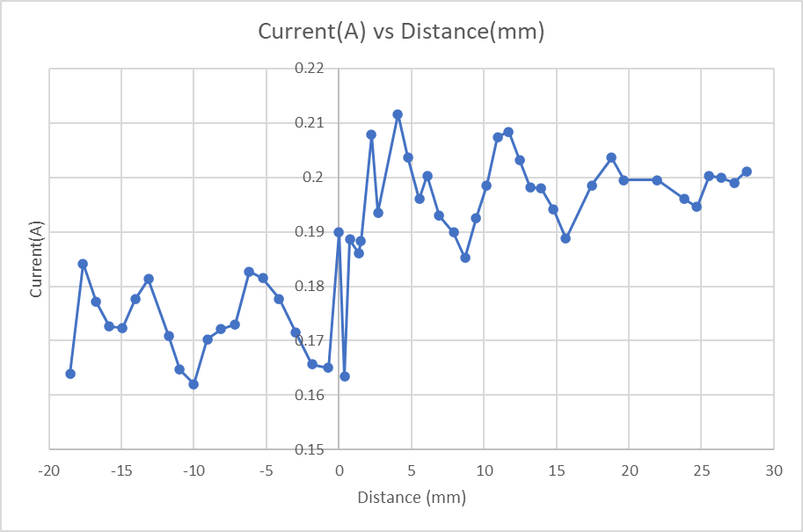

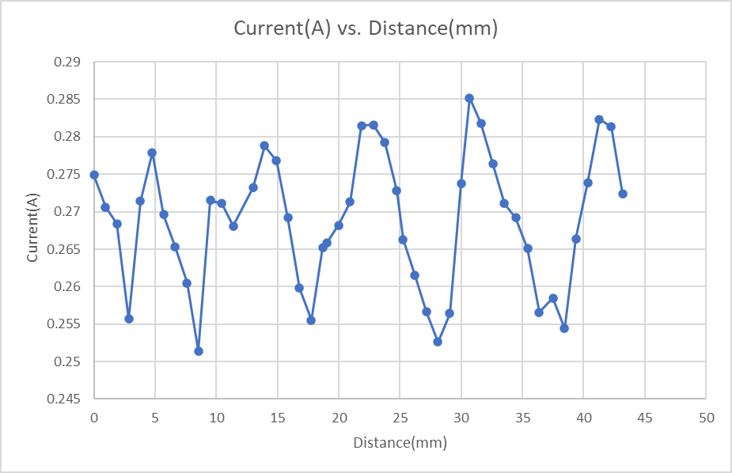

I found the best distances for the TinyLev to be at 53.4 mm, 42.98 mm, and 42.03 mm from

my own tests. These distances were obtained by measuring the distance from the innermost part of the top cavity to the innermost part of the bottom cavity with a caliper. In the graph, the x-axis is in mm with zero being a distance of 53 mm where I originally started measuring from, so the current can shift within mm and thus the performance can drastically change within a few mm. For distance tests on the BigLev I obtained the following graphs:

White BigLev:

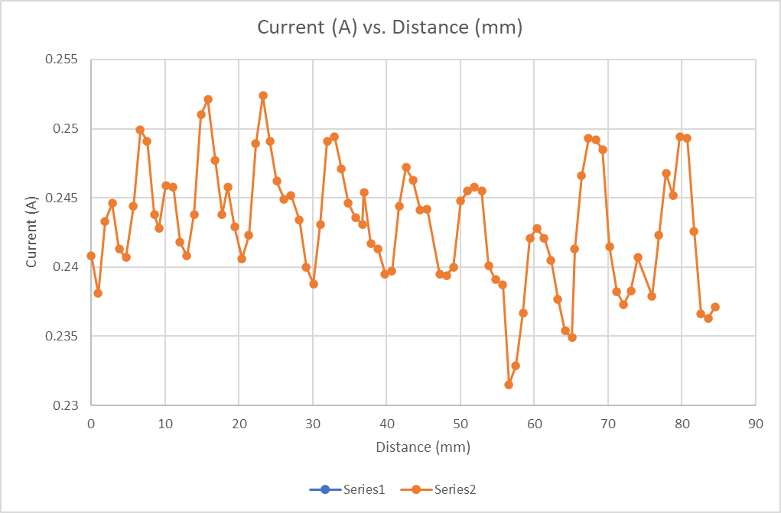

RedBigLev:



For the Red BigLev, I found that distances of 111.50-112.50 mm or 164.5-165.5 mm worked best, while as for the White BigLev, I found that distances of 144-146 mm worked best.

Section 5: Optimzing our Acoustic Levitator build

To improve our levitators from the initial first BigLev build, Nicholas and I ran some tests on the transducers and the OCR1A# to ensure we were optimizing the build as much as possible. To start, we did tests of OCR1A# and frequency to see the effect of OCR1A# on the frequency. The following graphs display the trends we saw: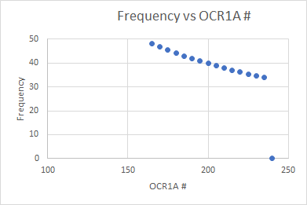

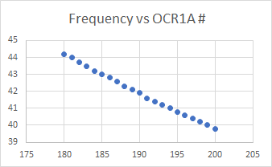

Similar to the frequency vs OCR1A graphs, these graphs show the peak values of Vpp based on the OCR1A number at 5(left) and 1(right) increments. On both graphs, we found the peak Vpp to occur at an OCR1A number of 190. I did the tests at single, more precise increments to confirm the peak was really at 190. This data helped us the most as it showed us where the signal is going to be proportionally the strongest. Based on this data, we saw that an OCR1A of 190-192 was good. The voltage of the power supply and the transducer used were fixed. 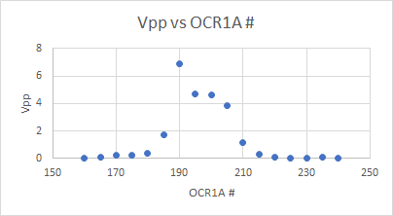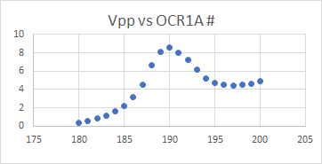

Lastly, we performed current tests to narrow down the best OCR1A# and hit that necessary minimum current that we desired. From these tests we got the following chart:

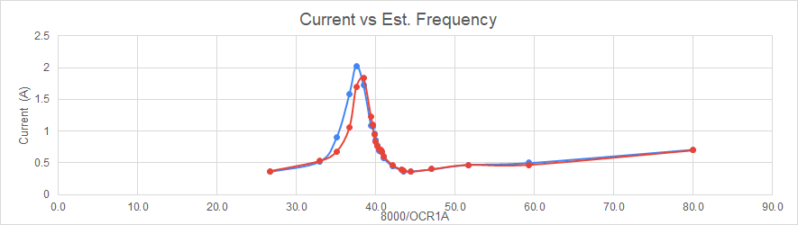

Since an OCR1A# of 191 yielded a lower current at a good Vpp output, we decided on 191 as the best OCR1A#. Beyond these tests, we also used the oscilloscope tests described previously to test each transducer that we ordered and select for the best performing ones to put onto the levitator. We noticed many of the transducers had noticeable differences in amplitude outputs that we could not jst randomly pick the transducers and place them onto the cavities. Upon doing these prior tests, we assembled the levitators with the strongest transducers in the center and the weakest ones along the outermost of the cavities. On the red BigLev, it was apparent that at 10V of power, the transducers on the outer rim had amplitudes of ~5V, while the centermost transducers had amplitudes of ~7.5V. For the TinyLev, the transducers had amplitudes of ~12-15V from the outer to the center rims. For both levitators, the transducers were operating at frequencies of 41.3 kHz.

Section 6: References and Sources

1. <https://aip.scitation.org/doi/full/10.1063/1.4989995>
2. <https://en.wikipedia.org/wiki/Ultrasonic_transducer>
3. <https://www.instructables.com/Acoustic-Levitator/>
4. [https://en.wikipedia.org/wiki/Standing_wave](https://en.wikipedia.org/wiki/Standing_wave#:~:text=In%20physics%2C%20a%20standing%20wave,the%20wave%20are%20in%20phase)
5. <https://en.wikipedia.org/wiki/Acoustic_levitation>
6. <https://brucedrinkwater.com/2016/06/11/acoustic-levitation-in-the-microgravity-of-space/>
7. <https://brucedrinkwater.com/portfolio/how-to-make-an-ultrasonic-levitator/>
8. <https://www.youtube.com/playlist?list=PLGMLYoMGTMH7K6_e_75AVECkDAZz7QSKi>
9. <https://aip.scitation.org/doi/10.1063/5.0013347>
10. Hi Sergey, It was a Er3Al2O8 glass. Big lev should be capable of levitating a more "normal" glass of a few gcc. There is a possibility the transducers have a slightly different resonance frequency to the 40 kHz in the big lev arduino code, so that might need to be tweaked to get optimal trapping force. Cheers,James - James Drewitt ([james.drewitt@bristol.ac.uk](mailto:james.drewitt@bristol.ac.uk))
11. Hi Sergey My suggestion is to use the levitator at a resonant length. Just try to tune the separation distance between the arrays and you'll see the difference. Take a look to: https://doi.org/10.1063/5.0013347 TinyLev is good enough to levitate steel, so BigLev should have no problem levitating your samples. Best, Victor Contreras - Victor Contreras ([victor@icf.unam.mx](mailto:victor@icf.unam.mx))
12. Dear Sergey, Feels like James, Asier and Victor have already suggested parameters that are the most central, and that I am coming late to this discussion. We have noticed a frequency shift to lower resonance frequencies when increasing the driving voltage, especially above 15V. Consequence of being off resonance is that the transducers heat up faster. So correction of frequency is a good idea (up to 1-2 kHz), which also implies adjusting the separation distance as mentioned by Victor. Good luck! Best regards, Romain - Romain Bordes ([bordes@chalmers.se](mailto:bordes@chalmers.se))
13. Dear Segey, As the article mentioned somewhere, monitoring the consumption current (as function of the cavity length) should be enough to find the resonant condition. Any questions feel free to ask. Best, Victor Contreras - Victor Contreras ([victor@icf.unam.mx](mailto:victor@icf.unam.mx))

Section 7: Further Reading

1. Asier Marzo’s available Publications: <https://aip.scitation.org/author/Marzo%2C+Asier>
2. <https://hackaday.com/tag/acoustic-levitation/>
3. <https://www.nature.com/articles/s41598-020-60978-4>