Software Requirements Specification
Lumen Cinema Booking Web Application
Team: Ruslan Rebo, Jegor Onoprijuk, Vadim Šamrin
Version 1.0
28 October 2026

1. Introduction
1.1 Purpose
This document defines the functional and non-functional requirements for the Lumen Cinema Booking Web Application. Each requirement is specific and testable so the team can use it for implementation, acceptance testing, and future maintenance.
1.2 Scope
Release 1 allows a visitor to browse the seven-day Tallinn programme, search and filter films, view film and screening details, choose available seats, and create a guest booking in English, Russian, or Estonian. The booking and tickets are saved in PostgreSQL through a TypeScript API. User registration, real payment processing, booking cancellation, and outgoing email are outside Release 1.

2. General Description
2.1 Product Perspective
Lumen is a responsive web application with a React frontend, a Node.js HTTP API, Drizzle ORM, and PostgreSQL. Docker Compose starts the database and preserves it in a named volume. PGlite provides a local PostgreSQL-compatible fallback for demonstrations when Docker is unavailable.
2.2 Product Features
Release 1 contains the following customer and administration capabilities.
• Programme: Shows active films and real database showtimes for seven consecutive Tallinn calendar dates.
• Discovery: Supports title and description search, genre filtering, and detailed film information.
• Localization: Provides English, Russian, and Estonian interface text and remembers the selected language.
• Seat selection: Displays occupied seats, prevents selecting them, and allows one to ten available seats per booking.
• Guest booking: Validates the visitor's name and email, calculates the total from the database price, stores the booking and tickets atomically, and returns a reference.
• Administration: Provides a server-protected endpoint for changing a film description or visibility; a complete admin interface is outside Release 1.
2.3 User Classes and Characteristics
Customer: a visitor using a desktop or mobile browser who can complete a booking without an account. Administrator: authorised cinema staff using a private service token for limited film updates. Developer or tester: a team member who runs migrations, seed data, verification, automated tests, and the local application.
2.4 Operating Environment
The frontend shall run in the latest two major versions of Chrome, Firefox, Edge, and Safari on desktop and mobile layouts. Development requires Node.js 22.13 or later. The primary database environment is PostgreSQL 17 in Docker Compose; PGlite is a local fallback only.
2.5 Design and Implementation Constraints
Database structure, foreign keys, checks, relations, and indexes shall be declared through Drizzle ORM and versioned migrations rather than handwritten deployment SQL. Public booking input shall be validated with Zod. The API shall bind locally during development, and the frontend shall communicate through the development proxy. Production deployment, authentication, TLS termination, and a payment provider require a separate release plan.

3. Functional Requirements
ID | SMART requirement | Verification and target
FR-01 | For Release 1, the system shall show seven consecutive programme dates calculated in the Europe/Tallinn time zone, starting with the current Tallinn date. | Automated date test and UI check show exactly 7 correctly labelled dates.
FR-02 | For a selected date, the system shall return only active films with scheduled screenings and display each film's title, poster, description, duration, age rating, language information, genre, price, and available showtimes. | API and UI tests compare all displayed fields with seeded database records.
FR-03 | Before Release 1 acceptance, a customer shall be able to search the selected day's programme by localized title, metadata, or description and filter it by All, Superhero, or Family genre. | Search and genre checks return only matching films and clear correctly.
FR-04 | A customer shall be able to switch the interface among English, Russian, and Estonian at any time; the selected locale shall be stored locally and restored after a page reload. | Switch each locale, reload, and verify labels plus the HTML language attribute.
FR-05 | Selecting a film shall open a details view containing its localized description, duration, rating, language information, and the selected date's bookable showtimes. | UI acceptance test verifies every field and showtime.
FR-06 | When a customer opens a screening, the system shall read the hall, database price, and currently occupied seats from the API and visually disable every occupied seat. | API response and seat map agree for a seeded screening.
FR-07 | A customer shall be able to select between 1 and 10 distinct active seats belonging to the screening hall; selecting an occupied, invalid, duplicate, or eleventh seat shall not proceed to checkout. | Boundary tests cover 0, 1, 10, 11, duplicate, occupied, and invalid seats.
FR-08 | To submit a Release 1 guest booking, the customer shall provide a trimmed name of 2-80 characters and a syntactically valid email of at most 255 characters; unknown JSON fields shall be rejected. | API validation tests return 400 for every invalid boundary case.
FR-09 | The server shall resolve the requested screening and price from the database and calculate the total as database price multiplied by selected seat count; client-supplied price, role, or status values shall never affect the result. | Forged-field tests confirm stored and returned totals use database values.
FR-10 | The system shall create the booking and all tickets in one database transaction and shall return HTTP 409 if any requested seat was already booked, including concurrent requests. | Concurrency test permits one booking per screening-seat pair and leaves no partial booking.
FR-11 | After a successful booking, the system shall display a unique reference beginning with LUM- together with the film, date, time, seats, and total; the records shall remain available after application restart. | Acceptance test verifies the confirmation and database rows before and after restart.
FR-12 | The administration endpoint shall allow only description and active-state updates for an existing film when the request contains the configured private Bearer token; every missing or invalid token shall receive HTTP 403. | Authorised and unauthorised PATCH tests verify the allowlist and status codes.

4. Non-Functional Requirements
ID | SMART requirement | Verification and target
NFR-01 | For Release 1 on a development laptop with the seeded dataset, 95% of catalogue, seat, and booking API requests shall complete within 1 second, and the first interactive page shall appear within 3 seconds on a local connection. | Measure 100 requests per endpoint and a browser load; report p95 and first-interactive time.
NFR-02 | Every Release 1 API input shall be schema-validated; request bodies larger than 16 KiB shall receive HTTP 413; unexpected server errors shall not expose stack traces, SQL, or secrets. | Automated malformed, oversized, and forced-error tests inspect status and response body.
NFR-03 | The admin service token shall contain at least 32 characters, remain server-side, and never be committed or included in a Vite client variable. Without such a token, administration shall remain disabled. | Repository secret scan and API tests confirm no token leakage and HTTP 403 by default.
NFR-04 | The database shall maintain zero orphan foreign keys, zero duplicate screening-seat tickets, and zero negative monetary values after migration, seeding, and booking tests. | The database verifier and constraint tests must complete with zero violations.
NFR-05 | The booking workflow shall remain usable from 360 by 800 pixels through 1440 by 900 pixels without horizontal page scrolling, clipped controls, or inaccessible checkout actions. | Manual responsive checks at both viewport sizes complete one booking successfully.
NFR-06 | All interactive controls in the Release 1 booking journey shall be reachable by keyboard, have a visible focus state, and expose an accessible name; text and controls shall meet WCAG 2.1 AA contrast targets. | Keyboard-only walkthrough plus automated accessibility scan reports no critical issue.
NFR-07 | The customer journey shall work in the latest two major versions of Chrome, Firefox, Edge, and Safari before Release 1 acceptance. | Cross-browser smoke test covers catalogue, details, seats, checkout, and confirmation.
NFR-08 | Every schema change shall be delivered as a versioned Drizzle migration. Before a merge to main, all backend tests, the production build, and database verification shall pass. | CI or recorded local check shows zero failed required commands.
NFR-09 | PostgreSQL data shall be stored in a named Docker volume and remain present after docker compose down followed by docker compose up; the seed command shall refuse to overwrite a non-empty application database. | Persistence test compares booking count before and after restart; second seed attempt fails safely.
NFR-10 | Release 1 shall collect only guest name and email needed for a booking, shall not collect card data, and shall not return guest contact data from public catalogue or seat endpoints. | API contract tests and response inspection find no guest data or payment details in public reads.
NFR-11 | With at least 100,000 screening and booking rows in a PostgreSQL performance dataset, indexed catalogue and screening lookup queries shall complete within 2 seconds at p95 on the agreed test machine. | Load script records query plans and p95 latency; results are stored with the test report.

5. System Models
5.1 Use Case Model
Customer use cases are browse programme, search or filter films, change language, view film details, select a showtime, inspect seat availability, select seats, enter guest details, and receive a booking reference. The administrator use case is update film description or visibility through the protected API. The developer or tester use cases are migrate, seed, verify, test, and run the application.
5.2 Booking Sequence
The browser requests occupied seats for a showtime key. The API validates the key and reads the screening, hall, price, and tickets. After the customer submits name, email, and seats, the API validates the body, opens a transaction, resolves active seats, checks conflicts, calculates the total from the screening price, inserts one booking and its tickets, commits, and returns the LUM reference. A conflict rolls back the transaction and returns HTTP 409.
5.3 Data Flow Model
PostgreSQL stores films, genres, cinemas, halls, seats, screenings, users, bookings, tickets, payments, favourites, and notifications. The catalogue endpoint reads active films, genres, and scheduled screenings. Seat availability reads tickets joined with seats. Booking writes bookings and tickets in one transaction. The frontend receives JSON only through the HTTP API and does not access the database directly.

5.4 Software Architecture
Lumen uses a layered three-tier client-server architecture. The presentation layer is the React and Vinext browser interface. The application layer is the Node.js HTTP API with Zod validation, access control, catalogue queries, and transactional booking logic. The data layer uses Drizzle ORM with PostgreSQL 17; PGlite provides a local fallback with the same schema and migrations. This architecture is suitable for a small team because each layer has one clear responsibility, can be tested independently, and can be changed without tightly coupling the user interface to database details.
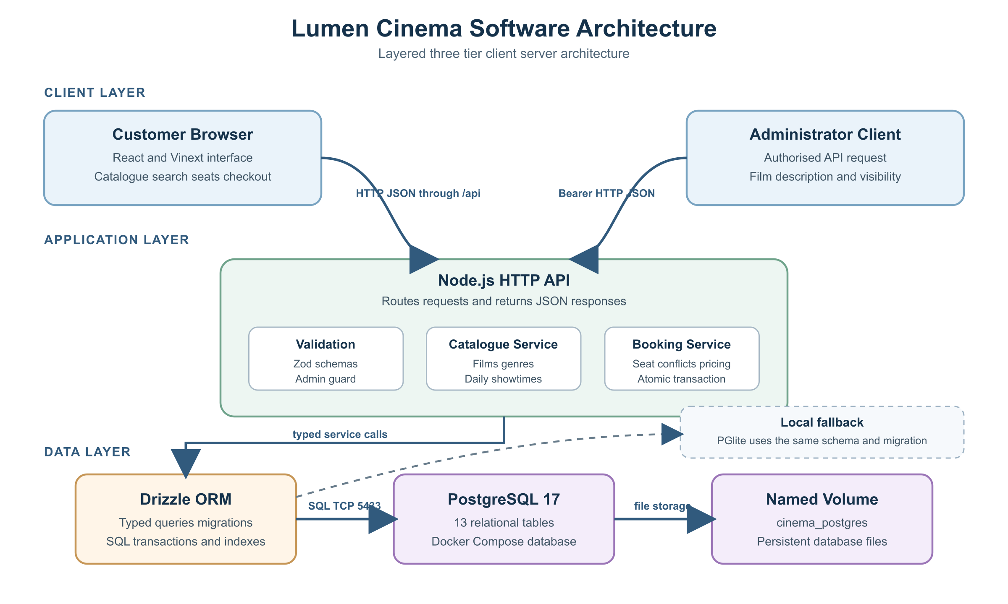
Figure 1. Lumen Cinema layered three-tier architecture

6. External Interface Requirements
6.1 User Interfaces
The customer interface shall include a header, language switcher, seven-day date selector, genre filters, responsive film catalogue, search dialog, movie details dialog, seat map, guest checkout form, success confirmation, error messages, retry action, mobile menu, and footer. Release 1 has no public account or payment screen.
6.2 Hardware Interfaces
No cinema-specific hardware is required for Release 1. The application requires a computer or mobile device with a browser, and the development environment requires sufficient storage for dependencies, the PostgreSQL image, and the named database volume.
6.3 Software Interfaces
The frontend uses React and Vinext. The API uses Node.js, Drizzle ORM, and Zod. The primary database is PostgreSQL 17 started by Docker Compose; PGlite is the local fallback. The API exposes health, catalogue, seat availability, guest booking, and protected film-update endpoints.
6.4 Communication Interfaces
During development the frontend listens on 127.0.0.1:3000 and proxies /api requests to the API on 127.0.0.1:3001. Requests and responses use HTTP and JSON. A production environment shall add HTTPS and a production-grade reverse proxy before handling real customer traffic.

7. Testing and Validation
7.1 Test Cases
The following acceptance cases provide traceability from requirements to observable results.
Test | Action | Expected result | Requirements
TC-01 | Choose each of the seven dates and inspect the programme. | Only active films and scheduled times for the chosen Tallinn date appear. | FR-01, FR-02
TC-02 | Search for Batman and apply each genre filter in all three locales. | Only matching localized catalogue entries remain and locale persists after reload. | FR-03, FR-04
TC-03 | Open a seeded screening with occupied seats and attempt invalid selections. | Hall and price match the database; occupied and invalid seats cannot proceed. | FR-06, FR-07
TC-04 | Submit invalid names, emails, unknown fields, and forged price or role values. | Invalid input is rejected and server-controlled values remain unchanged. | FR-08, FR-09
TC-05 | Send concurrent bookings for the same screening and seat. | Exactly one succeeds; the other receives 409; no partial booking remains. | FR-10, NFR-04
TC-06 | Complete a valid two-seat guest booking and restart the application. | A LUM reference is shown and the booking plus both tickets persist. | FR-11, NFR-09
TC-07 | Call the admin endpoint with no token, an invalid token, and a valid token. | Unauthorised calls return 403; the valid allowlisted update succeeds. | FR-12, NFR-03
TC-08 | Run backend tests, production build, migration, seed, and verifier. | Every required command exits successfully and the verifier reports no violation. | NFR-04, NFR-08
7.2 Validation Criteria
Release 1 is accepted when every mandatory FR and NFR has an executed test result, all automated backend tests and the production build pass, no severity-one or severity-two defect remains open, and the customer can complete the primary booking journey in each supported locale. Deferred features must remain clearly documented as out of scope rather than represented as complete.

8. Maintenance and Support
8.1 Maintenance Procedures
Schema changes shall update the Drizzle schema and generate a reviewed migration. Seed data shall run only on an empty application database. Before merging, the team shall run backend tests, the production build, and database verification. Database backups shall be taken before destructive migrations, and the named Docker volume shall not be removed during routine restart.
8.2 Support and Helpdesk
Defects and enhancement requests shall be recorded in the project repository with reproduction steps, expected result, actual result, environment, and severity. The team shall triage a reported blocking demonstration defect before the next scheduled presentation and document any workaround in the issue.

9. Appendices
9.1 Glossary
API: Application Programming Interface. ORM: Object Relational Mapper. SRS: Software Requirements Specification. GDPR: General Data Protection Regulation. Screening: a scheduled showing of a film in a hall. Booking: a guest reservation linked to one screening. Ticket: one reserved seat within a booking. PGlite: embedded PostgreSQL-compatible local development database. TTL: time to live for a cached response.
9.2 Revision History
Version 1.0 was prepared on 28 October 2026 for the Lumen Cinema Booking team and defines the initial testable Release 1 requirements.

