**3D Microphone Array**

**for Sound Sources Determination and Tracking**

Students: Nguyen Van Hoa Vu - Le Tu Quoc Nghi

# 1. Introduction

Vietnam is developing with a lots of metropolises rising rapidly. The goal of sustainable planning and development includes increasing living conditions. Beside good quality if air, food, water... noise control must be taken in account. Vietnamese law system has strictly regulations about sound level in particular residential area. In fact, there are rarely researching about sound level measuring in cites, which caused by expensive equipment, non-real time data and largescale requirements.

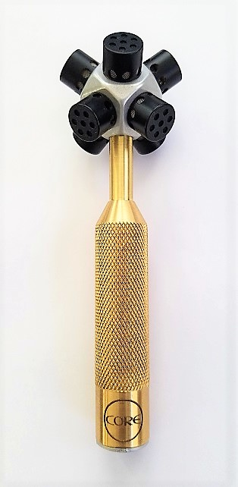

*Figure 1: Core sound octave microphone*

## 1.1 Objective

This project will cover 2 objects:

### 1.1.1 Low cost solution noise control

OTS (Off the shelf) will be used to minimized the price of final product satisfying the criteria: robustness, acceptable precision, be able to replace easily and mass productivity. Open source hardware and software will contribute significantly on building the project. Popular technologies such as: Zigbee, Raspberry Pi, Arduino, 3D printing will be considered.

### 1.1.2 Construct a 3D sound map combined with spherical coordinators

Many microphones will be place in multi-surface shape which has faces separately by walls. The icosahedron will be considered to use as below. This array of sensor will be read sequentially by ADC with multiplexing IC. Around 20 sensors will be attached to one central embedded computer which is compatible with previous system in 1.1.1. There will be one camera attaching fisheye lens (spherical camera) that is mapped with our microphone array. Therefore, sound level, indicated with color, should point exactly where and what the sound sources came from. High processing computers and optimal algorithms may help real time tracking the object generating sound. Ultrasound, subminiature or others kind of sound sensors working at specific spectra can be used to sense the medium in multi-spectra and multi-direction.

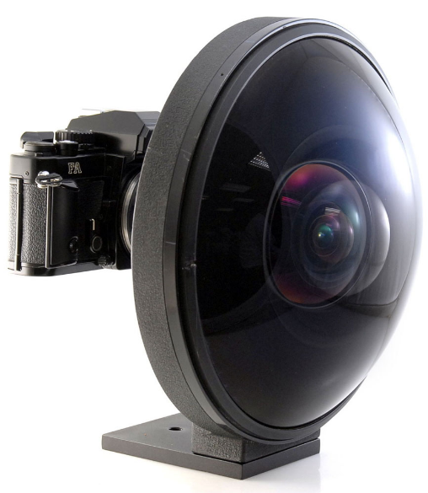

Figure 2: Fisheye lens attached to camera to capture a wide angles photos

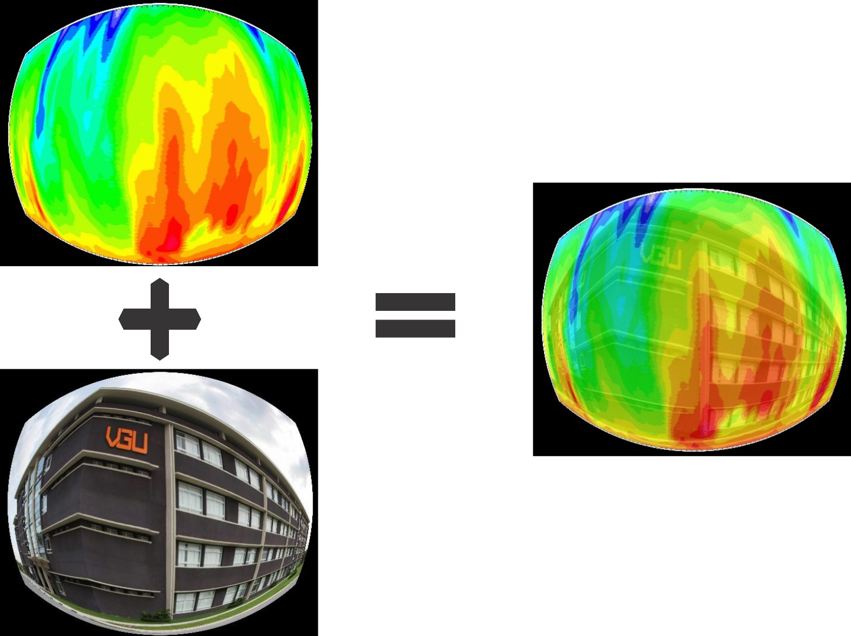

*Figure 3: A combination of contour and fish eye camera capture*

## 1.2 Background

People in Vietnam are dealing with serious noise pollution problem. The noise source may come from non-isolating building constructions, industrial zone, traffic, port, train stations, airport or even neighborhoods karaoke! Many cases reported that Ho Chi Minh city residents have damage in earing even they have no idea about. [1]

In market, there are sound level meter instruments working at IEC 61672-1, ANSI S1.4, ANSI S1.43 standards. However, the commercial products (Larson Davis, SEW, SNDWAY…) do not provide any developing functions which allowing customer can customize or modify the hardware and software. The regular price varies from $100 to $15000000 which is not affordable for low cost application

## 1.3 High-level requirement list

. The cost must be considered at first. General estimating for final product, price must not higher than $200 in total.

. Device can measure sound level from 10dbA to 120dBA with frequency varies from 100Hz to 10kHz. Tolerance is +/- 3dB

. Device has ability to self-calculating and detect noise source real time: maximum response must less than 50ms.

. Device can connect to the cloud and communicate with server.

# 2. Design

## 2.1 General block diagram

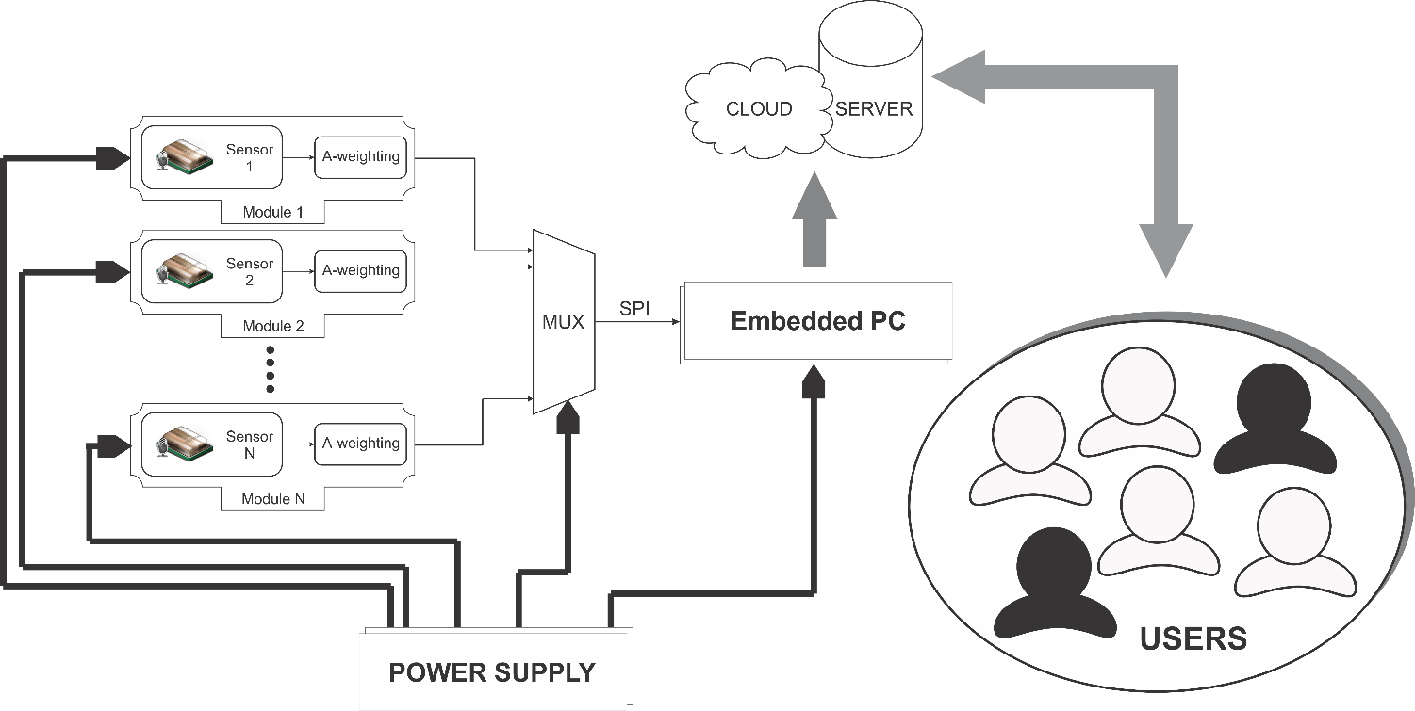

*Figure 4: Connections and links of a system including cloud interface*

### 2.1.1 Mems sensor array

Mems microphone consists of 2 main parts: Mems chip and ASIC, which is very small and low cost. It has wide applications especially on mobile devices. [2]

### 2.1.2 A-weighting filter

The audible sound is not listened at the same level through variable frequencies. For example, at the same power broadcasting, the sound at 100Hz must be listened differently from the sound at 1kHz [3]. The A-weighting filter will match the level sensed by the sensor to actual level that people can hear. There are more than one standards (B-weighting, C-weighting…) based on specific applications.

N sensors and filters should be integrated in one module.

### 2.1.3 Analog mux circuit

One ADC mux will take care the processing of reading from multiple sensors. This chip should communicate with center computer using SPI protocol which can handle high speed requirements.

### 2.1.4 Power control

This part takes care about the power regulation and monitoring.

### 2.1.4 Central computing

Embedded computer (Raspberry potentially) is used because these kind of things are getting more popular which will decrease the price rapidly. This will also provide higher speed on calculation and very flexible connectivity. Proposing connection is 3G cellular data.

### 2.1.4 Cloud and data analysis platform

This is a platform that processed data will be collected, analyzed and be available to access by users.

### 2.1.5 Users

Normal people or authorized users which have more control and accessibility.

## 2.2 Risk analysis

Analog circuits are difficult to implement at all time, it requires very low tolerance elements, which leads to the fail on constructing the A-weighting circuit.

Team members have no experience on IOT before, so that it takes time getting familiar to this field. The simple approaches (IOT platforms) would be consider such as Thingspeak, Blynk… which can be replaced in the long term because the project needs to be customized particularly.

The mapping technique of sound and photos takes much time to do research on math and simulation

# 3. Ethics and safety

High sensitive sensors used could sense any secrets communication arbitrarily. Sensitive information could be listened without warning coincidentally. Team members will discuss about the result and keep these as random data without sharing outside.

# 4. References

[1] Noise pollution in Vietnam, 2017 [ONLINE] <http://tapchimoitruong.vn/pages/...t-46567>

[2] What is MEMS Technology?, 2015 . [ONLINE] <https://www.mems-exchange.org/MEMS/what-is.html>

[3] Rod Elliott – ESP, ‘A-Weighting Filter For Audio Measurements’, [ONLINE] <http://sound.whsites.net/project17.htm>