MINISTRY OF EDUCATION AND TRAINING SOCIALIST REPUBLIC OF VIETNAM

VIETNAMESE GERMAN UNIVERSITY Independence – Freedom - Happiness

**APPLICATION FORM**

|  |  |
| --- | --- |
| Project title: | Satellite Ground Station Using Software-Defined Radio |

|  |  |  |  |
| --- | --- | --- | --- |
| Name: | Nguyễn Văn Hóa Vũ | DOB: | 06/12/1993 |
| Student ID: | 14979 | Phone: | 0932 932 121 |
| Faculty: | Faculty of Engineering | Program: | MSST |
| Address | 6A2, Lý Thường Kiệt, Ward 5, Mỹ Tho, Tiền Giang | Email: | 14979@student.vgu.edu.vn |

|  |  |  |  |
| --- | --- | --- | --- |
| Name: | Trần Anh Khoa | DOB: | 25/5/1997 |
| Student ID: | 9908 | Phone: | 0902 738 255 |
| Faculty: | Faculty of Engineering | Program: | ME |
| Address | 90/9, Vũ Tùng, Ward 2, Bình Thạnh District | Email: | Me2015_khoa.ta@student.vgu.edu.vn |

|  |  |  |  |
| --- | --- | --- | --- |
| Name: | Nguyễn Minh Dũng | DOB: | 15/04/1999 |
| Student ID: | 13482 | Phone: | 0931 023 914 |
| Faculty: | Faculty of Engineering | Program: | ME |
| Address | A26/10A, Bình Hưng Ward, Bình Chánh District | Email: | 13482@student.vgu.edu.vn |

|  |  |
| --- | --- |
| Supervisor: | Dr. Võ Bích Hiển |
| Department: | EEIT |
| Faculty | Faculty of Engineering |

|  |  |
| --- | --- |
| Supervisor: | Mr. Đỗ Hữu Minh Hiếu |
| Department: | GPEM |
| Faculty | Faculty of Engineering |

**I. Summary**

Small-size satellites are seriously in research not only for studying but also supporting the commercial purposes. Because of their tiny dimensions, it is convenient for the unique tasks such as: relaying signal, local area observing, environmental index measuring… which would down the price of both manufacturing and launching process. Therefore, small-size satellites are more and more be interested in.

Relating to jobs of satellites mentioned above, they need the system called Satellite Ground Station (SGS) for receiving control signals and communicating. Usually, the host (who has satellite launched) will own or renting one or some system for operating. However, orbit time of one satellite does not allow it to link to the SGS all the time. This is because most of small-size satellites work in LEO (Low earth orbit) and usually flight over the SGS twice per day. In the early orbit phase, all small-sized satellites are close for several days, even one month. All satellites developers are eager to assess the status of satellites as early as possible. The bigger orbit radius, the longer satellite can contact to its SGS. The problem is how to receive all the satellite signals simultaneously.

In the demand of getting signal as comprehensive as possible, people need to distribute SGS around the earth. This is nearly impossible because of boundary of nations and cost for building, operating and maintaining. The group of sharing private SGS seems to be a good solution. Individual owning SGS (so called Host) could join a network of sharing SGS. The requirements (bandwidth, rating, durability…) should be established when they join the network. People who wants to get signal from satellites (so called User) could match their requirements to suitable available SGS. To satisfying most various types of satellites in many frequencies, the SGS may have a mechanism to switch or turning between different frequencies which will easily be done using Software-Defined Radio (SDR).

Relating to SDR and its functionalities, generally understand that instead of using many hardware components in radio system design (mixers, filters, amplifiers…), the job is simplified by combined all of them in FPGA structure which allows hardware to be reconstructed by tuning parameters in computers. The benefits of SDR varies in areas form civilian to military, from class to industry. In satellite communication, the more sensitive ground station implies a higher quality of transmission between satellite and the earth. These day, SDR exponentially simplifies SGS design and increase the sensitivity based on it’s characteristic of low cost, portability and flexibility on solution.

VGU communication lab are equipped the USRP (Universal Software Radio Peripherals) which DSP engine and open-source SDR hardware designed by Matt Ettus. There is a tool call GNURadio providing an GUI mean to tune parameters of the SDR. The USRP are easily used to couple radio spectrum into digital world, and GNURadio can be used to manipulate the spectrum in digital domain. Being armed with transmitting and receiving capabilities, the possibilities of SDR to radio operator are endless.

**II. The project includes steps below:**

1. Doing comprehensive literature research on space engineering, spacecraft dynamic and satellite communicating.

2. Constructing azimuth and elevation rotational structure. Design and building the mechanical structure of universal-mounting rotary antennas. Figuring out the optimal solution for electrical system and design. Programing a software with graphic user interface helping people to control structure manually and automatically.

3. Observing satellites broadcasting signal using SDR with suitable antenna. The system should adapt with many frequencies.

4. Evaluating the performance and accuracy. Comparing with given projects if possible.

5. Finalizing and writing report.

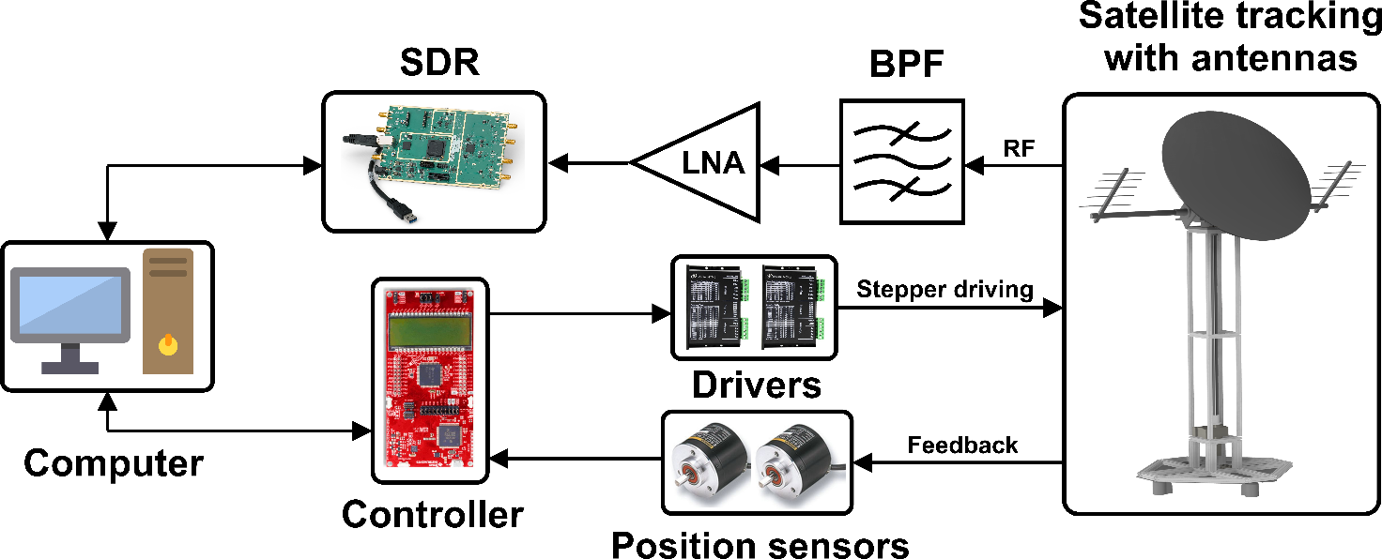

Figure: Flow of RF signal and tuning mechanism

**Detailed description:**

In the step one, we need to do research on previous relating problems to find the similarities for boosting the process. We will evaluate the demand of using SGS based on statistic information of satellites launched or going to be launch about: working frequencies, orbits, communicating and life time. The purpose of job is figuring out which suitable antenna and LNA we should use and economic benefit in the future. Moreover, we have to achieve the basic knowledge of spacecraft dynamic for and orbit studying for getting familiar with space positioning.

The work load in step two is very heavy. Firstly, we need to design a suitable structure which could be carry the universal-mount responsibility which means we want to mount as many kind of antenna as possible. The reason is about the SDR will work with many frequencies based on specific purpose, so the antennas must be suitable. The mechanical structure will allow the oriented antenna rotating in both azimuth and elevation axis. Secondly, the system requires appropriate motors and driving system as well as high precision electrical system. To manipulate this rotational system, we need to program a software running on computer to allow it working in both manual and automatic mode. The structure is expected to work outside with wind and rain resistance.

*We are currently working in this step and photos below are our results so far.*

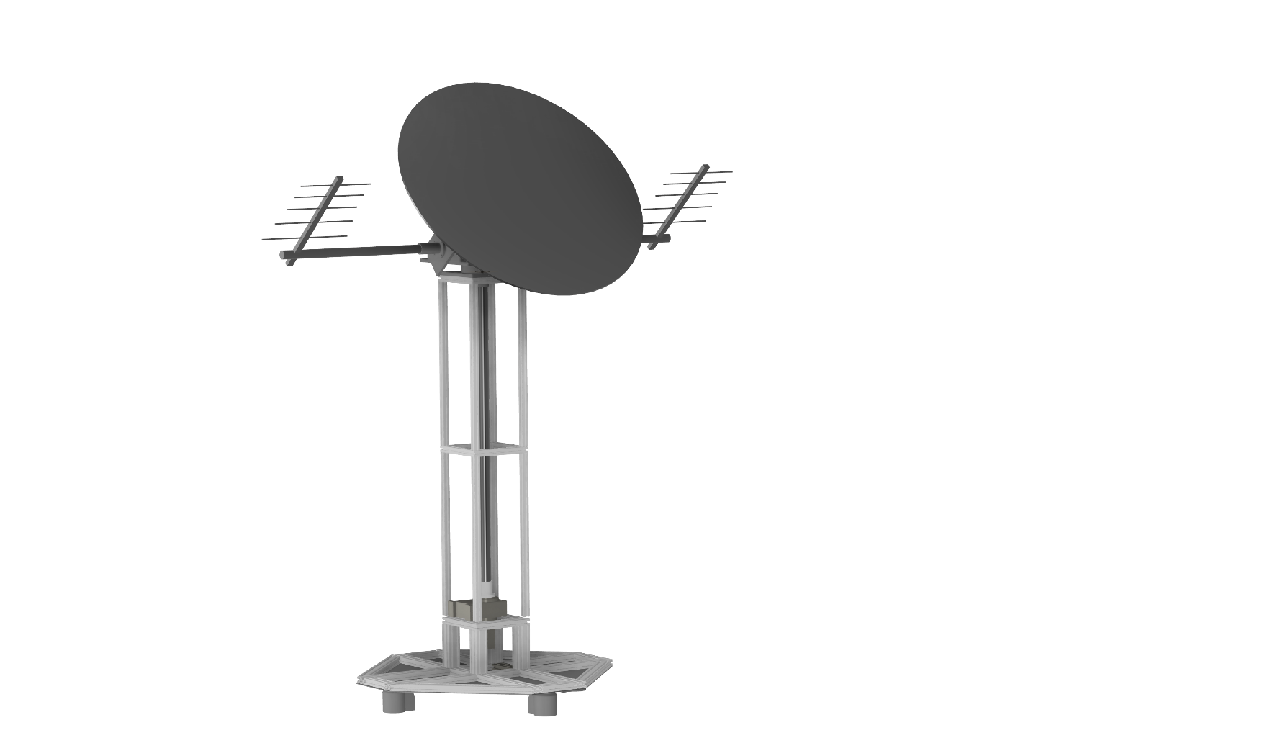



Figure: General CAD model of satellite tracking mechanism

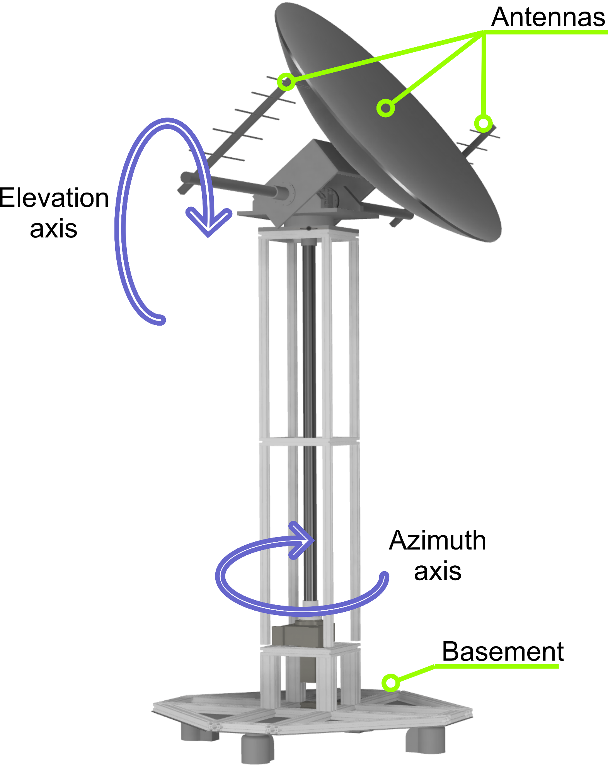

Figure: Working principle of rotary structure

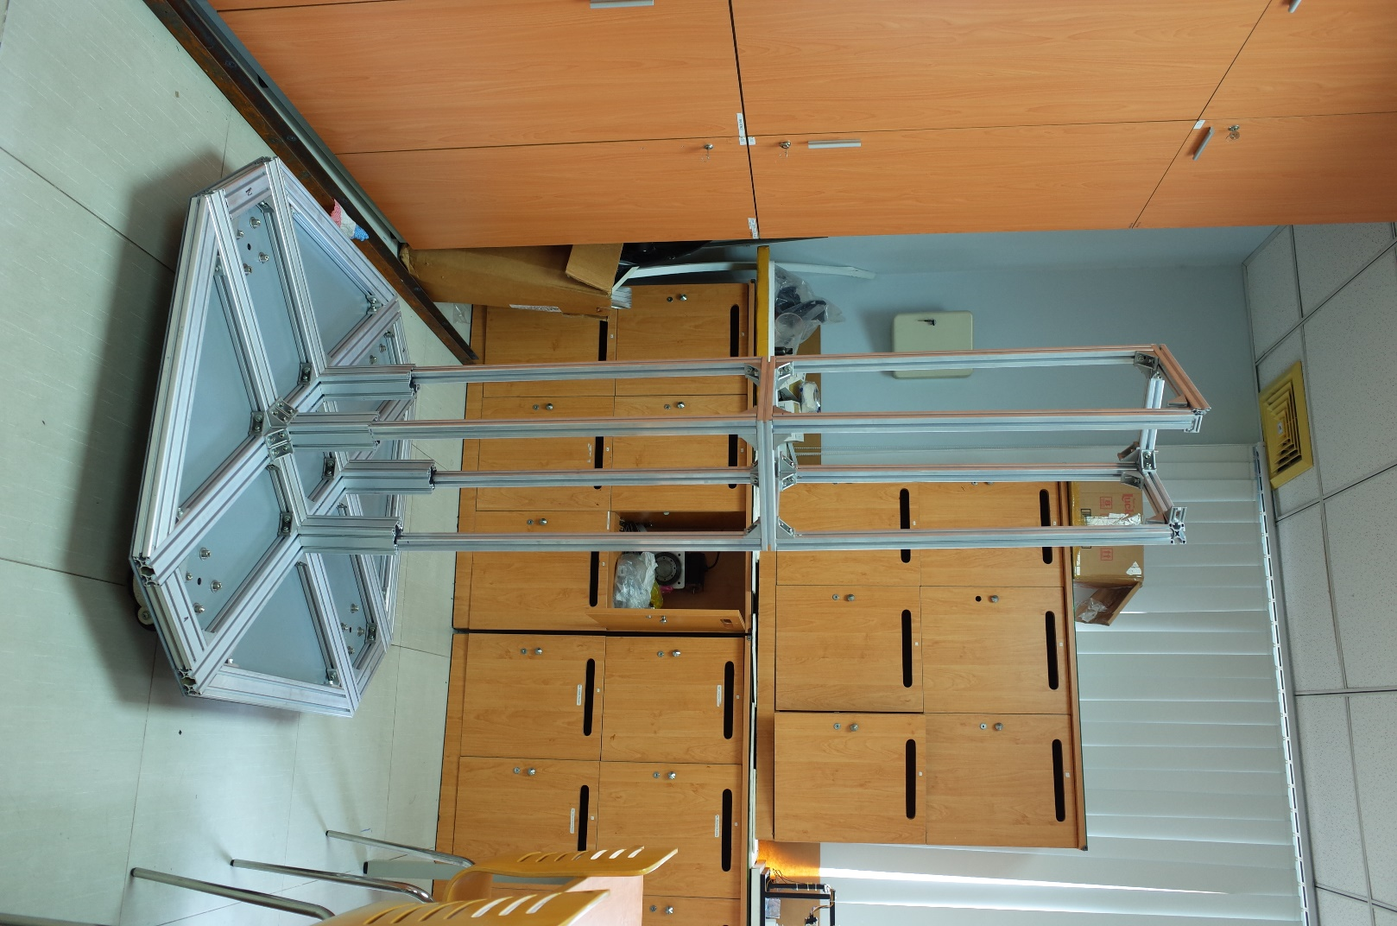

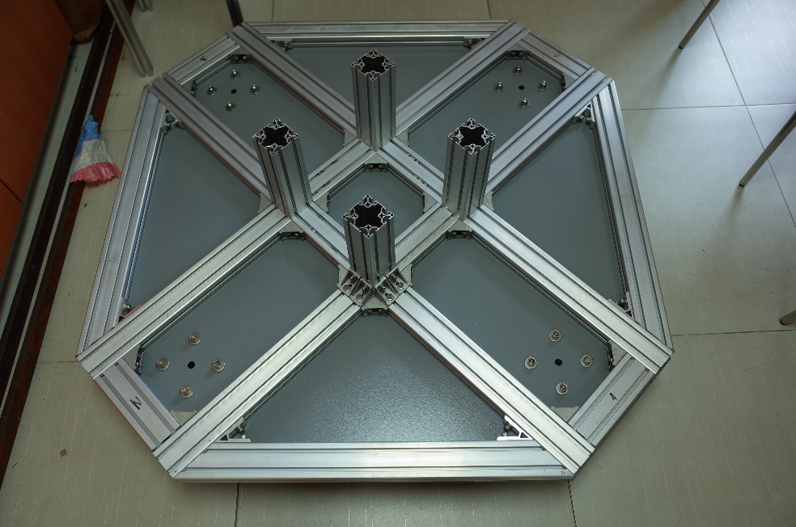

Figure: Structure body under constructing

In step three, we will work with SDR device which allows wide range frequency varying.

Using a GNURadio, it can be easily manipulated via block diagrams similar to Simulink. This stage will happen paralleling to the end of step two because while working with GNU radio, it will contribute some ideas for the software. The general idea of this is input the TLE (two-line elements which provide parameters about launched satellites) information of satellite and its working frequency, the rotary structure will point suitable antenna toward and keep tracking this satellite.

In the final step, we will summarize and write the report of the progress of this project. We will point out some important experience to develop later relating projects.

Expected outcomes:

|  |  |  |
| --- | --- | --- |
|  | Description | Criteria/Deliverable |
| Hardware | Two axes rotational system with universal mount for satellite tracking purpose and its controller working in both manual and automatic mode | . Mechanical frame  . Two axes with accuracy ±5 degrees and speed of 1 degree/second in minimum  . Have ability to be mounted:  + Parabolic antenna: 3m diameter, 20kg  + Two Yagi antennas: 0.5m x 0.5m x 2m, 5kg  . Wide range working frequency based on capacity of the used SDR (USRP B210: 70Mhz to 6Ghz) |
| Software | A program interfacing with SDR for frequency switching and signal processing | . Software to control the azimuth and elevation axis manually by tuning gauge in user interface.  . Software has availability to track the LEO satellite automatically.  . Software can interface with SDR, tuning frequencies.  . Software can receive the beacon signal and un-decoded downlink data. |
| Paper |  | Paper about Satellite ground station using SDR. |

In conclusion, in Vietnam, it is not only just a new project but also advanced. Being involve in this, we are going to take a big challenge because of the constraint of budget and time. However, the successful project will not only gain big opportunities for commercial benefits but also spark a light on space engineering research in VGU.

**III. Timeline (*)**

|  |  |  |  |  |  |  |
| --- | --- | --- | --- | --- | --- | --- |
| Step | From | To | Duration | Jobs | Detail | In charge |
| 1 | October 21st , 2018 | December 1st , 2018 | 1.5 months | Literature review and planning for the structure | Statistic the need of SGS | Vu |
| Satellite communicating | Vu |
| Dynamic of spacecraft | Khoa and Dung |
| Mechanism of structure | Dr Hien, Vu, Khoa and Dung |
| 2 | December 6th, 2018 | April 29th, 2019 | 5 months | Building rotary system | Detail design of mechanical structure | Dr Hien, Vu and Khoa |
| Construct the structure | Vu, Khoa and Dung |
| Design electrical system | Dr Hien and Vu |
| Software programing and graphic user interface | Vu |
| 3 | February 1st, 2019 | May 29th, 2019 | 4 months | SDR research | Interfacing with SDR to turning frequency and signal processing | Vu |
| Construct antenna feed line and switching | Dr Hien anh Vu |
| Combine the SDR part to software at step 2 | Vu |
| 4 | June 1st , 2019 | August 15th, 2019 | 2.5 months | Evaluate the model | Evaluate the accuracy of orienting | Dr Hien, Khoa and Dung |
| Perform the tracking ability on broadcast signal of satellite | Dr Hien and Vu |
| 5 | August 20th, 2019 | October 1st, 2019 | 1.5 months | Complete the report and papers | Writing report | Vu, Khoa and Dung |
| Paper for rotary part | Khoa and Dung |
| Paper for SDR part | Vu |

*\* Estimated timeline is set up based on our team current financial status expected receiving granting before March, 2019*

**IV. Budget plan**

|  |  |  |  |
| --- | --- | --- | --- |
| Item | Estimated cost | Request funding | Note |
| Aluminum frame and accessories | 6.000.000 VND | 6.000.000 VND | **Already paid in advance**  This is used for constructing the frame on ground station. Which is popular in industry because of its convenience in high load strength and assembling easily  Káº¿t quáº£ hÃ¬nh áº£nh cho aluminum profile |
| Aluminum sheet and billet | 3.000.000 VND | 3.000.000 VND | **Already paid in advance**  Aluminum sheet (6061 type) is used to fabricating parts of rotating structure.  Káº¿t quáº£ hÃ¬nh áº£nh cho aluminum material |
| Motor drive system (with controllers) | 8.000.000 VND | 8.000.000 VND | **Already paid in advance**  Harmonic and worm gear drive are for capacity of high load and precision.  Káº¿t quáº£ hÃ¬nh áº£nh cho harmonic drive motor |
| Main controller | 2.000.000 VND | 2.000.000 VND | Proposed to use the MSP432 launchpad or similar device which can provide real time calculation.  Káº¿t quáº£ hÃ¬nh áº£nh cho msp432p4111 |
| PCB manufacturing and circuit components (power ICs, transistor, resistor…) | 3.000.000 VND | 3.000.000 VND | Some PCB would be made for attaching the main controller to connecting many peripherals. |
| Wire and connector for cable management | 1.000.000 VND | 1.000.000 VND |  |
| Parabolic antenna and Yagi antenna | 10.000.000 VND | 10.000.000 VND | Based on market research, one 3m parabolic antenna (around 30dBi) has price of nearly $300 and one Yagi is about $50  https://sc01.alicdn.com/kf/HTB1AFcdKFXXXXX.XFXXq6xXFXXXr/200314768/HTB1AFcdKFXXXXX.XFXXq6xXFXXXr.jpg  Káº¿t quáº£ hÃ¬nh áº£nh cho yagi antenna |
| LNA filter, SMA, RF accessories | 2.000.000 VND | 2.000.000 VND | Káº¿t quáº£ hÃ¬nh áº£nh cho LNA s band |
| Manufacturing | 10.000.000 VND |  | Will be proposed to use CNC machines in GPEM labs |
| Labor | 60.000.000 VND |  | Brief estimate based on general working hours of team members |
| Misc (screws, nuts, spray, pulley, bearing, wheels, drills…) | 2.000.000 VND | 2.000.000 VND | **Already paid in advance** |
| Total | 107.000.000 VND | 37.000.000 VND | We already paid 19.000.000 VND in advance to start working seriously on this project. |

**ACADEMIC ADVISIORS**

I have reviewed this project description and projected budget, and I support this master research grant request.

*Supervisor’s signature date*

I have reviewed the mechanical parts and I support this master project on its designing and manufacturing.

*Supervisor’s signature date*

**ACADEMIC RESEARCH**

The proposed undergraduate research project is supported by the following research grants solely or jointly administered by me (*leave blank if not applicable)*:

*Supervisor’s signature*

|  |
| --- |
| Grant title: |
| Principal Investigator: |
| Project number: |
| Source of funding: |

**DO NOT WRITE BELOW THIS LINE**

(This part is filled in by the Chair of the Evaluation Committee)

*Comments:*

*Decision*:

*Funded amount:*

*Date:*

*Signature:*

*Name:*