**ABSTRACT**

LocalDeals is an online platform designed to address the challenge of establishing a localised online community that facilitates seamless communication between local community members, businesses and organisations. Community members can access local products and share them with their colleagues. They can also discover new experiences in the community, learn new skills online and even offline as well as emerging interests in their community.

The primary objective of this research is to create a web application that harmoniously blends the concept of local communities with the integration of user requirements and an effective implementation strategy for successful implementation.

The literature review offers an in-depth exploration of local communities and existing localised platforms, delving into best practices for designing these platforms.

The research methodology encompasses requirements gathering, involving user analysis to collect both functional and non-functional requirements. Additionally, this phase involves the development of user cases and stories to enhance the understanding of user preferences and needs.

The design phase revolves around the creation of system architecture, user interface design, database architecture, and the development of system integration and data flow diagrams.

In the development phase, we select the technology stack, build both the frontend and backend, conduct comprehensive testing and quality assurance, and devise effective deployment strategies.

The implementation phase entails user testing and onboarding, the development of a launch strategy and rollout plan, marketing and promotional activities, and the integration of user feedback for iterative improvements.

Lastly, the maintenance phase includes bug fixes, technical support, feature updates and enhancements, and the implementation of security and performance optimization measures to ensure the smooth operation of LocalDeals. This study carries significant implications for the design and development of localised community platforms that seamlessly incorporate local commerce and communal features, providing valuable insights for both industry practices and future research endeavours.

**CHAPTER 1: INTRODUCTION**

## **1.1 CHAPTER OVERVIEW**

**1.2 BACKGROUND OF THE STUDY**

The digital age has transformed the way people connect and interact with their surroundings and local communities. The proliferation of smartphones and location-based services has opened up new avenues for individuals to engage with their immediate physical environments. This shift has given rise to a range of innovative platforms and applications designed to facilitate connections within local communities. In this context, LocalDeals emerges as a noteworthy web application, specifically designed to enhance the experience of users within a defined geographic area.

In the past, local communities often relied on physical gatherings, word-of-mouth communication, and local publications to stay informed about local events, trade opportunities, and shared interests. However, in today's fast-paced and digitally connected world, people are seeking efficient, real-time, and user-friendly methods to engage with their local communities.

LocalDeals leverages the capabilities of modern web technology and geolocation services to address this need. By providing users with a dynamic platform that promotes local trade, community engagement, and the sharing of interests and local alerts, LocalDeals aligns itself with the changing landscape of local interactions. The application facilitates connections, promotes local commerce, and fosters a sense of belonging within local communities.

As local communities continue to evolve and adapt to the digital age, LocalDeals aims to play a vital role in connecting residents, local businesses, event organisers, and community administrators. By enabling seamless interactions and efficient communication, LocalDeals is poised to contribute significantly to the vibrancy of local communities, ultimately enhancing the quality of life for its users.

This research paper embarks on an exploration of LocalDeals, examining its development, features, user behaviour, competition, and best practices for its design. Through this research, we seek to provide a comprehensive understanding of the platform and its significance within the context of location-based community web applications.

**1.3 PROBLEM STATEMENT**

As people increasingly turn to digital platforms to meet their communication and trade needs, several issues have emerged:

* Fragmented Local Engagement: Traditional local communication channels, such as community bulletins and physical gatherings, have been disrupted by digital alternatives, leaving communities fragmented and less connected.
* Lack of Efficient Trade Opportunities: Local businesses and individuals often struggle to efficiently list, sell, or exchange goods and services within their geographic vicinity.
* Information Overload: The sheer volume of information available in digital environments can overwhelm individuals, making it challenging to access relevant local information, interests, and alerts.
* Privacy and Security Concerns: Users are increasingly concerned about the privacy and security of their data in digital environments, leading to hesitance in sharing and engaging within local communities.
* Limited User-Friendly Platforms: The lack of user-friendly platforms catering to local interactions hinders the seamless exchange of information, trade, and interests.

These challenges underscore the need for a location-based web application that not only addresses these issues but also encourages efficient communication, trade, and community engagement within local neighbourhoods.

**1.4 OBJECTIVES OF THE STUDY**

The primary objective of this research is to design and develop a location-based web application called LocalDeals to address the challenges faced by local communities in the digital age. To achieve this overarching goal, the study is guided by the following specific objectives:

* Create a Local Network: Develop a robust system for users to connect and engage with others in their local community. This objective aims to strengthen local bonds and encourage meaningful interactions among community members.
* Facilitate Trade: Enable users to efficiently list, sell, or exchange items with people nearby. This objective seeks to provide a seamless and user-friendly platform for local trade and commerce.
* Promote Community Engagement: Encourage users to share and discover common interests, local events, and activities. This objective emphasises the importance of community engagement and interaction.
* Local Alerts: Implement a notification system for sharing critical information within the community. This objective addresses the need for rapid dissemination of local alerts, enhancing community safety and awareness.
* User-Friendly Interface: Create an intuitive, responsive web application accessible on various devices. This objective focuses on delivering a user-centric platform that caters to the diverse needs of the community members.

**1.5 SCOPE AND LIMITATIONS**

1.5.1 SCOPE OF THE STUDY

The research on LocalDeals is primarily focused on the design, development, and implementation of the location-based web application within the context of local communities. The study encompasses various aspects related to the functionality and usability of the LocalDeals platform. It includes:

* User-centric design and interface development.
* Geolocation integration and the provision of location-based services.
* Real-time messaging and notification systems.
* Trade and marketplace features for local commerce.
* The establishment of local community networks and events.
* Security and data privacy measures.
* User behaviour analysis and trends.

1.5.2 LIMITATIONS

While this research aims to provide a comprehensive and user-focused solution, it is essential to acknowledge certain limitations:

* The study focuses on the design and initial implementation of the LocalDeals platform. Continuous updates and improvements may be required to meet evolving user needs and technological advancements.
* User adoption and community participation are essential for the platform's success. However, the study does not guarantee widespread adoption and user engagement.
* The geographical scope of this research is limited to the development of LocalDeals within specific geographic areas. Extending the platform to other regions and communities may require additional research and resources.
* Technical challenges, such as system performance and scalability, will be addressed during the initial development phase, but long-term scalability and performance under heavy user loads may require ongoing optimization.

**1.6 SIGNIFICANCE OF THE STUDY**

The research on LocalDeals carries significant importance due to the following reasons:

* Enhancing Local Community Connectivity

LocalDeals contributes to fostering stronger local communities by connecting residents, small businesses, event organisers, and community administrators. It facilitates communication, trade, and information sharing among community members.

* Supporting Small Businesses

The platform provides an avenue for small businesses to promote their products and services within their local communities. This not only aids local economic growth but also offers consumers a way to discover and access local businesses easily.

* Encouraging Social Engagement

LocalDeals encourages local residents to interact with one another, share common interests, and participate in local events and activities. This fosters a sense of belonging and strengthens community bonds.

* Ensuring Local Alerts

The inclusion of a notification system allows for the swift sharing of important local information, emergencies, and updates. This can be critical in ensuring community safety and awareness.

* 5. User-Centric Design

LocalDeals is designed with a user-centric approach, making it accessible and intuitive for a wide range of users. Its user-friendly interface and responsive design cater to various devices and user preferences.

This research is significant as it addresses the need for a location-based platform that focuses on local community engagement. By enabling users to connect, trade, share, and stay informed within their local communities, LocalDeals aims to enhance the quality of life for residents and support the growth of local businesses. The findings and outcomes of this study have the potential to contribute to a thriving, more interconnected, and informed local community environment.

**CHAPTER 2: LITERATURE REVIEW**

## **2.1 CHAPTER OVERVIEW**

The literature review in this chapter delves into the significant aspects of location-based platforms and their impact on local communities, including economic dynamics and social interactions. It provides an essential backdrop to understand the context in which LocalDeals operates.

**2.2 OVERVIEW OF LOCATION BASED PLATFORMS**

This section investigates the historical evolution of location-based platforms and their pivotal role in shaping local communities. Location-based platforms have witnessed a transformation in the digital era, influencing local economies and social interactions. By understanding their historical development, we gain insights into how these platforms have evolved and the changing dynamics they have introduced.

2.2.1 NEXTDOOR - A LOCAL SOCIAL NETWORK:

Nextdoor is a local-based social network designed to connect residents within specific geographic neighbourhoods, fostering community engagement and interaction. This platform allows neighbours to share information, discuss local issues, and promote events or services. Users can access a hyper-local platform that encourages neighbourly support, from recommendations for local businesses to safety alerts. Nextdoor provides a valuable platform for enhancing social bonds and addressing communal concerns (Nextdoor, 2023).

2.2.2 YELP - A LOCAL BUSINESS REVIEW SITE:

Yelp is a prominent local business review platform that facilitates user-generated reviews and recommendations for businesses, restaurants, and services. Founded in 2004, Yelp has become a go-to resource for consumers seeking information about local establishments. Users can share their experiences, rate businesses, and provide detailed feedback. Yelp's platform helps people discover new places and make informed decisions when choosing where to dine, shop, or access various services. It has transformed the way individuals interact with local businesses and has had a significant impact on the consumer landscape (Yelp, 2023).

**2.3 FEATURES AND FUNCTIONALITIES**

Common features found in location-based platforms similar to LocalDeals.

* Location Detection: Location-based platforms utilise GPS or other geolocation technologies to identify the user's position accurately. This feature enables the platform to provide relevant, location-specific information and services.
* User Profiles: Users can create and manage profiles that include personal details and location information. Profiles often serve as a foundation for social interactions and tailored services.
* Location-Based Search: Users can search for other users, events, or businesses based on their proximity. Location-based search functionality helps users discover local content.
* Real-Time Messaging: Messaging features enable users to communicate with each other in real time. Whether it's connecting with nearby individuals or engaging in local group chats, real-time messaging is a fundamental aspect of these platforms.
* Local Marketplace: Many location-based platforms offer a marketplace for buying, selling, or trading items and services within the local community. This feature promotes local commerce and can benefit small businesses and individual sellers.
* Community Groups: Users can join or create local community groups. These groups serve as hubs for shared interests, local events, and activities. They help users connect with like-minded individuals in their vicinity.
* Event and Activity Sharing: Location-based platforms often allow users to share and discover local events, activities, and attractions. This feature encourages community engagement and helps users stay informed about local happenings.
* Local Alerts and Notifications: Users can receive real-time alerts and notifications related to their location. These alerts may include emergency notifications, special deals, or local news updates.
* User Reviews and Recommendations: Some platforms incorporate user-generated reviews and recommendations for local businesses, services, and points of interest. This feature aids in local decision-making and supports community businesses.

**2.4 USER BEHAVIOUR AND EMERGENT TRENDS**

User behaviour in location-based platforms exhibits several key characteristics:

* Proximity Sensitivity: Users are highly sensitive to proximity. They actively seek local content, events, and people nearby. Location-based platforms enable them to connect with others and explore local opportunities.
* Spontaneous Engagement: Many users engage with location-based platforms spontaneously, driven by real-time information and opportunities leading to more immediate and dynamic interactions.
* Interest-Based Connections: Users often connect with others based on shared interests, activities, local events and communities aligned with their preferences.
* Local Commerce: Users show a strong interest in local commerce, both as consumers and sellers.
* Exploration and Discovery: Location-based platforms encourage users to explore and discover local businesses, attractions, and experiences.

Emerging Trends in Location-Based Platforms

* Hyper-Personalization: Platforms are increasingly personalising user experiences. They utilise user data to provide tailored content and services, enhancing user engagement and satisfaction.
* Sustainability and Local Initiatives: Users are showing a growing interest in sustainability and supporting local businesses.
* Integration with Internet of Things (IoT): Location-based apps can be integrated in real estate by enabling users to view properties equipped with smart locks and CCTV.
* Social Impact and Civic Engagement: Platforms are fostering social impact and civic engagement by encouraging users to participate in local initiatives, charity events, and community projects.

**2.5 COMPETITION ANALYSIS**

Major competitors in this space are not yet based in Kenya.

* Yelp: Yelp is a platform that focuses on business reviews, user recommendations, and local search. Users can explore local businesses, read reviews, and share their experiences. It's a valuable resource for those seeking information about local businesses.
* Nextdoor: Nextdoor is a private social network that connects neighbours and local communities. It encourages neighbours to communicate, share information, and assist one another with local matters. It emphasises local community building and engagement.

Major Competitors based on Kenya:

* Jiji.co.ke is a prominent online classifieds platform in Kenya, offering a wide range of products and services. It has a large user base and is known for its extensive listings, particularly in categories like electronics, real estate, and jobs. Jiji.co.ke benefits from strong brand recognition and a user-friendly interface.. However, it also faces challenges related to user trust, fraud prevention, and maintaining a safe marketplace for buyers and sellers in the online space.
* Glovo, operating in Kenya, sets itself apart by offering a wide variety of products, including groceries and pharmacy items, in addition to food delivery. Glovo's advantage lies in its quick delivery times and extensive partner network, but it also faces challenges related to maintaining delivery quality and managing a diverse range of items. Glovo is well-positioned to capture the growing demand for convenience in Kenya's urban areas.

LocalDeals distinguishes itself in the location-based platforms landscape by combining various elements of personal connections, localised business support, and community engagement.

**2.6 BEST PRACTICES FOR LOCATION-BASED PLATFORM DESIGN**

* User-Centred Design: Prioritising user experience involves intuitive navigation, clear interfaces, and personalization options.
* Data Privacy and Security: Implementing robust data privacy and security measures. Users entrust their location data,
* Scalability: Designing the platform with scalability in mind to accommodate growth in user numbers and data. The platform should remain responsive and reliable.
* Interactivity: Promoting user engagement through interactive features including real-time interactions, messaging, and notifications.
* Personalization: Offering users personalised experiences based on their location and preferences. Tailored content and recommendations make the platform more valuable.
* Community Building: Encouraging the development of local communities and fostering connections among users. Communities should be inclusive and reflect the diverse interests and needs of local residents.
* Mobile Responsiveness: Optimising the platform for mobile devices. Many users access location-based services through mobile apps, so responsiveness is crucial.
* Feedback and Iteration: Creating mechanisms for user feedback and incorporating user suggestions. Platforms should evolve based on user input and changing trends.

**CHAPTER 3:RESEARCH METHODOLOGY**

3.1 CHAPTER OVERVIEW

**3.2. TARGET AUDIENCE**

The target audience for LocalDeals encompasses local residents, small businesses, event organisers, and community administrators. Local residents are individuals seeking to connect and engage with others in their immediate geographic area. Small businesses view LocalDeals as an opportunity to reach potential customers within their locality. Event organisers leverage the platform to promote local events and activities. Community administrators, responsible for disseminating vital local alerts, find an efficient channel in LocalDeals to share essential information with their communities.

**3.3 SAMPLING**

Sampling is a crucial aspect of the research process, enabling us to draw meaningful insights from a manageable subset of the population. Given the diverse nature of LocalDeals' target audience we picked a group of 21 people to help us learn about our LocalDeals users. We chose them carefully to represent all the different types of people who might use our platform. This way, we can make sure that what we find out from these 21 people can help us understand all the people who use LocalDeals.

**3.4 DATA COLLECTION TECHNIQUES**

Data collection is the process of gathering information on values of interest in a systematic manner that enables one to answer stated research questions and evaluate outcomes.

The data collection techniques used for this study include questionnaires. This technique was used in the requirement gathering stage, after which the information and data collected was used for the design and development of the system.

3.4.2 QUESTIONNAIRE

The questionnaires used in the study were designed to capture as accurate information as possible. Two questionnaires were developed. One was used to determine the need and requirements for the development of LocalDeals. The second was used to gauge the impact of LocalDeals in its public usage setting.

The procedure used in the first questionnaire is as follows:

* Begin with a brief introduction to thank participants for their involvement in the survey.
* Clearly state the importance of their feedback in understanding the need for a local community web app like LocalDeals.
* Start by collecting demographic information, such as age, gender, and location. This data helps in understanding the characteristics of the respondents.
* Assess the respondents' level of local engagement by asking how frequently they participate in local community events or activities.
* Inquire about their awareness of local events or deals, which provides insights into their knowledge of local offerings.
* Determine if participants currently use online platforms for local community interaction. This helps identify their existing engagement channels.
* Gauge satisfaction with their current platforms, allowing for an understanding of the pain points in their current interactions.
* Evaluate the perceived value of a platform like LocalDeals in facilitating local community interaction.
* Allow respondents to specify the features they'd like to see in LocalDeals, which helps in shaping the platform's development according to user preferences.
* Offer an open-ended question for participants to share any additional comments or suggestions regarding the need for a local community web app like LocalDeals.
* Conclude by thanking the participants again for their valuable input.

The procedure followed in the second questionnaire is as follows:

* Introduction: Users are introduced to the questionnaire with a brief explanation of its purpose. They are informed that their feedback is essential for platform improvement.
* Demographic Information: Users are asked to provide basic demographic details, including age, gender, and location. This information helps categorise and segment the responses.
* LocalDeals Usage: Questions about the frequency and duration of LocalDeals usage help gauge user engagement and the extent of their experience with the platform.
* User Experience: Users are asked to rate their overall satisfaction with LocalDeals and assess its user-friendliness. They are also given the opportunity to report any technical issues or bugs they've encountered.
* Feature Satisfaction: Users are asked if they believe the features and functionalities of LocalDeals meet their expectations and needs. This helps identify areas that may require improvement.
* Impact Assessment: Users are prompted to evaluate how LocalDeals has impacted their local community engagement and whether they've connected with other users in their community. They are also asked to assess how the platform has influenced their knowledge of local events and activities.
* User Stories: Users are encouraged to share specific stories or experiences where LocalDeals has positively impacted their local community involvement. This provides qualitative insights into the platform's real-world effects.
* Suggestions and Feedback: Users are asked to provide input on new features or improvements they would like to see in LocalDeals. They are also encouraged to share any additional comments, suggestions, or feedback.
* Conclusion: In conclusion, users are thanked for their participation, and their feedback is acknowledged as valuable in ongoing efforts to enhance the LocalDeals platform. Users are assured that their input will contribute to making LocalDeals even better for them and their local communities.
* Data Collection: The responses collected are processed and analysed to draw conclusions and make informed decisions about potential improvements to the LocalDeals platform. Data analysis tools and techniques are used to generate insights from the collected data.

The questionnaires enabled easy data collection from a large number of respondents.

The setbacks involved while using this method are:

1. The respondents gave irrelevant answers.

2. It was time consuming to sample responses.

3. It requires a lot of resources to print and distribute questions to respondents.

**3.5. DATA ANALYSIS**

First Questionnaire:

* Participants satisfied with the current platforms: 24%.
* Participants dissatisfied with the current platforms: 33%.
* Participants neutral about their satisfaction with current platforms: 14%.
* Participants aware of local events: 76%.
* Participants not aware of local events: 24%.
* Participants who use online communities: 76%.
* Participants who do not use online communities: 24%.
* Participants who find LocalDeals valuable: 67%.
* Participants who do not find LocalDeals valuable: 33%.
* Participants who look forward to real-time local deals: 71%.
* Participants interested in local event listings: 81%.
* Participants eager to explore community groups and forums: 62%.
* Participants interested in neighbourhood alerts: 29%.
* Participants seeking access to local business listings: 52%.
* Participants enthusiastic about local engagement: 62%.
* Participants who expect enhanced local event awareness: 62%.
* Participants curious about local business offerings: 29%.
* Participants anticipating a more vibrant local community: 62%.
* Participants hoping for better access to local businesses: 33%.
* Participants excited about potential local deals: 43%.
* Participants seeking local business connections: 14%.
* Participants interested in improved local communication: 38%.

Second Questionnaire:

| Age:   * 18-24: 23.8% * 25-34: 19% * 35-44: 19% * 45-54: 19% * 55 and above: 19% | Gender:   * Male: 57.1% * Female: 42.9% |
| --- | --- |
| Location:   * Urban: 57.1% * Suburban: 28.6% * Rural: 14.3% | LocalDeals Usage:   * Less than 3 months: 14.3% * 3-6 months: 28.6% * 6-12 months: 28.6% * More than 12 months: 28.6% |
| User Type:   * Local Resident: 42.9% * Small Business Owner: 28.6% * Event Organiser: 19% * Community Administrator: 9.5% | Satisfaction:   * Very Satisfied: 42.9% * Satisfied: 42.9% * Neutral: 0% * Dissatisfied: 0% * Very Dissatisfied: 0% |
| User-Friendly:   * Very User-Friendly: 57.1% * User-Friendly: 42.9% * Neutral: 0% * Not User-Friendly: 0% * Very Not User-Friendly: 0% | Technical Issues:   * Yes: 42.9% * No: 57.1% |
| Feature Satisfaction:   * Yes: 76.2% * No: 23.8% | Impact on Community Engagement:   * Positive Impact: 90.5% * No Impact: 9.5% * Negative Impact: 0% |

3.5.1 RESEARCH METHODOLOGY CONCLUSION

The diverse sample of respondents, representing different age groups, genders, locations, and user types, has allowed us to gain a comprehensive understanding of the platform's usage and impact.

The study has revealed that LocalDeals has a positive impact on community engagement, with the majority of respondents acknowledging its role in enhancing local interactions and connections.

**3.6 SYSTEM DEVELOPMENT METHODOLOGY**

Methodologies in System development are principles or rules from which specific methods or procedures may be derived to solve different problems within the scope of a particular discipline.

Here are some of the Development methodologies considered:

3.6.1 RAPID PROTOTYPING

The prototyping model is a valuable consideration for the development of LocalDeals, as it aligns well with the dynamic and user-centric nature of the platform.

Key Consideration points include:

* **User-Centric Design**: LocalDeals is intended to serve a diverse user base, including local residents, small businesses, event organisers, and community administrators. The prototyping model emphasises involving end-users in the design and development process, ensuring that the final product aligns with their needs and preferences. It allows for continuous feedback and refinement, resulting in a user-friendly and effective platform.
* **Iterative Development**: Prototyping encourages iterative development, where developers create a series of increasingly refined prototypes. This approach is beneficial for a complex and evolving platform like LocalDeals. It allows the development team to adapt to changing requirements, incorporate new features, and address emerging challenges as they arise.
* **Visualisation of Features**: Prototypes provide a visual representation of the platform's features and functionalities. This is especially helpful for LocalDeals, which offers various features, including user profiles, local marketplaces, messaging, and notifications. Prototypes allow stakeholders to see how these features will work in practice and make informed decisions based on real-world usability.
* **Risk Mitigation**: The prototyping model helps in identifying and mitigating risks early in the development process. It allows for the detection of issues and potential bottlenecks before full-scale development, reducing the likelihood of costly corrections or redesigns later on.
* **User Engagement**: In the context of LocalDeals, user engagement is crucial. Prototyping enables users to interact with a functional representation of the platform, providing valuable feedback. This interaction helps in refining features, enhancing usability, and ensuring that LocalDeals resonates with its target audience.
* **Flexibility:** The prototyping model is flexible and accommodates changes. Given that LocalDeals may need to adapt to user feedback and changing market dynamics, this flexibility is a significant advantage. It allows for quick adjustments and refinements to keep the platform relevant and competitive.
* **Reduced Development Costs**: While initial prototyping may seem like an additional step, it can ultimately save development costs. By catching design and functionality issues early, developers can avoid costly rework and ensure that resources are used efficiently.

3.6.2 WATERFALL MODEL

It's important to discuss the model's strengths and potential applicability to LocalDeals:

* **Structured Approach**: The Waterfall Model follows a structured and sequential process. Given that LocalDeals is a complex web application with numerous features, this approach can ensure that each phase is completed thoroughly before moving on to the next. It could help in managing the project effectively.
* **Requirements Clarity**: LocalDeals requires a clear understanding of user needs and preferences. The Waterfall Model's initial phase focuses on gathering and documenting requirements comprehensively. This could be beneficial in defining the scope of the project.
* **Documentation**: This model emphasises extensive documentation. In the case of LocalDeals, clear documentation of design, features, and functionality can be essential for future development or updates.
* **Reliability and Security:** The Waterfall Model is well-suited for projects where reliability and security are paramount. LocalDeals may deal with sensitive user data, and ensuring its security is a priority.

However, there are some limitations to consider:

* **Flexibility**: The Waterfall Model is less flexible, making it challenging to adapt to changing requirements. In the fast-evolving world of web applications, this rigidity might hinder the platform's ability to adapt to user feedback.
* **Long Development Cycles**: Each phase in the Waterfall Model must be completed before moving on, potentially leading to longer development cycles. In a dynamic market, this could mean LocalDeals misses opportunities.
* **Limited User Involvement:** User involvement primarily occurs during the requirements phase. LocalDeals would benefit from ongoing user feedback, and the Waterfall Model isn't ideal for this.
* **Testing at the End:** Testing primarily occurs at the end of the Waterfall Model's cycle. In a system as complex as LocalDeals, this can be risky, as it leaves identifying issues late in the process.

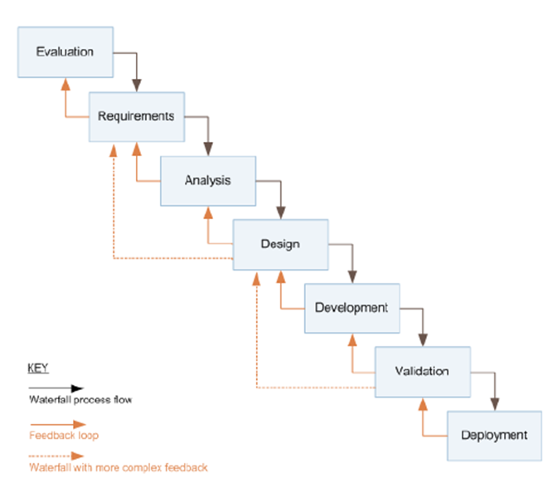

3.6.3 WHY THE WATERFALL MODEL?

The Waterfall model offers some advantages that might make it a suitable choice for this project:

* Well-Defined Requirements: If the project's requirements are well-understood, stable, and unlikely to change significantly during development, the Waterfall model can be a good fit.
* Predictability: Waterfall provides a structured and predictable development process. This can be beneficial when LocalDeals aims to provide a stable and reliable platform for its users from the start.
* Document-Driven: If LocalDeals requires extensive documentation, the Waterfall model's emphasis on documentation at each stage can be advantageous.
* Regulatory Compliance: In cases where LocalDeals needs to comply with specific regulations or standards, the Waterfall model's documentation and traceability features can help demonstrate compliance.
* Limited Changes: When it's essential to limit scope changes once the project is underway, the Waterfall model's strict phase dependency can help avoid scope creep.
* Small to Medium Projects: The Waterfall model is often used for smaller to medium-sized projects, and if LocalDeals falls into this category, it may be a good fit.
* User Training and Transition: For projects like LocalDeals, where user training and a smooth transition to the new system are crucial, the Waterfall model can ensure that the system is fully developed and tested before deployment.

**3.7 CHAPTER SUMMARY**

In the research methodology for LocalDeals, the project employed a structured approach to gather and analyse data, ensuring a comprehensive understanding of the project's various aspects. To represent the diverse user base of LocalDeals, we selected a sample of 21 respondents comprising local residents, small business owners, event organisers, and community administrators. We designed a comprehensive questionnaire to assess the requirements and expectations of LocalDeals' potential users. We employed a combination of qualitative and quantitative data analysis techniques to evaluate the responses. We designed the research process to align with the objectives of LocalDeals, focusing on user-centricity and effectiveness.

We then discussed different methodologies for the development of the system and carved out the best method to develop the system.

**CHAPTER 4: SYSTEM ANALYSIS AND DESIGN**

**4.1 CHAPTER SUMMARY**

**4.2 SYSTEMS ANALYSIS**

The systems analysis phase is vital in determining the requirements and functionalities of LocalDeals. We employ a systematic approach to break down the technicalities of the system.

4.2.1 CURRENT PLATFORMS AND THEIR LIMITATIONS

Most location-based platforms that operate in Kenya cater to medium to large scale businesses. For instance Glovo Kenya which largely manages logistics is a location-based on-demand delivery platform mainly used for food and grocery deliveries (Okuoro, 2020).

Glovo Kenya caters largely to middle to high-income individuals as well as large scale businesses.

Jiji.co.ke is a listings marketplace which mostly operates in large towns as well as cities. The platform enables users to list their products and services but does not handle any transactions between parties. With the wide audience as Jiji.co.ke has, it is able to charge users a fee to curate their items in the search results. This has the effect of drowning out smaller scale businesses who may not afford the high rents as they are charged monthly. While many condone such rent-seeking behaviour as a defence against fraud, fraudsters still afford these rents (2023).

4.2.2 LocalDeals: THE PROPOSED PLATFORM

Considering the various limitations the current systems fall short of, we have seen it as a niche that can be closed by some innovation. Instead of addressing the famous Last Mile Problem from a logistical standpoint, LocalDeals addresses it from the customer’s end. Giving the customer a digital reach over already existing retailers within a short distance of their vicinity. Customers would, for instance, wish to visit a shop and test before they buy a TV somewhere they know they can return it within minutes if it seeks warranty.

Most shopping in developing countries is done within a customer’s walking distance. This phenomenon is what has led to the development of urban areas. Bringing the local economy online may bring variety and improve industry within the same economy.

Local retailers suffer stock loss by expiry mainly because the local market lacks awareness to their products.

4.2.3: OBJECTIVES

* Enhance Local Connectivity:
* Enable Local Trade
* Promote Community Engagement.
* Foster Local Alerts
* Reduce Stock Loss: Raise awareness of local retailers' products and reduce stock loss
* Support Urban Development: Contribute to the growth of urban areas by bringing the local economy online.

4.2.4 REQUIREMENTS OF THE SYSTEM

First, we’ll begin by identifying use needs and preferences from a general perspective as well as from collected data and analysis

4.2.4.1 Identifying the User Needs and Preferences

The user needs and preferences for LocalDeals that we came up with include the following:

* Local Connectivity: Users expect the platform to facilitate connections and interactions with others in their local community.
* Easy Listing and Trading: Users want a straightforward process for listing items, services, or products and conducting trades with nearby users.
* Interest Sharing: Users express the need for a feature that allows them to share and discover common interests, hobbies, events, and activities within their local area.
* Local Alerts: Users value a notification system that keeps them informed about critical local information, such as emergencies or important community updates.
* User-Friendly Interface: Users prefer an intuitive and user-friendly interface that is accessible on various devices, making it easy to use and navigate.
* Data Security: Users have concerns about data security and privacy, so they expect robust measures to protect their information.
* Performance and Reliability: Users look for a platform that performs well, ensuring a seamless and reliable experience.
* Community Engagement: Users are interested in features that promote community engagement, fostering a sense of belonging and collaboration.
* Messaging: Users desire chat functionality for both private and group conversations, allowing them to connect and communicate effectively.
* User Feedback Channels: Users appreciate the ability to provide feedback and suggestions to improve the platform continually.

4.2.4.3 Functional Requirements

* User Registration and Profiles:

Users can create and manage personal profiles.

Profiles include location details for users to specify their local community.

Users can add interests, hobbies, and preferences to their profiles.

* Local Marketplace:

Users can list, sell, or exchange items, products, or services with other local users.

Listings include details, descriptions, images, and prices.

Real-time chat functionality is available for users to negotiate deals.

* Local Communities:

Users can join or create local community groups based on interests or geographic areas.

Within communities, users can share and discover common interests, local events, and activities.

Interaction features are provided for community members to connect and engage.

* Local Alerts:

The platform enables users to receive and send alerts relevant to their local area.

Alerts can be used to notify users about emergencies, important local updates, or community announcements.

* Messaging Functionality:

Users have access to real-time chat for private and group conversations.

Messages can include text, images, local deals, alerts, and events.

* User Feedback and Reporting:

Users can provide feedback and report issues or inappropriate content to maintain a safe and enjoyable community environment.

* Search and Discovery:

The platform offers search and discovery features, allowing users to find specific items, interests, or local events easily.

* User Notifications:

Users receive notifications for messages, alerts, and updates, enhancing their engagement with the platform.

4.2.4.4 Non-functional Requirements

* Performance:

LocalDeals should offer responsive and fast performance, ensuring quick page load times and smooth interactions.

The system must be capable of handling a substantial user load during peak usage times.

* Scalability:

The platform should be designed with scalability in mind to accommodate future growth in terms of users and data.

* Security:

LocalDeals must prioritise data security and user privacy.

User data, including personal information and transaction details, must be protected using encryption and secure protocols.

The system should guard against common web security threats, such as cross-site scripting (XSS) and SQL injection.

* Usability and User Experience (UI/UX):

The user interface must be intuitive, easy to navigate, and aesthetically pleasing.

The platform's design should cater to various devices and screen sizes to ensure a consistent user experience.

* Reliability:

LocalDeals should be highly reliable, with minimal downtime or service interruptions.

Regular maintenance and updates should be performed during off-peak hours.

* Availability:

The platform should be available 24/7, ensuring users can access it whenever they need it.

Redundancy and failover mechanisms can be implemented to prevent service disruptions.

* Compatibility:

LocalDeals should be compatible with a range of web browsers and devices, including mobile phones, tablets, and desktop computers.

* Regulatory Compliance:

The platform should adhere to relevant local and international regulations, especially concerning data protection and privacy.

* Backup and Recovery:

Regular backups of user data and system configurations should be performed.

A disaster recovery plan should be in place to ensure data can be restored in case of system failures.

4.2.5 FEASIBILITY STUDY

We conducted a feasibility study of the LocalDeals platform in the real world in terms of technical, economical and operational feasibility.

4.2.5.1 Market Research

**Objectives**:

1. Market Demand Assessment
2. User Needs and Preferences.
3. Competitor Analysis.
4. Market Size and Growth Potential.
5. Regulatory and Legal Considerations.
6. Technology Infrastructure
7. SWOT Analysis.
8. Feasibility Assessment

**Primary Target Audience:**

1. **Local Residents:** The primary users of LocalDeals are local residents living within specific geographic areas. This audience segment includes individuals who want to connect with others in their community, explore local deals, share common interests, and stay informed about local events.

**Secondary Target Audience:**

1. **Small Businesses:** LocalDeals also caters to small businesses located within the target geographic areas. These businesses can utilise the platform to reach potential customers within their vicinity, promote their products or services, and engage with the local community.
2. **Event Organisers:** Event organisers in the community represent another secondary audience. They can use LocalDeals to create and promote local events, sell event tickets, and enhance event visibility among local residents.
3. **Community Administrators:** Those responsible for managing and overseeing community affairs are part of the secondary audience. Local administrators can leverage LocalDeals to disseminate important local alerts and announcements to residents swiftly.

Population distribution and online connectivity within the Kenyan region. With an approximate population of 54 million people. There were 17.86 million internet users in Kenya in January 2023. Kenya’s internet penetration rate stood at 32.7 percent of the total population at the start of 2023. Kepios analysis indicates that internet users in Kenya increased by 1.3 million (+8.0 percent) between 2022 and 2023 (Kemp, 2023).

**Competitor Analysis**

In this competitor analysis, we will compare LocalDeals, a location-based community web app, with Jiji.co.ke, a well-established online marketplace and classifieds platform operating in Kenya. Both platforms serve the Kenyan market but have different primary purposes and features.

1. Target Audience:

* LocalDeals: Local residents, small businesses, event organisers, and community administrators looking for local engagement and community building.
* Jiji.co.ke: A broader audience including individuals and businesses looking to buy or sell products and services.

2. Features:

* LocalDeals: Emphasises real-time chat, location-based listings, community engagement, and local alerts.
* Jiji.co.ke: Primarily focuses on listings, classifieds, and a wide range of product categories.

3. User Engagement:

* LocalDeals: Places a strong emphasis on community building and social interaction through features like community groups, real-time chat, and event sharing.
* Jiji.co.ke: Provides a platform for transactional activities, but social interaction and community engagement are secondary.

4. Market Position:

* LocalDeals: A relatively new platform targeting community building and local engagement. It aims to fill a specific gap in the market.
* Jiji.co.ke: A well-established and prominent player in the Kenyan online marketplace.

5. User Experience:

* LocalDeals: Focused on user-centric design to enhance user satisfaction. Designed to be intuitive and user-friendly.
* Jiji.co.ke: Provides a straightforward user experience with an emphasis on listings and transactions.

**Market Trends and Growth Patterns:**

1. Community Engagement: Communities, both large and small, were looking for ways to enhance engagement and interaction among their residents (Knight Foundation Report).
2. Support for Local Businesses: The trend of supporting local businesses and entrepreneurs was gaining traction. Consumers were more inclined to explore and shop locally (Forbes Article, 2021).
3. Digital Transformation: Increased internet access and smartphone usage were driving digital transformation. People sought online solutions for local needs (World Economic Forum - Digital Transformation, 2016).
4. Local Events and Activities: The interest in local events, clubs, and activities was on the rise (Eventbrite Blog).
5. Hyper-Local Services: Demand for hyper-local services and information was increasing. People wanted to stay updated on what was happening in their immediate vicinity (Pew Research Report, 2015).

**Regulatory and Legal Considerations:**

Some of the key considerations include:

1. Data Privacy Laws: Kenya has a Data Protection Act, 2019, which governs the collection, processing, and storage of personal data. LocalDeals must comply with this law, which includes obtaining user consent for data collection, ensuring data security, and providing users with control over their data (Kenya, 2019).
2. Consumer Protection Laws: LocalDeals should adhere to Kenya's consumer protection laws to ensure that users are not subjected to unfair practices. This includes transparent pricing, honest advertising, and clear terms of service (Kenya).
3. Intellectual Property Rights: Respect intellectual property rights, including copyright and trademarks, when it comes to content shared on the platform. Users should not be allowed to post copyrighted material without permission (Kenya).
4. Business Registration: Register LocalDeals as a legal business entity in Kenya, following the necessary registration and licensing procedures. This includes registering with the Registrar of Companies and obtaining any required permits ( Kenya).
5. Tax Regulations: Comply with Kenyan tax laws, including income tax, value-added tax (VAT), and any other applicable taxes. LocalDeals may need to account for and remit taxes on transactions.
6. Cybersecurity and Data Protection: Invest in robust cybersecurity measures to protect user data and the platform from cyber threats. Implement security best practices and regularly update security protocols(Kenya, 2018)

**Technology Infrastructure Assessment**

1. Server Hosting: Identify the hosting solutions that will support LocalDeals. Assess the availability of reliable hosting providers and data centres.
2. Internet penetration in the target locations. According to Kepios analysis, internet users in Kenya increased by 1.3 million (+8.0 percent) between 2022 and 2023. Kenya’s internet penetration rate stood at 32.7 percent of the total population at the start of 2023(Kemp, 2023).
3. Backup and Recovery: Develop backup and recovery strategies to ensure data integrity and quick recovery in the event of server failures or data loss.
4. Data Redundancy: Implement redundancy to avoid data loss. Explore options such as replication for database systems.

Pricing Strategy for LocalDeals

1. Freemium Approach: Offer a basic version of LocalDeals for free to attract a wide user base. This version should provide essential features and functionality. This free version acts as a user acquisition tool, drawing in a large audience interested in the platform.
2. Advertising Revenue: Monetize the platform through advertising. Advertisers can pay to display their advertisements on the site or app. Implement various types of ads, such as display ads, sponsored listings, or in-app ads, depending on the platform's design and user experience.
3. Targeted Advertising: Use user data and behaviour analysis to offer targeted advertising. Advertisers often pay more for ads that reach specific demographics or user segments.

**SWOT analysis for LocalDeals**

Strengths:

* Location-Based Advantage: LocalDeals is designed to harness the power of location-based services, which can be a unique selling point, as it encourages local engagement.
* User-Centric Design: The platform is designed with a user-centric approach, focusing on user needs and preferences, leading to enhanced user satisfaction.
* Real-Time Features: The inclusion of real-time messaging and notifications can significantly improve user engagement.
* Market Gap: There is a noticeable gap in the market for a comprehensive local community web app, which LocalDeals aims to fill.

Weaknesses:

* Technical Challenges: Developing and maintaining a robust system with real-time features can pose technical challenges that need to be addressed.
* User Acquisition: Attracting an initial user base might be challenging, especially in areas where awareness of the platform is low.
* Competition: Competition from existing local community platforms might pose challenges in terms of market entry and user adoption.

Opportunities:

* Growing Local Economies: The opportunity to connect local residents, small businesses, and event organisers presents significant growth potential.
* Diverse User Base: The platform can attract a diverse user base, creating opportunities for various types of users and communities.
* Community Engagement: As community engagement and support for local businesses gain importance, there is a growing opportunity for platforms like LocalDeals.

Threats:

* Legal and Regulatory Challenges: Adhering to data privacy and local regulations can be a challenge.
* Technical Disruptions: Technical issues, server downtimes, or cybersecurity threats could disrupt the platform's services.
* Competition: The presence of established competitors in the local community and marketplace platforms can be a significant threat.

FEASIBILITY ASSESSMENT

Based on the research findings and the conducted market analysis, we can assess the feasibility of LocalDeals as follows:

Technical Feasibility:

* LocalDeals leverages commonly used web technologies such as HTML, CSS, JavaScript, PHP, and MySQL. These technologies are well-established and widely supported, making the technical development of the platform feasible.
* The integration of geolocation services through the browser's built-in Geolocation API is technically feasible and allows for precise location-based services.
* However, challenges may arise in the development and maintenance of real-time features like messaging and notifications. These challenges can be addressed with the right technical expertise.

Operational Feasibility:

* LocalDeals aims to create a vibrant local community by connecting local residents, businesses, event organisers, and community administrators. This aligns with the current trends of fostering community engagement and supporting local businesses, making it operationally feasible.
* The user-centric design of the platform, with a focus on user needs and preferences, enhances the operational feasibility by ensuring user satisfaction and engagement.

Market Feasibility:

* The market analysis has revealed a noticeable gap in the market for a comprehensive local community web application. The lack of a dominant player in this niche indicates favourable market conditions for LocalDeals.
* With the growth of local economies and the increasing importance of community engagement, LocalDeals is well-positioned to take advantage of these market opportunities.

Financial Feasibility:

* While attracting an initial user base might be a challenge, the diverse user base and the potential for community engagement offer financial feasibility over the long term.
* To address the financial challenges during the initial phase, LocalDeals may explore various revenue models, including freemium services, advertisements, or premium features for businesses.

Legal and Regulatory Feasibility:

* Adhering to data privacy and local regulations is a necessary aspect of the platform's feasibility. By implementing robust data security measures and privacy policies, LocalDeals can ensure legal and regulatory compliance.
* Overall, based on the analysis, LocalDeals appears to be technically, operationally, and market feasible. However, it may face challenges in user acquisition, competition, and legal compliance, which need to be effectively managed to ensure its long-term success.

**4.3 SYSTEM DESIGN**

The system design for LocalDeals, a location-based community web application, encompasses the architectural components, user interface, database structure, and other key aspects. The goal is to create a platform that promotes local engagement and community interaction.

4.3.1 SYSTEM ARCHITECTURE:

LocalDeals employs a client-server architecture, where the web application (client) interacts with the server for data storage and processing. The architecture consists of the following components:

* Client-Side: This includes the web interface accessible to users. It's built using HTML, CSS, and JavaScript for a responsive and user-friendly experience.
* Server: Hosted on a web server, the server handles user requests, authentication, real-time messaging, and database interactions.
* Database: MySQL is used for data storage, including user profiles, messages, listings, community groups, and other application-related data.
* Geolocation API: The browser's built-in Geolocation API is integrated to provide location-based services.

4.3.2. USER INTERFACE AND USER EXPERIENCE (UI/UX):

LocalDeals places a strong emphasis on an intuitive and user-centric design. Key design elements include:

* User Profiles: Users can create and manage personal profiles with options to add location details, interests, and preferences.
* Local Marketplace: A user-friendly listing interface for posting, selling, or exchanging items with detailed categorization.
* Local Communities: Creation of local community groups with features for sharing interests, events, and activities.
* Local Alerts: A user-friendly interface for sending and receiving local alerts.
* Messaging: Real-time chat for private and group conversations with the ability to share text, images, local deals, alerts, and events.

4.3.3. DATA FLOW DIAGRAMS (DFD):

The DFDs help in understanding the flow of information within LocalDeals. These diagrams are categorised into different levels:

**Context Diagram:** Provides an overview of the system's interactions with external entities

(local users, event organisers, businesses, civil authorities e.t.c).

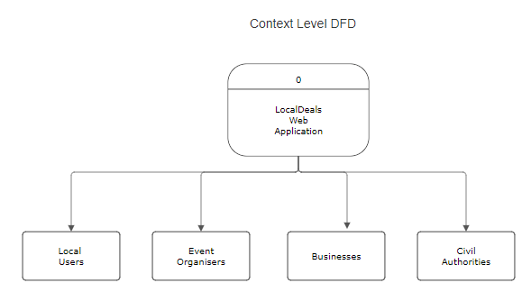

**Level 0 DFD**: Focuses on the major processes and data stores within the system, such as local deals and community feed.

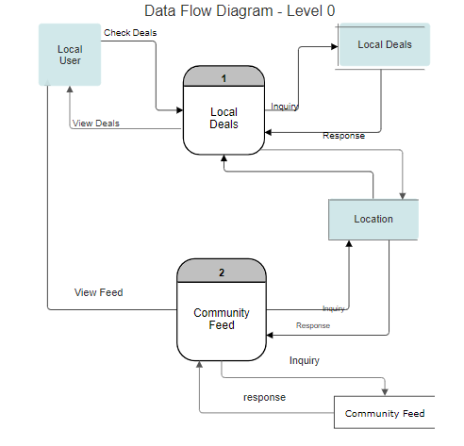

**Detailed DFDs**: Break down specific processes further, detailing how data flows within the system, e.g., how a user sends a message to a community.

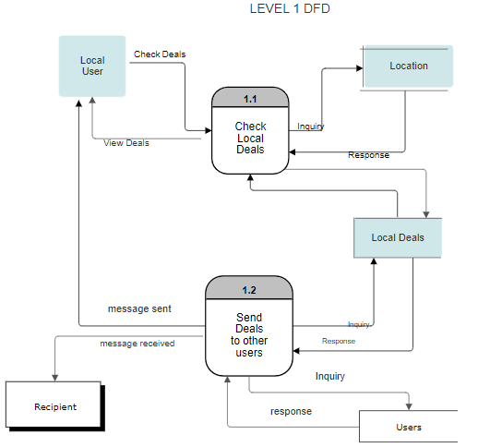

4.3.4. UNIFIED MODELLING LANGUAGE (UML):

UML diagrams are used for system modelling and design.

4.3.4.1 USER STORIES AND USE CASE DEVELOPMENT

Illustrate the interactions between users and the system, capturing various use cases such as creating profiles, posting listings, and sending messages.

4.3.4.1.1User Stories

**User Story: Sharing a Product Listing**

As a registered LocalDeals user I want to share a product listing with another user So that I can promote the product to potential buyers or notify users about items.

Acceptance Criteria:

* I can log in to my LocalDeals account.
* I can navigate to the product listing I want to share.
* I can click a "Share" button associated with the listing.
* I can enter the recipient user's email address or username.
* I can include an optional message with the shared listing.
* The system sends the shared product to the recipient and notifies them about it.

**User Story: Viewing Local Deals**

As a LocalDeals user I want to view deals and products available within my current location So that I can discover and purchase items from local sellers conveniently.

Acceptance Criteria:

* I am logged into my LocalDeals account.
* The application identifies my current location.
* I can browse a list of deals and products available in my vicinity.
* Each listing displays essential information, including the product name, price, and seller details.
* I can click on a listing to view more details.
* The system displays additional information about the product.

I can easily return to the list of local deals

4.3.4.1.2 Use Case Development

| Use Case Name | Sharing a Product Listing |
| --- | --- |
| Description | This use case describes the process of a user sharing a product listing with another user within the LocalDeals web application. Sharing allows users to promote their listings or notify potential buyers about products of interest. |
| Primary Actor | Registered LocalDeals User |
| Stakeholders | * User sharing the product (Initiator) * User receiving the shared product listing * LocalDeals Platform |
| Preconditions: | * The primary actor must be a registered user and logged into their LocalDeals account. * The product to be shared must already exist as a listing within the LocalDeals platform. * The recipient user should have a valid LocalDeals account |
| Postconditions: | * The shared product listing is sent to the recipient user. * The recipient user is notified about the shared product. |
| Main Path: | 1. The primary actor (User A) logs into their LocalDeals account. 2. User A navigates to a product listing they want to share. 3. User A clicks on a "Share" or "Send to Friend" button associated with the product listing. 4. User A enters the recipient user's (User B) email address or username. 5. User A includes an optional message to accompany the shared product listing. 6. User A confirms the sharing action. 7. The LocalDeals platform processes the request and sends a notification to User B. |
| Alternative Paths: | Invalid Recipient: If the recipient's email address or username is not associated with a valid LocalDeals account, the system will prompt User A to provide a valid recipient.  Technical Errors: In case of technical issues or errors during the sharing process, the system will display an error message to User A and attempt to retry the operation |

| Use Case Name | Viewing Local Deals |
| --- | --- |
| Description | This use case involves a LocalDeals user wanting to browse and explore deals and products available within their current location. |
| Primary Actor | LocalDeals User |
| Stakeholders | * LocalDeals User: The person using the LocalDeals application to view local deals. * LocalDeals Platform: The platform providing the local deals and facilitating user interactions. |
| Preconditions: | * The user has an active LocalDeals account and is logged in. * The user's device and the LocalDeals application have location services enabled. * The application has successfully determined the user's current location. |
| Postconditions: | * The user has viewed the available local deals and may choose to interact with them. |
| Main Path: | 1. The user opens the LocalDeals application. 2. The application automatically identifies the user's current location. 3. The user is presented with a list of local deals and products available in the vicinity. 4. Each deal or product listing includes essential information such as the product name, price, and seller details. 5. The user can click on a specific deal to view more details about the product. 6. The application displays additional information about the selected product. 7. The user can easily return to the list of local deals. |
| Alternative Paths: | If the application fails to identify the user's location, it may prompt the user to enable location services or manually input their location.  In case there are no local deals available in the user's vicinity, the application informs the user and may suggest expanding the search radius or checking back later.  If there are technical issues, such as a slow network connection, the application may notify the user and offer a retry option. |

**Class Diagrams**:

Model the system's classes and their relationships, helping in designing the database structure and overall architecture.

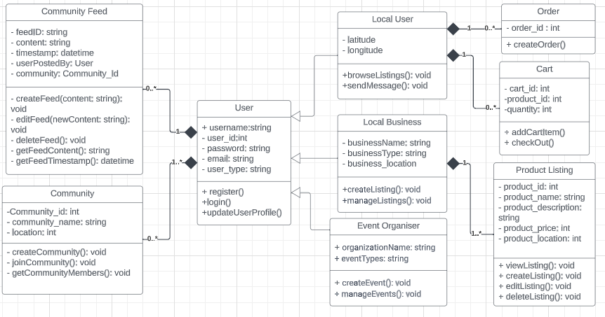

**Sequence Diagrams**:

Shows the sequence of interactions during processes of registration and receiving local alerts

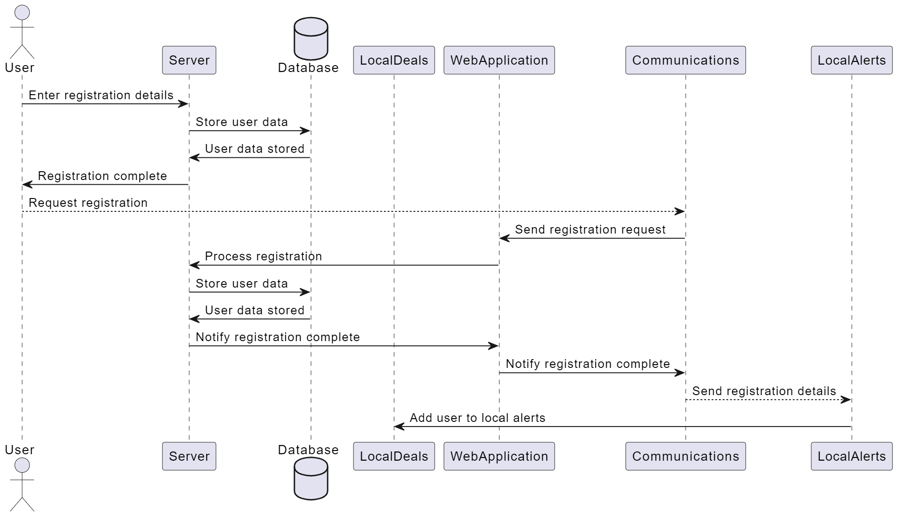

4.3.5. WORKFLOW DIAGRAMS:

Workflow diagrams represent the step-by-step processes within LocalDeals, such as how a user can view local deals within their location.

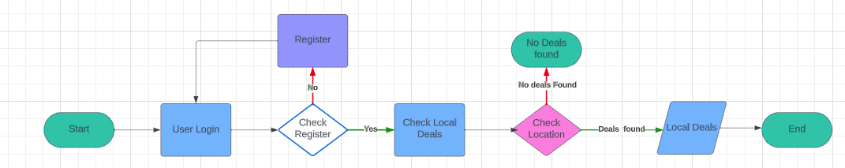

4.3.6. SECURITY MEASURES:

To ensure data security and user privacy, LocalDeals implements measures like encryption for data transmission and strict user authentication protocols. Privacy policies and data handling practices are in place to comply with legal and regulatory requirements.

4.3.7. SCALABILITY:

LocalDeals is designed with scalability in mind. The architecture can accommodate a growing user base, and measures are in place to ensure consistent app performance even as the user count increases.

4.3.8. USER-FRIENDLY DESIGN:

The design principles focus on user satisfaction, intuitive navigation, and a pleasant user experience. The user interface adapts to various devices and screen sizes for accessibility.

**4.4 CHAPTER SUMMARY**

The system analysis and design of the localDeals platform is discussed ranging from the system analysis of current systems and their operations. The chapter also discusses the proposed system’s objectives as well as its feasibility. A vivid feasibility study is undertaken and an assessment of its report leads to optimistic inferences over the implementation of the platform. This chapter describes the system analysis and design of the proposed LocalDeals platform extensively using relevant user stories and use cases of the system as well as UML and workflow diagrams.

**CHAPTER FIVE - IMPLEMENTATION AND TESTING**

**REFERENCES**

Nextdoor. (2023). About Nextdoor. https://nextdoor.com/about/

Reference: Yelp. (2023). About Yelp. https://www.yelp-press.com/about/

Kemp, S. (2023, February 13). *Digital 2023: Kenya - DataReportal – Global Digital Insights*. DataReportal. <https://datareportal.com/reports/digital-2023-kenya>

Knight Foundation. (n.d.). *Community Information Ecosystems.*<https://knightfoundation.org/reports/community-information-ecosystems/>

Forbes. (2021). *Why Consumers Are Supporting Local Businesses During The Pandemic. Forbes.*<https://www.forbes.com/sites/forbesnycouncil/2021/03/18/why-consumers-are-supporting-local-businesses-during-the-pandemic/>

World Economic Forum. (2016). *Digital Transformation.*<https://www.weforum.org/agenda/2016/01/what-is-digital-transformation/>

Eventbrite. (n.d.). *Eventbrite Blog.*<https://www.eventbrite.com/blog/>

Pew Research Center. (2015). *Local News in a Digital Age.*<https://www.journalism.org/2015/03/05/local-news-in-a-digital-age/>

Kenya. (2019). *Data Protection Act.*

Kenya. Consumer Protection Act.

Kenya. Copyright Act.

Kenya. *Business Registration Act*.

Kenya. *(2018). Computer Misuse and Cybercrime Act.*

Okuoro, S. (2020, November 19). *Glovo expands operations in Kenya*. The Standard. https://www.standardmedia.co.ke/article/2001394480/firm-expands-operations-in-kenya

NEWSWIRE. (2023, July 12). *Jiji*. iAfrica. https://iafrica.com/jiji-kenya-crowned-best-e-commerce-mobile-app/

APPENDIX

First Pre-Production Questionnaire:

| **Participant** | **Age** | **Gender** | **Location** | **Local Engagement** | **Awareness of Local Events** | **Online Community Usage** | **Satisfaction with Current Platforms** | **Value of LocalDeals** | **Preferred Features** | **Additional Comments** |
| --- | --- | --- | --- | --- | --- | --- | --- | --- | --- | --- |
| Participant 1 | 25 | Female | City | Weekly | Yes | Yes | Satisfied | Very valuable | Real-time local deals, Local event listings, Messaging and chat functionality | Excited to see how LocalDeals will enhance local interactions. |
| Participant 2 | 45 | Male | Suburb | Monthly | Yes | Yes | Neutral | Valuable | Local event listings, Community groups and forums | Looking forward to a more connected local community. |
| Participant 3 | 35 | Female | City | Rarely | No | No | Dissatisfied | Not valuable | Local business listings, Messaging and chat functionality | Improve local event awareness. |
| Participant 4 | 54 | Male | Rural Area | Weekly | Yes | Yes | Very satisfied | Very valuable | Real-time local deals, Local event listings, Community groups and forums | Excited to discover local deals. |
| Participant 5 | 28 | Female | City | Daily | Yes | Yes | Satisfied | Valuable | Real-time local deals, Local event listings | Hope it includes event reminders. |
| Participant 6 | 60 | Male | Suburb | Rarely | No | No | Dissatisfied | Not valuable | Neighbourhood alerts, Messaging and chat functionality | Simplify local communication. |
| Participant 7 | 19 | Female | City | Weekly | Yes | Yes | Neutral | Valuable | Real-time local deals, Local event listings, Community groups and forums | Eager to explore local offerings. |
| Participant 8 | 42 | Male | Suburb | Monthly | Yes | Yes | Satisfied | Valuable | Local event listings, Neighbourhood alerts | Hope it enhances local event awareness. |
| Participant 9 | 39 | Female | Rural Area | Monthly | No | No | Dissatisfied | Not valuable | Real-time local deals, Local event listings | Potential for connecting with local businesses. |
| Participant 10 | 31 | Male | City | Weekly | Yes | Yes | Very satisfied | Very valuable | Local event listings, Community groups and forums | Anticipating a more vibrant local community. |
| Participant 11 | 55 | Female | Suburb | Monthly | No | No | Neutral | Valuable | Real-time local deals, Local event listings, Local business listings | Improving access to local products. |
| Participant 12 | 22 | Male | City | Daily | Yes | Yes | Dissatisfied | Not valuable | Neighbourhood alerts, Local business listings | Simplifying local trade. |
| Participant 13 | 34 | Female | Suburb | Weekly | Yes | Yes | Very satisfied | Very valuable | Real-time local deals, Local event listings | Enhancing local engagement. |
| Participant 14 | 46 | Male | City | Rarely | No | No | Dissatisfied | Not valuable | Local event listings, Messaging and chat functionality | Potential for improved local communication. |
| Participant 15 | 25 | Female | Suburb | Weekly | Yes | Yes | Neutral | Valuable | Real-time local deals, Neighborhood alerts, Local business listings | Curious about local business offerings. |
| Participant 16 | 36 | Male | City | Monthly | Yes | Yes | Very satisfied | Very valuable | Real-time local deals, Local event listings, Community groups and forums | Expecting enhanced local event awareness. |
| Participant 17 | 44 | Female | Rural Area | Weekly | No | No | Dissatisfied | Not valuable | Local event listings, Local business listings | Hoping for better access to local businesses. |
| Participant 18 | 29 | Male | City | Daily | Yes | Yes | Satisfied | Valuable | Real-time local deals, Local event listings, Messaging and chat functionality | Excited about potential local deals. |
| Participant 19 | 53 | Female | Suburb | Monthly | Yes | Yes | Neutral | Not valuable | Local event listings, Local business listings | Seeking local business connections. |
| Participant 20 | 30 | Male | City | Weekly | Yes | Yes | Dissatisfied | Very valuable | Real-time local deals, Local event listings | Anticipating a more connected local community. |
| Participant 21 | 41 | Female | Suburb | Rarely | No | No | Very satisfied | Not valuable | Local event listings, Messaging and chat functionality | Interested in improved local communication. |

Post-Production Questionnaire:

| **Participant** | **Age** | **Gender** | **Location** | **LocalDeals Usage** | **User Type** | **Satisfaction** | **User-Friendly** | **Technical Issues** | **Feature Satisfaction** | **Impact on Community Engagement** |
| --- | --- | --- | --- | --- | --- | --- | --- | --- | --- | --- |
| 1 | 35 | Male | Urban | More than 12 months | Small Business Owner | Very Satisfied | Very User-Friendly | No | Yes | Positive Impact |
| 2 | 24 | Female | Suburban | 6-12 months | Event Organiser | Satisfied | User-Friendly | Yes | Yes | Positive Impact |
| 3 | 42 | Male | Urban | More than 12 months | Local Resident | Satisfied | User-Friendly | No | Yes | No Impact |
| 4 | 28 | Female | Urban | 3-6 months | Local Resident | Satisfied | User-Friendly | Yes | Yes | Positive Impact |
| 5 | 31 | Male | Rural | Less than 3 months | Small Business Owner | Very Satisfied | Very User-Friendly | No | Yes | Positive Impact |
| 6 | 22 | Female | Suburban | 6-12 months | Event Organiser | Satisfied | User-Friendly | No | Yes | Positive Impact |
| 7 | 29 | Male | Urban | 6-12 months | Local Resident | Very Satisfied | Very User-Friendly | No | Yes | Positive Impact |
| 8 | 36 | Female | Suburban | More than 12 months | Small Business Owner | Satisfied | User-Friendly | Yes | No | No Impact |
| 9 | 19 | Male | Rural | 3-6 months | Local Resident | Very Satisfied | Very User-Friendly | No | Yes | Positive Impact |
| 10 | 30 | Female | Urban | Less than 3 months | Event Organiser | Satisfied | User-Friendly | No | Yes | Positive Impact |
| 11 | 45 | Male | Urban | More than 12 months | Local Resident | Very Satisfied | Very User-Friendly | No | Yes | No Impact |
| 12 | 23 | Female | Suburban | 3-6 months | Small Business Owner | Very Satisfied | Very User-Friendly | No | Yes | Positive Impact |
| 13 | 32 | Male | Urban | 6-12 months | Event Organiser | Satisfied | User-Friendly | Yes | No | Positive Impact |
| 14 | 50 | Female | Suburban | 3-6 months | Local Resident | Very Satisfied | Very User-Friendly | Yes | No | Positive Impact |
| 15 | 27 | Male | Urban | 3-6 months | Small Business Owner | Satisfied | User-Friendly | No | Yes | Positive Impact |
| 16 | 21 | Female | Rural | More than 12 months | Local Resident | Satisfied | User-Friendly | Yes | Yes | No Impact |
| 17 | 33 | Male | Urban | Less than 3 months | Event Organiser | Very Satisfied | Very User-Friendly | No | Yes | Positive Impact |
| 18 | 46 | Female | Urban | More than 12 months | Local Resident | Satisfied | User-Friendly | No | Yes | Positive Impact |
| 19 | 26 | Male | Suburban | Less than 3 months | Small Business Owner | Very Satisfied | Very User-Friendly | Yes | No | No Impact |
| 20 | 18 | Female | Urban | 6-12 months | Event Organiser | Satisfied | User-Friendly | Yes | Yes | Positive Impact |
| 21 | 40 | Male | Urban | More than 12 months | Local Resident | Very Satisfied | Very User-Friendly | No | Yes | Positive Impact |