1. 安装nginx的依赖包

# 查看zlib是否安装

dpkg -l | grep zlib

# 解决依赖包openssl安装

sudo apt-get install openssl libssl-dev

# 解决依赖包pcre安装

sudo apt-get install libpcre3 libpcre3-dev

# 解决依赖包zlib安装

sudo apt-get install zlib1g-dev

2. 下载nginx

访问[nginx官网](http://nginx.org/en/download.html" \t "_blank)，

# 下载nginx

wget http://nginx.org/download/nginx-1.13.1.tar.gz

# 解压nginx

tar -xzvf nginx-1.13.1.tar.gz

# 重命名文件夹

mv nginx-1.13.1 nginx

# 移动文件夹到ubuntu常见软件目录下

mv nginx/ /usr/local/

3. 安装nginx

# 配置nginx

cd /usr/local/nginx

sudo ./configure --user=www --group=www --prefix=/usr/local/nginx --with-http\_stub\_status\_module --with-http\_ssl\_module --with-http\_realip\_module

# 编译nginx

sudo make

# 安装nginx

sudo make install

4. 检查nginx是否安装成功

cd /usr/local/nginx/sbin

./nginx -t

如果结果结果显示：

nginx: the configuration file /usr/local/nginx/conf/nginx.conf syntax is ok

nginx: configuration file /usr/local/nginx/conf/nginx.conf test is successful

* 1
* 2

5. 配置用户

# 添加www组

groupadd www

# 创建nginx运行账户www并加入到www组，不允许www用户直接登录系统

useradd -g www www -s /bin/false

6. 配置防火墙

如果是使用的腾讯服务器，只需要在服务器管理平台添加80端口的安全组就好   
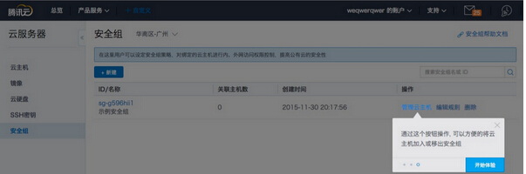   
服务器则可以设置防火墙：

# 修改防火墙配置：

vi + /etc/sysconfig/iptables

# 添加配置项

-A INPUT -m state --state NEW -m tcp -p tcp --dport 80 -j ACCEPT

# 重启防火墙

service iptables restart

7. 启动nginx

# 方法1

/usr/local/nginx/sbin/nginx -c /usr/local/nginx/conf/nginx.conf

# 方法2

cd /usr/local/nginx/sbin

./nginx

8 验证

zzh@zzh-virtual-machine:~/elb/nginx$ curl localhost:80

<!DOCTYPE html>

<html>

<head>

<title>Welcome to nginx!</title>

<style>

body {

width: 35em;

margin: 0 auto;

font-family: Tahoma, Verdana, Arial, sans-serif;

}

</style>

</head>

<body>

<h1>Welcome to nginx!</h1>

<p>If you see this page, the nginx web server is successfully installed and

working. Further configuration is required.</p>

<p>For online documentation and support please refer to

<a href="http://nginx.org/">nginx.org</a>.<br/>

Commercial support is available at

<a href="http://nginx.com/">nginx.com</a>.</p>

<p><em>Thank you for using nginx.</em></p>

</body>

</html>

zzh@zzh-virtual-machine:~/elb/nginx$ curl localhost:80

<!DOCTYPE html>

<html>

<head>

<title>Welcome to nginx!</title>

<style>

body {

width: 35em;

margin: 0 auto;

font-family: Tahoma, Verdana, Arial, sans-serif;

}

</style>

</head>

<body>

<h1>Welcome to nginx!</h1>

<p>If you see this page, the nginx web server is successfully installed and

working. Further configuration is required.</p>

<p>For online documentation and support please refer to

<a href="http://nginx.org/">nginx.org</a>.<br/>

Commercial support is available at

<a href="http://nginx.com/">nginx.com</a>.</p>

<p><em>Thank you for using nginx.</em></p>

</body>

</html>