###### START EMREP/LISTENE:

[oracle@host02 ~]$ export ORACLE_SID=EMREP;sqlplus / as sysdba

SQL*Plus: Release 12.1.0.2.0 Production on Fri Mar 10 12:29:54 2017

Copyright (c) 1982, 2014, Oracle. All rights reserved.

Connected to an idle instance.

SQL> startup
ORACLE instance started.

Total System Global Area 2147483648 bytes
Fixed Size 2926472 bytes
Variable Size 805308536 bytes
Database Buffers 1325400064 bytes
Redo Buffers 13848576 bytes
Database mounted.
Database opened.
SQL> exit
Disconnected from Oracle Database 12c Enterprise Edition Release 12.1.0.2.0 - 64bit Production
With the Partitioning, OLAP, Advanced Analytics and Real Application Testing options
[oracle@host02 ~]$ lsnrctl start

LSNRCTL for Linux: Version 12.1.0.2.0 - Production on 10-MAR-2017 12:30:12

Copyright (c) 1991, 2014, Oracle. All rights reserved.

Starting /u01/app/oracle/product/12.1.0/dbhome_1/bin/tnslsnr: please wait...

TNSLSNR for Linux: Version 12.1.0.2.0 - Production
System parameter file is /u01/app/oracle/product/12.1.0/dbhome_1/network/admin/listener.ora
Log messages written to /u01/app/oracle/diag/tnslsnr/host02/listener/alert/log.xml
Listening on: (DESCRIPTION=(ADDRESS=(PROTOCOL=tcp)(HOST=host02.example.com)(PORT=1521)))
Listening on: (DESCRIPTION=(ADDRESS=(PROTOCOL=ipc)(KEY=EXTPROC1521)))

Connecting to (DESCRIPTION=(ADDRESS=(PROTOCOL=TCP)(HOST=host02.example.com)(PORT=1521)))
STATUS of the LISTENER
------------------------
Alias LISTENER
Version TNSLSNR for Linux: Version 12.1.0.2.0 - Production
Start Date 10-MAR-2017 12:30:14
Uptime 0 days 0 hr. 0 min. 0 sec
Trace Level off
Security ON: Local OS Authentication
SNMP OFF
Listener Parameter File /u01/app/oracle/product/12.1.0/dbhome_1/network/admin/listener.ora
Listener Log File /u01/app/oracle/diag/tnslsnr/host02/listener/alert/log.xml
Listening Endpoints Summary...
(DESCRIPTION=(ADDRESS=(PROTOCOL=tcp)(HOST=host02.example.com)(PORT=1521)))
(DESCRIPTION=(ADDRESS=(PROTOCOL=ipc)(KEY=EXTPROC1521)))
The listener supports no services
The command completed successfully
[oracle@host02 ~]$ export ORACLE_SID=EMREP;sqlplus / as sysdba

SQL*Plus: Release 12.1.0.2.0 Production on Fri Mar 10 12:30:45 2017

Copyright (c) 1982, 2014, Oracle. All rights reserved.

Connected to:
Oracle Database 12c Enterprise Edition Release 12.1.0.2.0 - 64bit Production
With the Partitioning, Oracle Label Security, OLAP, Advanced Analytics
and Real Application Testing options

SQL> alter system register;

System altered.

SQL> !lsnrctl status

LSNRCTL for Linux: Version 12.1.0.2.0 - Production on 10-MAR-2017 12:30:53

Copyright (c) 1991, 2014, Oracle. All rights reserved.

Connecting to (DESCRIPTION=(ADDRESS=(PROTOCOL=TCP)(HOST=host02.example.com)(PORT=1521)))
STATUS of the LISTENER
------------------------
Alias LISTENER
Version TNSLSNR for Linux: Version 12.1.0.2.0 - Production
Start Date 10-MAR-2017 12:30:14
Uptime 0 days 0 hr. 0 min. 39 sec
Trace Level off
Security ON: Local OS Authentication
SNMP OFF
Listener Parameter File /u01/app/oracle/product/12.1.0/dbhome_1/network/admin/listener.ora
Listener Log File /u01/app/oracle/diag/tnslsnr/host02/listener/alert/log.xml
Listening Endpoints Summary...
(DESCRIPTION=(ADDRESS=(PROTOCOL=tcp)(HOST=host02.example.com)(PORT=1521)))
(DESCRIPTION=(ADDRESS=(PROTOCOL=ipc)(KEY=EXTPROC1521)))
Services Summary...
Service "EMREP.example.com" has 1 instance(s).
Instance "EMREP", status READY, has 1 handler(s) for this service...
Service "EMREPXDB.example.com" has 1 instance(s).
Instance "EMREP", status READY, has 1 handler(s) for this service...
The command completed successfully

SQL> exit
Disconnected from Oracle Database 12c Enterprise Edition Release 12.1.0.2.0 - 64bit Production
With the Partitioning, Oracle Label Security, OLAP, Advanced Analytics
and Real Application Testing options
f[oracle@host02 ~]$ free -m
total used free shared buffers cached
Mem: 4828 4793 34 0 12 2150
-/+ buffers/cache: 2629 2198
Swap: 6143 1 6142
[oracle@host02 ~]$

[oracle@host02 bin]$ ./emctl start agent
Oracle Enterprise Manager Cloud Control 12c Release 4
Copyright (c) 1996, 2014 Oracle Corporation. All rights reserved.
Starting agent ................................ started.
[oracle@host02 bin]$ pwd
/u01/app/oracle/product/agent12c/agent_inst/bin
[oracle@host02 bin]$

###### Start OMS/WEB/Agent:

[oracle@host02 bin]$ cd /u01/app/oracle/product/middleware/oms/oms/bin
oracle@host02 bin]$ ./emctl start oms
Oracle Enterprise Manager Cloud Control 12c Release 4
Copyright (c) 1996, 2014 Oracle Corporation. All rights reserved.
Starting Oracle Management Server...
Starting WebTier...
WebTier Successfully Started

Oracle Management Server Successfully Started
Oracle Management Server is Up
[oracle@host02 bin]$

[oracle@host02 bin]$ ./emctls status oms -details
-bash: ./emctls: No such file or directory
[oracle@host02 bin]$ ./emctl status oms -details
Oracle Enterprise Manager Cloud Control 12c Release 4
Copyright (c) 1996, 2014 Oracle Corporation. All rights reserved.
Enter Enterprise Manager Root (SYSMAN) Password :
Console Server Host : host02.example.com
HTTP Console Port : 7788
HTTPS Console Port : 7802
HTTP Upload Port : 4889
HTTPS Upload Port : 4903
EM Instance Home : /u01/app/oracle/product/middleware/gc_inst/em/EMGC_OMS1
OMS Log Directory Location : /u01/app/oracle/product/middleware/gc_inst/em/EMGC_OMS1/sysman/log
OMS is not configured with SLB or virtual hostname
Agent Upload is locked.
OMS Console is locked.
Active CA ID: 1
Console URL: https://host02.example.com:7802/em
Upload URL: https://host02.example.com:4903/empbs/upload

WLS Domain Information
Domain Name : GCDomain
Admin Server Host : host02.example.com
Admin Server HTTPS Port: 7102
Admin Server is RUNNING

Oracle Management Server Information
Managed Server Instance Name: EMGC_OMS1
Oracle Management Server Instance Host: host02.example.com
WebTier is Up
Oracle Management Server is Up

BI Publisher is not configured to run on this host.
[oracle@host02 bin]$

###### Apply Agent to Host01.

https://host02.example.com:7802/em
sysman
Oracle123

Setup/Add Target/Add Targets Manually/

Add Host Targets->Add Host ...

Add
host01.example.com/Linux x86-64

[oracle@host01 ~]$ ls -ld /u01/app/oracle/product/agent12c
ls: cannot access /u01/app/oracle/product/agent12c: No such file or directory
[oracle@host01 ~]$ mkdir /u01/app/oracle/product/agent12c
[oracle@host01 ~]$

/u01/app/oracle/product/agent12c

+oracle/oracle/oracle

Next/Deploy Agent

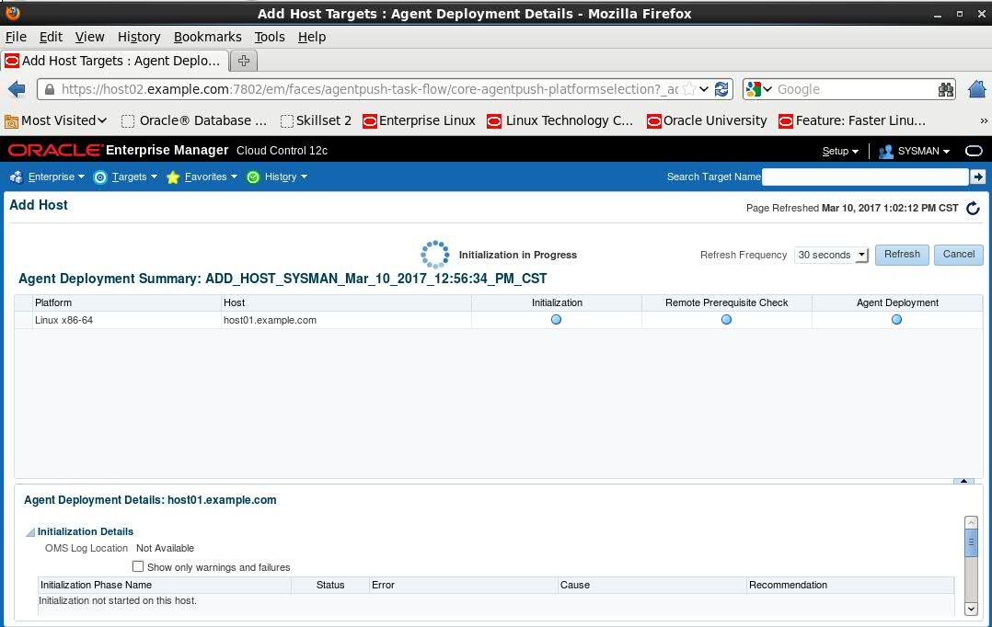
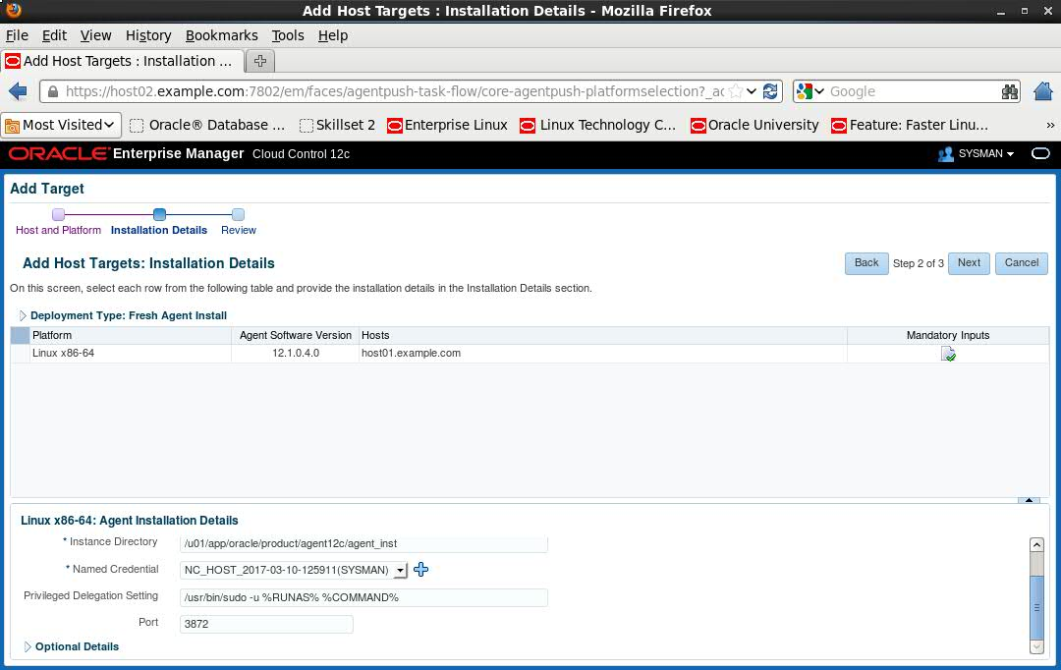
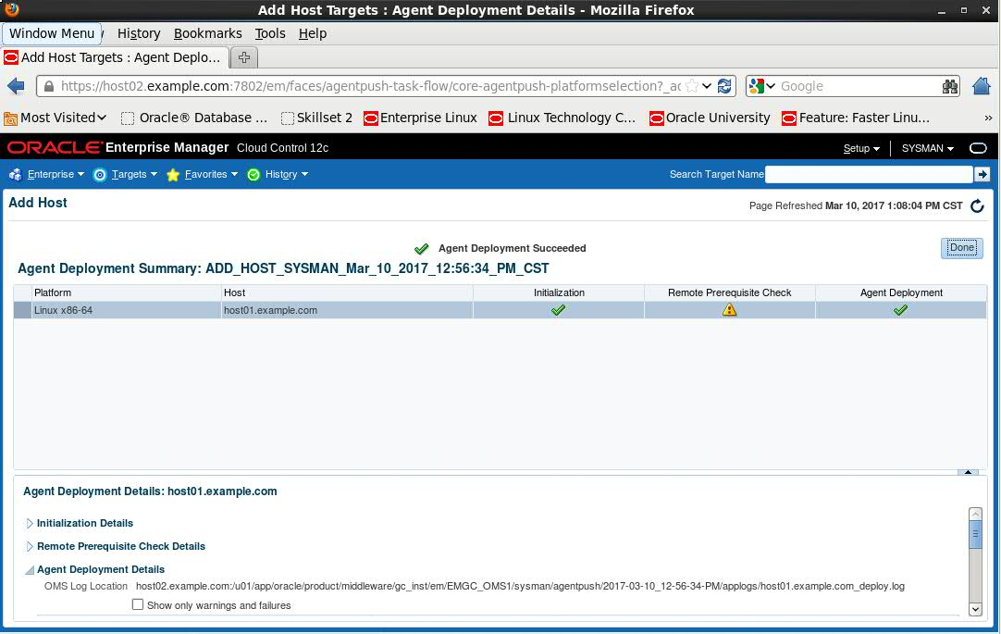

Add Target:

Target/Hosts
Target/Databases
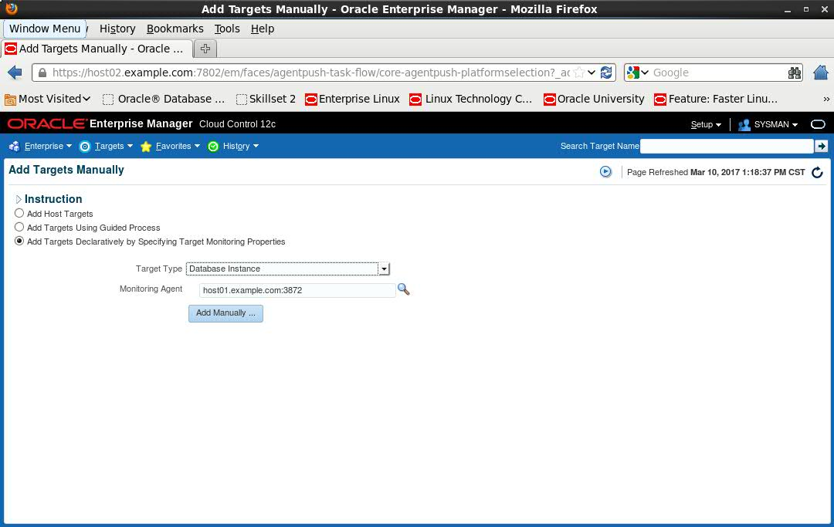
Host01:

SYS@PRODCDB> alter user dbsnmp identified by oracle account unlock;

User altered.

SYS@PRODCDB>

Host02:
[oracle@host02 admin]$ pwd
/u01/app/oracle/product/12.1.0/dbhome_1/network/admin
[oracle@host02 admin]$ cat tnsnames.ora
# tnsnames.ora Network Configuration File: /u01/app/oracle/product/12.1.0/dbhome_1/network/admin/tnsnames.ora
# Generated by Oracle configuration tools.

EMREP =
(DESCRIPTION =
(ADDRESS = (PROTOCOL = TCP)(HOST = host02.example.com)(PORT = 1521))
(CONNECT_DATA =
(SERVER = DEDICATED)
(SERVICE_NAME = EMREP.example.com)
)
)

PRODCDB =
(DESCRIPTION =
(ADDRESS = (PROTOCOL = TCP)(HOST = host01.example.com)(PORT = 1521))
(CONNECT_DATA =
(SERVER = DEDICATED)
(SERVICE_NAME = PRODCDB.example.com)
)
)

[oracle@host02 admin]$
[oracle@host02 admin]$ sqlplus dbsnmp/oracle@prodcdb

SQL*Plus: Release 12.1.0.2.0 Production on Fri Mar 10 13:29:56 2017

Copyright (c) 1982, 2014, Oracle. All rights reserved.

Last Successful login time: Fri Mar 10 2017 13:29:35 +08:00

Connected to:
Oracle Database 12c Enterprise Edition Release 12.1.0.2.0 - 64bit Production
With the Partitioning, Oracle Label Security, OLAP, Advanced Analytics
and Real Application Testing options

SQL>

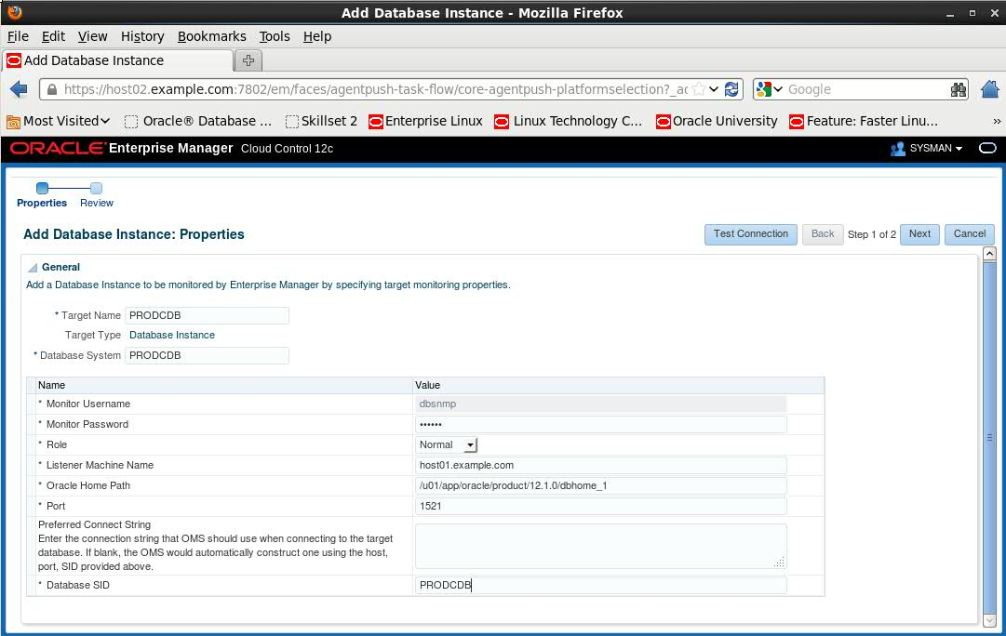

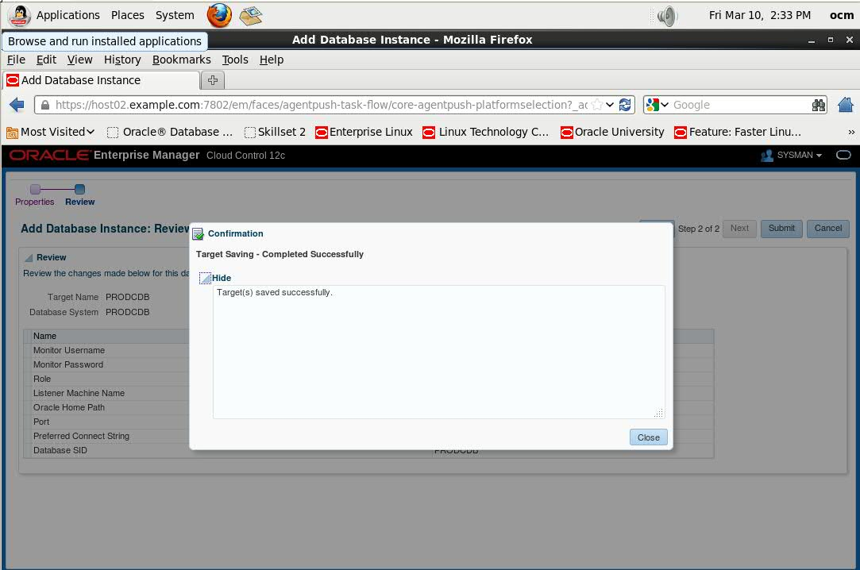

Administration/Resource Manager

Section 7： Use EM Cloud Control Configuration Resource Manager

Configuring Resource Manager to PRODCDB

1.Assign SYSTEM user as a resource administrator privileges

PRODCDB:
Schema/User
SYSTEM/EDIT
Modify System Privileges

SQL:

BEGIN
dbms_aqadm.revoke_system_privilege(privilege=>'DEQUEUE_ANY', grantee=>'SYSTEM');
COMMIT;
END;

BEGIN
dbms_aqadm.revoke_system_privilege(privilege=>'ENQUEUE_ANY', grantee=>'SYSTEM');
COMMIT;
END;

BEGIN
dbms_aqadm.revoke_system_privilege(privilege=>'MANAGE_ANY', grantee=>'SYSTEM');
COMMIT;
END;

BEGIN
dbms_resource_manager_privs.grant_system_privilege(privilege_name=>'ADMINISTER_RESOURCE_MANAGER', grantee_name=>'SYSTEM', admin_option=>TRUE);
END;

BEGIN
dbms_aqadm.grant_system_privilege(privilege=>'DEQUEUE_ANY', grantee=>'SYSTEM', admin_option=>FALSE);
COMMIT;
END;

BEGIN
dbms_aqadm.grant_system_privilege(privilege=>'ENQUEUE_ANY', grantee=>'SYSTEM', admin_option=>FALSE);
COMMIT;
END;

BEGIN
dbms_aqadm.grant_system_privilege(privilege=>'MANAGE_ANY', grantee=>'SYSTEM', admin_option=>FALSE);
COMMIT;
END;

Choose:

BEGIN
dbms_resource_manager_privs.grant_system_privilege(privilege_name=>'ADMINISTER_RESOURCE_MANAGER', grantee_name=>'SYSTEM', admin_option=>TRUE);
END;

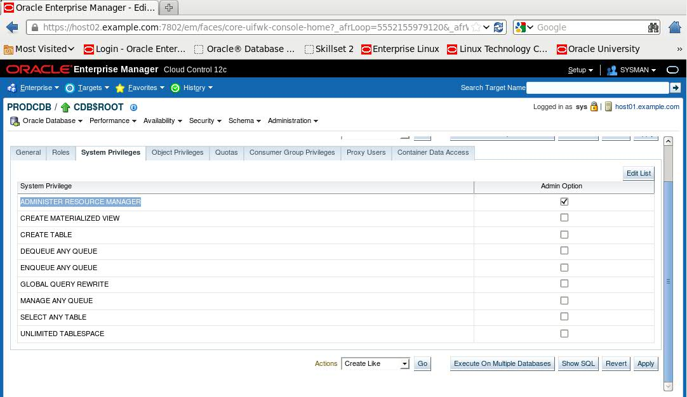

2.Create resource plans to DAYTIMEP for PRODCDB

PDBPROD1 get 6 parts CDB shared resources

PDBPROD2 get 3 parts of a shared resource CDB

PDBPROD3 get 1 share resources CDB

PDB can not get the extra 75% of available cpu time

PDB can not get the extra 50% parallel_servers_target

Administration/Resource Manager
Consumer Groups

DECLARE
spfileValue VARCHAR2(1000);
execText VARCHAR2(1000);
scopeValue VARCHAR2(30) := 'MEMORY';
planName VARCHAR2(100) :='DAYTIMEP';
BEGIN
dbms_resource_manager.clear_pending_area();
dbms_resource_manager.create_pending_area();
dbms_resource_manager.update_cdb_default_directive(
plan => 'DAYTIMEP',
new_comment => 'Default Directive',
new_shares => 1,
new_utilization_limit => 75,
new_parallel_server_limit => 50 );
dbms_resource_manager.create_cdb_plan_directive(
plan => 'DAYTIMEP',
pluggable_database => 'PDBPROD1',
comment => '',
shares => 6,
utilization_limit => NULL,
parallel_server_limit => NULL );
dbms_resource_manager.create_cdb_plan_directive(
plan => 'DAYTIMEP',
pluggable_database => 'PDBPROD2',
comment => '',
shares => 3,
utilization_limit => NULL,
parallel_server_limit => NULL );
dbms_resource_manager.create_cdb_plan_directive(
plan => 'DAYTIMEP',
pluggable_database => 'PDBPROD3',
comment => '',
shares => 1,
utilization_limit => NULL,
parallel_server_limit => NULL );
dbms_resource_manager.submit_pending_area();
END;

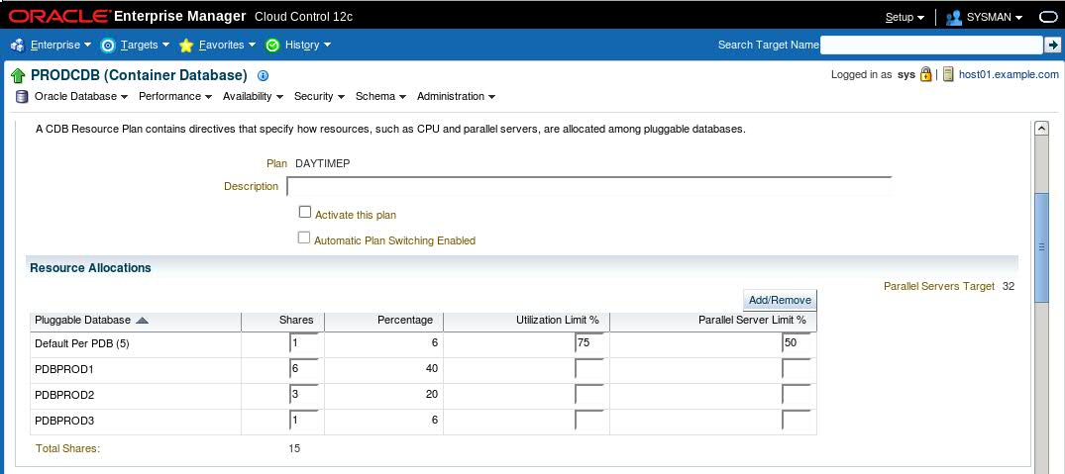

3.Create two consumer group ONLINE_GRP and REPORTING_GRP in the PDBPROD1

Use comments indicated the group used

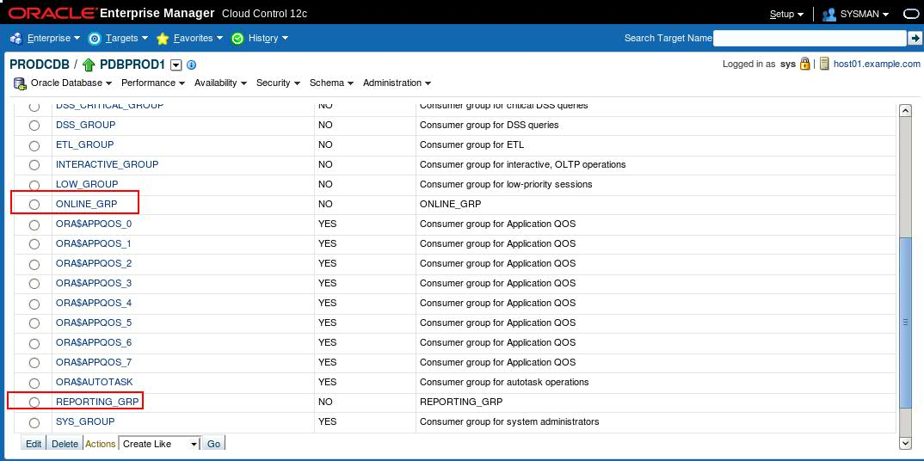

4.Create a resource management plan in PDBPROD1

（1）Project Title: DAYTIMEC

（2）For ONLINE_GRP group can not be allowed more than 25 active sessions. If 26 users try to log on, wait 90 seconds later, this demand will be terminated.

（3）REPORTING_GRP set the maximum number of active sessions to 8. If you need extra eight sessions ,150 seconds after this request will be terminated.

（4）In ONLINE_GRP group, a conversation longest query execution time is 5 seconds,If the query estimate exceeds 5s, the query should be error

（5）ONLINE_GRP group of maximum undo 350M

（6）cpu ratio, ONLINE_GRP, REPORTING_GRP, OTHER_GROUPS respectively 50,40,10

（7）REPORTING_GRP group should limit the degree of parallelism of 30

（8）If the session exceeds 8000i / o or data transmission over 2000m, and in any PEPORTING_grp Group interaction should be temporary to low_group group. When the call is completed, the session also return to the group.

5.daytime activation

