This document is meant to outline the Network setup to allow a Linux VM running on a Desktop/Laptop to connect into the Oracle Solution Center's (OSC) VPN. There are various ways this can work. What works and what doesn't depend on how the VirtualBox Host is connected to the network, be it a Wired or Wireless connection and whether it is in a Corporate location or some off-site location like at home or at a customer.

Please use the following link to retrieve the latest version of this document:

<https://stbeehive.oracle.com/content/dav/st/North%20American%20Infrastructure%20&%20Architecture%20Work-Group/Documents/VirtualBox/VirtualBox-VM-Network-OSC.docx>

The Guest/VM will need to have a VPN client installed on it for this to work. In my testing I used the OpenConnect VPN package which is available for most Linux distributions.

**VirtualBox Guest Network Setting's for Oracle Solution Center VPN Access:**

This is a list of configuration options and if it identifies the ones that work and don't work for gaining access to the OSC VPN from a VM. This list is not exhaustive, so other options may also exist. This was all tested using a Windows as the Host OS, but these should also all work if the Host OS is OS X:

|  |  |  |  |  |  |
| --- | --- | --- | --- | --- | --- |
| **Your**  **Location** | **Connection**  **Type** | **Host OS**  **Actions** | **Virtual Network**  **Adapter** | **OSC VPN**  **Access?** | **Guest OS**  **Actions** |
| Oracle Office | Wireless | Connect to clear-corp | Bridged Adapter | No |  |
| Oracle Office | Wireless | Connect to clear-corp | NAT | Yes |  |
| Oracle Office | Wireless | Connect to clear-guest | Bridged Adapter | No |  |
| Oracle Office | Wireless | Connect to clear-guest | NAT | Yes |  |
| Oracle Office | Wired | Connect cable | Bridged Adapter | Yes |  |
| Oracle Office | Wired | Connect cable | NAT | Yes |  |
| Remote | Wireless | Connect to Wi-Fi | Bridged Adapter | Yes |  |
| Remote | Wired | Connect cable | NAT | Yes |  |

**Notes:**

1. The Virtual Network Adapter needs to be setup as either **Bridged Adapter** or **NAT**. Using **Bridged Adapter** works best in the configurations where it is possible, as it provides an independent connection to the network and it allows for things like Guest OS patching, which may be blocked otherwise.
2. Using the **Bridged Adapter** does not sit on top of the Host OS connection and any VPN or other security configuration.
3. Using the **NAT** configuration means the Guest/VM sits on top of whatever Host OS connection has already been established, so if using the Cisco VPN or connecting to **clear-corp** or **clear-guest** those connections must be started prior to the Guest starting, and if they or dropped the guest also losses its connection

**VirtualBox Network Configuration**

**Settings → Network → Adapter 1**

Attached to: Selects how this virtual adapter is attached to the real network of the Host OS, Options we care about Include: **Bridged Adapter** and **NAT**

Name: When using the **Bridged Adapter** this is the Host OS's real network you want to use, it could be the wireless, onboard ethernet or the dock's ethernet, it will typically default correctly. When using **NAT** this will be greyed out.

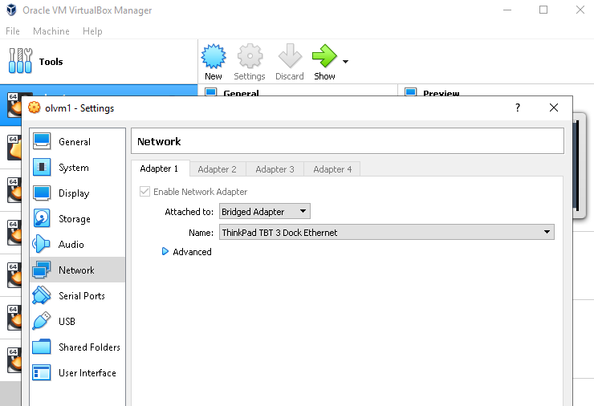

**Additional Details:**

**VirtualBox → Select the VM (mlvm01) → Settings → Network → Adapter 1**

1. **On-Site Wireless Connection (clear-corp)**
2. Attached to: Bridged Adapter

Name: ?

***Note:*** *Not working when tested*

1. Attached to: NAT

Name: Nothing to select, it will be grayed out

***Note:*** *The connection is not a regular VPN, it is more mimics a wired corporate connection, so within the VM you can use the VPN Client to connect to the OSC VPN.*

1. **On-Site Wireless Connection (clear-guest)**
2. Attached to: Bridged Adapter

Name: Choose the wireless ethernet you are connected to, there should only be one wireless option listed in the drop down

***Note:*** *Not working when tested*

1. Attached to: NAT

Name: Nothing to select, it will be grayed out

***Note:*** *The Host must already be connected to wireless, having supplied any required guest credentials, available from* [*https://gmp.oracle.com/captcha*](https://gmp.oracle.com/captcha)*. This will work whether the Host is already connected to the Oracle Corp VPN, or not, however since this configuration piggy backs on the Host's connection, any change you make to the Host's connection will affect the Guest's connection. For example: if start the Guest without the Host being on the Oracle Corp VPN, the Guest will work, but if you then start the Host's VPN, the Guest's connection will be lost, and you will need to reboot the Guest.*

1. **On-Site Wired Connection**
2. Attached to: Bridged Adapter

Name: Choose the wired ethernet you are connected to, could be from the laptop or docking station

1. Attached to: NAT

Name: Nothing to select, it will be grayed out

***Note:*** *This configuration piggy backs on the Host's connection, so it will automatically be on the corporate LAN, so no VPN is used on the Host.*

1. **Off-Site Wireless Connection**
2. Attached to: Bridged Adapter

Name: Choose the wireless ethernet you are connected to, there should only be one wireless option listed in the drop down

***Note:*** *The Host must already be connected to wireless, having supplied any required credentials. This will work whether the Host is already connected to the Oracle Corp VPN, or not. Also, because this is not piggy backing on the Host's connection, Host can connect and disconnect from the Oracle Corp VPN without impacting the Guest's connection to the OSC.*

1. Attached to: NAT

Name: Nothing to select, it will be grayed out

***Note:*** *The Host must already be connected to wireless, having supplied any required credentials. This will work whether the Host is already connected to the Oracle Corp VPN, or not, however since this configuration piggy backs on the Host's connection, any change you make to the Host's connection will affect the Guest's connection. For example: if start the Guest without the Host being on the Oracle Corp VPN, the Guest will work, but if you then start the Host's VPN, the Guest's connection will be lost, and you will need to reboot the Guest.*

1. **Off-Site Wired Connection**
2. Attached to: Bridged Adapter

Name: Choose the wired ethernet you are connected to, could be from the laptop or docking station

1. Attached to: NAT

Name: Nothing to select, it will be grayed out

***Note:*** *This will work whether the Host is already connected to the Oracle Corp VPN, or not, however since this configuration piggy backs on the Host's connection, any change you make to the Host's connection will affect the Guest's connection. For example: if start the Guest without the Host being on the Oracle Corp VPN, the Guest will work, but if you then start the Host's VPN, the Guest's connection will be lost, and you will need to reboot the Guest.*