The SSB schema contains the tables: lineorder, customer, supplier, part, and dwdate. The following is a list of sample queries and analytic views you can use against the SSB schema. Note that you need to prefix the table names with the schema name SSB in your queries.

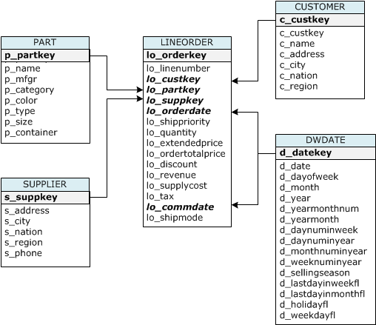

--> https://www.cs.umb.edu/~poneil/StarSchemaB.PDF will explain each table and also query for perf test

for oracle, they merge line item + order item into lineorder table

this falls under TPC-H

TPC-H is a Decision Support Benchmark

The TPC Benchmark™H (TPC-H) is a decision support benchmark. It consists of a suite of business oriented ad-hoc queries and concurrent data modifications. The queries and the data populating the database have been chosen to have broad industry-wide relevance. This benchmark illustrates decision support systems that examine large volumes of data, execute queries with a high degree of complexity, and give answers to critical business questions. The performance metric reported by TPC-H is called the TPC-H Composite Query-per-Hour Performance Metric (QphH@Size), and reflects multiple aspects of the capability of the system to process queries. These aspects include the selected database size against which the queries are executed, the query processing power when queries are submitted by a single stream, and the query throughput when queries are submitted by multiple concurrent users. The TPC-H Price/Performance metric is expressed as $/QphH@Size.